SHORTEST PATH ALGORITHM BASED ON SLIME MOLD BEHAVIOR

Ryan Anderson and Hudson DeVoe
Department of Mathematics and Computer Science
Stetson University
DeLand, FL
{randerson1, hdevoe}@stetson.edu

ABSTRACT

In this paper, we develop a shortest path algorithm for solving mazes by implementing the observed search behavior of Physarum polycephalum, a species of slime mold and member of the Myxogastria class. The purpose of this project was to compare the time and space complexities of a naturally occurring shortest path solver like the slime mold with two popular shortest path algorithms in contemporary computing, the algorithms of Floyd and Dijkstra. We chose to first write and analyze the two known algorithms. We then analyzed Physarum polycephalum’s life cycle and attempted to replicate its behavior in the form of a shortest path algorithm.

PROBLEM

The shortest path problem is one of computing’s most famous challenges. The Travelling Salesperson problem is, for example, a shortest path problem where the goal is to find the shortest path between a series of points on a map. When multiple vertices are added, the complexity becomes factorial. Over time, algorithms have been developed to solve the shortest path problem at reduced order of complexities. While mathematicians and computer scientists continue to develop shortest path algorithms, a particular species of slime mold has been solving shortest path problems without the help of a human or even a brain of its own. The motive of our paper is to implement a slime mold-inspired algorithm and compare the strengths and weaknesses of said algorithm in relation to established shortest path algorithms.

METHODOLOGY

Because our starting goal was to convert a naturally-occurring organic sequence into a computer algorithm, a large portion of our time was spent on researching the Physarum polycephalum slime mold. The implementation of Physarum polycephalum’s behavior was more difficult than we initially expected. This difficulty was primarily due to the fact that Physarum polycephalum has neither the limitations nor the expectations that an efficient computer program has. Physarum polycephalum has no limit on time complexity, no limit on space complexity, and no central processing unit. Yet, almost always, Physarum polycephalum efficiently finds the shortest path. The word “efficiently” is in terms of the natural world, not software, because each individual process is closer to a brute-force method of finding the shortest path. However, this does not mean that there is nothing to be learned from the slime mold. Our project’s work was first to analyze the steps of the Physarum polycephalum.
The slime mold will first send out cloud-like protoplasmic veins. These veins, made of large cells with many nuclei, are searching for food sources for the Physarum polycephalum to consume. When a piece of food is found, the slime mold will check all semi-random paths that found the food, comparing their respective lengths and allowing all but the shortest path do wither and die. The slime mold continues this same process for as long as it is alive, moving from food source to food source. Interestingly, it can enter dormant phases, when it will build hardened tissue around itself called a sclerotium. Once food sources have been exhausted, Physarum polycephalum begins the reproduction stage, where it grows spore-spreading stalks called sporangia. The spores can survive dormant for several years waiting for favorable environmental conditions.
Because our focus was on developing a shortest path algorithm, we focused on the food-searching phase of the Physarum polycephalum life cycle. In our algorithm, the slime mold traverses through an adjacency matrix constructed to simulate a maze. We chose to ignore the lifespan, the sclerotium phase, and the death/reproduction of the slime mold, as we believe that they fall outside of the current scope of the project.

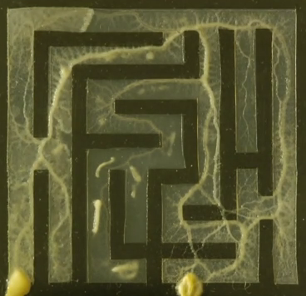
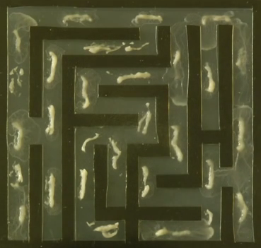
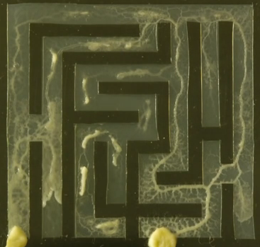

The food-finding process of Physarum polycephalum.
(source: https://www.youtube.com/watch?v=5UfMU9TsoEM)

IMPLEMENTATION

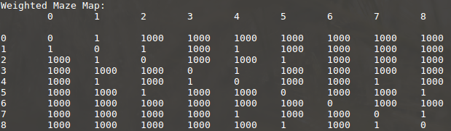
Floyd’s, Dijkstra’s, and the Physarum polycephalum shortest path algorithms were implemented in C++ for use in adjacency matrices simulating the structure of randomly-generated mazes. The maze-generation algorithm takes in an integer n such that n=m^2 where (m * m) are the dimensions of the maze and then generates an adjacency matrix with the dimensions n * n. An adjacency matrix is a two-dimensional matrix representing the distances between specific vertices, where address (x , y) on the adjacency matrix contains the distance between vertex x and vertex y. The limitations on n are necessary because an adjacency matrix with dimensions n * n represents a maze with dimensions √n * √n. Further limitations were implemented in order to invoke to generation of more maze-like adjacency matrices. If vertices were not adjacent vertically or horizontally, the value at the vertices’ address was set to 1000, indicating that the distance between them was impassible without traversal through other vertices. A generated adjacency matrix (9 * 9) can be seen here:
The adjacency matrix in the previous image represents the following 3 * 3 maze:

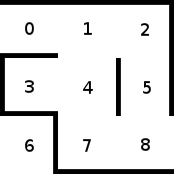

Floyd’s algorithm was implemented using the pseudocode of Algorithm 3.3 in Foundations of Algorithms Fifth Edition by Richard E. Neapolitan. The Dijkstra’s algorithm implemented was based on the pseudocode of Foundations of Algorithms Fifth Edition’s Algorithm 4.3. Floyd’s algorithm attempts to find the shortest path between two vertices by taking in the randomly generated two-dimensional adjacency matrix and outputting a second two-dimensional adjacency matrix containing the shortest available paths from each vertex to every other vertex. Dijkstra’s algorithm takes a greedy approach, taking in the two-dimensional matrix and outputting a set of vertices containing the vertices found in the shortest path.
As an algorithm of order of complexity θ(n^3) in every case, Floyd’s algorithm performs n^3 comparisons for an adjacency matrix of size n * n to find the shortest path. Because the shortest path problem is one of optimization, the shortest path from the beginning of the maze to the end can be found by finding the optimal route between the intermediate vertices. Floyd’s algorithm determines these optimal routes by comparing the immediate distance between two vertices ((x, y) on Floyd’s adjacency matrix) against the added sum of the distances between the two vertices and an intermediate vertex((x, i) + (i, y) on Floyd’s adjacency matrix). If the summed distance is less than the immediate distance between the two points, the (x, y) point on Floyd’s output adjacency matrix is set equal to the (x, i) + (i,y) value. Once Floyd’s algorithm has completed its loop through every (x, y) address on the adjacency matrix, the value returned in the (beginning, end) address on the adjacency matrix represents the distance of the shortest path from beginning to end. Floyd’s approach differs from that of Physarum polycephalum in that where Floyd’s algorithm loops through every index of the 2-dimensional adjacency matrix, Physarum polycephalum would only be able to perceive and therefore move to vertices that are open (distance of 1 on the adjacency matrix) and continue searching for the shortest path from the open vertex, resulting in semi-random looping through the rows of the adjacency matrix.
Dijkstra’s algorithm is of order of complexity θ(n^2) in the worst case, meaning that Dijkstra’s performs n^2 comparisons for an adjacency matrix of size n * n. In order to find the shortest path, Dijkstra’s algorithm implements the greedy approach. Initially, Dijkstra’s algorithm initializes for all vertices the initial vertex as the last vertex on the current shortest path from the initial vertex, and it initializes the length of the current shortest path from the vertex to the initial vertex as the distance from the initial vertex to the vertex. While the instance is not solved, Dijkstra’s algorithm performs a loop of selecting the vertex from V (the set of all vertices) not found in Y (initially the set containing the vertex whose shortest paths are to be determined) with the shortest path from the initial vertex using only the vertices in Y as intermediates. After selecting this vertex, Dijkstra’s algorithm adds the vertex to Y and adds the edge on the shortest path that touches the vertex to F (the set of edges on the shortest path). This loop continues until V == Y. Instead of generating a two-dimensional adjacency matrix as in Floyd’s, Dijkstra’s algorithm’s output consists of the set of edges F that make up the shortest path. Although Dijkstra’s algorithm is similar to Physarum polycephalum’s behavior than Floyd’s algorithm (the greedy approach better simulates the slime mold’s traversal through the maze than Floyd’s “overhead” scanning of the adjacency matrix), certain aspects of Dijkstra’s failed to fully replicate the limitations of Physarum polycephalum. For example, where Dijkstra’s algorithm begins with a set of all vertices V, Physarum polycephalum has no awareness of vertices until they are adjacent to its current location in the maze.
After implementing Dijkstra’s and Floyd’s algorithms and testing their ability to find the shortest path in the generated adjacency matrices, we developed pseudocode representing the behavior of Physarum polycephalum as it searches and moves towards food. The pseudocode for Physarum polycephalum reads as follows:

//inputs are currentLocation of slimemold, a bool array of food locations, and an empty shortestPaths array

void slimePath(currentLocation, bool w[][], shortestPaths[][]) {
list promisingPaths
index foodLocation
int n = size of w[][]
bool foodIsFound

//main while loop
while(w[][] contains more than 0 trues) {
//find a path to a specific food location, choosing a random path through i and j indices
for(i -> n)
{
for(j -> n)
{
if(currentLocation contains a true)
{
//store the path that was taken
add path to promisingPaths

//store the w index of the true
foodLocation = index of w
}
}
}
//slime mold will make several random paths to the previously discovered food source, and only keep the shortest of those paths
for(arbitrary number of paths to make)
{
for(i -> n) //i and j are again randomly chosen
{
for(j -> n)
{
if(iterator[i][j] = foodlocation
{
//store the path that was taken
add path to promisingPaths
}
}
}
}
//a slime mold will let the other paths die, keeping only the shortest that it found
iterate through promisingPaths, store only the shortest path in its appropriate index in shortestPaths[][]
//the value stored in shortestPaths[][] represents the shortest path from the currentLocation to the foodLocation

//eat the food
w[foodlocation] = false
//move currentLocation because now we need to find a new source of food
currentLocation = foodlocation
}//end of main while loop
}//end of algorithm

One of the first implementation challenges was conceptualizing how the slime mold would run if it were a loop. We could not use a for-loop, because a slime mold only grows veins in semi-random directions until it finds food. We chose a while-loop because we needed to customize our incrementations as the slime mold travelled through the maze. We also created a 2D vector of Booleans, sharing the same dimensions as the adjacency matrix, which would prevent the slime mold from returning to previously occupied vertices. This is true in real life, as a slime mold does not grow veins on top of previous veins. This Boolean vector made smaller mazes a challenge because there are few paths to take; but in larger mazes, where potentially hundreds of paths exist, it decreases the time complexity by preventing a new direction leading back into a previous path. Compared to our earlier versions of the program, the Boolean 2D vector is a much more elegant solution to the problem of preventing the slime mold from travelling in a circuit. The main while loop continues until the food is located. In all of our models, due to the project’s complexity, we only place a single piece of food. During the entire process of the slime mold proceeding through the maze, every vertex is stored in a vector, and each time one of these vectors is completed, it is stored in a vector of vectors. The vector of vectors is sorted by size, and the smallest is then returned.
The algorithm is still rife with inefficiencies, and plenty of potential options for future versions exist, of which several follows. The structure that the slime molds travels through could be changed into a map with multiple food sources, and the slime mold could start at a random location. This would not only be a more realistic simulation, but would also dovetail nicely into 3D shortest path programs. We are also aware that there exists a more efficient solution than our Boolean array for preventing the slime mold from traveling to previous nodes, because larger maps with potentially thousands of vertices would require a new 2D Boolean vector of the same size. We also have acknowledged the reality that the adjacency matrix is not a perfect representation of the environment in which Physarum polycephalum searches for food, but made sense in our algorithm due to the goals of the project.

RESULTS

If we were to compare time complexities, the slime mold would be only slightly more efficient than the brute-force method, which is on the order of two to the nth power. This is, of course, less efficient than either Dijkstra’s or Floyd’s algorithms. If we attempt to compare space complexity, then the slime mold would take up as much space as the food allows its body to grow. In our algorithm, the space complexity is massive; we could not even calculate it. First, we double the two-dimensional vector size by creating the matching Boolean version. Then vectors are created or each path that is found to each piece of food. For example, if there are ten ways to find one piece of food, and ten ways to find another piece of food, then twenty vectors are created, and on top of that are sorted to find the shortest vector. The space complexity is likely the most improvable part of the algorithm. The reason for the immense size complexity is due to the fact that an algorithm based on behavior in the natural world must account for many factors that are taken for granted in the physical space. For example, the two-dimensional Boolean vector representing where the Physarum polycephalum algorithm has previously been is a representation of something that in the physical world would be innately understood by the slime mold.

CONCLUSION

The slime mold model is a good example of parallel computing. Small specialized cells unaware of their surroundings each repeat simple tasks until the overall goal is achieved. A computer could achieve similar results by using small simple processors, which is the structure that would lower the time complexity of Physarum polycephalum into something closer to real world observation. This system is also an example of swarm intelligence. The phrase was introduced by Gerardo Beni and Jing Wang in 1989, and it refers to a collection of simple agents that only interact with each’s nearest neighbors, which enables the overall system to accomplish complicated tasks. Examples of swarm intelligence in nature include bacterial growth, fish schooling, ant colonies, bee hives, and bird flocking.
We believe that most insight that we have gained from this project is that there is not a clean way to compare natural progressions like this to a computer algorithm. To generalize, the project showed us that nature is vastly more complicated than it appears, that nature has often done it first and done it better, and that the structure of organisms like this provide valuable insight into some of our most challenging problems.

WORKS CITED

Furman, Marschall, et al. “Investigating the Efficiency of Slime Mold as a Maze-Solving Algorithm.” NCSU, Nov. 2014, www4.stat.ncsu.edu/~reich/CSUMS/presentations/Slime.pdf.

Bonifaci, Vincenzo, et al. "Physarum Can Compute Shortest Paths." Journal of Theoretical Biology, vol. 309, 21 Sept. 2012, pp. 121-133. EBSCOhost, doi:10.1016/j.jtbi.2012.06.017.

Liu, Yuxin, et al. "A New Multi-Agent System to Simulate the Foraging Behaviors of Physarum." Natural Computing, no. 1, 2017, p. 15. EBSCOhost, doi:10.1007/s11047-015-9530-5.

Oxenham, Simon. “Why bees could be the secret to superhuman intelligence.” BBC, BBC, 15 Dec. 2016, www.bbc.com/future/story/20161215-why-bees-could-be-the-secret-to-superhuman-intelligence.

Beni, Gerardo, and Jing Wang. Swarm Intelligence in Cellular Robotic Systems. Vol. 102, NATO ASI Series, 1993.

