SHORTEST PATH ALGORITHM BASED ON SLIME MOLD BEHAVIOR

Ryan Anderson and Hudson DeVoe
Department of Mathematics and Computer Science
Stetson University
DeLand, FL
{randerson1, hdevoe}@stetson.edu

ABSTRACT

In this paper, we develop a shortest path algorithm for solving mazes by implementing the observed search behavior of Physarum polycephalum, a species of slime mold and member of the Myxogastria class. The purpose of this project was to compare the time and space complexities of a naturally occurring shortest path solver like the slime mold with two popular shortest path algorithms in contemporary computing, the algorithms of Floyd and Dijkstra. We chose to first write and analyze the two known algorithms. We then analyzed Physarum polycephalum’s life cycle and attempted to replicate its behavior in the form of a shortest path algorithm.

PROBLEM

The shortest path problem is one of computing’s most famous challenges. The Travelling Salesperson problem is, for example, a shortest path problem where the goal is to find the shortest path between a series of points on a map. When multiple vertices are added, the complexity becomes factorial. Over time, algorithms have been developed to solve the shortest path problem at reduced order of complexities. While mathematicians and computer scientists continue to develop shortest path algorithms, a particular species of slime mold has been solving shortest path problems without the help of a human or even a brain of its own. The motive of our paper is to implement a slime mold-inspired algorithm and compare the strengths and weaknesses of said algorithm in relation to established shortest path algorithms.

METHODOLOGY

Because our starting goal was to convert a naturally-occurring organic sequence into a computer algorithm, a large portion of our time was spent on researching the Physarum polycephalum slime mold. The implementation of Physarum polycephalum’s behavior was more difficult than we initially expected. This difficuly was primarily due to the fact that Physarum polycephalum has neither the limitations nor the expectations that an efficient computer program has. Physarum polycephalum has no limit on time complexity, no limit on space complexity, and no central processing unit. Yet, almost always, Physarum polycephalum efficiently finds the shortest path. The word “efficiently” is in terms of the natural world, not software, because each individual process is closer to a brute-force method of finding the shortest path. However, this does not mean that there is nothing to be learned from the slime mold. Our project’s work was first to analyze the steps of the Physarum polycephalum.
The slime mold will first send out cloud-like protoplasmic veins. These veins, made of large cells with many nuclei, are searching for food sources for the Physarum polycephalum to consume. When a piece of food is found, the slime mold will check all semi-random paths that found the food, comparing their respective lengths and killing all but the shortest path. The slime mold continues this same process for as long as it is alive, moving from food source to food source. Interestingly, it can enter dormant phases, when it builds hardened tissue around itself called a sclerotium. Once food sources have been exhausted, Physarum polycephalum begins the reproduction stage, where it grows spore-spreading stalks called sporangia. The spores can survive dormant for several years waiting for favorable environmental conditions.
Because our focus was on developing a shortest path algorithm, we focused on the food-searching phase of the Physarum polycephalum life cycle. In our algorithm, the slime mold traverses through an adjacency matrix constructed to simulate a maze. We chose to ignore the lifespan, the sclerotium phase, and the death/reproduction of the slime mold, as we believe that they fall outside of the current scope of the project.

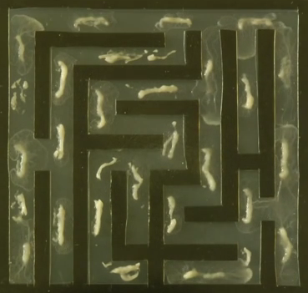
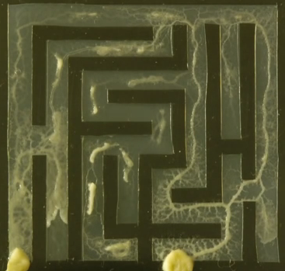
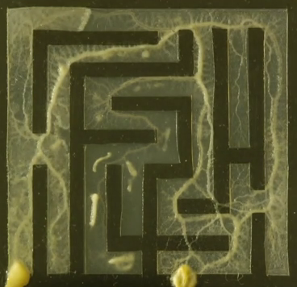

(source: https://www.youtube.com/watch?v=5UfMU9TsoEM)

IMPLEMENTATION

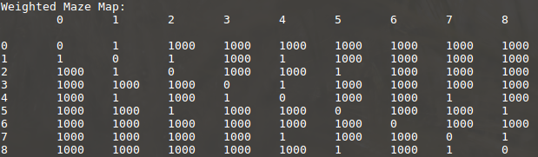
Floyd’s and Dijkstra’s shortest path algorithms were implemented in C++ for use in adjacency matrices simulating the structure of randomly-generated mazes. The maze-generation algorithm takes in an integer n such that n is a square number, and then generates an adjacency matrix with the dimensions n * n. An adjacency matrix is a two-dimensional matrix representing the distances between specific vertices, where address (x , y) on the adjacency matrix contains the distance between vertex x and vertex y. The limitations on n are necessary because an adjacency matrix with dimensions n * n represents a maze with dimensions √n * √n. Further limitations were implemented in order to invoke to generation of more maze-like adjacency matrices. If vertices were not adjacent vertically or horizontally, the value at the vertices’ address was set to 1000, indicating that the distance between them was impassible without traversal through other vertices. A generated adjacency matrix (9 * 9) can be seen here:
The adjacency matrix in the previous image represents the following 3 * 3 maze:

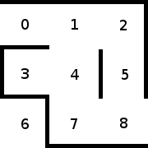

Floyd’s algorithm was implemented using the psuedocode of Algorithm 3.3 in Foundations of Algorithms Fifth Edition by Richard E. Neapolitan. The Djikstra’s algorithm implemented was based on the pseudocode of Foundations of Algorithms Fifth Edition’s Algorithm 4.3. Floyd’s algorithm attempts to find the shortest path between two vertices by taking in the randomly generated two-dimensional adjacency matrix and outputting a second two-dimensional adjacency matrix containing the shortest available paths from each vertex to every other vertex. Djikstra’s algorithm takes a greedy approach, taking in the two-dimensional matrix and outputting a set of vertices containing the vertices found in the shortest path.
As an algorithm of θ(n^3), Floyd’s algorithm performs n^3 comparisons on an adjacency matrix of size n * n to find the shortest path.

We then wrote the pseudo code for our slime mold algorithm, but it was almost completely rewritten during the process of translating the code into C++. We could not use Dijkstra’s algorithm for reference, because a slime mold has no awareness of surrounding vertices. One of the challenges was conceptualizing how the slime mold would run if it were a loop. We could not use a for-loop, because a slime mold only grows veins in semi-random directions until it finds food. We chose a while-loop because we needed to customize our incrementations as the slime mold travelled through the maze. We also created a 2D vector of Booleans, sharing the same dimensions as the adjacency matrix, which would prevent the slime mold from returning to previously occupied vertices. This is true in real life, as a slime mold does not grow veins on top of previous veins. This Boolean vector made smaller mazes a challenge because there are few paths to take; but in larger mazes, where potentially hundreds of paths exist, it decreases the time complexity by preventing a new direction leading back into a previous path. Compared to our earlier versions of the program, the Boolean 2D vector is a much more elegant solution to the problem of preventing the slime mold from travelling in a circuit. The main while loop continues until the food is located. In all of our models, due to the project’s complexity, we only place a single piece of food. During the entire process of the slime mold proceeding through the maze, every vertex is stored in a vector, and each time one of these vectors is completed, it is stored in a vector of vectors. The vector of vectors is sorted by size, and the smallest is then returned.
The algorithm is still rife with inefficiencies, and plenty of potential options for future versions exist, of which several follows. The structure that the slime molds travels through could be changed into a map with multiple food sources, and the slime mold could start at a random location. This would not only be a more realistic simulation, but would also dovetail nicely into 3D shortest path programs. We are also aware that there exists a more efficient solution than our Boolean array for preventing the slime mold from traveling to previous nodes, because larger maps with potentially thousands of vertices would require a new 2D Boolean vector of the same size. We also have acknowledged the reality that the adjacency matrix is not a perfect representation of the way that Physarum polycephalum searches for food, but made sense in our algorithm due to the goals of the project.

CONCLUSION

If we were to compare time complexities, the slime mold would be only slightly more efficient than the brute-force method, which is on the order of n squared. But this makes sense because the slime mold is searching for food in nature, and the time that it requires is not limited by processing power, but by its actual lifespan; any organism searching for food will exhaust every possible path to it.
If we attempt to compare space complexity, then the slime mold would take up as much space as the food allows its body to grow. In our algorithm, the space complexity is massive; we could not even calculate it. First, we double the 2D vector size by creating the matching Boolean version. Then vectors are created or each path that is found to each piece of food. For example, if there are ten ways to find one piece of food, and ten ways to find another piece of food, then twenty vectors are created, and on top of that are sorted to find the shortest vector. The space complexity is likely the most improvable part of the algorithm. It is worth reiterating that Physarum polycephalum accomplishes all of this without a brain.
We believe that most insight that we have gained from this project is that there is not a clean way to compare natural progressions like this to a computer algorithm. To generalize, the project showed us that nature is vastly more complicated than it appears, that nature has often done it first and done it better, and that the structure of organisms like this provide valuable insight into some of our most challenging problems.

