The Text in the ((brackets)) are the Navigationpoints. I colored the different sections just for better understanding.

**Text website:**

((Anniversary))

20 years of Formschön shoe manufacture

Always one step ahead

Celebrate with us!

In September 2001, we siblings, Maria Gracia and Paolo Zuretti, opened our shoe manufactory in Bad Godesberg. Prior to this, we had both acquired a master craftsman's certificate and gained several years of professional experience in various workshops. In September 2021, we will be celebrating the 20th anniversary of our manufactory. We look forward to your visit - whether online or directly at Alte Bahnhofstraße 5a in Bonn-Bad Godesberg.

((Chronology))

20 years

Shoe manufactory Formschön

Milestones:

September 2001 Together we siblings, Maria Gracia and Paolo Zuretti, open our shoe manufactory in Bad Godesberg. We have both acquired a master craftsman's certificate and have already gained several years of professional experience in various workshops.

September 2004 Lukas Bischoff starts his apprenticeship with us. Today he is the team's specialist for upper production.

August 2007 WDR regional television visits the manufactory and portrays our work. This is the breakthrough: many potential customers become aware of us - and not just in the Rhineland.

May 2010 We open a small showroom next to our workshop and store. This ensures an individual atmosphere when taking measurements and trying on shoes.

October 2014 The Formschön shoe manufactory presents its models at the Rhineland Crafts Exhibition in Düsseldorf.

December 2015 We participate in the reorganization of the "bespoke shoemaker" profession so that our young professionals are up to date.

March 2016 We are a guest at the European leather and fashion trade fair in Brussels.

January 2017 The annual meeting of bespoke shoemakers from German-speaking countries takes place at our Formschön shoe manufactory.

December 2017 We show the production of bespoke shoes at the "Tage der Manufakturen" in Berlin.

September 2019 Leonie Meißner starts her new apprenticeship as a bespoke shoemaker with us.

September 2021 We celebrate our 20th anniversary.

((Services))

What we do for you

Repair:

Come to us with high-quality leather goods if something is broken. For example: a torn strap on a rucksack, a zipper on a bag that has snagged, the soles of boots that have been kicked askew, a shoe heel that has become loose. The preservation of beautiful quality goods that have become dear to you is important to us. Throwing them away is a thing of the past!

Improve them:

Don't be afraid to come to us with good, industrially manufactured quality shoes if you have special fitting requirements. For example: widening shoes, shortening boot shafts, fitting special soles, compensating for leg length differences, raising heels. It is important to us that your feet have a perfect fit. Pain is avoidable.

Create:

Talk to us if you want to wear exclusive shoes, models according to your fashion ideas and the characteristics of your feet. In addition to custom-made shoes, there are also more cost-effective options, such as made-to-measure clothing with a wide range of options. Do not hesitate!

((Customized shoes))

Manufaktur Formschön

Always one step ahead

The path to your made-to-measure shoe

1 The foot measurement

2 Choosing the color and shape

3 Choosing the leather

4 Making the last

5 Making the shoe - Part I

6 The fitting

7 Making the shoe - Part II

8 Final adjustments and finishing touches

The time required to produce your individual custom-made shoes can vary considerably, depending on the model, design and special requests. We estimate at least 30 working hours. The entire work process usually takes eight weeks. During this time, you will be asked three times: to measure and select the model, for an initial fitting and finally on the day of completion. You can expect to pay between 2000 and 3000 euros per pair. As soon as we have made a last to suit your feet, we can use it for all subsequent models - and you save money. Women's shoes are generally more elaborate and therefore somewhat more expensive than models for men.

Accessoires

Herrengürtel Carlos Santos braun 99,00 EUR*

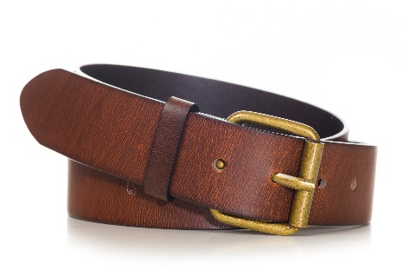

Herrengürtel Carlos Santos schwarz 99,00 EUR*

Ein Bild, das Kleidung, Schnalle, Gürtelschnalle, Band enthält.

Schuhpflege Saphir Shoe Wax 16,90 EUR*

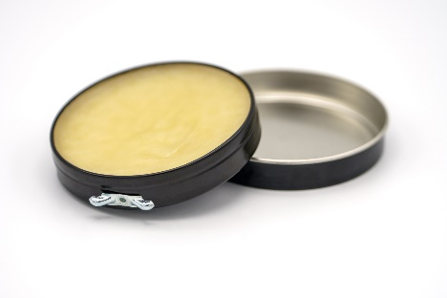

Herrensocken Doré 18,90 EUR*

Ein Bild, das Kleidung, Socke enthält.

Schuhspanner 69,00 EUR*

Ein Bild, das Schuhwerk, Beige, Holz, Hellbraun enthält.

* Alle Preise inkl. 19 % MwSt. zzgl. Lieferung

Vorname*

Nachname*

Straße*

Hausnummer*

Postleitzahl*

Ort*

E-Mail*

Telefon

Gewünschtes Lieferdatum

((Voices))

What our customers say:

“I don't know how much time I always wasted trying to find shoes that I both liked and that fitted really well. I usually opted for something visually appealing and put up with pain on my feet. That is now a thing of the past.”

“What matters to me is the price-performance ratio. And with "Formschön", that's just right.”

“I'm literally on my feet for 16 hours a day. And you quickly notice which shoes you're wearing. Ever since I realized what a difference it makes whether the shoes fit like a glove or not, it has been clear to me that Formschön's made-to-measure shoes are worth the price.”

“I like coming to the Formschön bespoke shoemakers because I like the atmosphere and because I always feel well advised.”

“I hate shopping. And that's why I'm glad that the Formschön shoe manufactory exists. I know what I'm getting for my money there. What's more, a pair of made-to-measure shoes simply lasts a long time - and saves me having to choose and try them on again and again.”

“When I see all those plastic shoes in the usual shops, I think: what a waste of material! Handmade shoes are much more sustainable.”

“I can't afford custom-made shoes. Fortunately, I have an unproblematic pair of feet for which I can easily find high-quality ready-made shoes. They have to look timelessly good and be made from the best leather. Then, over the years, I take them to the Formschön shoe manufactory every now and then when heels need to be repaired or new soles fitted. It's worth it!”

“I once heard a very fitting saying: "If you buy cheap, you pay twice!"”

((Care tips))

Shoe manufacturer Formschön

For the sake of your feet

Our care tips:

1. use wooden stretch lasts and break in your shoes while they are still warm and supple from wear.

2. do not use the same pair every day. Good shoes need to be allowed to rest.

3. store shoes in a cupboard with ventilation slots.

4. care for the upper leather from time to time with a liquid cleaner. Look out for special care products for patent and suede leather.

5 Stuff wet shoes with newspaper and remove white marks with warm water.

6. use suitable care products after stain removal. We will be happy to advise you.

7. remove the laces before polishing.

8. polish extensively. Ask us for the right brushes.

9. put your shoes in air-permeable bags when traveling.

10. always use a shoehorn.

((Footer))

Opening hours and contact:

Monday-Friday 9-17 o'clock

Saturday 10-15 o'clock

and by appointment

Shoe manufacturer Formschön GmbH

Alte Bahnhofstraße 5a

53173 Bonn-Bad Godesberg

Tel: 0228-123450

Fax: 0228-123459

info@schuhmanufaktur-formschön.de

www.schuhmanufaktur-formschön.de

Imprint

Shoe manufacturer Formschön GmbH

Management: Maria Gracia and Paolo Zuretti

Alte Bahnhofstraße 5a

53173 Bonn-Bad Godesberg

Tel: 0228-123450, Fax: 0228-123459

info@schuhmanufaktur-formschön.de

www.schuhmanufaktur-formschön.de

Bonn Local Court, Commercial Register No. XXX000XXX

Tax office Bonn-Außenstadt, VAT ID: DE10111011