STARTUP EXECUTION PLAN | INVESTMENT PROPOSAL | IMPLEMENTATION ROADMAP
SmartBiz AI
Complete Startup Execution Plan, Investment Proposal, and Implementation Roadmap

A proposed business management tool for small online sellers and home-based businesses in Karachi, Pakistan

Prepared by: FAKHAAR AHMED
Contact: +92 341 4663393 | Email: fakharmiqdad@gmail.com
Prepared for: the founding group of entrepreneurs, university project reviewers, and prospective advisors
Version 1.0 | 31 October 2026 | Project start assumed at Day 1 (Week 1)
Important. SmartBiz AI is a proposed startup. No product, customers, revenue, partnerships, investors, or legal approvals exist yet. All forecasts are planning scenarios, not guaranteed outcomes. Legal and tax content is general information and must be confirmed by qualified Pakistani professionals.
Table of Contents
Document Purpose, Scope and Reading Guide 4
Scope 4
How to read the evidence labels 4
Startup Vision, Mission and Objectives 4
Assumptions and Research Limitations 5
Step 1: Executive Summary 6
Step 2: Problem and Market Analysis 8
2.1 Market overview 8
2.2 Needs of small online sellers in Karachi (hypotheses to validate) 8
2.3 Existing ways sellers solve these problems 9
2.4 Target customer segments and personas 9
2.5 Customer buying behaviour and willingness to pay 10
2.6 Market opportunity: TAM, SAM and SOM 10
2.7 Proposed customer interview questionnaire 11
2.8 Competitor and market research methodology 12
2.9 Market validation plan 12
Step 3: Solution and Product Scope 13
3.1 Product vision, mission and value proposition 13
3.2 Core features, MVP scope and exclusions 13
3.3 Feature prioritisation 13
3.4 User journey and customer workflow 14
3.5 Technical architecture and technology stack 15
3.6 Where AI is optional and how it affects the budget 16
3.7 Product roadmap 17
Step 4: Competitor Analysis and Positioning 19
4.1 SWOT analysis 19
4.2 Positioning matrix 20
4.3 SmartBiz AI differentiation strategy (hypotheses to test) 20
Step 5: Business Model and Pricing 22
5.1 Options evaluated 22
5.2 Illustrative pricing tiers (PKR per month, excluding tax) 22
5.3 Financial metrics in simple English 23
Step 6: Go-to-Market and Marketing Plan 25
6.1 Positioning and message 25
6.2 Channels 25
6.3 Sales funnel and how each stage is measured 26
6.4 Marketing budgets 26
6.5 Onboarding, support and retention 27
Step 7: Operations and Team Structure 29
7.1 Roles, responsibilities and indicative pay 29
7.2 Responsibility assignment matrix (RACI) 30
7.3 Operating workflows 31
7.4 Recommended tools 31
Step 8: Legal, Regulatory, Security and Risk Plan 33
8.1 Risk register 34
Step 9: Execution Timeline and Gantt Chart 35
9.1 Task schedule, owners, dependencies and deliverables 35
9.2 Milestone approval criteria 37
9.3 30-, 60- and 90-day plans 37
9.4 Month-by-month 12-month roadmap 37
Step 10: Financial Plan and Investment Requirements 39
10.1 Key assumptions 39
10.2 Three funding scenarios 39
10.3 Twelve-month forecast (Standard plan, PKR thousand) 40
10.4 Break-even analysis 41
10.5 Twenty-four-month summary (Standard plan, illustrative) 42
10.6 Funding sources to consider 42
Step 11: KPIs and Performance Dashboard 43
11.1 Provisional targets: 30, 60 and 90 days 43
Step 12: Immediate Next Actions 45
Appendix A: Financial Assumptions and Detailed Tables 46
A.1 Staffing schedules used in the model (PKR per month) 46
A.2 Lean and Growth plan monthly forecasts (PKR thousand) 47
Appendix B: Mermaid Diagram Code 49
Appendix C: Glossary 50
Appendix D: References and Source Links 51
Figures, tables, and appendices are listed in the order they appear. Page numbers refer to the PDF version.

Document Purpose, Scope and Reading Guide
This document is an execution plan for SmartBiz AI, a proposed software startup for small online sellers and home-based businesses in Karachi, Pakistan. It is written so that a group of entrepreneurs can decide whether to proceed, what to do first, who does what, how much it may cost, and how to judge progress. It can be used as a university project submission and as a starting point for investor or advisor discussions.
Status of SmartBiz AI. SmartBiz AI is a proposal. No product has been built, launched, or connected to any external service. There are no customers, revenues, partnerships, investor commitments, or legal approvals. Everything described as a feature, price, target, or forecast is a plan or an assumption to be tested.

Scope
- Covered: market and problem analysis, product scope, competitors, business model, go-to-market, team, legal and risk plan, timeline, financial plan, KPIs, and immediate next actions (12 steps).
- Not covered: detailed software design documents, final legal advice, tax advice, or audited financial statements. These need qualified professionals (see Step 8).
- Geography and currency: Karachi first. All financial figures are in Pakistani rupees (PKR). US dollar amounts are shown only where the source prices in dollars, using an assumed rate of PKR 278 per US$1 [A].

How to read the evidence labels
Every market figure and financial estimate carries one of four labels, so the reader can see how much trust to place in it:
Table 1. Evidence labels used throughout
Label | Meaning | Example in this document
[V] | Verified figure with a source (listed in the References). | SMEDA estimate of 5.2 million SMEs in Pakistan.
[C] | Calculation based on sourced data, with the formula shown. | Estimated SMEs in Karachi = 5.2 million x 18% x 36.6%.
[A] | Illustrative assumption chosen by the authors. It must be tested. | Monthly customer churn of 6%.
[Q] | Quotation required before any money is committed. | Company registration agent fees; AI API running cost.

Startup Vision, Mission and Objectives
Table 2. Vision, mission and objectives
Element | Statement
Vision | Every small online seller in Pakistan can run orders, stock, and money from one simple, affordable tool, in a language they are comfortable with.
Mission | Replace scattered chats and spreadsheets with a simple order, customer, and inventory system priced in PKR, then add AI help that saves sellers time.
90-day objective | Within 90 days of Day 1: finish customer validation (target 30 interviews), finish product design, and have an alpha version of the core MVP running with 5-10 pilot users [A].
12-month objective | Within 12 months: public launch in Karachi, first paying customers from month 5, and about 129 paying customers by month 12 under the Standard plan forecast [A].
Long-term direction | Add AI assistance (Phase 2) and carefully selected integrations (Phase 3) only after the core product proves it keeps customers.

Assumptions and Research Limitations
- No reliable count of online sellers. No source reviewed gives a verified number of online sellers in Pakistan or Karachi. The market sizing in Step 2 therefore uses a transparent, labelled estimation method instead of a quoted statistic.
- Published e-commerce estimates disagree. 2025 market-size figures range from US$4.74 billion to US$10.42 billion depending on the publisher (Figure 2). They measure different things, so none is used as a revenue forecast for SmartBiz AI.
- Competitor information comes from public web pages viewed in October 2026. Prices change, and some pages are marketing material. Competitor features not stated on a page are marked "not stated", not "absent".
- Costs are benchmarks, not quotations. Salary figures come from job-site averages for Pakistan and Karachi. They vary widely and must be confirmed with real offers.
- Forecasts are not guarantees. The financial model uses assumptions for customer growth, churn, and costs. The results are planning scenarios, not predictions of profit.
- Legal and tax content is general information. A Pakistani lawyer and a tax adviser must confirm every point before action.
- Personas are fictional composites created to organise hypotheses. Interviews in Phase 1 should replace them with real findings.

Step 1: Executive Summary
Table 3. Executive summary at a glance
Item | Summary
Business concept | SmartBiz AI is a proposed cloud-based business management tool for small online sellers: one place for orders, customers, stock, expenses, and simple reports.
Problem (to be validated) | Orders arrive through WhatsApp, Instagram, and Facebook and are tracked in chats or spreadsheets. Possible results: missed messages, unclear order status, overselling, and no clear view of profit.
Proposed solution | MVP: login and dashboard, order and customer records, product and inventory management, order-status tracking, sales summaries, expense tracking with estimated profit, low-stock alerts, PKR support. Later: AI help (Phase 2) and integrations (Phase 3).
Target customers | Home-based and small online sellers in Karachi with roughly 15-500 orders a month, selling mainly through WhatsApp, Instagram, and Facebook.
Value proposition | A simple, PKR-priced tool that takes minutes to start using and shows what is pending, what is in stock, and roughly what was earned.
Revenue model | Monthly and annual subscriptions: Free (limited), Starter PKR 1,499, Growth PKR 2,999, Business PKR 5,999 per month (ex-tax) [A]. Planned blended revenue per paying customer: PKR 2,549 per month [C].
Competitive position | Competitors include spreadsheets and manual WhatsApp use, global tools priced in US dollars, and local POS or inventory products. SmartBiz AI aims at the gap between them. This is a hypothesis to test, not an established advantage.
90-day objective | Validate the problem with about 30 interviews, finish design, and run an alpha of the core MVP with 5-10 pilot users [A].
12-month objective | Launch publicly in Karachi in month 5; reach about 129 paying customers by month 12 (Standard plan forecast, PKR 329,194 monthly revenue) [A].
Proposed team | Minimum for the MVP: two founders (CEO/product and technical lead) plus a developer and outsourced accounting, design, and legal review. Further hires only when revenue supports them.
Funding requirement | Three scenarios: Lean PKR 1.05 million, Standard PKR 3.45 million, Growth PKR 13.70 million, each including a 15% contingency [A] [Q]. Recommended starting point: Lean-to-Standard, released in stages after validation gates.
Key milestones | Week 4: validation gate. Week 6: design freeze. Week 13 (about day 90): alpha. Week 18: pilot exit and launch decision. Month 5: first paid customers. Month 7: AI beta. Month 12: review.
No promises. This plan does not promise profitability or any number of customers. The Standard plan forecast shows a monthly operating loss at month 12 and reaches break-even at roughly 142 paying customers, which the forecast reaches only after the first year. If the validation gates in Step 2 fail, the recommended action is to narrow the segment, change the product, or stop, and to spend little before that point.
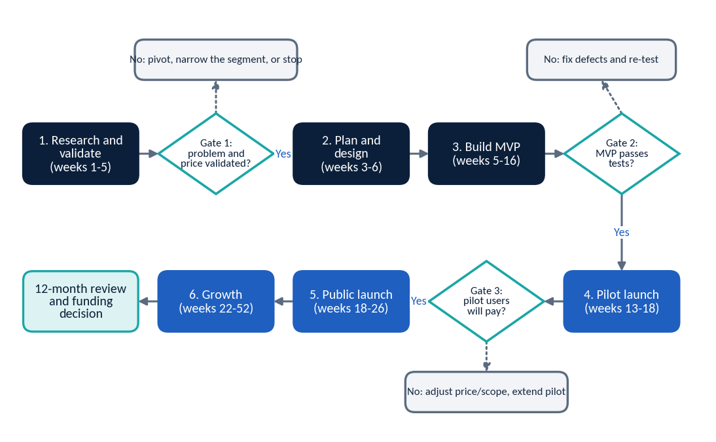
Figure 1. End-to-end business implementation flow with investment gates

Step 2: Problem and Market Analysis

2.1 Market overview
Online selling in Pakistan is growing, and a large part of it runs through social media and chat apps rather than through dedicated online stores. The figures below describe the environment. They are not forecasts for SmartBiz AI.
- Connectivity. DataReportal reports about 117 million internet users in Pakistan in October 2025 [V]. It reported about 66.9 million social media user identities in January 2025 [V]. User identities may not be unique people.
- E-commerce size estimates differ widely. Statista, quoted by DHL, projects US$4.74 billion for 2025 [V]. ECDB estimates US$5.78 billion in 2025 revenue with 10-15% growth [V]. A payments-company blog cites the Asian Development Bank at US$10.42 billion for 2025 [V] (secondary source; low confidence). Definitions differ, so the gap is expected.
- Cash dominates. In a SMEDA-ADBI survey, 72.29% of Pakistani SMEs reported cash as their main payment method [V]. Cash on delivery (COD) is common in online selling, which is why payment and COD tracking matter to sellers.
- Small businesses are numerous and mostly informal. SMEDA and others estimate about 5.2 million SMEs, with Sindh holding about 17-18% [V]. About 70% are estimated to operate in the informal sector, and 98% report annual turnover below PKR 150 million [V].
- Karachi is large. The 2023 census counted about 20.38 million people in Karachi Division and 55.70 million in Sindh [V].
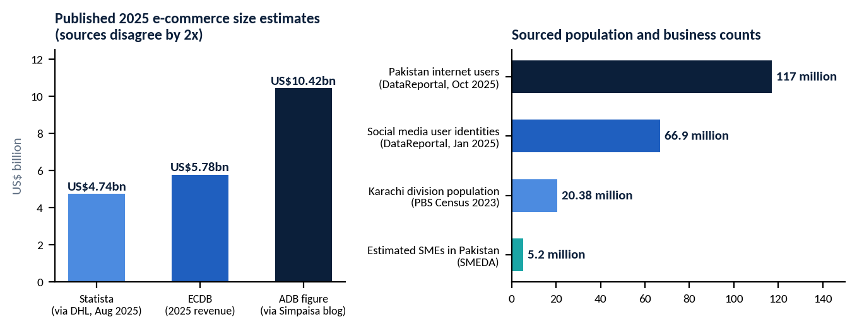
Figure 2. Published e-commerce size estimates (left) and sourced counts (right). Sources: DHL/Statista, ECDB, Simpaisa blog citing ADB, DataReportal, PBS census, SMEDA.

2.2 Needs of small online sellers in Karachi (hypotheses to validate)
The problems below come from the project brief and general observation of social commerce. They are hypotheses. Phase 1 interviews decide which are real, how severe they are, and whether sellers will pay to solve them.
Table 4. Customer pain points, hypothesised severity and evidence needed
Pain point | What the seller may experience | Hypothesised severity | Evidence to collect
Orders scattered across channels | Orders in WhatsApp, Instagram DMs, Facebook, notebooks, spreadsheets. | High | Count of channels used; time spent searching for an order.
Missed or late replies | Messages buried; customers lost while the seller is busy. | High | Self-reported lost sales; reply time.
Unclear order status | Pending, confirmed, cancelled, delivered kept in memory. | High | Disputes or confusion per month.
Stock confusion and overselling | Selling items that are out of stock; no low-stock warning. | Medium-High | Overselling incidents per month.
No customer records | No history of who bought what; no follow-up. | Medium | Share of repeat customers; use of notes.
No view of profit | Sales known roughly; expenses and profit unclear. | Medium-High | Do they know last month's profit? How?
Affordable software is hard to find | Global tools priced in US dollars; local tools built for shops (POS). | Medium | Tools tried and why abandoned; spend on software.

2.3 Existing ways sellers solve these problems
- WhatsApp Business app, chats and labels (free). Familiar, but not a database.
- Spreadsheets and notebooks (free). Flexible, but error-prone and hard to use on a phone during a busy day.
- Local POS and inventory software such as Hulm POS, Granet Pro, ManageKaro, and Smart Stock. Built mainly for shops with counter billing [V] (Step 4).
- Global inventory tools such as Zoho Inventory. Priced in US dollars, with English-first support [V].
- Marketplace seller tools such as Daraz Seller Center for sellers on that marketplace. These do not cover orders from WhatsApp or Instagram. This route was not researched in detail.

2.4 Target customer segments and personas
Table 5. Target segments. Order ranges are assumptions for planning only
Segment | Typical seller | Orders / month [A] | Main channel | Likely need
A. Micro home-based seller | Home bakery, handmade items, tailoring, resellers. Usually one person with family help. | 15-60 | WhatsApp, Instagram DMs | Simple order list, status, reminders.
B. Growing social seller | Clothing, shoes, accessories, gifts. May have one helper or packer. | 60-250 | Instagram, Facebook, WhatsApp | Stock control, COD tracking, customer history.
C. Established small online business | Cosmetics, electronics, fashion with 2-5 staff. | 250-600 | Facebook page, website, WhatsApp | Reports, expenses, profit view, team use.
Table 6. Fictional composite personas (hypotheses to be replaced by interview findings)
 | Persona 1: Ayesha | Persona 2: Bilal | Persona 3: Sana
Business | Home bakery and gift boxes, Gulshan-e-Iqbal | Streetwear reseller, North Nazimabad | Skincare and cosmetics seller, DHA
Team and volume | 1 person; about 30 orders a month | 1 owner + 1 packer; about 150 orders | 3 staff; about 400 orders
How she/he works now | WhatsApp chats and a notebook | Instagram DMs, Facebook page, spreadsheet | WhatsApp Business, several spreadsheets
Main frustration | Forgets who asked for what; late replies | Sells items already sold; COD confusion | Does not know real profit; weak follow-up
Might pay for | Free or PKR 1,499 plan | PKR 2,999 plan | PKR 5,999 plan

2.5 Customer buying behaviour and willingness to pay
There is no verified data in this document on what Karachi sellers will pay for such software. The pricing in Step 5 is built from competitor prices and must be tested in interviews and in the pilot. Early signals to look for:
- Sellers already paying for any tool (software, ads, courier apps) and how much.
- Whether the buyer is the owner or a family member, and whether payment is by mobile wallet, bank transfer, or card.
- Reaction to three price points (PKR 1,499 / 2,999 / 5,999 per month) shown in a simple price-reaction question.
- Sensitivity to US-dollar pricing, because exchange-rate changes can alter the local cost of imported tools.

2.6 Market opportunity: TAM, SAM and SOM
TAM = Total Addressable Market: everyone who could in theory use the product (the whole market). SAM = Serviceable Available Market: the part of the TAM the business can actually serve with its product, language, and location. SOM = Serviceable Obtainable Market: the part of the SAM the business can realistically win in the near term.
Because no verified count of online sellers exists, the estimate below starts from sourced SME numbers and applies labelled assumptions. It is an illustrative scenario, not market data.
Table 7. Transparent calculation inputs for market sizing
Step | Calculation | Result | Basis
1. SMEs in Pakistan | SMEDA estimate | 5,200,000 | [V]
2. Sindh share of SMEs | 5,200,000 x 18% (SMEDA-ADBI: 18.05%) | 936,000 | [C]
3. Karachi share of Sindh | Karachi Division 20.38m / Sindh 55.70m = 36.6% of population | 36.6% | [C]
4. SMEs in Karachi | 936,000 x 36.6% (assumes SMEs follow population; probably understates Karachi) | about 342,000 | [C] [A]
5. Share selling online | Assumed 5% of SMEs sell through social media or online channels | 5% | [A]
6. National online-selling SMEs | 5,200,000 x 5% | 260,000 | [C] [A]
7. Karachi online sellers | 342,000 x 5% | about 17,100 | [C] [A]
8. Fit with target segment | Assumed 40% are small social-commerce sellers with 15+ orders a month, using phone and chat apps | 40% | [A]
9. Revenue per customer | Blended average PKR 2,549 per month x 12 | PKR 30,588 per year | [C] [A]
Table 8. TAM, SAM and SOM (illustrative scenario; every figure depends on the assumptions above)
Measure | Customers | Annual revenue potential | Formula
TAM (national) | 260,000 | about PKR 7.95 billion | 260,000 x PKR 30,588
SAM (Karachi, target segment) | 6,840 | about PKR 209 million | 17,100 x 40% = 6,840; x PKR 30,588
SOM (12 months, Standard plan) | about 129 | about PKR 4.0 million run-rate | forecast customers at month 12 x PKR 30,588
SOM (24 months, illustrative) | about 504 | about PKR 15.4 million run-rate | Standard plan extension (Step 10)
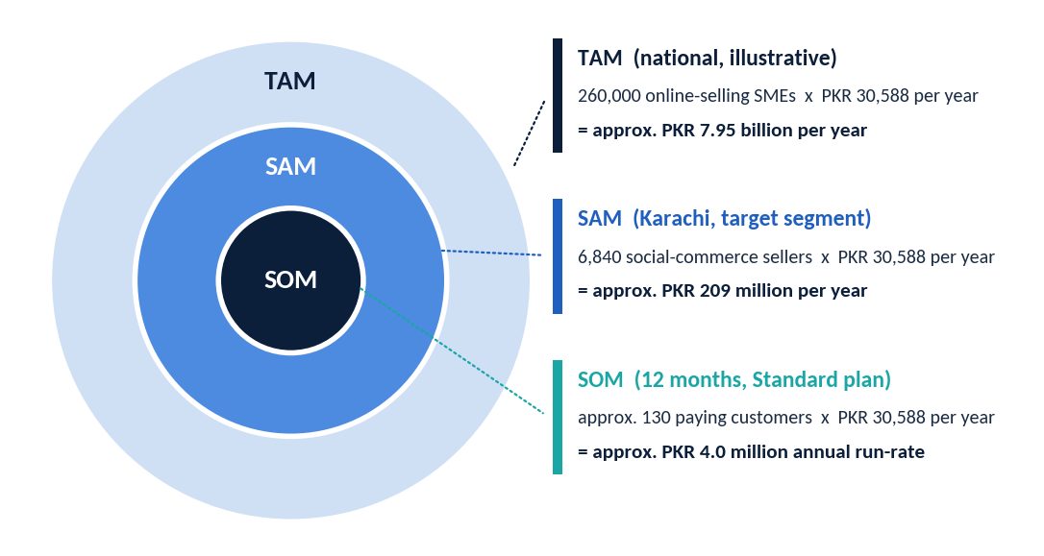
Figure 3. TAM, SAM and SOM diagram (illustrative scenario)
Reading the result. The 12-month SOM of about 129 customers is about 1.9% of the SAM. If the real SAM is half the estimate, the same customer target becomes about 3.8% of it. Sensitivity matters: changing the online-seller share from 5% to 3% cuts the SAM by 40%.

2.7 Proposed customer interview questionnaire
Interview at least 30 sellers across the three segments, 20-30 minutes each, in Urdu or English. Do not pitch. Ask about past behaviour, not future intentions. Offer a small thank-you (for example, a mobile top-up) [A].
- Tell me about your business: what you sell, how long, how many people help you.
- Where do customers contact you? Roughly how many orders do you get in a typical week?
- Walk me through the last order you received, from the first message to delivery.
- Where do you write down orders and customer details today?
- How do you know what stock is left? Have you ever sold something you did not have? What happened?
- How do you track pending, confirmed, cancelled, and delivered orders?
- How many customer messages went unanswered or answered late last week? What did that cost you?
- How do you handle cash on delivery and returns?
- How do you work out your expenses and profit? When did you last check?
- What tools or apps have you tried for your business? What did you like or dislike? Why did you stop?
- What do you spend each month on tools, ads, or software?
- Who would use such a tool: you, family, staff?
- What phone or computer do you use for business? How comfortable are you with apps and spreadsheets?
- Which language do you prefer for an app and for customer messages: Urdu, Roman Urdu, English?
- If a tool solved your biggest problem, how would you want to pay (monthly, yearly, mobile wallet, bank transfer, card)?
- At what monthly price would this be too cheap to trust? A bargain? Getting expensive? Too expensive?
- Would you test an early version for four weeks and share feedback? Can I contact you again?
- Whom else should I talk to?

2.8 Competitor and market research methodology
- List direct competitors (order and inventory tools), indirect competitors (CRM, POS, storefront builders), and substitutes (spreadsheets, WhatsApp Business app).
- Record from official websites and pricing pages: price, currency, billing period, limits, features, languages, integrations. Save a dated screenshot of each page.
- Test the free plans or trials as a new seller. Time how long it takes to record the first order.
- Ask for quotes on WhatsApp or by email where prices are not published.
- Read public reviews and app-store comments for recurring complaints.
- Score each competitor on the same criteria (Step 4) and update the table every quarter.

2.9 Market validation plan
Table 9. Validation plan with proposed success criteria
Hypothesis | Test | Success criterion (proposed) | Week
Sellers lose time or sales because orders and stock are scattered. | 30 interviews; severity ranking. | At least 20 of 30 rate order tracking or stock as a top-3 problem. | 1-4
Current tools are not satisfying. | Interview question 10; competitor trials. | At least 15 of 30 have tried and dropped a tool, or still use spreadsheets or chats only. | 1-4
Sellers will try a new tool. | Click-through prototype demo; sign-up list. | At least 10 sellers commit to be pilot users. | 3-6
Price between PKR 1,499 and 5,999 is acceptable. | Price-reaction question; pilot offer. | At least 8 of 30 accept a price at or above PKR 1,499 as fair. | 3-5
Setup is simple enough. | Alpha: time to first recorded order. | At least 7 of 10 pilot users record 5 orders within 14 days. | 13-16

Step 3: Solution and Product Scope

3.1 Product vision, mission and value proposition
Table 10. Product vision, mission and value proposition
Product vision | One simple screen where a small seller sees every order, who it is for, what is in stock, and roughly what was earned.
Product mission | Make the first order entry take under a minute and the first useful report appear within a week.
Main value proposition | Less chaos, fewer missed orders, fewer overselling mistakes, and a clearer view of profit, at a price a small seller can afford. These benefits are hypotheses until pilot users confirm them.

3.2 Core features, MVP scope and exclusions
Table 11. MVP scope and exclusions
Module | MVP features (planned) | Not in the MVP
Account and dashboard | User login; dashboard with today's orders, pending orders, low-stock items. | Multiple user roles and permissions; social login.
Orders | Add, edit, view, delete orders; order status (pending, confirmed, shipped, delivered, cancelled). | Automatic capture of orders from WhatsApp or Instagram.
Customers | Customer records, contact details, order history. | Customer messaging inside the app.
Products and stock | Product list, prices, stock quantity, automatic stock reduction, low-stock alerts. | Barcode scanning, multi-warehouse.
Money | Expense tracking; estimated profit = sales minus product cost minus expenses; PKR formatting. | Tax invoicing, accounting ledger, payment gateway.
Reports | Sales summaries by day, week, month; top products; expense summary; export to CSV. | Advanced analytics and forecasting.
Excluded from the MVP: WhatsApp Business API, courier integrations, payment and COD reconciliation, AI features, native mobile apps, point-of-sale features, marketplace synchronisation, and multi-branch management. These are planned only as future phases.

3.3 Feature prioritisation
Priority uses MoSCoW (Must, Should, Could). Value and effort are scored 1-5 by the authors [A] and should be revised after interviews. Priority score = value divided by effort.
Table 12. Feature prioritisation (scores are the authors' estimates)
Feature | Phase | MoSCoW | Value | Effort | Score | Needs AI?
Login and dashboard | MVP | Must | 5 | 2 | 2.5 | No
Order add/edit/view/delete | MVP | Must | 5 | 3 | 1.7 | No
Order status tracking | MVP | Must | 5 | 2 | 2.5 | No
Customer records and history | MVP | Must | 4 | 2 | 2.0 | No
Product and inventory management | MVP | Must | 5 | 3 | 1.7 | No
Low-stock alerts | MVP | Should | 4 | 2 | 2.0 | No
Sales summaries and basic reports | MVP | Must | 4 | 3 | 1.3 | No
Expense tracking and estimated profit | MVP | Must | 4 | 2 | 2.0 | No
PKR currency support | MVP | Must | 3 | 1 | 3.0 | No
AI reply suggestions | Phase 2 | Should | 4 | 3 | 1.3 | Yes
Urdu / English message help | Phase 2 | Should | 4 | 4 | 1.0 | Yes
Suggested follow-ups | Phase 2 | Could | 3 | 2 | 1.5 | Optional
AI sales summaries | Phase 2 | Could | 3 | 2 | 1.5 | Yes
WhatsApp Business API integration | Phase 3 | Could | 5 | 5 | 1.0 | Optional
Courier tracking integrations | Phase 3 | Could | 4 | 4 | 1.0 | No
Payment and COD reconciliation | Phase 3 | Should | 4 | 4 | 1.0 | No
Advanced reports and analytics | Phase 3 | Could | 3 | 4 | 0.8 | Optional

3.4 User journey and customer workflow
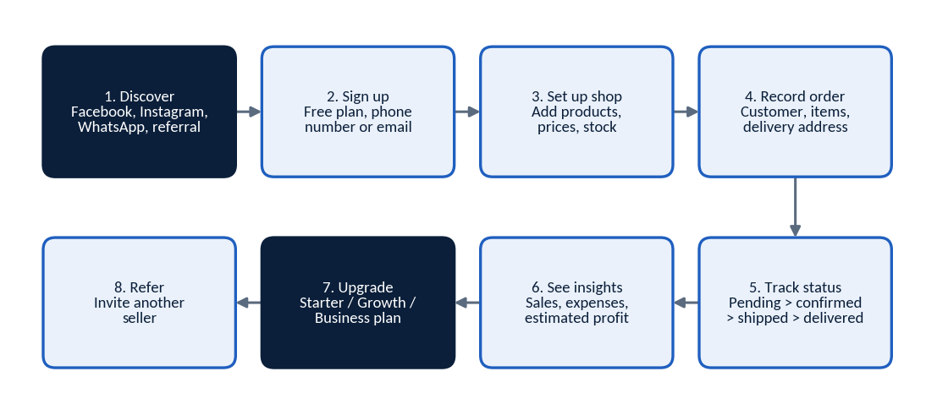
Figure 4. Seller user journey (planned MVP flow)
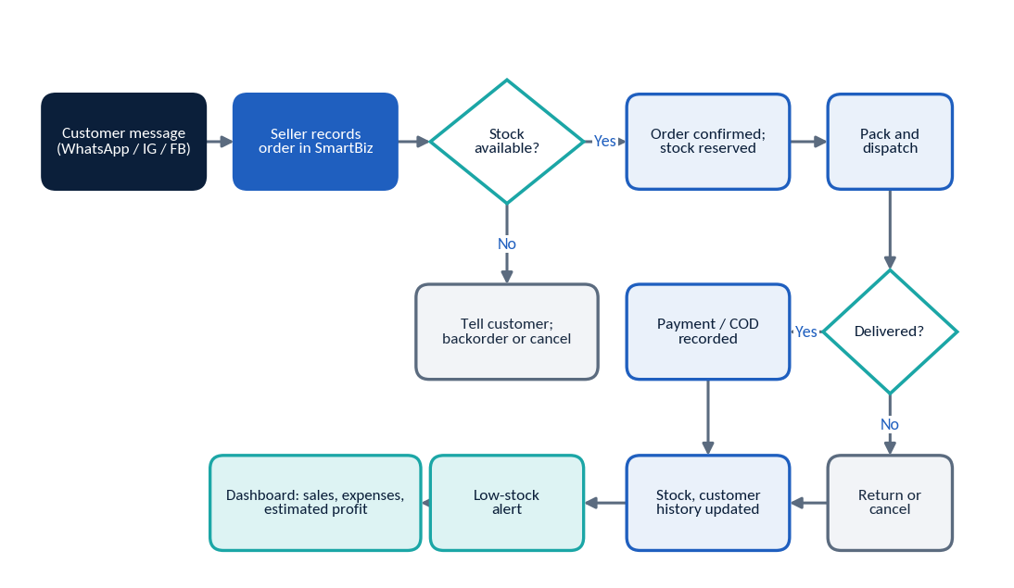
Figure 5. Customer order management business flow (planned MVP)

3.5 Technical architecture and technology stack
The prototype uses simple, low-cost tools so a small team can build and change it quickly. Each part has a clear upgrade path if the product succeeds.
Table 13. Proposed technology stack
Layer | Initial prototype / MVP | Production option | Note
Front end | Streamlit (Python) | React or similar web front end | Streamlit is fast to build but offers less control over mobile layout and multi-user behaviour.
Application logic | Python modules: auth, orders, customers, inventory, expenses, reports | FastAPI or Django service | Separate logic from screens from day one so the front end can change.
Database | SQLite | PostgreSQL (managed or self-hosted) | SQLite is simple but handles few simultaneous writers; plan the move before many users are active.
Authentication | Hashed passwords, session handling | Verified-email or phone login, rate limiting | Never store plain-text passwords. Security review before public launch.
Hosting | Small cloud server (for example a virtual private server), HTTPS | Managed cloud with staging and production | Hosting cost is set at PKR 6,000-30,000 per month by scenario [A] [Q].
Backups and monitoring | Daily database backup; uptime monitor; error logs | Automated backups, alerts, restore tests | Test restoring a backup before launch.
AI layer (Phase 2) | Optional external AI API called from the server | Provider choice and fallback | See 3.6. The product must still work if the AI service is off.
Integrations (Phase 3) | None in MVP | WhatsApp Business API, courier APIs, payment partners | Subject to approval, access, and charges.
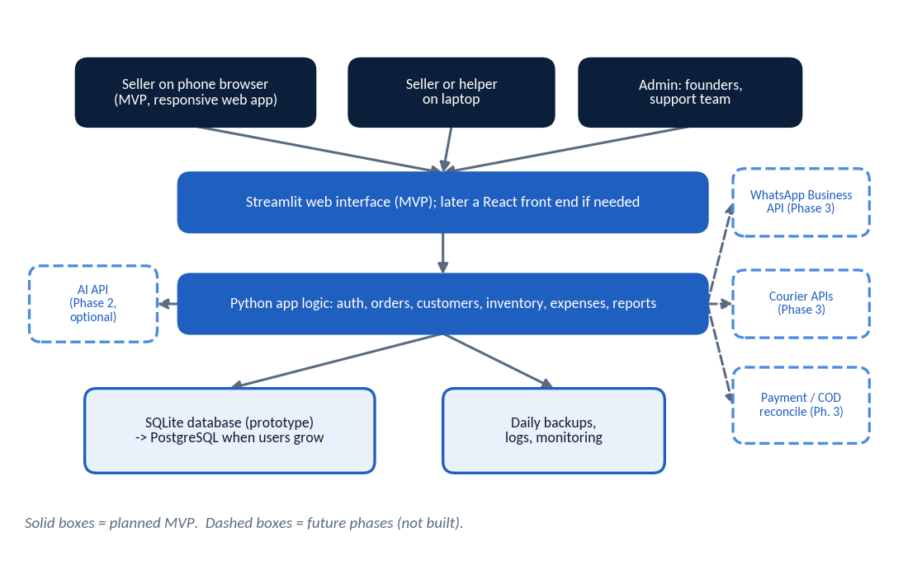
Figure 6. Basic system architecture (solid = MVP; dashed = future phases)

3.6 Where AI is optional and how it affects the budget
- Works without AI (all of the MVP): orders, customers, stock, status, expenses, profit estimates, reports, low-stock alerts, and rule-based follow-up reminders (for example, "no reply for 24 hours").
- AI-assisted (Phase 2, optional): reply suggestions, Urdu and English message help, follow-up wording, and plain-language summaries of sales. A seller can accept, edit, or ignore every suggestion.
- Cost effect. AI is billed per use by the provider. The model assumes PKR 120 per paying customer per month from month 7 [A] [Q]. The real cost depends on message volume, text length, and the provider's current price list, so Phase 2 starts with a two-week usage test and per-plan usage limits.
- Data caution. Messages sent to an AI provider may contain customer names and phone numbers. Send only what is needed, tell users, and check the provider's data terms (Step 8).
- WhatsApp costs (Phase 3). Meta charges per message and bills in US dollars. For Pakistan, one source lists US$0.0473 per marketing message and US$0.010 per utility message [V], while a September 2026 news report says Pakistan's rate for utility, authentication and service messages is US$0.015 from October 2026, with 1,000 free service messages a month [V]. At PKR 278/US$ [A] this is about PKR 13 per marketing message and PKR 3-4 per utility message [C]. These costs are not in the base forecast and would be passed through to customers.
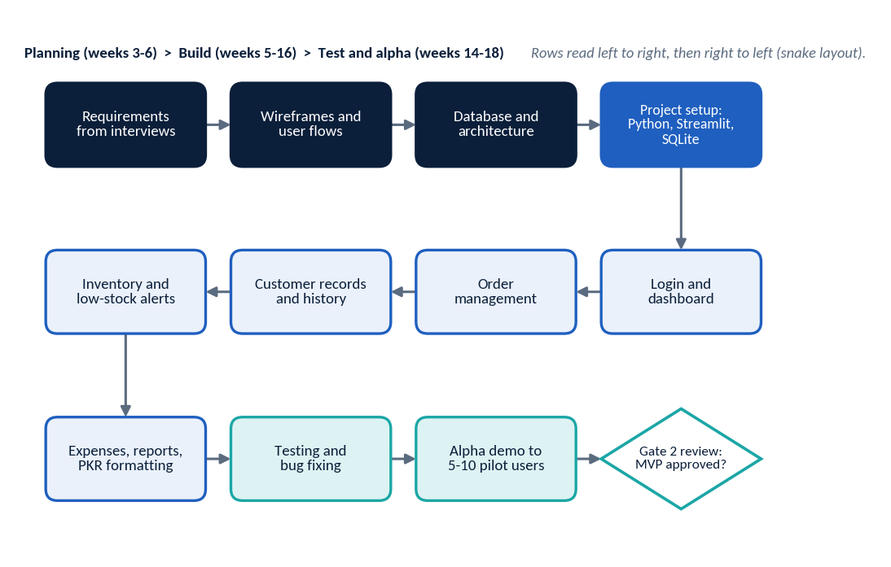
Figure 7. MVP development flowchart

3.7 Product roadmap
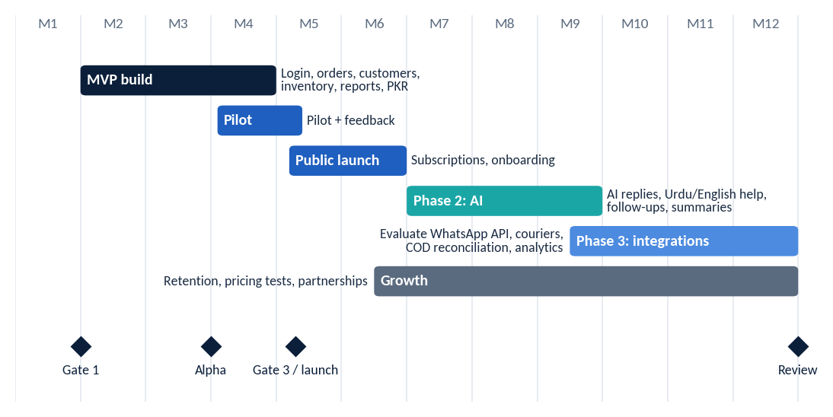
Figure 8. Product roadmap by month (MVP, pilot, launch, Phase 2 AI, Phase 3 integrations)
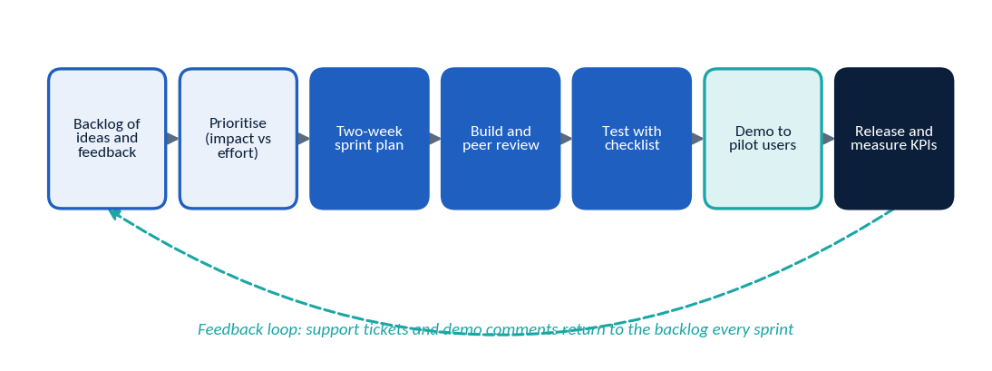
Figure 9. Product development workflow (two-week sprint cycle)

Step 4: Competitor Analysis and Positioning
Competitors were reviewed from their own public pages in October 2026. Dollar prices are converted at PKR 278 per US$1 [A]. "Not stated" means the reviewed page did not say, not that the feature is missing.
Table 14. Competitor comparison (sources: official pages; see References)
Competitor | Type | Target audience | Price and currency | Inventory / orders | AI | Local fit | Notes
WhatsApp + spreadsheets | Substitute (manual) | Almost every micro-seller | Free [V] | Manual; no stock logic | None | Fully familiar | Hard to scale, error-prone.
Zoho Inventory | Direct (global) | Small and mid-size businesses | Free (50 orders); Standard US$29 a month billed annually or US$39 monthly, 500 orders [V]; about PKR 8,100-10,800 [C] | Strong inventory and orders | Not stated | English-first, USD | More features than a micro-seller may need.
Hulm POS | Direct (local POS) | Pakistani SMEs and shops | PKR 2,500 a month, 14-day trial [V] | Order and inventory management listed | Not stated | FBR-compliant invoicing, WhatsApp support | Shop and POS oriented.
Granet Pro | Direct (local POS) | Cafes, retail counters | PKR 2,999 / 5,999 / 9,999 per branch a month [V] | Inventory in Growth plan and above | Not stated | PKR pricing | Restaurant and retail focus.
ManageKaro | Direct (local) | Retailers, distributors | PKR 10,000 a year; lifetime PKR 25,000 [V] | Inventory, POS, HR, finance | Not stated | PKR pricing | Broad business suite, not social-seller flow.
Smart Stock | Direct (local desktop/cloud) | Retailers, wholesalers, pharmacies | PKR 24,000 or 40,000 one-time; cloud add-on PKR 1,000 a month [V] | Inventory and accounting | Not stated | PKR pricing, WhatsApp share of bills | Shop-oriented; upfront cost.
Sellio | Direct (WhatsApp-first) | Bakers, boutiques, resellers | "Free to start"; paid plans not found on the page [V] | Catalog, orders, payments, follow-ups | Not stated | Built for Pakistani sellers | Closest in idea; small and new. Needs a deeper review.
CRM and storefront tools | Indirect | Businesses with larger sales teams or own websites | Not researched in this edition | Varies | Varies | Varies | Research task for week 1-3.
What the table shows. Local tools are mostly built for shops with counters (POS). Global tools are priced in dollars. A tool built around orders that arrive by chat, with PKR pricing, is a possible gap. Sellio suggests others see the same gap, so speed and real seller feedback matter more than the idea itself.

4.1 SWOT analysis
Table 15. SWOT analysis (strengths and opportunities are hypotheses)
Strengths (to be proven) | Weaknesses
- Low-cost cloud product; small team can iterate quickly  - Focus on chat-based sellers, not shops  - Local knowledge, PKR pricing, Urdu support planned | - No product, brand, or customers yet  - Limited funds and a small team  - Dependence on a few founders; Streamlit/SQLite limits at scale

Opportunities | Threats
- Social commerce growth and mobile-first buying  - WhatsApp message charges push sellers to be organised  - Urdu and Roman Urdu AI help is rarely built into local tools  - Partnerships with couriers and payment providers | - Free alternatives (spreadsheets, WhatsApp Business app)  - Competitors adding order features or cutting prices  - Low willingness to pay; high churn among micro-sellers  - Platform changes by Meta; rising API costs  - Inflation and exchange-rate swings affect cloud and AI costs

4.2 Positioning matrix
The matrix uses two axes: affordability for a small seller (price in PKR and local billing) and ease of use for a WhatsApp or Instagram seller. Positions are the authors' judgement from public pages. They must be checked in interviews and by trying the products.
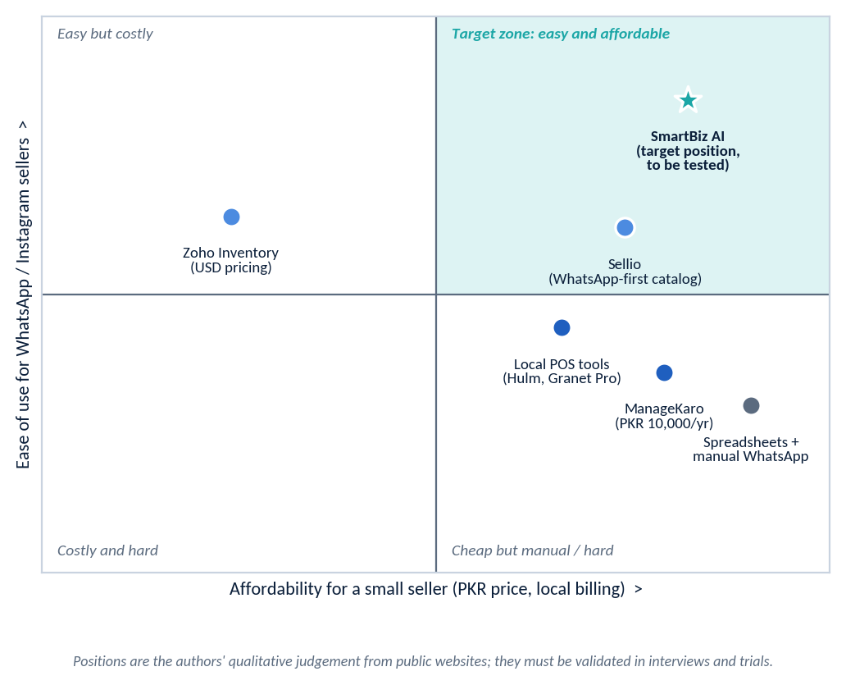
Figure 10. 2x2 positioning matrix: affordability versus ease of use (qualitative judgement)

4.3 SmartBiz AI differentiation strategy (hypotheses to test)
SmartBiz AI is not assumed to be the market leader or to have a unique advantage. The ideas below are competitive-advantage hypotheses, each with a test.
Table 16. Differentiation hypotheses and tests
# | Hypothesis | How to test | Evidence needed
H1 | Easiest start for chat-based sellers: first order recorded in under 60 seconds. | Timed first-use tests with 10 sellers. | Median time to first order below 2 minutes; 7 of 10 complete without help.
H2 | PKR pricing under PKR 3,000 with a free plan beats USD tools and shop software on value. | Price-reaction questions; pilot offer. | At least 25% of activated pilot users agree to pay.
H3 | Profit visibility (expenses plus estimated profit) matters more to sellers than invoicing. | Interview ranking; feature-usage logs. | Profit view used weekly by at least 40% of active users.
H4 | Urdu and Roman Urdu reply help saves time (Phase 2). | AI beta with 20 users; reply-time tracking. | Median self-reported time saving above 30 minutes a week.
H5 | Local onboarding by WhatsApp and Urdu support lifts activation. | Compare onboarding styles in the pilot. | Higher activation in assisted group.

Step 5: Business Model and Pricing

5.1 Options evaluated
Table 17. Business model options
Option | Strengths | Risks | Decision
Monthly subscription | Low entry barrier; fits small cash flows. | Higher churn; monthly payment effort. | Use as the main option.
Annual subscription | Better cash flow and retention. | Small sellers may not pay upfront. | Offer at 10 months' price (2 months free) [A].
Free plan / trial | Lowers risk; creates referrals. | Free users cost support and hosting. | Use a limited free plan (30 orders a month) and a 14-day trial of paid features [A].
Premium AI features | Clear extra value; protects margin. | AI cost per use; quality in Urdu uncertain. | Phase 2, in Growth and Business plans.
Partnerships (couriers, payments) | Possible referral income. | Depends on partner terms; none exist. | Explore after month 9. No income assumed.

5.2 Illustrative pricing tiers (PKR per month, excluding tax)
Table 18. Illustrative pricing tiers {A}. Final prices only after interviews and the pilot
Plan | Price | Limits (proposed) | Features | Assumed mix
Free | PKR 0 | 30 orders a month, 1 user | Orders, customers, products, basic dashboard | lead generation
Starter | PKR 1,499 | 150 orders a month, 1 user | Full MVP: inventory, low-stock alerts, expenses, reports | 50%
Growth | PKR 2,999 | 600 orders a month, 2 users | Starter plus advanced reports; AI assistance from Phase 2 | 40%
Business | PKR 5,999 | Unlimited orders, 5 users | Growth plus priority support, CSV export, integrations when available | 10%

Pricing logic
- Competitor reference points. Local entry prices found: Hulm POS PKR 2,500 a month, Granet Pro from PKR 2,999, ManageKaro PKR 10,000 a year (about PKR 833 a month [C]), Smart Stock PKR 1,000 a month for cloud after a PKR 24,000 purchase [V]. Zoho Inventory's paid entry plan is about PKR 8,100-10,800 a month [C].
- Positioning. Starter below local POS entry prices; Growth in line with them but focused on chat-based sellers; Business below global tools.
- Recommendation rule. Recommend final prices only after (1) interview price reactions, (2) pilot willingness to pay, and (3) updated competitor prices. Start with the table above and change it if fewer than 25% of activated pilot users would pay.
- Tax. Prices are shown excluding sales tax. Whether and at what rate tax applies to the subscription must be confirmed (Step 8).
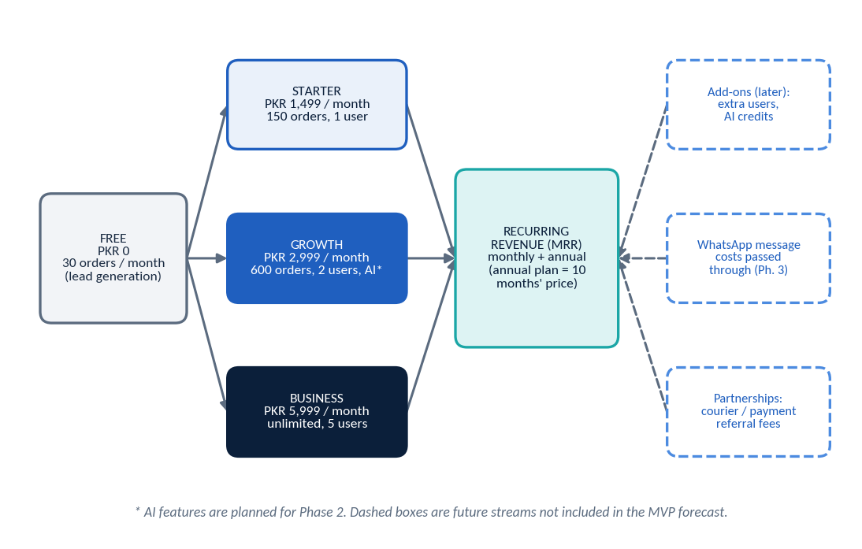
Figure 11. Revenue model: planned tiers and future revenue streams

5.3 Financial metrics in simple English
Table 19. Metrics, formulas and numerical examples
Metric | Simple meaning | Formula | Example (planning assumptions)
Average revenue per customer (ARPU) | How much one paying customer pays in a typical month. | Sum of (price x share of customers on that plan) | 0.5 x 1,499 + 0.4 x 2,999 + 0.1 x 5,999 = PKR 2,549 [C]
Monthly recurring revenue (MRR) | Subscription income expected every month. | Paying customers x ARPU | 100 customers x 2,549 = PKR 254,900 [C]
Variable cost per customer | Cost that grows with each customer: hosting, AI, payment fees. | Hosting + AI + payment fee | 60 + 120 (from month 7) + 2.5% of ARPU (64) = PKR 244 [A] [Q]
Gross margin | Money left from each customer after direct costs. | (ARPU - variable cost) / ARPU | (2,549 - 244) / 2,549 = 90.4%, or PKR 2,305 per customer [C]. Staff costs are counted separately.
Churn rate | Share of customers who cancel each month. | Customers lost in month / customers at start of month | Assumed 6% a month [A]
Customer lifetime | Average months a customer stays. | 1 / churn rate | 1 / 0.06 = 16.7 months [C]
Customer lifetime value (LTV) | Total gross profit expected from one customer. | Gross profit per month x lifetime | 2,305 x 16.7 = about PKR 38,417 [C]
Customer acquisition cost (CAC) | Marketing and sales cost to win one paying customer. | (Marketing spend + sales/marketing staff cost) / new paying customers | Standard plan, year 1: about PKR 7,417 (Lean 5,536, Growth 6,424) [C] [A]
LTV : CAC ratio | Value created for each rupee spent on winning customers. | LTV / CAC | 38,417 / 7,417 = 5.2 (Standard) [C]
Payback period | Months to earn back CAC. | CAC / gross profit per month | 7,417 / 2,305 = 3.2 months [C]
Caution on CAC. The CAC above is the planned marketing budget divided by planned new customers. It is a target, not an observed result, and it is partly circular. Real CAC is known only after the pilot and launch. Founder time is not included.
Table 20. Sensitivity of LTV and LTV:CAC to churn (Standard plan CAC). A ratio near 3 or above is a common rule of thumb; micro-seller churn may be higher than assumed
Monthly churn | Lifetime (months) | LTV | LTV : CAC (base CAC) | LTV : CAC (CAC x2)
4% | 25.0 | PKR 57,625 | 7.8 | 3.9
6% | 16.7 | PKR 38,417 | 5.2 | 2.6
10% | 10.0 | PKR 23,050 | 3.1 | 1.6
15% | 6.7 | PKR 15,367 | 2.1 | 1.0
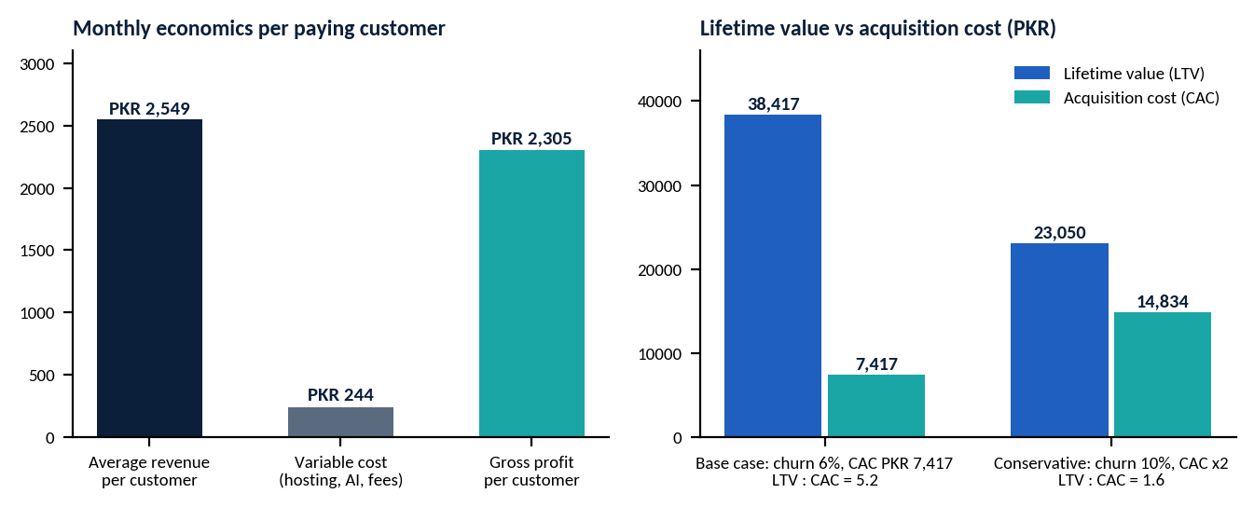
Figure 12. Unit economics: monthly economics per customer, and LTV versus CAC (base and conservative)

Step 6: Go-to-Market and Marketing Plan

6.1 Positioning and message
Table 21. Positioning and message
Element | Plan
Target segments | Segment A and B first (home-based and growing social sellers in Karachi); Segment C later.
Brand positioning | "The simple order and stock book for sellers who sell on WhatsApp and Instagram." Friendly, practical, Urdu-and-English.
Core message (to test) | "Every order in one place. Know what is pending, what is in stock, and what you earned." Draft Urdu tagline to be tested with sellers.
Proof points to collect | Pilot users' time saved, fewer missed orders, and quotes (only with permission).

6.2 Channels
Table 22. Customer acquisition channels
Channel | How it will be used | Notes and cautions
Seller communities | Join Karachi seller Facebook groups and WhatsApp communities as a helpful member; share order-management tips; offer free demos. | Follow each group's rules; no spamming.
Facebook and Instagram | Short Urdu/English reels and carousels (before/after of messy chats vs one dashboard); small paid campaigns to Karachi sellers aged 22-40. | Test creatives weekly; track cost per demo booked.
WhatsApp outreach | Reply to people who message the SmartBiz business number; invite pilot users personally. | Only contact people who agreed to hear from us; obtain consent; WhatsApp policies apply.
Direct outreach | Visit markets and seller meetups in person; 15-minute live demos on a phone. | Good for trust; time-intensive for founders.
Referral programme | A seller who refers another paying seller gets one free month (both sides). | Cost is a discount, not cash; cap the credits.
Partnerships | Talk to couriers, photographers, packaging and payment providers who serve the same sellers about co-promotion. | No partnerships exist; do not claim any.
Pilot testing | 5-10 pilot users from week 13; weekly check-ins; testimonials with consent. | Pilot users get free use for the pilot period.

6.3 Sales funnel and how each stage is measured
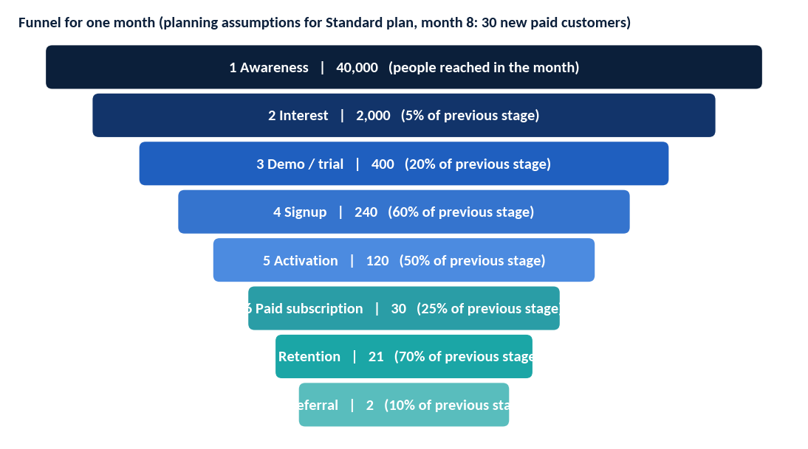
Figure 13. Sales funnel with illustrative monthly numbers for one month of the Standard plan (planning assumptions, not results)
Table 23. Funnel stage definitions and measurement
Stage | Definition | Metric | Source | Frequency
Awareness | Person sees an ad, post or referral. | Reach; cost per 1,000 reached | Meta Business Suite | Weekly
Interest | Clicks, messages, or joins a seller group. | Click-through rate; messages received | Meta, WhatsApp Business | Weekly
Demo or trial | Books a demo or starts a trial. | Demos booked; booking rate | Calendar, product log | Weekly
Signup | Creates an account. | Signups; demo-to-signup rate | Product database | Weekly
Activation | Records 5+ orders within 14 days. | Activation rate | Product database | Weekly
Paid subscription | Pays for a plan. | Free-to-paid rate; MRR | Payment records | Weekly
Retention | Still paying after 3 months. | Churn; 3-month retention | Payment records | Monthly
Referral | Brings another seller who signs up. | Referrals per 100 customers | Referral code log | Monthly
The funnel numbers are planning assumptions. They show what must be true to win 30 customers in one month: about 40,000 people reached, 5% interested, 20% of them booking a demo or trial, 60% signing up, 50% activating, and 25% paying. If real conversion is lower, the marketing budget or the timeline must change.

6.4 Marketing budgets
Table 24. Marketing budget (Standard plan). Lean uses PKR 20,000-30,000 a month; Growth PKR 80,000-200,000 a month
Period | Item | Budget (Standard plan, PKR) | Basis
Days 1-90 (pre-launch) | Pilot recruitment: community time, small ad tests, demo materials | 40,000 | [A]
Months 5-7 (public launch, 90 days) | Paid Facebook and Instagram ads | 120,000 | [A] [Q]
 | Content and creative (reels, templates, Urdu copy) | 40,000 | [A] [Q]
 | Seller community events and meetups | 40,000 | [A]
 | Referral rewards and trial incentives | 30,000 | [A]
 | Tools (scheduler, analytics, WhatsApp Business set-up) | 10,000 | [A]
Launch quarter total |  | 240,000 | [C]
Months 9-12 | Continuing campaigns | 60,000 a month | [A]

90-day launch marketing plan
Table 25. 90-day launch marketing plan (months 5-7). Targets are proposals
Days | Focus | Key activities | Owner | Target [A]
1-30 | Prepare | Finish positioning; create 6 posts and 2 short videos; set up business WhatsApp number, Facebook page and Instagram; prepare demo script and sign-up page. | Marketing executive | Assets ready; 100 follow-ups
31-60 | Launch campaigns | Run two small ad campaigns (PKR 40,000); join 10 seller communities; book 2 live demo sessions a week; start referral invitations. | Marketing + CEO | 150 demos or trials booked
61-90 | Convert and learn | Follow up every trial by WhatsApp call; onboard in 14 days; collect testimonials; drop the weakest channel; double the best. | Sales and support | 20 paid customers (cumulative)

6.5 Onboarding, support and retention
- Onboarding: welcome message on WhatsApp within an hour; guided setup of the first 10 products; first 5 orders within 14 days; a short Urdu video guide.
- Support: WhatsApp and email, working hours, first reply target under 4 hours; every bug logged and tagged.
- Retention: weekly summary message, monthly check-in call for Growth and Business users, annual-plan offer after 3 months, and a simple cancellation survey to learn why users leave.
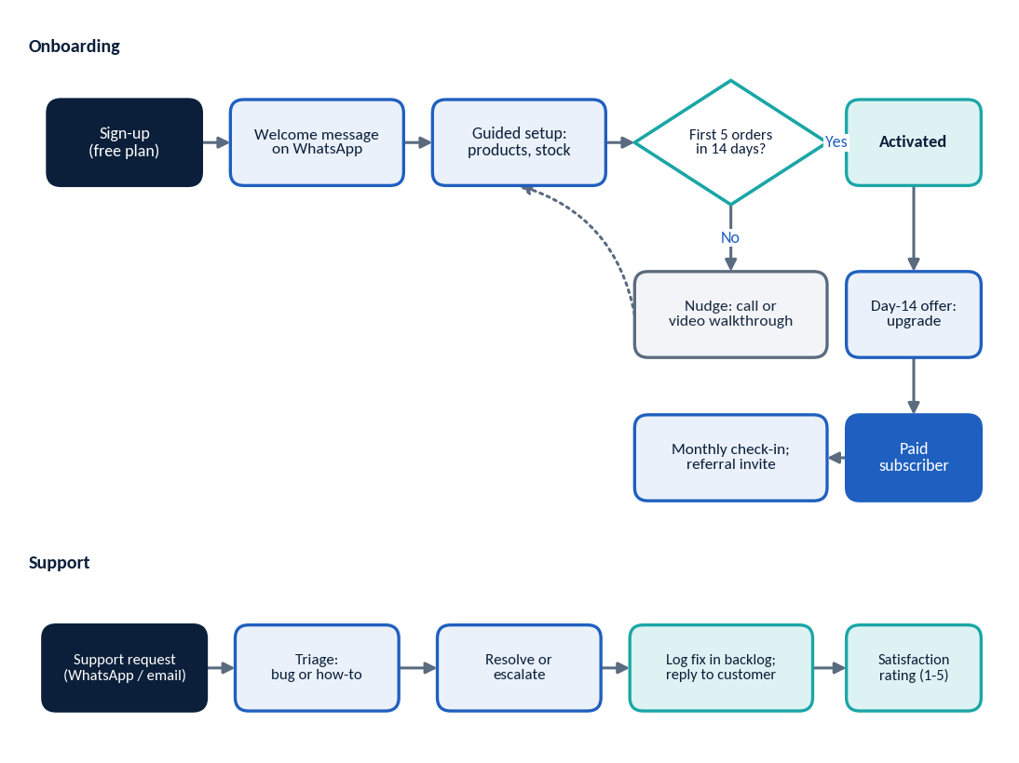
Figure 14. Customer onboarding and support workflow

Step 7: Operations and Team Structure
Not every role is hired at the start. The minimum MVP team is two founders (CEO/product owner and technical lead) plus one developer (a founder, a contractor, or one full-time hire), with accounting, design, and legal review outsourced.
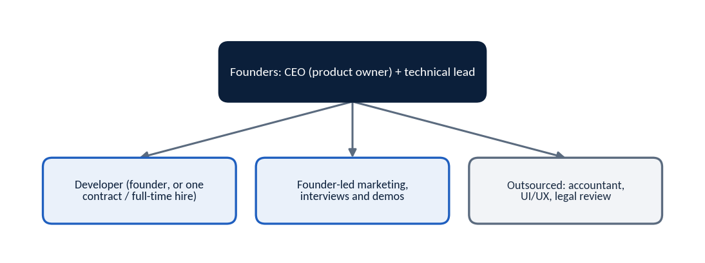
Figure 15. Minimum team required for the MVP

7.1 Roles, responsibilities and indicative pay
Pay figures are monthly planning benchmarks in PKR [A] [Q]. Salary sources show wide ranges: entry-level software engineers typically earn about PKR 50,000-100,000 and mid-level PKR 100,000-250,000 a month, with a Karachi average near PKR 86,667 [V]. Check against actual offers.
Table 26. Role definitions (staffing and pay match the financial model)
Role | Responsibilities | Key skills | Status by scenario (Lean / Standard / Growth) | Monthly PKR | Reports to | KPIs
Founder / CEO | Strategy, funding, interviews, partnerships, pricing. | Leadership, selling, finance basics | Founder-led / founder-led / stipend | 0 / 0 / 60,000 each | Board / investors | Gates passed; runway; MRR
Product manager | Specification, backlog, pilot feedback. | Product discovery, writing | Founder / founder / full-time | 0 / 0 / 130,000 | CEO | Features shipped; activation
Software developer | Build, test, deploy, fix. | Python, SQL, web basics, security | Founder + contractor / full-time / lead + 1 developer | 60,000 (3 mo) / 110,000 / 180,000 + 110,000 | Product manager or CEO | Sprint delivery; bug rate; uptime
AI and data specialist | Prompts, evaluation, cost control, reports. | Prompt design, Urdu text, data | Not hired / contractor later / part-time from month 6 | 0 / 0 / 90,000 | Product manager | AI cost per customer; suggestion acceptance
Marketing manager or executive | Campaigns, content, community, analytics. | Social media, copywriting, ads | Freelance part-time / part-time / full-time manager | 25,000 / 45,000 / 100,000 | CEO | Demos booked; CAC
Sales and business development | Demos, partnerships, closing paid plans. | Selling, Urdu/English | Combined with support / combined with support / 2 hires | in support role / 55,000 / 120,000 (2) | CEO | Free-to-paid rate; MRR added
Customer support | Onboarding, tickets, retention calls. | Empathy, Urdu/English, product knowledge | Part-time / combined with sales / 2 hires | 35,000 / in sales role / 90,000 (2) | CEO | First reply time; CSAT; churn
Finance and administration | Bookkeeping, payments, filings, budget tracking. | Accounting, tax filing | Outsourced / outsourced / full-time | 10,000 / 15,000 / 45,000 | CEO | On-time filings; budget variance
Legal / cybersecurity consultant | Contracts, privacy notice, security review. | Pakistani law; application security | Project basis / project basis / retainer | one-time / one-time / 30,000 | CEO | Documents ready; issues fixed
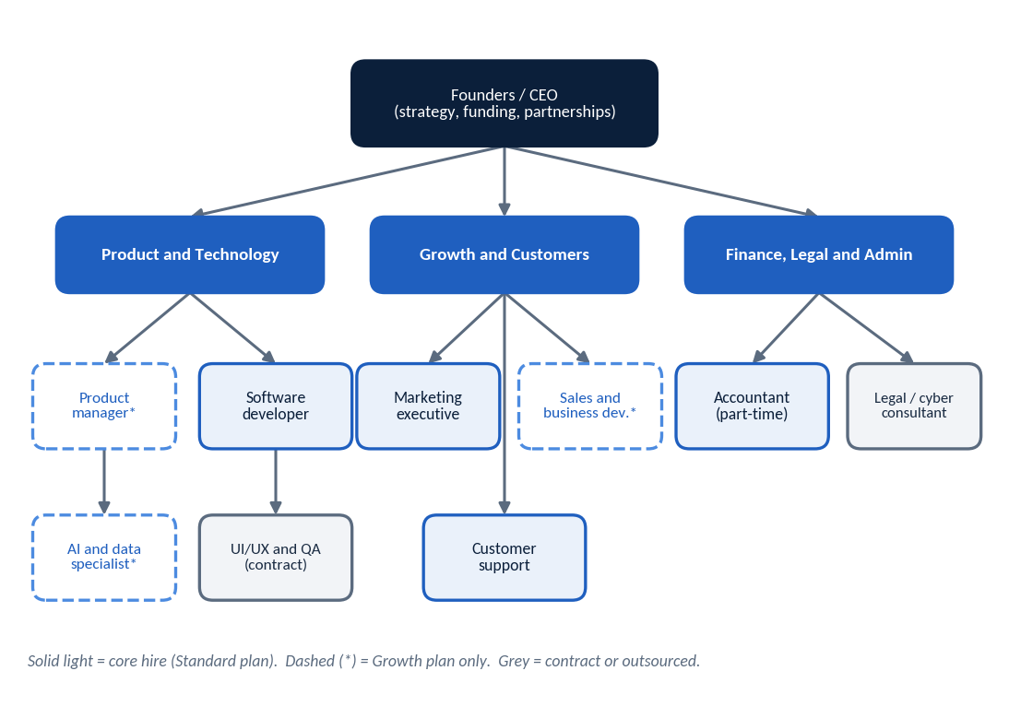
Figure 16. Professional organisation chart and team hierarchy (target structure for the Growth plan)

7.2 Responsibility assignment matrix (RACI)
R = Responsible (does the work), A = Accountable (final decision), C = Consulted, I = Informed. In small teams one person may hold several roles.
Table 27. Implementation responsibility matrix
Activity | CEO | Product / tech lead | Developer | Marketing | Support / sales | Finance
Customer interviews | A | R | I | R | C | I
Competitor research | A | R | I | R | C | I
Product specification | A | R | C | C | C | I
UI design | C | A | R | C | C | I
Build and test MVP | I | A | R | I | C | I
Pilot recruitment and demos | A | C | I | R | R | I
Pricing decisions | A | C | I | C | C | R
Marketing campaigns | A | I | I | R | C | C
Customer support | I | C | C | I | A/R | I
Budget approval and payments | A | C | I | C | I | R
Legal, tax and privacy compliance | A | C | C | C | I | R
Security and backups | I | A | R | I | I | I

7.3 Operating workflows
Table 28. Daily, weekly and monthly operating workflows
Frequency | Workflow
Daily | 15-minute stand-up; reply to messages and tickets; check server health and backups; update the task board; record spending.
Weekly | Sprint review and planning (every 2 weeks); review funnel numbers; pilot or customer calls; content publishing; budget vs actual check.
Monthly | Close the books; review KPIs, cash, and runway; review churn reasons; update competitor prices; update risk register; report to funders.
Quarterly | Pricing review; roadmap review; security and backup restore test; legal and tax compliance check.
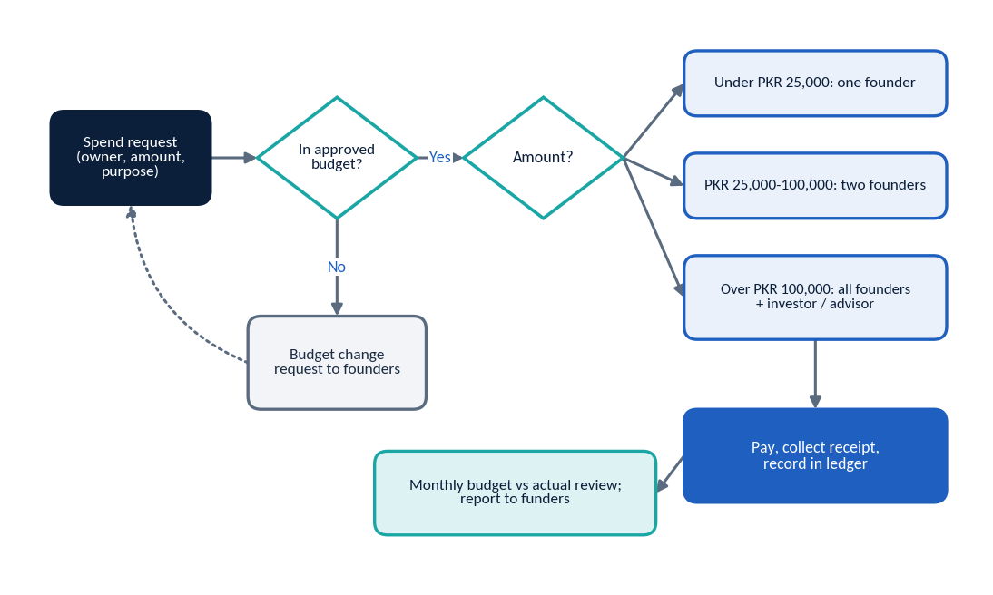
Figure 17. Funding and expenditure approval workflow

7.4 Recommended tools
Table 29. Recommended tools (prices not verified; confirm before purchase)
Purpose | Suggested tool type (examples) | Note
Team communication | WhatsApp group, Google Workspace | Check current prices.
Task and sprint board | Trello, Notion, or GitHub Projects | Free tiers usually suffice at first.
Code and deployment | GitHub, Python virtual environments, automated tests | Private repository.
Design | Figma | Free tier for early wireframes.
Customer messaging | WhatsApp Business app, Meta Business Suite | Business API only in Phase 3.
Analytics and uptime | Simple event log in the product; free uptime monitor | Avoid collecting more data than needed.
Bookkeeping | Spreadsheet plus outsourced accountant | Move to accounting software when volume grows.

Step 8: Legal, Regulatory, Security and Risk Plan
This is general information, not legal or tax advice. Pakistani law, tax rates, and platform rules change. Items below are sorted into three groups: Confirmed (supported by the sources reviewed), Conditional (depends on facts such as company type or turnover), and Adviser needed (a qualified Pakistani professional must decide).
Table 30. Legal, regulatory and security considerations (sources: SECP/FBR guides, Sindh tax sources, data-protection reviews, Meta pricing documentation)
Area | What the sources say | Status | Action
Legal structure | Sole proprietors and most partnerships do not incorporate with SECP but may still need an NTN. A single-member or private limited company registers with SECP through its eServices portal and gives a separate legal entity [V]. Indicative government fees range from about PKR 1,000 to 3,500 depending on capital and filing route [V]; professional fees are extra [Q]. | Confirmed (general) / Conditional | Validate as a founder-owned sole proprietorship or partnership if cash is very tight; incorporate (Private Limited or SMC) before taking customer payments or outside investment. Adviser to confirm.
Tax registration | FBR registration yields an NTN, which is needed for a business bank account, invoices, and tax filing [V]. Income tax on business profit applies. | Confirmed (NTN) / Adviser needed (rates) | Obtain NTN; engage an accountant; keep records from day 1.
Sales tax on subscriptions | Services are taxed by provinces. The general Sindh rate on services is 15% [V]. One secondary guide says IT and software-as-a-service may have reduced rates (3-8% in Sindh); this was not confirmed from the Sindh Revenue Board in this review. | Adviser needed | Ask a tax adviser whether and when to register with the Sindh Revenue Board, and at what rate. Prices in this plan exclude tax.
Banking and accounting | A business account normally needs the NTN and registration papers. | Conditional | Open a separate business account before charging customers; keep separate books.
Contracts and subscription terms | Terms of service and subscription terms should be accepted by an explicit click. Courts' treatment of online terms should be confirmed. | Adviser needed | Lawyer to draft terms: price, renewal, cancellation, refunds, acceptable use, liability limits.
Privacy and consent | Pakistan had no comprehensive personal-data-protection law in force in the sources reviewed (2026); the Personal Data Protection Bill had not been enacted [V]. The Prevention of Electronic Crimes Act 2016 (amended) still applies to electronic offences. The position may change. | Confirmed (no general law yet) / Adviser needed | Adopt good practice anyway: plain-language privacy notice, collect only needed data, consent for messages, deletion on request. Monitor the bill.
Personal data and cybersecurity | Customer names, phone numbers, and addresses will be stored. | Conditional | Hash passwords, use HTTPS, restrict access, encrypt backups, log access, run a security check before launch, and prepare a breach response plan.
Intellectual property | Code, brand, and content are assets. Contractor work needs written assignment. | Adviser needed | Written IP assignment from every founder, employee, and contractor; check the name; consider trade-mark registration through the Intellectual Property Organisation of Pakistan.
Software licensing | Open-source parts (for example Streamlit, SQLite, PostgreSQL) have their own licences. | Conditional | Keep a list of libraries and licences; comply with attribution terms.
Electronic communications and platform policies | WhatsApp Business Platform needs approval and per-message fees, and requires user opt-in; Meta changes rates, including a change due 1 October 2026 [V]. Facebook and Instagram have their own advertising and commerce rules. | Confirmed (platform rules exist) / Adviser needed (local anti-spam law) | Read current Meta terms before Phase 3; get opt-in before any marketing message.
Payment processing and integrations | Collecting subscription money needs a bank or licensed payment provider; courier and WhatsApp integrations need provider approval and may charge. | Conditional | Use a licensed provider; do not hold customer funds; get written terms and fees [Q].

8.1 Risk register
Probability (P) and impact (I): L = low, M = medium, H = high, set by the authors [A]. Owners are roles, not named people.
Table 31. Risk register
# | Risk | P | I | Mitigation | Owner | Contingency
1 | Market: sellers do not see enough pain or will not pay. | M | H | 30 interviews; paper prototype; gates before spending. | CEO | Narrow segment, change product, or stop after Gate 1.
2 | Customer retention: high churn among micro-sellers. | H | H | Onboarding to 5 orders; weekly summaries; annual plans. | Support | Fix top churn reason; lower the entry price.
3 | Competition: competitors add similar features or cut prices. | M | M | Stay close to sellers; ship fast; own the chat-seller niche. | CEO | Differentiate on service and language; reprice.
4 | Financial: funds run out before break-even. | M | H | Staged funding; monthly cash review; 15% reserve; hire only on revenue. | CEO / finance | Cut marketing; pause hires; bridge funding.
5 | Financial: cost increases from inflation or dollar-priced cloud and AI. | M | M | Budget in PKR with buffer; usage caps; annual plans. | Finance | Adjust prices; switch providers.
6 | Technical: SQLite or Streamlit limits cause slowness or data issues. | M | M | Separate logic from UI; plan PostgreSQL move; load test. | Tech lead | Migrate earlier than planned.
7 | Technical: data loss. | L | H | Daily backups; restore tests. | Developer | Restore from backup; notify users.
8 | Cybersecurity: breach of customer data. | M | H | Security review; access control; encryption; minimal data. | Tech lead | Breach response plan; notify users; legal advice.
9 | Legal: unclear tax, privacy, or contract obligations. | M | M | Adviser review before launch; written terms; monitor law changes. | CEO / finance | Adviser-led correction; register late if required.
10 | Platform dependence: Meta changes WhatsApp or ads rules and prices. | M | M | Do not depend on WhatsApp API for core value; pass costs on. | Product | Re-scope Phase 3.
11 | Operational: founder overload or team conflict. | M | M | Written roles, equity and decision rules; weekly review. | CEO | Bring in an adviser; adjust roles.
12 | Operational: key developer leaves. | M | H | Documentation; code in shared repository; second developer on core. | Tech lead | Contract replacement.
13 | AI quality and cost (Phase 2): poor Urdu output or high cost. | M | M | Usage test; human approval; per-plan caps; AI is optional. | AI specialist | Limit or remove AI features.
14 | Market: economic or power and internet disruption. | M | M | Mobile-friendly; save drafts; clear outage communication. | Ops | Support by phone; extend billing dates.

Step 9: Execution Timeline and Gantt Chart
Start date. No start date was supplied, so Day 1 is Week 1, Day 1. Week n covers Days 7n-6 to 7n. Month m covers about Weeks 4.33(m-1)+1 to 4.33m. If the real start is, for example, 1 January, add the week offsets to that date.
The plan is built for a small team of two founders plus a developer. Work that can run in parallel is shown as overlapping bars; work that cannot start until earlier work is finished is linked by arrows.
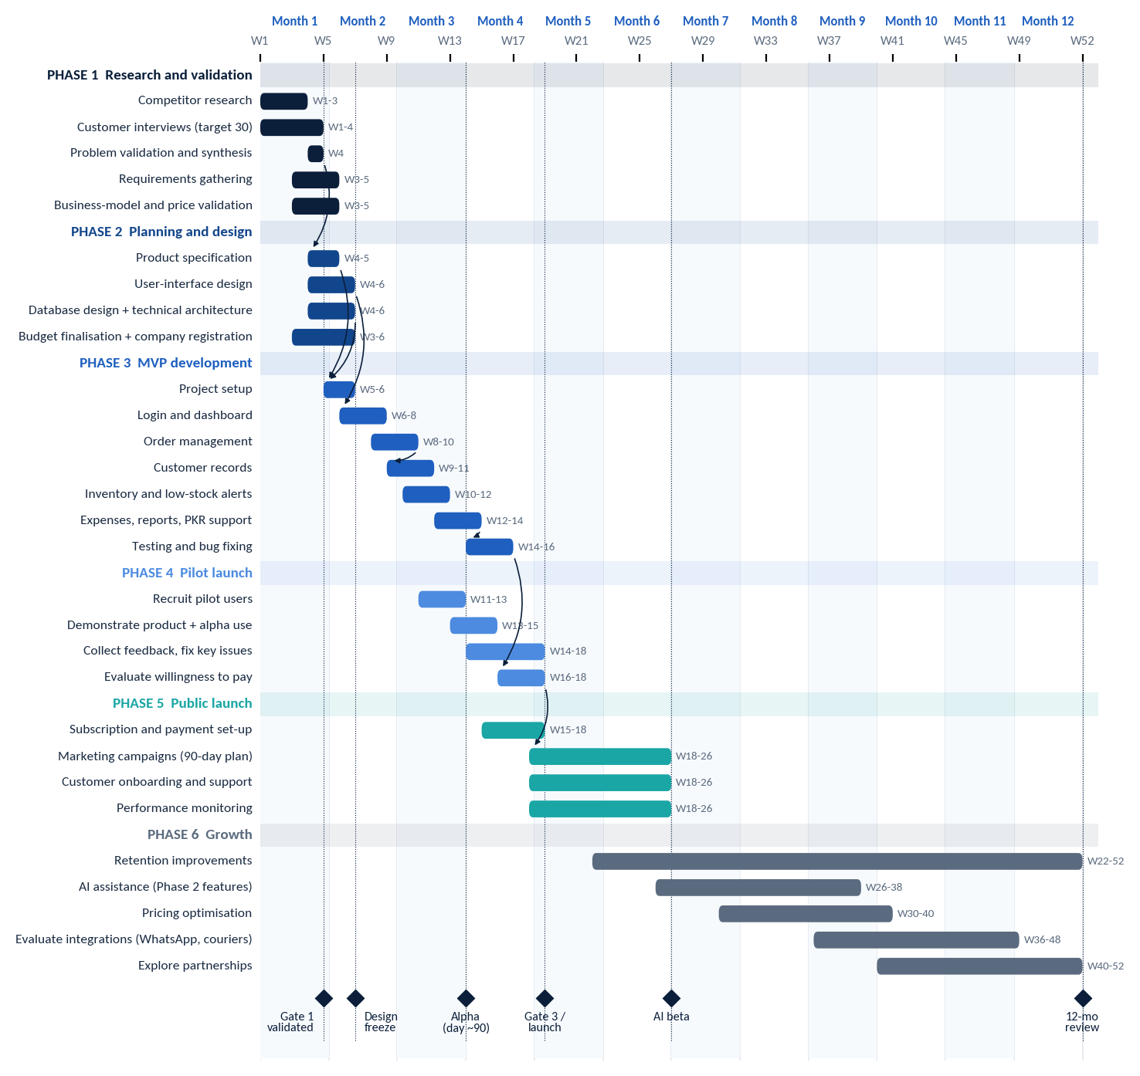
Figure 18. Gantt chart: 52-week plan with dependencies (arrows) and milestones (diamonds)

9.1 Task schedule, owners, dependencies and deliverables
Table 32. Detailed schedule with dependencies (Phase 1-6)
ID | Task | Ph. | Weeks | Owner | Depends on | Deliverable
T1 | Competitor research | 1 | 1-3 | Founder / PM | - | Competitor sheet with dated prices
T2 | Customer interviews (30) | 1 | 1-4 | CEO + marketer | - | 30 interview notes; summary
T3 | Problem validation | 1 | 4 | CEO | T2 | Validation memo (Gate 1)
T4 | Requirements gathering | 1 | 3-5 | PM / tech lead | T2 (partial) | Requirements list
T5 | Business model and price validation | 1 | 3-5 | CEO | T1, T2 | Price table v2
T6 | Product specification | 2 | 4-5 | PM | T3 | MVP specification
T7 | User-interface design | 2 | 4-6 | UI/UX contract | T4 | Clickable prototype
T8 | Database and technical architecture | 2 | 4-6 | Tech lead | T4 | Schema; architecture note
T9 | Budget finalisation and registration | 2 | 3-6 | CEO / finance | T5 | Approved budget; NTN and registration filed
T10 | Project setup | 3 | 5-6 | Developer | T6, T8 | Repository, environment, CI checks
T11 | Login and dashboard | 3 | 6-8 | Developer | T7, T10 | Working login and dashboard
T12 | Order management | 3 | 8-10 | Developer | T11 | Order create/edit/status
T13 | Customer records | 3 | 9-11 | Developer | T12 | Customer list and history
T14 | Inventory and low-stock alerts | 3 | 10-12 | Developer | T12 | Stock logic and alerts
T15 | Expenses, reports, PKR support | 3 | 12-14 | Developer | T12-T14 | Reports; profit estimate
T16 | Testing and bug fixing | 3 | 14-16 | Developer + QA | T15 | Test report; Gate 2 pack
T17 | Recruit pilot users | 4 | 11-13 | Marketer | T7 | 5-10 confirmed pilot users
T18 | Demonstrate product; alpha use | 4 | 13-15 | CEO | T17, T14 | Pilot accounts live
T19 | Collect feedback; fix key issues | 4 | 14-18 | PM / developer | T18 | Feedback log; fixes
T20 | Evaluate willingness to pay | 4 | 16-18 | CEO | T18 | WTP report (Gate 3)
T21 | Subscription and payment set-up | 5 | 15-18 | Developer / finance | T9 | Billing flow; terms live
T22 | Marketing campaigns | 5 | 18-26 | Marketer | T20 | Campaign results
T23 | Customer onboarding and support | 5 | 18-26 | Support | T16 | Support playbook in use
T24 | Performance monitoring | 5 | 18-26 | PM | T16 | Weekly KPI dashboard
T25 | Retention improvements | 6 | 22-52 | PM / support | T23 | Churn reduction actions
T26 | AI assistance (Phase 2) | 6 | 26-38 | Developer / AI | T24, usage test | AI beta
T27 | Pricing optimisation | 6 | 30-40 | CEO | T22 | Revised price table
T28 | Evaluate integrations | 6 | 36-48 | Tech lead | T26 | Integration decision memo
T29 | Explore partnerships | 6 | 40-52 | CEO / sales | T27 | Partnership shortlist

Tasks that can run in parallel
- T1, T2, T4, T5, and T9 (weeks 1-6): research, requirements, pricing, and registration paperwork.
- T7 (UI design) and T8 (database design) with T6 (specification).
- T13 and T14 overlap T12 once the order data model exists.
- T17 (pilot recruitment) runs while T12-T15 are being built; T21 (billing) runs while the pilot is in progress.

Tasks that depend on earlier work
- No build spending beyond design before Gate 1 (T3).
- T22 (public marketing) waits for T20 and Gate 3.
- T26 (AI) waits for stable core operation and a usage-cost test.

9.2 Milestone approval criteria
Table 33. Milestone approval criteria
Milestone / gate | Week | Approval criteria (proposed) | Approver
Gate 1: validation | 4 | At least 20 of 30 sellers rank order tracking or stock confusion in their top three problems; at least 10 sellers willing to pilot; price range acceptable to 8 or more. | All founders
Design freeze | 6 | Specification and prototype reviewed by 5 or more sellers; budget approved; registration filed. | Founders
Alpha (about day 90) | 13 | Core order, customer, and stock flows pass the test checklist; 5-10 pilot users onboarded. | Founders
Gate 2: MVP quality | 16 | No critical bugs; backup restore tested; security checklist complete; support playbook ready. | Tech lead + CEO
Gate 3: launch decision | 18 | 7 of 10 pilot users activated; at least 25% of activated users would pay; terms, privacy notice, and billing ready; cash runway of 6 months or more. | Founders + funder
AI beta | 26 | Usage test shows AI cost within the assumed PKR 120 per customer a month, or plan limits adjusted; 20 beta users agree. | CEO + tech lead
12-month review | 52 | KPI review against Step 11; funding decision for year 2. | Founders + funder

9.3 30-, 60- and 90-day plans
Table 34. 30-60-90 day plan
Period | Goals | Main activities | Deliverables
Days 1-30 (weeks 1-4) | Learn and validate. | Agree roles and decision rules; competitor research; 30 interviews; start registration; draft price table. | Interview summary; competitor sheet; Gate 1 memo.
Days 31-60 (weeks 5-8) | Design and start building. | Specification; wireframes and prototype; database design; project setup; login, dashboard, start of orders; collect pilot commitments. | Approved design; working login and dashboard; 10 pilot commitments.
Days 61-90 (weeks 9-13) | Core build and alpha. | Orders, customers, inventory; recruit pilot users; demos; start alpha with 5-10 users. | Alpha live; first feedback log.

9.4 Month-by-month 12-month roadmap
Table 35. Month-by-month roadmap (customer and revenue numbers are forecasts, not results)
Month | Weeks | Key work | Paying customers (Standard forecast) | Monthly revenue (PKR)
M1 | 1-4 | Validate problem; interviews; registration; competitor research. | 0 | 0
M2 | 5-8 | Design, specification, architecture; project setup; start build. | 0 | 0
M3 | 9-13 | Build orders, customers, inventory; recruit pilot users; alpha at week 13. | 0 | 0
M4 | 14-17 | Reports, expenses, testing; pilot feedback; Gate 2. | 0 | 0
M5 | 18-22 | Gate 3; public launch; subscriptions; first paying customers. | 6 | 15,294
M6 | 23-26 | Campaigns; onboarding; support playbook; weekly KPI review. | 16 | 39,866
M7 | 27-30 | AI beta planning and usage test; retention work. | 29 | 73,160
M8 | 31-35 | AI assistance released to Growth users; pricing tests. | 45 | 114,653
M9 | 36-39 | Review results; plan integrations; start partnership talks. | 63 | 161,303
M10 | 40-43 | Integration evaluation (WhatsApp, couriers); pricing update. | 84 | 212,800
M11 | 44-48 | Hiring decision based on revenue; partnership shortlist. | 106 | 268,855
M12 | 49-52 | 12-month review; year-2 plan and funding decision. | 129 | 329,194
A complete, renderable Mermaid version of the Gantt chart is in Appendix B for editing in documentation tools.

Step 10: Financial Plan and Investment Requirements
Forecasts, not guarantees. All figures are planning scenarios in PKR built from labelled assumptions. Revenue is not profit, and profit is not cash. Taxes (income tax and sales tax) are not included. Founders are unpaid in the Lean and Standard plans, which is a real cost and a risk.

10.1 Key assumptions
Table 36. Core financial assumptions (full list in Appendix A)
Assumption | Value | Basis
Prices (Starter / Growth / Business) | PKR 1,499 / 2,999 / 5,999 a month, ex-tax | [A]
Plan mix | 50% / 40% / 10%; ARPU PKR 2,549 | [A] [C]
Paid sales begin | Month 5 (after pilot and Gate 3) | [A]
Monthly churn | 6%, applied from month 6 | [A]
Hosting per customer | PKR 60 a month | [A] [Q]
AI cost per customer | PKR 120 a month from month 7 | [A] [Q]
Payment processing | 2.5% of revenue | [A] [Q]
Billing | All customers pay monthly in advance; no annual prepayments assumed (conservative) | [A]
Salaries | Benchmarks from job-site salary averages for Pakistan and Karachi (see Step 7) | [V] [A] [Q]
One-time costs | Booked in month 1 for simplicity (conservative); real timing will spread over months 1-4 | [A] [Q]
Contingency | 15% of the peak cumulative cash shortfall | [A]
Exchange rate | PKR 278 per US$1, for reference only | [A]
Excluded | Income tax, sales tax, WhatsApp API pass-through costs, founder salaries (Lean and Standard), interest | -

10.2 Three funding scenarios
Table 37. Scenario comparison. Costs are planning estimates {A}{Q}; the 'one-time development' row is a subset of one-time costs plus contract developer fees
PKR unless stated | Lean / Minimum Budget | Standard Small Startup | Higher-Investment Growth Plan
Initial investment (one-time costs) | 150,000 | 475,000 | 1,225,000
Monthly operating cost at month 6 (fixed run-rate) | 122,000 | 347,000 | 1,345,000
Monthly fixed cost at month 12 | 122,000 | 327,000 | 1,345,000
One-time development and design (outsourced) | 250,000 | 260,000 | 400,000
Marketing budget (12 months) | 290,000 | 640,000 | 1,780,000
Staffing budget (12 months) | 805,000 | 2,455,000 | 10,270,000
Technology budget (hosting, tools; 12 months) | 168,000 | 324,000 | 840,000
Admin and legal (12 months, excl. one-time) | 96,000 | 180,000 | 720,000
Variable costs (12 months) | 77,543 | 113,588 | 304,546
Revenue forecast (12 months) | 833,181 | 1,215,125 | 3,239,413
Peak cumulative cash shortfall | 871,334 | 2,972,463 | 11,900,133
Contingency reserve (15%) | 130,700 | 445,869 | 1,785,020
Total funding requirement (rounded up) | 1,050,000 | 3,450,000 | 13,700,000
Approximate US dollars | US$3,777 | US$12,410 | US$49,281
Estimated runway with zero revenue (months) | 7.4 | 8.6 | 9.3
Lowest forecast cash balance after funding | 178,666 (M9) | 477,537 (M12) | 1,799,867 (M12)
How the funding requirement is calculated: run the monthly cash flow with no funding; take the lowest cumulative point (the peak shortfall); add 15% as contingency; round up to the next PKR 50,000. Runway with zero revenue = (funding minus one-time costs) divided by the month-6 fixed run-rate. It shows how long cash would last if no customer ever paid.
Recommended release of money (Standard plan): about 10% before Gate 1 (interviews, registration, design deposit); about 45% after Gate 1 for design and the MVP build through alpha; the balance after Gate 3 for launch marketing and further hires [A].
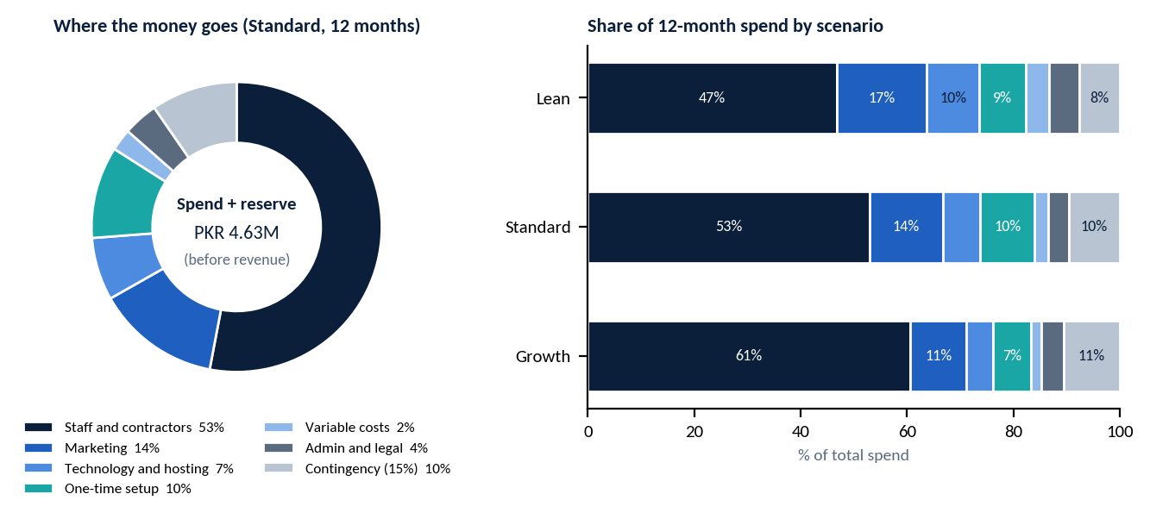
Figure 19. Investment allocation: where the money goes (Standard) and share by scenario

10.3 Twelve-month forecast (Standard plan, PKR thousand)
Table 38. Standard plan 12-month forecast. Cash = funding of PKR 3,450,000 plus cumulative net. Month 1 includes all one-time costs. Forecast, not result
Month | New cust. | Active cust. | Revenue | Variable | Staff | Market-ing | Tech + admin | One-time | Total cost | Net | Cash
M1 | 0 | 0 | 0 | 0 | 15 | 0 | 42 | 475 | 532 | -532 | 2,918
M2 | 0 | 0 | 0 | 0 | 165 | 0 | 42 | 0 | 207 | -207 | 2,711
M3 | 0 | 0 | 0 | 0 | 210 | 40 | 42 | 0 | 292 | -292 | 2,419
M4 | 0 | 0 | 0 | 0 | 265 | 40 | 42 | 0 | 347 | -347 | 2,072
M5 | 6 | 6 | 15 | 1 | 225 | 80 | 42 | 0 | 348 | -332 | 1,740
M6 | 10 | 16 | 40 | 2 | 225 | 80 | 42 | 0 | 349 | -309 | 1,430
M7 | 14 | 29 | 73 | 7 | 225 | 80 | 42 | 0 | 354 | -281 | 1,150
M8 | 18 | 45 | 115 | 11 | 225 | 80 | 42 | 0 | 358 | -243 | 906
M9 | 21 | 63 | 161 | 15 | 225 | 60 | 42 | 0 | 342 | -181 | 725
M10 | 24 | 84 | 213 | 20 | 225 | 60 | 42 | 0 | 347 | -135 | 591
M11 | 27 | 106 | 269 | 26 | 225 | 60 | 42 | 0 | 353 | -84 | 507
M12 | 30 | 129 | 329 | 31 | 225 | 60 | 42 | 0 | 358 | -29 | 478
Reading the table. By month 12 monthly revenue is about PKR 329,194 against operating costs of about PKR 358,476, so the business is still making a monthly operating loss of about PKR 29,282. Closing cash of PKR 477,537 covers roughly 16 months at that loss, enough time for the forecast to reach break-even, but only if customer growth and churn follow the assumptions. Lean and Growth tables are in Appendix A.
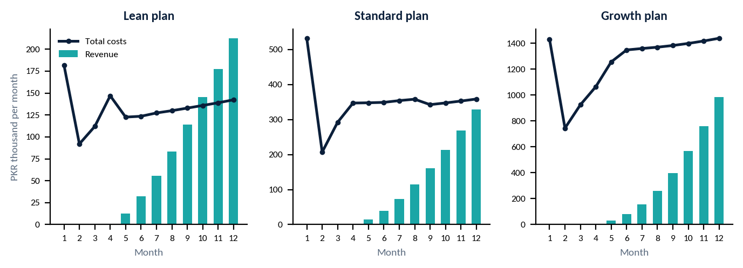
Figure 20. Monthly revenue versus total costs by scenario (month 1 includes one-time costs)
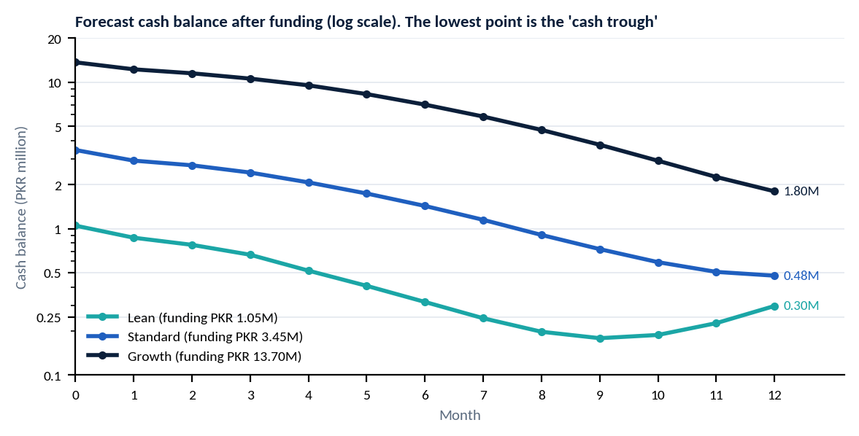
Figure 21. Cash runway: forecast cash balance after funding by scenario

10.4 Break-even analysis
Break-even customers = monthly fixed costs / gross profit per customer. Gross profit per customer is PKR 2,305 (ARPU 2,549 minus variable cost 244) [C].
Table 39. Break-even customer counts (PKR; costs held at month-12 level; extra hires would delay break-even)
Scenario | Monthly fixed costs (month 12) | Gross profit per customer | Break-even customers | Forecast customers at month 12 | Operating break-even (forecast)
Lean | 122,000 | 2,305 | 53 | 83 | Month 10
Standard | 327,000 | 2,305 | 142 | 129 | About month 13 if growth continues [A]
Growth | 1,345,000 | 2,305 | 584 | 386 | About month 15 if growth continues [A]
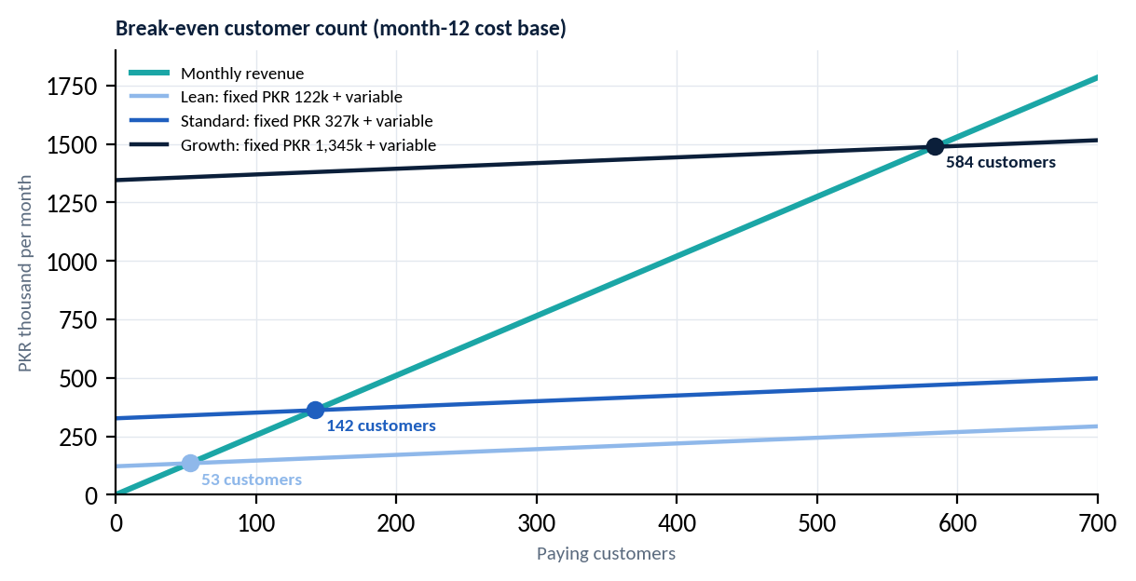
Figure 22. Break-even analysis: monthly revenue versus cost at different customer counts
Break-even is operating break-even only. It does not recover the money already invested, pay founders, or cover taxes.

10.5 Twenty-four-month summary (Standard plan, illustrative)
Year-2 assumptions [A]: new customers rise from 32 a month by 2.5 each month, churn falls to 5%, and fixed costs grow 1% a month with extra hires at months 13 (developer, PKR 110,000), 16 (support, 55,000), 19 (marketing, 60,000), and 22 (sales, 60,000). These are weaker assumptions than year 1, so treat them as direction only.
Table 40. Standard plan, selected months of year 2 (PKR). Illustrative
Month | Customers | Revenue | Total cost | Net | Cash balance
M14 | 181 | 462,421 | 488,888 | -26,466 | 367,300
M18 | 300 | 763,511 | 591,837 | 171,673 | 718,523
M21 | 398 | 1,015,152 | 692,826 | 322,326 | 1,471,519
M24 | 504 | 1,285,436 | 797,927 | 487,508 | 2,706,123

10.6 Funding sources to consider
- Founders' own savings (Lean plan), friends and family, or small angel investors for the Standard plan.
- Startup competitions, incubators, and university programmes. Specific programmes and terms were not researched here; they must be checked before any application.
- No investor commitment, grant, or loan exists. None is assumed.

Step 11: KPIs and Performance Dashboard
These are proposed management targets, not existing results. Targets are initial settings and should be revised after the pilot.
Table 41. KPI framework (proposed management targets)
KPI | Definition and formula | Data source | How often | Owner | Initial target | If missed
Customer interviews completed | Count of completed seller interviews. | Interview log | Weekly | CEO | 30 by day 30 | Extend 1 week; use referrals; widen segments.
Pilot users onboarded | Count of accounts with first login. | Product database | Weekly | Marketing | 10 by day 90 | Call the waitlist; offer longer free use.
Active users | Users with 1+ order recorded in last 7 days / total users. | Product log | Weekly | PM | 60% of pilot users | Call inactive users; find blockers.
Signup-to-activation | Users who record 5 orders in 14 days / signups. | Product log | Weekly | Support | 50% | Simplify setup; add guided import.
Free-to-paid conversion | Paid accounts / signups (cohort). | Billing records | Monthly | CEO | 12% by day 120 | Test price, trial length, plan limits.
Monthly recurring revenue | Paying customers x ARPU. | Billing records | Monthly | CEO | PKR 15,000 in month 5 | Review funnel; boost best channel.
Customer acquisition cost | (Marketing + sales cost) / new paying customers. | Ledger; CRM | Monthly | Marketing | At or below PKR 7,417 | Cut weak channels; improve demo-to-signup.
Churn rate | Customers lost / customers at start of month. | Billing records | Monthly | Support | 6% or less (alert at 8%) | Call leavers; fix top reason; offer annual plan.
Customer retention | Customers still paying after 3 months / cohort. | Billing records | Monthly | Support | 70% or more | Strengthen onboarding and check-ins.
Average revenue per user | MRR / paying customers. | Billing records | Monthly | CEO | Near PKR 2,549 | Review plan mix and upgrade prompts.
Support response time | Median time to first reply (working hours). | Ticket log | Weekly | Support | Under 4 hours | Add coverage; use templates.
Product uptime (after launch) | Minutes available / total minutes. | Uptime monitor | Weekly | Developer | 99% or more | Root-cause review; improve hosting.
Customer satisfaction (CSAT) | Average rating on a 1-5 survey. | Survey after support and day 30 | Monthly | Support | 4.0 or more | Read comments; fix top three issues.
Monthly cash burn | Cash out minus cash in for the month. | Ledger; bank | Monthly | Finance | Within plan +10% | Freeze discretionary spending.
Remaining runway | Cash / average monthly burn of last 3 months. | Ledger; bank | Monthly | CEO | 6 months or more | Cut costs; raise funds early.

11.1 Provisional targets: 30, 60 and 90 days
Table 42. Provisional 30/60/90-day targets (proposals; paid revenue starts in month 5)
KPI | Day 30 | Day 60 | Day 90
Customer interviews completed | 30 | 30 (complete) | -
Pilot users committed / onboarded | - | 10 committed | 5-10 onboarded
Prototype / product status | Problem validated; Gate 1 passed | Design frozen; login, dashboard, orders started | Alpha with orders, customers, stock
Active pilot users | - | - | 60% active weekly
Signup-to-activation | - | - | 50% of pilot users
Willingness to pay signals | 8 of 30 accept price range | - | 3 or more pilot users agree to a paid plan
Cash spent vs plan | Within plan | Within plan | Within plan +10%
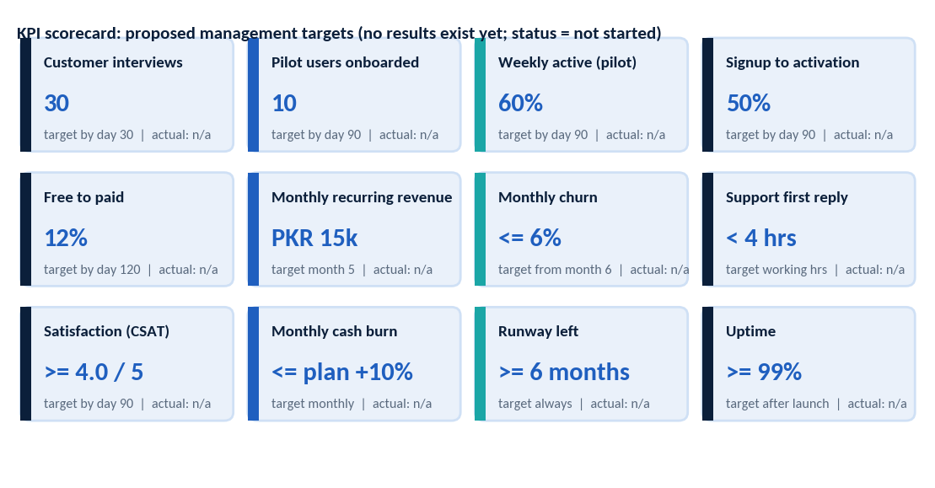
Figure 23. KPI scorecard (targets only; no actual results exist yet)

Step 12: Immediate Next Actions
Before spending significant money, do these three things:
1. Align the founders (week 1). Agree written roles, time commitment, equity split, decision rules, and who owns the code. Cost: close to zero.
2. Interview 30 sellers (weeks 1-4). Test the problem, the current tools, and the price range with the questionnaire in Step 2. Cost: a few thousand rupees for transport and thank-you gifts.
3. Show a clickable prototype and collect 10 pilot commitments (weeks 3-6). Use free design tools. Only if Gate 1 is passed, release the next tranche of money.
Table 43. Implementation checklist for the first eight weeks
# | Task | Owner | Priority | Duration | Depends on | Deadline | Deliverable | Status
1 | Founders' agreement and roles | All founders | Critical | 3 days | - | Week 1 | Signed agreement | Not started
2 | Create interview list and schedule 30 interviews | CEO + marketer | Critical | 1 week | 1 | Week 1 | Interview calendar | Not started
3 | Run interviews and summarise | CEO + marketer | Critical | 4 weeks | 2 | Week 4 | Interview summary | Not started
4 | Competitor research and price table | Founder / PM | High | 3 weeks | - | Week 3 | Competitor sheet | Not started
5 | Gate 1 decision meeting | All founders | Critical | 1 day | 3, 4 | Week 4 | Go / pivot / stop memo | Not started
6 | Clickable prototype and pilot sign-up list | PM + UI designer | High | 3 weeks | 3 | Week 6 | Prototype; 10 commitments | Not started
7 | Choose legal structure; start registration and NTN; open business account | CEO + accountant | High | 3 weeks | 5 | Week 6 | Registration filed | Not started
8 | Get quotes: hosting, AI usage, developer, legal drafts | Finance / tech lead | High | 2 weeks | 5 | Week 6 | Quotation file; budget v2 | Not started
9 | Hire or contract developer; set up repository | Tech lead | High | 2 weeks | 5, 8 | Week 6 | Developer on board | Not started
10 | Start MVP build sprint 1 | Developer | High | 2 weeks | 6, 9 | Week 8 | Login and dashboard | Not started

Appendix A: Financial Assumptions and Detailed Tables

A.1 Staffing schedules used in the model (PKR per month)

Lean plan
Cost line | PKR per month | From month | To month
Accountant (outsourced, part-time) | 10,000 | 1 | 12
Contract developer (MVP support) | 60,000 | 2 | 4
Freelance marketer (part-time) | 25,000 | 4 | 12
Support and sales assistant (part-time) | 35,000 | 5 | 12
Hosting and cloud (VPS, backups) | 6,000 | 1 | 12
Software tools (workspace, design, repo) | 8,000 | 1 | 12
Admin, bank charges, compliance filings | 8,000 | 1 | 12
Marketing (PKR per month): M3: 20,000; M4: 30,000; M5: 30,000; M6: 30,000; M7: 30,000; M8: 30,000; M9: 30,000; M10: 30,000; M11: 30,000; M12: 30,000.
One-time cost (month 1) | PKR
Business registration and NTN (sole proprietor / SMC) | 15,000
Legal documents (terms, privacy notice review) | 25,000
Brand identity and UI design (freelance) | 30,000
Equipment (founders use own laptops) | 0
Domain, SSL, initial setup | 10,000
Outsourced QA and security check | 40,000
Pilot incentives (free months, onboarding gifts) | 30,000
Total | 150,000

Standard plan
Cost line | PKR per month | From month | To month
Accountant (outsourced, part-time) | 15,000 | 1 | 12
Software developer (full-time) | 110,000 | 2 | 12
Marketing executive (part-time) | 45,000 | 3 | 12
Sales and support executive (full-time) | 55,000 | 4 | 12
Contract UI/UX and QA (project) | 40,000 | 2 | 4
Hosting and cloud (managed DB, backups) | 12,000 | 1 | 12
Software tools and subscriptions | 15,000 | 1 | 12
Admin, bank charges, compliance filings | 15,000 | 1 | 12
Marketing (PKR per month): M3: 40,000; M4: 40,000; M5: 80,000; M6: 80,000; M7: 80,000; M8: 80,000; M9: 60,000; M10: 60,000; M11: 60,000; M12: 60,000.
One-time cost (month 1) | PKR
Company registration (SMC/Pvt Ltd), NTN, bank account | 60,000
Legal documents (terms, privacy, contracts) | 60,000
Brand identity and UI design | 80,000
Equipment (1 laptop + peripherals) | 150,000
Domain, SSL, initial setup | 15,000
Outsourced QA and security check | 60,000
Pilot incentives (free months, onboarding gifts) | 50,000
Total | 475,000

Growth plan
Cost line | PKR per month | From month | To month
Finance and administration (full-time) | 45,000 | 1 | 12
Lead developer (full-time) | 180,000 | 2 | 12
Software developer (full-time) | 110,000 | 2 | 12
Product manager (full-time) | 130,000 | 2 | 12
Marketing manager (full-time) | 100,000 | 3 | 12
Sales and business development x2 | 120,000 | 4 | 12
Customer support x2 | 90,000 | 5 | 12
AI and data specialist (part-time) | 90,000 | 6 | 12
Founder stipends x2 | 120,000 | 2 | 12
Legal / cybersecurity consultant (retainer) | 30,000 | 1 | 12
Hosting and cloud (production + staging) | 30,000 | 1 | 12
Software tools and subscriptions | 40,000 | 1 | 12
Office/co-working, admin, compliance | 60,000 | 1 | 12
Marketing (PKR per month): M3: 80,000; M4: 100,000; M5: 200,000; M6: 200,000; M7: 200,000; M8: 200,000; M9: 200,000; M10: 200,000; M11: 200,000; M12: 200,000.
Table 44. Cost schedules by scenario {A}{Q}
One-time cost (month 1) | PKR
Company registration (Pvt Ltd), NTN, bank account | 100,000
Legal documents and IP advice | 150,000
Brand identity, UI/UX design (agency) | 250,000
Equipment (3 laptops + peripherals) | 450,000
Domain, SSL, initial setup | 25,000
Penetration test and security audit | 150,000
Pilot incentives and launch event | 100,000
Total | 1,225,000

A.2 Lean and Growth plan monthly forecasts (PKR thousand)

Lean plan
Month | New | Active | Revenue | Total cost | Net | Cash
M1 | 0 | 0 | 0 | 182 | -182 | 868
M2 | 0 | 0 | 0 | 92 | -92 | 776
M3 | 0 | 0 | 0 | 112 | -112 | 664
M4 | 0 | 0 | 0 | 147 | -147 | 517
M5 | 5 | 5 | 13 | 123 | -110 | 407
M6 | 8 | 13 | 32 | 124 | -91 | 316
M7 | 10 | 22 | 56 | 127 | -71 | 245
M8 | 12 | 33 | 83 | 130 | -47 | 198
M9 | 14 | 45 | 114 | 133 | -19 | 179
M10 | 15 | 57 | 145 | 136 | 9 | 188
M11 | 16 | 70 | 177 | 139 | 38 | 226
M12 | 18 | 83 | 213 | 142 | 70 | 297

Growth plan
Table 45. Lean and Growth 12-month forecasts
Month | New | Active | Revenue | Total cost | Net | Cash
M1 | 0 | 0 | 0 | 1,430 | -1,430 | 12,270
M2 | 0 | 0 | 0 | 745 | -745 | 11,525
M3 | 0 | 0 | 0 | 925 | -925 | 10,600
M4 | 0 | 0 | 0 | 1,065 | -1,065 | 9,535
M5 | 12 | 12 | 31 | 1,256 | -1,226 | 8,309
M6 | 20 | 31 | 80 | 1,349 | -1,269 | 7,040
M7 | 32 | 61 | 157 | 1,360 | -1,203 | 5,837
M8 | 45 | 103 | 262 | 1,370 | -1,108 | 4,728
M9 | 60 | 157 | 399 | 1,383 | -984 | 3,744
M10 | 75 | 222 | 566 | 1,399 | -833 | 2,911
M11 | 90 | 299 | 762 | 1,418 | -656 | 2,255
M12 | 105 | 386 | 984 | 1,439 | -455 | 1,800

Appendix B: Mermaid Diagram Code
Paste into any Mermaid-compatible tool (for example the Mermaid live editor) to render and edit the Gantt chart. The dates assume Day 1 = 2027-01-04 as an example only; change the start date to match the real start.
gantt
title SmartBiz AI - 52-week plan (example start date)
dateFormat YYYY-MM-DD
axisFormat %b %d
section Phase 1 Research
Competitor research :t1, 2027-01-04, 21d
Customer interviews (30) :t2, 2027-01-04, 28d
Problem validation (Gate 1) :t3, after t2, 7d
Requirements :t4, 2027-01-18, 21d
Price validation :t5, 2027-01-18, 21d
section Phase 2 Design
Product specification :t6, 2027-01-25, 14d
UI design :t7, 2027-01-25, 21d
Database and architecture :t8, 2027-01-25, 21d
Budget and registration :t9, 2027-01-18, 28d
section Phase 3 MVP build
Project setup :t10, 2027-02-01, 14d
Login and dashboard :t11, 2027-02-08, 21d
Order management :t12, 2027-02-22, 21d
Customer records :t13, 2027-03-01, 21d
Inventory and alerts :t14, 2027-03-08, 21d
Expenses and reports :t15, 2027-03-22, 21d
Testing and fixes :t16, 2027-04-05, 21d
section Phase 4 Pilot
Recruit pilot users :t17, 2027-03-15, 21d
Demo and alpha :t18, 2027-03-29, 21d
Feedback and fixes :t19, 2027-04-05, 35d
Willingness to pay :t20, 2027-04-19, 21d
section Phase 5 Launch
Subscription setup :t21, 2027-04-12, 28d
Marketing campaigns :t22, 2027-05-03, 63d
Onboarding and support :t23, 2027-05-03, 63d
section Phase 6 Growth
Retention :t25, 2027-06-07, 210d
AI assistance :t26, 2027-06-28, 84d
Pricing optimisation :t27, 2027-07-26, 70d
Integration evaluation :t28, 2027-09-06, 84d
Partnerships :t29, 2027-10-11, 84d

Appendix C: Glossary
Term | Meaning
API | Application Programming Interface: a way for one program to talk to another.
ARPU | Average revenue per user (customer) per month.
CAC | Customer acquisition cost: cost of winning one paying customer.
Churn | The share of customers who cancel in a period.
COD | Cash on delivery: the customer pays the courier on receipt.
CRM | Customer relationship management: software that records customers and contacts.
FBR / NTN | Federal Board of Revenue / National Tax Number.
Gross margin | Revenue minus direct costs, as a share of revenue.
KPI | Key performance indicator: a measure of progress toward a goal.
LTV | Customer lifetime value: gross profit expected from a customer over their stay.
MoSCoW | Must, Should, Could, Won't: a way to rank features.
MRR | Monthly recurring revenue from subscriptions.
MVP | Minimum viable product: the smallest version that tests the idea with real users.
PECA | Prevention of Electronic Crimes Act, 2016.
PKR | Pakistani rupee.
RACI | Responsible, Accountable, Consulted, Informed: a role-assignment matrix.
Runway | How many months cash will last at the current spending.
SECP | Securities and Exchange Commission of Pakistan.
SMC | Single-member company: a private company with one shareholder.
SMEDA | Small and Medium Enterprises Development Authority.
SOM / SAM / TAM | Serviceable obtainable / serviceable available / total addressable market.
SRB / SST | Sindh Revenue Board / Sindh Sales Tax on services.
SWOT | Strengths, weaknesses, opportunities, threats.
Streamlit | An open-source Python framework for building web apps quickly.
SQLite / PostgreSQL | A simple file-based database / a larger server database.

Appendix D: References and Source Links
All links were accessed in October 2026 unless noted. Secondary sources are marked. Verify figures at the source before relying on them.
- DHL Discover, Social commerce strategy in Pakistan (cites Statista, Aug 2025: US$4.74 billion e-commerce 2025). https://www.dhl.com/discover/en-pk/e-commerce-advice/e-commerce-trends/social-commerce-strategy-pakistan
- ECDB, E-Commerce Industry in Pakistan (US$5,776 million in 2025). https://ecdb.com/resources/sample-data/market/pk/all
- Simpaisa blog citing ADB (US$10.42 billion, 2025) - secondary, low confidence. https://test-astro.simpaisa.com/blogs/why-cash-on-delivery-is-killing-your-e-commerce-business-and-what-to-do
- DataReportal, Digital 2026: Pakistan (117 million internet users, Oct 2025). https://datareportal.com/reports/digital-2026-pakistan
- DataReportal, Digital 2025: Pakistan (66.9 million social media user identities). https://datareportal.com/reports/digital-2025-pakistan
- SMEDA / ADB presentation, Accelerating Dynamics of MSMEs post COVID-19 (5.2 million SMEs; provincial shares). https://events.development.asia/system/files/materials/2021/12/202112-accelerating-dynamics-msmes-post-covid-19-south-asia-case-study-pakistan.pdf
- Business Recorder, SMEDA CEO on 5.24 million SMEs. https://www.brecorder.com/feeds/news/40303806
- SMEDA-ADBI, Impact of COVID-19 on SMEs (72.29% cash as major payment method). https://smeda.org/phocadownload/Research_Publications/SMEDA%20-%20ADBI%20Report%20on%20Impact%20of%20COVID-19%20on%20SMEs.pdf
- GAIN policy brief (about 70% informal; 98% below PKR 150 million turnover). https://gainhealth.org/sites/default/files/publications/documents/pakistan-policy-brief-1.pdf
- Pakistan Bureau of Statistics census 2023 via CityPopulation (Karachi Division 20,382,881; Sindh 55,696,147). https://citypopulation.de/en/pakistan/karachi/admin/807__karachi_east/
- Dawn, 2023 census results (Pakistan 241.49 million). https://www.dawn.com/news/amp/1846604
- Zoho Inventory pricing comparison (official). https://www.zoho.com/inventory/pricing-comparison/
- Hulm POS pricing (PKR 2,500 a month). https://hulmsolutions.com/
- Granet Pro pricing. https://www.granetpro.com/pricing.html
- ManageKaro pricing. https://managekaro.org/pricing
- Smart Stock pricing. https://smartstock.pk/
- Sellio. https://pk-sellio.vercel.app/
- Meta, WhatsApp Business Platform pricing documentation. https://developers.facebook.com/documentation/business-messaging/whatsapp/pricing
- ProPakistani, Meta WhatsApp rates for Pakistan, 15 Sep 2026. https://propakistani.pk/2026/09/15/meta-charges-pakistan-11x-more-than-india-for-whatsapp-business-messages/
- ChatMaxima, WhatsApp API pricing Pakistan (BSP page; marketing US$0.0473, utility US$0.01). https://chatmaxima.com/whatsapp-api-pricing/pakistan/
- Wetarseel, WhatsApp API pricing in Pakistan (PKR 278 per US$ rate; BSP page). https://wetarseel.ai/whatsapp-api-pricing-in-pakistan/
- Software engineer salary in Pakistan 2026 (entry PKR 50,000-100,000; Karachi average PKR 86,667). https://whatisthesalary.com/software-engineer-salary-in-pakistan/
- Indeed Pakistan, junior developer salaries (average PKR 50,925). https://pk.indeed.com/career/junior-developer/salaries
- Chambers, Data Protection and Privacy 2026: Pakistan. https://practiceguides.chambers.com/practice-guides/data-protection-privacy-2026/pakistan
- Recording Law, Pakistan data privacy laws guide (2026). https://www.recordinglaw.com/world-laws/world-data-privacy-laws/pakistan-data-privacy-laws/
- EY Tax Alert, provincial sales tax changes (Sindh standard rate 15%). https://www.ey.com/en_gl/technical/tax-alerts/2024-1353-pakistan-adopts-changes-to-provincial-sales-tax-laws
- Kintsugi, Pakistan sales tax guide 2026 (secondary; IT service rates need verification). https://trykintsugi.com/sales-tax-guides/apac/pakistan
- Sindh Revenue Board, taxable services (official; check current tariff). https://www.srb.gos.pk/srb/taxable-services/
- SECP vs FBR guide, 2026. https://www.ict.edu.pk/blogs/secp-vs-fbr-pakistan-differences-filing-guide-2026
- SECP company registration process 2026 (fee schedule, secondary). https://bacoconsultants.com/blogs/secp-company-registration-process-in-pakistan-2026

