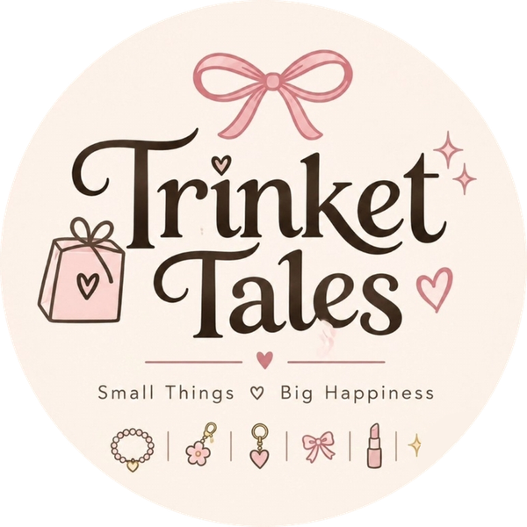
Trinket Tales
One Product, Four Connected Assignments
Product: Trinket Tales Dreamy Kids Makeup Set for Girls (Gift Set)

Student | Kanzul Eman
Roll No. | ________________
Instructor | Adeen Amjad (Visiting Lecturer)
Course | ________________
Date | 9 November 2026
Shopify store | https://wmyj10-ju.myshopify.com
Product link | https://wmyj10-ju.myshopify.com/products/dreamy-kids-makeup-set-for-girls
Supplier | aliexpress.com/item/1005012993298696.html
Instagram | instagram.com/trinket_tales_1

How the four assignments connect
Assignment 1 - Keyword & Niche Research: finds the niche and the words buyers type.
Assignment 2 - Product Hunting: picks the product that fits those words and has a real online supplier.
Assignment 3 - Product Listing: puts that product on our Shopify store using those words.
Assignment 4 - Competitor Analysis & Case Study: studies who else sells it, and feeds the price and positioning back into the listing.
The same product, the same keywords and the same store run through all four parts, so together they make one complete business project.

Project at a glance
Brand | Trinket Tales - Small Things, Big Happiness
Product | Dreamy Kids Makeup Set for Girls: a makeup play set with eyeshadow, lipstick and press-on nails, in packs of 1 to 4 kits
Who buys | Mothers, aunts and elder sisters buying a birthday, Eid or return gift for girls
Price | Rs 2,999 for one kit (compare-at Rs 3,999), delivered all over Pakistan
Selling platform | Shopify store. Our Instagram page @trinket_tales_1 brings buyers to it
Supplier | AliExpress through the DSers app (dropshipping), with a backup seller and a local-stock plan
Main keyword | kids makeup kit for girls
Case study | MINISO - low-price, cute lifestyle retailer with stores in Pakistan
Rest of the store | Our own Instagram range (bracelets, gift bundles, little gift boxes) is sold from our own stock with cash on delivery. One more AliExpress product, a flower bead bracelet set, is dropshipped the same way as the kit. Neither is the main product of this project.

Contents
1. Assignment 1 - Keyword and Niche Research
2. Assignment 2 - Product Hunting
3. Assignment 3 - Product Listing
4. Assignment 4 - Competitor Analysis and Case Study (MINISO)

