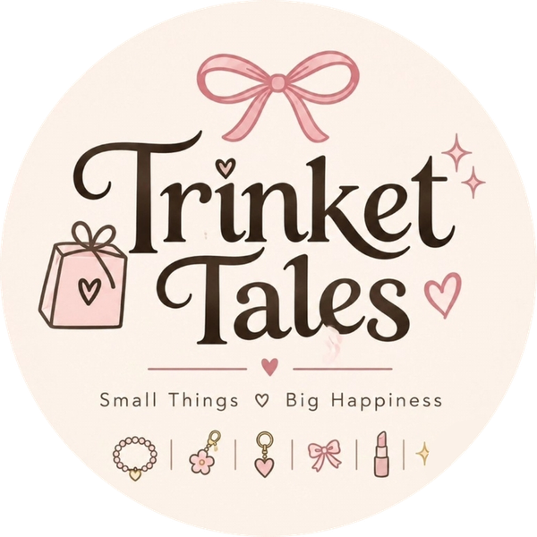 | Assignment 1 of 4  Keyword and Niche Research  Product: Trinket Tales Dreamy Kids Makeup Set for Girls (Gift Set)

Student | Kanzul Eman
Roll No. | ________________
Instructor | Adeen Amjad (Visiting Lecturer)
Course | ________________
Date | 9 November 2026
Selling platform | Shopify store (Instagram @trinket_tales_1 brings buyers to it)
Store link | https://wmyj10-ju.myshopify.com

Where this fits
This is part 1 of one connected project. Here I choose the niche and find the words buyers use. The product picked in Assignment 2, the listing in Assignment 3 and the competitors in Assignment 4 all use the niche and keywords from this page.

For this project I am building Trinket Tales, a small online gift shop on Shopify. Our Instagram page @trinket_tales_1 shows our products and sends buyers to the store. Our line is "Small things, big happiness", so we sell little things that make someone smile. In this first part I narrow down the niche and collect the keywords people type when they look for our product.

1. Niche selection
Broad market | Gifts and toys for girls
Niche | Makeup gifts for girls
Micro-niche (our focus) | Kids' makeup gift sets for dress-up play, for girls aged about 6 to 12
Who buys | Mothers, aunts and elder sisters buying a gift
When they buy | Birthdays, Eid, return gifts for parties, school results

Why this niche
- It is a gift. People do not need a big reason to buy a small gift for a child, and occasions come round all year: Eid twice a year, birthdays every month.
- The price fits a gift budget. Kids makeup kits sell for about Rs 449 to Rs 2,199 on OLX, Daraz and Markaz, and Rs 1,649 to Rs 4,995 in online toy stores.
- It is small and light. A boxed set is easy to ship across Pakistan.
- It looks good in photos. A colourful gift box makes an attractive product page and Instagram post.
- It matches our brand. Our logo already shows a bow, a lipstick and little gifts.

Niche check
Factor | What I found | Result
Demand | Many sellers on Daraz, Markaz, OLX and toy stores list kids makeup kits, which shows people keep buying them. | Good
Competition | Lots of sellers, but most listings are plain toy kits with mixed photos and no gift feel. | Medium
Price range | About Rs 449 to Rs 2,199 on marketplaces, Rs 1,649 to Rs 4,995 in toy stores | Fits Rs 2,999
Profit | About 29% if supplier shipping is free or low (worked out in Assignment 2) | Good
Shipping | Small box, sent straight from the supplier | Easy
Seasonality | Busier before Eid and in the birthday and party season, steady the rest of the year | Good
Risk | Makeup for children needs clear notes: age, adult help, patch test | Manageable

2. How I did the keyword research
1. Typed seed words into Google, Daraz and Instagram search and noted the suggestions that came up.
2. Read the titles of competitor listings on Daraz, Markaz, OLX and toy stores to see which words sellers use.
3. Grouped the keywords by what the buyer wants: just looking, comparing, or ready to buy.
4. Picked one main keyword and a few supporting ones for the product listing.
Seed words: makeup kit, kids makeup, gift for girls, makeup set, dress-up
Demand and competition below are my own estimates, based on how often a phrase came up in search suggestions and in competitor titles. The same list can be checked for exact monthly numbers in Google Keyword Planner or Google Trends (Pakistan).
Keyword | Type | Buyer intent | Demand | Competition
makeup kit for girls | Main | Comparing | High | High
kids makeup kit | Main | Comparing | High | High
kids makeup kit for girls | Main (chosen) | Ready to buy | Medium | Medium
kids makeup set | Product name | Ready to buy | Medium | Medium
makeup play set for girls | Supporting | Ready to buy | Medium | Low
makeup gift set for girls | Supporting | Ready to buy | Medium | Medium
birthday gift for girls | Gift | Looking | High | High
Eid gift for girls | Gift / seasonal | Looking | High before Eid | Medium
return gifts for girls birthday | Gift | Buying in bulk | Medium | Low
kids makeup kit price in Pakistan | Long-tail | Ready to buy | Medium | Low
press on nails for kids | Long-tail | Ready to buy | Low | Low
bachiyon ka makeup set (Roman Urdu) | Local | Ready to buy | Low | Low

3. Final keyword set
Main keyword | kids makeup kit for girls
Supporting | kids makeup set, makeup play set for girls, makeup gift set for girls, birthday gift for girls, Eid gift for girls
Long-tail | kids makeup kit price in Pakistan
Used in (Assignment 3) | Product title, URL, first line of description, image alt text, SEO title, meta description, tags
Instagram hashtags | #trinkettales #kidsmakeupkit #makeupkitforgirls #giftsforgirls #birthdaygiftideas #eidgifts #returngifts #giftideaspakistan #smallbusinesspakistan

4. Who we are selling to
 | Buyer 1 | Buyer 2
Who | Sana, 34, mother of two, Lahore | Ayesha, 27, works in an office, Karachi
Buys for | Her daughter and her daughter's friends (birthdays, Eid) | Her nieces and younger cousins
Where she shops | Instagram at night, sometimes Daraz | Instagram and online stores on her phone
What she wants | Cute, safe-looking, under Rs 4,000 | A gift that looks special without much effort
What she searches | kids makeup kit price in Pakistan, birthday gift for girls | makeup gift set for girls, Eid gift for girls

How this connects to the other assignments
Assignment 2: I hunted for a product that matches the main keyword "kids makeup kit for girls" and these two buyers, with a real online supplier. The winner is the Dreamy Kids Makeup Set.
Assignment 3: The final keyword set above goes into the Shopify title, description, tags and SEO.
Assignment 4: The sellers who show up for these keywords on Daraz, Markaz, OLX, toy stores and Instagram are the competitors I study.

Sources
- Daraz.pk kids makeup kit listings (reviewed Nov 2026), e.g. daraz.pk/products/makeup-kits-for-kids-toy-cosmetic-pretend-play-kit-for-girl-gift-with-princess-case-makeup-set-kids-toy-i269342763-s1483322824.html
- Markaz kids makeup kits, e.g. markaz.app/shop/product/pink-makeup-kit-for-girls-eid-party-school-use/552365
- OLX Pakistan makeup kit listings: olx.com.pk/others_g10077/q-makeup-kit
- Toynix.pk makeup sets: toynix.pk/collections/makeup-set
- GoodBaby Pakistan beauty kit: goodbabypakistan.com/products/beauty-cosmetic-makeup-kit-for-kids
- Planet Junior makeup sets: planetjunior.pk/collections/makeup-beauty-sets
- Gift4u.pk makeup bag kit: gift4u.pk/product/premium-makeup-bag-kit/

