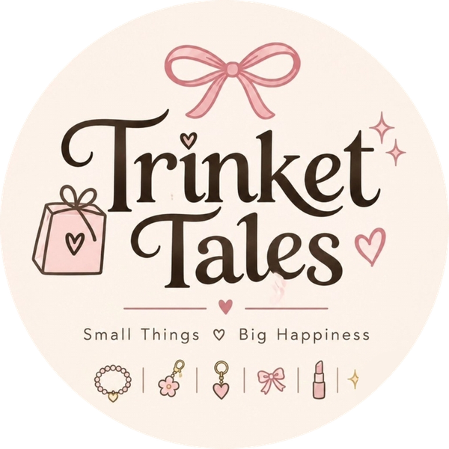 | Assignment 2 of 4  Product Hunting  Product: Trinket Tales Mini Makeup Kit for Girls (Gift Pouch)

Student | Kanzul Eman
Roll No. | ________________
Instructor | Adeen Amjad (Visiting Lecturer)
Course | ________________
Date | 9 November 2026
Selling platform | Shopify store + Instagram (@trinket_tales_1)
Store link | ________________________________

Where this fits
In Assignment 1 I chose the niche "mini makeup gift pouches for girls" and the main keyword "mini makeup kit for girls". Here I find the actual product and the dropshipping supplier. This same product is listed in Assignment 3 and compared with competitors in Assignment 4.

1. Where I looked
- Instagram: small Pakistani gift pages and packing reels (girls gift boxes with lip balm, sheet masks, bracelets and claw clips).
- Daraz.pk: kids makeup kits and pouches, to see prices and what sells.
- Markaz (markaz.app): a Pakistani dropshipping and reselling platform that lists kids makeup kits for Eid and parties.
- OLX: quick price check of local sellers.
- AliExpress through the DSers app: to see the same kind of kits sold from China.

2. What makes a winning product for us
1. Wow factor: looks cute in a photo or reel
2. Price under Rs 1,500
3. Small and light, so delivery is cheap
4. Strong gift appeal
5. Does not break easily
6. Available from a dropshipping supplier
7. Leaves around 25% profit after costs
8. Easy to make content with

3. Shortlist and scores
I scored four products that fit our brand (all four appear as icons in our logo). Each criterion is out of 5.
Criteria | Mini Makeup Pouch | Beaded Bracelet Set | Flower Claw Clips | Bag Charm Keychain
Wow factor | 5 | 3 | 4 | 4
Price under Rs 1,500 | 5 | 5 | 5 | 5
Small and light | 4 | 5 | 4 | 5
Gift appeal | 5 | 4 | 3 | 4
Does not break | 4 | 5 | 3 | 4
Supplier available | 4 | 5 | 5 | 4
Profit | 4 | 4 | 3 | 4
Content potential | 5 | 3 | 4 | 4
Total (out of 40) | 36 | 34 | 31 | 34

Winner: Mini Makeup Gift Pouch. It scored highest on wow factor, gift appeal and content. Bracelets and bag charms also scored well, so they can be added later as add-ons, but this project stays on one product, as required.

4. The winning product
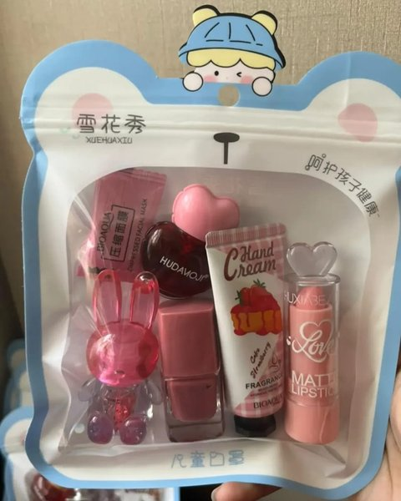 | 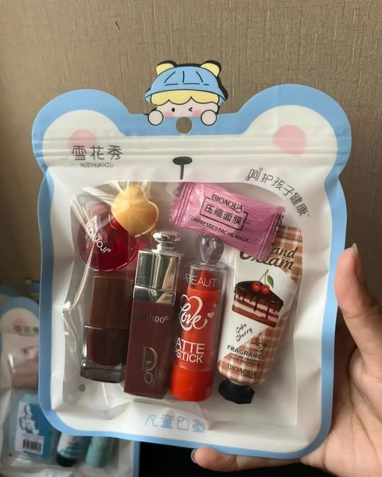 | 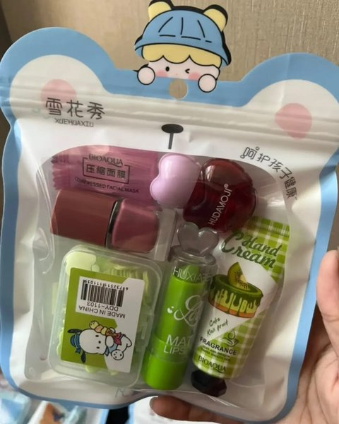 | 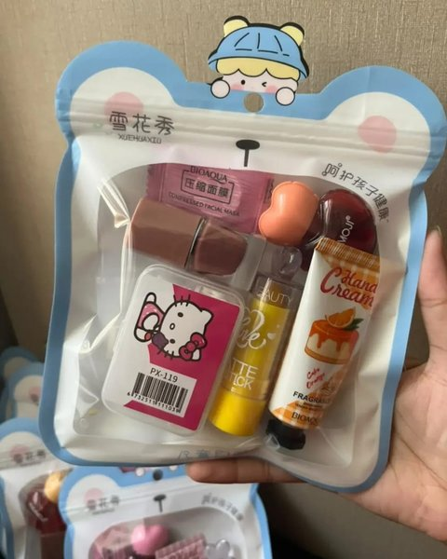 | 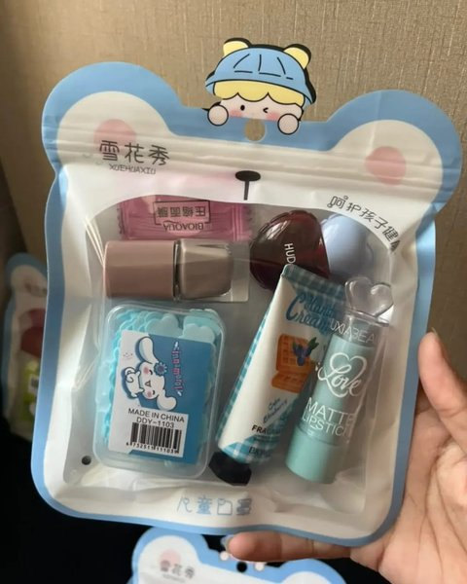
Strawberry Pink | Cherry Red | Kiwi Green | Orange Sunshine | Blueberry Blue

Name | Trinket Tales Mini Makeup Kit for Girls (Gift Pouch)
What's inside | Matte lipstick, heart-shaped lip tint, nail polish, mini scented hand cream (fruit-cake design), compressed face mask tablet, and a cute hair clip or small accessory. Small extras vary by colour.
Packaging | Clear zip pouch with a bear-shaped top and a hanging hole, so it is gift-ready as it arrives
Colours | Strawberry Pink, Cherry Red, Kiwi Green, Orange Sunshine, Blueberry Blue
Age | 8 and up; younger children with an adult
Selling price | Rs 1,200 (compare-at Rs 1,500)

5. Supplier and dropshipping plan
 | Markaz (Pakistan) | DSers + AliExpress
How it links to Shopify | Pick products, set our margin and export a product file that Shopify imports ("Export to My Store"). When an order comes in, we place it in our Markaz account and Markaz delivers to the customer. | Official AliExpress dropshipping app on the Shopify App Store. Products are imported or mapped; many orders can be placed in one click and tracking numbers sync back to Shopify.
Delivery time | Local stock, about 2 to 5 days | Ships from China, about 15 to 20 days
Payment | Cash on delivery for the customer | We prepay the supplier; COD is not tracked by the app
Cost to use | Free reseller account | Free Basic plan (paid plan $19.90/month)
Our choice | Main supplier | Backup / later for international orders

Why Markaz first: Pakistani buyers expect cash on delivery and quick delivery. A local supplier gives both. DSers stays as a backup because it gives fully automatic order sync if we sell outside Pakistan later.

Order flow
1. Customer orders on our Shopify store and chooses cash on delivery.
2. We confirm the order on WhatsApp (cuts fake COD orders).
3. We place the same order with the supplier (Markaz).
4. Supplier packs the pouch and sends it with the courier.
5. Courier collects cash from the customer; our margin is paid out to us.

6. Costing (per pouch, planning estimate)
Item | Amount
Selling price | Rs 1,200
Product cost from supplier (estimate) | - Rs 650
Thank-you card / sticker | - Rs 30
COD returns allowance (about 5%) | - Rs 60
Marketing per order (Instagram) | - Rs 150
Profit per order | about Rs 310 (26%)
Delivery charge | Rs 200, paid by the customer at checkout (free over Rs 2,500)

The supplier price will be confirmed in the Markaz app before launch; these numbers are for planning.

7. Risks and how we handle them
Risk | What we do
Cosmetics used by children | Clear notes on the listing: age 8+, patch test on the hand first, keep away from eyes, adult help for younger kids.
Cartoon characters on some packaging | We never use character or brand names in our titles, tags or ads, and we do not claim to be an official licensed product.
Nail polish could leak | Supplier packs in a zip pouch with bubble wrap; we replace anything that arrives damaged.
Same product sold by others | We win on presentation, colour choice, honest listing and fast replies (see Assignment 4).

How this connects to the other assignments
From Assignment 1: chosen because it matches the main keyword "mini makeup kit for girls" and our two buyer types.
To Assignment 3: this product, its 5 colours, contents, Rs 1,200 price and Markaz supply are what the Shopify listing is built on.
To Assignment 4: the competitors studied are other sellers of this same kind of kit.

Sources
- Markaz - Shopify dropshipping in Pakistan: markaz.app/blog-post/shopify-dropshipping-in-pakistan
- Markaz - Sell Markaz products on Shopify / WooCommerce: markaz.app/blog-post/sell-markaz-products-on-shopify-woocommerce
- DSers - AliExpress Dropshipping (Shopify App Store): apps.shopify.com/dsers
- EasySell - COD dropshipping on Shopify, setup guide: easysellapp.com/blogs/wiki/cod-dropshipping-shopify-setup-guide
- Releasit - Dropshipping in Pakistan with COD: releas.it/blogs/news/dropshipping-in-pakistan-with-cod-trials-tribulations-and-triumphs
- Daraz.pk kids makeup kit listings (reviewed Nov 2026), e.g. daraz.pk/products/makeup-kits-for-kids-toy-cosmetic-pretend-play-kit-for-girl-gift-with-princess-case-makeup-set-kids-toy-i269342763-s1483322824.html
- Markaz kids makeup kits, e.g. markaz.app/shop/product/pink-makeup-kit-for-girls-eid-party-school-use/552365
- OLX Pakistan makeup kit listings: olx.com.pk/others_g10077/q-makeup-kit

