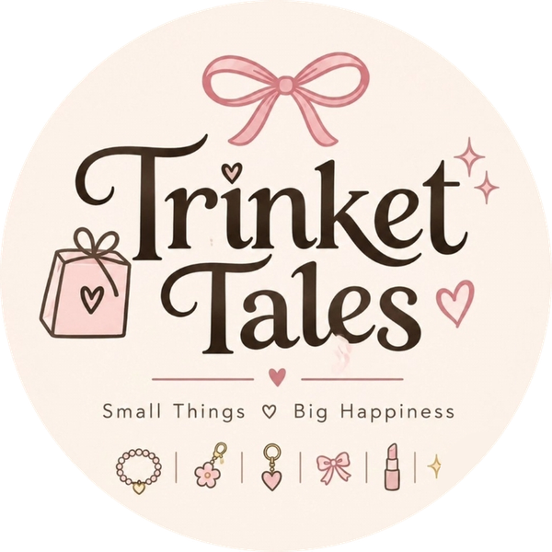 | Assignment 3 of 4  Product Listing  Product: Trinket Tales Lollipop Makeup Kit for Girls (Washable Gift Box)

Student | Kanzul Eman
Roll No. | ________________
Instructor | Adeen Amjad (Visiting Lecturer)
Course | ________________
Date | 9 November 2026
Selling platform | Shopify store (Instagram @trinket_tales_1 brings buyers to it)
Store link | https://wmyj10-ju.myshopify.com

Where this fits
This is the Shopify listing for the product chosen in Assignment 2, written with the keywords from Assignment 1. The price and selling points were set after the competitor study in Assignment 4.

Platform | Shopify (store name: Trinket Tales)
Store link | https://wmyj10-ju.myshopify.com
Product link | https://wmyj10-ju.myshopify.com/products/lollipop-makeup-kit-for-girls
Instagram | instagram.com/trinket_tales_1 (store link in bio)

1. Listing details
Product title | Lollipop Makeup Kit for Girls - Washable Gift Box
Price | Rs 3,499
Compare-at price | Rs 4,499
Options | As offered by the supplier, imported by DSers
Product type | Kids Makeup Set
Vendor | Trinket Tales
Collections | Kids Makeup Gifts; Gifts for Girls
Tags | kids makeup kit for girls, washable makeup kit for kids, lollipop makeup kit, makeup gift set for girls, birthday gift for girls, eid gift for girls, dropship
URL handle | lollipop-makeup-kit-for-girls
Payment | Advance payment: bank transfer, JazzCash or Easypaisa
Fulfilment | Dropshipped from AliExpress through DSers (see Assignment 2)

2. Product description (as on the store)
A sweet treat she can play with.
This washable makeup kit comes in a cute lollipop-shaped case that opens in layers, so every layer feels like a little surprise. A lovely gift for birthdays, Eid and return gifts.
What's inside
• Lip colours
• Eyeshadow
• Blush
• Nail polish
• Pieces as shown in the photos
Good to know
• Washable makeup made for kids.
• Best for ages 6 and up; younger girls with a grown-up.
• Try a small patch test first and keep away from eyes.
Delivery and payment: This gift box ships from our supplier and arrives in about 10 to 20 working days. Pay in advance by bank transfer, JazzCash or Easypaisa; we confirm every order on WhatsApp.

3. Product images
Screenshot of the live product page
Paste a screenshot of the product page here (Shopify admin: Products > Lollipop Makeup Kit > View).

# | Image | Alt text (for Google and screen readers)
1 | Closed lollipop case (main image) | Lollipop makeup kit for girls, washable gift box
2 | Case opened, showing the layers | Kids makeup kit for girls opened in layers
3 | Close-up of the makeup | Washable makeup kit for kids with lip colours and eyeshadow
4 | Gift packaging | Makeup gift set for girls in gift packaging

The supplier's photos are imported by DSers, so the product we show is exactly the product that is shipped. The theme shows every product photo in the same 4:5 frame, so the page and collection grid look even.

4. Search engine listing (SEO)
Page title | Lollipop Makeup Kit for Girls | Washable Gift Box | Trinket Tales
Meta description | Cute washable makeup kit for girls in a lollipop-shaped gift box. Lip colours, eyeshadow, blush and nail polish. Delivered across Pakistan.
URL handle | /products/lollipop-makeup-kit-for-girls

5. Where the Assignment 1 keywords are used
Keyword | Where it appears
kids makeup kit for girls (main) | Description, image alt text, tags
lollipop makeup kit | Title, URL, SEO title, first image alt text, tags
washable makeup kit for kids | Description ("washable makeup kit"), alt text, tags
makeup gift set for girls | Alt text, tags, description ("a lovely gift")
birthday gift / Eid gift for girls | Description ("for birthdays, Eid and return gifts"), tags
... price in Pakistan | Meta description ("Delivered across Pakistan"), price shown in Rs

6. Store setup around the listing
- Theme: Shopify Dawn, using the cream, cocoa and rose colours from our logo.
- Home page: full-width brand banner "Small things, big happiness" with the kit's price and a Shop button, a trust bar, the kit with Add to cart and Buy it now, a "More little joys" product grid and quick answers.
- Product page: option buttons, Buy it now, a delivery date line (10 to 20 working days for imported items) and a sticky Add to cart bar on mobile. The cart shows a free-delivery progress bar.
- Pages: About, Contact, FAQ. Policies: Shipping, Refund, Privacy, Terms.
- Payment: advance payment (bank transfer, JazzCash, Easypaisa) for imported items; cash on delivery for our own stock.
- Shipping: Rs 200 flat across Pakistan, free on orders over Rs 2,500.
- Instagram: store link in the @trinket_tales_1 bio; the kit is posted with a link to the product page.
- Rest of the store: our own Instagram range (bracelets, gift bundles, little gift boxes) is sold from our own stock with cash on delivery.

Instagram post for this product
Caption
A lollipop that's actually a makeup kit 🍭
Washable lip colours, eyeshadow, blush and nail polish, all in a cute gift box.
Rs 3,499 | Delivered all over Pakistan | Link in bio
#trinkettales #kidsmakeupkit #giftsforgirls #eidgifts #giftideaspakistan

How this connects to the other assignments
From Assignment 1: title, tags and SEO are built on the keywords "kids makeup kit for girls" and "lollipop makeup kit".
From Assignment 2: the product, its supplier photos and options, the DSers connection and the advance-payment rule for imported items.
From Assignment 4: Rs 3,499 sits inside the Rs 1,649 to Rs 4,995 toy-store range; we show delivery dates and contents clearly because most competitor listings do not.

