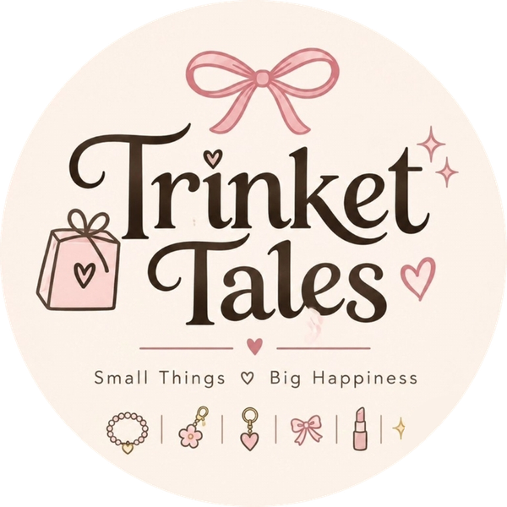 | Assignment 4 of 4  Competitor Analysis and Case Study  Product: Trinket Tales Dreamy Kids Makeup Set for Girls (Gift Set)

Student | Kanzul Eman
Roll No. | ________________
Instructor | Adeen Amjad (Visiting Lecturer)
Course | ________________
Date | 9 November 2026
Selling platform | Shopify store (Instagram @trinket_tales_1 brings buyers to it)
Store link | https://wmyj10-ju.myshopify.com

Where this fits
Here I look at who else sells the product from Assignment 2 to the buyers from Assignment 1, and what we can learn from a bigger competitor. The findings decided the price and selling points in the Assignment 3 listing.

1. Who our competitors are
- Direct: Daraz sellers, Markaz resellers, OLX sellers, online kids' toy stores and Instagram gift pages selling kids makeup kits.
- Indirect: MINISO Pakistan (cute beauty items and accessories in malls) and general toy shops.

2. Competitor comparison
Competitor | Where | Price seen | Strengths | Weaknesses
Daraz kids makeup kit sellers | Daraz.pk | e.g. Rs 589 on sale (was Rs 1,099) | Huge traffic, buyer trust, vouchers | Generic titles, plain photos, no gift feel
Online kids' toy stores (Toynix, GoodBaby, Planet Junior, Gift4u) | Own websites | Rs 1,649 to Rs 4,995 | Branded kits, COD, big sets | Mostly big pretend-play sets, higher price
Markaz resellers | Markaz app and reseller pages | Varies by reseller | Cash on delivery, many resellers | Same product everywhere; a buyer review complains of missing or broken items
OLX sellers | OLX | Rs 449 to Rs 2,199 | Cheap, local pick-up | No brand, low trust, no returns
Instagram gift pages | Instagram DMs | Around Rs 1,200 per "deal" | Reels, personal touch | No checkout, slow DM replies, prices hidden
MINISO Pakistan | Mall stores and online | Varies | Strong brand, cute character products, shop experience | Not focused on kids makeup gift kits

Trinket Tales against the usual seller
Feature | Daraz sellers | Instagram pages | Trinket Tales
Own website with checkout | No | No | Yes (Shopify)
Delivery dates shown on the product page | Rarely | No | Yes
Full contents listed honestly | Sometimes | Rarely | Yes
Gift-ready look and brand | No | Sometimes | Yes
Safety notes (age, patch test) | Rarely | Rarely | Yes

3. SWOT for Trinket Tales
Strengths | Weaknesses
Cute brand and logo; gift-ready product; own Shopify store plus Instagram; honest, clear listing | New brand with no reviews yet; imported items take 2 to 3 weeks and need advance payment

Opportunities | Threats
Eid and birthday seasons; bulk return-gift orders; local stock later for faster delivery and cash on delivery; reels | Price wars on Daraz; buyers who only trust cash on delivery; supplier shipping costs changing

4. Case study: MINISO
I chose MINISO because it sells the same kind of thing we do (small, cute, low-price beauty items and gifts), it is in Pakistan, and it grew from one store into a global brand.

Background
- Chinese lifestyle retailer; opened its first store in mainland China in 2013, co-founded by Ye Guofu.
- Sells low-priced, design-led small items: beauty, accessories, toys, stationery and gifts, often with cartoon or film character collaborations.
- Listed on the New York Stock Exchange (filed in 2020) and on the Hong Kong Stock Exchange in July 2022 at HK$13.80 a share.

Size and growth
Measure | Figure | Period
Total stores | 7,780 | 31 Dec 2024
Total stores | 8,485 (705 more than a year earlier) | 31 Dec 2025
MINISO-brand stores outside mainland China | 3,583 | 31 Dec 2025
Full-year revenue | RMB 21,443.8 million (about US$3,066 million), up 26.2% | 2025

MINISO in Pakistan
- First Pakistani store opened in 2017, and the brand reached 45 stores within two years (Profit, 2019).
- In an interview with Dawn's Aurora magazine, a MINISO executive said the company had 68 stores in Pakistan, 34 of them operating in 11 cities.
- Partnered with Jomo.pk to sell online in Pakistan (Business Recorder).

What MINISO does well
- Low price, high fun: most items are small impulse buys, so people pick up "just one more".
- Always something new: a fast flow of new products gives people a reason to come back.
- Presentation: clean, cute shop design; it has even refreshed stores with a pink theme and bigger character zones.
- Character collaborations: a normal item feels special with a well-loved character on it.
- Going online: in Pakistan it added e-commerce through a local partner instead of relying only on malls.

Lessons for Trinket Tales
- Keep the experience big for a small price. That is exactly our line: Small things, big happiness.
- Add new gifts and small "drops" regularly and show them on Instagram so followers keep checking back.
- Presentation sells: even photos, a soft pastel store and a product that is ready to gift.
- Build our own cute brand look instead of borrowing famous characters, since we do not hold any licence.
- Be online first: Shopify for checkout, Instagram for reach.

5. Decisions taken into the listing (Assignment 3)
Finding | Decision
Similar kits sell for about Rs 449 to Rs 2,199 on marketplaces and Rs 1,649 to Rs 4,995 in kids' toy stores | Price Rs 2,999 with a compare-at of Rs 3,999: inside the toy-store range, with a gift-set look the marketplace kits do not have
Competitor listings hide contents and delivery times | Show the supplier photos, list what is inside and show delivery dates on the product page
Buyers search for gifts (Assignment 1) | Write the description around birthdays, Eid and return gifts
Instagram-only shops make buyers wait for DM replies | Shopify checkout, quick WhatsApp confirmation and Instagram posts that link straight to the product
Big brands win on presentation (MINISO) | Use our logo colours across the store, photos and Instagram

How all four assignments connect
Assignment 1 - Keyword & Niche Research: finds the niche and the words buyers type.
Assignment 2 - Product Hunting: picks the product that fits those words and has a real online supplier.
Assignment 3 - Product Listing: puts that product on our Shopify store using those words.
Assignment 4 - Competitor Analysis & Case Study: studies who else sells it, and feeds the price and positioning back into the listing.

Sources
- MINISO Group - December Quarter and Full Year 2025 Unaudited Financial Results (31 Mar 2026): ir.miniso.com/2026-03-31-MINISO-Group-Announces-December-Quarter-and-Full-Year-of-2025-Unaudited-Financial-Results
- MINISO Group - December Quarter and Full Year 2024 Results (store count 31 Dec 2024): quantisnow.com/insight/miniso-group-announces-december-quarter-and-full-year-of-2024-unaudited-financial-results-5955234
- MINISO announces public listing on HKSE (July 2022): investinchina.chinaservicesinfo.com/s/202207/14/WS62cfc896498ea2749279d3bc/miniso-announces-public-listing-on-hkse.html
- EqualOcean - MINISO files for IPO (Sept 2020): equalocean.com/news/2020092414849-lifestyle-products-retailer-miniso-files-ipo-gmv-reached-cny-19-bn-2019
- Profit (Pakistan Today) - Can a Miniso franchise make you a millionaire overnight? (Oct 2019): profit.pakistantoday.com.pk/2019/10/21/can-a-miniso-franchise-make-you-a-millionaire-overnight
- Aurora (Dawn) - interview with MINISO Pakistan: aurora.dawn.com/news/1143321
- Business Recorder - Global retail giant Miniso partners with Jomo.pk: brecorder.com/news/40195352
- Apparel Resources - Miniso reopens three stores with pink theme, expanding IP zones: apparelresources.com/business-news/retail/miniso-reopens-three-stores-pink-theme-expanding-ip-zones
- Markaz buyer review (kids makeup kit): markaz.app/shop/product/pizza-shape-makeup-kit-for-girls-ages-3/387781
- Daraz.pk kids makeup kit listings (reviewed Nov 2026), e.g. daraz.pk/products/makeup-kits-for-kids-toy-cosmetic-pretend-play-kit-for-girl-gift-with-princess-case-makeup-set-kids-toy-i269342763-s1483322824.html
- Markaz kids makeup kits, e.g. markaz.app/shop/product/pink-makeup-kit-for-girls-eid-party-school-use/552365
- OLX Pakistan makeup kit listings: olx.com.pk/others_g10077/q-makeup-kit
- Toynix.pk makeup sets: toynix.pk/collections/makeup-set
- GoodBaby Pakistan beauty kit: goodbabypakistan.com/products/beauty-cosmetic-makeup-kit-for-kids
- Planet Junior makeup sets: planetjunior.pk/collections/makeup-beauty-sets
- Gift4u.pk makeup bag kit: gift4u.pk/product/premium-makeup-bag-kit/

