Smart AI Planner
by
Bonnie Hou
Callie Jacobs
Fakhruddin Shaik
Bilal Ahmadzai

Submitted to
the Faculty of the School of Information Technology
in Partial Fulfillment of the Requirements for
the Degree of Bachelor of Science
in Information Technology AND/OR Cybersecurity

© Copyright 2025 STUDENT NAMES

The author grants to the School of Information Technology permission
to reproduce and distribute copies of this document in whole or in part.

Bonnie Hou 11/2/2026
Callie Jacobs 11/2/2026
Fakhruddin Shaik 11/2/2026
Bilal Ahmadzai 11/2/2026

ADVISOR , Faculty Advisor Date

University of Cincinnati
College of Education, Criminal Justice, and Human Services

TABLE OF CONTENTS

LIST OF FIGURES ii
ABSTRACT iii
INTRODUCTION 1
1.1 Introduction 1
1.2 Problem 1
1.3 Solution 1
1.4 Project Goals 2
1.5 Overview 2
DISCUSSION 3
2.1 Project Concept 3
2.2 Design Objectives 3
2.3 Methodology and Technical Approach 4
2.4 User Profiles/Personas 4
2.5 Use Case Diagrams 5
2.6 Technical Architecture 6
2.7 Testing 6
2.8 Budget 7
2.9 Project Plan 8
2.10 Problems Encountered and Analysis of Problems Solved 8
2.11 Recommendations for Improvement 10
CONCLUSION 11
3.1 Lessons Learned 11
3.2 Abilities and Skills Developed Throughout Project 11
3.3 Plans for Spring 12
REFERENCES AND APPENDIX 13
4.1 References 13
4.2 Appendix 14

LIST OF FIGURES

ABSTRACT

Smart AI Planner is a senior design project focused on creating a centralized web-based planning application for organizing events, tasks, schedules, and calendar information. The project combines a user-facing website, database functionality, calendar import and export, and planned account-based features.

INTRODUCTION

  - Introduction
Smart AI Planner is being developed to provide users with one place to organize planning information such as school events, tasks, schedules, and calendar data. The project combines a web-based user experience with database-backed functionality and calendar import/export capabilities. Because the application is being built by a multidisciplinary team, the work includes interface development, data management, feature integration, testing, documentation, security, privacy, accessibility, and usability.

  - Problem
Planning information is often distributed across separate calendars, task lists, schedules, and other tools, making it difficult for users to maintain a clear view of responsibilities and upcoming activities. A useful planner must support different types of information while remaining understandable and consistent.

  - Solution

The team’s solution is Smart AI Planner, a web-based planning application designed to combine calendar management, task organization, scheduling, and calendar interoperability within one system. The project includes a user-facing website, database components, calendar import and export functionality, and planned account-based features. A major goal of the project is to incorporate artificial intelligence to make the planning experience more intuitive and useful to the user. Rather than requiring users to manually organize every part of their schedule, the planned AI functionality will assist with interpreting planning information and helping users organize their schedules and tasks more effectively. The intent is for AI to support the user’s decision-making and reduce some of the manual effort involved in planning while still allowing the user to remain in control of their calendar.

  - Project Goals
The primary goals of Smart AI Planner are to provide a clear interface for organizing events and tasks, support schedule and calendar information, allow calendar data to be imported and exported using common formats, and connect the website to the project's data layer. The team also aims to make the application reliable, understandable, secure, accessible, and respectful of user privacy. Supporting objectives include maintaining technical documentation, testing features during integration, identifying usability improvements, and establishing security requirements for account and data-handling functionality.
  - Overview
This report presents the project concept, design objectives, technical approach, testing considerations, project challenges, recommendations, lessons learned, and planned work.

DISCUSSION

  - Project Concept

The project uses an iterative sprint-based approach in which website, database, calendar, documentation, and security work are developed and reviewed as the system progresses. Components are evaluated individually before broader integration so issues can be identified while changes remain manageable. Calendar functionality is being assessed with provider-generated iCalendar files, while database and website components are reviewed as integration progresses. Cybersecurity work follows the same iterative model through requirements documentation, code and design review, privacy review, and security test planning
  - Design Objectives
The project’s design objectives are:
- To enable import of google and apple calendars to the users account through the existing export methods requiring minimal input from the user.
- To enable export of calendar events from the user’s website account to a format directly usable by google and apple calendar’s existing import functionality requiring minimal input from the user.
- Dynamic scheduling and rescheduling allowing from the adjusting of events and tasks in real time with proposals for new dates if events or tasks are missed.
- Smart task prioritization through ranking of tasks based on urgency and importance to the user.
- Smart reminders and alerts through providing notifications relevant to upcoming tasks and deadlines from events and tasks in the user’s calendar.
- Progressive monitoring and insights through tracking or progress and productivity and offering feedback to improve habits

  - Methodology and Technical Approach
Our team uses an iterative approach to develop, test, and integrate features. GitHub supports version control, task tracking, and sprint documentation. We coordinate interface, database, calendar, and security work as the application develops. The website uses HTML, CSS, and JavaScript. Users can manage events and tasks, view weekly schedules, search tasks, and mark work complete. Validation checks dates and times, while overlap warnings identify conflicting events. Guest mode keeps plans in the browser, with optional device saving. Account mode uses Supabase authentication and database storage. Registration, sign-in, recovery, and account deletion are implemented, but email delivery and complete account workflows still require validation. Calendar import and export use iCalendar files (Desruisseaux, 2009). Our implementation supports limited timed events. Recurrence, named time zones, all-day events, and multi-day events are not fully supported. Exports currently contain events only. The four existing automated data tests passed during review. They cover validation, normalization, and text escaping. Browser and service testing remain necessary. Local development previews also include optional AI advice and open-tab reminders; automated scheduling remains planned.
  - User Profiles/Personas
Our team designed Smart AI Planner for students balancing academic, work, and personal responsibilities. Research connecting poor planning and limited progress monitoring with procrastination supports this focus (Faure-Carvallo et al., 2025). The following personas are design scenarios, not results from a completed user study.
- Course-focused student. Needs one place for classes, assignments, and study sessions. Calendar views, dated tasks, and completion controls support these needs.
- Working student. Balances coursework with shifts and other commitments. Categories and overlap warnings help identify scheduling conflicts.
- Student needing flexible access. May use shared computers or prefer a simpler display. Guest mode, optional device storage, solid display mode, and reduced-motion support provide useful choices.
We will use WCAG 2.2 to guide further accessibility review. Existing features do not establish compliance (W3C, 2024).
  - Use Case Diagrams
Our use cases cover guest and registered users. Both can manage events and tasks, view schedules, transfer supported calendar events, and adjust display settings. Guests can enable device saving. Registered users can save account plans, import local plans with confirmation, and delete their accounts. Figure A1 in the appendix summarizes these interactions. It separates core functions from local AI and reminder previews. Automatic prioritization, rescheduling, live calendar connections, and longer-term insights remain planned. When a user creates an event, the application validates and saves it through the selected storage mode. Overlap warnings require user review. Failed account saves retain current edits and display recovery controls. Calendar file import does not establish continuous synchronization with another service.
  - Technical Architecture
Our application uses HTML, CSS, and JavaScript hosted through GitHub Pages. The browser handles planner interactions and calendar files. Guest plans remain in memory or optional device storage, while Supabase provides authentication and the database. The current database contains accounts, events, and tasks. Events and tasks reference an account through accountid. The event table includes fields for dates, times, recurrence, location, and alerts, although these fields do not mean every feature is supported by the interface. The earlier tables remain as profiles_OLD, events_OLD, and tasks_OLD. Our frontend and database functions still reference the earlier structure, so account storage requires updates before we can describe it as fully integrated. Row-level security is enabled on the new tables, but access policies and the connection between application accounts and authenticated users still need implementation. Figures A2 and A3 show the architecture, current database relationships, and remaining integration work.
  - Testing
Our team uses automated tests and manual checks to evaluate functionality, data handling, security, and accessibility. Automated tests use Node.js’s built-in test runner to check the website’s JavaScript data functions. All four existing tests passed during the latest review. These tests cover dates, time order, duplicate identifiers, invalid categories, import limits, data normalization, and text escaping. Earlier browser checks covered event editing, task completion, search, local saving, calendar views, and display settings. The Supabase PostgreSQL schema has changed since the earlier account tests. Our team will work on updating the frontend integration and SQL tests before confirming account saving, loading, deletion, and access restrictions. We will use separate test accounts and fictional data to check that users cannot access another account’s records. We will also work on calendar import/export testing, failed-save recovery, conflicting edits, and email confirmation and recovery. Accessibility testing will cover keyboard navigation, screen readers, contrast, reduced motion, and 200% zoom. The optional AI assistant and browser reminders will receive separate testing.
  - Budget
Our team’s current project budget is $0. We use free and educational accounts, existing computers, and tools available at no additional cost. No paid services or additional hardware have been purchased for the project. The website uses HTML, CSS, and JavaScript, with Visual Studio Code for development. Git and GitHub support version control and collaboration, while GitHub Actions and GitHub Pages support website deployment. Supabase Auth and PostgreSQL provide authentication and database services. Development tools include Node.js and npm for dependencies and automated testing, esbuild for bundling the Supabase JavaScript client, and draw.io for diagrams. The repository also includes Python calendar-processing prototypes, which remain separate from the current website’s browser-based calendar import and export. The local AI preview contains integrations for OpenAI and Anthropic using a user-provided API key. It is optional and is not required for the core planner. Our team will work on evaluating AI access within the zero-dollar budget; we will not assume that free or educational chat accounts include API usage. We will continue working with free and educational resources. If a future feature requires a paid service, our team will work on identifying a no-cost alternative or reviewing the proposed expense before changing the budget.
  - Project Plan
Our project spans Fall 2026 and Spring 2027. Fall work focuses on the website, database, calendar files, and feature integration. The original schedule places dynamic scheduling in late Fall, followed by prioritization, reminders, and progress insights in Spring. Some features have advanced ahead of the original schedule. Account functionality is implemented, although email delivery and release validation remain incomplete. AI advice and open-tab reminders exist as local previews. Table A1 compares planned dates with the reviewed status. Our team coordinates frontend development, database integration, calendar processing, security, testing, and documentation. Upcoming reviews will focus on complete workflows, including saving and reloading plans, importing calendars, recovering from failed saves, and using the interface across devices.
  - Problems Encountered and Analysis of Problems Solved
During the course of project development many problems were encountered that needed to be solved.
- Problem 1: Adapting to the budget
- Description: The lack of a budget meant that many tools could not be utilized as they had a subscription cost or one-time fee.
- Solution: The team researched services online that provided toolsets required for the completion of the project while also having free hosting for small scale projects. This had to be applied to every aspect of the project such as the website being designed in Figma and the database being hosted on Supabase. This also required parts of the project such as the already written T-SQL code to be translated to PostgreSQL to be useable within the chosen hosting platform for the database.
- Analysis: The problem required compromise on the part of the team in trading the lack of money invested into the project into more time being spent on the project. It was decided as a team that instead of investing money in the budget for the project that we would be willing to invest our time in updating our work to conform to the tools we had for free. The team weighed the costs of each option and determined the best course of action was to utilize free tools with the investment of more man hours.
- Problem 2: Working with AI
- Description: The team lacked any previous experience on developing technology that interfaces with AI.
- Solution: TBD
- Analysis: TBD
- Problem 3: TBD
- Description: TBD
- Solution: TBD
- Analysis: TBD
  - Recommendations for Improvement

If future work was to be done for this project, after its finalization for capstone, several improvements could be made that were considered out of scope for the current project timeline. The state of the project for the capstone end would have the ability to import and export calendars from google and apple, however, further integration with external API’s would expand the interoperability with more niche event and task planning software. In addition, voice assistance features would likely provide an improvement in accessibility for the project that currently may not be possible with the current scope of the project.

CONCLUSION

  - Lessons Learned
Our work has shown the importance of separating planned, implemented, and tested features. Technology choices changed during development, so documentation must reflect the current application rather than the original proposal. Calendar integration requires more than reading and writing files. Recurrence, time zones, event types, and identifiers can affect results. We need broader testing with files from different calendar providers. We also learned that a screen update does not guarantee a successful save. Clear status messages, retained edits, and conflict checks help users handle failures. Authentication must work alongside database ownership rules to protect each user’s plans. Privacy and accessibility are shared design responsibilities. Users need to understand where information is stored, what exports preserve, and when AI requests send planning information to an external provider.
  - Abilities and Skills Developed Throughout Project
Our team developed practical skills in web development, database design, and system integration. We gained experience using HTML, CSS, and JavaScript to build calendar views, task controls, forms, and display settings. This work strengthened our understanding of responsive layouts, input validation, and clear feedback when users create or change plans. Working with Supabase and PostgreSQL expanded our knowledge of authentication, table relationships, and access policies. We learned how database changes affect frontend code and why both components must follow consistent data structures. Calendar import and export work also improved our understanding of file formats, event information, and date and time handling. We strengthened our testing and troubleshooting skills through JavaScript tests, SQL checks, and browser reviews. These activities helped us identify invalid inputs, storage issues, and integration gaps. We also learned to distinguish a feature that exists in code from one that has passed complete workflow testing. Git and GitHub supported our growth in version control, collaboration, and technical documentation. Coordinating interface, database, and security work helped us communicate dependencies, track progress, and explain technical decisions through reports and diagrams. The project increased our awareness of privacy and accessibility, including storage choices, keyboard navigation, readable displays, and clear status messages. We will work on applying these skills as we complete integration, expand testing, and prepare the final demonstration.
  - Plans for Spring
Our team will begin the Spring semester by validating account workflows, improving email delivery, and resolving conflicting-save behavior. We will expand calendar testing and evaluate a backup option that preserves both events and tasks. January work targets task prioritization. The local AI preview currently provides advice based on today’s events and unfinished tasks. It does not rank or update planner records. Future suggestions should remain subject to user approval. February work targets reminders. The current preview requires an open planner and browser permission. Notifications after the tab closes need additional implementation and testing (MDN Web Docs, n.d.). March work targets progress insights beyond daily counts and task completion. We will continue accessibility checks and gather user feedback throughout the semester. Live calendar connections and automatic rescheduling will require separate acceptance tests before we describe them as complete.

REFERENCES AND APPENDIX

  - References
Desruisseaux, B. (Ed.). (2009). Internet calendaring and scheduling core object specification (iCalendar) (RFC 5545). Internet Engineering Task Force. RFC 5545
Faure-Carvallo, A., Nieto-Fernández, S., Calderon, C., & Gustems, J. (2025). Relationship between procrastination, time management, personality, and psychological distress in higher education. Journal of Further and Higher Education, 49(4), 417–429. University of Barcelona repository copy
GitHub. (n.d.). What is GitHub Pages? Retrieved November 2, 2026, from GitHub Docs
MDN Web Docs. (n.d.). Notifications API. Retrieved November 2, 2026, from MDN Web Docs
Smart AI Planner project team. (2026). Smart AI Planner [Source code and project documentation]. GitHub repository
Supabase. (n.d.-a). Auth. Retrieved November 2, 2026, from Supabase Docs
Supabase. (n.d.-b). Row level security. Retrieved November 2, 2026, from Supabase Docs
World Wide Web Consortium. (2024). Web Content Accessibility Guidelines (WCAG) 2.2. W3C Recommendation
  - Appendix
Table A1. Project schedule and implementation status
Status reflects the repository and local development files reviewed on November 2, 2026. Target dates come from the original project plan and do not indicate completion.
Table A1. Project schedule and implementation status
Work area | Original target | Reviewed status
Database and calendar | Sept. 28–Oct. 5, 2026 | Supabase schema and core planner implemented; earlier database prototypes remain.
Calendar import | Oct. 5–12, 2026 | Limited browser based .ics import implemented; Python prototype incomplete.
Calendar export | Oct. 12–26, 2026 | Event export implemented; tasks excluded.
Initial website | Oct. 5–26, 2026 | Core pages and planning views implemented.
Visual integration | Oct. 26–Nov. 9, 2026 | Refinement and integration review ongoing.
Dynamic scheduling | Nov. 9–Dec. 13, 2026 | Planned; manual editing and overlap warnings implemented.
Task prioritization | Jan. 2027 | Planned; local AI preview provides advice only.
Smart reminders | Feb. 2027 | Local open-tab preview exists; broader reminders planned.
Progress insights | Mar. 2027 | Planned beyond daily counts and task completion.
Registration and login | Mar. 2027 | Implemented ahead of the baseline; email delivery and validation remain.

Figure A1. Planner use cases
Core user interactions, storage options, and development-preview functions.
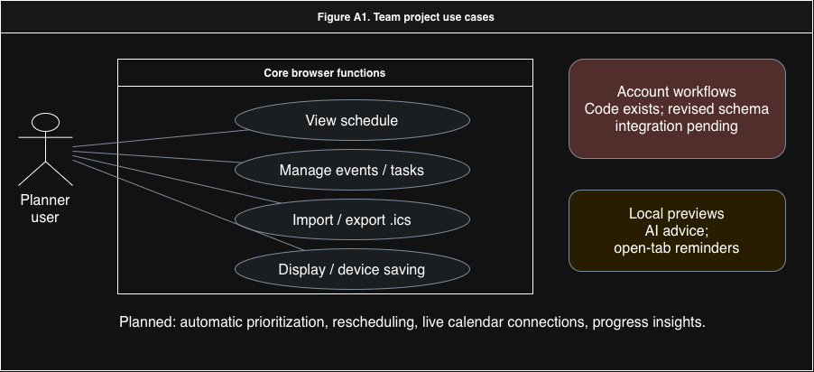Figure A1. Planner use cases
Figure A2. Application architecture
Static website delivery, browser storage, Supabase services, and local development previews.
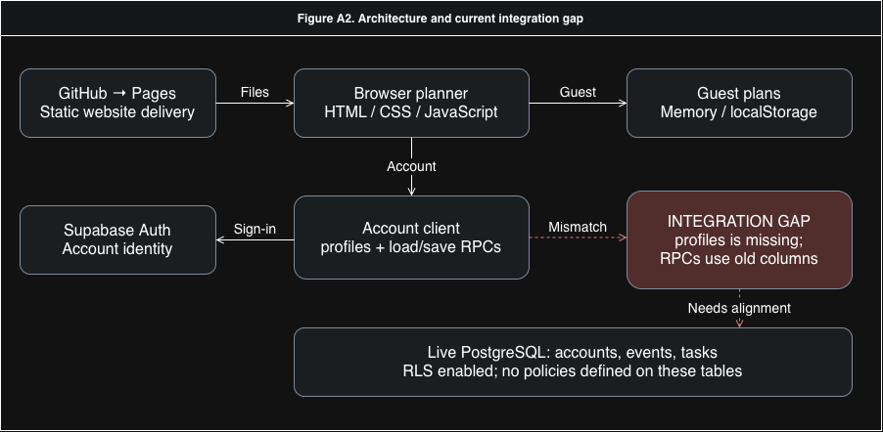Figure A2. Application architecture
Figure A3. Account data model
Relationships between authenticated accounts, profiles, events, and tasks. Timestamps and indexes are omitted for clarity.
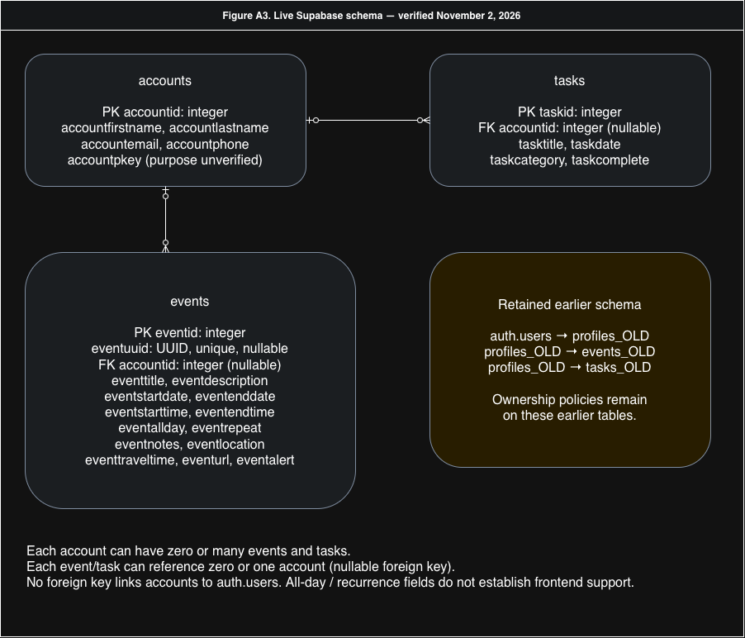Figure A3. Account data model

