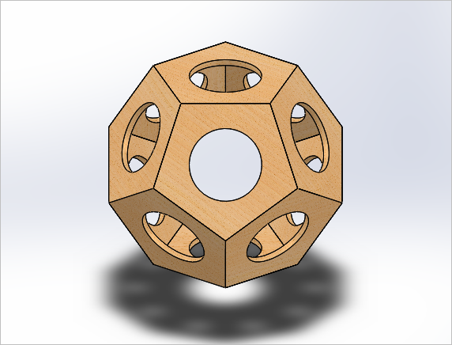

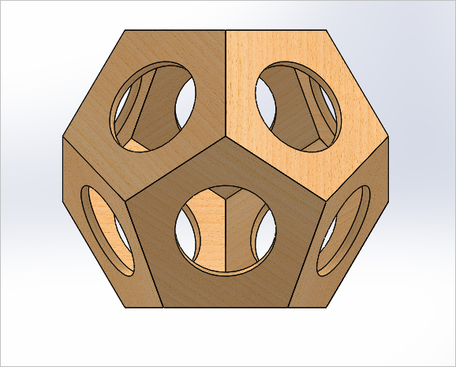

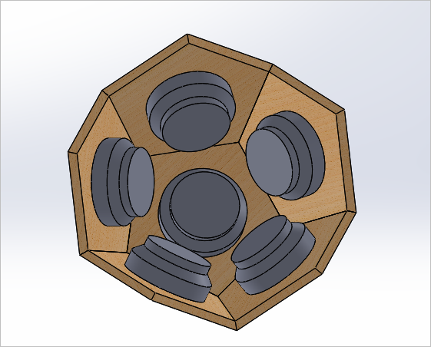

SolidWorks

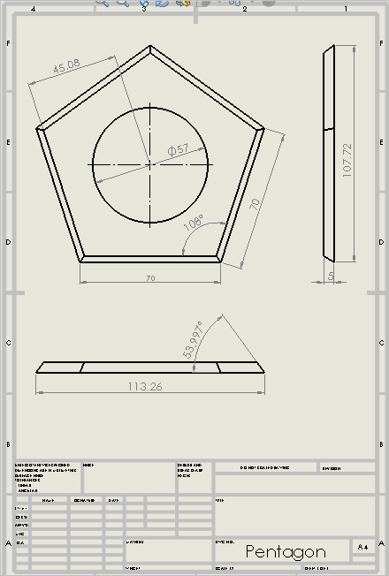

SolidWorks Drawing

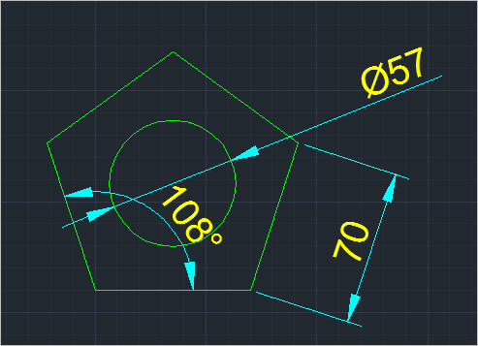

AutoCAD drawing single pentagon

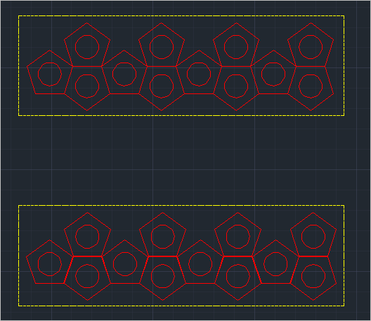

AutoCAD model for cutting: Lineweight 0.05, Red for cutter. Upper model: no spacing between cuts, Lower model: 1 mm spacing