|  |
| --- |
| VISVESVARAYA TECHNOLOGICAL UNIVERSITY    Jnana Sangama, Belagavi-590014, Karnataka      PROJECT SYNOPSIS ON    “PREDICTION OF CROP YIELD USING MACHINE LEARNING”    Submitted by    KAVANA R  (4UB22MC039)  Under the Guidance of    CHETAN KUMAR G S  Asst. Prof (Ad-hoc)  Department of MCA  UBDTCE, DAVANGERE      Department of Master of Computer Applications  UNIVERSITY B.D.T COLLEGE OF ENGINEERING,  DAVANGERE-577 004 |

|  |
| --- |
| CONTENTS     1. INTRODUCTION 2. OBJECTIVES 3. HARDWARE AND SOFTWARE REQUIREMENTS 4. METHODOLOGY 5. MODULES DESCRIPTION 6. CONCLUSION 7. REFERENCES |

1. INTRODUCTION

Agriculture is the most important sector of Indian Economy. Indian agriculture sector accounts

But latest studies have shown a steady decline in the contribution made by agriculture to the Indian economy although it is demographically the broadest economic sector and plays a significant role in the overall socio-economic fabric of India. Agricultural researchers insist on the need for an efficient mechanism to predict and improve the crop growth. Majority of research works in agriculture focus on biological mechanisms to identify crop growth and improve its yield. The outcome of crop yield primarily depends on parameters such as variety of crop, seed type and environmental parameters such as sunlight (Temperature), soil (ph.), water (ph.), rainfall and humidity. By analysing the soil and atmosphere at particular region best crop in order to have more crop yield and the net crop yield can be predicted. India is a highly populated country and randomly change in the climatic conditions need to secure the world food resources. Farmers face serious problems in drought conditions. Type of soil plays a major role in the crop yield. Suggesting the use of fertilizers may help the farmers to make the best decision for their cropping situation. Here the number of studies that Information and Communication Technology (ICT) can be applied for prediction of crop yield. By fully analyse the previous data we can suggest the farmer for a better crop for the better yield. Different Data mining techniques were used to predict the crop yield for maximizing the crop productivity Accurate and timely monitoring of agricultural crop conditions and estimating potential crop yields are essential processes for operational programs. Because of the importance of predicting crop yield, the purpose of this study is to apply several forecasting methods for evaluating crop yield. Crop yield forecasting, which provides information for decision Makers.

1. OBJECTIVES

The objective is to predict the parameters such as sunlight (Temperature), soil(ph.), water(ph.), NPK, rainfall and humidity using IoT device. Provide the farmer with the yield 2of a crop based on land area, rainfall, temperature, and district using machine learning. Predict the future market price of crops by taking previous crop price and predicted yield data into consideration. To predict the crop price using multiple linear regression and random forest. Suggest the fertilizer to be used for better crop yield. Provide the farmer information about the crop growth rate in percentage. Provide the farmer all the forecasting details in the form of SMS through mobile phone.

1. HARDWARE AND SOFTWARE REQUIREMENTS:

|  |  |
| --- | --- |
| Computer | Intel Core i5 or AMD FX 8 core series with clock speed of 2.4 GHz or above |
| Memory RAM | Four GB |
| Hard Drive | 500 GB |
| Functioning System | Most recent Windows 64-bit version |

|  |  |
| --- | --- |
| Structure | A flask |
| Operating System | Windows XP/7 or above |
| Programming language | Python |
| Software | Python 1.2 |

1. METHODOLOGY:

CROP YIELD PREDECTION

The outcome of crop yield primarily depends on parameters such as variety of crop, seed type and environmental parameters such as sunlight (Temperature), soil (ph), water (ph), rainfall and humidity shown in below figure.

FERTILIZER PREDICTION

Based on soil type and soil PH we suggest what kind of fertilizer should be used for particular crop.

RANDOM FOREST

We can see it from its name, which is to create a forest by some way and make it random. There is a direct relationship between the number of trees in the forest and the results it could get the larger the number of trees, the more accurate the result.

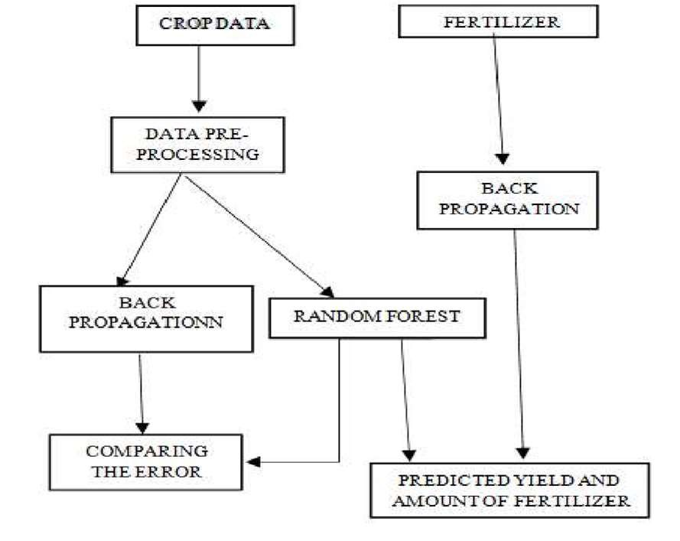

Fig: Methodology

5. MODULES DESCRIPTION:

Dataset Training

Data patterns are recognized in this module, and correlations between various factors are calculated.

Learning Algorithm Training

After getting the user input these predictions algorithms give the correct output based on the previously available trained data and the range of the parameters.

IoT Sensor

The Third module uses the measured data and uses functionalities to fetch the data from cloud platforms using IoT Sensors which can be directly used for input rather than the

Final prediction

It is the final part of the application in which results are provided to the users based on the comparison of parameters entered.

Fig: Working of Crop prediction

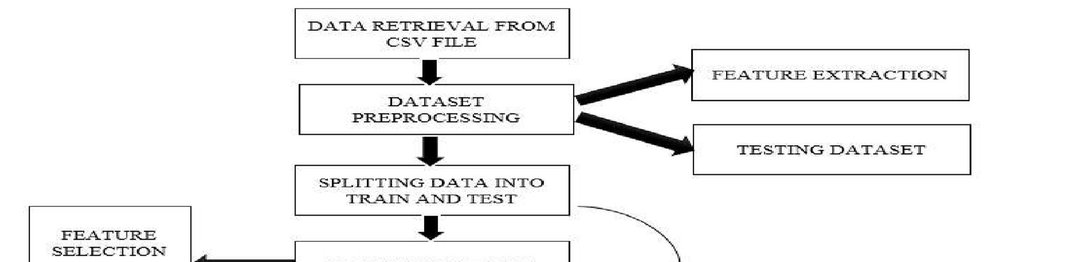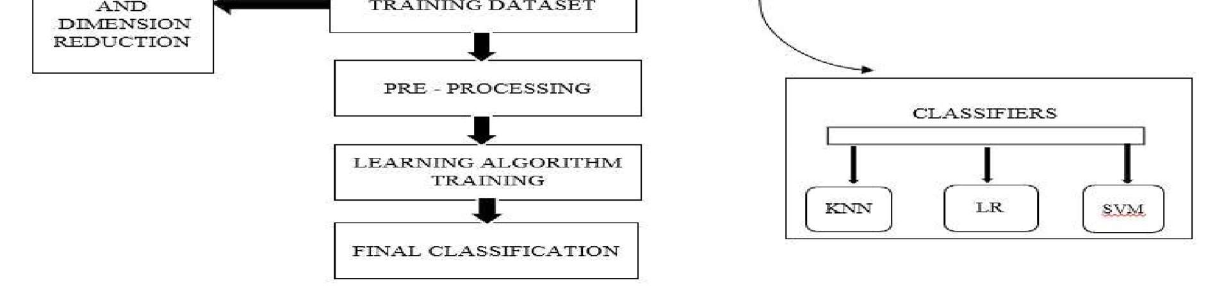

1. CONCLUSION:

Crop yield prediction and efficient utilization of fertilisers is victoriously anticipated and effective algorithm is also established from both the algorithm and acquired the great efficient result of the harvest. Here, we can see that proposed system for Smart Management of Crop Cultivation using IoT and Machine Learning a smart system that can assist farmers in crop management by considering sensed parameters (temperature, humidity) and other parameters (soil type, rainfall) that predicts the most suitable crop to grow in that environment. Overall, crop prediction using ML and IoT holds immense potential to revolutionize agriculture by empowering farmers with real-time data, precise decisionmaking, and improved productivity, ultimately contributing to global food security and sustainable farming practices.

1. REFERENCES

1. Li, L.; Wang, B.; Feng, P.; Liu, D.L.; He, Q.; Zhang, Y.; Wang, Y.; Li, S.; Lu, X.; Yue, C.; et al. Developing machine learning models with multi-source environmental data to predict wheat yield in China. Comput. Electron. Agric. 2022, 194, 106790

1. van Klompenburg, T.; Kassahun, A.; Catal, C. Crop yield prediction using machine learning: A systematic literature review. Comput. Electron. Agric. 2020, 177, 105709.

1. Kuradusenge, M.; Hitimana, E.; Hanyurwimfura, D.; Rukundo, P.; Mtonga, K.; Mukasine, A.; Uwitonze, C.; Ngabonziza, J.; Uwamahoro, A. Crop Yield Prediction Using Machine Learning Models: Case of Irish Potato and Maize. Agriculture 2023, 13, 225

1. Xu, W.; Kaili, Z.; Tianlei, W. Smart Farm Based on Six-Domain Model. In Proceedings of the IEEE 4th International Conference on Electronics Technology (ICET), Chengdu, China, 7–10 May 2021; pp. 417–421.