Progress Test 2

-------------------------------------------------------------------------------------------------------------------------------

Q1)

[Program]

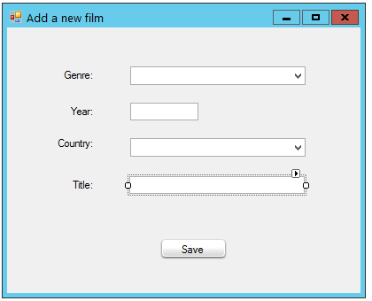

txtYear

cboCountryCode

cboGenreID

txtTitle

btnSave

public partial class Form1 : Form

{

string strConn = @"server = localhost; database = cinema; integrated security=true";

public Form1()

{

InitializeComponent();

// Gan du lieu tu bang Genres cho cboGenreID

// Hien Name, lay gia tri la GenreID va sap xep theo Name

DataView dv = new DataView(selectDS().Tables[0]);

A

dv.Sort = "Name";

cboGenreID.DataSource = dv;

cboGenreID.DisplayMember = "Name";

cboGenreID.ValueMember = "GenreID";

// Gan du lieu tu bang Countries cho cboCountryCode

// Hien CountryName, lay gia tri la CountryCode va sap xep theo CountryName

DataView dv1 = new DataView(selectDS().Tables[1]);

B

dv1.Sort = "CountryName";

cboCountryCode.DataSource = dv1;

cboCountryCode.DisplayMember = "CountryName";

cboCountryCode.ValueMember = "CountryCode";

}

private DataSet selectDS()

{

SqlConnection conn = new SqlConnection(strConn);

C

SqlCommand cmd = new SqlCommand("select * from genres; select * from countries", conn);

SqlDataAdapter da = new SqlDataAdapter();

da.SelectCommand = cmd;

DataSet ds = new DataSet();

da.Fill(ds);

return ds;

}

private void btnSave_Click(object sender, EventArgs e)

{

int year;

D

try

{

year = int.Parse(txtYear.Text);

}

catch

{

MessageBox.Show("Year must be integer!");

return;

}

if (txtTitle.Text == "")

{

MessageBox.Show("Title required!");

return;

}

SqlConnection conn = new SqlConnection(strConn);

E

SqlCommand cmd = new SqlCommand("insert into films(genreID, year, countryCode, title) " +

"values(@genreID, @year, @countryCode, @title)", conn);

cmd.Parameters.AddWithValue("@genreID", int.Parese(cboGenreID.SelectedValue));

cmd.Parameters.AddWithValue("@year", year);

cmd.Parameters.AddWithValue("@countryCode", cboCountryCode.SelectedValue);

cmd.Parameters.AddWithValue("@title", txtTitle.Text);

conn.Open();

cmd.ExecuteNonQuery();

conn.Close();

string info = "";

info += "A new film is added:\n";

info += "Genre:" + cboGenreID.Text + "\n";

info += "Year:" + txtYear.Text + "\n";

info += "Country:" + cboCountryCode.Text + "\n";

info += "Title:" + txtTitle.Text;

F

MessageBox.Show(info, "Information dialog");

}

}

Q2)

[Program]

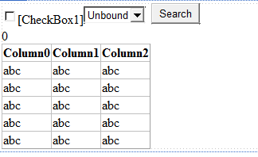

GridView1

Label1

Button1

DropDownList1

CheckBox1

public partial class WebForm1 : System.Web.UI.Page

{

protected void Page_Load(object sender, EventArgs e)

{

if (!IsPostBack)

{

DataView dv = new DataView(selectFilmsDS().Tables[0]);

A

dv.Sort = "Title";

DropDownList1.DataSource = dv;

DropDownList1.DataTextField = "Title";

DropDownList1.DataValueField = "FilmID";

DropDownList1.DataBind();

}

}

private DataSet selectFilmsDS()

{

string strConn = @"server = localhost; database = cinema; integrated security=true";

SqlConnection conn = new SqlConnection(strConn);

SqlDataAdapter da = new SqlDataAdapter("select * from films", conn);

DataSet ds = new DataSet();

da.Fill(ds);

return ds;

}

private DataSet selectShowsDS()

{

string strConn = @"server = localhost; database = cinema; integrated security=true";

B

SqlConnection conn = new SqlConnection(strConn);

SqlDataAdapter da = new SqlDataAdapter("SELECT shows.filmID, Name as Room, Title, ShowDate, Price, SlotStatus, Status " +

"FROM shows, Rooms, Films WHERE shows.roomID = rooms.roomID and shows.filmID = films.filmID", conn);

DataSet ds = new DataSet();

da.Fill(ds);

return ds;

}

protected void Button1_Click(object sender, EventArgs e)

{

DataView dv = new DataView(selectShowsDS().Tables[0]);

C

if (CheckBox1.Checked)

{

dv.RowFilter = "filmID = " + DropDownList1.SelectedValue;

}

GridView1.DataSource = dv;

GridView1.DataBind();

}

protected void GridView1_RowDataBound(object sender, GridViewRowEventArgs e)

{

if (e.Row.RowType == DataControlRowType.DataRow || e.Row.RowType == DataControlRowType.Header)

{

e.Row.Cells[0].Visible = false;

}

if (e.Row.RowType == DataControlRowType.DataRow)

{

D

e.Row.Cells[3].Text = DateTime.Parse(e.Row.Cells[3].Text).ToString("dd/MM/yyyy");

}

}

protected void GridView1_DataBound(object sender, EventArgs e)

{

Label1.Text = "";

Label1.Text += "Number of shows: " + GridView1.Rows.Count;

if (CheckBox1.Checked)

{

E

Label1.Text += " (Available:" + selectShowsDS().Tables[0].Compute("COUNT(filmID)"

, "filmID =" + DropDownList1.SelectedValue + " AND status = false");

Label1.Text += ",Closed:" + selectShowsDS().Tables[0].Compute("COUNT(filmID)"

, "filmID =" + DropDownList1.SelectedValue + " AND status = true") + ")";

}

else

{

F

Label1.Text += " (Available:" + selectShowsDS().Tables[0].Compute("COUNT(filmID)", "status = false");

Label1.Text += ",Closed:" + selectShowsDS().Tables[0].Compute("COUNT(filmID)", "status = true") + ")";

}

}

}