Progress Test 2

-------------------------------------------------------------------------------------------------------------------------------

Q1)

[Program]

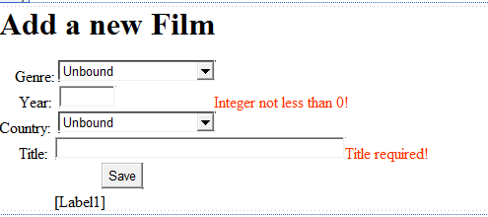

Label1

Button1

DropDownList2

TextBox2

TextBox1

DropDownList1

public partial class WebForm1 : System.Web.UI.Page

{

protected void Page_Load(object sender, EventArgs e)

{

if (!IsPostBack)

{

// Gan du lieu tu bang Genres cho DropDownList1

// Hien Name, lay gia tri la GenreID va sap xep theo Name

DataView dv = new DataView(selectDS().Tables[0]);

A

DropDownList1.DataSource = dv;

dv.Sort = "Name";

DropDownList1.DataTextField = "Name";

DropDownList1.DataValueField = "GenreID";

DropDownList1.DataBind();

// Gan du lieu tu bang Countries cho DropDownList2

// Hien Title, lay gia tri la CountryCode va sap xep theo Title

DataView dv1 = new DataView(selectDS().Tables[1]);

B

DropDownList2.DataSource = dv1;

dv1.Sort = "CountryName";

DropDownList2.DataTextField = "CountryName";

DropDownList2.DataValueField = "CountryCode";

DropDownList2.DataBind();

}

}

private DataSet selectDS()

{

string strConn = @"server=localhost; database=cinema; integrated security=true";

C

SqlConnection conn = new SqlConnection(strConn);

SqlCommand cmd = new SqlCommand("select * from genres; select * from countries", conn);

SqlDataAdapter da = new SqlDataAdapter();

da.SelectCommand = cmd;

DataSet ds = new DataSet();

da.Fill(ds);

return ds;

}

protected void Button1_Click(object sender, EventArgs e)

{

string strConn = @"server=localhost; database=cinema; integrated security=true";

D

SqlConnection conn = new SqlConnection(strConn);

SqlCommand cmd = new SqlCommand("insert into films(genreID, year, countryCode, Title) "+

"Values(@genreID, @year, @countryCode, @Title)", conn);

cmd.Parameters.AddWithValue("@GenreID", int.Parse(DropDownList1.SelectedValue));

cmd.Parameters.AddWithValue("@year", int.Parse(TextBox1.Text));

cmd.Parameters.AddWithValue("@CountryCode", DropDownList2.SelectedValue);

cmd.Parameters.AddWithValue("@Title", TextBox2.Text);

conn.Open();

cmd.ExecuteNonQuery();

conn.Close();

Label1.Text = "A new film is added!";

}

}

Q2)

[Program]

button1

comboBox1

checkBox1

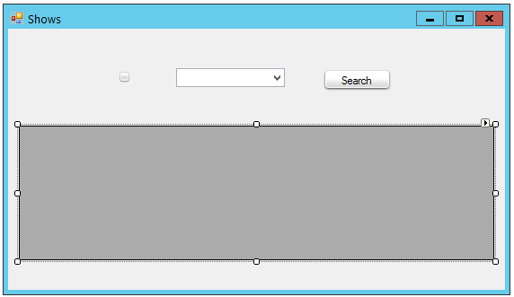

label1

dataGridView1

public partial class Form1 : Form

{

public Form1()

{

InitializeComponent();

DataView dv = new DataView(selectFilmsDS().Tables[0]);

A

dv.Sort = "Title";

comboBox1.DataSource = dv;

comboBox1.DisplayMember = "Title";

comboBox1.ValueMember = "FilmID";

}

private DataSet selectFilmsDS()

{

string strConn = @"server = localhost; database = cinema; integrated security=true";

B

SqlConnection conn = new SqlConnection(strConn);

SqlDataAdapter da = new SqlDataAdapter("select * from films", conn);

DataSet ds = new DataSet();

da.Fill(ds);

return ds;

}

private DataSet selectShowsDS()

{

string strConn = @"server = localhost; database = cinema; integrated security=true";

C

SqlConnection conn = new SqlConnection(strConn);

SqlDataAdapter da = new SqlDataAdapter("SELECT shows.filmID, Name as Room, Title, ShowDate, Price, SlotStatus, Status " +

"FROM shows, Rooms, Films WHERE shows.roomID = rooms.roomID and shows.filmID = films.filmID", conn);

DataSet ds = new DataSet();

da.Fill(ds);

return ds;

}

private void button1_Click(object sender, EventArgs e)

{

DataView dv = new DataView(selectShowsDS().Tables[0]);

D

if (checkBox1.Checked)

dv.RowFilter = "filmID = " + comboBox1.SelectedValue;

dataGridView1.DataSource = dv;

}

private void dataGridView1_DataBindingComplete(object sender, DataGridViewBindingCompleteEventArgs e)

{

E

dataGridView1.Columns["FilmID"].Visible = false;

dataGridView1.Columns["ShowDate"].DefaultCellStyle.Format = "dd/MM/yyy";

label1.Text = "Number of shows:" + dataGridView1.Rows.Count;

if (checkBox1.Checked)

F

label1.Text +=

"(Available:" + selectShowsDS().Tables[0].Compute("COUNT(filmID)", "filmID = " + comboBox1.SelectedValue + " AND status = false") +

",Closed:" + selectShowsDS().Tables[0].Compute("COUNT(filmID)", "filmID = " + comboBox1.SelectedValue + " AND status = true") +

")";

else

G

label1.Text +=

" (Available:" + selectShowsDS().Tables[0].Compute("COUNT(filmID)", "status = false") +

",Closed:" + selectShowsDS().Tables[0].Compute("COUNT(filmID)", "status = true") +

")";

}

}