**==========================================================**

**Web application based on Web services**

**Lab 4 (week 7, 8)**

# Goals:

The goal of Lab 4 is to develop a Web Application “Library system” with the given database “Library”.

# System description:

Your Library system must have the following functions:

1. Register members (add/edit/delete)
2. Register books and its copies (add/edit/delete)
3. Borrow a copy
4. Return a copy
5. Reserve a book

All requirements are described in document “List of sample projects”

# Sample web pages:

## 3.1. Home page

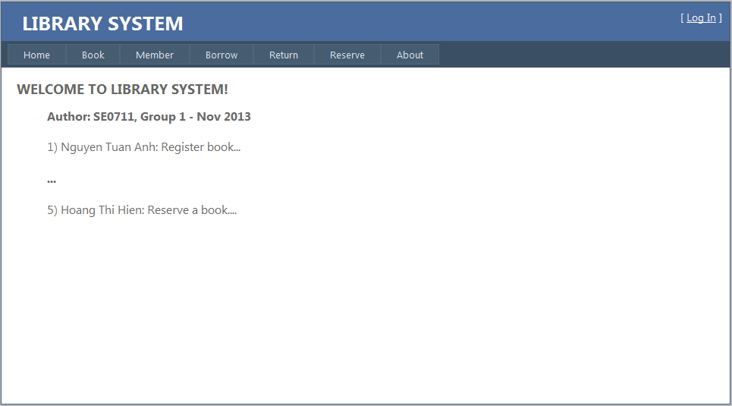

Requirements: Display name of class, group number and the list of members

## 3.2. Register books and copies

Interface Flow Diagram is shown as below

[Click Copies]

[Click Add]

[Click Edit]

[Click Edit]

[Click Add]

Add a copy

Edit a copy

List of copies

Edit a book

Add a book

List of books

(3.2

### 3.2.1. List of books

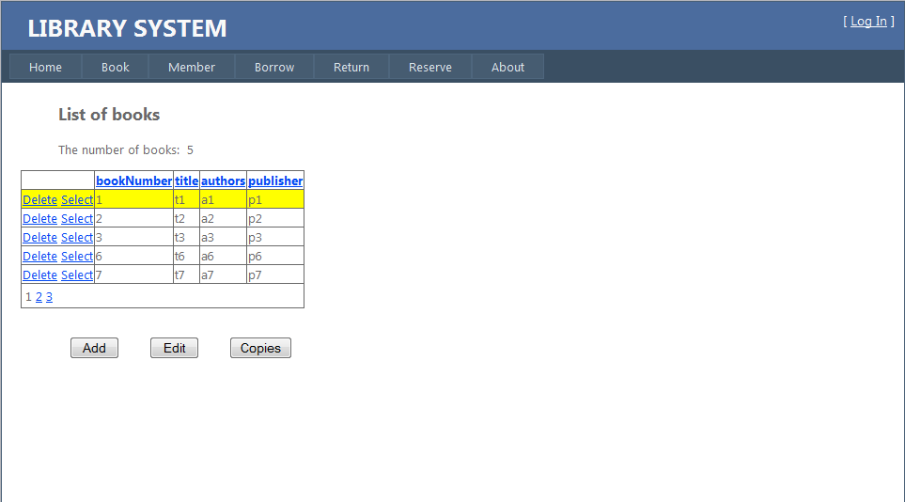

Requirements:

1. Enable sorting and paging in GridView
2. The user can:
   1. Add a new book by clicking button “Add”. The “Add a book” page will be displayed.
   2. Delete a book by clicking “Select”, then clicking “Delete”
   3. Edit a book by by clicking “Select”, then click button “Edit”. The “Edit a book” page will be displayed.
   4. List all copies of a book by clicking “Select”, then click button “Copies”. The “List of copies” page will be displayed

### 3.2.2. Add a book

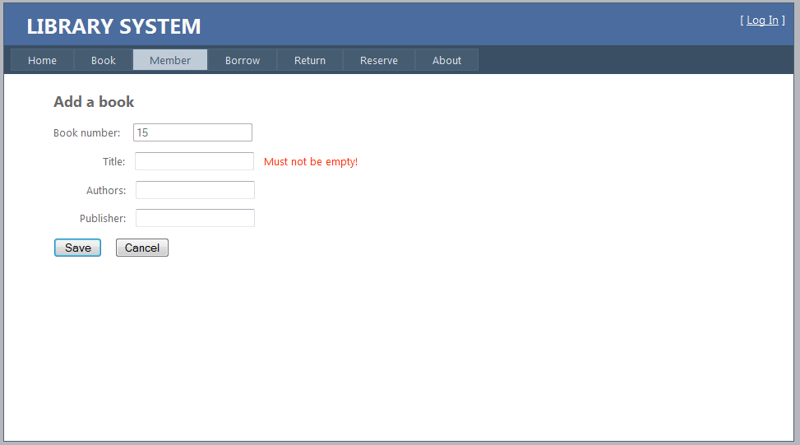

Requirements:

1. Validate data entered by the user:
   1. The title of book must not be empty
   2. The number of characters of all fields must not be greater than in database
2. Book number is generated by the system and the user can enter the remaining information and can:
3. Add this new book by clicking “Save” button. If it is successfully, the “List of books ” page will be displayed back, otherwise errors will be displayed.
4. Cancel adding by clicking “Cancel” button, then the “List of books” page will be displayed back

### Edit a book

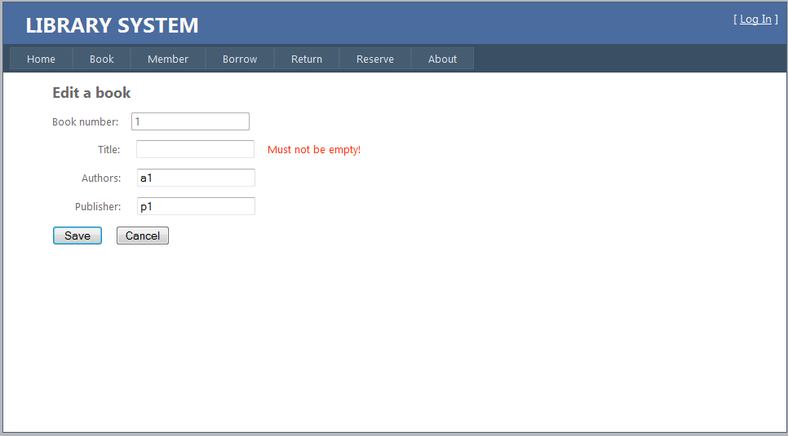

Requirements:

1. Validate data entered by the user:
2. The title of book must not be empty
3. The number of characters of all fields must not be greater than in database
4. The user can edit the book’s information (except book number) and can:
5. Update this book by clicking “Save” button. If it is successfully, the “List of books ” page will be displayed back, otherwise errors will be displayed.
6. Cancel editing by clicking “Cancel” button, then the “List of books” page will be displayed back

### List of copies

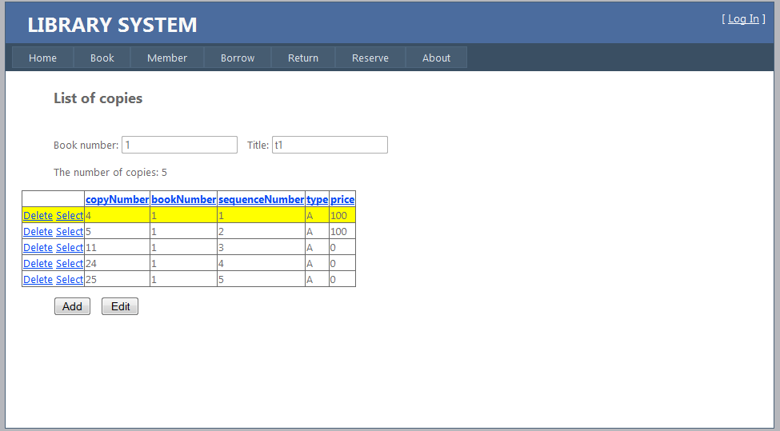

Requirements:

1. Enable sorting and paging in GridView
2. The user can:
   1. Add a new copy by clicking button “Add”. The “Add a copy” page will be displayed.
   2. Delete a copy by clicking “Select”, then click “Delete”
   3. Edit a copy by by clicking “Select”, then click button “Edit”. The “Edit a copy” page will be displayed.

### Add a copy

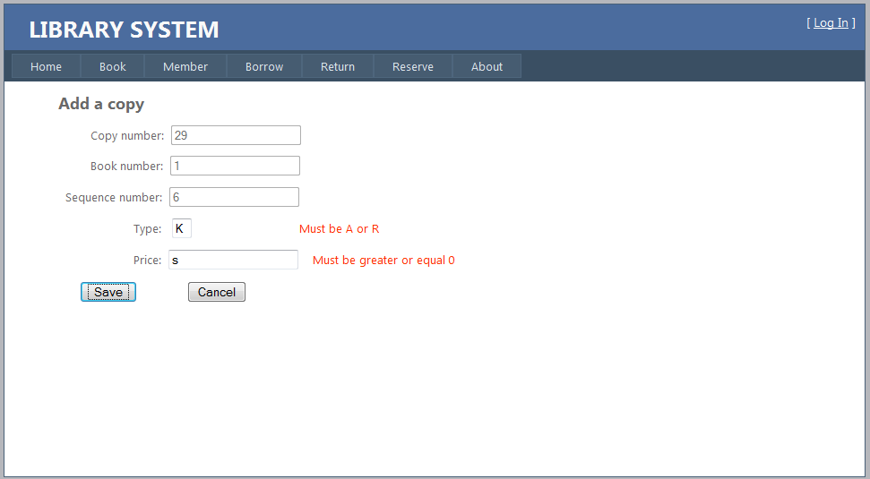

Requirements:

1. Validate data entered by the user:
   1. The Type of copy must be A or R, and the Price must be double >= 0.
   2. The number of characters of all fields must not be greater than in database
2. Copy number, book number, and sequence number are generated by the system and the user can enter the remaining information and can:
3. Add this new copy by clicking “Save” button. If it is successfully, the “List of copies ” page will be displayed back, otherwise errors will be displayed.
4. Cancel adding by clicking “Cancel” button, then the “List of copies” page will be displayed back

### Edit a copy

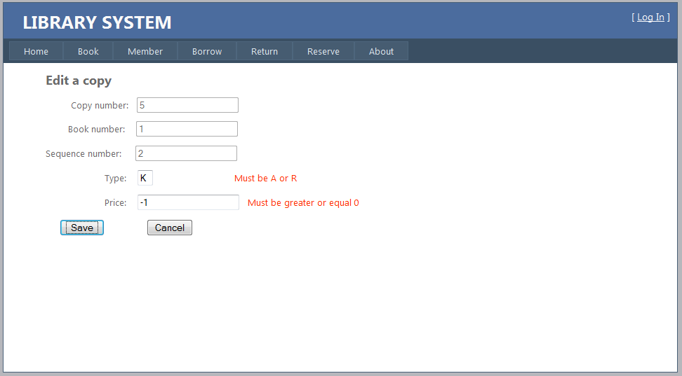

1. Validate data entered by the user:
   1. The Type must not be A or R, and the Price must be double and >= 0.
   2. The number of characters of all fields must not be greater than in database
2. The user can enter the copy’s information (except copy number, book number, and sequence number) and can:
3. Update this copy by clicking “Save” button. If it is successfully, the “List of copies ” page will be displayed back, otherwise errors will be displayed.
4. Cancel editing by clicking “Cancel” button, then the “List of copies” page will be displayed back

## Register members

### List of members

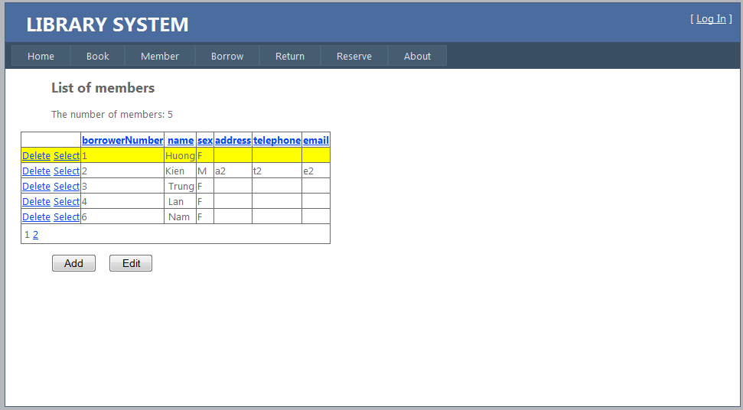

Requirements:

1. Enable sorting and paging in GridView
2. The user can:
3. Add a new member by clicking button “Add”. The “Add a member” page will be displayed.
4. Delete a member by clicking “Select”, then click “Delete”
5. Edit a member by by clicking “Select”, then click button “Edit”. The “Edit a member” page will be displayed.

### Add a member

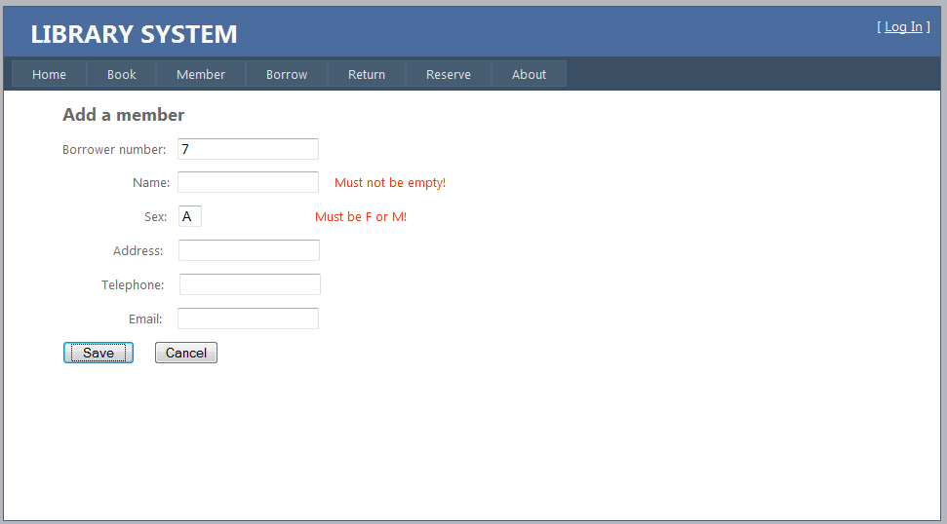

Requirements:

1. Validate data entered by the user:
   1. The Name must not be empty, and the Sex must be F or M.
   2. The number of characters of all fields must not be greater than in database
2. Borrower number is generated by the system and the user can enter the remaining information and can:
   1. Add this new member by clicking “Save” button. If it is successfully, the “List of members ” page will be displayed back, otherwise errors will be displayed.
   2. Cancel adding by clicking “Cancel” button, then the “List of members” page will be displayed back .

### Edit a member

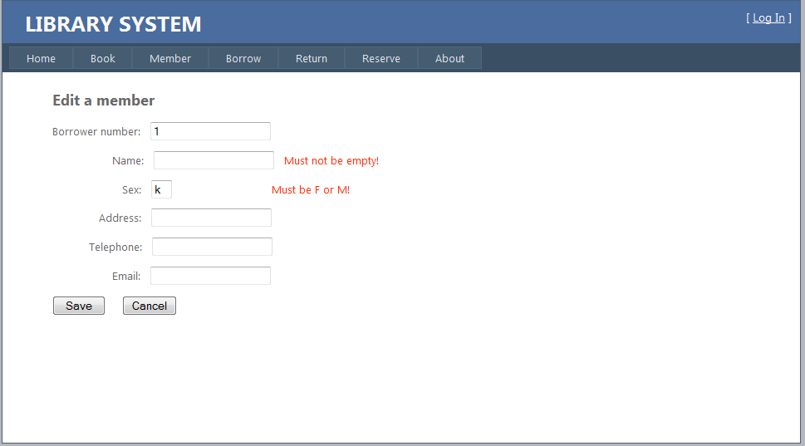

Requirements:

1. Validate data entered by the user:
   1. The Name must not be empty, and the Sex must be F or M.
   2. The number of characters of all fields must not be greater than in database
2. The user can edit the member’s information (except the borrower number) and can:
   1. Update this member by clicking “Save” button. If it is successfully, the “List of members” page will be displayed back, otherwise errors will be displayed.
   2. Cancel editing by clicking “Cancel” button, and then the “List of members” page will be displayed back.

### Borrow a copy

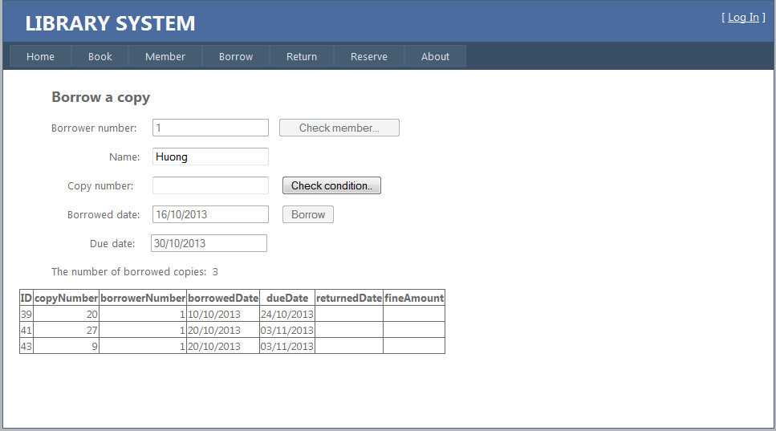

Requirements:

1. Check member by entering borrower number, then click button “Check member”:
   1. If this member is existed in Database, his/her name and the list of borrowed copies will be displayed and the user can move to step 2).
   2. If this member number is not existed in Database, error message will be displayed.
2. Check condition by entering copy number, then click button “Check condition”:
   1. If all condition described in requirements are satisfied, the user can move to step 3).
   2. If any condition is not satisfied, error message will be displayed.
3. Borrow this copy by entering the borrowed date (format is ‘’dd/MM/yyyy”), then click “Borrow” button.

## Return a copy

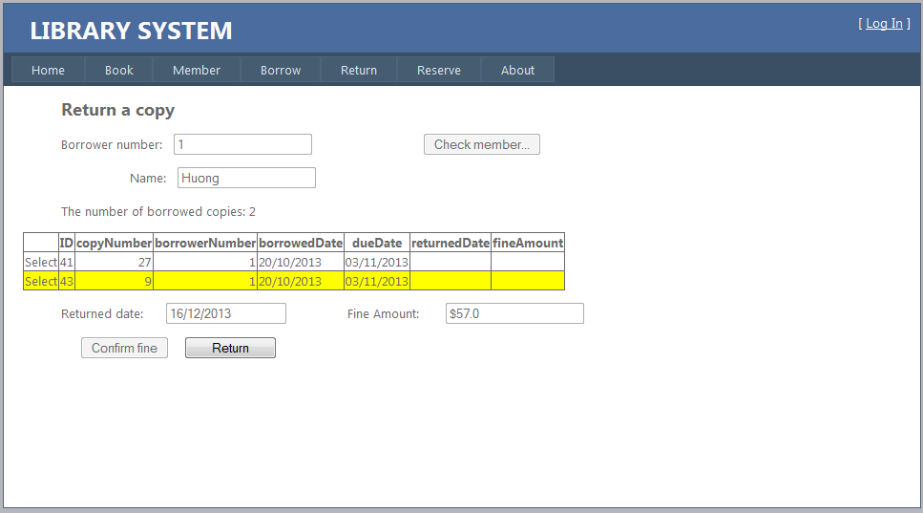

Requirements:

1. Check member by entering borrower number, then click button “Check member”:
   1. If this member is existed in Database, his/her name and the list of borrowed copies will be displayed and the user can move to step 2).
   2. If this member number is not existed in Database, error message will be displayed.
2. Calculate fine amount by clicking “Select”, enter returned date (format is “dd/MM/yyyy”), then click button “Confirm fine”:
   1. If the date format is correct, fine amount will be calculated and displayed in currency format, then the user can move to step 3).
   2. If the date format is not correct, error message will be displayed.
3. Return this copy by clicking “Return” button.

## Reserve a book

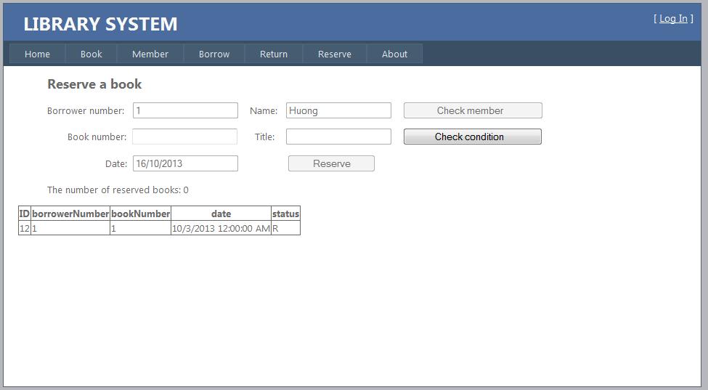

Requirements:

1. Check member by entering borrower number, then click button “Check member”:
   1. If this member is existed in Database, his/her name and the list of his/her reservations will be displayed and the user can move to step 2).
   2. If this member number is not existed in Database, error message will be displayed.
2. Check condition by entering book number, then click button “Check condition”:
   1. If all condition described in requirements are satisfied, the user can move to step 3).
   2. If any condition is not satisfied, error message will be displayed.
3. Reserve this book by entering the date (format is ‘’dd/MM/yyyy”), then click “Reserve” button.

# References:

1. How to use ObjectDataSource: http://msdn.microsoft.com/en-us/library/aa581783.aspx
2. Align right numerical values in GridView in ASP.NET: <http://blog.gsmodi.com/2010/11/aspnet-gridview-align-right-numerical.html>
3. Format date column in GridView: <http://forums.asp.net/t/1399403.aspx>
4. Converting HTML special characters in ASP.NET: <http://stackoverflow.com/questions/11336801/converting-html-special-characters-in-asp-net>
5. Change GridView selected row background color in asp.net: Set property BackColor of SelectedRowStyle in GridView to Yellow
6. [Get connection string using app.config file in C#](http://stackoverflow.com/questions/8707763/get-connection-string-using-app-config-file-in-c-sharp):

http://stackoverflow.com/questions/8707763/get-connection-string-using-app-config-file-in-c-sharp

# Note:

* + **Solution name:** Lab4_GroupN, where N = 1, or 2…
  + **File name** : ClassID_GroupN_Lab4.zip, where:
    - ClassID = SE0715, or SE0714…
    - N = 1 or 2…
  + **Connect string to connect Database must be:**

“Server = localhost; Database = Library; Integrated Security = true”