TaiLM

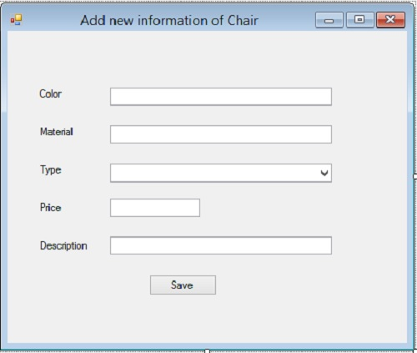

using System;

using System.Collections.Generic;

using System.ComponentModel;

using System.Data;

using System.Drawing;

using System.Linq;

using System.Text;

using System.Windows.Forms;

using System.Data.SqlClient;

namespace Question1

{

public partial class Form1 : Form

{

public Form1()

{

InitializeComponent();

SqlConnection cn = new SqlConnection("Data Source=KHJ;Initial Catalog=Y12S2B2;Integrated Security=True");

cn.Open();

SqlDataAdapter da = new SqlDataAdapter("select * from ChairTypes order by TypeName ",cn);

DataSet ds = new DataSet();

da.Fill(ds);

cbType.DataSource = ds.Tables[0];

cbType.DisplayMember = "TypeName";

cbType.ValueMember = "TypeID";

}

private void btSave_Click(object sender, EventArgs e)

{

String color;

String material;

double price;

String description;

if (tbColor.Text == "")

{

MessageBox.Show("Please enter values into color");

}

else {

color = tbColor.Text;

if (tbMaterial.Text == "") {

MessageBox.Show("Please enter values into Material");

}

else{

material = tbMaterial.Text;

if (tbPrice.Text == "")

{

MessageBox.Show("Please enter values into Price");

}

else {

try

{

price = double.Parse(tbPrice.Text);

if (price <= 0) {

Exception ex = new Exception("Please enter price>0");

throw ex;

}

if (tbDescription.Text == "")

{

MessageBox.Show("Please enter values into Description");

}

else

{

try

{

description = tbDescription.Text;

SqlConnection cn = new SqlConnection("Data Source=localhost;Initial Catalog=Y12S2B2;Integrated Security=True");

string sqlcmd = string.Format("insert into Chairs values('{0}','{1}',{2},{3},'{4}')", color, material, int.Parse(cbType.SelectedValue.ToString()), price, description);

SqlCommand cmd = new SqlCommand(sqlcmd, cn);

cn.Open();

cmd.ExecuteNonQuery();

cn.Close();

MessageBox.Show("New information of Chair is added");

}

catch (Exception ex)

{

MessageBox.Show(ex.Message);

}

}

}

catch (Exception ex) {

MessageBox.Show("Price : "+ex.Message);

}

}

}

}

}

}

}

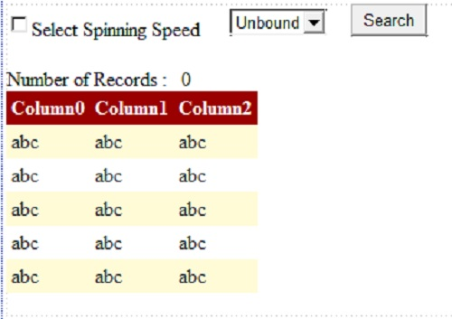

using System;

using System.Collections.Generic;

using System.Linq;

using System.Web;

using System.Web.UI;

using System.Web.UI.WebControls;

using System.Data.SqlClient;

using System.Data;

using System.Windows.Forms;

namespace Question2

{

public partial class Main : System.Web.UI.Page

{

protected void Page_Load(object sender, EventArgs e)

{

if (!IsPostBack) {

Label1.Visible = false;

tbNumber.Visible = false;

SqlConnection cn = new SqlConnection("Data Source=localhost;Initial Catalog=Y12S2B2;Integrated Security=True");

cn.Open();

SqlDataAdapter da = new SqlDataAdapter("select distinct SpinningSpeed from Washers", cn);

DataSet ds = new DataSet();

da.Fill(ds);

DropDownListSpeed.DataSource = ds.Tables[0];

DropDownListSpeed.DataTextField = "SpinningSpeed";

DropDownListSpeed.DataValueField = "SpinningSpeed";

DropDownListSpeed.DataBind();

cn.Close();

}

}

protected void GridViewWashers_DataBound(object sender, EventArgs e)

{

tbNumber.Text = GridViewWashers.Rows.Count.ToString();

}

protected void btSearch_Click(object sender, EventArgs e)

{

Label1.Visible = true;

tbNumber.Visible = true;

SqlConnection cn2 = new SqlConnection("Data Source=localhost;Initial Catalog=Y12S2B2;Integrated Security=True");

SqlDataAdapter da2 = new SqlDataAdapter("select washers.washerTypeID,Model, MakerName,capacity,spinningSpeed,price from Washers,washerTypes,makers where washers.washerTypeID=washerTypes.washerTypeID and washers.makerID = makers.makerID order by SpinningSpeed", cn2);

DataSet ds2 = new DataSet();

da2.Fill(ds2);

DataView dw = new DataView(ds2.Tables[0]); ;

if (CheckBoxSelect.Checked)

{

dw.RowFilter = "SpinningSpeed = '" + DropDownListSpeed.SelectedValue.ToString()+"'";

GridViewWashers.DataSource = dw;

GridViewWashers.DataBind();

}

else

{

GridViewWashers.DataSource = dw;

GridViewWashers.DataBind();

}

cn2.Close();

}

}

}

**KhanhDN**

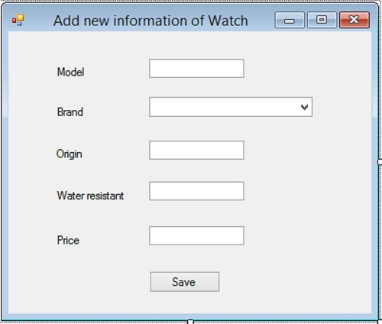

using System;

using System.Collections.Generic;

using System.ComponentModel;

using System.Data;

using System.Drawing;

using System.Linq;

using System.Text;

using System.Windows.Forms;

using System.Data.SqlClient;

namespace Q1

{

public partial class Form1 : Form

{

public Form1()

{

InitializeComponent();

try

{

DataSet ds = new DataSet();

String con = "server=localhost;database=Y12S2B3; Integrated Security = true";

SqlConnection cn = new SqlConnection(con);

SqlCommand cmd = new SqlCommand("select * from Brands order by BrandName", cn);

cn.Open();

SqlDataAdapter da = new SqlDataAdapter(cmd);

da.Fill(ds);

cn.Close();

cbBrand.DataSource = ds.Tables[0];

cbBrand.DisplayMember = "BrandName";

cbBrand.ValueMember = "BrandID";

}

catch (Exception)

{

return;

}

}

private void btSave_Click(object sender, EventArgs e)

{

Boolean check = true;

if (tbModel.Text.Length == 0)

{

MessageBox.Show("input value to Model textbox");

check = false;

}

if (tbOrigin.Text.Length == 0)

{

MessageBox.Show("input value to Origin textbox");

check = false;

}

if (tbWater.Text.Length == 0)

{

MessageBox.Show("input value to Water resistant textbox");

check = false;

}

if (tbPrice.Text.Length == 0)

{

MessageBox.Show("input value to Price textbox");

check = false;

}

try

{

double price = double.Parse(tbPrice.Text);

if (price <= 0)

{

MessageBox.Show("Price must be numeric and greater than 0");

check = false;

}

}

catch (Exception)

{

MessageBox.Show("Price must be numeric and greater than 0");

check = false;

}

if (check == true)

{

string strConn = "Server = localhost; database =Y12S2B3; Integrated Security = true";

SqlConnection cn = new SqlConnection(strConn);

SqlCommand cmd = new SqlCommand("Insert into Watches(Model, BrandID, Origin, WaterResistant, Price) " +

"Values(@Model, @BrandID, @Origin, @WaterResistant, @Price)", cn);

cmd.Parameters.AddWithValue("@Model", tbModel.Text);

cmd.Parameters.AddWithValue("@BrandID", cbBrand.SelectedValue);

cmd.Parameters.AddWithValue("@Origin", tbOrigin.Text);

cmd.Parameters.AddWithValue("@WaterResistant", tbWater.Text);

cmd.Parameters.AddWithValue("@Price", double.Parse(tbPrice.Text));

cn.Open();

cmd.ExecuteNonQuery();

cn.Close();

MessageBox.Show("New information of Watch is added");

}

}

}

}

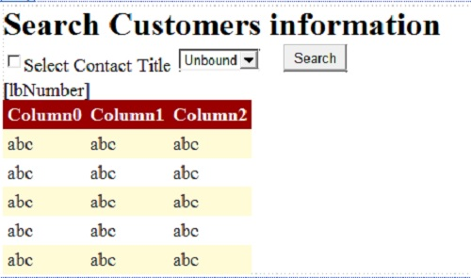

using System;

using System.Collections.Generic;

using System.Linq;

using System.Web;

using System.Web.UI;

using System.Web.UI.WebControls;

using System.Data.SqlClient;

using System.Data;

namespace Q2

{

public partial class Question2 : System.Web.UI.Page

{

protected void Page_Load(object sender, EventArgs e)

{

if (!IsPostBack)

{

string strConn = "Server = localhost; database = Y12S2B3; Integrated Security = true";

DataSet ds = new DataSet();

SqlConnection cn = new SqlConnection(strConn);

SqlCommand cmd = new SqlCommand("select * from ContactTitles order by ContactTitle", cn);

SqlDataAdapter da = new SqlDataAdapter(cmd);

da.Fill(ds);

ddContact.DataSource = ds.Tables[0];

ddContact.DataTextField = "ContactTitle";

ddContact.DataValueField = "ContactTitleID";

ddContact.DataBind();

}

}

protected void btSearch_Click(object sender, EventArgs e)

{

if (checkBox1.Checked == false)

{

try

{

DataSet ds = new DataSet();

string strConn = "Data Source=localhost;Initial Catalog=Y12S2B3;Integrated Security=True";

SqlConnection cn = new SqlConnection(strConn);

SqlDataAdapter da = new SqlDataAdapter("SELECT CustomerID, CompanyName, ContactName, ContactTitleID, Address, Phone, Fax" +

" FROM Customers ORDER BY ContactTitleID", cn);

da.Fill(ds);

DataView dv = new DataView(ds.Tables[0]);

gvContact.DataSource = dv;

gvContact.DataBind();

gvContact.Visible = true;

lbNumber.Text = "Number of Records: "+gvContact.Rows.Count.ToString();

}

catch (Exception)

{

return;

}

}

else

{

try

{

DataSet ds = new DataSet();

string strConn = "Data Source=localhost;Initial Catalog=Y12S2B3;Integrated Security=True";

SqlConnection cn = new SqlConnection(strConn);

SqlCommand cmd = new SqlCommand("SELECT CustomerID, CompanyName, ContactName, ContactTitleID, Address, Phone, Fax" +

" FROM Customers WHERE ContactTitleID=@ContactTitleID ORDER BY ContactTitleID", cn);

cmd.Parameters.AddWithValue("@ContactTitleID",ddContact.SelectedValue);

SqlDataAdapter da = new SqlDataAdapter(cmd);

da.Fill(ds);

DataView dv = new DataView(ds.Tables[0]);

gvContact.DataSource = dv;

gvContact.DataBind();

gvContact.Visible = true;

lbNumber.Text = "Number of Records: " + gvContact.Rows.Count.ToString();

}

catch (Exception)

{

return;

}

}

}

}

}

ANhNH

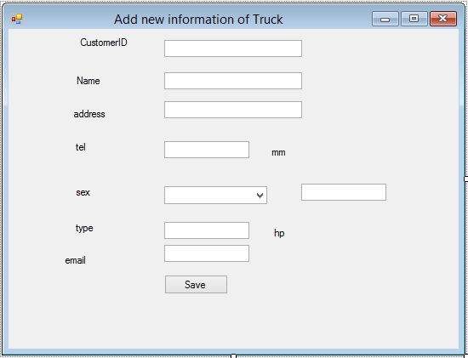

using System;

using System.Collections.Generic;

using System.ComponentModel;

using System.Data;

using System.Drawing;

using System.Linq;

using System.Text;

using System.Windows.Forms;

using System.Data.SqlClient;

namespace Question1

{

public partial class Form1 : Form

{

string strConn = "server=localhost;database=Y12S2B1; Integrated Security = true";

public Form1()

{

InitializeComponent();

SqlConnection cn = new SqlConnection(strConn);

SqlDataAdapter da = new SqlDataAdapter("select * from Cabs order by CabName", cn);

DataSet ds = new DataSet();

da.Fill(ds);

comboBox1.DataSource = ds.Tables[0];

comboBox1.DisplayMember = "CabName";

comboBox1.ValueMember = "CabID";

}

private void button1_Click(object sender, EventArgs e)

{

if (tb_Name.Text == "")

{

MessageBox.Show("Must input values for Name");

return;

}

if (tb_weight.Text == "")

{

MessageBox.Show("Must input values for Total weight");

return;

}

try

{

int wheel = Convert.ToInt32(tb_base.Text.Trim());

if (wheel <= 0)

{

MessageBox.Show("Wheel base must be number integer and greater than 0 !");

return;

}

}

catch

{

MessageBox.Show("Wheel base must be number integer and greater than 0 !");

return;

}

try

{

int engine = Convert.ToInt32(tb_Engine.Text.Trim());

if (engine <= 0)

{

MessageBox.Show("Engine must be number integer and greater than 0 !");

return;

}

}

catch

{

MessageBox.Show("Engine must be number integer and greater than 0 !");

return;

}

try

{

SqlConnection cn = new SqlConnection(strConn);

SqlCommand cmd = new SqlCommand("Insert into Trucks(TruckName,TotalWeight,Wheelbase,CabID,Engine)" +

"values(@TruckName,@TotalWeight,@Wheelbase,@CabID,@Engine)", cn);

cmd.Parameters.AddWithValue("@TruckName", tb_Name.Text);

cmd.Parameters.AddWithValue("@TotalWeight", tb_weight.Text);

cmd.Parameters.AddWithValue("@Wheelbase", tb_base.Text);

cmd.Parameters.AddWithValue("@CabID", int.Parse(comboBox1.SelectedValue.ToString()));

cmd.Parameters.AddWithValue("@Engine", tb_Engine.Text);

cn.Open();

cmd.ExecuteNonQuery();

cn.Close();

MessageBox.Show("New information of Truck is added");

}

catch (Exception ex)

{

MessageBox.Show(ex.Message);

}

}

}

}

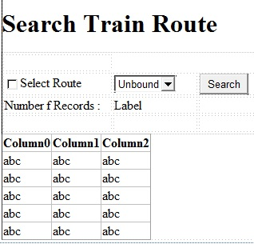

using System;

using System.Collections.Generic;

using System.Linq;

using System.Web;

using System.Web.UI;

using System.Web.UI.WebControls;

using System.Data;

using System.Data.SqlClient;

namespace Question2

{

public partial class WebForm1 : System.Web.UI.Page

{

DataView dv;

protected void Page_Load(object sender, EventArgs e)

{

if (!IsPostBack)

{

string strConn = "Server = localhost; database = Y12S2B1; Integrated Security = true";

DataSet ds = new DataSet();

SqlConnection cn = new SqlConnection(strConn);

SqlDataAdapter da = new SqlDataAdapter("select * from Routes order by RouteName", cn);

da.Fill(ds);

// Display Colors in DropDownList

DropDownList1.DataSource = ds.Tables[0];

DropDownList1.DataTextField = "RouteName";

DropDownList1.DataValueField = "RouteID";

DropDownList1.DataBind();

}

}

protected void GridView1_SelectedIndexChanged(object sender, EventArgs e)

{

}

protected void Button1_Click(object sender, EventArgs e)

{

string st = "select Routes.RouteName, TrainCodes.TrainCode,RailwayStations.StationName,TrainStops.ArrivalTime,TrainStops.DepartureTime from Routes join TrainCodes on Routes.RouteID=TrainCodes.RouteID join TrainStops on TrainStops.TrainCode=TrainCodes.TrainCode join RailwayStations on RailwayStations.StationID=TrainStops.StationID";

if (CheckBox1.Checked == false)

{

string strConn = "Server = localhost; database = Y12S2B1; Integrated Security = true";

DataSet ds = new DataSet();

SqlConnection cn = new SqlConnection(strConn);

SqlDataAdapter da = new SqlDataAdapter(st, cn);

da.Fill(ds);

DataTable dt = ds.Tables[0];

GridView1.DataSource = dt;

GridView1.DataBind();

Label2.Text = GridView1.Rows.Count.ToString();

}

else

{

int i = int.Parse(DropDownList1.SelectedValue.ToString());

string d = DropDownList1.SelectedItem.ToString();

string strConn = "Server = localhost; database = Y12S2B1; Integrated Security = true";

DataSet ds = new DataSet();

SqlConnection cn = new SqlConnection(strConn);

SqlDataAdapter da = new SqlDataAdapter(string.Format("select Routes.RouteName, TrainCodes.TrainCode,RailwayStations.StationName,TrainStops.ArrivalTime,TrainStops.DepartureTime from Routes join TrainCodes on Routes.RouteID=TrainCodes.RouteID join TrainStops on TrainStops.TrainCode=TrainCodes.TrainCode join RailwayStations on RailwayStations.StationID=TrainStops.StationID = '{0}'", i), cn);

da.Fill(ds);

DataTable dt = ds.Tables[0];

GridView1.DataSource = dt;

GridView1.DataBind();

}

}

}

}

TuanPM

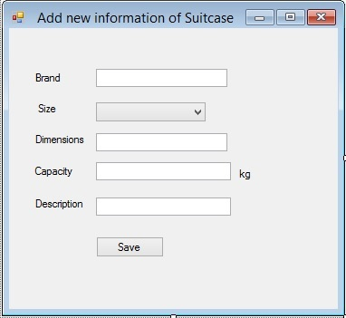

using System;

using System.Collections.Generic;

using System.ComponentModel;

using System.Data;

using System.Drawing;

using System.Linq;

using System.Text;

using System.Windows.Forms;

using System.Data.SqlClient;

namespace Question1

{

public partial class Form1 : Form

{

String strConn = "Data Source=localhost;Initial Catalog=Y12S2B3;Integrated Security=True";

public Form1()

{

InitializeComponent();

SqlConnection cn = new SqlConnection(strConn);

SqlDataAdapter da = new SqlDataAdapter("SELECT * from Sizes ORDER BY SizeName", cn);

DataSet ds = new DataSet();

da.Fill(ds);

cbSize.DataSource = ds.Tables[0];

cbSize.DisplayMember = "SizeName";

cbSize.ValueMember = "SizeID";

}

private void btSave_Click(object sender, EventArgs e)

{

if (txtBrand.Text.Equals(""))

{

MessageBox.Show("Please enter value for Brand !");

return;

}

if (txtDimension.Text.Equals(""))

{

MessageBox.Show("Please enter value for Dimensions !");

return;

}

if (txtCapacity.Text.Equals(""))

{

MessageBox.Show("Please enter value for Capacity !");

return;

}

if (txtDescription.Text.Equals(""))

{

MessageBox.Show("Please enter value for Description !");

return;

}

int capacity = 0;

try

{

capacity = int.Parse(txtCapacity.Text);

if (capacity <= 0)

{

MessageBox.Show("Capacity must be greater than 0 !");

return;

}

}

catch (Exception)

{

MessageBox.Show("Capacity must be integer !");

return;

}

try

{

SqlConnection cn = new SqlConnection(strConn);

SqlCommand cmd = new SqlCommand("INSERT INTO Suitcases(Brand,SizeID,Dimensions,Capacity, Description) VALUES (@Brand,@SizeID,@Dimensions,@Capacity,@Description)", cn);

cmd.Parameters.AddWithValue("@Brand", txtBrand.Text);

cmd.Parameters.AddWithValue("@SizeID", cbSize.SelectedValue);

cmd.Parameters.AddWithValue("@Dimensions", txtDimension.Text);

cmd.Parameters.AddWithValue("@Capacity", capacity);

cmd.Parameters.AddWithValue("@Description", txtDescription.Text);

cn.Open();

cmd.ExecuteNonQuery();

cn.Close();

}

catch (Exception ex)

{

MessageBox.Show(ex.Message);

return;

}

MessageBox.Show("New information of Suitcases is added");

}

}

}

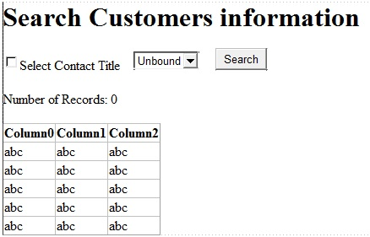

using System;

using System.Collections.Generic;

using System.Linq;

using System.Web;

using System.Web.UI;

using System.Web.UI.WebControls;

using System.Data.SqlClient;

using System.Data;

namespace Question2

{

public partial class Question2 : System.Web.UI.Page

{

String strConn = "Data Source=localhost;Initial Catalog=Y12S2B3;Integrated Security=True";

protected void Page_Load(object sender, EventArgs e)

{

if (!IsPostBack)

{

SqlConnection cn = new SqlConnection(strConn);

SqlDataAdapter da = new SqlDataAdapter("SELECT * from ContactTitles ORDER BY ContactTitle", cn);

DataSet ds = new DataSet();

da.Fill(ds);

DropDownList1.DataSource = ds.Tables[0];

DropDownList1.DataTextField = "ContactTitle";

DropDownList1.DataValueField = "ContactTitleID";

DropDownList1.DataBind();

}

}

protected void Button1_Click(object sender, EventArgs e)

{

Label1.Visible = true;

Label2.Visible = true;

String sqlStr = "";

String a = DropDownList1.Text;

if (CheckBox1.Checked)

{

sqlStr = "SELECT CustomerID, CompanyName, ContactName,Customers.ContactTitleID, Address, Phone, Fax FROM Customers, ContactTitles where Customers.ContactTitleID = ContactTitles.ContactTitleID and Customers.ContactTitleID = " + DropDownList1.SelectedValue + "ORDER BY Customers.ContactTitleID ";

}

else

{

sqlStr = "SELECT CustomerID, CompanyName, ContactName,Customers.ContactTitleID, Address, Phone, Fax FROM Customers, ContactTitles where Customers.ContactTitleID = ContactTitles.ContactTitleID ORDER BY Customers.ContactTitleID";

}

SqlConnection cn = new SqlConnection(strConn);

SqlDataAdapter da = new SqlDataAdapter(sqlStr, cn);

DataSet ds = new DataSet();

da.Fill(ds);

GridView1.DataSource = new DataView(ds.Tables[0]);

GridView1.DataBind();

}

protected void GridView1_DataBound(object sender, EventArgs e)

{

Label1.Text = GridView1.Rows.Count.ToString();

}

}

}

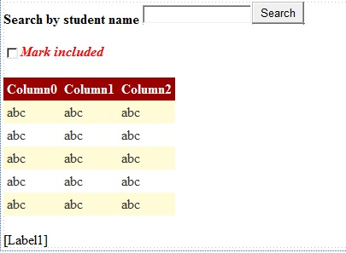

using System;

using System.Collections.Generic;

using System.Linq;

using System.Web;

using System.Web.UI;

using System.Web.UI.WebControls;

using System.Data.SqlClient;

using System.Data;

using System.Web.Configuration;

public partial class Index : System.Web.UI.Page

{

protected void Page_Load(object sender, EventArgs e)

{

}

SqlConnection sqlConn = null;

string connectionString = WebConfigurationManager.ConnectionStrings["QLDiemConnection"].ConnectionString;

protected void Button1_Click(object sender, EventArgs e)

{

string fullName = TextBox1.Text;

string sqlSelect = "";

if (CheckBox1.Checked)

{

sqlSelect = "select s.RollNo,s.FullName,s.BirthDate,c.ClassCode,c.TimeSlot,m.SubjectCode,m.Mark ";

sqlSelect += " from Class c inner join Student s on c.ClassCode = s.ClassCode ";

sqlSelect += " inner join Mark m on m.RollNo = s.RollNo ";

sqlSelect += " where s.FullName like '%" + fullName + "%'";

}

else

{

sqlSelect = "select s.RollNo,s.FullName,s.BirthDate,c.ClassCode,c.TimeSlot ";

sqlSelect += " from Class c inner join Student s on c.ClassCode = s.ClassCode ";

sqlSelect += " where s.FullName like '%" + fullName + "%'";

}

sqlConn = new SqlConnection(connectionString);

SqlCommand sqlCmdSelect = new SqlCommand(sqlSelect, sqlConn);

sqlConn.Open();

SqlDataAdapter sda = new SqlDataAdapter(sqlCmdSelect);

DataSet ds = new DataSet();

sda.Fill(ds, "studentmark");

GridView1.DataSource = ds.Tables["studentmark"];

GridView1.DataBind();

sqlConn.Close();

//get total rows

int totalRow = ds.Tables["studentmark"].Rows.Count;

if (totalRow > 0)

{

if (CheckBox1.Checked)

{

double sum = 0;

for (int i = 0; i < totalRow; i++)

{

double m = double.Parse(GridView1.Rows[i].Cells[6].Text);

sum += m;

}

Label1.Text = "Average mark: " + Math.Round((sum / totalRow), 2);

}

else

{

Label1.Text = "Total students: " + totalRow;

}

}

else

Label1.Text = "Could not find any matched data";

}

}

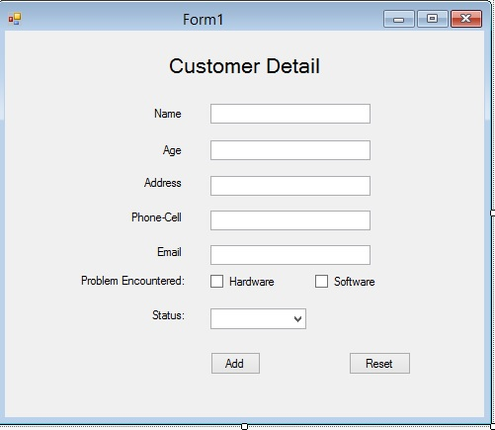

using System;

using System.Collections.Generic;

using System.ComponentModel;

using System.Data;

using System.Drawing;

using System.Text;

using System.Windows.Forms;

using System.Text.RegularExpressions;

using System.Data.SqlClient;

namespace Lap_03

{

public partial class Form1 : Form

{

string connectionString = "data source=KHJ;database=Lab3;integrated security=true";

private bool IsValidNumber(string pwd)

{

if (pwd.Length > 3) return false;

double x = Double.Parse(pwd);

if (x <= 0) return false;

bool test = true;

foreach (char c in pwd.ToCharArray())

{

if (char.IsLetter(c))

{

test = false;

break;

}

}

return test;

}

public static bool isValidEmail(string inputEmail)

{

// if (inputEmail.Length <= 10) return false;

string strRegex = @"^([a-zA-Z0-9_\-\.]+)@((\[[0-9]{1,3}" + @"\.[0-9]{1,3}\.[0-9]{1,3}\.)|(([a-zA-Z0-9\-]+\" + @".)+))([a-zA-Z]{2,4}|[0-9]{1,3})(\]?)$";

Regex reg = new Regex(strRegex);

if (reg.IsMatch(inputEmail))

return (true);

else

return (false);

}

public Form1()

{

InitializeComponent();

}

private void button1_Click(object sender, EventArgs e)

{

string add = textBox3.Text;

string phone = textBox4.Text;

string status = comboBox1.Text;

//name

string name = textBox1.Text;

if (string.IsNullOrEmpty(name) || name.Length > 50)

{

MessageBox.Show("Name cannot be null or blank and \nName cannot longer than 50 characters.");

textBox1.Focus();

return;

}

//age

string age = textBox2.Text;

if (!IsValidNumber(age))

{

MessageBox.Show("Age cannot be null or must be positive number and not longer 3 character.");

textBox2.Focus();

return;

}

//Email

string email = textBox5.Text;

if (!isValidEmail(email))

{

MessageBox.Show("Email cannot be null or must have only one @ character.");

textBox2.Focus();

return;

}

string proEnt = "";

if (checkBox1.Checked == true)

{

checkBox2.Checked = false;

proEnt = checkBox1.Text;

}

if (checkBox2.Checked == true)

{

checkBox1.Checked = false;

proEnt += checkBox2.Text;

}

string sqlInsert = " insert into CustomerDetail values (@v0,@v1,@v2,@v3,@v4,@v5,@v6)";

SqlConnection sqlConn = new SqlConnection(connectionString);

SqlCommand sqlCmdUpdate = new SqlCommand(sqlInsert, sqlConn);

sqlConn.Open();

//set parametes properties

sqlCmdUpdate.Parameters.AddWithValue("@v0", name);

sqlCmdUpdate.Parameters.AddWithValue("@v1", age);

sqlCmdUpdate.Parameters.AddWithValue("@v2", add);

sqlCmdUpdate.Parameters.AddWithValue("@v3", phone);

sqlCmdUpdate.Parameters.AddWithValue("@v4", email);

sqlCmdUpdate.Parameters.AddWithValue("@v5", proEnt);

sqlCmdUpdate.Parameters.AddWithValue("@v6", status);

int i = sqlCmdUpdate.ExecuteNonQuery();

if (i != 0)

MessageBox.Show("Inserted");

sqlConn.Close();

}

private void button2_Click(object sender, EventArgs e)

{

textBox1.Text = "";

textBox2.Text = "";

textBox3.Text = "";

textBox4.Text = "";

textBox5.Text = "";

checkBox1.Checked = false;

checkBox2.Checked = false;

comboBox1.SelectedIndex = 0;

MessageBox.Show("Clear all inputs...");

}

}

}

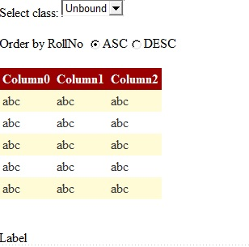

using System;

using System.Collections.Generic;

using System.Linq;

using System.Web;

using System.Web.UI;

using System.Web.UI.WebControls;

using System.Web.Configuration;

using System.Data;

using System.Data.SqlClient;

public partial class Index : System.Web.UI.Page

{

SqlConnection sqlConn = null;

string connectionString = WebConfigurationManager.ConnectionStrings["QLDiemConnection"].ConnectionString;

protected void Page_Load(object sender, EventArgs e)

{

if (!IsPostBack)

{

/*to do list

* 1.read data from class to dataset

* 2.bind dataset to dropdownlist as datasource

*

*

* */

sqlConn = new SqlConnection(connectionString);

string sqlSelect = "select * from class";

SqlCommand sqlCmdSelect = new SqlCommand(sqlSelect, sqlConn);

sqlConn.Open();

SqlDataAdapter sda = new SqlDataAdapter(sqlCmdSelect);

DataSet ds = new DataSet();

sda.Fill(ds, "Class");

DropDownList1.DataSource = ds.Tables[0];

DropDownList1.DataTextField = "ClassCode";

DropDownList1.DataValueField = "ClassCode";

DropDownList1.DataBind();

sqlConn.Close();

}

}

protected void DropDownList1_SelectedIndexChanged(object sender, EventArgs e)

{

//get selected class

string classcode = DropDownList1.SelectedValue;

sqlConn = new SqlConnection(connectionString);

string sqlSelect = "select s.*, m.Mark, m.SubjectCode ";

sqlSelect +=" from class c inner join student s on c.classcode = s.classcode ";

sqlSelect +=" inner join mark m on m.RollNo = s.RollNo ";

sqlSelect += " where c.ClassCode = @classcode order by s.rollno";

//if DESC is checked

if(RadioButton2.Checked)

sqlSelect += " DESC";

SqlCommand sqlCmdSelect = new SqlCommand(sqlSelect, sqlConn);

sqlConn.Open();

//assign value to @classcode

sqlCmdSelect.Parameters.AddWithValue("@classcode", classcode);

SqlDataAdapter sda = new SqlDataAdapter(sqlCmdSelect);

DataSet ds = new DataSet();

sda.Fill(ds, "studentmark");

GridView1.DataSource = ds.Tables[0];

GridView1.DataBind();

sqlConn.Close();

//calculate avg

int totalRow = GridView1.Rows.Count;

//sum of mark

double sum = 0;

for (int i = 0; i < totalRow; i++)

{

double m = double.Parse(GridView1.Rows[i].Cells[7].Text);

sum += m;

}

//if data is not empty

if (totalRow > 0)

Label1.Text = "Average mark(class): " + Math.Round((sum / totalRow),2);

else

Label1.Text = "No record found";

}

protected void RadioButton1_CheckedChanged(object sender, EventArgs e)

{

//reload data and sorting if needed

DropDownList1_SelectedIndexChanged(null, null);

}

protected void RadioButton2_CheckedChanged(object sender, EventArgs e)

{

DropDownList1_SelectedIndexChanged(null, null);

}

}

LamNH

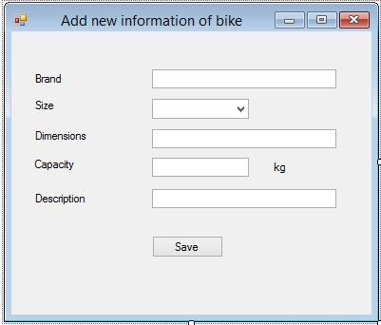

using System;

using System.Collections.Generic;

using System.ComponentModel;

using System.Data;

using System.Drawing;

using System.Linq;

using System.Text;

using System.Windows.Forms;

using System.Data.SqlClient;

namespace Question1

{

public partial class Form1 : Form

{

public Form1()

{

InitializeComponent();

string sql = "Data Source=localhost;Initial Catalog=Y12S2B3;Integrated Security=True";

SqlConnection cn = new SqlConnection(sql);

SqlDataAdapter da = new SqlDataAdapter("SELECT * FROM Sizes ORDER BY SizeName", cn);

DataSet dt = new DataSet();

da.Fill(dt);

cbSide.DataSource = dt.Tables[0];

cbSide.DisplayMember = "SizeName";

cbSide.ValueMember = "SizeID";

}

private void button1_Click(object sender, EventArgs e)

{

if (tbBrand.Text == "")

{

MessageBox.Show("Must not be empty");

return;

}

if (tbDescription.Text == "")

{

MessageBox.Show("Must not be empty");

return;

}

if (tbCapacity.Text == "")

{

MessageBox.Show("Must not be empty");

return;

}

if (tbDimemsion.Text == "")

{

MessageBox.Show("Must not be empty");

return;

}

try { int.Parse(tbCapacity.Text); }

catch

{

MessageBox.Show(" Capacity Must be numeric");

return;

}

if (int.Parse(tbCapacity.Text) < 0)

{

MessageBox.Show("Capacity Must not < 0");

return;

}

string sql = "Data Source=localhost;Initial Catalog=Y12S2B3;Integrated Security=True";

SqlConnection cn = new SqlConnection(sql);

SqlCommand cmd = new SqlCommand("INSERT INTO Suitcases(Brand,SizeID,Dimensions,Capacity,Description)"

+ "VALUES(@Brand,@SizeID,@Dimensions,@Capacity,@Description)", cn);

cmd.Parameters.AddWithValue("@Brand", tbBrand.Text);

cmd.Parameters.AddWithValue("@SizeID", cbSide.SelectedValue);

cmd.Parameters.AddWithValue("@Dimensions", tbDimemsion.Text);

cmd.Parameters.AddWithValue("@Capacity", tbCapacity.Text);

cmd.Parameters.AddWithValue("@Description", tbDescription.Text);

cn.Open();

cmd.ExecuteNonQuery();

cn.Close();

MessageBox.Show("New information of Suitcase is added");

}

}

}

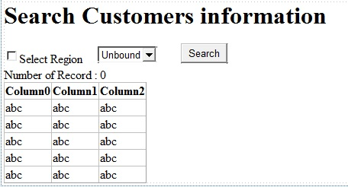

using System;

using System.Collections.Generic;

using System.Linq;

using System.Web;

using System.Web.UI;

using System.Web.UI.WebControls;

using System.Data;

using System.Data.SqlClient;

namespace Question2

{

public partial class Question2 : System.Web.UI.Page

{

protected void Page_Load(object sender, EventArgs e)

{

if (!IsPostBack)

{

string sql = "Data Source=localhost;Initial Catalog=Y12S2B3;Integrated Security=True";

DataSet ds = new DataSet();

SqlConnection cn = new SqlConnection(sql);

SqlDataAdapter da = new SqlDataAdapter("SELECT * FROM Regions ORDER BY Region", cn);

da.Fill(ds);

ddl.DataSource = ds.Tables[0];

ddl.DataTextField = "Region";

ddl.DataValueField = "RegionID";

ddl.DataBind();

}

}

protected void Button1_Click(object sender, EventArgs e)

{

string sql = "Data Source=localhost;Initial Catalog=Y12S2B3;Integrated Security=True";

if (CheckBox1.Checked)

{

DataSet ds = new DataSet();

SqlConnection cn = new SqlConnection(sql);

SqlDataAdapter da = new SqlDataAdapter("SELECT CustomerID,CompanyName,ContactName,Customers.RegionID,PostalCode,Phone,Fax FROM Customers,Regions WHERE Customers.RegionID = Regions.RegionID AND Regions.RegionID =" + ddl.SelectedValue, cn);

da.Fill(ds);

DataView dv = new DataView(ds.Tables[0]);

GridView1.DataSource = dv;

GridView1.DataBind();

}

else

{

DataSet ds = new DataSet();

SqlConnection cn = new SqlConnection(sql);

SqlDataAdapter da = new SqlDataAdapter("SELECT CustomerID,CompanyName,ContactName,Customers.RegionID ,PostalCode,Phone,Fax FROM Customers,Regions WHERE Regions.RegionID =" + ddl.SelectedValue, cn);

da.Fill(ds);

DataView dv = new DataView(ds.Tables[0]);

GridView1.DataSource = dv;

GridView1.DataBind();

}

}

protected void GridView1_DataBound(object sender, EventArgs e)

{

Label1.Text = GridView1.Rows.Count.ToString();

}

}

}

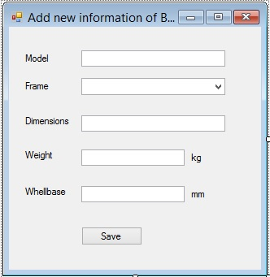

using System;

using System.Collections.Generic;

using System.ComponentModel;

using System.Data;

using System.Drawing;

using System.Linq;

using System.Text;

using System.Windows.Forms;

using System.Data.SqlClient;

namespace Question1

{

public partial class Form1 : Form

{

SqlConnection con = new SqlConnection("Data Source=localhost;Initial Catalog=Y12S2B1;Integrated Security=True");

public Form1()

{

InitializeComponent();

Load_comboBox();

cbFrame.SelectedIndex = 1;

}

private void Load_comboBox()

{

SqlCommand cmd = new SqlCommand("select * from Frames", con);

SqlDataReader dr;

List<ComboBoxItem> cbi = new List<ComboBoxItem>();

try

{

con.Open();

dr = cmd.ExecuteReader();

if (dr.HasRows)

{

while (dr.Read())

{

ComboBoxItem cb = new ComboBoxItem();

cb.value = int.Parse(dr[0].ToString());

cb.Text = dr[1].ToString();

cbi.Add(cb);

}

//cbFrame.SelectedIndex = 1;

}

}

catch (Exception ex)

{

MessageBox.Show(ex.Message);

}

finally

{

con.Close();

for (int i = 0; i < cbi.Count; i++)

{

cbFrame.Items.Add(cbi[i]);

}

}

}

private bool checkDigit(string x)

{

bool valid = false;

try

{

double a = double.Parse(x);

valid = true;

if (a > 0)

{

valid = true;

}

else

{

MessageBox.Show("Weight must greater than 0");

valid = false;

}

}

catch (Exception)

{

valid = false;

MessageBox.Show("Weight is not a numberic ! Please try again");

}

return valid;

}

private bool checkInt(string x)

{

bool valid = false;

try

{

int a = int.Parse(x);

valid = true;

if (a > 0)

{

valid = true;

}

else

{

MessageBox.Show("Wheelbase must greater than 0");

valid = false;

}

}

catch (Exception)

{

valid = false;

MessageBox.Show("Wheelbase is not a integer ! Please try again");

}

return valid;

}

public int GetMax(string attribute, string table)

{

int max = 0;

SqlCommand cmd;

try

{

cmd = new SqlCommand("select Max(" + attribute + ")from " + table, con);

con.Open();

SqlDataReader dr = cmd.ExecuteReader();

while (dr.Read())

{

try

{

max = int.Parse(dr[0].ToString());

}

catch (Exception)

{

max = 0;

}

}

}

catch (Exception ex)

{

MessageBox.Show(ex.Message);

}

finally

{

con.Close();

}

return max;

}

private void btSave_Click(object sender, EventArgs e)

{

bool valid = true;

if (txtModel.Text.Trim().Equals(""))

{

MessageBox.Show("Please input value for Model field !");

valid = true;

return;

}

if (txtDimen.Text.Trim().Equals(""))

{

MessageBox.Show("Please input value for Dimension field !");

valid = true;

return;

}

if (txtWeight.Text.Trim().Equals(""))

{

MessageBox.Show("Please input value for Weight field !");

valid = true;

return;

}

if (txtWhelbase.Text.Trim().Equals(""))

{

MessageBox.Show("Please input value for Wheelbase field !");

valid = true;

return;

}

if (valid)

{

int ID = GetMax("BikeID", "Bikes")+1;

int frame = ((ComboBoxItem)cbFrame.SelectedItem).value;

string model = txtModel.Text;

string dimens = txtDimen.Text;

string weight = txtWeight.Text;

string wheelbase = txtWhelbase.Text;

if (checkDigit(weight) && checkInt(wheelbase))

{

try

{

SqlCommand cmd = new SqlCommand("SET IDENTITY_INSERT [dbo].[Bikes] On insert into Bikes(BikeID,Model,FrameID,Dimensions,Weight,Wheelbase) "

+"values (@BikeID,@Model,@FrameID,@Dimensions,@Weight,@Wheelbase) SET IDENTITY_INSERT [dbo].[Bikes] Off", con);

cmd.Parameters.AddWithValue("@BikeID", ID);

cmd.Parameters.AddWithValue("@Model", model);

cmd.Parameters.AddWithValue("@FrameID", frame);

cmd.Parameters.AddWithValue("@Dimensions", dimens);

cmd.Parameters.AddWithValue("@Weight", weight);

cmd.Parameters.AddWithValue("@Wheelbase", wheelbase);

con.Open();

cmd.ExecuteNonQuery();

con.Close();

MessageBox.Show("New information of Bike is added");

}

catch (Exception ex)

{

MessageBox.Show(ex.Message);

}

}

}

}

}

public class ComboBoxItem

{

public int value;

public string Text;

public ComboBoxItem()

{

}

public ComboBoxItem(int value, string text)

{

this.value = value;

this.Text = text;

}

public override string ToString()

{

return this.Text;

}

}

}

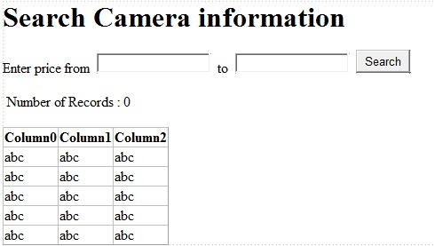

using System;

using System.Collections.Generic;

using System.Linq;

using System.Web;

using System.Web.UI;

using System.Web.UI.WebControls;

using System.Data.SqlClient;

using System.Data;

namespace Question2

{

public partial class Question2 : System.Web.UI.Page

{

SqlConnection con = new SqlConnection("Data Source=localhost;Initial Catalog=Y12S2B1;Integrated Security=True");

protected void Page_Load(object sender, EventArgs e)

{

}

protected void btSearch_Click(object sender, EventArgs e)

{

string min = txtMin.Text;

string max = txtMax.Text;

getSearch(min, max);

lbCount.Visible = true;

Label1.Visible = true;

}

private void getSearch(string min, string max)

{

if (min.Equals("") && max.Equals(""))

{

string cmd = "select Cameras.Model,Makers.MakerName,Cameras.Lens,Cameras.Aperture,Cameras.Resolution,Cameras.ShutterSpeed,"

+ "Cameras.Zoom,Cameras.Price from Cameras,Makers where Cameras.MakerID = Makers.MakerID order by Cameras.Price";

displayData(cmd);

}

else

{

if ((!min.Equals("") && max.Equals("")))

{

string cmd = "select Cameras.Model,Makers.MakerName,Cameras.Lens,Cameras.Aperture,Cameras.Resolution,"

+ "Cameras.ShutterSpeed,Cameras.Zoom,Cameras.Price from Cameras,Makers where Cameras.MakerID = Makers.MakerID and Cameras.Price >= " + min + "order by Cameras.Price";

displayData(cmd);

}

else

{

if ((min.Equals("") && !max.Equals("")))

{

string cmd = "select Cameras.Model,Makers.MakerName,Cameras.Lens,Cameras.Aperture,Cameras.Resolution,"

+ "Cameras.ShutterSpeed,Cameras.Zoom,Cameras.Price from Cameras,Makers where Cameras.MakerID = Makers.MakerID and Cameras.Price <= " + max + "order by Cameras.Price desc";

displayData(cmd);

}

else

{

if ((!min.Equals("") && !max.Equals("")))

{

string cmd = "select Cameras.Model,Makers.MakerName,Cameras.Lens,Cameras.Aperture,Cameras.Resolution,"

+ "Cameras.ShutterSpeed,Cameras.Zoom,Cameras.Price from Cameras,Makers where Cameras.MakerID = Makers.MakerID and Cameras.Price >= "+min+ " and Cameras.Price <= " + max+ "order by Cameras.Price";

displayData(cmd);

}

}

}

}

}

private void displayData(string cmd)

{

try

{

SqlDataAdapter da = new SqlDataAdapter(cmd, con);

DataSet ds = new DataSet();

da.Fill(ds);

DataView dv = new DataView(ds.Tables[0]);

GridView1.DataSource = dv;

GridView1.DataBind();

lbCount.Text = GridView1.Rows.Count.ToString();

}

catch (Exception)

{ }

}

}

}