|  |
| --- |
| Software design |
| [Project Name] |
| [Version] |
| Prepared by [author]  [Create date] |

Contents

Revision history 4

1. Document description 5

2. SRS overview 5

2.1. List of system users 5

2.2. List of use cases 5

2.3. Use case diagram 6

2.3.1. Preliminary use case diagram 6

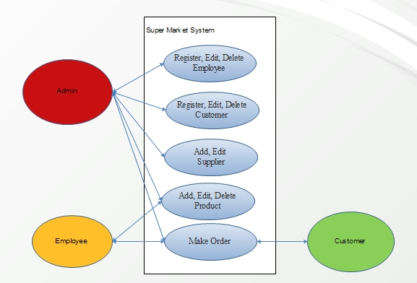 6

2.3.2. Use case detail diagrams 6

2.4. Activity diagrams of use case scenarios 8

2.4.1. Activity diagram for use case “Make Order” 8

2.4.. Activity diagram for use case “Register Employee (Customer, Supplier)” 9

2.4.2. Activity diagram for use case “Add Product” 9

3. Data model 10

3.1 Entity Relationship Diagram 10

3.2. Table details/Chi tiết các bảng 11

3.2.1 Table name: Suppliers 11

3.2.2 Table name: Products 11

3.2.3 Table name: OrderDetails 12

3.2.4 Table name: Orders 12

3.2.5 Table name: Customers 13

3.2.6 Table name: Employees 13

3.2.7 Table name: Accounts 13

2. Class diagram 15

2.1. List of classes in the layer 15

15

2.2. Modeling the Class Behaviors - sequence diagrams ( p. 66, p.77) 16

3. User Interface Model Design (p. 70 – p.74) 16

3.1. User interface model design 16

3.2. Interface Flow Diagrams (p. 51) 16

# Revision history

|  |  |  |  |
| --- | --- | --- | --- |
| **Date** | **Authors** | **Modifications** | **Version** |
|  |  |  |  |
|  |  |  |  |
|  |  |  |  |
|  |  |  |  |
|  |  |  |  |

# Document description

1. **Document organization**: Describe the overall organization of the document. List the major sections of the document and describe what concerns each section addresses.
2. **Terminology and definitions**: Define any terms used throughout the document and provide context for terminology.
3. **References and relevant documents**: List any other relevant documents that the reader might need to refer to, and most importantly, describe their relationships to this document and why the reader might want to (or need to) refer to them.

# SRS overview

## 2.1. List of system users

1. Admin: The person who manager whole system.

2. Employee: The person who sell product.

3. Customer: The person who buy product.

## 2.2. List of use cases

1. Register, Edit, Delete Employee

2. Register, Edit, Delete Customer

3. Add, Edit Supplier

4. Add, Edit, Delete Product

5. Make Order

## 2.3. Use case diagram

### 2.3.1. Preliminary use case diagram

### 

### 2.3.2. Use case detail diagrams

#### 2.3.2.1. Use case “Register, Edit, Delete Employee”

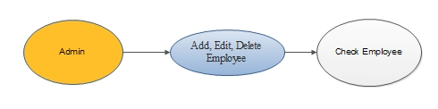

#### 2.3.2.2. Use case “Register, Edit, Delete Customer”

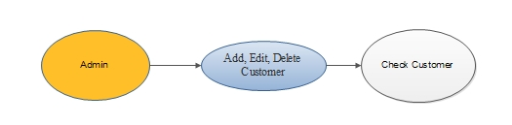

#### 2.3.2.3. Use case “Register, Edit Supplier”

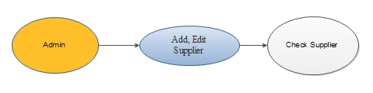

#### 2.3.2.3. Use case “Register, Edit, Delete Product”

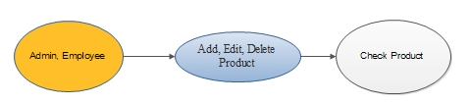

#### 2.3.2.3. Use case “Make Order”

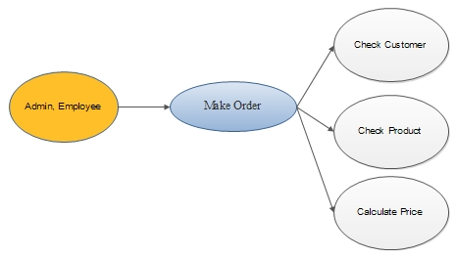

## 2.4. Activity diagrams of use case scenarios

### 2.4.1. Activity diagram for use case “Make Order”

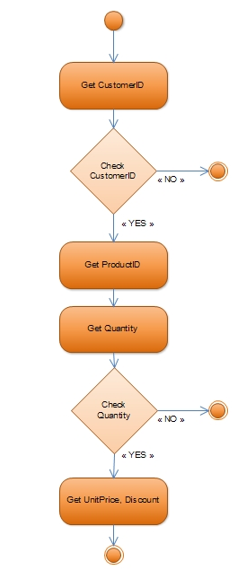

### 2.4.. Activity diagram for use case “Register Employee (Customer, Supplier)”

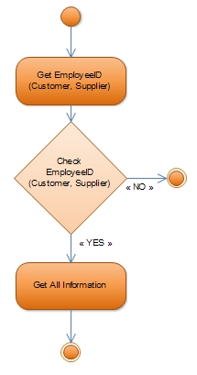

### 2.4.2. Activity diagram for use case “Add Product”

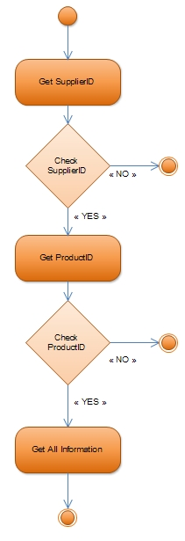

# Data model

## 3.1 Entity Relationship Diagram

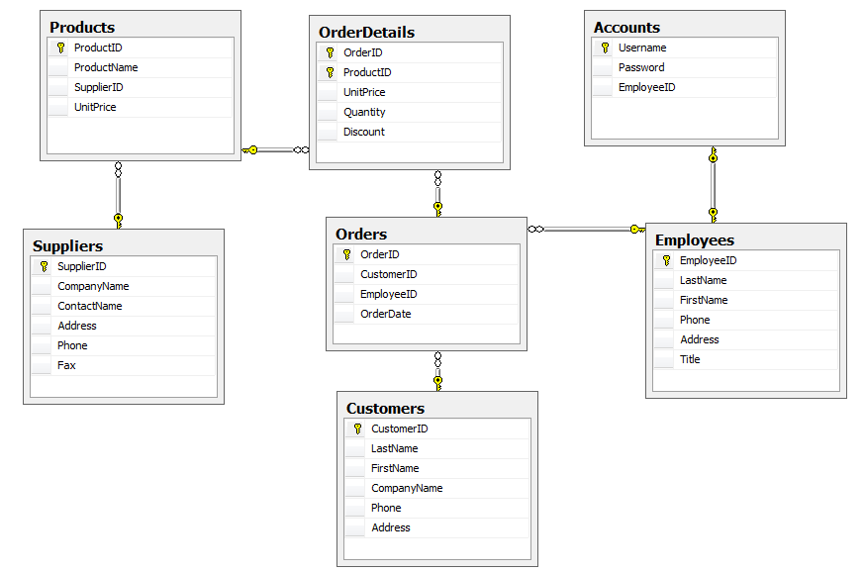

## 3.2. Table details/Chi tiết các bảng

Note: Attribute with underline is Primary key

### Table name: Suppliers

|  |  |  |  |
| --- | --- | --- | --- |
| **Field name** | **Type** | **Size** | **Note** |
| SupplierID | Integer |  | Primary key |
| CompanyName | String | 20 | Not null |
| ContactName | String | 20 | Allows null |
| Address | String | 20 | Allows null |
| Phone | String | 20 | Allows null |
| Fax | String | 20 | Allows null |

### Table name: Products

|  |  |  |  |
| --- | --- | --- | --- |
| **Field name** | **Type** | **Size** | **Note** |
| ProductID | Integer |  | Primary key |
| ProductName | String | 20 | Allows null |
| SupplierID | Integer |  | Foreign key, refers to Suppliers table |
| UnitPrice | Double |  | Allows null |

### Table name: OrderDetails

|  |  |  |  |
| --- | --- | --- | --- |
| **Field name** | **Type** | **Size** | **Note** |
| OrderID | Integer |  | Primary key  Foreign key, refers to Orders table |
| ProductID | Integer |  | Primary key  Foreign key, refers to Products table |
| UnitPrice | Double |  | Allows null |
| Quantity | Integer |  | Allows null |
| Discount | Integer |  | Allows null |

### Table name: Orders

|  |  |  |  |
| --- | --- | --- | --- |
| **Field name** | **Type** | **Size** | **Note** |
| OrderID | Integer |  | Primary key |
| CustomerID | Integer |  | Allows null  Foreign key, refers to Customers table |
| EmployeeID | Integer |  | Allows null  Foreign key, refers to Employees table |
| OrderDate | Date |  | Allows null |

### Table name: Customers

|  |  |  |  |
| --- | --- | --- | --- |
| **Field name** | **Type** | **Size** | **Note** |
| CustomerID | Integer |  | Primary key |
| LastName | String | 10 | Not null |
| FirstName | String | 10 | Not null |
| CompanyName | String | 20 | Allows null |
| Phone | String | 20 | Allows null |
| Address | String | 30 | Allows null |

### Table name: Employees

|  |  |  |  |
| --- | --- | --- | --- |
| **Field name** | **Type** | **Size** | **Note** |
| EmployeeID | Integer |  | Primary key |
| LastName | String | 10 | Not null |
| FirstName | String | 10 | Not null |
| Phone | String | 20 | Allows null |
| Address | String | 30 | Allows null |
| Title | String | 10 | Not null  ‘Admin’ or ‘Employee’ |

### Table name: Accounts

|  |  |  |  |
| --- | --- | --- | --- |
| **Field name** | **Type** | **Size** | **Note** |
| Username | String | 50 | Primary key |
| Password | String | 30 | Not null |
| EmployeeID | Integer |  | Not null  Foreign key, refers to Employees table |

# Class diagram

## List of classes in the layer

Layer GUI

WarehouseGUI

AccountGUI

CustomerGUI

HomeGUI

SellGUI

Layer BL

AccountBL

CustomerBL

SellBL

WarehouseBL

Layer DA

AccountDA

CustomerDA

SellDA

ReservationDA

Note: Allow to use

BL: Business logic

DA: Data access

Library Database

## Modeling the Class Behaviors - sequence diagrams ( p. 66, p.77)

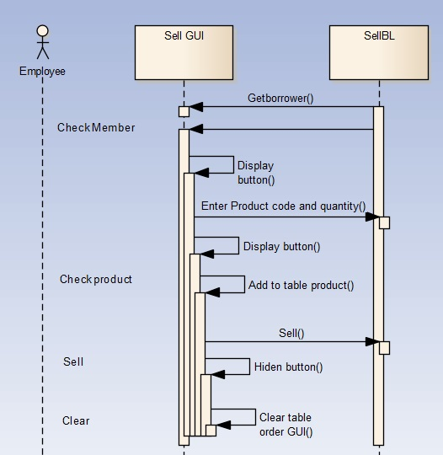

# User Interface Model Design (p. 70 – p.74)

## User interface model design

## Interface Flow Diagrams (p. 51)

**Reference:** Beginning C# ObjectOriented.pdf

1. Class diagram (p.18 – p.26)

Association, Inheritance, Aggregation relationships, Aggregation class

1. Use case scenarios descriptions (p. 29 – p. 30); http://usability.gov/methods/design_site/usecasesresource.html )

|  |  |
| --- | --- |
| **Use Case Title: One line descriptive title** | **Use Case ID: Pneumonic reference if desired** |
| **General Use Case Description:**  Provide a short Narrative Description | |
| **Entities Involved:**  List entities involved. The Entity Identification Table entries can be referenced. In any case make sure that entities or defined before they are used here. | |
| **Preconditions:**  Describe any pre-existing conditions or assumptions prior to the start of the flow of events. | |
| **Primary Use Case Flow of Events:** | |
| **1.** | The flow of events should be described in terms of actions and responses between the actor and the system. While not necessary, numbering steps are helpful |
| **N.** |  |
| **Primary Use Case Post Conditions:**  Describe and relevant post conditions or assumptions after the flow of events. | |
| **Alternate Use Case #_____ Flow of Events:** |  |
| **1.** | The flow of events should be described in terms of actions and responses between the actor and the system. While not necessary, numbering steps are helpful. |
| **N.** |  |
| **Alternate Use Case #_____ Post Conditions:**  Describe any relevant post conditions or assumptions after the flow of events. | |

1. Sequence diagram and messages (p.33 - p.42)

* Message types: (synchronous, asynchronous, return)
* Recursive Message
* Message Iteration
* Message Constrains
* Message Branching

1. Activity diagram (p.42 - p.48)

* Decision points and Guard conditions
* Parallel Processing
* Activity Ownership