Guide for PE_Sample_00

1. Question 1 (Windows Forms Application):
2. Cretae a new windows forms project named Question1 by clicking File, New, Project, Windows, Windows Forms Application, then type “Question1” as below

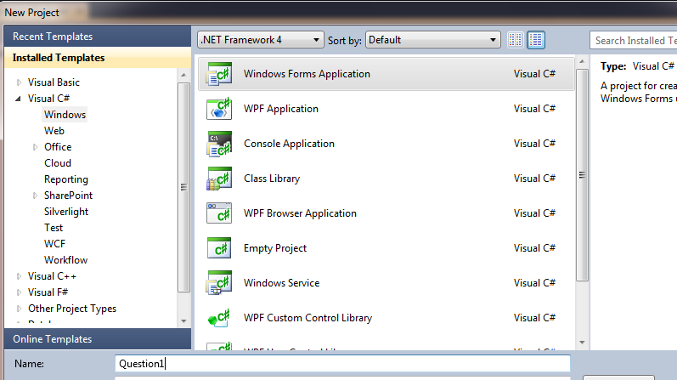

1. Open Form1, add the following controls as below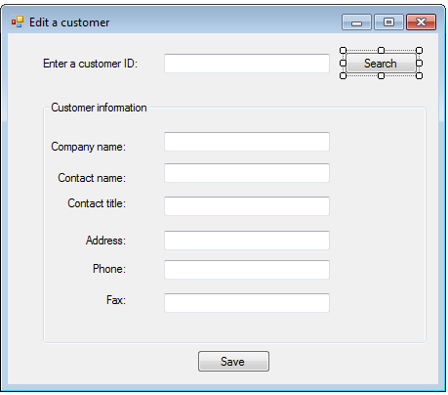

txtCompanyName

groupBox1

btnSave

txtFax

txtPhone

txtAddress

txtContactTitle

txtContactName

btnSearch

txtCustomerID

Methods handle events as below

public partial class Form1 : Form

{

string strConn = "Server = localhost; Database = SampleExam; Integrated security = true";

public Form1()

{

InitializeComponent();

btnSave.Enabled = false;

}

private void txtCustomerID_TextChanged(object sender, EventArgs e)

{

btnSearch.Enabled = true;

btnSave.Enabled = false;

}

private void btnSearch_Click(object sender, EventArgs e)

{

//Khong go CustomerID

if (txtCustomerID.Text == "")

{

MessageBox.Show("Please enter value for CustomerID!");

return;

}

/*

//1. Tao object Connection

SqlConnection conn = new SqlConnection(strConn);

//2. Tao object DataAdapter

SqlDataAdapter da = new SqlDataAdapter();

SqlCommand cmd = new SqlCommand("select * from customers where CustomerID = @CustomerID", conn);

cmd.Parameters.AddWithValue("@CustomerID", txtCustomerID.Text);

da.SelectCommand = cmd;

//3. Tao object DataSet

DataSet ds = new DataSet();

//4. Lay du lieu ve ds

da.Fill(ds);

// Neu khong co customer ID

if(ds.Tables[0].Rows.Count == 0)

{

MessageBox.Show(string.Format("Customer ID {0} doesn't exists!", txtCustomerID.Text));

return;

}

DataRow row = ds.Tables[0].Rows[0];

txtCompanyName.Text = row["CompanyName"].ToString();

txtContactName.Text = row["Contactname"].ToString();

txtContactTitle.Text = row["ContactTitle"].ToString();

txtAddress.Text = row["Address"].ToString();

txtPhone.Text = row["Phone"].ToString();

txtFax.Text = row["Fax"].ToString(); */

//1. Tao object Connection

SqlConnection conn = new SqlConnection(strConn);

//2. Tao object Command

SqlCommand cmd = new SqlCommand("select * from customers where CustomerID = @CustomerID", conn);

cmd.Parameters.AddWithValue("@CustomerID", txtCustomerID.Text);

//3. Mo ket noi

conn.Open();

//4. Tạo object DataReader

SqlDataReader dr = cmd.ExecuteReader();

//5. Thuc hien method Read() của DataReader

// Neu khong co customer ID

if (!dr.Read())

{

MessageBox.Show(string.Format("Customer ID {0} doesn't exists!", txtCustomerID.Text));

return;

}

//Gan cho cac TextBox

txtCompanyName.Text = dr["CompanyName"].ToString();

txtContactName.Text = dr["Contactname"].ToString();

txtContactTitle.Text = dr["ContactTitle"].ToString();

txtAddress.Text = dr["Address"].ToString();

txtPhone.Text = dr["Phone"].ToString();

txtFax.Text = dr["Fax"].ToString();

// 6. Dong cac ket noi

dr.Close();

conn.Close();

btnSearch.Enabled = false;

btnSave.Enabled = true;

}

private void btnSave_Click(object sender, EventArgs e)

{

//1. Tao object ket noi

SqlConnection conn = new SqlConnection(strConn);

//2. Tao object Command

SqlCommand cmd = new SqlCommand("update Customers set CompanyName = @CompanyName, ContactName = @ContactName, ContactTitle = @ContactTitle, " +

"Address = @Address, Phone = @Phone, Fax = @Fax " +

"WHERE CustomerID = @CustomerID", conn);

cmd.Parameters.AddWithValue("@CustomerID", txtCustomerID.Text);

cmd.Parameters.AddWithValue("@CompanyName", txtCompanyName.Text);

cmd.Parameters.AddWithValue("@ContactName", txtContactName.Text);

cmd.Parameters.AddWithValue("@ContactTitle", txtContactTitle.Text);

cmd.Parameters.AddWithValue("@Address", txtAddress.Text);

cmd.Parameters.AddWithValue("@Phone", txtPhone.Text);

cmd.Parameters.AddWithValue("@Fax", txtFax.Text);

// MessageBox.Show(cmd.CommandText);

//3. Mo ket noi

conn.Open();

//4. Thuc hien method ExecuteNonQuery() cua object Command

cmd.ExecuteNonQuery();

//5. Dong ket noi

conn.Close();

MessageBox.Show("Information of this customer is updated!");

}

}

1. Question 2 (Web Application):
2. Cretae a new web project named Question2 by clicking File, New, Project, Web, ASP.NET Empty Web Application, then type “Question2” as below 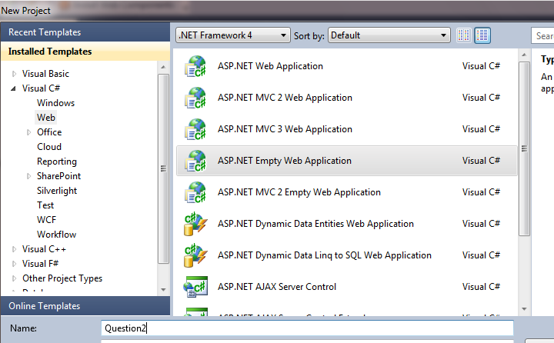
3. Add a new page named Question2.aspx by pointing to Project name, right clicking to display context menu, then click Add, New Item, Web, Web Form, then type “Question2.aspx” as below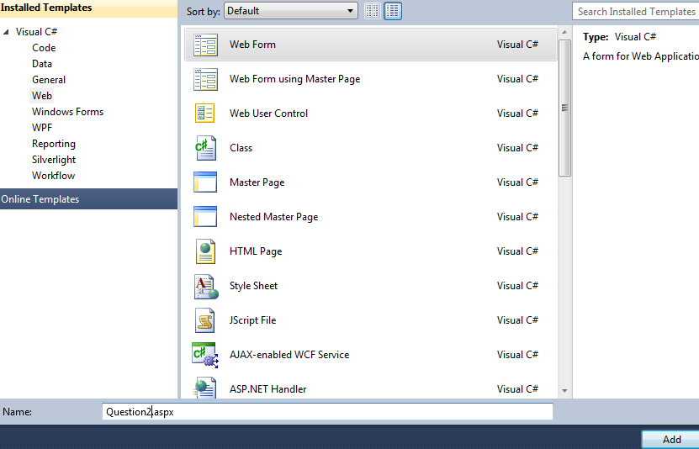
4. Open page “Question2.aspx”, add the following controls as below

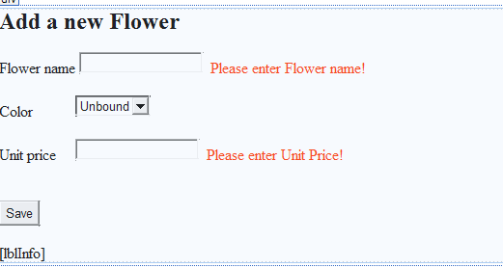

lblInfo

txtFlowerName

RequiredFieldValidator2

RequiredFiledValidator1

btnSave

txtUnitPrice

ddlColorID

Methods handle events as below

public partial class Question1 : System.Web.UI.Page

{

static string strConn = @"Server = localhost; Database = SampleExam; Integrated Security = true";

protected void Page_Load(object sender, EventArgs e)

{

if (!IsPostBack)

{

//Lay du lieu tu bang Color ve DataSet

SqlConnection conn = new SqlConnection(strConn);

SqlDataAdapter da = new SqlDataAdapter("select * from Colors order by ColorName", conn);

DataSet ds = new DataSet();

da.Fill(ds);

//Gan du lieu cho DropDownList

ddlColorID.DataSource = ds.Tables[0];

//Hien theo column "ColorName"

ddlColorID.DataTextField = "ColorName";

//Gia tri thuc theo Column "ColorID"

ddlColorID.DataValueField = "ColorID";

//Thuc hien bind du lieu (chi voi WEB)

ddlColorID.DataBind();

}

}

protected void btnSave_Click(object sender, EventArgs e)

{

try

{

SqlConnection conn = new SqlConnection(strConn);

SqlCommand cmd = new SqlCommand("INSERT INTO Flowers(FlowerName, ColorID, UnitPrice) " +

"VALUES(@FlowerName, @ColorID, @UnitPrice)", conn);

cmd.Parameters.AddWithValue("@FlowerName", txtFlowerName.Text);

cmd.Parameters.AddWithValue("@ColorID", ddlColorID.SelectedValue);

cmd.Parameters.AddWithValue("@UnitPrice", double.Parse(txtUnitPrice.Text));

conn.Open();

cmd.ExecuteNonQuery();

conn.Close();

lblInfo.Text = "Information of a new flower is addded!";

}

catch (Exception ex)

{

lblInfo.Text = "Can't add a new flower!";

}

}

}