1. The first page: SearchProducts.aspx
1.1. User Interface (1 point)
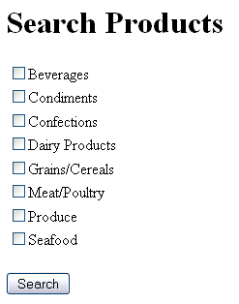
Requirements:
- Use <h1> tag to format the title “Search Products”.
- Use CheckBoxList control to display CategoryName of all data in Categories table.
- Has “Search” button.

1.2. Functions (1 point)
When click Search button,
- Use Session to store selected Categories.
- Redirect user to the second page.

2. The second page: SearchResults.aspx (3 point)
2.1. User Interface
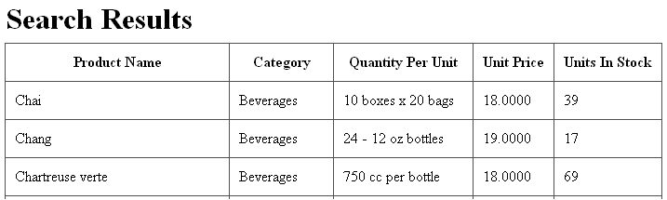
Requirements:
- Use <h1> tag to format the title “Search Results”.
- Use GridView control to display results. This grid must have 5 columns: Product Name, Category, Quantity Per Unit, Unit Price and Units In Stock.

2.2. Functions
Requirements:
- Search products by categories which are selected in the first page.
- Order data by Category and Product Name ascending.
Test cases:
- Test case 1: Don’t choose any categories in the first page
  - Display all products in Products table.
- Test case 2: Choose one category is “Beverages” in the first page
  - Display products which have category are “Beverages”.
- Test case 3: Choose two categories are “Beverages” and “Grains/Cereals”
  - Display products which have category are “Beverages” or “Grains/Cereals”.

