- Write a Fraction class that defines adding, subtracting, multiplying, and dividing fractions. Then write a method for reducing factors and methods for inputting and outputting fractions.
- Farey fractions of level one are defined as sequence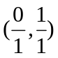. This sequence is extended in level two to form a sequence 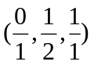, sequence 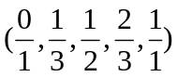 at level three, sequence 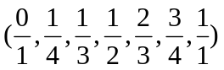at level four, so that at each level n a new fraction 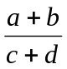 is inserted between two neighbor fractions 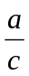 and 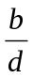 only if 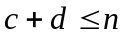. Write a program which for a number n entered by the user creates – by constantly extending it – a linked list of fractions at level n and then display them.
Submission Requirements
At the beginning of your program, include comments with the following information formatted neatly, and reflecting accurate information for you.
/* Lab 1 */
/* Course: Summer 2010 - SE.4xx */
/* Family Name: Student */
/* Given Name: John */
/* Student Number: 123-456-789 */
/* Login name: jstudent */
/* Professor: Mr..... */
/* Due Date: May 16, 2010 */
/* */
/* I declare that the attached assignment is my own work in accordance with */
/* FPT UniversityPolicy. No part of this assignment has been copied manually */
/* or electronically from any other source (including web sites) or distributed */
/* to other students*/

