- Write program of which GUI (Graphic User Interface) is similarity to Calculator of Windows:

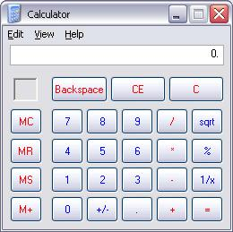

Menus must have complete menu items and controls as Calculator. The program can execute operators +, -, *, / for positive integer. Other functions don’t need to be implemented. Students have to submit Project Solution.
- Write program of which GUI is similarity to Notepad of Windows:
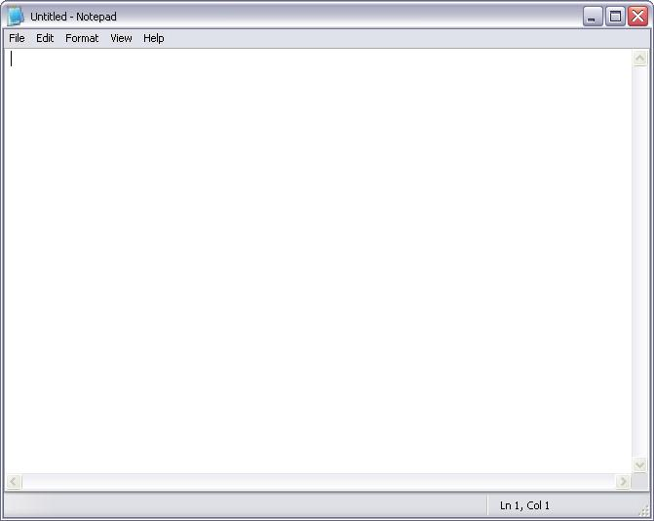
Menus must have complete menu items as Notepad. The program also displays the following toolbar:
The program will display appropriate Common Dialogs when user selects menu items such as Open, Save, Save As, Print, and Format Font. Students have to submit Project Solution.

Submission Requirements
At the beginning of your program, include comments with the following information formatted neatly, and reflecting accurate information for you.
/* Lab 1 */
/* Course: Fall 2009 - SE.4xx */
/* Family Name: Student */
/* Given Name: John */
/* Student Number: 123-456-789 */
/* Login name: jstudent */
/* Professor: Mr..... */
/* Due Date: July 02, 2009 */
/* */
/* I declare that the attached assignment is my own work in accordance with */
/* FPT UniversityPolicy. No part of this assignment has been copied manually */
/* or electronically from any other source (including web sites) or distributed */
/* to other students*/

