Build a console application, based on the below database schema, which is included in Northwind database:
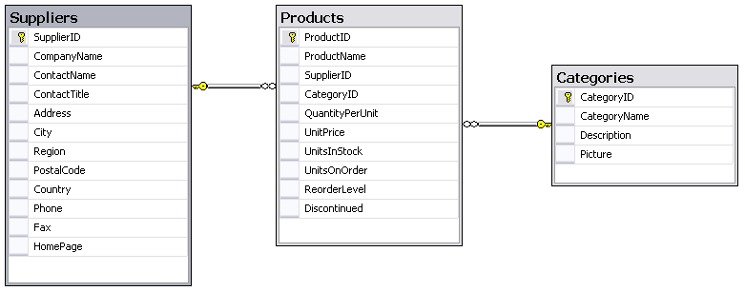

The application has the following functions:
- List all products.
- Insert a new product.
- Update an existing product.
- Delete an existing product.
- List all Suppliers.
- List all Categories (not display Picture).
Requirements:
  - Data must be invalidated before inserting or updating. Information of Products needs to be validated:
    - SupplierID
    - CategoryID
    - UnitPrice
    - UnitsInStock
    - UnitsOnOrder
    - ReorderLevel
  - Information such as connection string should be specified in config file.
  - Students will use Northwind database attached this lab.
Submission Requirements:
- Students have to submit Project Solution under rar format. Example: Student Name.rar.
- At the beginning of your program, include comments with the following information formatted neatly, and reflecting accurate information for you.
/* Lab 1 */
/* Course: Fall 2009 - SE.4xx */
/* Family Name: Student */
/* Given Name: John */
/* Student Number: 123-456-789 */
/* Login name: jstudent */
/* Professor: Mr..... */
/* Due Date: July 02, 2009 */
/* */
/* I declare that the attached assignment is my own work in accordance with */
/* FPT UniversityPolicy. No part of this assignment has been copied manually */
/* or electronically from any other source (including web sites) or distributed */
/* to other students*/

