Design a website, based on the below database schema, which includes 3 pages corresponding to 3 tables:
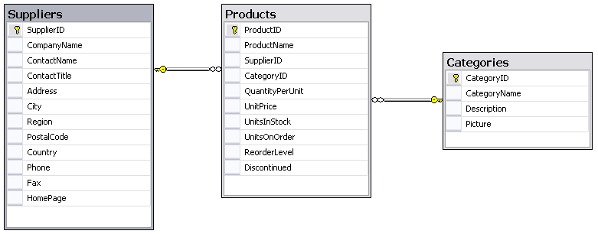

Requirements:
  - For each page, each field (except Picture of Categories) is represented by an appropriate web control based on characters of field. Besides, there are 2 buttons: Save, and Cancel in each page.
  - Layout of each page includes two zones:
    - Left menu: contains links of 3 pages.
    - Right content: display web page when its link is accessed.
Hint: Student can use master page to implement this requirement.
  - When button Save is clicked, the page will show data entered.
  - When button Cancel is clicked, the page will show message: “You canceled inputting data”.
Submission Requirements:
- Students have to submit Project Solution under rar format. Example: Student Name.rar.
- At the beginning of your program, include comments with the following information formatted neatly, and reflecting accurate information for you.
/* Lab 1 */
/* Course: Fall 2009 - SE.4xx */
/* Family Name: Student */
/* Given Name: John */
/* Student Number: 123-456-789 */
/* Login name: jstudent */
/* Professor: Mr..... */
/* Due Date: July 02, 2009 */
/* */
/* I declare that the attached assignment is my own work in accordance with */
/* FPT UniversityPolicy. No part of this assignment has been copied manually */
/* or electronically from any other source (including web sites) or distributed */
/* to other students*/

