- Develop a web service named FractionOperators provides operators such as +, - , *, /, ==, >, <, !=, >=, <=, -=, += , which are implemented in Lab 2.
- Build a Windows application or Web application to test the above web service. Interface of this application has the following form:

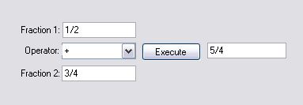
Submission Requirements:
- Students have to submit Project Solution under rar format. Example: Student Name.rar.
- At the beginning of your program, include comments with the following information formatted neatly, and reflecting accurate information for you.
/* Lab 1 */
/* Course: Fall 2009 - SE.4xx */
/* Family Name: Student */
/* Given Name: John */
/* Student Number: 123-456-789 */
/* Login name: jstudent */
/* Professor: Mr..... */
/* Due Date: July 02, 2009 */
/* */
/* I declare that the attached assignment is my own work in accordance with */
/* FPT UniversityPolicy. No part of this assignment has been copied manually */
/* or electronically from any other source (including web sites) or distributed */
/* to other students*/

