1. The first page: SearchProducts.aspx
1.1. User Interface (1 point)
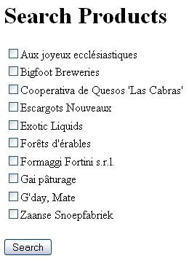
Requirements:
- Use <h1> tag to format the title “Search Products”.
- Use CheckBoxList control to display CompanyName of all data in Suppliers table (29 records).
- Has “Search” button.

1.2. Functions (1 point)
When click Search button,
- Use Session to store selected Suppliers.
- Redirect user to the second page.

2. The second page: SearchResults.aspx (3 point)
2.1. User Interface
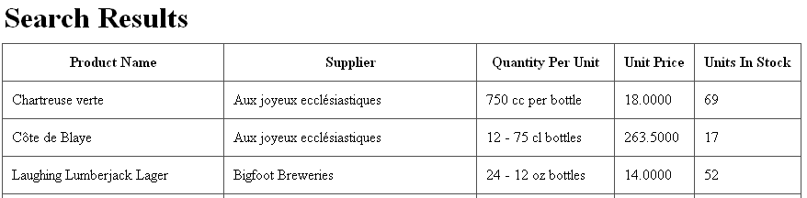
Requirements:
- Use <h1> tag to format the title “Search Results”.
- Use GridView control to display results. This grid must have 5 columns: Product Name, Supplier (CompanyName), Quantity Per Unit, Unit Price and Units In Stock.

2.2. Functions
Requirements:
- Search products by suppliers which are selected in the first page.
- Order data by Supplier and Product Name ascending.
Test cases:
- Test case 1: Don’t choose any suppliers in the first page
  - Display all products in Products table.
- Test case 2: Choose one supplier is “Cooperativa de Quesos 'Las Cabras'” in the first page
  - Display products which have supplier are “Cooperativa de Quesos 'Las Cabras'”.
- Test case 3: Choose two suppliers are “Cooperativa de Quesos 'Las Cabras'” and “Forêts d'érables”
  - Display products which have supplier are “Cooperativa de Quesos 'Las Cabras'” or “Forêts d'érables”.

