Write a Windows Forms application to add new Asset Type.
1. User Interface
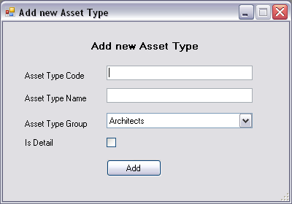
Requirements:
- Uses ComboBox control to display data of AssetTypeGroups table.
- Orders data by GroupName ascending.
2. Validation (1 point)
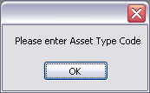 | 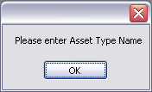
Requirements:
- Requires user to input value for Asset Type Code and Asset Type Name.
3. Event “Click” of “Add” button (2 point)
After validation,
- Adds a new Asset Type into database. (1 point)
- Displays a new dialog box: (1 point)
