ARIZONA STATE UNIVERSITY
CSE 434 — COMPUTER NETWORKS — FALL 2026
SOCKET PROGRAMMING PROJECT
FINAL PROJECT DESIGN REPORT
Distributed Hash Table with Ring Management and Hot-Potato Query Processing
Item | Details
Socket Project Group | 33
Leader peer name | falabbad
Language / transport | Python 3 / UDP sockets
Group port range | 17500–17999
Full-project demonstration | Six peers; DHT n=5; dataset year 1996
Dataset supplied here | details-1950.csv: 223 data rows, 51 columns; s=449
Before submission | Insert real commit-history screenshot, public/unlisted video URL and accurate timestamps.

1. Executive Summary
This report documents a socket-based DHT application with a UDP manager and interactive peer processes. The manager handles the ten commands in the project specification. Peers create a logical ring, distribute storm records, query using hot-potato forwarding, and manage join/leave/teardown. JSON UTF-8 datagrams provide named fields. The code uses Python 3 and the standard library.
The supplied details-1950.csv contains 223 data rows and 51 columns. Its first prime greater than 2ℓ is 449. The full-project demonstration requires details-1996.csv, which was not supplied in this chat; the package includes a downloader for the official NOAA/NCEI file.

1.1 Full-Project Manager Commands
Command | Purpose / success conditions
register | Register unique alphabetic peer; store IP, m-port, p-port and Free state.
setup-dht | Create one DHT; n≥3; manager chooses n−1 Free peers; leader tuple first.
dht-complete | Leader confirms DHT construction.
query-dht | Registered Free peer asks manager for a random DHT start member.
leave-dht | Member initiates teardown, renumbering and rebuild with n−1 members.
join-dht | Registered Free peer requests inclusion in a DHT rebuild.
dht-rebuilt | Confirm matching pending join/leave; update states and leader.
deregister | Remove a Free peer; DHT members cannot deregister.
teardown-dht | Leader initiates DHT deletion.
teardown-complete | Leader confirms deletion; former members become Free.

1.2 Group 33 Port Allocation
Group 33 is odd, giving the assigned range 17500–17999. All application ports must remain in this range.
Process | Manager port | Peer port
Manager | 17500 | —
falabbad | 17501 | 17502
peerone | 17503 | 17504
peertwo | 17505 | 17506
peerthree | 17507 | 17508
peerfour | 17509 | 17510
peerfive | 17511 | 17512

2. Architecture and State Model
Each peer binds one UDP socket for manager traffic and one for peer-to-peer traffic. A listener thread handles peer messages while the CLI issues manager requests. Manager requests and responses are paired; the peer waits for a response before its next manager command.
Component | Data / responsibility
Manager | Peer table, leader, ordered members, year, hash table size, pending modification; validates and updates state.
Peer | Name, IP, m/p ports, node ID, ring size, member list, right neighbour and local table.
Local table | Hash position maps to a list of records to preserve collisions.
Ring | Management and STORE forwarding go ID 0→1→…→n−1→0.
Query context | Query ID, return tuple, visited node IDs and id-seq.
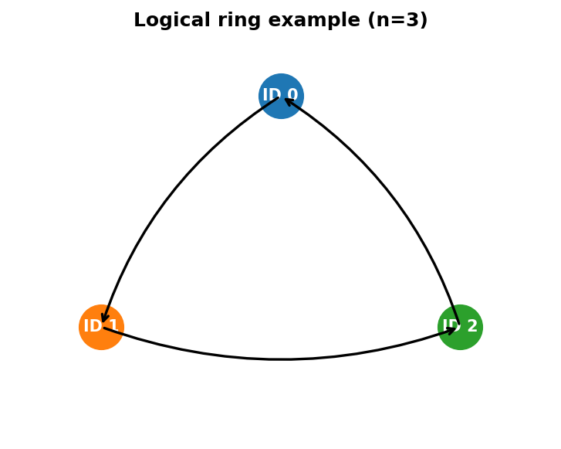
Figure 1. Logical ring example (n=3); same next-neighbour rule applies to n=5.

3. Wire Protocol and Message Formats
Each UDP datagram is a UTF-8 JSON object. Manager requests contain command; manager responses contain type=manager-response, code=SUCCESS or FAILURE, and message. Peer-to-peer messages contain type and operation-specific fields.

3.1 Manager examples
{"command":"register","peer_name":"falabbad","ip":"192.0.2.10","m_port":17501,"p_port":17502}
{"command":"setup-dht","peer_name":"falabbad","n":5,"year":1996}
{"command":"query-dht","peer_name":"peerfive"}

3.2 Peer message catalog
Message | Fields / purpose
set-id / set-id-ack | node_id, ring_size, ordered members, year; ACK confirms initialization.
store / store-ack | store_id, position, destination_id, full record and return address; destination stores idempotently and acknowledges.
store-complete / count-report | Ring barrier and per-node record counts.
find-event / find-event-response | Event ID, hash metadata, visited IDs, id-seq, return address; result returns full record or failure.
teardown | Clears local table as it circles the ring.
reset-id | Ordered remaining members, cursor, year and return address; renumbers after leave.
rebuild-dht / rebuild-complete | New leader rebuilds and notifies initiator.
join-request | Current leader rebuilds membership to include a joining Free peer.

4. Time–Space Diagrams
The diagrams show the order of messages between communicating entities and the key action on receipt.
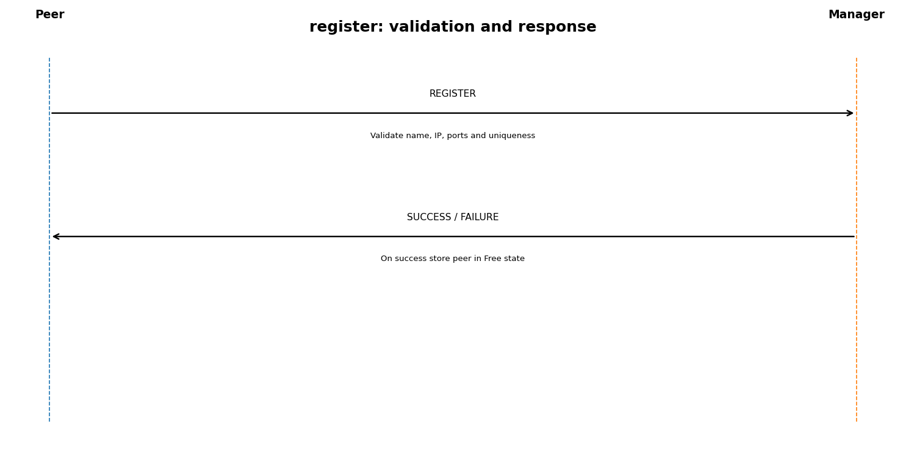
Figure 2. register request and response.
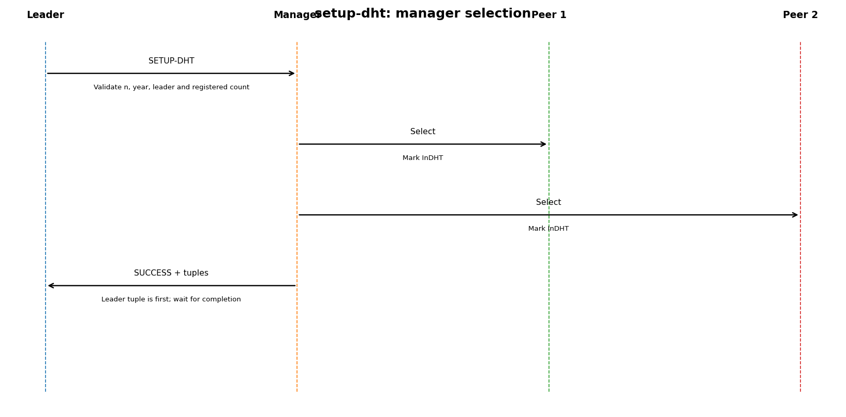
Figure 3. setup-dht and member selection.
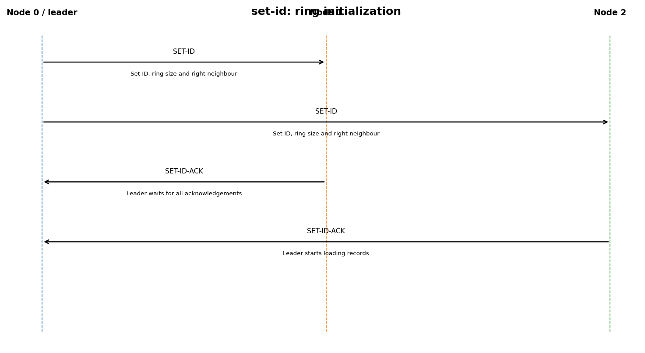
Figure 4. set-id initialization and acknowledgements.
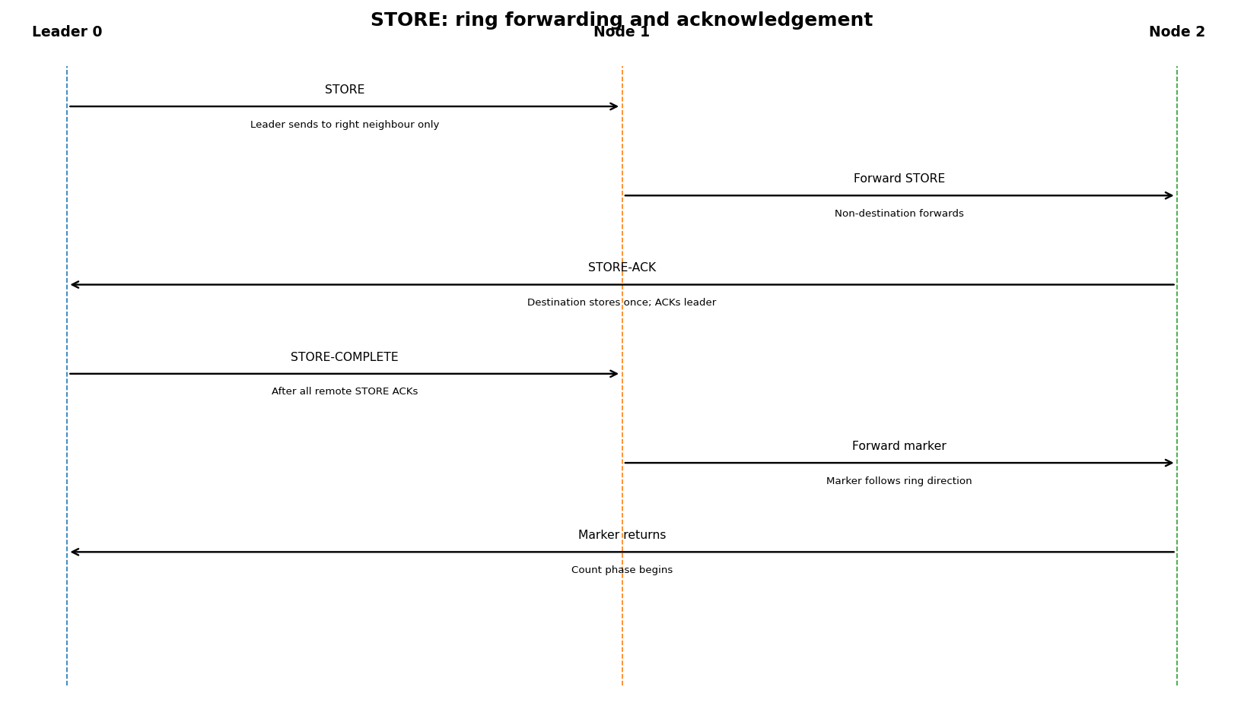
Figure 5. STORE forwarding and completion barrier.
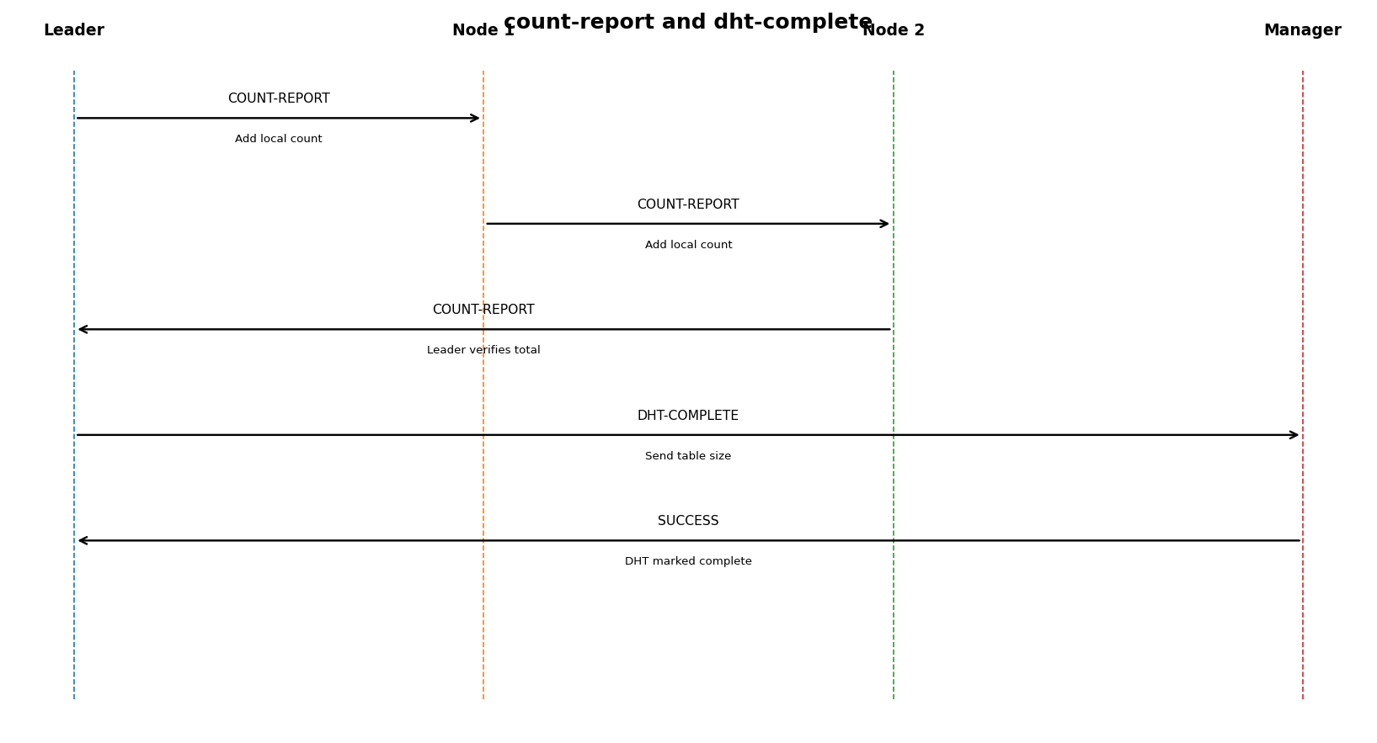
Figure 6. count-report and dht-complete.
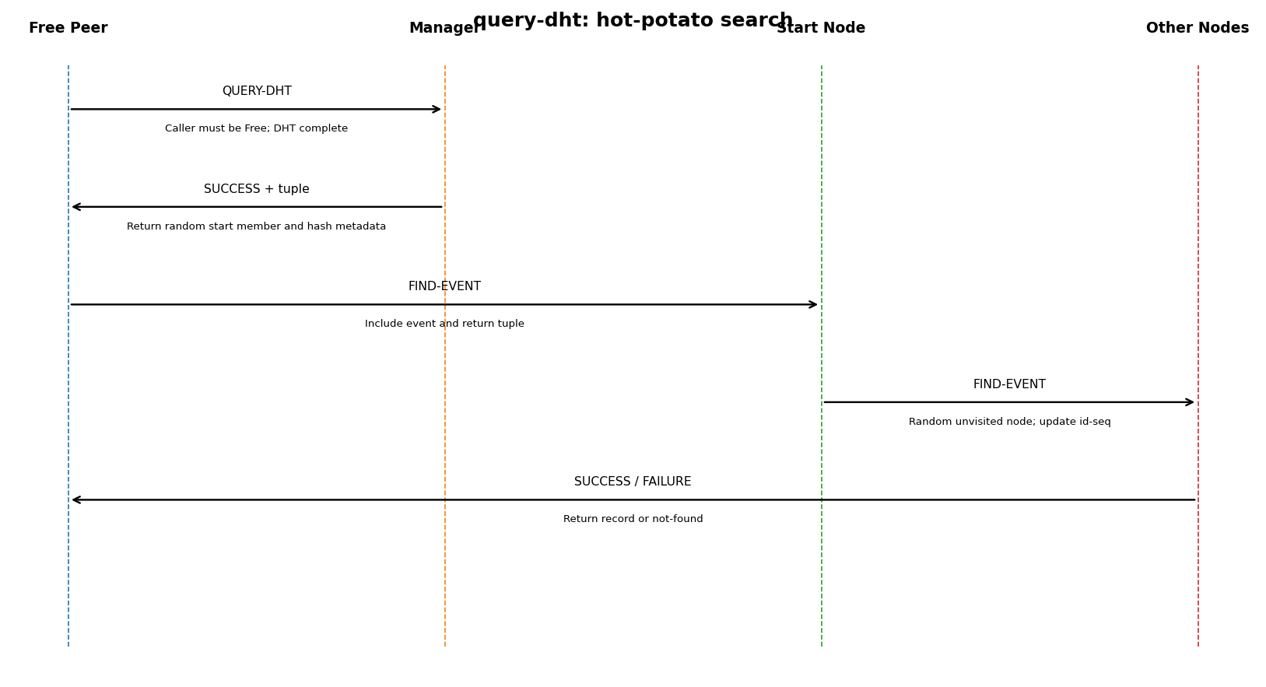
Figure 7. query-dht hot-potato search.
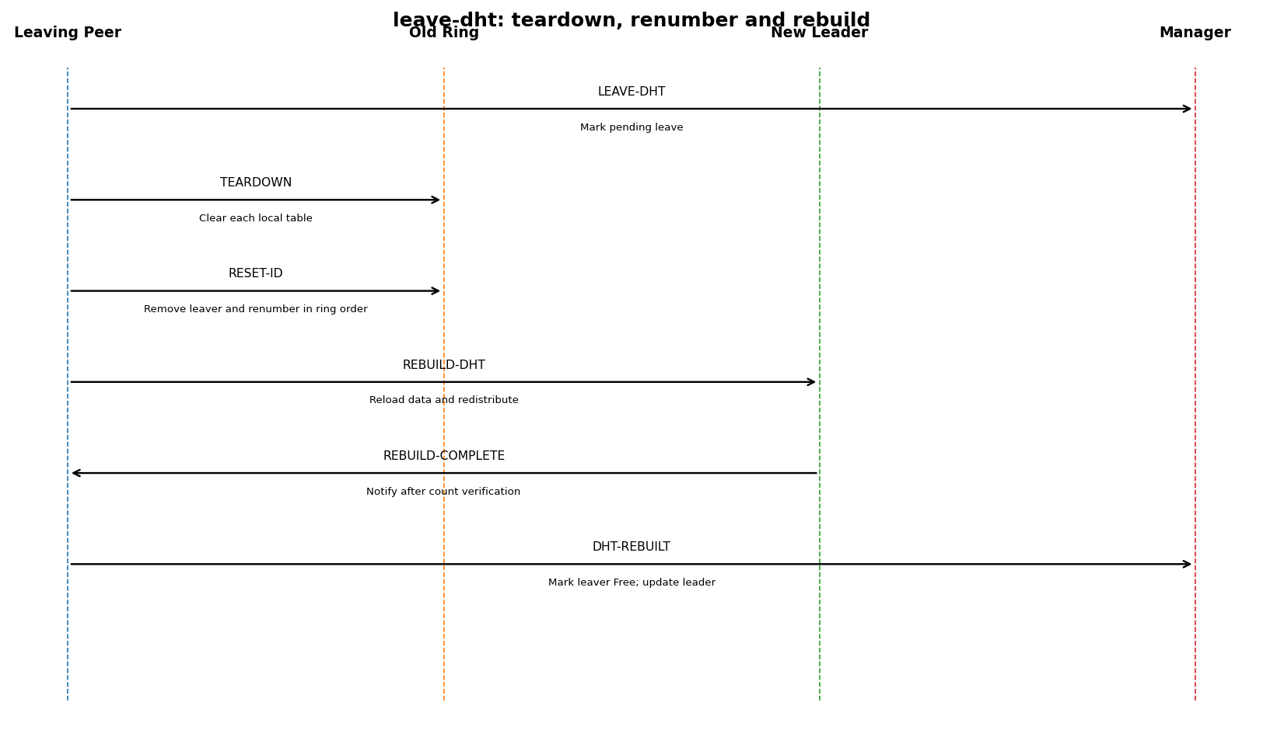
Figure 8. leave-dht teardown and rebuild.
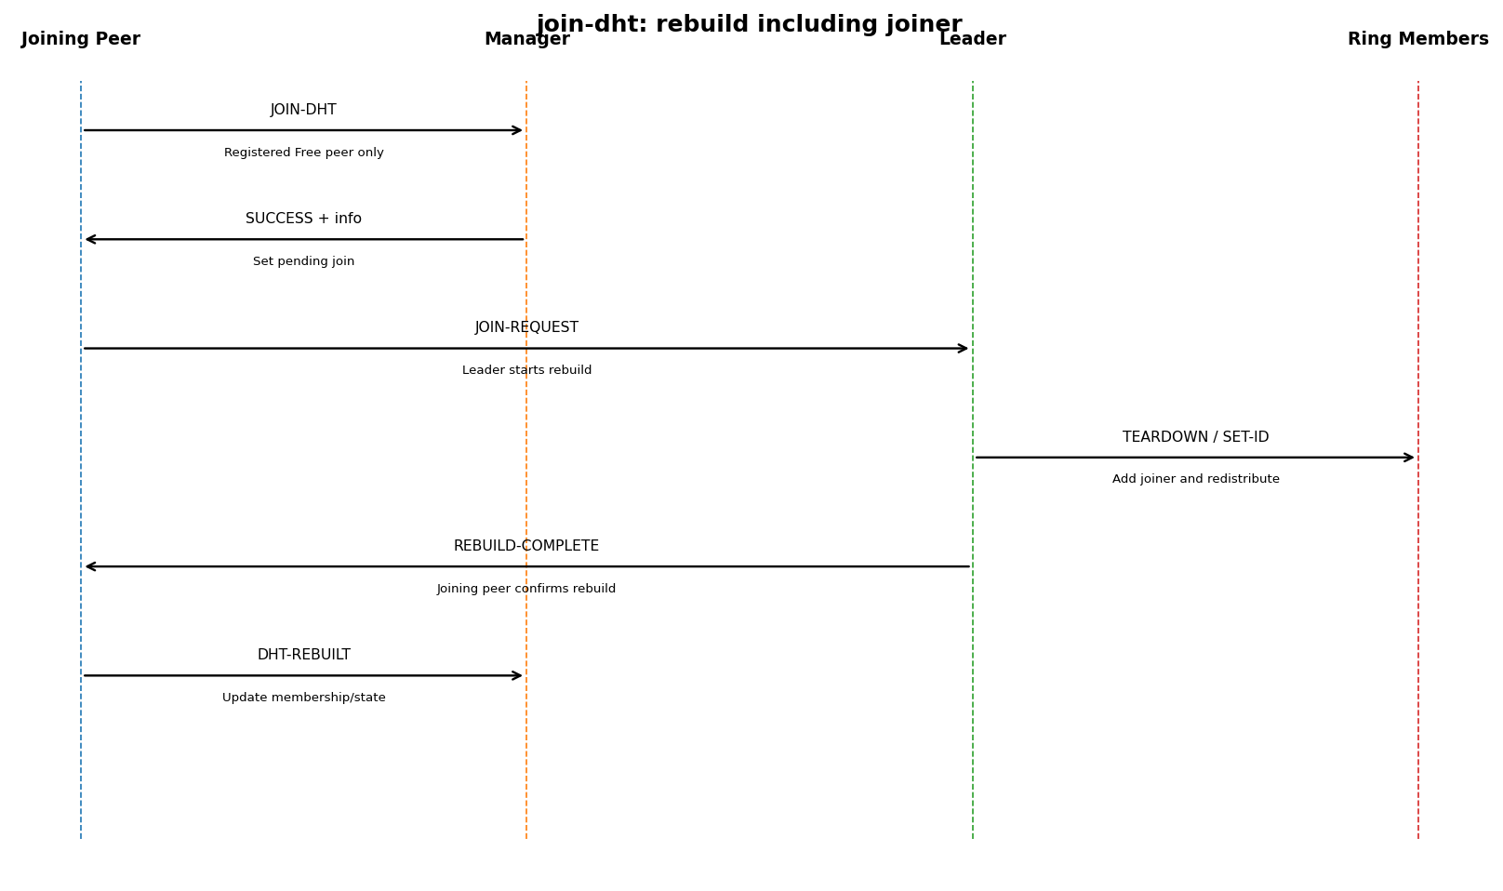
Figure 9. join-dht rebuild.
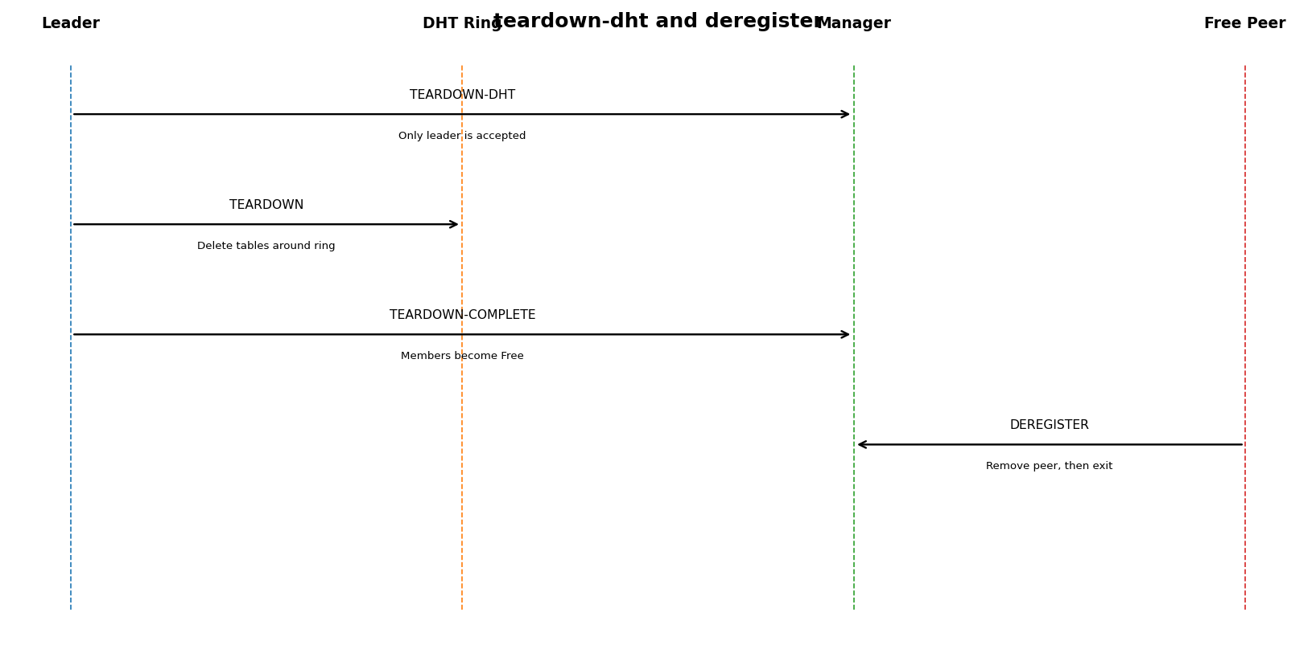
Figure 10. teardown and deregistration.

5. Dataset and Hashing
The first CSV row is a header and is excluded from ℓ. For the supplied 1950 file, ℓ=223, 2ℓ=446, and the first prime greater than 2ℓ is s=449. The parser finds EVENT_ID by header name and preserves all columns.
position = EVENT_ID mod 449
destination_id = position mod ring_size
For other years, ℓ and s are recalculated. The full-project demo requires year 1996. Run python3 download_dataset.py 1996 on a host with Internet access; the downloader uses the NOAA/NCEI archive. No substitute 1996 data is fabricated.

5.1 Collision handling and UDP reliability
Each hash position maps to a list (separate chaining). STORE messages carry unique store_id values; destinations store each ID once and send acknowledgements to the leader. The leader retries unacknowledged records through its right neighbour, then sends store-complete after all remote acknowledgements arrive.

6. Manager state transitions
Event | State transition
register | Not registered → Free.
setup-dht | No DHT → leader Leader; selected peers InDHT; manager waits for dht-complete.
dht-complete | DHT under construction → complete.
query-dht | No state change; caller must be Free and DHT complete.
leave-dht | Pending leave; on dht-rebuilt, leaver Free and new leader recorded.
join-dht | Pending join; on dht-rebuilt, joiner becomes InDHT.
dht-rebuilt | Update member list, leader and completed state.
deregister | Remove a Free peer.
teardown-dht | Leader starts deletion; manager waits for teardown-complete.
teardown-complete | Clear DHT state; all former members become Free.

7. Implementation decisions and error handling
- Validate Group 33 ports (17500–17999), IPv4, peer-name length/alphabetic rule, and port uniqueness.
- Use separate manager and peer UDP sockets; a listener thread handles P2P messages.
- Use direct set-id distribution only for initial assignment; all STORE traffic follows the logical ring.
- Use store acknowledgements and idempotent store IDs to mitigate UDP loss.
- Use random unvisited nodes for hot-potato query forwarding; return id-seq and the complete record.
- Reject queries during construction/modification and reject query-dht for peers not in Free state.
- Serialize join/leave/teardown operations through manager pending state.
- Missing data files and invalid EVENT_ID values raise explicit errors.

8. Build and run instructions

8.1 Syntax check
python3 -m py_compile manager.py peer.py protocol.py dht_utils.py download_dataset.py
No C compiler or third-party package is required.

8.2 Start manager
python3 manager.py 17500

8.3 Start and register six peers
python3 peer.py <MANAGER_IPV4> 17500
register falabbad <FALABBAD_IPV4> 17501 17502
register peerone <PEERONE_IPV4> 17503 17504
register peertwo <PEERTWO_IPV4> 17505 17506
register peerthree <PEERTHREE_IPV4> 17507 17508
register peerfour <PEERFOUR_IPV4> 17509 17510
register peerfive <PEERFIVE_IPV4> 17511 17512
Use real reachable IPv4 addresses on each host. Do not use 127.0.0.1 across different machines. Peer CLI has exactly two command-line parameters: manager IPv4 and manager port. Registration details are entered interactively.

8.4 Full-project demonstration sequence
- Download 1996 data: python3 download_dataset.py 1996
- On falabbad: setup-dht falabbad 5 1996
- From the Free peer after random selection: query-dht <FREE_PEER_NAME> 5536849
- Run query-dht <FREE_PEER_NAME> 2402920, then 5539287, then 55770111.
- From a DHT member: leave-dht <MEMBER_NAME>; then have the leaving peer query.
- From the other Free peer: join-dht <JOINER_NAME>; then have the remaining outside peer query.
- From the current leader: teardown-dht <LEADER_NAME>.
- After teardown, deregister every peer: dereg <PEER_NAME>; stop manager with Ctrl+C.
The full-project video requires at least four distinct end-hosts and six peer processes, a maximum duration of 15 minutes, audio, no splicing/edits, readable terminals, and labelled message traces.

8.5 Milestone test with supplied data
setup-dht falabbad 3 1950
Expected supplied-data total: 223 records; table size 449; node counts must sum to 223 before dht-complete.

9. Verification status
Test | Status
Syntax check for Python files | Passed locally.
Three peers register and setup DHT using supplied 1950 data | Passed locally.
Record counts: 223 total; table size 449 | Passed locally; counts summed to expected total.
Manager dht-complete response | Passed locally.
Four-host demo / year 1996 query set / join / leave / teardown | Must be exercised on the actual demo hosts before claiming full-project validation.
This package is not a substitute for recording the required real demo. Insert only actual screenshots, commits and video evidence.

10. Version-control evidence
Create a repository, commit incrementally, and ensure access settings prevent plagiarism. Insert a real screenshot of commit history; do not fabricate commits.
Evidence | To complete
Repository URL/name | ________________________________________
Commit history screenshot | Paste actual screenshot into this report.
Working tree | Record clean state or explain outstanding changes.

11. Video URL and timestamps
Spec step | Required video content | Actual timestamp
3(a) | Compile/syntax-check manager and peer | ____________
3(b) | Run fresh programs on ≥4 distinct end-hosts | ____________
3(c) | Start manager and six registered peers | ____________
3(d) | Build n=5 DHT with year 1996 | ____________
3(e) | Query all four specified event IDs | ____________
3(f) | Leave DHT and query from leaving peer | ____________
3(g) | Join DHT and query from remaining outside peer | ____________
3(h) | Leader tears down DHT | ____________
3(i) | Deregister all peers and stop manager | ____________
YouTube URL: ________________________________________________
Replace all timestamps with exact timestamps from the uploaded unedited video. Make sure graders can access the link.

12. Submission checklist
- Include source code, README, data files required for the demonstrated year, design PDF and documentation in the course ZIP.
- Confirm the course's exact ZIP naming requirement; the specification gives Socket Project X.zip for group X.
- Insert actual version-control evidence, public/unlisted video URL and accurate timestamps.
- Verify the full sequence on at least four distinct hosts and six peer processes.
- Keep every application port within 17500–17999.

References
Arizona State University, CSE 434, SLN 81721, Computer Networks, Fall 2026. Socket Programming Project, §§1.1–1.2.5, 2, 3 and 4.2.
NOAA/NCEI Storm Events Database, bulk CSV archive: https://www.ncei.noaa.gov/pub/data/swdi/stormevents/csvfiles/

