HAW Analysis – Initial Findings
15/06/2026-
1. Destination-wise Booking Analysis
- Dubai received the highest number of bookings (41).
- Manali received 36 bookings.
- Kashmir received 35 bookings.
- Kerala received the lowest number of bookings (23).
2. Revenue Analysis
- Dubai generated the highest revenue (₹24,93,352).
- Bali generated the second highest revenue (₹22,51,676).
- Kerala generated the lowest revenue (₹5,16,974).
3. Cancellation Analysis
- Total Bookings: 200
- Confirmed Bookings: 155
- Cancelled Bookings: 45
- Cancellation Rate: 22.5%
Cancellation Rate = (Cancelled Bookings ÷ Total Bookings) × 100
= (45 ÷ 200) × 100
= 22.5%
Business Conclusion
- Dubai is the strongest destination in terms of both bookings and revenue.
- Kerala shows the lowest demand and revenue.
- The company should investigate the causes of the 22.5% cancellation rate and explore strategies to reduce cancellations.
screenshots-
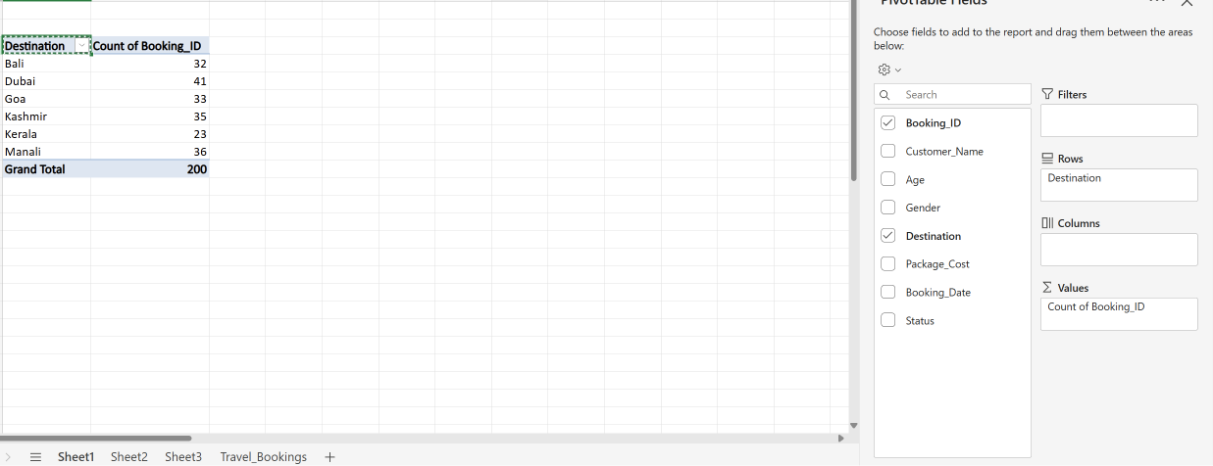
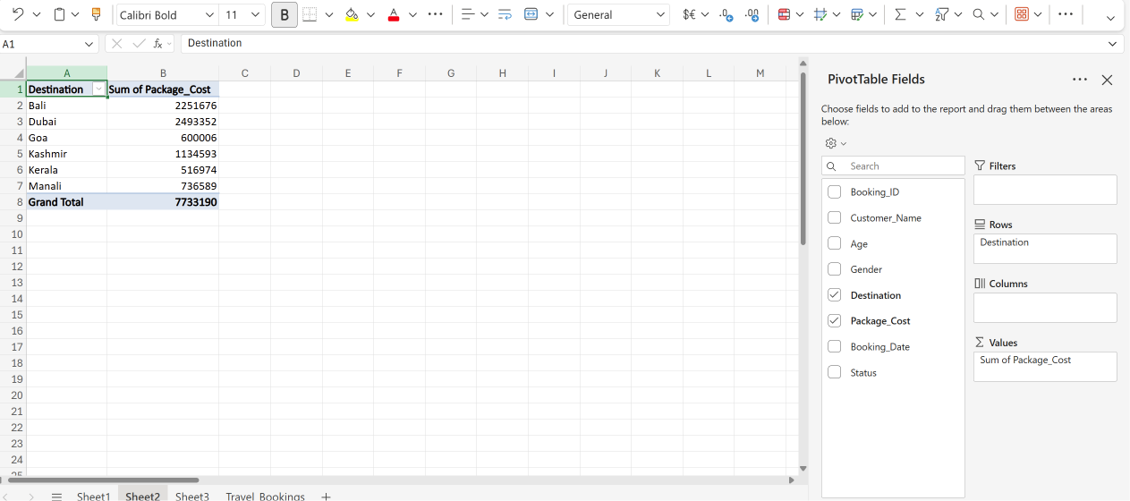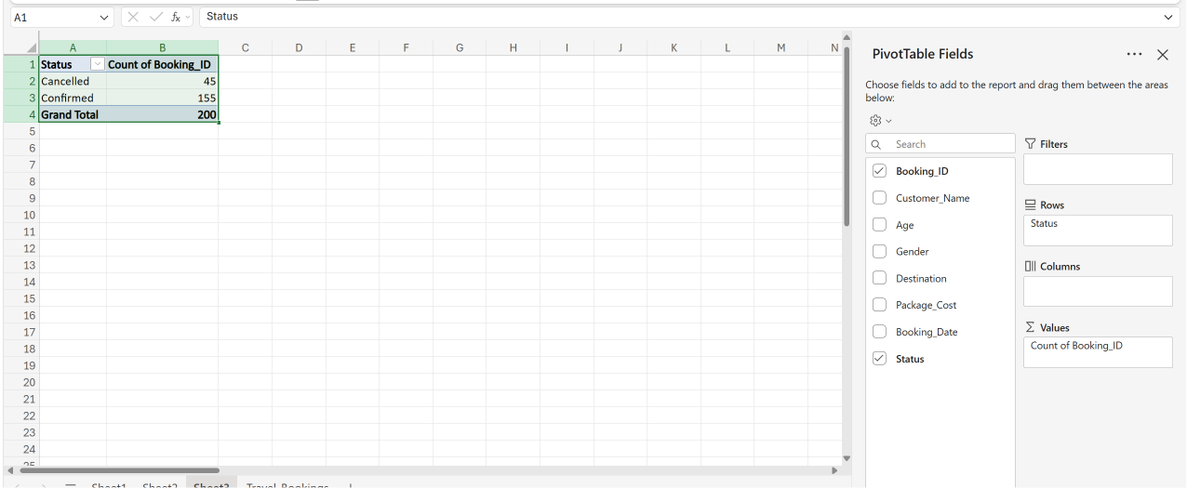
16/06/2026-
Customer Age Group Analysis
- Conducted age-group analysis to understand the demographic distribution of customers.
- The 36–40 age group recorded the highest number of bookings with 42 transactions.
- The 21–25 age group followed closely with 41 bookings.
- The 31–35 and 41–45 age groups each contributed 33 bookings.
- The 26–30 and 46–50 age groups recorded 26 and 25 bookings respectively.
- The analysis indicates that working professionals and middle-aged customers form a significant portion of the agency's customer base.
- These insights can help the company design targeted marketing campaigns and customized travel packages for the most active customer segments.
Gender-wise Customer Analysis
- Performed gender-based analysis to evaluate customer participation.
- Male customers accounted for 107 bookings (53.5%).
- Female customers accounted for 93 bookings (46.5%).
- The results indicate a relatively balanced customer distribution across both genders.
- The slightly higher participation of male customers suggests opportunities to further strengthen engagement among female travelers through targeted promotional strategies.
Monthly Booking Trend Analysis
- Analyzed booking patterns from January 2026 to June 2026 to identify seasonal demand trends.
- January recorded the highest booking volume with 38 bookings.
- April and February followed with 36 and 34 bookings respectively.
- May and June recorded 32 and 31 bookings respectively.
- March recorded the lowest booking volume with 29 bookings.
- The booking pattern remained relatively stable throughout the six-month period.
- Understanding monthly trends can help the organization plan promotional campaigns, allocate resources effectively, and improve demand forecasting.
Key Findings
- Largest customer segment: 36–40 years (42 bookings).
- Male customers represented 53.5% of total bookings.
- Female customers represented 46.5% of total bookings.
- January was the highest-performing month with 38 bookings.
- March recorded the lowest booking volume with 29 bookings.
- Customer participation remained balanced across demographic groups, indicating a diverse customer base.
Conclusion
- The analysis provided valuable insights into customer demographics and booking behavior.
- Working professionals emerged as the primary customer segment.
- Monthly booking activity remained consistent with minor fluctuations across the study period.
- The findings can support customer targeting, marketing strategy development, and future business planning for the travel agency.

Screenshots-
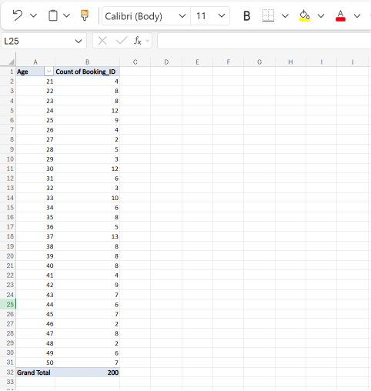
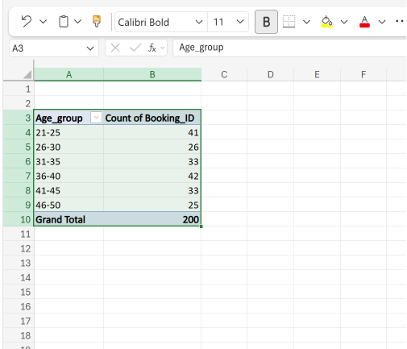
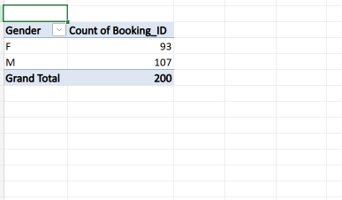

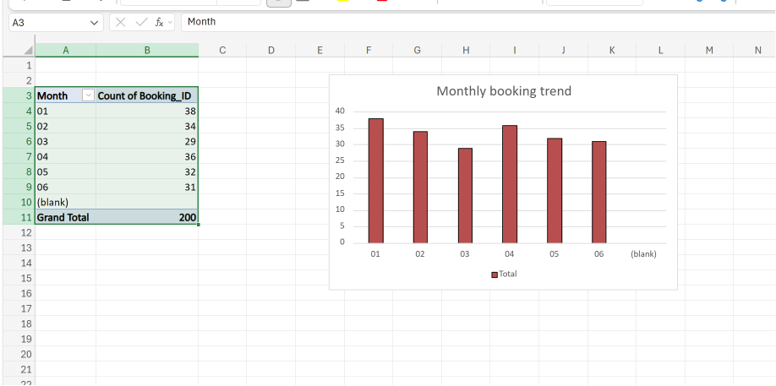

17/6/2026-
Revenue Contribution by Gender
- Conducted a gender-wise revenue analysis to determine which customer segment contributed the highest revenue to the travel agency.
- Male customers generated a total revenue of ₹40,74,446, accounting for approximately 52.7% of total revenue.
- Female customers generated a total revenue of ₹36,58,744, accounting for approximately 47.3% of total revenue.
- The analysis indicates that male customers contributed slightly more revenue than female customers.
- The relatively balanced revenue distribution suggests that travel packages are appealing to both customer groups.
- These insights can help the company develop targeted marketing strategies to increase customer engagement and revenue generation.

Revenue Contribution by Age Group
- Performed age-group-based revenue analysis to identify the most valuable customer segment.
- The 36–40 years age group generated the highest revenue of ₹17,18,534.
- The 21–25 years age group generated the second-highest revenue of ₹16,99,426.
- Customers aged 31–35 years contributed ₹14,05,968 in revenue.
- The 41–45 years age group generated ₹11,19,848.
- The 26–30 years and 46–50 years age groups generated ₹9,53,635 and ₹8,36,139 respectively.
- The findings indicate that middle-aged customers contribute significantly to the company's revenue.
- Understanding high-value customer segments can assist the company in designing premium travel packages and personalized promotional campaigns.

Monthly Revenue Trend Analysis
- Conducted monthly revenue analysis to identify revenue fluctuations across the six-month period.
- February generated the highest revenue of ₹15,29,782.
- January and April generated revenues of ₹14,77,289 and ₹14,26,755 respectively.
- June contributed ₹11,72,695 in revenue.
- May generated ₹10,91,475, while March recorded the lowest revenue of ₹10,35,194.
- The revenue trend remained relatively stable throughout the study period with moderate variations between months.
- The higher revenue observed during February may indicate increased customer demand and successful package sales during that period.
- Revenue trend analysis can support business forecasting, budget planning, and future marketing decisions.

Key Findings
- Total revenue analyzed: ₹77,33,190
- Highest revenue-generating gender: Male customers (₹40,74,446)
- Highest revenue-generating age group: 36–40 years (₹17,18,534)
- Highest revenue-generating month: February (₹15,29,782)
- Lowest revenue-generating month: March (₹10,35,194)
- Revenue contribution remained relatively balanced across demographic groups.

Conclusion
- Revenue analysis provided valuable insights into customer spending behavior and revenue generation patterns.
- Male customers contributed slightly higher revenue compared to female customers.
- The 36–40 age group emerged as the most valuable customer segment in terms of revenue generation.
- Monthly revenue trends remained stable, with February recording the highest revenue performance.
- The findings can support strategic decision-making, customer targeting, pricing strategies, and future business growth initiatives.

Screenshots-
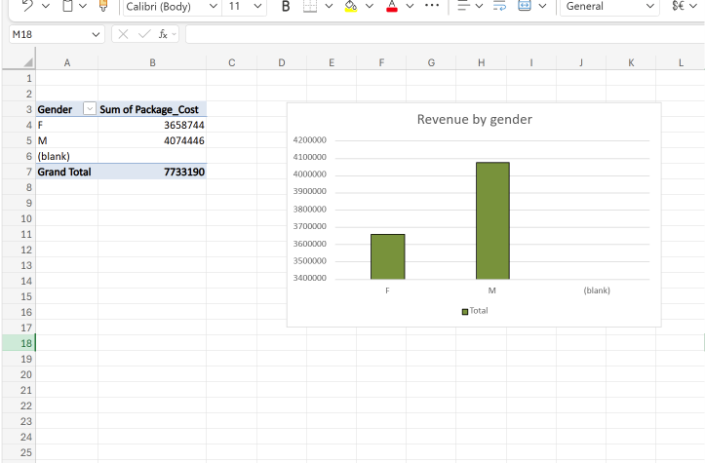
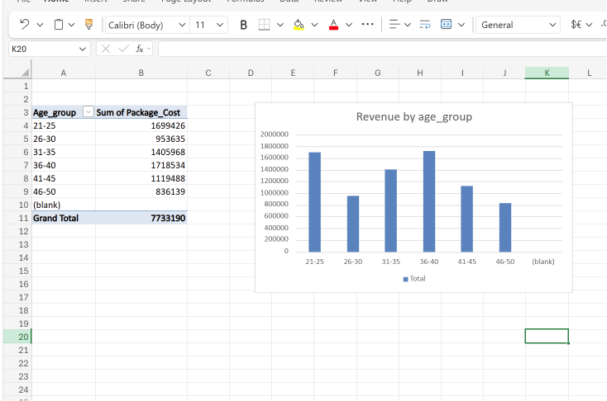
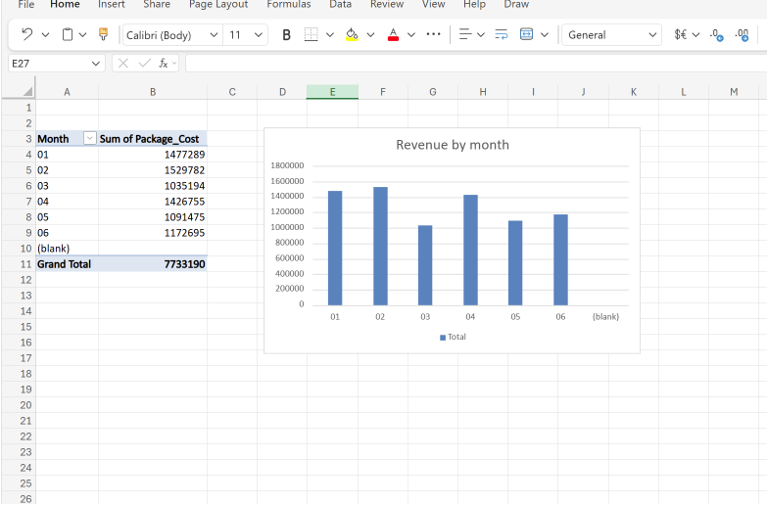
18/6/2026-
Dashboard Development
- Developed an interactive dashboard to summarize key business metrics and analytical findings.
- Integrated booking, revenue, customer demographic, and cancellation analyses into a single reporting interface.
- Displayed key performance indicators including Total Bookings, Total Revenue, Cancellation Rate, Top Destination, and Best Revenue Month.
- Incorporated multiple charts to improve data visualization and decision-making.
- The dashboard provides management with a quick overview of business performance and customer trends.

Key Performance Indicators (KPIs)
- Total Bookings: 200
- Total Revenue: ₹77,33,190
- Confirmed Bookings: 155
- Cancelled Bookings: 45
- Cancellation Rate: 22.5%
- Top Destination: Dubai
- Best Revenue Month: February

Conclusion
- Successfully consolidated all analytical findings into a single dashboard.
- Improved accessibility of business insights through graphical visualizations and KPI tracking.
- The dashboard serves as a comprehensive overview of customer behavior, booking trends, and revenue performance.

Screenshots-
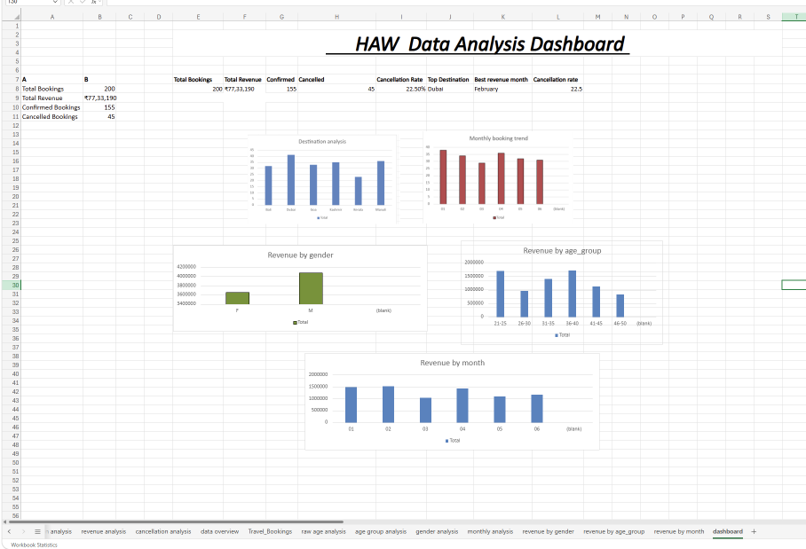

19/06/2026-
Destination-wise Cancellation Analysis
Objective
To analyze booking cancellations across different travel destinations and identify destinations with high cancellation rates that may impact business performance.
Analysis Performed
- Created a Pivot Table to summarize confirmed and cancelled bookings for each destination.
- Calculated destination-wise cancellation rates using cancelled bookings and total bookings.
- Developed a chart to visualize cancellation patterns across destinations.
- Compared cancellation performance among destinations to identify areas requiring business attention.
Key Findings
- Dubai recorded the highest cancellation rate at 36.59%.
- Kerala recorded the second-highest cancellation rate at 34.78%.
- Manali recorded a cancellation rate of 22.22%.
- Bali and Kashmir recorded cancellation rates of 15.63% and 14.29% respectively.
- Goa recorded the lowest cancellation rate at 12.12%.
- The overall cancellation rate for the travel agency was 22.5%.
Business Insights
- High cancellation rates in Dubai and Kerala may result in revenue loss and reduced operational efficiency.
- Goa demonstrates strong booking retention and may serve as a benchmark for customer engagement strategies.
- Identifying reasons behind cancellations can help improve booking conversion and customer satisfaction.
Recommendations
- Investigate customer feedback and booking behavior for Dubai and Kerala packages.
- Introduce booking confirmation incentives and reminder campaigns.
- Review pricing and package structures for destinations with high cancellation rates.
- Replicate successful customer retention practices used for Goa.

Destination-wise Revenue Analysis
Objective
To evaluate the revenue contribution of each destination and identify the most profitable destinations for the travel agency.
Analysis Performed
- Created a Pivot Table to calculate total revenue generated by each destination.
- Sorted destinations based on revenue contribution.
- Developed a revenue visualization chart for comparative analysis.
- Compared revenue performance with booking and cancellation trends.
Key Findings
- Dubai generated the highest revenue of ₹24,93,352.
- Bali generated the second-highest revenue of ₹22,51,676.
- Kashmir generated ₹11,34,593 in revenue.
- Manali generated ₹7,36,589 in revenue.
- Goa generated ₹6,00,006 in revenue.
- Kerala generated the lowest revenue of ₹5,16,974.
- Dubai emerged as both the highest-booked and highest revenue-generating destination.
Business Insights
- Dubai and Bali are the primary revenue drivers for the company.
- Kerala contributes the least revenue and also experiences high cancellation rates.
- Revenue concentration in a few destinations indicates opportunities to strengthen performance in lower-performing destinations.
Recommendations
- Increase promotional efforts for high-performing destinations such as Dubai and Bali.
- Develop premium package offerings for popular destinations.
- Improve marketing strategies for low-revenue destinations.
- Monitor cancellation trends to prevent revenue leakage from high-demand destinations.

Screenshots-
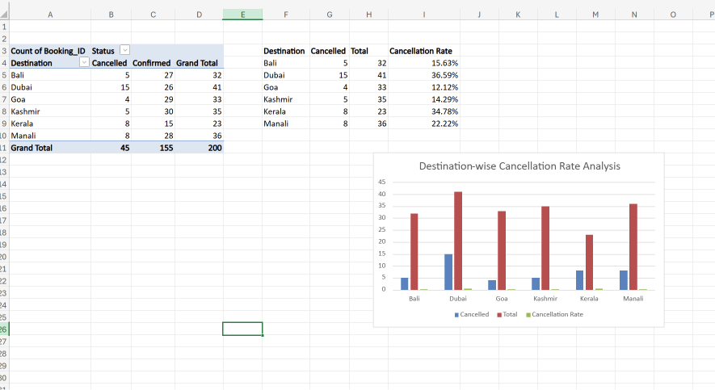
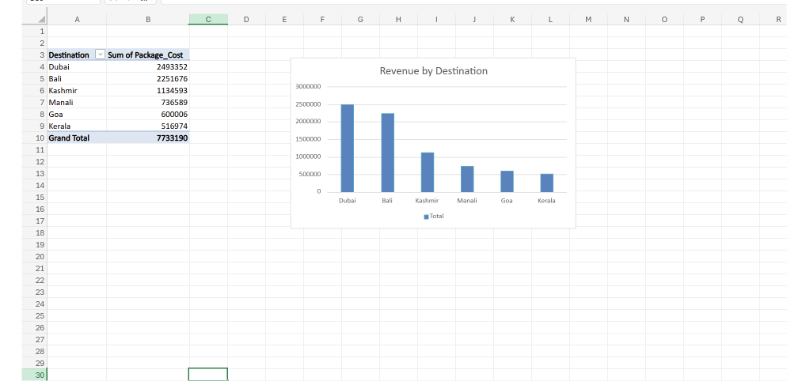

22/06/2026-
Average Package Cost Analysis by Destination
Objective
To determine the average package cost for each travel destination and identify premium, mid-range, and budget travel destinations.
Analysis Performed
- Created a Pivot Table to calculate the average package cost for each destination.
- Compared pricing patterns across destinations.
- Identified destinations with premium and budget pricing structures.
- Evaluated the relationship between package pricing and revenue generation.
Key Findings
- Bali recorded the highest average package cost at ₹70,364.88.
- Dubai recorded the second-highest average package cost at ₹60,813.46.
- Kashmir recorded an average package cost of ₹32,416.94.
- Kerala recorded an average package cost of ₹22,477.13.
- Manali recorded an average package cost of ₹20,460.81.
- Goa recorded the lowest average package cost at ₹18,182.00.
Business Insights
- Bali and Dubai represent premium travel destinations with high customer spending.
- Kashmir serves as a mid-range destination with balanced pricing.
- Goa and Manali cater primarily to budget-conscious travelers.
- Destination pricing plays a significant role in revenue generation and customer purchasing decisions.
Recommendations
- Promote Bali and Dubai as premium travel experiences.
- Introduce luxury package upgrades for high-value destinations.
- Create attractive bundled offers for Goa and Manali to increase booking volumes.
- Use pricing insights to design destination-specific marketing campaigns.

Customer Segmentation and Revenue Contribution Analysis
Objective
To classify customers based on package spending and evaluate the contribution of each customer segment to overall bookings and revenue.
Analysis Performed
- Categorized customers into Budget, Standard, and Premium segments based on package cost.
- Calculated customer distribution across each segment.
- Analyzed revenue contribution generated by each segment.
- Evaluated customer spending patterns and segment profitability.
Key Findings
- Budget customers accounted for 104 bookings (52% of total customers).
- Premium customers accounted for 73 bookings (36.5% of total customers).
- Standard customers accounted for 23 bookings (11.5% of total customers).
- Premium customers generated the highest revenue of ₹47,45,028.
- Budget customers generated ₹21,84,244 in revenue.
- Standard customers generated ₹8,03,918 in revenue.
- Premium customers contributed approximately 61.4% of total company revenue.
Business Insights
- Premium customers are the most valuable customer segment and contribute the majority of business revenue.
- Budget customers form the largest customer base and ensure consistent booking volume.
- The Standard segment has growth potential through targeted package upgrades and promotional strategies.
- Customer spending patterns indicate strong demand for premium travel experiences.
Recommendations
- Strengthen customer retention programs for Premium travelers.
- Introduce personalized offers and loyalty benefits for high-value customers.
- Encourage Budget customers to upgrade to Standard or Premium packages.
- Focus marketing campaigns on customer segments that generate the highest revenue.

Screenshots-
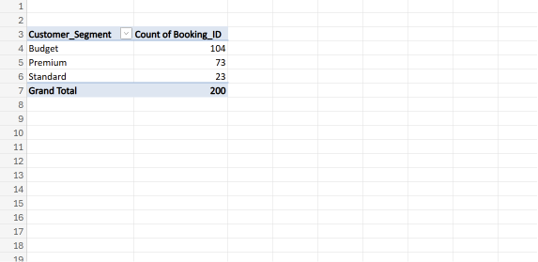
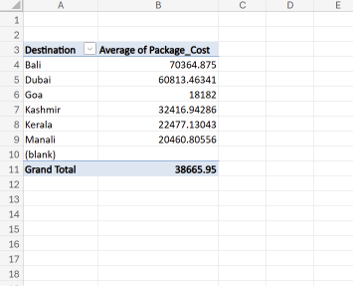
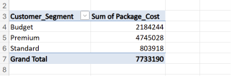

23/6/2026-
Revenue Contribution Analysis by Destination
Objective
To determine the percentage contribution of each destination to the company's total revenue and identify the most profitable destinations.
Analysis Performed
- Calculated total revenue generated by each destination.
- Computed the percentage contribution of each destination to overall revenue.
- Created a pie chart to visualize revenue distribution across destinations.
- Compared destination performance based on revenue contribution.
Key Findings
- Dubai contributed the highest share of revenue at 32%.
- Bali contributed 29% of total revenue, making it the second-highest revenue-generating destination.
- Kashmir contributed 15% of total revenue.
- Manali contributed 10% of total revenue.
- Goa and Kerala contributed 8% and 7% respectively.
- Dubai and Bali together generated 61% of the company's total revenue.
Business Insights
- Revenue is concentrated in a few key destinations, particularly Dubai and Bali.
- Dubai and Bali are the strongest revenue drivers for the business.
- Lower-performing destinations such as Goa and Kerala may require additional marketing efforts to increase revenue generation.
- Diversifying revenue sources across destinations can reduce business dependency on a few locations.
Recommendations
- Continue promoting Dubai and Bali as flagship destinations.
- Develop premium travel packages for high-performing destinations.
- Increase promotional campaigns for Goa and Kerala to improve revenue contribution.
- Allocate marketing budgets based on destination profitability.

Top Value Booking Analysis
Objective
To identify the highest-value bookings and evaluate which destinations attract premium-spending customers.
Analysis Performed
- Sorted all bookings in descending order based on package cost.
- Identified the highest-value bookings in the dataset.
- Examined destination distribution among premium bookings.
- Evaluated the role of premium bookings in revenue generation.
Key Findings
- The highest booking value recorded was ₹83,794.
- All top 10 highest-value bookings belonged to Bali.
- Bali consistently appears as the leading premium destination.
- Premium bookings are concentrated in a small number of destinations, particularly Bali.
Business Insights
- Bali attracts customers willing to spend significantly more on travel packages.
- Premium travel demand is strongest for Bali packages.
- High-value bookings contribute substantially to overall business revenue.
- Bali has established itself as the company's premium destination offering.
Recommendations
- Expand premium and luxury package offerings for Bali.
- Introduce exclusive add-on services and customized travel experiences.
- Replicate Bali's premium package strategy for other destinations such as Dubai and Kashmir.
- Focus targeted marketing campaigns on high-spending customer segments.

Screenshots-
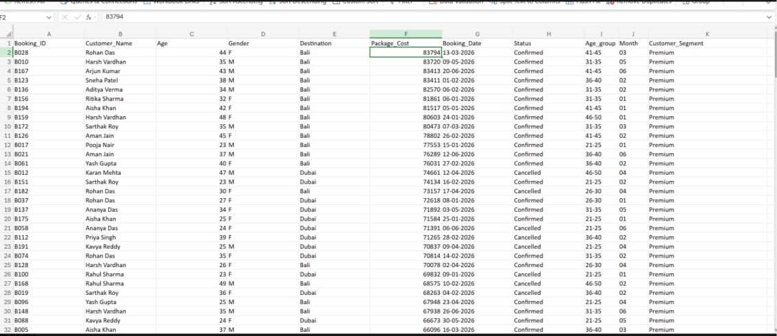
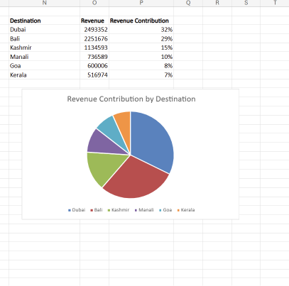

24/06/2026-
Destination Performance Analysis
Objective
To evaluate destination performance by analyzing bookings, revenue generation, and cancellation rates in order to identify the strongest and weakest performing destinations.
Analysis Performed
- Combined booking volume, revenue, and cancellation rate data for each destination.
- Compared destination performance using key business metrics.
- Ranked destinations based on overall performance.
- Classified destinations according to their business impact and risk level.
Key Findings
- Bali ranked as the best-performing destination due to strong revenue generation and a relatively low cancellation rate.
- Dubai generated the highest revenue but recorded the highest cancellation rate among major destinations.
- Kashmir demonstrated stable performance with moderate revenue and low cancellations.
- Goa recorded the lowest cancellation rate, making it the most reliable destination.
- Manali showed average performance with moderate revenue and cancellation levels.
- Kerala recorded the lowest revenue and one of the highest cancellation rates.
Destination Ranking
- Bali – Excellent
- Kashmir – Very Good
- Goa – Good
- Dubai – High Revenue, High Risk
- Manali – Average
- Kerala – Needs Improvement
Business Insights
- Bali is the company's strongest overall destination and should remain a priority for marketing and promotional activities.
- Dubai contributes significantly to revenue but requires investigation into cancellation causes.
- Goa's low cancellation rate indicates strong customer satisfaction and booking stability.
- Kerala requires performance improvement initiatives to increase bookings and reduce cancellations.
- Revenue diversification across destinations can reduce business dependence on a few locations.
Recommendations
- Increase promotional campaigns for Bali and Kashmir.
- Investigate and address cancellation issues affecting Dubai.
- Use Goa as a benchmark for improving booking reliability.
- Introduce attractive offers and package enhancements for Kerala and Manali.
- Focus marketing investments on destinations with high profitability and low cancellation rates.

Screenshots-
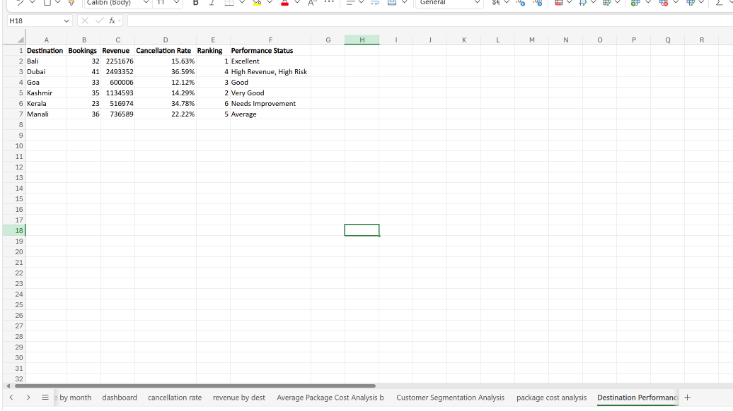

25/06/2026-
Power BI Dashboard Development
Tasks Performed:
• Imported the Travel Booking dataset into Power BI Desktop.
• Created KPI Cards to display:
- Total Bookings (200)
- Total Revenue (₹7,733,190)[M]
- Confirmed Bookings (155)
- Cancelled Bookings (45)
• Developed Revenue by Destination visual to compare revenue generated across travel destinations.
• Created Monthly Booking Trend chart to analyze booking distribution across different months.
• Developed Revenue by Age Group visual to identify revenue contribution from different customer age groups.
• Created Revenue by Gender visual to compare revenue generated by male and female customers.
Key Insights:
• Dubai generated the highest revenue among all destinations.
• Customers aged 21–40 contributed the majority of total revenue.
• Male customers generated slightly higher revenue than female customers.
• Monthly bookings remained relatively consistent with moderate fluctuations.
Outcome:
Successfully initiated Power BI dashboard development and created the core KPI cards and analytical visualizations required for business reporting.

Screenshots-
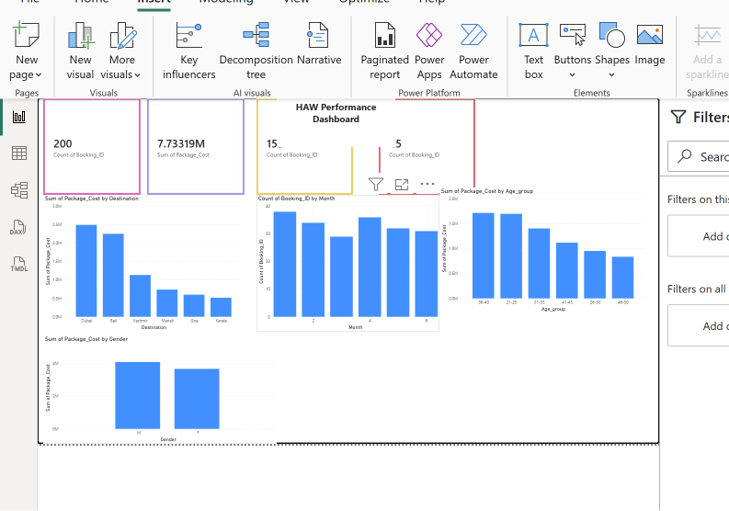

26/06/2026-
DAY 10 – Power BI Dashboard Enhancement
Tasks Performed:
• Developed a Customer Segment Distribution donut chart to visualize booking distribution among Budget, Premium, and Standard customers.
• Created a Revenue by Customer Segment chart to analyze revenue generated by each customer category.
• Developed a Booking Status by Destination chart to compare confirmed and cancelled bookings across different destinations.
• Added interactive slicers for Destination, Month, and Gender, enabling dynamic filtering of all dashboard visuals.
• Improved the dashboard layout by organizing KPI cards, charts, and slicers for enhanced readability and user interaction.
Key Insights:
• Premium customers contributed the highest revenue.
• Budget customers accounted for the highest number of bookings.
• Cancellation rates varied across destinations, helping identify locations requiring operational attention.
• Interactive slicers allow users to analyze data dynamically based on destination, month, and gender.
Outcome:
Successfully enhanced the Power BI dashboard with advanced visualizations and interactive filtering, making it suitable for business reporting and decision-making.

Screenshots-

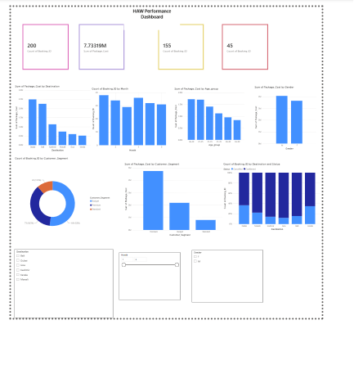

29/6/2026-
DAY 11 – Power BI Dashboard Formatting and Enhancement
Tasks Performed:
• Applied a professional Power BI theme to improve dashboard appearance.
• Added a dashboard title and subtitle for better presentation.
• Formatted KPI cards and aligned dashboard visuals for a clean and organized layout.
• Renamed visual titles to improve readability and maintain consistency.
• Added a Key Business Insights section summarizing the major findings from the analysis.
• Verified interactive slicers for Destination, Month, and Gender to ensure dynamic filtering across all dashboard visuals.
Key Insights:
• Dubai generated the highest overall revenue.
• Premium customers contributed the highest revenue.
• Budget customers accounted for the largest number of bookings.
• Customers aged 21–40 generated the highest revenue.
• Male customers generated slightly higher revenue than female customers.
• Higher cancellation rates were observed for Dubai and Kerala.
Outcome:
Successfully transformed the Power BI dashboard into a professional business intelligence dashboard with improved formatting, usability, and interactive reporting capabilities.

Screenshot-
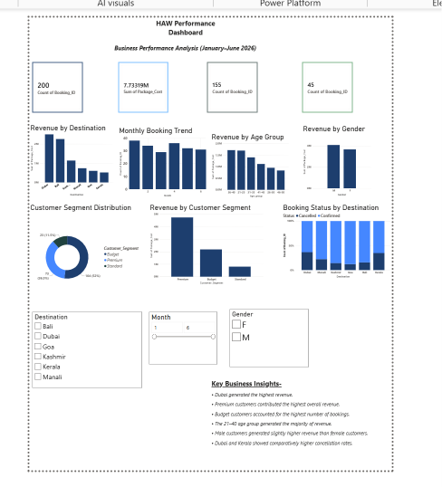

30/6/2026-
DAY 12 – Dynamic KPI Development Using DAX Measures
Tasks Performed:
• Created DAX measures for Total Revenue, Total Bookings, Confirmed Bookings, Cancelled Bookings, Cancellation Rate, Average Package Cost, and Average Revenue per Booking.
• Replaced static KPI cards with dynamic DAX-based KPI cards to improve dashboard flexibility and accuracy.
• Configured KPI cards to update automatically based on Destination, Month, and Gender slicer selections.
• Formatted KPI cards by adjusting font sizes, display units, and alignment for a professional dashboard appearance.
• Verified the accuracy of DAX calculations by testing interactive filters and slicers.
Key Insights:
• Dynamic DAX measures enabled real-time calculation of business metrics based on user-selected filters.
• The dashboard now provides accurate and interactive KPIs for revenue, bookings, cancellation rate, and average package cost.
• Business users can instantly analyze performance across different destinations, months, and customer demographics.
Outcome:
Successfully enhanced the Power BI dashboard by implementing dynamic DAX measures and interactive KPI cards, improving analytical capabilities and supporting real-time business decision-making.

Screenshot-

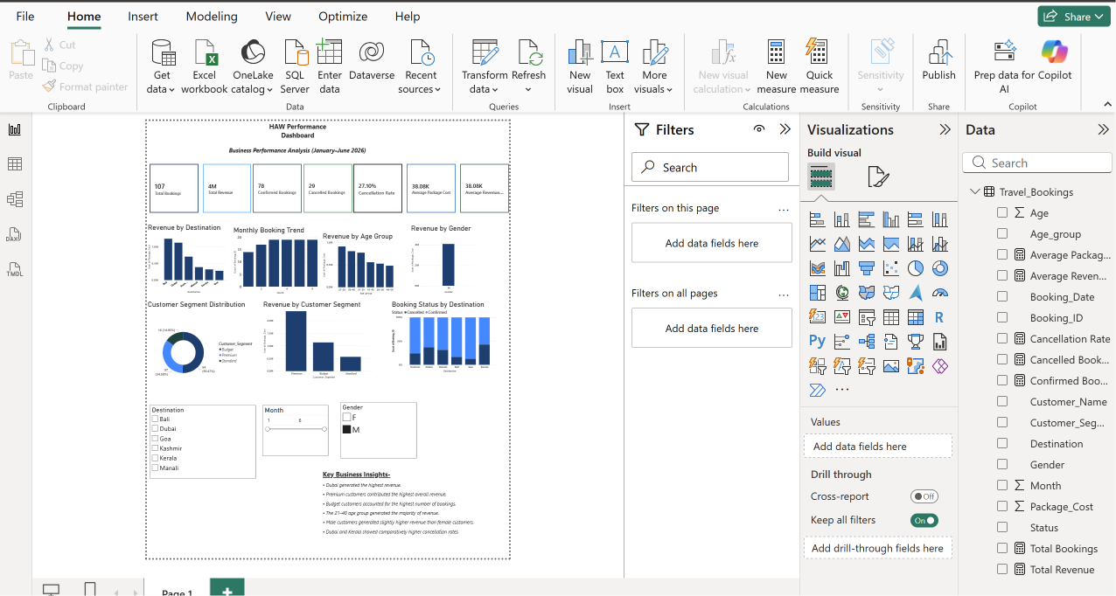

1/07/2026-
DAY 13 – Power BI Dashboard Enhancement and Final Formatting
Tasks Performed:
• Reviewed and refined the existing Power BI dashboard layout for a cleaner and more professional appearance.
• Improved the alignment and consistency of KPI cards, charts, and slicers across the dashboard.
• Added tooltip functionality to visuals for enhanced interactivity and detailed data insights.
• Standardized chart titles, dashboard formatting, and overall visual presentation.
• Added project footer and finalized the dashboard for presentation and reporting purposes.
Key Insights:
• The single-page interactive dashboard provides a comprehensive overview of business performance.
• Consistent formatting and improved layout enhance readability and user experience.
• Interactive tooltips and slicers enable users to explore data efficiently without cluttering the dashboard.
Outcome:
Successfully enhanced and finalized the Power BI dashboard by improving its design, interactivity, and overall presentation, making it suitable for business reporting and internship project submission.

Screenshot-
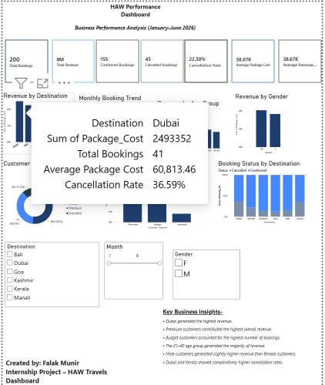

2/7/2026-
DAY 14 – Project Finalization and Dashboard Validation
Tasks Performed:
• Reviewed and validated all dashboard visuals, KPI cards, charts, and slicers for accuracy and consistency.
• Tested interactive filters to ensure all visuals responded correctly to user selections.
• Finalized dashboard formatting, alignment, titles, and overall presentation.
• Prepared the dashboard for submission by saving the Power BI project and exporting the final report.
• Documented key business insights and prepared a project explanation for presentation and evaluation.
Key Insights:
• The dashboard provides a comprehensive view of business performance through interactive visualizations and dynamic KPIs.
• DAX measures and slicers enable real-time analysis across destinations, customer segments, age groups, months, and booking status.
• The final dashboard supports informed business decision-making with clear and actionable insights.
Outcome:
Successfully completed, validated, and finalized the HAW Performance Dashboard, making it ready for internship submission, presentation, and business reporting.

Screenshots-
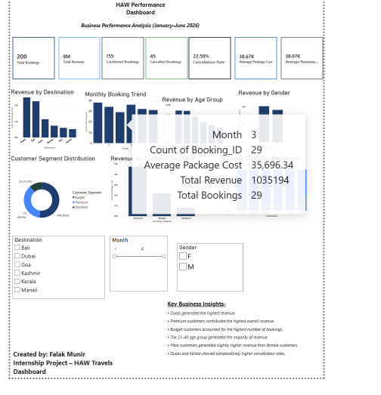
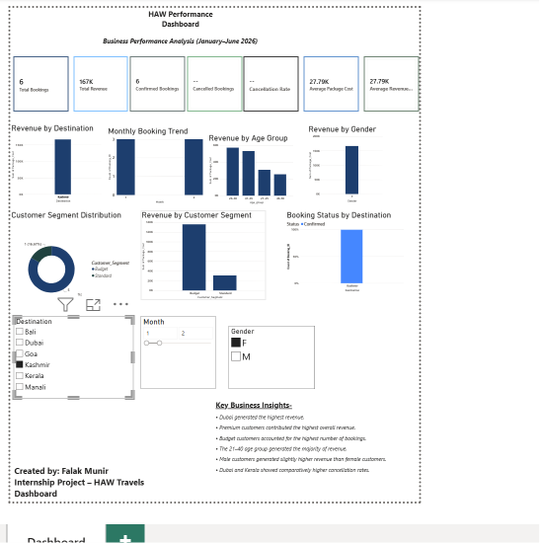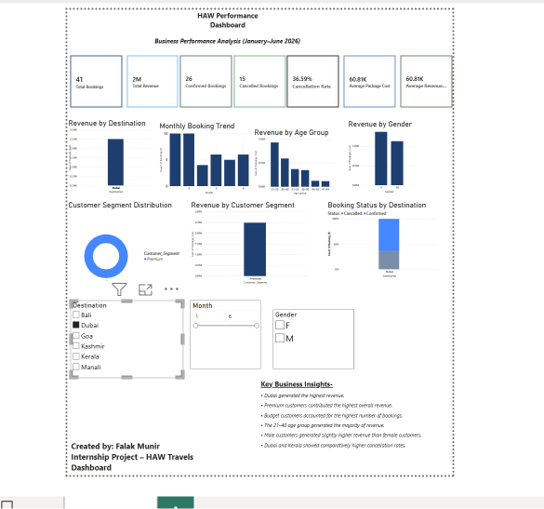

3/7/2026-
DAY 15 – Business Recommendations and Dashboard Optimization
Tasks Performed:
• Added a Business Recommendations section to provide actionable insights based on dashboard analysis.
• Added project information and dashboard metadata for documentation purposes.
• Performed a comprehensive review of all KPI cards, charts, slicers, and DAX measures to verify accuracy and consistency.
• Improved dashboard presentation by ensuring proper alignment, formatting, and readability.
• Created backup copies of the Power BI dashboard for version management and project safety.
Key Insights:
• Premium packages are the primary source of revenue.
• Customers aged 21–40 represent the most valuable customer segment.
• Dubai and Kerala require focused strategies to reduce booking cancellations.
• The dashboard now combines descriptive analytics with actionable business recommendations.
Outcome:
Successfully optimized and documented the Power BI dashboard by incorporating business recommendations and validating all dashboard components for professional presentation.

Screenshot-
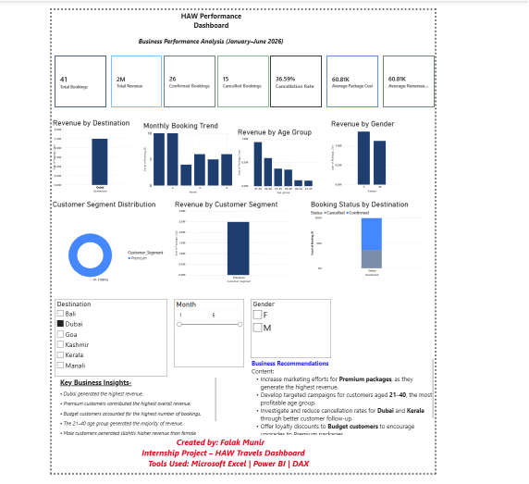

DAY 16 – Dashboard Documentation and Business Interpretation
Tasks Performed:
• Prepared detailed documentation explaining the purpose, KPIs, and visual components of the Power BI dashboard.
• Documented business interpretations derived from dashboard analysis.
• Developed actionable business recommendations based on data-driven insights.
• Captured the final dashboard for inclusion in the internship report.
Key Insights:
• The dashboard provides a comprehensive view of travel booking performance through interactive KPIs and visualizations.
• Business interpretations and recommendations improve the practical value of the analysis by supporting informed decision-making.
Outcome:
Successfully documented the dashboard, interpreted analytical findings, and prepared supporting materials for the final internship report.

DAY 17 – Internship Report Preparation (Part 1)
Tasks Performed:
• Prepared the cover page, declaration, acknowledgement, company profile, project objectives, and project scope for the internship report.
• Organized the initial report structure according to professional documentation standards.
• Documented the purpose and expected outcomes of the travel booking analysis project.
Outcome:
Successfully completed the introductory section of the internship report, establishing a structured foundation for documenting the complete internship project.

DAY 18 – Technical Documentation of the Internship Project
Tasks Performed:
• Documented the tools, technologies, and dataset used in the project.
• Explained the data cleaning, Excel analysis, and Power BI dashboard development process.
• Documented the DAX measures implemented for dynamic business calculations.
• Described the dashboard features, functionality, and business benefits.
Outcome:
Successfully completed the technical documentation of the internship project, providing a detailed explanation of the project development process and analytical techniques used.

10/07/2026-
DAY 20 – Project Completion and Final Submission
Tasks Performed:
• Conducted the final review of the internship project, including Excel analysis, Power BI dashboard, and supporting documentation.
• Verified the accuracy and functionality of dashboard visuals, DAX measures, KPI cards, and interactive slicers.
• Organized all project deliverables, including the dataset, Power BI dashboard, screenshots, and report content.
• Finalized the internship project documentation and prepared all materials for submission.
• Created backup copies of the project files to ensure data safety and future reference.
Outcome:
Successfully completed the internship project and prepared all deliverables for final submission. The project demonstrates the effective use of Microsoft Excel and Power BI for business data analysis, reporting, and visualization.

