1. Introduction to AJAX

What is AJAX?
AJAX stands for
Asynchronous JavaScript AndXML
AJAX mostly exchanges JSON instead of XML.
AJAX allows a web page to
- Update data without refreshing the page
- Send requests to a server
- Receive data from a server
- Create fast and interactive web applications

Without AJAX
User
|
V
Browser
|
Entire Page Request
|
Server
|
Entire Page Reload
Every click reloads the webpage.

With AJAX
User
|
V
Browser
|
AJAX Request
|
Server
|
JSON Response
|
Only Required Data Updates
The page does not reload.

Advantages
- Faster websites
- No page refresh
- Less bandwidth
- Better user experience

Applications
- Gmail
- Google Maps
- Facebook Notifications
- Instagram Feed
- Online Shopping

2. Working of AJAX

Steps
User Clicks Button
|
JavaScript sends Request
|
Server receives Request
|
Server processes Data
|
Server returns JSON
|
JavaScript updates HTML

3. XMLHttpRequest Object
Before Fetch API, AJAX used
XMLHttpRequest

Important Methods

Method | Purpose
open() | Opens request
send() | Sends request
onreadystatechange | Detects response
status | HTTP Status
responseText | Server response

readyState Meaning
0 Request not initialized
1 Connection opened
2 Request received
3 Processing request
4 Request completed

Common status codes
Code | Meaning
200 | ✅ OK / Request successful
201 | Created
400 | ❌ Bad request
401 | ❌ Unauthorized
403 | ❌ Forbidden
404 | ❌ Not found
500 | ❌ Server error

XMLHttpRequest Syntax
letxhr=newXMLHttpRequest();
xhr.open("GET","data.json",true);
xhr.send();

4. AJAX Example using XMLHttpRequest
Create three files.

index.html
<!DOCTYPE html>
<html>
<head>
<title>AJAX Example</title>
</head>
<body>
<h2>AJAX Example</h2>
<buttononclick="loadData()">
Load Data
</button>
<pid="demo"></p>
<scriptsrc="script.js"></script>
</body>
</html>

data.json
{
"name":"CBIT",
"course":"Full Stack Development",
"year":"Second Year"
}

script.js
functionloadData(){
letxhr=newXMLHttpRequest();
xhr.onreadystatechange=function(){
if(this.readyState==4&&this.status==200){
letobj=JSON.parse(this.responseText);
document.getElementById("demo").innerHTML=
obj.name+"<br>"+
obj.course+"<br>"+
obj.year;
}
};
xhr.open("GET","data.json",true);
xhr.send();
}

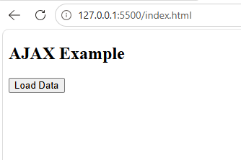
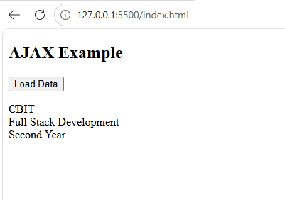

Output
AJAX Example
[Load Data]
CBIT
Full Stack Development
Second Year

XMLHttpRequest Flow
Create XMLHttpRequest
↓
open()
↓
send()
↓
Server Response
↓
responseText
↓
Update HTML

5. Fetch API
Modern JavaScript uses
fetch()
instead of XMLHttpRequest.
Advantages
- Cleaner syntax
- Promise-based
- Easier to understand
- Better error handling

Syntax
fetch("data.json")
.then(response=>response.json())
.then(data=>console.log(data));

6. Fetch API Example

index.html
<!DOCTYPE html>
<html>
<head>
<title>Fetch API Example</title>
</head>
<body>
<h2>Fetch API</h2>
<buttononclick="getData()">
Get Data
</button>
<pid="demo"></p>
<script>
functiongetData(){
fetch("data.json")
.then(response=>response.json())
.then(data=>{
document.getElementById("demo").innerHTML=
data.name+"<br>"+
data.course+"<br>"+
data.year;
})
.catch(error=>console.log(error));
}
</script>
</body>
</html>
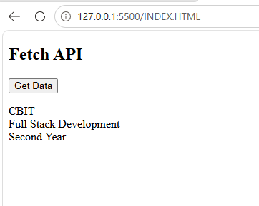

Output
CBIT
Full Stack Development
Second Year

Step 1: fetch("data.json")
fetch("data.json")
fetch() sends a GET request to data.json.
get the data.json file. //tells browser to get the data
For example, suppose data.json contains:
{
"name": "Rahul",
"course": "BCA",
"year": 2
}

Step 2: .then(response => response.json())
.then(response => response.json())
After fetch() gets a response, .then() runs.
Response contains the server's response.
JSON data isn't automatically a JavaScript object
response.json()
converts the JSON response into a JavaScript object.
For example:
JSON data
↓
response.json()
↓
JavaScript object

Step 3: .then(data => console.log(data))
.then(data => console.log(data));
After the JSON is converted into an object, that object is given to:
data
Then:
console.log(data)

prints it in the browser's console.

{name: "Rahul", course: "BCA", year: 2}

We can access individual values:
.then(data => {
console.log(data.name);
console.log(data.course);
console.log(data.year);
});
Output:
Rahul
BCA

.then() basically means:
"After the previous operation is finished, do this."

fetch data.json
↓
when response arrives
↓
convert response to JSON
↓
when conversion is finished
↓
put the data in console

Compare with your previous XMLHttpRequest
XMLHttpRequest:

Create xhr
↓
onreadystatechange
↓
Check readyState
↓
Check status
↓
JSON.parse()
Fetch:
fetch()
↓
.then()
↓
response.json()
↓
.then()
↓
Data
Fetch API is generally preferred for new JavaScript code

JSON
JSON stands for
JavaScript Object Notation
Used to exchange data between
- Browser
- Server

JSON Example
{
"name":"CBIT",
"course":"MERN",
"year":2
}

JavaScript Object
letstudent={
name:"CBIT",
course:"MERN",
year:2
};

Differences
JSON | JavaScript Object
Keys inside quotes | Quotes optional
String | Object
Used for data transfer | Used inside JavaScript

JSON Methods

JSON.parse()
Converts
JSON
↓
JavaScript Object
Example

Using Visual Studio Code

Step 1: Create a file named index.html
<!DOCTYPE html>
<html>
<head>
<title>JSON.parse() Example</title>
</head>
<body>
<h2>JSON.parse() Example</h2>
<pid="demo"></p>
<script>
lettext='{"name":"CBIT"}';
letobj=JSON.parse(text);
console.log(obj.name);
// Display on webpage
document.getElementById("demo").innerHTML=obj.name;
</script>
</body>
</html>

Step 2
Save the file.

Step 3
Install Live Server in VS Code.

Step 4
Right-click on index.html
↓
Open with Live Server

Output on Webpage
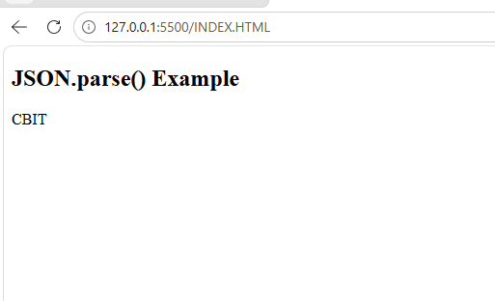
JSON.parse() Example

Let text='{"name":"CBIT"}';
letobj=JSON.parse(text);
console.log(obj.name);
Output
CBIT
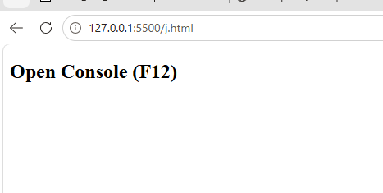

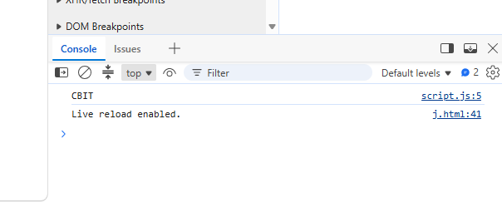

JSON.stringify()
Converts
Object
↓
JSON
<!DOCTYPE html>
<html lang="en">
<head>
<meta charset="UTF-8">
<meta name="viewport" content="width=device-width, initial-scale=1.0">
<title>JSON.stringify() Example</title>
</head>
<body>

<h2>JSON.stringify() Example</h2>

<button onclick="convertJSON()">Convert to JSON</button>

<h3>Output</h3>

<p id="object"></p>
<p id="json"></p>

<script>

functionconvertJSON() {

// JavaScript Object
let student = {
name: "CBIT",
course: "Full Stack Development",
year: 2,
city: "Hyderabad"
};

// Display JavaScript Object
document.getElementById("object").innerHTML =
"<b>JavaScript Object:</b><br>" +
"Name: " + student.name + "<br>" +
"Course: " + student.course + "<br>" +
"Year: " + student.year + "<br>" +
"City: " + student.city;

// Convert Object into JSON String
letjsonData = JSON.stringify(student);

// Display JSON String
document.getElementById("json").innerHTML =
"<br><b>JSON String:</b><br>" +
jsonData;

// Console Output
console.log("JavaScript Object:");
console.log(student);

console.log("JSON String:");
console.log(jsonData);
}

</script>

</body>
</html>
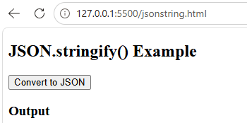

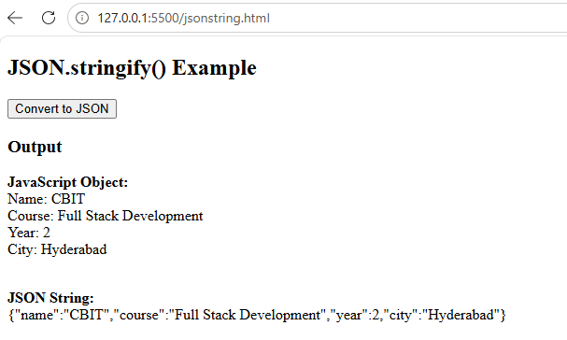

9. Sending JSON Data
Example
<!DOCTYPE html>
<html>
<head>
<title>Sending JSON</title>
</head>
<body>

<h2>Sending JSON Data</h2>

<button onclick="sendData()">Send Data</button>

<script>

functionsendData(){

let student={
name:"CBIT",
course:"MERN",
year:2
};

letjsonData=JSON.stringify(student);

console.log(jsonData);

alert(jsonData);

}

</script>

</body>
</html>

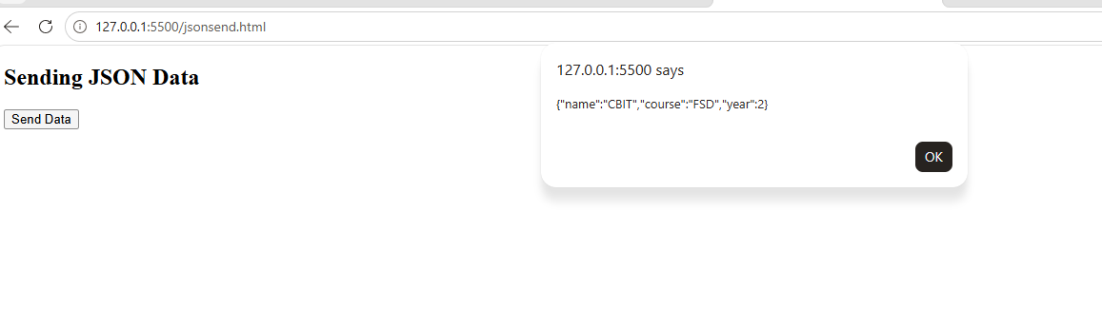

Receiving JSON Data

Receiving JSON Data Asynchronously (Fetch API)

Folder Structure
AJAX
index.html
data.json

data.json
{
"name":"CBIT",
"course":"Full Stack Development",
"year":2
}

index.html
<!DOCTYPE html>
<html>
<head>
<title>Receive JSON</title>
</head>
<body>
<h2>Receiving JSON Data</h2>
<buttononclick="loadData()">Load Data</button>
<pid="demo"></p>
<script>
functionloadData(){
fetch("data.json")
.then(response=>response.json())
.then(data=>{
document.getElementById("demo").innerHTML=
data.name+"<br>"+
data.course+"<br>"+
data.year;
});
}
</script>
</body>
</html>

Output
CBIT
Full Stack Development
2

Flow
Button Click
↓
fetch()
↓
Read data.json
↓
Convert to Object
↓
Display on Screen

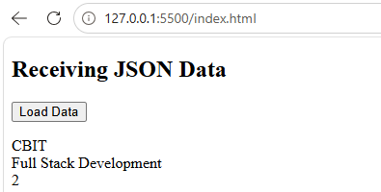

11. Handling Server Responses
<!DOCTYPE html>
<html>
<head>
<title>Server Response</title>
</head>
<body>

<h2>Handling Server Responses</h2>

<button onclick="getData()">Get Data</button>

<p id="demo"></p>

<script>

functiongetData(){

fetch("data.json")

.then(response=>{

if(response.ok){

returnresponse.json();

}

else{

throw new Error("File Not Found");

}

})

.then(data=>{

document.getElementById("demo").innerHTML=data.name;// to display only name
document.getElementById("demo").innerHTML =
"<b>Name:</b> " + data.name + "<br>" +
"<b>Course:</b> " + data.course + "<br>" +
"<b>Year:</b> " + data.year;

})

.catch(error=>{

document.getElementById("demo").innerHTML=error;

});

}

</script>

</body>
</html>
Output
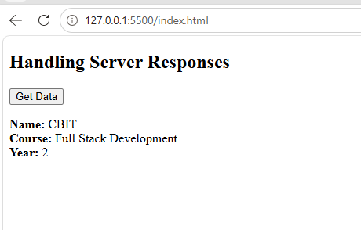
Network Error
if the file is missing.(HANDLING ERRORS)
<!DOCTYPE html>
<html lang="en">
<head>
<meta charset="UTF-8">
<meta name="viewport" content="width=device-width, initial-scale=1.0">
<title>Handling Server Responses</title>
</head>
<body>

<h2>Handling Server Responses using Fetch API</h2>

<button onclick="getData()">Load Data</button>

<h3>Output</h3>

<p id="demo"></p>

<script>

functiongetData() {

fetch("data.json")

.then(function(response) {

// Check whether the response is successful
if (response.ok) {
returnresponse.json();
}

throw new Error("Unable to load data!");
})

.then(function(data) {

document.getElementById("demo").innerHTML =
"<b>Name:</b> " + data.name + "<br>" +
"<b>Course:</b> " + data.course + "<br>" +
"<b>Year:</b> " + data.year;

})

.catch(function(error) {

document.getElementById("demo").innerHTML =
"<span style='color:red'>" + error.message + "</span>";

});

}

</script>

</body>
</html>
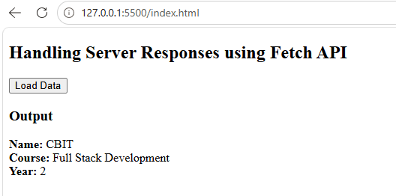

RENAME THE FILE FROM “ DATA.JSON” TO “ DEMO.JSON”

RUN THE PROGRAM AGAIN
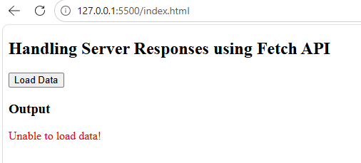

Receiving JSON using XMLHttpRequest

data.json
{
"name":"CBIT",
"course":"FSD"
}

Click Button
│
▼
fetch("data.json")
│
▼
Receive Response
│
▼
Is response.ok ?
┌───────────────┐
│
Yes No
│
▼
response.json() Error
│
▼
Display Data Display Error

index.html
<!DOCTYPE html>
<html>
<head>
<title>XMLHttpRequest Example</title>
</head>
<body>
<h2>XMLHttpRequest Example</h2>
<buttononclick="loadData()">Load</button>
<pid="demo"></p>
<script>
functionloadData(){
letxhr=newXMLHttpRequest();
xhr.onreadystatechange=function(){
if(this.readyState==4&&this.status==200){
letobj=JSON.parse(this.responseText);
document.getElementById("demo").innerHTML=
obj.name+"<br>"+obj.course;
}
};
xhr.open("GET","data.json",true);
xhr.send();
}
</script>
</body>
</html>

Output
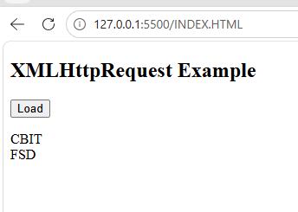

AJAX vs Fetch API
AJAX (XMLHttpRequest) | Fetch API
Older | Modern
More code | Less code
Callback based | Promise based
Complex | Easy
Used in old applications | Used in modern applications

In JavaScript, a Promise is an object that represents a value that you will get later.

A JavaScript Promise works similarly:
- Start an operation
- ↓
- Wait for it to finish
- ↓
- Success → get the result
- Failure → get an error

A Promise has 3 states
State | Meaning
Pending | Still waiting
Fulfilled | Successfully completed
Rejected | Failed

In Fetch example
fetch("data.json")
The browser needs some time to get data.json.
While waiting:
Promise → Pending
If the file is successfully received:
Promise → Fulfilled
Then this runs:
.then(response => response.json())
If something goes wrong:
Promise → Rejected
You can handle the error using .catch():
fetch("data.json")
.then(response => response.json())
.then(data => console.log(data))
.catch(error => console.log(error));
So, Promise = a way to handle an operation whose result is available now or sometime in the future.
In fetch() example, the Promise is useful because getting data from a file/server takes some time.
The Promise is returned by fetch() itself.

In code:
fetch("data.json")
.then(response => response.json())
.then(data => console.log(data));

fetch("data.json")
↓
Promise
↓
.then(...)
↓
response
↓
response.json()
↓
Promise
↓
.then(...)
↓
data

Where exactly is the Promise?
Here:
fetch("data.json")
fetch() returns a Promise.
we could even store it in a variable:
let result = fetch("data.json");
console.log(result);
The console will show something similar to:
Promise { <pending> }
At that moment, the request is still running.
Then:
fetch("data.json")
.then(response => response.json())
means:
"When the Promise returned by fetch() is successful, give me the response."
And response.json() also returns a Promise, which is why we have another .then():
.then(data => console.log(data))
So there are actually two Promises in your example:
  - fetch() → returns a Promise for the HTTP response.
  - response.json() → returns a Promise for the converted JSON data.

How to Execute in Visual Studio Code

Step 1
Create a folder
AJAX

Step 2
Create
index.html
script.js
data.json

Step 3
Install
Live Server Extension
Extensions →
Search
Live Server
Install

Step 4
Open
index.html
Right Click
Open with Live Server

Step 5
Click
Load Data
Output appears without refreshing the webpage.

Folder Structure
AJAX
│
├── index.html
├── script.js
└── data.json

