CSS GRID
<!DOCTYPE html>
<html>
<head>
<style>
.container {
display: grid;
grid-template-areas:
"header header"
"menu content"
"footer footer";
grid-template-columns: 1fr 3fr;
gap: 3px;
background-color: dodgerblue;
padding: 5px;
}
.container div {
background-color: white;
padding: 10px;
}
.container div.header {
grid-area: header;
text-align: center;
}
.container div.menu {
grid-area: menu;
}
.container div.content {
grid-area: content;
}
.container div.footer {
grid-area: footer;
text-align: center;
}
</style>
</head>
<body>

<h1>CSS Grid Layout</h1>

<p>The Grid Layout Module offers a grid-based layout system, with rows and columns.</p>
<p>The Grid Layout Module makes it easy to design complex and responsive web pages without using floats and positioning:</p>

<div class="container">
<div class="header"><h2>My Header</h2></div>
<div class="menu"><a href="#">Link 1</a><br><a href="#">Link 2</a><br><a href="#">Link 3</a></div>
<div class="content"><h3>Lorem Ipsum</h3><p>Lorem ipsum odor amet, consectetuer adipiscing elit. Ridiculus sit nisl laoreet facilisis aliquet. Potenti dignissim litora eget montes rhoncus sapien neque urna. Cursus libero sapien integer magnis ligula lobortis quam ut.</p></div>
<div class="footer"><h4>Footer</h4></div>
</div>

</body>
</html>

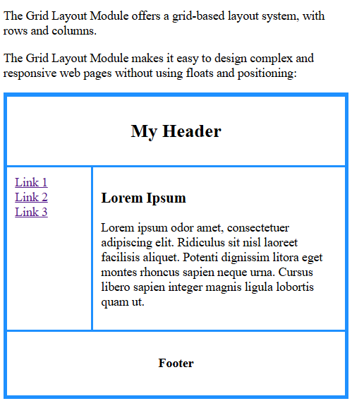

CSS Grid Components
A grid always consists of:
- A Grid Container - The parent (container) element, where the display property is set to grid or inline-grid
- One or more Grid Items - The direct children of the grid container automatically becomes grid items
- A Grid Container with Five Grid Items
- The element below represents a grid container (the blue area) with five grid items.
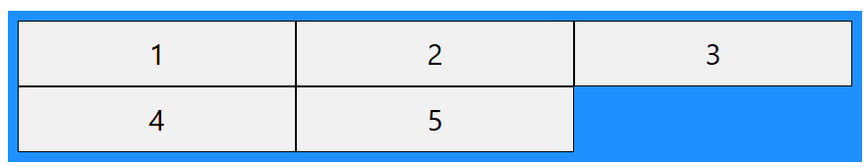

<!DOCTYPE html>
<html>
<head>
<style>
.container {
display: grid;
grid-template-columns: auto auto auto;
background-color: dodgerblue;
padding: 10px;
}
.container div {
background-color: #f1f1f1;
border: 1px solid black;
padding: 10px;
font-size: 30px;
text-align: center;
}
</style>
</head>
<body>

<h1>Grid Layout</h1>

<p>A Grid Layout must have a parent element with the <em>display</em> property set to <em>grid</em> or <em>inline-grid</em>.</p>

<p>Direct child element(s) of the grid container automatically becomes grid items.</p>

<div class="container">
<div>1</div>
<div>2</div>
<div>3</div>
<div>4</div>
<div>5</div>
</div>

</body>
</html>

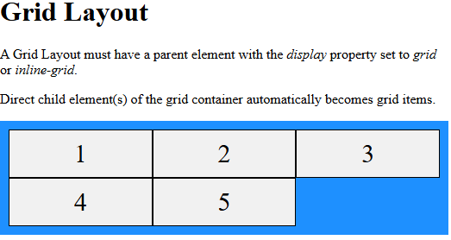
CSS Grid and Bootstrap solve different problems. CSS Grid is mainly a layout system, while Bootstrap is a complete front-end framework.
Here's a comparison.
CSS Grid | Bootstrap
Creates page layouts | Provides layouts plus ready-made UI components
Built into CSS | External framework
More flexible | Faster for building common designs
You write your own styles | Many styles are already available

What CSS Grid gives you
CSS Grid helps you arrange elements on the page.
Example:
.container {
display: grid;
grid-template-columns: 1fr 2fr 1fr;
gap: 20px;
}
This creates a three-column layout.
But Grid doesn't provide things like:
- Buttons
- Navigation bars
- Cards
- Modals
- Forms
- Alerts
- Responsive utility classes
You have to build and style those yourself.

What Bootstrap gives you
Bootstrap includes:
- ✅ Responsive grid system
- ✅ Buttons
- ✅ Cards
- ✅ Navbar
- ✅ Forms
- ✅ Tables
- ✅ Modals
- ✅ Alerts
- ✅ Dropdowns
- ✅ Spacing utilities (mt-3, p-4)
- ✅ Color utilities (bg-primary, text-danger)
- ✅ Flexbox helpers
- ✅ Responsive classes
Example:
<button class="btn btn-primary">
Login
</button>
Without Bootstrap, you'd write:
button {
background: blue;
color: white;
padding: 10px 20px;
border-radius: 5px;
}
Bootstrap saves you from writing those common styles.

Real-world example
Imagine you're building an Amazon-like website.

With CSS Grid
You create the layout:
--------------------------------
Navbar
--------------------------------
Sidebar | Products
--------------------------------
Footer
--------------------------------
You'll still need to design:
- Navbar
- Search bar
- Buttons
- Cards
- Login form
Everything is custom CSS.

With Bootstrap
The layout is easier because you can use Bootstrap's grid, and many UI pieces are ready:
<div class="container">
<div class="row">
<div class="col-md-3">Sidebar</div>
<div class="col-md-9">Products</div>
</div>
</div>
Need a button?
<button class="btn btn-success">
Buy Now
</button>
Need a card?
<div class="card">
...
</div>
Much of the styling is already done.

Does Bootstrap use CSS Grid?
Modern Bootstrap primarily uses Flexbox for its grid system, not native CSS Grid. You can still use CSS Grid alongside Bootstrap when it better fits your layout needs.

When should you use CSS Grid?
Use CSS Grid when:
- You want full control over the layout.
- You're building custom designs.
- You don't need a UI framework.
- You're comfortable writing your own CSS.

When should you use Bootstrap?
Use Bootstrap when:
- You need to build a site quickly.
- You want pre-designed UI components.
- You need consistent responsive behavior.
- You're creating dashboards, admin panels, or prototypes.

Simple analogy
- CSS Grid is like buying bricks to build a house—you decide exactly how everything is arranged.
- Bootstrap is like buying a house-building kit—it includes the bricks, plus ready-made doors, windows, stairs, and furniture, so you can build faster.
In practice, many developers use both: Bootstrap for common UI components and responsiveness, and CSS Grid (or Flexbox) for custom layouts where they need more control.

BOOTSTRAP

1. Document Type
<!DOCTYPE html>
Purpose:
- Tells the browser that this is an HTML5 document.
- Ensures the browser renders the page in standards mode.

2. HTML Tag
<html lang="en">
Purpose:
- The root element of the HTML document.
- lang="en" tells browsers and search engines that the page is in English.

3. Head Section
<head>
Purpose:
- Contains information about the webpage.
- This information is not displayed directly on the page.

4. Title
<title>Bootstrap Example</title>
Purpose:
- Sets the page title shown:
  - In the browser tab.
  - In bookmarks.
Example:
Browser Tab
-----------------------
Bootstrap Example

5. Character Encoding
<meta charset="utf-8">
Purpose:
- Uses the UTF-8 character set.
- Allows the page to display characters from many languages correctly.
Examples:
Hello
नమస్తే
こんにちは
😊

6. Viewport Meta Tag
<meta name="viewport" content="width=device-width, initial-scale=1">
This is one of the most important lines for responsive design.

width=device-width
Makes the page width equal to the device's screen width.
For example:
- Laptop → about 1366px
- Tablet → about 768px
- Mobile → about 390px

initial-scale=1
Sets the initial zoom level to 100%.
Without this line, a page can appear zoomed out or scaled incorrectly on mobile devices.

7. Bootstrap CSS
<link rel="stylesheet" href="https://maxcdn.bootstrapcdn.com/bootstrap/3.4.1/css/bootstrap.min.css">

link
Links an external CSS file.

rel="stylesheet"
Tells the browser that the linked file is a stylesheet.

href
Specifies where the CSS file is located.
Here it loads Bootstrap 3.4.1.
After loading Bootstrap, you can use classes like:
<button class="btn btn-primary">Save</button>
without writing the CSS yourself.

8. jQuery Library
<script src="https://ajax.googleapis.com/ajax/libs/jquery/3.7.1/jquery.min.js"></script>

Why is it needed?
Bootstrap 3 depends on jQuery for interactive features.
Examples include:
- Dropdown menus
- Modals
- Tabs
- Tooltips
- Collapse menus
So jQuery must be loaded before Bootstrap's JavaScript.

9. Bootstrap JavaScript
<script src="https://maxcdn.bootstrapcdn.com/bootstrap/3.4.1/js/bootstrap.min.js"></script>
This loads Bootstrap's JavaScript features.
Examples:
- Modal windows
- Dropdowns
- Carousels
- Tooltips
- Navigation menu toggle
Without this file, only Bootstrap's CSS styling works. Interactive components won't function.

10. Closing Head
</head>
Ends the head section.

11. Body
<body>
Everything inside the <body> is visible on the webpage.

12. Bootstrap Container
<div class="container">
This is a Bootstrap class.
It creates a responsive container that:
- Centers the content.
- Adds left and right padding.
- Uses a fixed maximum width that changes at different screen sizes.
Example:
Browser Window

|--------------------------------------|
| |
| Content starts here |
| because container adds margins |
| |
|--------------------------------------|
Without .container, content stretches from edge to edge.

13. Heading
<h1>My First Bootstrap Page</h1>
Displays a large heading.
Output:

My First Bootstrap Page

14. First Paragraph
<p>This part is inside a .container class.</p>
Displays:
This part is inside a .container class.

15. Second Paragraph
<p>The .container class provides a responsive fixed width container.</p>
Displays:
The .container class provides a responsive fixed width container.

16. Closing Div
</div>
Ends the container.

17. Closing Body
</body>
Ends the visible content of the page.

18. Closing HTML
</html>
Ends the HTML document.

Final Flow
Browser opens page
│
▼
<!DOCTYPE html> → HTML5 document
│
▼
<html> → Start HTML
│
▼
<head> → Page information
│
├── Title
├── UTF-8 encoding
├── Viewport (mobile-friendly)
├── Bootstrap CSS
├── jQuery
└── Bootstrap JS
│
▼
<body> → Visible content
│
▼
.container → Responsive centered layout
│
├── H1 Heading
├── Paragraph
└── Paragraph
│
▼
</body>
│
▼
</html>

One important note
This example uses Bootstrap 3.4.1, which is an older version and requires jQuery. Modern Bootstrap 5 no longer depends on jQuery, so newer projects typically include only Bootstrap's CSS and JavaScript files.
what is jquery
jQuery is a JavaScript library that makes it easier to write JavaScript code for common tasks like manipulating HTML, handling events, animations, and making AJAX requests.

Simple definition
jQuery is a library that lets you do more with less JavaScript code.

Why was jQuery created?
Before jQuery, developers had to write a lot of JavaScript, and different browsers often behaved differently.
For example, changing the text of a paragraph:

Plain JavaScript
document.getElementById("demo").innerHTML = "Hello";

jQuery
$("#demo").text("Hello");
- #demo selects the element with id="demo".
- .text("Hello") changes its text.
The jQuery version is shorter and was historically more consistent across browsers.

Real-world example
Suppose you have a button that hides a paragraph.

HTML
<button id="btn">Hide</button>

<p id="para">Welcome to jQuery!</p>

Using JavaScript
document.getElementById("btn").addEventListener("click", function () {
document.getElementById("para").style.display = "none";
});

Using jQuery
$("#btn").click(function () {
$("#para").hide();
});
The jQuery code is shorter and easier to read.

Common jQuery tasks

1. Hide an element
$("#box").hide();

2. Show an element
$("#box").show();

3. Change CSS
$("#box").css("color", "red");

4. Change HTML
$("#box").html("<h1>Hello</h1>");

5. Handle a click event
$("#btn").click(function () {
alert("Button clicked!");
});

Why does Bootstrap 3 include jQuery?
Bootstrap 3 uses jQuery to power interactive components such as:
- Dropdown menus
- Modals (pop-up windows)
- Carousels (sliders)
- Tabs
- Tooltips
- Collapse menus
That's why Bootstrap 3 examples load jQuery before Bootstrap's JavaScript.

Do we still use jQuery today?
Less often than before.
Modern JavaScript has added many features that jQuery used to provide, so many projects now use plain JavaScript.
For example:

jQuery
$("#title").text("Hello");

Modern JavaScript
document.getElementById("title").textContent = "Hello";
Both achieve the same result.

Is jQuery still worth learning?
Yes, if you:
- Maintain older websites.
- Work with Bootstrap 3 or older projects.
- Join companies with legacy codebases.
For new projects, it's usually better to learn modern JavaScript (ES6+) because most current frameworks (such as React, Angular, and Vue) don't rely on jQuery.

Easy analogy
Imagine you need to tighten a screw.
- JavaScript is like a full toolbox—you can do almost anything, but some tasks take more steps.
- jQuery is like a specialized power screwdriver—it makes many common tasks quicker and simpler.
Today, JavaScript itself has improved so much that many of those shortcuts are built in, which is why jQuery is less essential for new development.
the above code in bootstrap 5 version
In Bootstrap 5, you do not need jQuery. Bootstrap 5 uses plain JavaScript for its interactive components.
Here's the Bootstrap 5 version of your code:
<!DOCTYPE html>
<html lang="en">
<head>
<title>Bootstrap 5 Example</title>

<meta charset="UTF-8">

<meta name="viewport" content="width=device-width, initial-scale=1">

<!-- Bootstrap 5 CSS -->
<link href="https://cdn.jsdelivr.net/npm/bootstrap@5.3.8/dist/css/bootstrap.min.css" rel="stylesheet">
</head>

<body>

<div class="container mt-5">
<h1>My First Bootstrap 5 Page</h1>

<p>This part is inside a <code>.container</code> class.</p>

<p>The <code>.container</code> class provides a responsive fixed-width container.</p>
</div>

<!-- Bootstrap 5 JavaScript -->
<script src="https://cdn.jsdelivr.net/npm/bootstrap@5.3.8/dist/js/bootstrap.bundle.min.js"></script>

</body>
</html>

What's changed?

1. Bootstrap CSS
Bootstrap 3
<link rel="stylesheet" href="https://maxcdn.bootstrapcdn.com/bootstrap/3.4.1/css/bootstrap.min.css">
Bootstrap 5
<link href="https://cdn.jsdelivr.net/npm/bootstrap@5.3.8/dist/css/bootstrap.min.css" rel="stylesheet">
The CDN has changed to jsDelivr, and the version is Bootstrap 5.

2. jQuery is removed
Bootstrap 3
<script src="https://ajax.googleapis.com/ajax/libs/jquery/3.7.1/jquery.min.js"></script>
❌ Not needed in Bootstrap 5.
Bootstrap 5's JavaScript is written without jQuery.

3. Bootstrap JavaScript
Bootstrap 3
<script src="https://maxcdn.bootstrapcdn.com/bootstrap/3.4.1/js/bootstrap.min.js"></script>
Bootstrap 5
<script src="https://cdn.jsdelivr.net/npm/bootstrap@5.3.8/dist/js/bootstrap.bundle.min.js"></script>
Notice the word bundle.
The bundle includes Popper.js, which Bootstrap uses for components such as:
- Dropdowns
- Tooltips
- Popovers
So you don't need to include Popper separately.

4. Added mt-5
<div class="container mt-5">
mt-5 means:
- m = margin
- t = top
- 5 = spacing size
It adds top margin so the content isn't flush against the top of the page.

Bootstrap 3 vs Bootstrap 5
Bootstrap 3 | Bootstrap 5
Requires jQuery | No jQuery required
Uses bootstrap.min.js | Uses bootstrap.bundle.min.js
Older grid and components | Improved grid, utilities, and components
Glyphicons included | Glyphicons removed (use libraries like Bootstrap Icons if needed)

Create First Web Page with Bootstrap
1. Add the HTML5 doctype
Bootstrap uses HTML elements and CSS properties that require the HTML5 doctype.
Always include the HTML5 doctype at the beginning of the page, along with the lang attribute and the correct character set:
<!DOCTYPE html>
<html lang="en">
<head>
<meta charset="utf-8">
</head>
</html>
2. Bootstrap 3 is mobile-first
Bootstrap 3 is designed to be responsive to mobile devices. Mobile-first styles are part of the core framework.
To ensure proper rendering and touch zooming, add the following <meta> tag inside the <head> element:
<meta name="viewport" content="width=device-width, initial-scale=1">
The width=device-width part sets the width of the page to follow the screen-width of the device (which will vary depending on the device).
The initial-scale=1 part sets the initial zoom level when the page is first loaded by the browser.
3. Containers
Bootstrap also requires a containing element to wrap site contents.
There are two container classes to choose from:
- The .container class provides a responsive fixed width container
- The .container-fluid class provides a full width container, spanning the entire width of the viewport
.container
.container-fluid

Two Basic Bootstrap Pages
The following example shows the code for a basic Bootstrap page (with a responsive fixed width container):

Example
<!DOCTYPE html>
<html lang="en">
<head>
<title>Bootstrap Example</title>
<meta charset="utf-8">
<meta name="viewport" content="width=device-width, initial-scale=1">
<link rel="stylesheet" href="https://maxcdn.bootstrapcdn.com/bootstrap/3.4.1/css/bootstrap.min.css">
<script src="https://ajax.googleapis.com/ajax/libs/jquery/3.7.1/jquery.min.js"></script>
<script src="https://maxcdn.bootstrapcdn.com/bootstrap/3.4.1/js/bootstrap.min.js"></script>
</head>
<body>

<div class="container">
<h1>My First Bootstrap Page</h1>
<p>This part is inside a .container class.</p>
<p>The .container class provides a responsive fixed width container.</p>
</div>

</body></html>
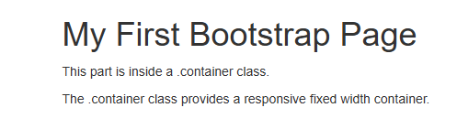
EXAMPLE2: The following example shows the code for a basic Bootstrap page (with a full width container):
<!DOCTYPE html>
<html lang="en">
<head>
<title>Bootstrap Example</title>
<meta charset="utf-8">
<meta name="viewport" content="width=device-width, initial-scale=1">
<link rel="stylesheet" href="https://maxcdn.bootstrapcdn.com/bootstrap/3.4.1/css/bootstrap.min.css">
<script src="https://ajax.googleapis.com/ajax/libs/jquery/3.7.1/jquery.min.js"></script>
<script src="https://maxcdn.bootstrapcdn.com/bootstrap/3.4.1/js/bootstrap.min.js"></script>
</head>
<body>

<div class="container-fluid">
<h1>My First Bootstrap Page</h1>
<p>This part is inside a .container-fluid class.</p>
<p>The .container-fluid class provides a full width container, spanning the entire width of the viewport.</p>
</div>

</body>
</html>
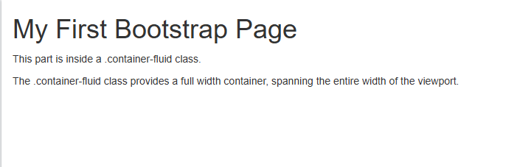
EXAMPLE 3
<!DOCTYPE html>
<html lang="en">
<head>
<title>Bootstrap Example</title>
<meta charset="utf-8">
<meta name="viewport" content="width=device-width, initial-scale=1">
<link rel="stylesheet" href="https://maxcdn.bootstrapcdn.com/bootstrap/3.4.1/css/bootstrap.min.css">
<script src="https://ajax.googleapis.com/ajax/libs/jquery/3.7.1/jquery.min.js"></script>
<script src="https://maxcdn.bootstrapcdn.com/bootstrap/3.4.1/js/bootstrap.min.js"></script>
</head>
<body>

<div class="jumbotron text-center">
<h1>My First Bootstrap Page</h1>
<p>Resize this responsive page to see the effect!</p>
</div>

<div class="container">
<div class="row">
<div class="col-sm-4">
<h3>Column 1</h3>
<p>COLUMN ONE CONTENT...</p>
<p>COLUMN ONE CONTENT CONTINUED...</p>
</div>
<div class="col-sm-4">
<h3>Column 2</h3>
<p>COLUMN TWO CONTENT......</p>
<p>COLUMN TWO CONTENT CONTINUE . .....</p>
</div>
<div class="col-sm-4">
<h3>Column 3</h3>
<p>COLUMN THREE CONTENT......</p>
<p>COLUMN THREE CONTENT CONTINUE......</p>
</div>
</div>
</div>

</body>
</html>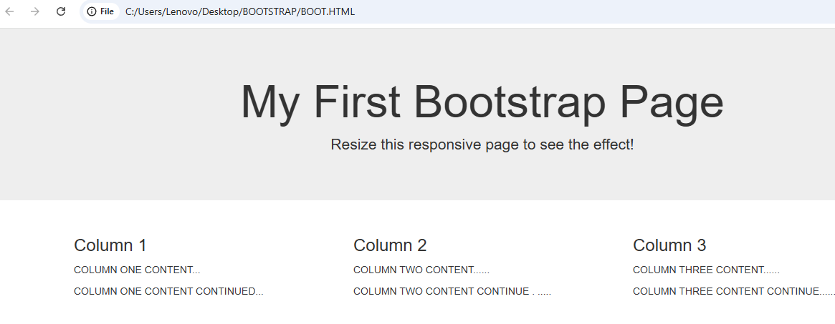

Bootstrap Grid System
Bootstrap's grid system allows up to 12 columns across the page.
If you do not want to use all 12 columns individually, you can group the columns together to create wider columns:
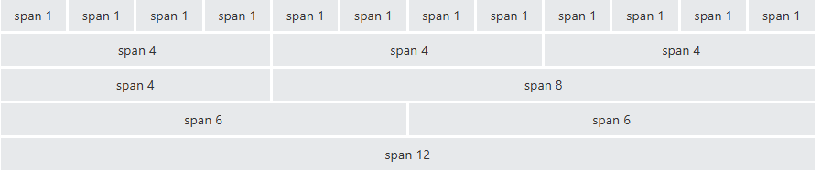
Bootstrap's grid system is responsive, and the columns will re-arrange automatically depending on the screen size.

Grid Classes
The Bootstrap grid system has four classes:
- xs (for phones - screens less than 768px wide)
- sm (for tablets - screens equal to or greater than 768px wide)
- md (for small laptops - screens equal to or greater than 992px wide)
- lg (for laptops and desktops - screens equal to or greater than 1200px wide)
The classes above can be combined to create more dynamic and flexible layouts.

Basic Structure of a Bootstrap Grid
The following is a basic structure of a Bootstrap grid:
<div class="row">
<div class="col-*-*"></div>
<div class="col-*-*"></div>
</div>
<div class="row">
<div class="col-*-*"></div>
<div class="col-*-*"></div>
<div class="col-*-*"></div>
</div>
<div class="row">
...
</div>
First; create a row (<div class="row">). Then, add the desired number of columns (tags with appropriate .col-*-* classes). Note that numbers in .col-*-* should always add up to 12 for each row.

Three Equal Columns

<!DOCTYPE html>

<html lang="en">

<head>

<title>Bootstrap Example</title>

<meta charset="utf-8">

<meta name="viewport" content="width=device-width, initial-scale=1">

<link rel="stylesheet" href="https://maxcdn.bootstrapcdn.com/bootstrap/3.4.1/css/bootstrap.min.css">

<script src="https://ajax.googleapis.com/ajax/libs/jquery/3.7.1/jquery.min.js"></script>

<script src="https://maxcdn.bootstrapcdn.com/bootstrap/3.4.1/js/bootstrap.min.js"></script>

</head>

<body>

<div class="container-fluid">

<h1>Hello World!</h1>

<p>Resize the browser window to see the effect.</p>

<p>The columns will automatically stack on top of each other when the screen is less than 768px wide.</p>

<div class="row">

<div class="col-sm-4" style="background-color:lavender;">.col-sm-4</div>

<div class="col-sm-4" style="background-color:lavenderblush;">.col-sm-4</div>

<div class="col-sm-4" style="background-color:lavender;">.col-sm-4</div>

</div>

</div>

</body>

</html>

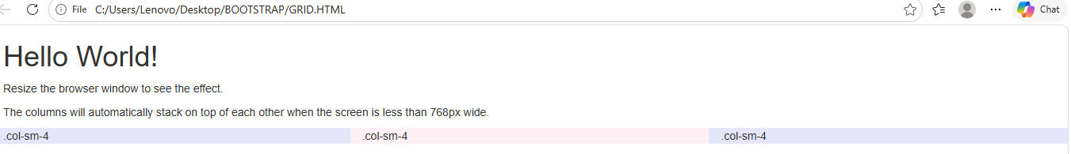

Two Unequal Columns

<!DOCTYPE html>

<html lang="en">

<head>

<title>Bootstrap Example</title>

<meta charset="utf-8">

<meta name="viewport" content="width=device-width, initial-scale=1">

<link rel="stylesheet" href="https://maxcdn.bootstrapcdn.com/bootstrap/3.4.1/css/bootstrap.min.css">

<script src="https://ajax.googleapis.com/ajax/libs/jquery/3.7.1/jquery.min.js"></script>

<script src="https://maxcdn.bootstrapcdn.com/bootstrap/3.4.1/js/bootstrap.min.js"></script>

</head>

<body>

<div class="container-fluid">

<h1>Hello World!</h1>

<p>Resize the browser window to see the effect.</p>

<p>The columns will automatically stack on top of each other when the screen is less than 768px wide.</p>

<div class="row">

<div class="col-sm-4" style="background-color:lavender;">.col-sm-4</div>

<div class="col-sm-8" style="background-color:lavenderblush;">.col-sm-8</div>

</div>

</div>

</body>

</html>
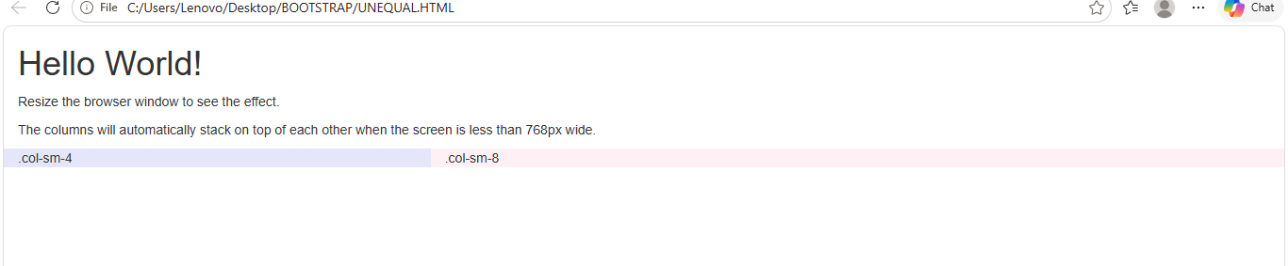

Button Styles
Bootstrap provides different styles of buttons:
To achieve the button styles above, Bootstrap has the following classes:
- .btn
- .btn-default
- .btn-primary
- .btn-success
- .btn-info
- .btn-warning
- .btn-danger
- .btn-link
The following example shows the code for the different button styles:
<!DOCTYPE html>
<html lang="en">
<head>
<title>Bootstrap Example</title>
<meta charset="utf-8">
<meta name="viewport" content="width=device-width, initial-scale=1">
<link rel="stylesheet" href="https://maxcdn.bootstrapcdn.com/bootstrap/3.4.1/css/bootstrap.min.css">
<script src="https://ajax.googleapis.com/ajax/libs/jquery/3.7.1/jquery.min.js"></script>
<script src="https://maxcdn.bootstrapcdn.com/bootstrap/3.4.1/js/bootstrap.min.js"></script>
</head>
<body>

<div class="container">
<h2>Button Styles</h2>
<button type="button" class="btn">Basic</button>
<button type="button" class="btn btn-default">Default</button>
<button type="button" class="btn btn-primary">Primary</button>
<button type="button" class="btn btn-success">Success</button>
<button type="button" class="btn btn-info">Info</button>
<button type="button" class="btn btn-warning">Warning</button>
<button type="button" class="btn btn-danger">Danger</button>
<button type="button" class="btn btn-link">Link</button>
</div>

</body>
</html>
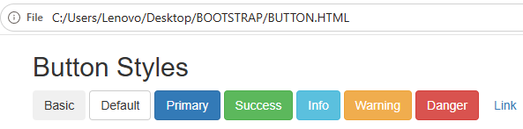

The button classes can be used on an <a>, <button>, or <input> element:
<!DOCTYPE html>
<html lang="en">
<head>
<title>Bootstrap Example</title>
<meta charset="utf-8">
<meta name="viewport" content="width=device-width, initial-scale=1">
<link rel="stylesheet" href="https://maxcdn.bootstrapcdn.com/bootstrap/3.4.1/css/bootstrap.min.css">
<script src="https://ajax.googleapis.com/ajax/libs/jquery/3.7.1/jquery.min.js"></script>
<script src="https://maxcdn.bootstrapcdn.com/bootstrap/3.4.1/js/bootstrap.min.js"></script>
</head>
<body>

<div class="container">
<h2>Button Tags</h2>
<a href="#" class="btn btn-info" role="button">Link Button</a>
<button type="button" class="btn btn-info">Button</button>
<input type="button" class="btn btn-info" value="Input Button">
<input type="submit" class="btn btn-info" value="Submit Button">
</div>

</body>
</html>
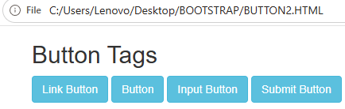
Button Sizes
Bootstrap provides four button sizes:
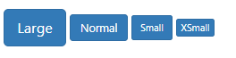
The classes that define the different sizes are:
- .btn-lg
- .btn-sm
- .btn-xs
The following example shows the code for different button sizes:

<!DOCTYPE html>
<html lang="en">
<head>
<title>Bootstrap Example</title>
<meta charset="utf-8">
<meta name="viewport" content="width=device-width, initial-scale=1">
<link rel="stylesheet" href="https://maxcdn.bootstrapcdn.com/bootstrap/3.4.1/css/bootstrap.min.css">
<script src="https://ajax.googleapis.com/ajax/libs/jquery/3.7.1/jquery.min.js"></script>
<script src="https://maxcdn.bootstrapcdn.com/bootstrap/3.4.1/js/bootstrap.min.js"></script>
</head>
<body>

<div class="container">
<h2>Button Sizes</h2>
<button type="button" class="btn btn-primary btn-lg">Large</button>
<button type="button" class="btn btn-primary">Normal</button>
<button type="button" class="btn btn-primary btn-sm">Small</button>
<button type="button" class="btn btn-primary btn-xs">XSmall</button>
</div>

</body>
</html>
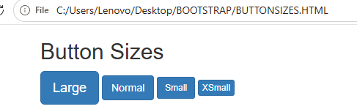

Block Level Buttons
A block level button spans the entire width of the parent element.
Add class .btn-block to create a block level button:

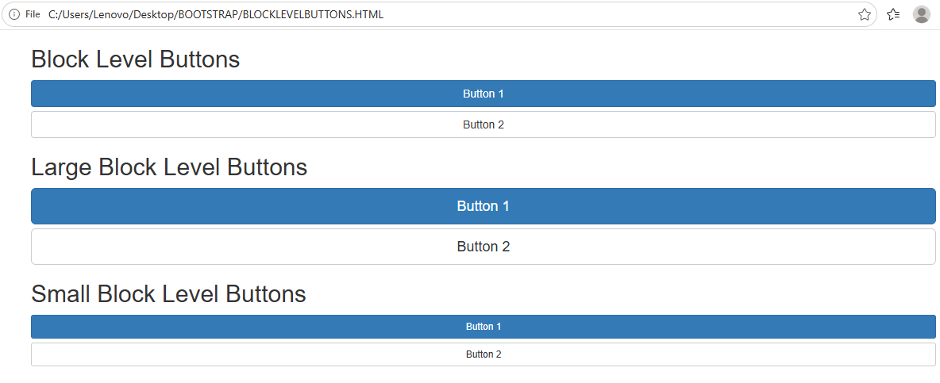

Active/Disabled Buttons
A button can be set to an active (appear pressed) or a disabled (unclickable) state:
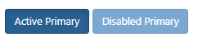
The class .active makes a button appear pressed, and the class .disabled makes a button unclickable:

Example

<!DOCTYPE html>
<html lang="en">
<head>
<title>Bootstrap Example</title>
<meta charset="utf-8">
<meta name="viewport" content="width=device-width, initial-scale=1">
<link rel="stylesheet" href="https://maxcdn.bootstrapcdn.com/bootstrap/3.4.1/css/bootstrap.min.css">
<script src="https://ajax.googleapis.com/ajax/libs/jquery/3.7.1/jquery.min.js"></script>
<script src="https://maxcdn.bootstrapcdn.com/bootstrap/3.4.1/js/bootstrap.min.js"></script>
</head>
<body>

<div class="container">
<h2>Button States</h2>
<button type="button" class="btn btn-primary">Primary Button</button>
<button type="button" class="btn btn-primary active">Active Primary</button>
<button type="button" class="btn btn-primary disabled">Disabled Primary</button>
</div>

</body>
</html>
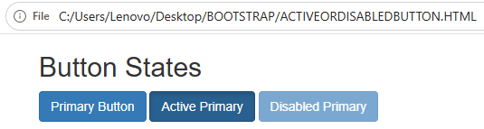

Button Groups
Bootstrap allows you to group a series of buttons together (on a single line) in a button group:

Use a <div> element with class .btn-group to create a button group:

Example

<!DOCTYPE html>
<html lang="en">
<head>
<title>Bootstrap Example</title>
<meta charset="utf-8">
<meta name="viewport" content="width=device-width, initial-scale=1">
<link rel="stylesheet" href="https://maxcdn.bootstrapcdn.com/bootstrap/3.4.1/css/bootstrap.min.css">
<script src="https://ajax.googleapis.com/ajax/libs/jquery/3.7.1/jquery.min.js"></script>
<script src="https://maxcdn.bootstrapcdn.com/bootstrap/3.4.1/js/bootstrap.min.js"></script>
</head>
<body>

<div class="container">
<h2>Button Group</h2>
<p>The .btn-group class creates a button group:</p>
<div class="btn-group">
<button type="button" class="btn btn-primary">Apple</button>
<button type="button" class="btn btn-primary">Samsung</button>
<button type="button" class="btn btn-primary">Sony</button>
</div>
</div>

</body>
</html>
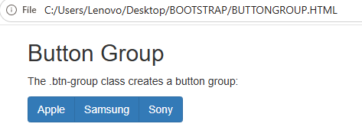
Carousel / Slideshow
The Carousel is a slideshow for cycling through elements:
How to Create a Carousel
The following example shows how to create a basic carousel with indicators and controls:
<!-- Carousel -->
<div id="demo" class="carousel slide" data-bs-ride="carousel">
<!-- Indicators/dots -->
<div class="carousel-indicators">
<button type="button" data-bs-target="#demo" data-bs-slide-to="0" class="active"></button>
<button type="button" data-bs-target="#demo" data-bs-slide-to="1"></button>
<button type="button" data-bs-target="#demo" data-bs-slide-to="2"></button>
</div>
<!-- The slideshow/carousel -->
<div class="carousel-inner">
<div class="carousel-item active">
<img src="la.jpg" alt="Los Angeles" class="d-block w-100">
</div>
<div class="carousel-item">
<img src="chicago.jpg" alt="Chicago" class="d-block w-100">
</div>
<div class="carousel-item">
<img src="ny.jpg" alt="New York" class="d-block w-100">
</div>
</div>
<!-- Left and right controls/icons -->
<button class="carousel-control-prev" type="button" data-bs-target="#demo" data-bs-slide="prev">
<span class="carousel-control-prev-icon"></span>
</button>
<button class="carousel-control-next" type="button" data-bs-target="#demo" data-bs-slide="next">
<span class="carousel-control-next-icon"></span>
</button>
</div>

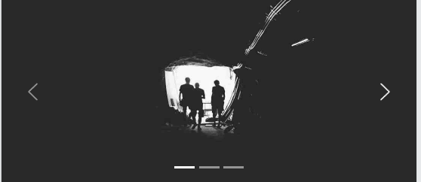

Bootstrap Basic Table
A basic Bootstrap table has a light padding and only horizontal dividers.
The .table class adds basic styling to a table:
<!DOCTYPE html>
<html lang="en">
<head>
<title>Bootstrap Example</title>
<meta charset="utf-8">
<meta name="viewport" content="width=device-width, initial-scale=1">
<link rel="stylesheet" href="https://maxcdn.bootstrapcdn.com/bootstrap/3.4.1/css/bootstrap.min.css">
<script src="https://ajax.googleapis.com/ajax/libs/jquery/3.7.1/jquery.min.js"></script>
<script src="https://maxcdn.bootstrapcdn.com/bootstrap/3.4.1/js/bootstrap.min.js"></script>
</head>
<body>

<div class="container">
<h2>Basic Table</h2>
<p>The .table class adds basic styling (light padding and only horizontal dividers) to a table:</p>
<table class="table">
<thead>
<tr>
<th>Firstname</th>
<th>Lastname</th>
<th>Email</th>
</tr>
</thead>
<tbody>
<tr>
<td>John</td>
<td>Doe</td>
<td>john@example.com</td>
</tr>
<tr>
<td>Mary</td>
<td>Moe</td>
<td>mary@example.com</td>
</tr>
<tr>
<td>July</td>
<td>Dooley</td>
<td>july@example.com</td>
</tr>
</tbody>
</table>
</div>

</body>
</html>

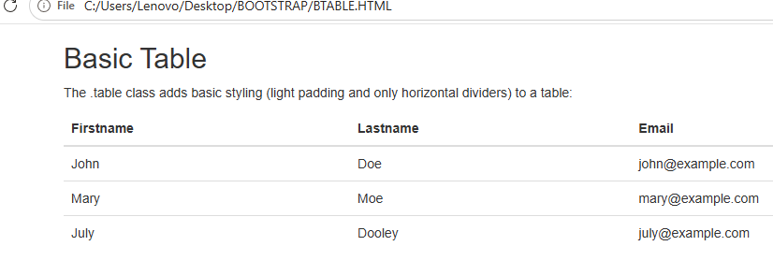
Striped Rows
The .table-striped class adds zebra-stripes to a table:
<!DOCTYPE html>
<html lang="en">
<head>
<title>Bootstrap Example</title>
<meta charset="utf-8">
<meta name="viewport" content="width=device-width, initial-scale=1">
<link rel="stylesheet" href="https://maxcdn.bootstrapcdn.com/bootstrap/3.4.1/css/bootstrap.min.css">
<script src="https://ajax.googleapis.com/ajax/libs/jquery/3.7.1/jquery.min.js"></script>
<script src="https://maxcdn.bootstrapcdn.com/bootstrap/3.4.1/js/bootstrap.min.js"></script>
</head>
<body>

<div class="container">
<h2>Striped Rows</h2>
<p>The .table-striped class adds zebra-stripes to a table:</p>
<table class="table table-striped">
<thead>
<tr>
<th>Firstname</th>
<th>Lastname</th>
<th>Email</th>
</tr>
</thead>
<tbody>
<tr>
<td>John</td>
<td>Doe</td>
<td>john@example.com</td>
</tr>
<tr>
<td>Mary</td>
<td>Moe</td>
<td>mary@example.com</td>
</tr>
<tr>
<td>July</td>
<td>Dooley</td>
<td>july@example.com</td>
</tr>
</tbody>
</table>
</div>

</body>
</html>
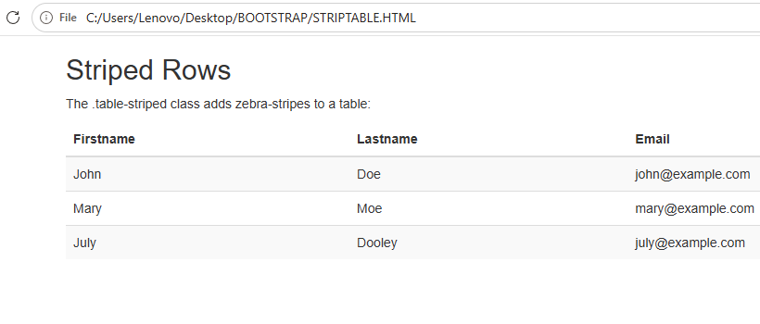
Bordered Table
The .table-bordered class adds borders on all sides of the table and cells:
<!DOCTYPE html>
<html lang="en">
<head>
<title>Bootstrap Example</title>
<meta charset="utf-8">
<meta name="viewport" content="width=device-width, initial-scale=1">
<link rel="stylesheet" href="https://maxcdn.bootstrapcdn.com/bootstrap/3.4.1/css/bootstrap.min.css">
<script src="https://ajax.googleapis.com/ajax/libs/jquery/3.7.1/jquery.min.js"></script>
<script src="https://maxcdn.bootstrapcdn.com/bootstrap/3.4.1/js/bootstrap.min.js"></script>
</head>
<body>

<div class="container">
<h2>Bordered Table</h2>
<p>The .table-bordered class adds borders to a table:</p>
<table class="table table-bordered">
<thead>
<tr>
<th>Firstname</th>
<th>Lastname</th>
<th>Email</th>
</tr>
</thead>
<tbody>
<tr>
<td>John</td>
<td>Doe</td>
<td>john@example.com</td>
</tr>
<tr>
<td>Mary</td>
<td>Moe</td>
<td>mary@example.com</td>
</tr>
<tr>
<td>July</td>
<td>Dooley</td>
<td>july@example.com</td>
</tr>
</tbody>
</table>
</div>

</body>
</html>
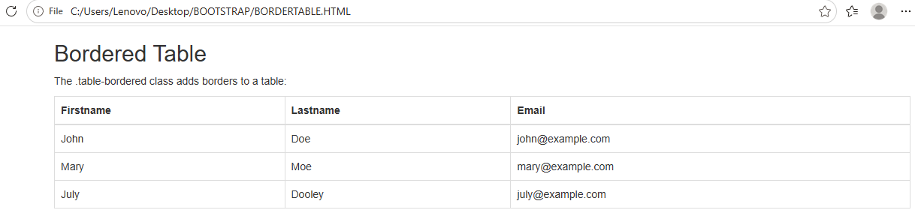
TABLE COMPONENTS
<!DOCTYPE html>
<html lang="en">
<head>
<meta charset="UTF-8">
<meta name="viewport" content="width=device-width, initial-scale=1.0">
<title>Color-Coded Table</title>
<style>
/* Table styling */
table {
border-collapse: collapse;
width: 70%;
margin: 20px auto;
font-family: Arial, sans-serif;
}
th, td {
border: 1px solid #555;
padding: 10px;
text-align: center;
}
th {
background-color: #333;
color: white;
}
/* Alternate row colors */
tr:nth-child(even) {
background-color: #f2f2f2;
}
/* Custom cell colors */
.good {
background-color: #c8e6c9; /* light green */
}
.average {
background-color: #fff9c4; /* light yellow */
}
.poor {
background-color: #ffcdd2; /* light red */
}
</style>
</head>
<body>

<h2 style="text-align:center;">Performance Table</h2>

<table>
<tr>
<th>Name</th>
<th>Math</th>
<th>Science</th>
<th>English</th>
</tr>
<tr>
<td>Alice</td>
<td class="good">95</td>
<td class="average">75</td>
<td class="poor">50</td>
</tr>
<tr>
<td>Bob</td>
<td class="average">70</td>
<td class="good">90</td>
<td class="average">78</td>
</tr>
<tr>
<td>Charlie</td>
<td class="poor">45</td>
<td class="poor">55</td>
<td class="good">88</td>
</tr>
</table>

</body>
</html>

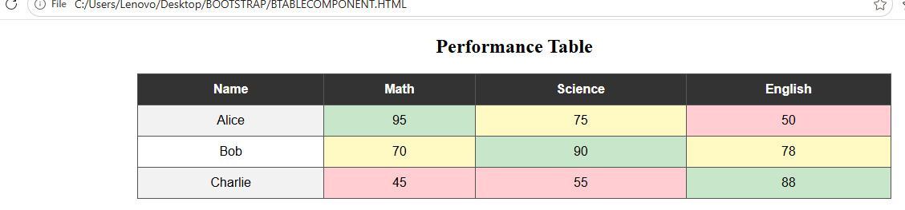

BOOTSTRAP IMAGES

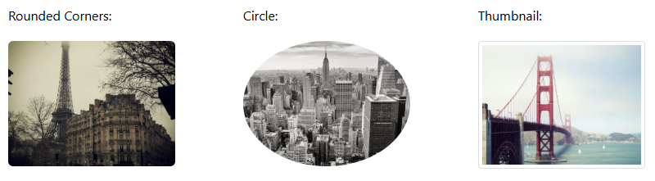
The .img-rounded class adds rounded corners to an image

<!DOCTYPE html>
<html lang="en">
<head>
<title>Bootstrap Example</title>
<meta charset="utf-8">
<meta name="viewport" content="width=device-width, initial-scale=1">
<link rel="stylesheet" href="https://maxcdn.bootstrapcdn.com/bootstrap/3.4.1/css/bootstrap.min.css">
<script src="https://ajax.googleapis.com/ajax/libs/jquery/3.7.1/jquery.min.js"></script>
<script src="https://maxcdn.bootstrapcdn.com/bootstrap/3.4.1/js/bootstrap.min.js"></script>
</head>
<body>

<div class="container">
<h2>Rounded Corners</h2>
<p>The .img-rounded class adds rounded corners to an image (not available in IE8):</p>
<img src="cinqueterre.jpg" class="img-rounded" alt="Cinque Terre" width="304" height="236">
</div>
</body>
</html>
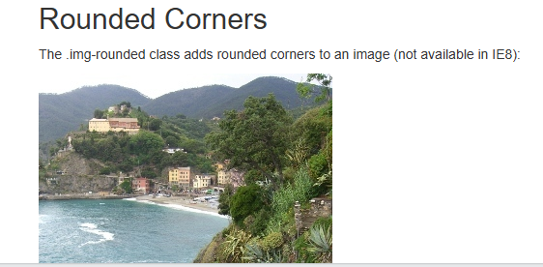
Circle
The .img-circle class shapes the image to a circle (IE8 does not support rounded corners):
<!DOCTYPE html>
<html lang="en">
<head>
<title>Bootstrap Example</title>
<meta charset="utf-8">
<meta name="viewport" content="width=device-width, initial-scale=1">
<link rel="stylesheet" href="https://maxcdn.bootstrapcdn.com/bootstrap/3.4.1/css/bootstrap.min.css">
<script src="https://ajax.googleapis.com/ajax/libs/jquery/3.7.1/jquery.min.js"></script>
<script src="https://maxcdn.bootstrapcdn.com/bootstrap/3.4.1/js/bootstrap.min.js"></script>
</head>
<body>

<div class="container">
<h2>Circle</h2>
<p>The .img-circle class shapes the image to a circle (not available in IE8):</p>
<img src="cinqueterre.jpg" class="img-circle" alt="Cinque Terre" width="304" height="236">
</div>

</body>
</html>
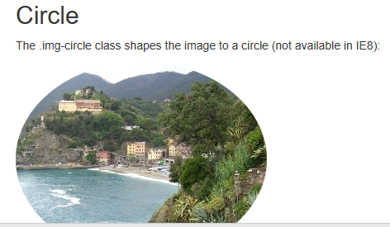
Thumbnail
The .img-thumbnail class shapes the image to a thumbnail:
<!DOCTYPE html>
<html lang="en">
<head>
<title>Bootstrap Example</title>
<meta charset="utf-8">
<meta name="viewport" content="width=device-width, initial-scale=1">
<link rel="stylesheet" href="https://maxcdn.bootstrapcdn.com/bootstrap/3.4.1/css/bootstrap.min.css">
<script src="https://ajax.googleapis.com/ajax/libs/jquery/3.7.1/jquery.min.js"></script>
<script src="https://maxcdn.bootstrapcdn.com/bootstrap/3.4.1/js/bootstrap.min.js"></script>
</head>
<body>

<div class="container">
<h2>Thumbnail</h2>
<p>The .img-thumbnail class creates a thumbnail of the image:</p>
<img src="cinqueterre.jpg" class="img-thumbnail" alt="Cinque Terre" width="304" height="236">
</div>
</body>
</html>
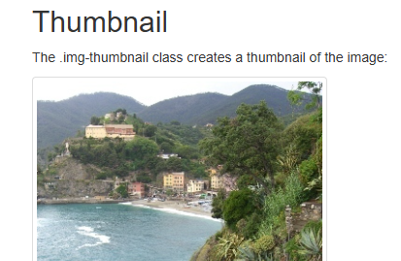

BOOTSTRAP FORMS

Bootstrap's Default Settings
Form controls automatically receive some global styling with Bootstrap:
All textual <input>, <textarea>, and <select> elements with class .form-control have a width of 100%

Bootstrap Form Layouts
Bootstrap provides three types of form layouts:
- Vertical form (this is default)
- Horizontal form
- Inline form
Standard rules for all three form layouts:
- Wrap labels and form controls in <div class="form-group"> (needed for optimum spacing)
- Add class .form-control to all textual <input>, <textarea>, and <select> elements

<!DOCTYPE html>
<html lang="en">

<head>
<title>Bootstrap Example</title>

<link href="https://cdn.jsdelivr.net/npm/bootstrap@5.2.1/dist/css/bootstrap.min.css" rel="stylesheet">

</head>

<body>
<div class="container">
<form>
<h1>Chaitanya Bharathi Institute of Technology (Autonomous)</h1>
<!-- EMAIL SUBMISSION -->
<div>
<label>Email address</label>
<input type="email" class="form-control" id="exampleInputEmail1" placeholder="Enter email">
<small >We'll never share your email with anyone else.</small>
</div>
<!-- PASSWORD -->
<div>
<label>Password</label>
<input type="password" class="form-control" id="Password" placeholder="Password">
</div>
<!-- DROPDOWN SELECT -->
<label>Select list (select one):</label>
<select class="form-select" id="select1" >
<option>1</option>
<option>2</option>
<option>3</option>
<option>4</option>
</select>
<!-- MULTIPLE SELECT OPTIONS -->
<label>Mutiple select list (Hold shift to select more than one):</label>
<select multiple class="form-select" id="select22">
<option>1</option>
<option>2</option>
<option>3</option>
<option>4</option>
<option>5</option>
</select>
<!-- TEXT AREA -->
<div>
<label>Comments:</label>
<textarea class="form-control" rows="5" id="comment"></textarea>
</div>
<!-- FILE UPLOAD INPUT -->
<div>
<label>File input</label>
<input type="file" class="form-control-file" id="InputFile">
</div>
<!-- RADIO BUTTONS -->
<fieldset>
<legend>Radio buttons</legend>
<div class="form-check">
<label class="form-check-label">
<input type="radio" class="form-check-input" name="optionsRadios" value="CBIT" checked>
CBIT
</label>
</div>
<div class="form-check">
<label class="form-check-label">
<input type="radio" class="form-check-input" name="optionsRadios" value="MGIT">
MGIT
</label>
</div>
<div class="form-check disabled">
<label class="form-check-label">
<input type="radio" class="form-check-input" name="optionsRadios" id="optionsRadios3" value="option3"
disabled>
VCE is disabled
</label>
</div>
</fieldset>
<!-- CHECK BUTTON -->
<div class="form-check">
<label class="form-check-label">
<input type="checkbox" class="form-check-input">
Check me out
</label>
</div>
<button type="submit" class="btn btn-primary">Submit</button>
</form>
</div>
</body>

</html>

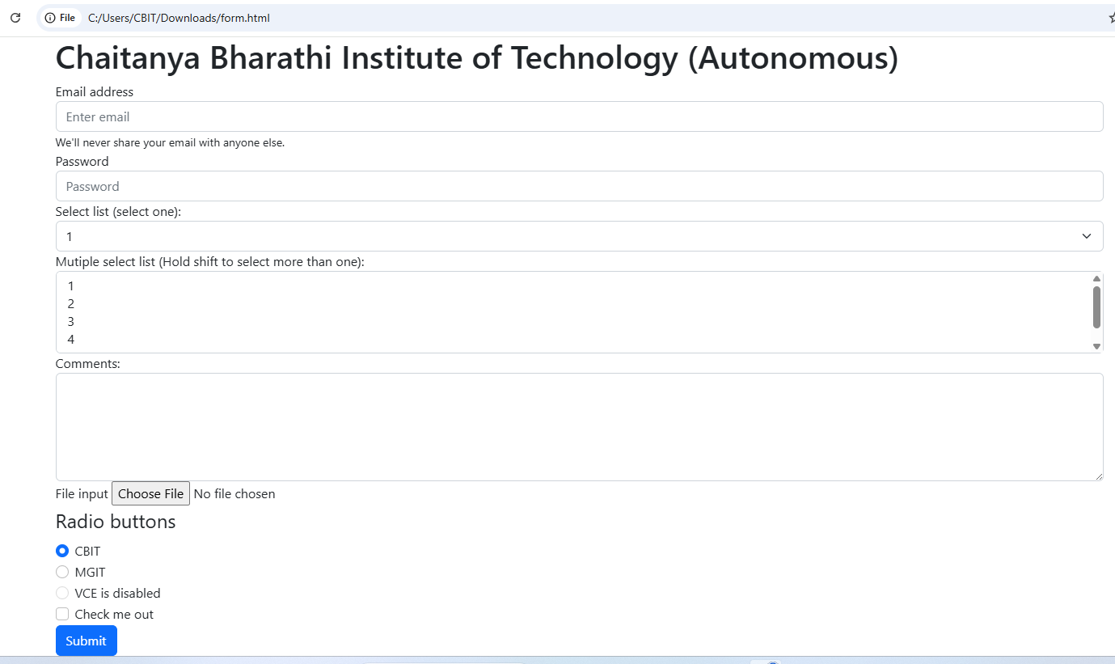

BOOTSTRAP VALIDATION
<!DOCTYPE html>
<html lang="en">
<head>
<title>Bootstrap Example</title>
<meta charset="utf-8">
<meta name="viewport" content="width=device-width, initial-scale=1">
<link href="https://cdn.jsdelivr.net/npm/bootstrap@5.3.8/dist/css/bootstrap.min.css" rel="stylesheet">
<script src="https://cdn.jsdelivr.net/npm/bootstrap@5.3.8/dist/js/bootstrap.bundle.min.js"></script>
</head>
<body>

<div class="container mt-3">
<h3>Form Validation</h3>
<p>Try to submit the form.</p>

<form action="/action_page.php" class="was-validated">
<div class="mb-3 mt-3">
<label for="uname" class="form-label">Username:</label>
<input type="text" class="form-control" id="uname" placeholder="Enter username" name="uname" required>
<div class="valid-feedback">Valid.</div>
<div class="invalid-feedback">Please fill out this field.</div>
</div>
<div class="mb-3">
<label for="pwd" class="form-label">Password:</label>
<input type="password" class="form-control" id="pwd" placeholder="Enter password" name="pswd" required>
<div class="valid-feedback">Valid.</div>
<div class="invalid-feedback">Please fill out this field.</div>
</div>
<div class="form-check mb-3">
<input class="form-check-input" type="checkbox" id="myCheck" name="remember" required>
<label class="form-check-label" for="myCheck">I agree on blabla.</label>
<div class="valid-feedback">Valid.</div>
<div class="invalid-feedback">Check this checkbox to continue.</div>
</div>
<button type="submit" class="btn btn-primary">Submit</button>
</form>
</div>

</body>
</html>

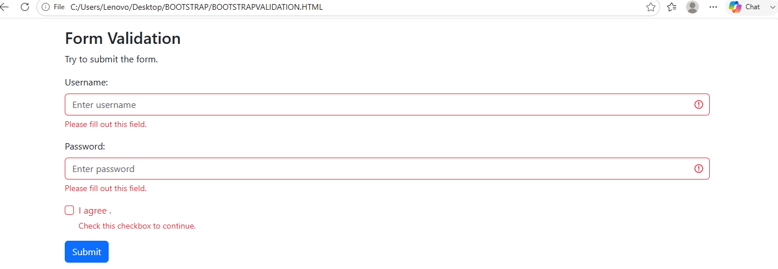

Bootstrap Alerts
Alerts are created with the .alert class, followed by one of the four contextual classes .alert-success, .alert-info, .alert-warning or .alert-danger:
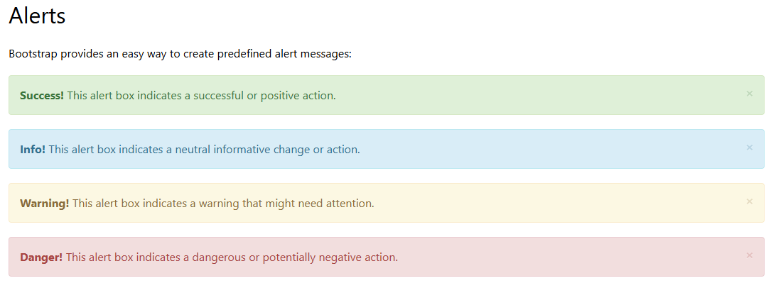

<!DOCTYPE html>
<html lang="en">
<head>
<title>Bootstrap Example</title>
<meta charset="utf-8">
<meta name="viewport" content="width=device-width, initial-scale=1">
<link rel="stylesheet" href="https://maxcdn.bootstrapcdn.com/bootstrap/3.4.1/css/bootstrap.min.css">
<script src="https://ajax.googleapis.com/ajax/libs/jquery/3.7.1/jquery.min.js"></script>
<script src="https://maxcdn.bootstrapcdn.com/bootstrap/3.4.1/js/bootstrap.min.js"></script>
</head>
<body>

<div class="container">
<h2>Alerts</h2>
<div class="alert alert-success">
<strong>Success!</strong> This alert box could indicate a successful or positive action.
</div>
<div class="alert alert-info">
<strong>Info!</strong> This alert box could indicate a neutral informative change or action.
</div>
<div class="alert alert-warning">
<strong>Warning!</strong> This alert box could indicate a warning that might need attention.
</div>
<div class="alert alert-danger">
<strong>Danger!</strong> This alert box could indicate a dangerous or potentially negative action.
</div>
</div>

</body>
</html>

Creating Alert Messages with Bootstrap
Alert boxes are used quite often to stand out the information that requires immediate attention of the end users such as warning, error or confirmation messages.
With Bootstrap you can easily create elegant alert messages for various purposes by adding the contextual classes (e.g., .alert-success, .alert-warning, .alert-info etc.) to the .alert base class. You can also add an optional close button to dismiss any alert.

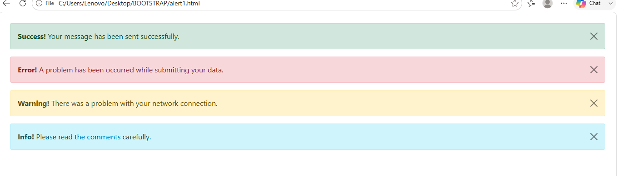
ALERT TYPES IN HTML

<!DOCTYPE html>
<html lang="en">
<head>
<meta charset="utf-8">
<meta name="viewport" content="width=device-width, initial-scale=1">
<title>Bootstrap New Alert Boxes</title>
<link href="https://cdn.jsdelivr.net/npm/bootstrap@5.0.2/dist/css/bootstrap.min.css" rel="stylesheet">
<script src="https://cdn.jsdelivr.net/npm/bootstrap@5.0.2/dist/js/bootstrap.bundle.min.js"></script>
</head>
<body>
<div class="m-4">
<!-- Primary Alert -->
<div class="alert alert-primary alert-dismissible fade show">
<strong>Primary!</strong> This is a simple primary alert box.
<button type="button" class="btn-close" data-bs-dismiss="alert"></button>
</div>

<!-- Secondary Alert -->
<div class="alert alert-secondary alert-dismissible fade show">
<strong>Secondary!</strong> This is a simple secondary alert box.
<button type="button" class="btn-close" data-bs-dismiss="alert"></button>
</div>

<!-- Dark Alert -->
<div class="alert alert-dark alert-dismissible fade show">
<strong>Dark!</strong> This is a simple dark alert box.
<button type="button" class="btn-close" data-bs-dismiss="alert"></button>
</div>

<!-- Light Alert -->
<div class="alert alert-light alert-dismissible fade show">
<strong>Light!</strong> This is a simple light alert box.
<button type="button" class="btn-close" data-bs-dismiss="alert"></button>
</div>
</div>
</body>
</html>

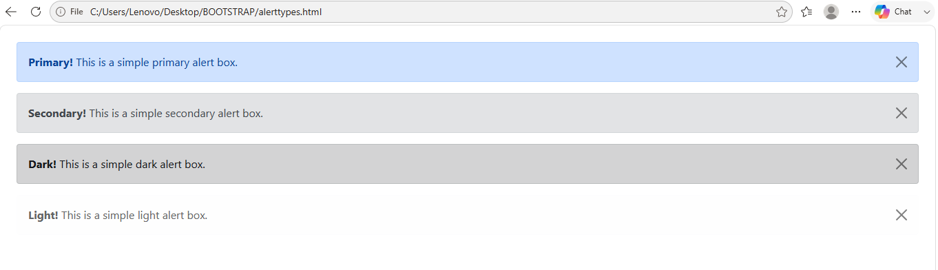

Matching Links Color inside Alerts
You can apply the utility class .alert-link to the links inside any alert boxes to quickly create matching colored links, as shown in the example below:

<!DOCTYPE html>
<html lang="en">
<head>
<meta charset="utf-8">
<meta name="viewport" content="width=device-width, initial-scale=1">
<title>Link inside Bootstrap Alerts</title>
<link href="https://cdn.jsdelivr.net/npm/bootstrap@5.0.2/dist/css/bootstrap.min.css" rel="stylesheet">
<script src="https://cdn.jsdelivr.net/npm/bootstrap@5.0.2/dist/js/bootstrap.bundle.min.js"></script>
</head>
<body>
<div class="m-4">
<div class="alert alert-warning alert-dismissible fade show">
<strong>Warning!</strong> A simple warning alert with <a href="#" class="alert-link">an example link</a>.
<button type="button" class="btn-close" data-bs-dismiss="alert"></button>
</div>
</div>
</body>
</html>

<!DOCTYPE html>
<html lang="en">
<head>
<meta charset="utf-8">
<meta name="viewport" content="width=device-width, initial-scale=1">
<title>Matching Links Color inside Bootstrap Alerts</title>
<link href="https://cdn.jsdelivr.net/npm/bootstrap@5.0.2/dist/css/bootstrap.min.css" rel="stylesheet">
<script src="https://cdn.jsdelivr.net/npm/bootstrap@5.0.2/dist/js/bootstrap.bundle.min.js"></script>
</head>
<body>
<div class="m-4">
<!-- Success Alert -->
<div class="alert alert-success alert-dismissible fade show">
<strong>Success!</strong> A simple success alert with <a href="#" class="alert-link">an example link</a>.
<button type="button" class="btn-close" data-bs-dismiss="alert"></button>
</div>

<!-- Error Alert -->
<div class="alert alert-danger alert-dismissible fade show">
<strong>Error!</strong> A simple danger alert with <a href="#" class="alert-link">an example link</a>.
<button type="button" class="btn-close" data-bs-dismiss="alert"></button>
</div>

<!-- Warning Alert -->
<div class="alert alert-warning alert-dismissible fade show">
<strong>Warning!</strong> A simple warning alert with <a href="#" class="alert-link">an example link</a>.
<button type="button" class="btn-close" data-bs-dismiss="alert"></button>
</div>

<!-- Info Alert -->
<div class="alert alert-info alert-dismissible fade show">
<strong>Info!</strong> A simple info alert with <a href="#" class="alert-link">an example link</a>.
<button type="button" class="btn-close" data-bs-dismiss="alert"></button>
</div>

<!-- Primary Alert -->
<div class="alert alert-primary alert-dismissible fade show">
<strong>Primary!</strong> A simple primary alert with <a href="#" class="alert-link">an example link</a>.
<button type="button" class="btn-close" data-bs-dismiss="alert"></button>
</div>

<!-- Secondary Alert -->
<div class="alert alert-secondary alert-dismissible fade show">
<strong>Secondary!</strong> A simple secondary alert with <a href="#" class="alert-link">an example link</a>.
<button type="button" class="btn-close" data-bs-dismiss="alert"></button>
</div>

<!-- Dark Alert -->
<div class="alert alert-dark alert-dismissible fade show">
<strong>Dark!</strong> A simple dark alert with <a href="#" class="alert-link">an example link</a>.
<button type="button" class="btn-close" data-bs-dismiss="alert"></button>
</div>

<!-- Light Alert -->
<div class="alert alert-light alert-dismissible fade show">
<strong>Light!</strong> A simple light alert with <a href="#" class="alert-link">an example link</a>.
<button type="button" class="btn-close" data-bs-dismiss="alert"></button>
</div>
</div>
</body>
</html>

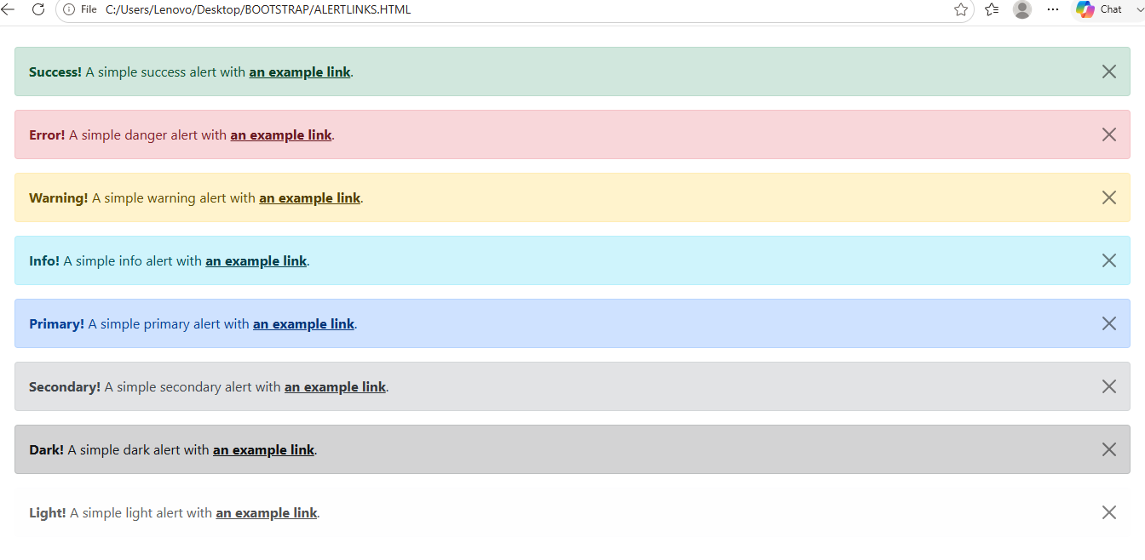

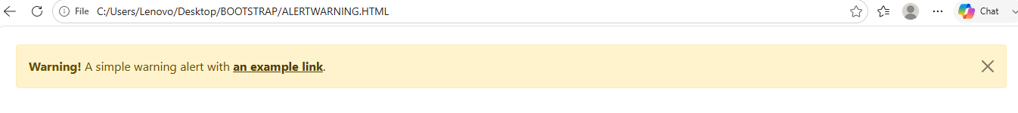

Navbar
Bootstrap navbar component to create responsive navigation header for your website or application.
<!DOCTYPE html>
<html lang="en">
<head>
<meta charset="utf-8">
<meta name="viewport" content="width=device-width, initial-scale=1">
<title>Bootstrap Static Navbar</title>
<link href="https://cdn.jsdelivr.net/npm/bootstrap@5.0.2/dist/css/bootstrap.min.css" rel="stylesheet">
<script src="https://cdn.jsdelivr.net/npm/bootstrap@5.0.2/dist/js/bootstrap.bundle.min.js"></script>
</head>
<body>
<div class="m-4">
<nav class="navbar navbar-expand-lg navbar-light bg-light">
<div class="container-fluid">
<a href="#" class="navbar-brand">Brand</a>
<button type="button" class="navbar-toggler" data-bs-toggle="collapse" data-bs-target="#navbarCollapse">
<span class="navbar-toggler-icon"></span>
</button>
<div class="collapse navbar-collapse" id="navbarCollapse">
<div class="navbar-nav">
<a href="#" class="nav-item nav-link active">Home</a>
<a href="#" class="nav-item nav-link">Profile</a>
<a href="#" class="nav-item nav-link">Messages</a>
<a href="#" class="nav-item nav-link disabled" tabindex="-1">Reports</a>
</div>
<div class="navbar-nav ms-auto">
<a href="#" class="nav-item nav-link">Login</a>
</div>
</div>
</div>
</nav>
</div>
</body>
</html>

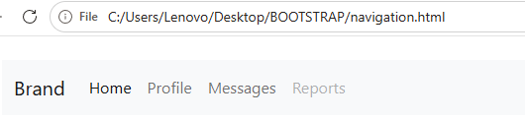

Adding Logo Images to Navbars
You can also place your logo image inside the navbar, instead of plain text.
<!DOCTYPE html>
<html lang="en">
<head>
<meta charset="utf-8">
<meta name="viewport" content="width=device-width, initial-scale=1">
<title>Bootstrap Navbar with Logo Image</title>
<link href="https://cdn.jsdelivr.net/npm/bootstrap@5.0.2/dist/css/bootstrap.min.css" rel="stylesheet">
<script src="https://cdn.jsdelivr.net/npm/bootstrap@5.0.2/dist/js/bootstrap.bundle.min.js"></script>
</head>
<body>
<div class="m-4">
<nav class="navbar navbar-expand-lg navbar-light bg-light">
<div class="container-fluid">
<a href="#" class="navbar-brand">
<img src="/examples/images/logo.svg" height="28" alt="CoolBrand">
</a>
<button type="button" class="navbar-toggler" data-bs-toggle="collapse" data-bs-target="#navbarCollapse">
<span class="navbar-toggler-icon"></span>
</button>
<div class="collapse navbar-collapse" id="navbarCollapse">
<div class="navbar-nav">
<a href="#" class="nav-item nav-link active">Home</a>
<a href="#" class="nav-item nav-link">Profile</a>
<a href="#" class="nav-item nav-link">Messages</a>
<a href="#" class="nav-item nav-link disabled" tabindex="-1">Reports</a>
</div>
<div class="navbar-nav ms-auto">
<a href="#" class="nav-item nav-link">Login</a>
</div>
</div>
</div>
</nav>
</div>
</body>
</html>

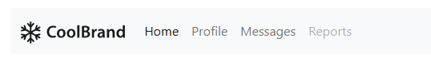

Adding Dropdowns to Navbar
You can also include dropdowns and search box within the navbars, as shown here:
<!DOCTYPE html>
<html lang="en">
<head>
<meta charset="utf-8">
<meta name="viewport" content="width=device-width, initial-scale=1">
<title>Bootstrap Navbar with Dropdown</title>
<link href="https://cdn.jsdelivr.net/npm/bootstrap@5.0.2/dist/css/bootstrap.min.css" rel="stylesheet">
<script src="https://cdn.jsdelivr.net/npm/bootstrap@5.0.2/dist/js/bootstrap.bundle.min.js"></script>
</head>
<body>
<div class="m-4">
<nav class="navbar navbar-expand-lg navbar-light bg-light">
<div class="container-fluid">
<a href="#" class="navbar-brand">Brand</a>
<button type="button" class="navbar-toggler" data-bs-toggle="collapse" data-bs-target="#navbarCollapse">
<span class="navbar-toggler-icon"></span>
</button>
<div class="collapse navbar-collapse" id="navbarCollapse">
<div class="navbar-nav">
<a href="#" class="nav-item nav-link active">Home</a>
<a href="#" class="nav-item nav-link">Profile</a>
<div class="nav-item dropdown">
<a href="#" class="nav-link dropdown-toggle" data-bs-toggle="dropdown">Messages</a>
<div class="dropdown-menu">
<a href="#" class="dropdown-item">Inbox</a>
<a href="#" class="dropdown-item">Sent</a>
<a href="#" class="dropdown-item">Drafts</a>
</div>
</div>
<a href="#" class="nav-item nav-link disabled" tabindex="-1">Reports</a>
</div>
<div class="navbar-nav ms-auto">
<a href="#" class="nav-item nav-link">Login</a>
</div>
</div>
</div>
</nav>
</div>
</body>
</html>

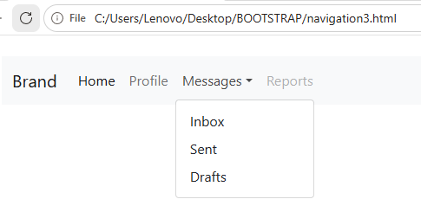

Placing Search Form inside Navbar
Search form is a very common component of the navbars and you have seen it on various website quite often. You can place various form controls within a navbar using the class .d-flex on the <form> element, as demonstrated in the following example:
<!DOCTYPE html>
<html lang="en">
<head>
<meta charset="utf-8">
<meta name="viewport" content="width=device-width, initial-scale=1">
<title>Bootstrap Navbar with Dropdown</title>
<link href="https://cdn.jsdelivr.net/npm/bootstrap@5.0.2/dist/css/bootstrap.min.css" rel="stylesheet">
<link rel="stylesheet" href="https://cdn.jsdelivr.net/npm/bootstrap-icons@1.5.0/font/bootstrap-icons.css">
<script src="https://cdn.jsdelivr.net/npm/bootstrap@5.0.2/dist/js/bootstrap.bundle.min.js"></script>
</head>
<body>
<div class="m-4">
<nav class="navbar navbar-expand-lg navbar-light bg-light">
<div class="container-fluid">
<a href="#" class="navbar-brand">Brand</a>
<button type="button" class="navbar-toggler" data-bs-toggle="collapse" data-bs-target="#navbarCollapse">
<span class="navbar-toggler-icon"></span>
</button>
<div class="collapse navbar-collapse justify-content-between" id="navbarCollapse">
<div class="navbar-nav">
<a href="#" class="nav-item nav-link active">Home</a>
<a href="#" class="nav-item nav-link">Profile</a>
<div class="nav-item dropdown">
<a href="#" class="nav-link dropdown-toggle" data-bs-toggle="dropdown">Messages</a>
<div class="dropdown-menu">
<a href="#" class="dropdown-item">Inbox</a>
<a href="#" class="dropdown-item">Sent</a>
<a href="#" class="dropdown-item">Drafts</a>
</div>
</div>
</div>
<form class="d-flex">
<div class="input-group">
<input type="text" class="form-control" placeholder="Search">
<button type="button" class="btn btn-secondary"><i class="bi-search"></i></button>
</div>
</form>
<div class="navbar-nav">
<a href="#" class="nav-item nav-link">Login</a>
</div>
</div>
</div>
</nav>
</div>
</body>
</html>
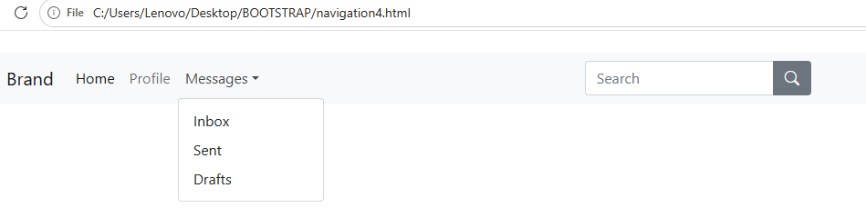

Changing the Color Scheme of Navbars
You can also change the color scheme of the navbar by using the .navbar-light for the light background colors, or .navbar-dark for the dark background colors. Then, customize it with the background color utility classes, such as .bg-dark, .bg-primary, and so on.
Alternatively, you can also apply the CSS background-color property on the .navbar element yourself to customize the navbar theme, as shown in the following example:
<!DOCTYPE html>
<html lang="en">
<head>
<meta charset="utf-8">
<meta name="viewport" content="width=device-width, initial-scale=1">
<title>Bootstrap Navbar Color Schemes</title>
<link href="https://cdn.jsdelivr.net/npm/bootstrap@5.0.2/dist/css/bootstrap.min.css" rel="stylesheet">
<link rel="stylesheet" href="https://cdn.jsdelivr.net/npm/bootstrap-icons@1.5.0/font/bootstrap-icons.css">
<script src="https://cdn.jsdelivr.net/npm/bootstrap@5.0.2/dist/js/bootstrap.bundle.min.js"></script>
<style>
/* Custom style */
.navbar{
margin-bottom: 1rem;
}
</style>
</head>
<body>
<div class="m-4">
<nav class="navbar navbar-expand-lg navbar-dark bg-dark">
<div class="container-fluid">
<a href="#" class="navbar-brand">Brand</a>
<button type="button" class="navbar-toggler" data-bs-toggle="collapse" data-bs-target="#navbarCollapse1">
<span class="navbar-toggler-icon"></span>
</button>
<div class="collapse navbar-collapse" id="navbarCollapse1">
<div class="navbar-nav">
<a href="#" class="nav-item nav-link active">Home</a>
<a href="#" class="nav-item nav-link">About</a>
<a href="#" class="nav-item nav-link">Products</a>
</div>
<form class="d-flex ms-auto">
<input type="text" class="form-control me-sm-2" placeholder="Search">
<button type="submit" class="btn btn-outline-light">Search</button>
</form>
</div>
</div>
</nav>

<nav class="navbar navbar-expand-lg navbar-dark bg-primary">
<div class="container-fluid">
<a href="#" class="navbar-brand">Brand</a>
<button type="button" class="navbar-toggler" data-bs-toggle="collapse" data-bs-target="#navbarCollapse2">
<span class="navbar-toggler-icon"></span>
</button>
<div class="collapse navbar-collapse" id="navbarCollapse2">
<div class="navbar-nav">
<a href="#" class="nav-item nav-link active">Home</a>
<a href="#" class="nav-item nav-link">About</a>
<a href="#" class="nav-item nav-link">Products</a>
</div>
<form class="d-flex ms-auto">
<input type="text" class="form-control me-sm-2" placeholder="Search">
<button type="submit" class="btn btn-outline-light">Search</button>
</form>
</div>
</div>
</nav>

<nav class="navbar navbar-expand-lg navbar-dark bg-secondary">
<div class="container-fluid">
<a href="#" class="navbar-brand">Brand</a>
<button type="button" class="navbar-toggler" data-bs-toggle="collapse" data-bs-target="#navbarCollapse3">
<span class="navbar-toggler-icon"></span>
</button>
<div class="collapse navbar-collapse" id="navbarCollapse3">
<div class="navbar-nav">
<a href="#" class="nav-item nav-link active">Home</a>
<a href="#" class="nav-item nav-link">About</a>
<a href="#" class="nav-item nav-link">Products</a>
</div>
<form class="d-flex ms-auto">
<input type="text" class="form-control me-sm-2" placeholder="Search">
<button type="submit" class="btn btn-outline-light">Search</button>
</form>
</div>
</div>
</nav>

<nav class="navbar navbar-expand-lg navbar-dark bg-success">
<div class="container-fluid">
<a href="#" class="navbar-brand">Brand</a>
<button type="button" class="navbar-toggler" data-bs-toggle="collapse" data-bs-target="#navbarCollapse4">
<span class="navbar-toggler-icon"></span>
</button>
<div class="collapse navbar-collapse" id="navbarCollapse4">
<div class="navbar-nav">
<a href="#" class="nav-item nav-link active">Home</a>
<a href="#" class="nav-item nav-link">About</a>
<a href="#" class="nav-item nav-link">Products</a>
</div>
<form class="d-flex ms-auto">
<input type="text" class="form-control me-sm-2" placeholder="Search">
<button type="submit" class="btn btn-outline-light">Search</button>
</form>
</div>
</div>
</nav>

<nav class="navbar navbar-expand-lg navbar-dark bg-info">
<div class="container-fluid">
<a href="#" class="navbar-brand">Brand</a>
<button type="button" class="navbar-toggler" data-bs-toggle="collapse" data-bs-target="#navbarCollapse5">
<span class="navbar-toggler-icon"></span>
</button>
<div class="collapse navbar-collapse" id="navbarCollapse5">
<div class="navbar-nav">
<a href="#" class="nav-item nav-link active">Home</a>
<a href="#" class="nav-item nav-link">About</a>
<a href="#" class="nav-item nav-link">Products</a>
</div>
<form class="d-flex ms-auto">
<input type="text" class="form-control me-sm-2" placeholder="Search">
<button type="submit" class="btn btn-outline-light">Search</button>
</form>
</div>
</div>
</nav>

<nav class="navbar navbar-expand-lg navbar-dark bg-danger">
<div class="container-fluid">
<a href="#" class="navbar-brand">Brand</a>
<button type="button" class="navbar-toggler" data-bs-toggle="collapse" data-bs-target="#navbarCollapse6">
<span class="navbar-toggler-icon"></span>
</button>
<div class="collapse navbar-collapse" id="navbarCollapse6">
<div class="navbar-nav">
<a href="#" class="nav-item nav-link active">Home</a>
<a href="#" class="nav-item nav-link">About</a>
<a href="#" class="nav-item nav-link">Products</a>
</div>
<form class="d-flex ms-auto">
<input type="text" class="form-control me-sm-2" placeholder="Search">
<button type="submit" class="btn btn-outline-light">Search</button>
</form>
</div>
</div>
</nav>

<nav class="navbar navbar-expand-lg navbar-dark bg-warning">
<div class="container-fluid">
<a href="#" class="navbar-brand">Brand</a>
<button type="button" class="navbar-toggler" data-bs-toggle="collapse" data-bs-target="#navbarCollapse7">
<span class="navbar-toggler-icon"></span>
</button>
<div class="collapse navbar-collapse" id="navbarCollapse7">
<div class="navbar-nav">
<a href="#" class="nav-item nav-link active">Home</a>
<a href="#" class="nav-item nav-link">About</a>
<a href="#" class="nav-item nav-link">Products</a>
</div>
<form class="d-flex ms-auto">
<input type="text" class="form-control me-sm-2" placeholder="Search">
<button type="submit" class="btn btn-outline-light">Search</button>
</form>
</div>
</div>
</nav>

<nav class="navbar navbar-expand-lg navbar-light bg-light">
<div class="container-fluid">
<a href="#" class="navbar-brand">Brand</a>
<button type="button" class="navbar-toggler" data-bs-toggle="collapse" data-bs-target="#navbarCollapse8">
<span class="navbar-toggler-icon"></span>
</button>
<div class="collapse navbar-collapse" id="navbarCollapse8">
<div class="navbar-nav">
<a href="#" class="nav-item nav-link active">Home</a>
<a href="#" class="nav-item nav-link">About</a>
<a href="#" class="nav-item nav-link">Products</a>
</div>
<form class="d-flex ms-auto">
<input type="text" class="form-control me-sm-2" placeholder="Search">
<button type="submit" class="btn btn-outline-secondary">Search</button>
</form>
</div>
</div>
</nav>

<nav class="navbar navbar-expand-lg navbar-light" style="background-color: #e3f2fd;">
<div class="container-fluid">
<a href="#" class="navbar-brand">Brand</a>
<button type="button" class="navbar-toggler" data-bs-toggle="collapse" data-bs-target="#navbarCollapse9">
<span class="navbar-toggler-icon"></span>
</button>
<div class="collapse navbar-collapse" id="navbarCollapse9">
<div class="navbar-nav">
<a href="#" class="nav-item nav-link active">Home</a>
<a href="#" class="nav-item nav-link">About</a>
<a href="#" class="nav-item nav-link">Products</a>
</div>
<form class="d-flex ms-auto">
<input type="text" class="form-control me-sm-2" placeholder="Search">
<button type="submit" class="btn btn-outline-primary">Search</button>
</form>
</div>
</div>
</nav>
</div>
</body>
</html>

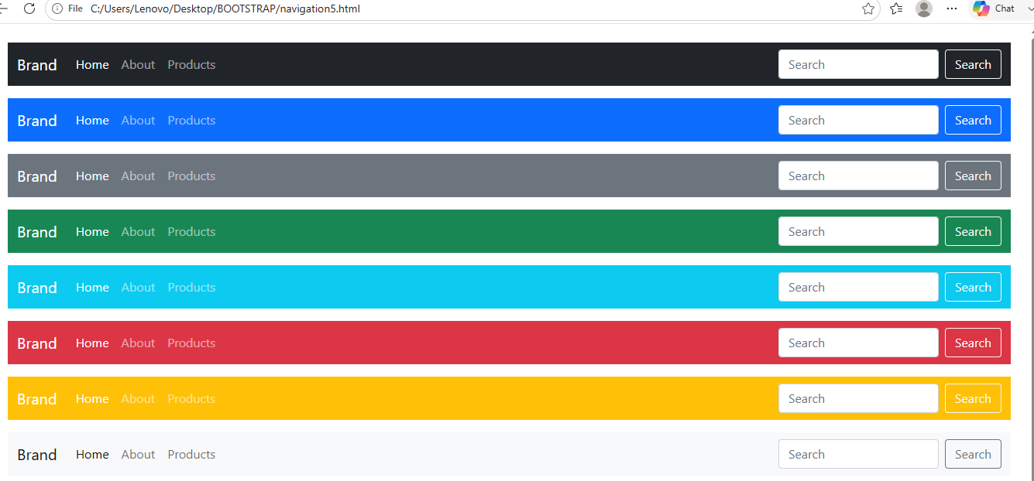

Bootstrap Fixed Navbars
Bootstrap also provides mechanism to create navbar that is fixed to the top, fixed to the bottom, or stickied to the top (i.e. scrolls with the page until it reaches the top, then stays there).

Navbar Fixed to the Top
Apply the position utility class .fixed-top to the .navbar element to fix the navbar at the top of the viewport, so that it won't scroll with the page. Here's an example:

<!DOCTYPE html>
<html lang="en">
<head>
<meta charset="utf-8">
<meta name="viewport" content="width=device-width, initial-scale=1">
<title>Bootstrap Navbar Fixed to Top</title>
<link href="https://cdn.jsdelivr.net/npm/bootstrap@5.0.2/dist/css/bootstrap.min.css" rel="stylesheet">
<script src="https://cdn.jsdelivr.net/npm/bootstrap@5.0.2/dist/js/bootstrap.bundle.min.js"></script>
<style>
/* Custom CSS to prevent the content
to go underneath the navbar */
body{
padding-top: 70px;
}
</style>
</head>
<body>
<div class="m-4">
<nav class="navbar fixed-top navbar-expand-lg navbar-dark bg-dark">
<div class="container-fluid">
<a href="#" class="navbar-brand">Brand</a>
<button type="button" class="navbar-toggler" data-bs-toggle="collapse" data-bs-target="#navbarCollapse">
<span class="navbar-toggler-icon"></span>
</button>
<div class="collapse navbar-collapse" id="navbarCollapse">
<div class="navbar-nav">
<a href="#" class="nav-item nav-link active">Home</a>
<a href="#" class="nav-item nav-link">Profile</a>
<a href="#" class="nav-item nav-link">Messages</a>
<a href="#" class="nav-item nav-link disabled" tabindex="-1">Reports</a>
</div>
<div class="navbar-nav ms-auto">
<a href="#" class="nav-item nav-link">Login</a>
</div>
</div>
</div>
</nav>

<!-- Demo Content -->
<div class="container">
<div class="p-5 mb-4 bg-light rounded-3">
<h1>Fixed Top Navbar</h1>
<p class="lead">The fixed-top navbar bar is fixed at the top of the viewport and does not scroll with the rest of the page.</p>
</div>
<p>Lorem ipsum dolor sit amet, consectetur adipiscing elit. Nam eu sem tempor, varius quam at, luctus dui. Mauris magna metus, dapibus nec turpis vel, semper malesuada ante. Vestibulum id metus ac nisl bibendum scelerisque non non purus. Suspendisse varius nibh non aliquet sagittis. In tincidunt orci sit amet elementum vestibulum. Vivamus fermentum in arcu in aliquam. Quisque aliquam porta odio in fringilla. Vivamus nisl leo, blandit at bibendum eu, tristique eget risus. Integer aliquet quam ut elit suscipit, id interdum neque porttitor. Integer faucibus ligula.Quis quam ut magna consequat faucibus. Pellentesque eget nisi a mi suscipit tincidunt. Ut tempus dictum risus. Pellentesque viverra sagittis quam at mattis. Suspendisse potenti. Aliquam sit amet gravida nibh, facilisis gravida odio. Phasellus auctor velit at lacus blandit, commodo iaculis justo viverra. Etiam vitae est arcu. Mauris vel congue dolor. Aliquam eget mi mi. Fusce quam tortor, commodo ac dui quis, bibendum viverra erat. Maecenas mattis lectus enim, quis tincidunt dui molestie euismod. Curabitur et diam tristique, accumsan nunc eu, hendrerit tellus. Tibulum consectetur scelerisque lacus, ac fermentum lorem convallis sed.</p>
<p>Orci facilisis, dignissim tortor vitae, ultrices mi. Vestibulum a iaculis lacus. Phasellus vitae convallis ligula, nec volutpat tellus. Vivamus scelerisque mollis nisl, nec vehicula elit egestas a. Sed luctus metus id mi gravida, faucibus convallis neque pretium. Maecenas quis sapien ut leo fringilla tempor vitae sit amet leo. Donec imperdiet tempus placerat. Pellentesque pulvinar ultrices nunc sed ultrices. Morbi vel mi pretium, fermentum lacus et, viverra tellus. Phasellus sodales libero nec dui convallis, sit amet fermentum sapien auctor. Vestibulum ante ipsum primis in faucibus orci luctus et ultrices posuere cubilia Curae; Sed eu elementum nibh, quis varius libero.Nam eget purus nec est consectetur vehicula. Nullam ultrices nisl risus, in viverra libero egestas sit amet. Etiam porttitor dolor non eros pulvinar malesuada. Vestibulum sit amet est mollis nulla tempus aliquet. Praesent luctus hendrerit arcu non laoreet. Morbi consequat placerat magna, ac ornare odio sagittis sed. Donec vitae ullamcorper purus. Vivamus non metus ac justo porta volutpat.</p>
<p>Pulvinar leo id risus pellentesque vestibulum. Sed diam libero, sodales eget sapien vel, porttitor bibendum enim. Donec sed nibh vitae lorem porttitor blandit in nec ante. Pellentesque vitae metus ipsum. Phasellus sed nunc ac sem malesuada condimentum. Etiam in aliquam lectus. Nam vel sapien diam. Donec pharetra id arcu eget blandit. Proin imperdiet mattis augue in porttitor. Quisque tempus enim id lobortis feugiat. Suspendisse tincidunt risus quis dolor fringilla blandit. Ut sed sapien at purus lacinia porttitor. Nullam iaculis, felis a pretium ornare, dolor nisl semper tortor, vel sagittis lacus est consequat eros. Sed id pretium nisl. Curabitur dolor nisl, laoreet vitae aliquam id.Nullam hendrerit justo non leo aliquet imperdiet. Etiam in sagittis lectus. Suspendisse ultrices placerat accumsan. Mauris quis dapibus orci. In dapibus velit blandit pharetra tincidunt. Quisque non sapien nec lacus condimentum facilisis ut iaculis enim. Sed viverra interdum bibendum. Donec ac sollicitudin dolor. Sed fringilla vitae lacus at rutrum. Phasellus congue vestibulum ligula sed consequat.</p>
<p>Enim arcu, interdum vel metus dignissim, venenatis feugiat purus. Nulla posuere orci ut leo sodales, sed cursus dolor ornare. Cum sociis natoque penatibus et magnis dis parturient montes, nascetur ridiculus mus. Etiam sit amet quam orci. Nulla sollicitudin lectus eget posuere venenatis. Sed vestibulum elementum sagittis. Quisque tristique tortor quis feugiat sollicitudin. Ut pellentesque luctus vulputate. Ut at odio ac erat blandit vehicula ut eget urna. In hac habitasse platea dictumst. Nullam ut iaculis nibh, eget eleifend elit.Convallis eget pretium eu, bibendum non leo. Proin suscipit purus adipiscing dolor gravida, in fermentum sapien blandit. Praesent pellentesque ligula dui, in gravida turpis vehicula ac. Pellentesque hendrerit nunc ut luctus hendrerit. Aliquam nec tincidunt urna. Ut interdum nec odio non interdum. Curabitur ligula justo, dapibus non ligula tristique, dapibus tristique nulla. Aliquam pulvinar dapibus eros, rutrum pretium urna iaculis ut. Nam est est, tempus id egestas et, viverra in dui. Aliquam gravida orci tortor, sed congue justo ornare vel. Cras in quam consectetur eros varius scelerisque. Ut vel fermentum purus. Nullam interdum blandit turpis, id pellentesque massa feugiat at. Ut sed lectus lectus. Vestibulum ante ipsum primis in faucibus orci luctus et ultrices posuere cubilia Curae; Nulla rutrum, ante quis convallis ultricies, magna quam rhoncus erat, in lacinia libero magna a ipsum.</p>
<p>Fusce enim arcu, interdum vel metus dignissim, venenatis feugiat purus. Nulla posuere orci ut leo sodales, sed cursus dolor ornare. Cum sociis natoque penatibus et magnis dis parturient montes, nascetur ridiculus mus. Etiam sit amet quam orci. Nulla sollicitudin lectus eget posuere venenatis. Sed vestibulum elementum sagittis. Quisque tristique tortor quis feugiat sollicitudin. Ut pellentesque luctus vulputate. Ut at odio ac erat blandit vehicula ut eget urna. In hac habitasse platea dictumst. Nullam ut iaculis nibh, eget eleifend elit.</p>
</div>
</div>
</body>
</html>

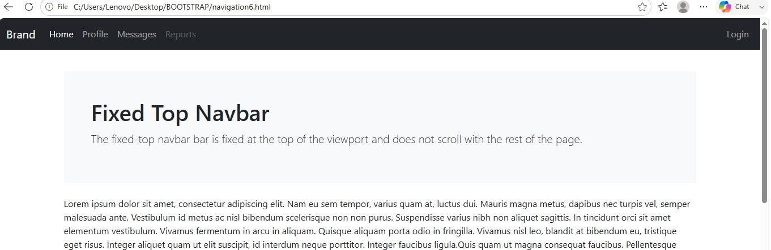

Navbar Fixed to the Bottom
Similarly, add the class .fixed-bottom to the .navbar element to fix the navbar at the bottom of the viewport. It also won't scroll with the page. Let's see how it works:
<!DOCTYPE html>
<html lang="en">
<head>
<meta charset="utf-8">
<meta name="viewport" content="width=device-width, initial-scale=1">
<title>Bootstrap Navbar Fixed to Bottom</title>
<link href="https://cdn.jsdelivr.net/npm/bootstrap@5.0.2/dist/css/bootstrap.min.css" rel="stylesheet">
<script src="https://cdn.jsdelivr.net/npm/bootstrap@5.0.2/dist/js/bootstrap.bundle.min.js"></script>
<style>
/* Custom CSS to prevent the content
to go underneath the navbar */
body{
padding-bottom: 70px;
}
</style>
</head>
<body>
<div class="m-4">
<nav class="navbar fixed-bottom navbar-expand-lg navbar-dark bg-dark">
<div class="container-fluid">
<a href="#" class="navbar-brand">Brand</a>
<button type="button" class="navbar-toggler" data-bs-toggle="collapse" data-bs-target="#navbarCollapse">
<span class="navbar-toggler-icon"></span>
</button>
<div class="collapse navbar-collapse" id="navbarCollapse">
<div class="navbar-nav">
<a href="#" class="nav-item nav-link active">Home</a>
<a href="#" class="nav-item nav-link">Profile</a>
<a href="#" class="nav-item nav-link">Messages</a>
<a href="#" class="nav-item nav-link disabled" tabindex="-1">Reports</a>
</div>
<div class="navbar-nav ms-auto">
<a href="#" class="nav-item nav-link">Login</a>
</div>
</div>
</div>
</nav>

<!-- Demo Content -->
<div class="container">
<div class="p-5 mb-4 bg-light rounded-3">
<h1>Fixed Bottom Navbar</h1>
<p class="lead">The fixed-bottom navbar bar is fixed at the bottom of the viewport and does not scroll with the rest of the page.</p>
</div>
<p>Lorem ipsum dolor sit amet, consectetur adipiscing elit. Nam eu sem tempor, varius quam at, luctus dui. Mauris magna metus, dapibus nec turpis vel, semper malesuada ante. Vestibulum id metus ac nisl bibendum scelerisque non non purus. Suspendisse varius nibh non aliquet sagittis. In tincidunt orci sit amet elementum vestibulum. Vivamus fermentum in arcu in aliquam. Quisque aliquam porta odio in fringilla. Vivamus nisl leo, blandit at bibendum eu, tristique eget risus. Integer aliquet quam ut elit suscipit, id interdum neque porttitor. Integer faucibus ligula.Quis quam ut magna consequat faucibus. Pellentesque eget nisi a mi suscipit tincidunt. Ut tempus dictum risus. Pellentesque viverra sagittis quam at mattis. Suspendisse potenti. Aliquam sit amet gravida nibh, facilisis gravida odio. Phasellus auctor velit at lacus blandit, commodo iaculis justo viverra. Etiam vitae est arcu. Mauris vel congue dolor. Aliquam eget mi mi. Fusce quam tortor, commodo ac dui quis, bibendum viverra erat. Maecenas mattis lectus enim, quis tincidunt dui molestie euismod. Curabitur et diam tristique, accumsan nunc eu, hendrerit tellus. Tibulum consectetur scelerisque lacus, ac fermentum lorem convallis sed.</p>
<p>Orci facilisis, dignissim tortor vitae, ultrices mi. Vestibulum a iaculis lacus. Phasellus vitae convallis ligula, nec volutpat tellus. Vivamus scelerisque mollis nisl, nec vehicula elit egestas a. Sed luctus metus id mi gravida, faucibus convallis neque pretium. Maecenas quis sapien ut leo fringilla tempor vitae sit amet leo. Donec imperdiet tempus placerat. Pellentesque pulvinar ultrices nunc sed ultrices. Morbi vel mi pretium, fermentum lacus et, viverra tellus. Phasellus sodales libero nec dui convallis, sit amet fermentum sapien auctor. Vestibulum ante ipsum primis in faucibus orci luctus et ultrices posuere cubilia Curae; Sed eu elementum nibh, quis varius libero.Nam eget purus nec est consectetur vehicula. Nullam ultrices nisl risus, in viverra libero egestas sit amet. Etiam porttitor dolor non eros pulvinar malesuada. Vestibulum sit amet est mollis nulla tempus aliquet. Praesent luctus hendrerit arcu non laoreet. Morbi consequat placerat magna, ac ornare odio sagittis sed. Donec vitae ullamcorper purus. Vivamus non metus ac justo porta volutpat.</p>
<p>Pulvinar leo id risus pellentesque vestibulum. Sed diam libero, sodales eget sapien vel, porttitor bibendum enim. Donec sed nibh vitae lorem porttitor blandit in nec ante. Pellentesque vitae metus ipsum. Phasellus sed nunc ac sem malesuada condimentum. Etiam in aliquam lectus. Nam vel sapien diam. Donec pharetra id arcu eget blandit. Proin imperdiet mattis augue in porttitor. Quisque tempus enim id lobortis feugiat. Suspendisse tincidunt risus quis dolor fringilla blandit. Ut sed sapien at purus lacinia porttitor. Nullam iaculis, felis a pretium ornare, dolor nisl semper tortor, vel sagittis lacus est consequat eros. Sed id pretium nisl. Curabitur dolor nisl, laoreet vitae aliquam id.Nullam hendrerit justo non leo aliquet imperdiet. Etiam in sagittis lectus. Suspendisse ultrices placerat accumsan. Mauris quis dapibus orci. In dapibus velit blandit pharetra tincidunt. Quisque non sapien nec lacus condimentum facilisis ut iaculis enim. Sed viverra interdum bibendum. Donec ac sollicitudin dolor. Sed fringilla vitae lacus at rutrum. Phasellus congue vestibulum ligula sed consequat.</p>
<p>Enim arcu, interdum vel metus dignissim, venenatis feugiat purus. Nulla posuere orci ut leo sodales, sed cursus dolor ornare. Cum sociis natoque penatibus et magnis dis parturient montes, nascetur ridiculus mus. Etiam sit amet quam orci. Nulla sollicitudin lectus eget posuere venenatis. Sed vestibulum elementum sagittis. Quisque tristique tortor quis feugiat sollicitudin. Ut pellentesque luctus vulputate. Ut at odio ac erat blandit vehicula ut eget urna. In hac habitasse platea dictumst. Nullam ut iaculis nibh, eget eleifend elit.Convallis eget pretium eu, bibendum non leo. Proin suscipit purus adipiscing dolor gravida, in fermentum sapien blandit. Praesent pellentesque ligula dui, in gravida turpis vehicula ac. Pellentesque hendrerit nunc ut luctus hendrerit. Aliquam nec tincidunt urna. Ut interdum nec odio non interdum. Curabitur ligula justo, dapibus non ligula tristique, dapibus tristique nulla. Aliquam pulvinar dapibus eros, rutrum pretium urna iaculis ut. Nam est est, tempus id egestas et, viverra in dui. Aliquam gravida orci tortor, sed congue justo ornare vel. Cras in quam consectetur eros varius scelerisque. Ut vel fermentum purus. Nullam interdum blandit turpis, id pellentesque massa feugiat at. Ut sed lectus lectus. Vestibulum ante ipsum primis in faucibus orci luctus et ultrices posuere cubilia Curae; Nulla rutrum, ante quis convallis ultricies, magna quam rhoncus erat, in lacinia libero magna a ipsum.</p>
<p>Fusce enim arcu, interdum vel metus dignissim, venenatis feugiat purus. Nulla posuere orci ut leo sodales, sed cursus dolor ornare. Cum sociis natoque penatibus et magnis dis parturient montes, nascetur ridiculus mus. Etiam sit amet quam orci. Nulla sollicitudin lectus eget posuere venenatis. Sed vestibulum elementum sagittis. Quisque tristique tortor quis feugiat sollicitudin. Ut pellentesque luctus vulputate. Ut at odio ac erat blandit vehicula ut eget urna. In hac habitasse platea dictumst. Nullam ut iaculis nibh, eget eleifend elit.</p>
</div>
</div>
</body>
</html>

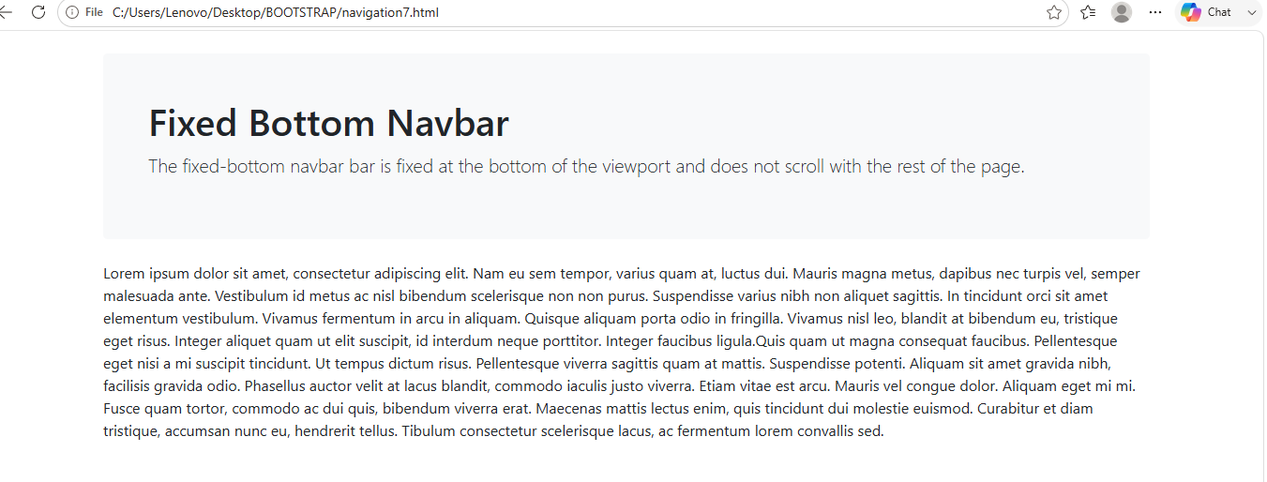

Navbar Stickied to the Top
You can also create sticky top navbar that scrolls with the page until it reaches the top, then stays there, by simply using the .sticky-top class on the .navbar element, like this:
<!DOCTYPE html>
<html lang="en">
<head>
<meta charset="utf-8">
<meta name="viewport" content="width=device-width, initial-scale=1">
<title>Bootstrap Navbar Stickied to the Top</title>
<link href="https://cdn.jsdelivr.net/npm/bootstrap@5.0.2/dist/css/bootstrap.min.css" rel="stylesheet">
<script src="https://cdn.jsdelivr.net/npm/bootstrap@5.0.2/dist/js/bootstrap.bundle.min.js"></script>
</head>
<body>
<div class="p-5 bg-warning">
<h1>Demo Header</h1>
</div>
<nav class="navbar sticky-top navbar-expand-lg navbar-dark bg-dark">
<div class="container-fluid">
<a href="#" class="navbar-brand">Brand</a>
<button type="button" class="navbar-toggler" data-bs-toggle="collapse" data-bs-target="#navbarCollapse">
<span class="navbar-toggler-icon"></span>
</button>
<div class="collapse navbar-collapse" id="navbarCollapse">
<div class="navbar-nav">
<a href="#" class="nav-item nav-link active">Home</a>
<a href="#" class="nav-item nav-link">Profile</a>
<a href="#" class="nav-item nav-link">Messages</a>
<a href="#" class="nav-item nav-link disabled" tabindex="-1">Reports</a>
</div>
<div class="navbar-nav ms-auto">
<a href="#" class="nav-item nav-link">Login</a>
</div>
</div>
</div>
</nav>

<!-- Demo Content -->
<div class="container mt-4">
<div class="p-5 mb-4 bg-light rounded-3">
<h1>Sticky Top Navbar</h1>
<p class="lead">The static-top navbar scrolls with the page until it reaches the top, then stays there.</p>
</div>
<p>navbar fixed at top this is bootstrap</p>

</body>
</html>
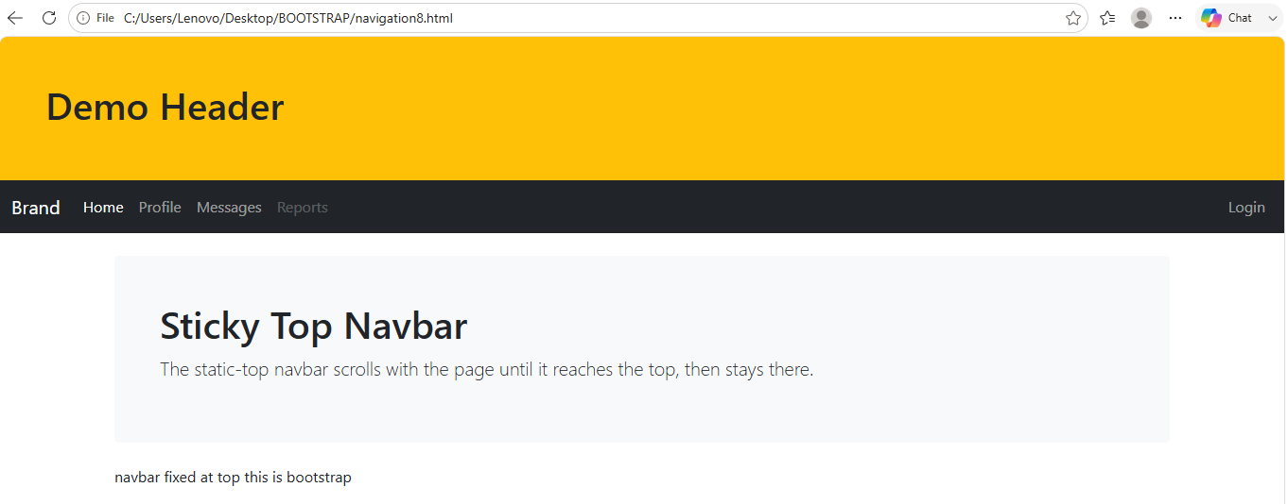

BOOTSTRAP MODAL

The Modal Plugin
The Modal plugin is a dialog box/popup window that is displayed on top of the current page:

<!DOCTYPE html>
<html lang="en">
<head>
<title>Bootstrap Example</title>
<meta charset="utf-8">
<meta name="viewport" content="width=device-width, initial-scale=1">
<link rel="stylesheet" href="https://maxcdn.bootstrapcdn.com/bootstrap/3.4.1/css/bootstrap.min.css">
<script src="https://ajax.googleapis.com/ajax/libs/jquery/3.7.1/jquery.min.js"></script>
<script src="https://maxcdn.bootstrapcdn.com/bootstrap/3.4.1/js/bootstrap.min.js"></script>
</head>
<body>

<div class="container">
<h2>Modal Example</h2>
<!-- Trigger the modal with a button -->
<button type="button" class="btn btn-info btn-lg" data-toggle="modal" data-target="#myModal">Open Modal</button>

<!-- Modal -->
<div class="modal fade" id="myModal" role="dialog">
<div class="modal-dialog">

<!-- Modal content-->
<div class="modal-content">
<div class="modal-header">
<button type="button" class="close" data-dismiss="modal">&times;</button>
<h4 class="modal-title">Modal Header</h4>
</div>
<div class="modal-body">
<p>Some text in the modal.</p>
</div>
<div class="modal-footer">
<button type="button" class="btn btn-default" data-dismiss="modal">Close</button>
</div>
</div>

</div>
</div>

</div>

</body>
</html>
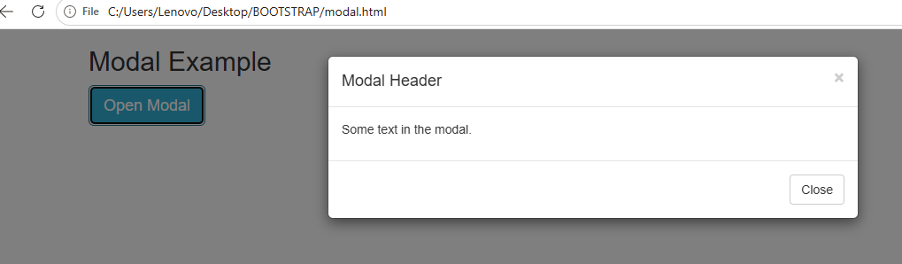

Example Explained
The "Trigger" part:
To trigger the modal window, you need to use a button or a link.
Then include the two data-* attributes:
- data-toggle="modal" opens the modal window
- data-target="#myModal" points to the id of the modal
The "Modal" part:
The parent <div> of the modal must have an ID that is the same as the value of the data-target attribute used to trigger the modal ("myModal").
The .modal class identifies the content of <div> as a modal and brings focus to it.
The .fade class adds a transition effect which fades the modal in and out. Remove this class if you do not want this effect.
The attribute role="dialog" improves accessibility for people using screen readers.
The .modal-dialog class sets the proper width and margin of the modal.
The "Modal content" part:
The <div> with class="modal-content" styles the modal (border, background-color, etc.). Inside this <div>, add the modal's header, body, and footer.
The .modal-header class is used to define the style for the header of the modal. The <button> inside the header has a data-dismiss="modal" attribute which closes the modal if you click on it. The .close class styles the close button, and the .modal-title class styles the header with a proper line-height.
The .modal-body class is used to define the style for the body of the modal. Add any HTML markup here; paragraphs, images, videos, etc.
The .modal-footer class is used to define the style for the footer of the modal. Note that this area is right aligned by default.

REMOVE ADS

Modal Size
Change the size of the modal by adding the .modal-sm class for small modals or .modal-lg class for large modals.
Add the size class to the <div> element with class .modal-dialog
SMALL MODAL
<!DOCTYPE html>
<html lang="en">
<head>
<title>Bootstrap Example</title>
<meta charset="utf-8">
<meta name="viewport" content="width=device-width, initial-scale=1">
<link rel="stylesheet" href="https://maxcdn.bootstrapcdn.com/bootstrap/3.4.1/css/bootstrap.min.css">
<script src="https://ajax.googleapis.com/ajax/libs/jquery/3.7.1/jquery.min.js"></script>
<script src="https://maxcdn.bootstrapcdn.com/bootstrap/3.4.1/js/bootstrap.min.js"></script>
</head>
<body>

<div class="container">
<h2>Small Modal</h2>
<!-- Trigger the modal with a button -->
<button type="button" class="btn btn-info btn-lg" data-toggle="modal" data-target="#myModal">Open Small Modal</button>

<!-- Modal -->
<div class="modal fade" id="myModal" role="dialog">
<div class="modal-dialog modal-sm">
<div class="modal-content">
<div class="modal-header">
<button type="button" class="close" data-dismiss="modal">&times;</button>
<h4 class="modal-title">Modal Header</h4>
</div>
<div class="modal-body">
<p>This is a small modal.</p>
</div>
<div class="modal-footer">
<button type="button" class="btn btn-default" data-dismiss="modal">Close</button>
</div>
</div>
</div>
</div>
</div>

</body>
</html>

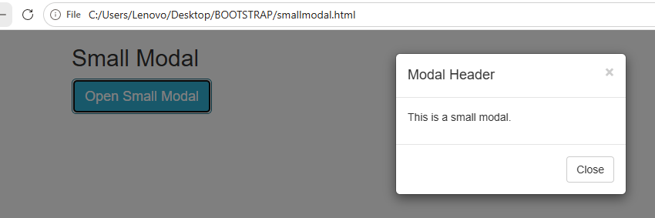

LARGE MODAL
<!DOCTYPE html>
<html lang="en">
<head>
<title>Bootstrap Example</title>
<meta charset="utf-8">
<meta name="viewport" content="width=device-width, initial-scale=1">
<link rel="stylesheet" href="https://maxcdn.bootstrapcdn.com/bootstrap/3.4.1/css/bootstrap.min.css">
<script src="https://ajax.googleapis.com/ajax/libs/jquery/3.7.1/jquery.min.js"></script>
<script src="https://maxcdn.bootstrapcdn.com/bootstrap/3.4.1/js/bootstrap.min.js"></script>
</head>
<body>

<div class="container">
<h2>Large Modal</h2>
<!-- Trigger the modal with a button -->
<button type="button" class="btn btn-info btn-lg" data-toggle="modal" data-target="#myModal">Open Large Modal</button>

<!-- Modal -->
<div class="modal fade" id="myModal" role="dialog">
<div class="modal-dialog modal-lg">
<div class="modal-content">
<div class="modal-header">
<button type="button" class="close" data-dismiss="modal">&times;</button>
<h4 class="modal-title">Modal Header</h4>
</div>
<div class="modal-body">
<p>This is a large modal.</p>
</div>
<div class="modal-footer">
<button type="button" class="btn btn-default" data-dismiss="modal">Close</button>
</div>
</div>
</div>
</div>
</div>

</body>
</html>

