

|  |  |  |  |  |
| --- | --- | --- | --- | --- |
|  |  |  |  |  |
| #8C1B2F | #012840 | #2474A6 | #0B1E26 | #144C59 |

|  |  |  |  |  |
| --- | --- | --- | --- | --- |
|  |  |  |  |  |
| #A61F38 | #2474A6 | #0F3240 | #41C0F2 | #4BF2F2 |

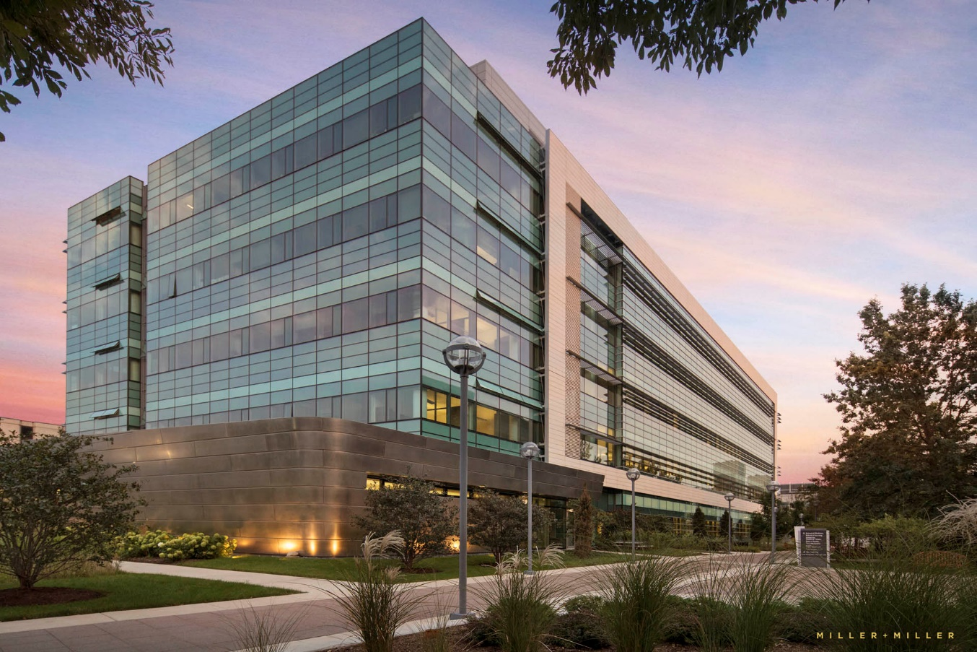

|  |  |  |  |  |
| --- | --- | --- | --- | --- |
|  |  |  |  |  |
| #343F46 | #3A4010 | #D3B9AB | #8F969A | #6A584B |

|  |  |  |  |  |
| --- | --- | --- | --- | --- |
|  |  |  |  |  |
| #999FBF | #403D13 | #F29849 | #594839 | #F2A29B |

Inclusive Sans

# DM Sans

# Dosis

# Source Sans Pro

# Spectral

# Proxima Nova

# Roboto

# Roboto Slab

# Trump Gothic