Qualtrics Assignment #2 – Experimentation
Frank Renn
2026-09-30
Table of contents

1. Random assignment
Random assignment using Randomizer and Branch functions in a Survey flow. Show the whole survey flow. If necessary, take multiple screen shots to capture the whole survey flow.
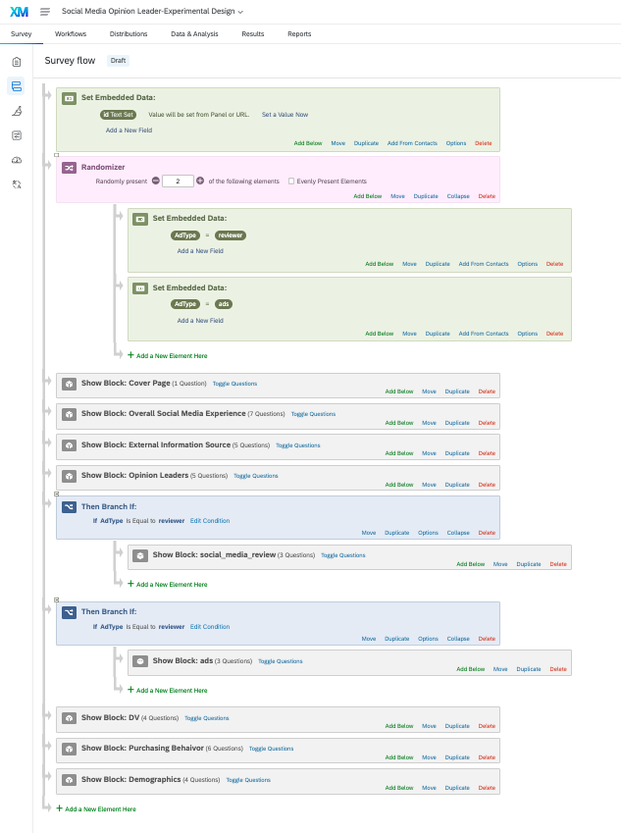
Random assignment

2. Improvement of Q2.2
Improvement of Q2.2 that allows you to capture the whole usage rate for all the social media separately, not as a whole. There are at least three ways that I know of. One method is to use a series of combinations of Piped Text function and Display Logic. Secondly, you may use Carry forward function. Regardless of which one you use, the first step will be to ask them to ask to tell you usage rate for each of the social media platform. My preference is carry forward method since it is more elegant and simple. You are required to achieve the goal with only one of the two methods to get full credit.
I used the Carry Forward Statements method. First, the participant identifies the social-media platforms used. The existing question wording was preserved exactly:
Which of the following social media platforms have you used during the past seven days? Select all that apply.
The question allows participants to select multiple platforms. I then configured Q2.2 to carry forward the selected platforms as statements in a matrix table. Each selected platform appears as a separate row, and the participant selects the applicable usage-time category for each row.
The existing Q2.2 wording was preserved exactly:
How often do you use social media platforms (e.g. Facebook, Instagram, Twitter, Snapchat)?
The matrix uses the existing time categories as the response choices. This allows the survey to capture usage separately for each selected platform instead of combining all social-media usage into one response.
For other platforms, I used the existing follow-up question without changing its wording:
Which other social media platforms have you used during the past seven days? Please list each platform in a separate box.
This question uses multiple single-line text fields and is displayed when the participant selects Other.
[Screenshot Placeholder: Insert the Q58 multiple-answer and Q2.2 Carry Forward Statements screenshot here.]
[Screenshot Placeholder: Insert the Other-platform multiple-text-field screenshot here.]

3. Additional improvements
Show additional three improvements you made in the questionnaire as part of Task 5 of Step 5, and explain why your approaches are better.
The following three improvements preserve the wording of the existing survey questions.

3.1 1. Add “Prefer not to answer” to sensitive demographic questions
I added a Prefer not to answer response option to sensitive demographic questions, such as questions about gender, income, or other personal characteristics. This gives participants more control over their personal information and reduces the likelihood that they will abandon the survey.
This improvement changes only the response options and does not change the wording of the existing questions.
[Screenshot Placeholder: Insert a screenshot showing the added “Prefer not to answer” option here.]

3.2 2. Add “Not applicable” to relevant matrix questions
I added a Not applicable response option to matrix questions when a participant may not have enough experience to evaluate an item. This is better because participants do not have to select an inaccurate answer simply to continue the survey.
This improvement makes the response choices more complete without changing the wording of the existing questions.
[Screenshot Placeholder: Insert a screenshot showing the added “Not applicable” option here.]

3.3 3. Improve survey presentation
I enabled the progress bar and reviewed the survey in Preview mode using a smaller screen. These changes make it easier for participants to understand how much of the survey remains and improve the readability of the matrix questions on mobile devices.
This improvement reduces respondent uncertainty and improves the survey experience without changing any existing question wording.
[Screenshot Placeholder: Insert a screenshot showing the progress-bar or mobile-friendly presentation setting here.]

