Introduction
The Nebraska Department of Transportation, otherwise known as NDOT, has engaged our firm to transition its current concrete mix design process from Excel to a Python-based system. The goal of this project is to automate the logic contained in the “Mix Design” worksheet so that users can enter material properties and design parameters through a clear step-by-step workflow. The system will produce an automatically generated weight chart for one cubic yard of concrete.
In addition to simple replication, this project aims to enhance the consistency and reliability of the mix design process by moving calculations from an offline Excel spreadsheet to a Python-based system. Moving the logic into Python helps to ensure that the logic is fixed, easy to comprehend, and repeatable, making it simpler for future integration into a web-based tool. The objectives of this project include translating Excel logic into Python, implementing user inputs step-by-step, generating a final mix design output, and researching and preparing four concrete mix scenarios. All project materials will be submitted to Canvas by Tuesday, February 24th at 6:00 PM CT. Deliverables will include a GitHub link, a scope of work, gantt chart, a mix of scenarios research document, Python code, an annotated code document, and a written technical report.
Methods
To create the interactive user interface, all coding was done in a Jupyter notebook, and all methods were executed by Python functions and coding. An annotated code document is available to explain each function and the methodology behind the code used in the project. To ensure proper calculation for the necessary values, both pandas and numpy were imported into the notebook. Additionally, the numbers for a cubic yard and a unit of water were defined to ease calculations later on.
Then, various functions were created to calculate the needed values. These functions calculated water weight, cement volume, fly ash volume, silica volume, other SCM volume, air volume, water volume, total aggregate volume, fine aggregate volume, coarse aggregate volume, and other aggregate volume. In each function, the parameters were defined based on the required mathematical components outlined in the provided excel sheet. These parameters were then utilized in those same mathematical calculations, but in a manner that python could understand and utilize to produce a result. At the end of each function, each respective value was returned to be utilized later on.
After every function was defined, a string of user inputs was created to provide the code with values that could be used in calculation. The user will be asked to input the project number and concrete class. They will also input the cement, fly ash, silica fume, and other SCM weights. Then inputs for the target water-cement ratio and target air content will be prompted. Next, the user is asked to input the percent of fine aggregate, coarse aggregate, and other SCM. Lastly, the specific gravities for cement, fly ash, silica fume, other SCM, fine aggregate, coarse aggregate, and other aggregate will be inputted by the user. Finally, if all inputs were correctly inputted, a statement will be printed indicating success.
To actually run a mix-design, the functions and inputs need to be put together in one string of code. To do so, a series of variables were defined that allowed each function to utilize the respective inputs given by the user. These variables were determined using the specified variables for each input displayed in the provided excel sheet. When all inputs and calculations are done, a weight chart for one cubic yard of concrete will print utilizing the inputs, functions, and variables outlined in the code.
Results and Discussion
There are four different mix designs selected: pavement concrete, bridge deck concrete, high early-strength concrete, and high-performance structural concrete. There are several differences within the mix designs, all of which achieve a different requirement and have an intended use that is being served.

Scenario 1 : Pavement Concrete
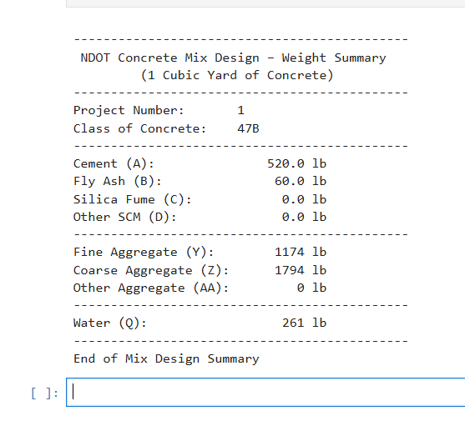
This mix design was intended for highway and roadway applications for durability, moderate strength, and resistance to winter conditions. The water-cement ratio and air content were used to balance the strength and workability of the concrete while creating long-lasting durability. The aggregate volume balanced the cement and supplementary cementitious material amounts, which led to a cost-effective design.
Compared to the other mixes, the pavement concrete has lower cementitious content. This shows the mix is durable and erosion resistant, which is the requirement for pavement concrete. The aggregate content was relatively high, but that is pretty typical in pavement concrete mixes. The aggregate content helps improve stability and reduces shrinkage.

Scenario 2: Bridge Deck Concrete
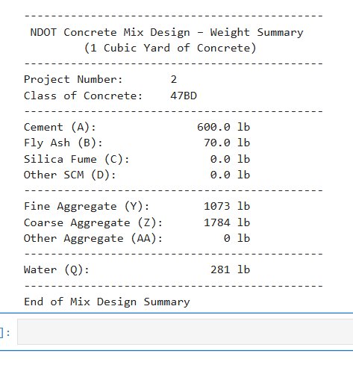
The bridge deck concrete is designed to withstand extreme exposure to salts, moisture, and temperature fluctuations. As seen in the design, the water content ratio is lower with a higher cementitious content compared to the pavement concrete. The air content helps with the adjustment of weather, such as the freezing and thawing of water.
The results show lower water volume and higher cementitious material compared to the pavement mix. This creates a denser mix with a lower ability to absorb water. With fly ash or silica fume, it allows the mix to be more durable and to achieve greater long-term strength gain. This mix compared to the pavement concrete, is more resistant to water absorption and is more durable over cost effective.

Scenario 3: High Early Strength Concrete
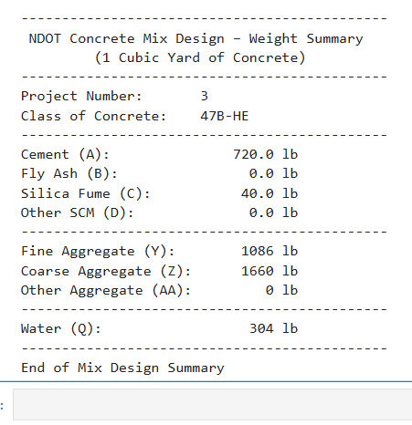
The high early-strength concrete mix was designed to gain strength rapidly for projects that don’t have as much time, or that need an early form removal. To achieve a mix like this, the mix has a higher cement content and a lower water content ratio than the previous mix designs. There is minimal use of SCM to avoid delaying early hydration.
The results show an increase in cement weight and reduced water content. This led to higher early compressive strength, but also an increase in heat of hydration and material cost. This mix has one of the highest cementitious contents and one of the lowest water volumes, to reflect the requirement for early strength development.

Scenario 4: High-performance structural concrete
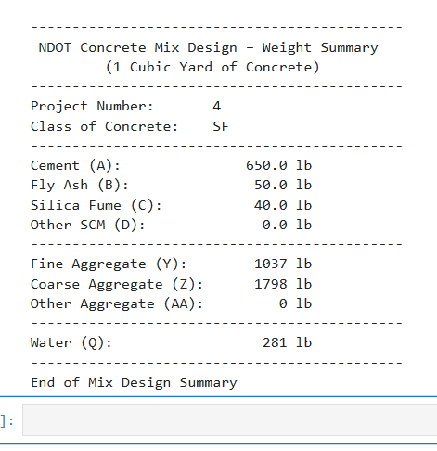
The high-performance structural concrete was designed for structural elements. This requires very high strength, durability, and long-term performance. This mix has the lowest water content ratio out of the four scenarios and has used more SCMs, like fly ash and silica fume, to improve the structure and reduce water absorption.
The results show the highest overall cementitious content and the most balanced aggregate volumes. The water content was limited, but with the use of SCMs, this improved workability and long-term strength. Compared to the high early strength mix, the high-performance concrete is focused on long-term durability and strength rather than rapid gain. It also has a higher precision in specific gravities and SCM percentages; this reflects the specific requirements for this mix design.
Overall, the water-cement ratio decreased from the pavement concrete to the high-performance structural concrete. The lower ratios correspond with the higher strength and reduced water absorption. The cementitious content increased throughout the concrete mix designs, impacting the strength and cost. The SCM usage was very minimal in the first scenario, but increased through the designs, relating to the durability and long-term performance. Finally, the aggregate percentages were relied on more in the pavement due to the stability and economy, rather than a high-performance concrete that needed more volume of cementitious materials. Each mix design reflects its intended use, whether that be for structural purpose of durability. With the adjustment of water content ratios, air content, cement weight, SCM percentage, and aggregate proportions, the requirements for each scenario were met. The Python code captured the differences in each scenario and demonstrated the code as well as captured the differences in each concrete mix design.

Works Cited
Heyen, Wally , et al. Optimized Aggregates Gradations for Portland Cement Concrete Mix Designs Evaluation. Sept. 2002.
Nebraska Department of Transportation. Standard Specifications for Highway Construction 2017 Edition. 2017.

