Introduction
This project is to evaluate the risks of natural disasters for the client Risk Averse, LLC. We are using data from the National Risk Index (NRI) and Federal Emergency Management Agency (FEMA) as the basis of our analysis. Our sensitivity analysis was completed through first developing a composite risk assessment that differs from the NRI results. The current assessment of risk performed by the NRI was then compared to our independent assessment in order to find potential biases within the NRI standards. We performed the general comparison using two U.S. states at the Census Tract level.

Methods
To begin our analysis, we began by checking our data sets in Python for null values. After the null values were sufficiently cleared, we started our sensitivity analysis.
To begin our sensitivity analysis, we developed an independent calculation of risk. The NRI calculation of risk utilizes two values: frequency and exposure. These values are multiplied to simulate the approximate instances of the selected weather conditions. Our risk analysis is slightly different, as it is based on the same model of frequency and exposure, but also divides the resulting value by the listed value for community resilience. The reasoning behind this is that the higher a community’s resilience to natural disasters, the lower the risk will be. On the other hand, if a community has lower resilience compared to the frequency and exposure to natural disasters, they are of higher risk. This method utilizes the complete NRI data in a way that the NRI defined risk does not, because it considers the impact of individual communities on risk.
The sample assessment of risk that we conducted was performed on the winter weather values. This was for our selected states, both Maine and Vermont. We then represented our defined risk by generating maps using GeoPandas. We also created two direct comparisons between our defined risk and the NRI risk and represented that through the use of bar charts. This was for each of our selected states.

Results and Discussion
The risk assessment was carried out by the use of bar plots and choropleth maps using GeoPandas in our code. For our two states, Vermont and Maine, we chose to evaluate winter weather between the chosen state and the NRI dataset.

Our group first analyzed Vermont’s risk versus NRI using a bar plot. This was done by grouping our risk values and the NRI risk values. In the bar plot, our definition of risk for winter weather produced a much higher value than the NRI dataset. For nearly every county, our risk definition was at least 2-3 values higher than the NRI risk. There are two counties where the NRI exceeded or equated to our definition of risk, those being Essex and Lamoille.
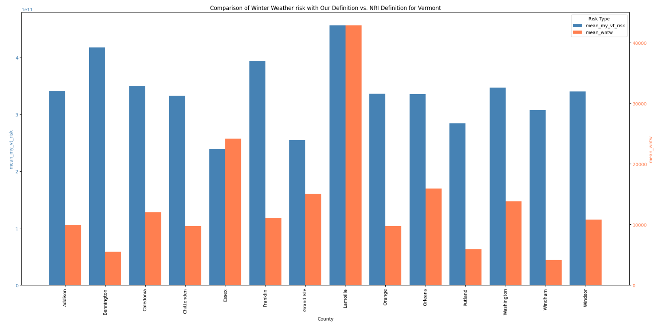

Following the bar plot, a map of Vermont was created illustrating the risk of winter weather. The map showed that most counties had a higher risk compared to lower risks. On the map, there is one cluster of counties with a deep red color, indicating that the area has the highest risk of winter weather. There are a few counties that are at a lower risk, but none that have less than a 0.25 risk.
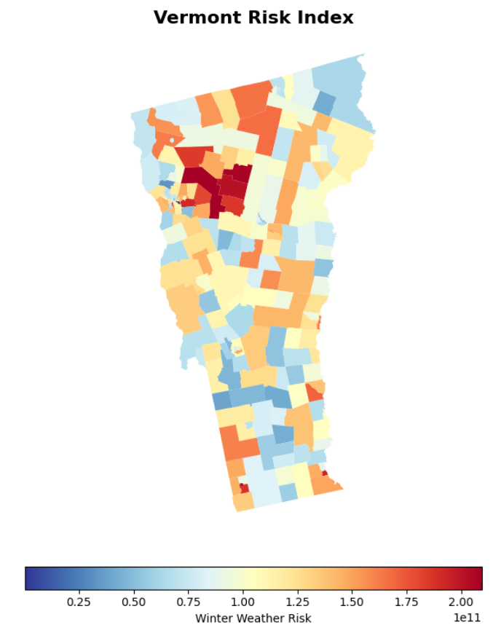

Next, the state of Maine was analyzed using the same steps from Vermont. However, for the comparison of winter weather risk with our definition versus the NRI definition for Maine, the NRI risk was nearly equal or closer to our risk value for every county. For a few counties, our risk is 1-2 values higher than the NRI. There are two counties where the values are equal; those being Knox and Waldo. York is the only county in the data set that has the highest difference between values, with ours at 3 and NRI’s close to 0. There are 5 counties where NRI’s risk is higher than ours; those counties being Aroostook, Hancock, Lincoln, Piscataquis, and Washington.
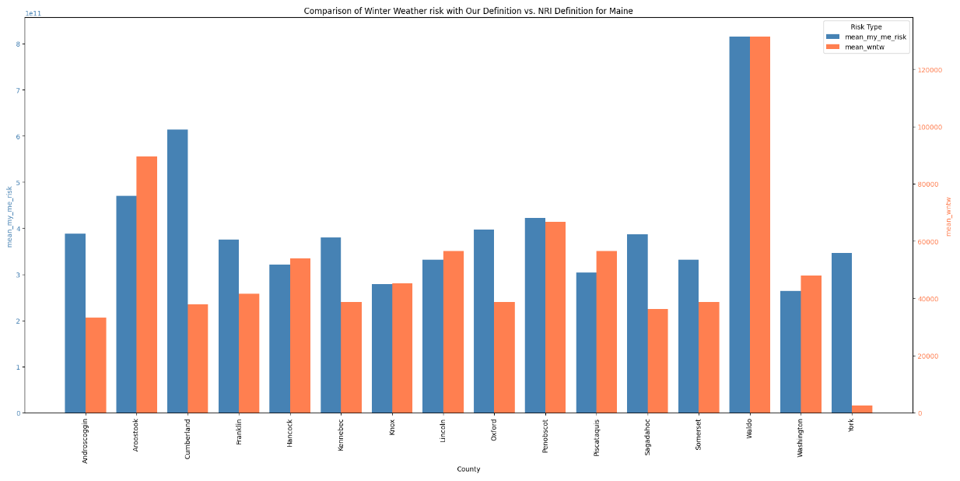

Lastly, a risk index map was created for Maine, illustrating Winter Weather throughout the state. The map mostly consists of lighter and darker blue, which indicates that those counties have a low risk of winter weather. However, there are two clusters of counties closer to the coastline that have a higher risk of winter weather. The clusters mostly consist of yellow and orange colors, indicating a risk of 3. There are two counties that are dark red, indicating the highest risk of 4 or above.
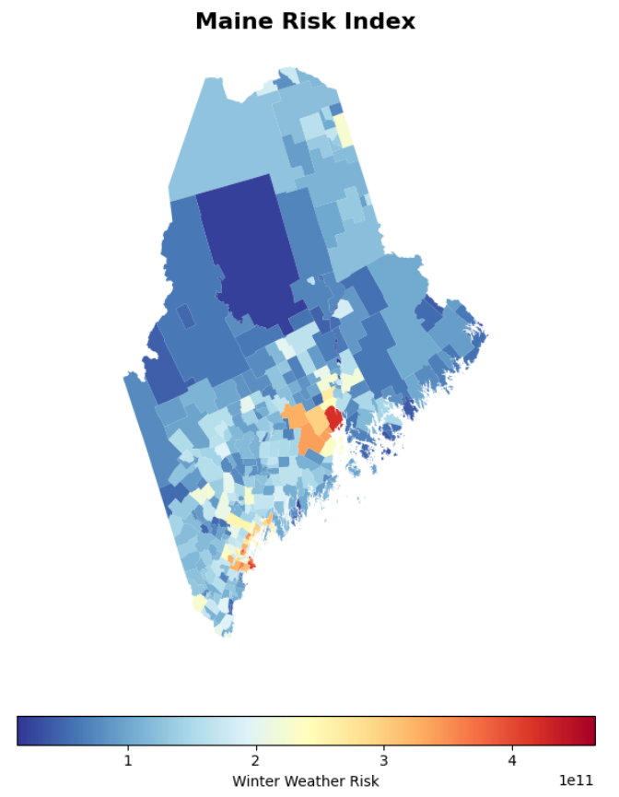

Conclusion
The NRI definition of risk utilizes two values: frequency and exposure. These values are multiplied to simulate the approximate instances of the selected weather conditions. Our group’s definition of risk is based on the same model of frequency and exposure but also divides the resulting value by the listed value for community resilience. Using the NRI dataset and the datasets from both Vermont and Maine, our group was successfully able to analyze and illustrate the risk for winter weather within the selected regions and compare it to the NRI definition of risk.
Through our assessment, we were able to find that Vermont’s data under our definition of risk ranges quite differently from that of NRI’s definition. The values within the barplot had a 2-3 value difference for nearly every county except for two. The choropleth map further illustrated our definition of risk and showed that most counties had a high risk of winter weather.
Maine’s data, however, under our definition of risk, had values that were much closer to that of NRI’s definition. Nearly every county’s value for our definition equated or was close to NRI. There were seven counties that had a bigger difference between values, with our definition being the higher value. Upon illustrating the choropleth map with our definition of risk, it showed that most counties had a very low risk of winter weather, while two small clusters of counties closer to the coastline had a higher risk.
Overall, incorporating community resilience to the NRI model reveals important regional differences in winter weather risk. While Main’s results remain similar under both models, Vermont’s variation shows that resilience plays a critical role in shaping the overall risk factor. This suggests that future risk assessments should consider resilience to better reflect real-world vulnerabilities across different communities.

References
Risk map products | fema.gov. (n.d.-d). https://www.fema.gov/flood-maps/tools-resources/risk-map/products
Resilience Analysis and Planning Tool (RAPT) | fema.gov. (n.d.-d). https://www.fema.gov/emergency-managers/practitioners/resilience-analysis-and-planning-tool
Centers for Disease Control and Prevention. (n.d.-b). SVI data & documentation download. Centers for Disease Control and Prevention. https://www.atsdr.cdc.gov/place-health/php/svi/svi-data-documentation-download.html

