Introduction
Risk Averse, LLC, has asked our firm to continue our analysis of natural hazards in the United States using NRI datasets. We are to examine one specific natural hazard across 6 different states. Our firm chose to analyze tornadoes in the following states: Nebraska, Iowa, Illinois, Kansas, Michigan, and South Dakota. Risk Averse allows us to choose either the NRI definitions of risk or our own for the analysis, based on the available data from the NRI and SVI. They have asked us to continue using the NRI Census Tract data for our analysis and have also requested to see information related to the population impacted by the natural hazard.

Methods
The data for analysis was obtained from the FEMA National Risk index (NRI) Census Tract and the Social Vulnerability Index (SVI) dataset from ASTDR. The NRI Census Tract dataset included data that showed natural hazards from different regions of the United States. The SVI dataset identifies and ranks the vulnerability of communities to disasters. All the analyses conducted were made using these two CSV files.
Data was extracted in Jupyter notebook (Python version 3.14.2) by importing the pandas’ package and converting it into a dataframe. Measurements were grouped and organized into a table to highlight key trends. Additionally, the Seaborn library was installed to create a summary plot of the CSV data provided. These visualizations provided key differences in hazard risks across the six different states.
The dataset was filtered to include only the selected natural hazard and the six different states of interest. The NRI Census Tracts belonging to these states were isolated using state identifiers. Data was organized to create descriptive statistics which included the mean, median and range of the hazard for each of the six states.
Data was analyzed using the Hazard-Specific Risk Score, Expected Annual Loss (EAL), total population and SVI percentile ranking. These variables were organized into tables to easily identify the key differences between each state. To evaluate the relationship between natural hazard risk and population direct two approaches were used: Direct Comparison and Adjusted Risk Metric. The first approach uses plots of Risk metrics plotted against total population at the census tract level in order to compare and find correlations between population size and hazard risks. The second approach uses EAL and SVI multiply by each other to account for both economic exposure and community vulnerability. By using this second approach, it emphasizes areas where hazards are impacted differently based on social conditions.

Results and Discussion
Across the selected states, Nebraska stands out as having the highest tornado risk, as illustured in figure 1. The surrounding states; Kansas, Iowa, South Dakota, and Illion, all exhibit relatively similar risk levels, suggesting a regional clustering of elevated tornado vulnerability across the central Plains and the Midwest. This pattern likely refelcts shared geographic and atmospheric conditions, including their location withing tornado alley, where warm, moist air from the Gulf of Mexico frequently collides with cooler, drier air.
In contrast, Michigan shows a notably lower risk score, nearly twenty points below Nebraska, indicating a significantly reduced exposure to tornado impacts. This difference highlights how even within broadly affected regions, localized climate factors, storm patterns, and geographic positioning can create substantial variation in risk. Overall, the data suggests that while several Midwestern states face comparable levels of tornado hazard, Nebraska emerges as the most vulnerable among those analyzed, with Michigan representing a comparatively lower-risk outlier.
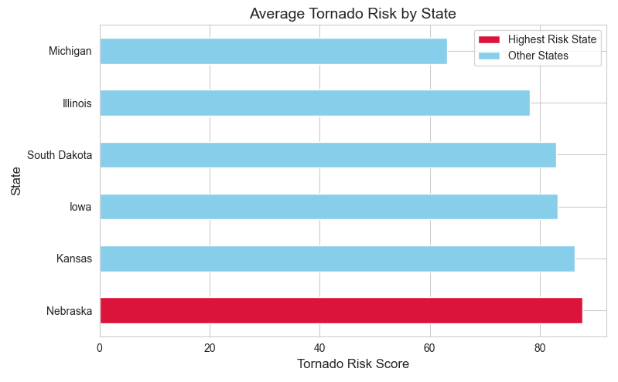

Figure two shows the relationship between population and tornado risk score across six states. Nebraska has the highest tornado risks score despite having only a moderate population. Similarly, Kansas, Iowa, and South Dakota cluster closer together in both population and risk. This tight grouping suggests consistent regional exposure to tornado conditions across the central Plains. In contrast, Illinois and Michigan break the pattern. Illinois has by far the largest population but only a moderate risk score,

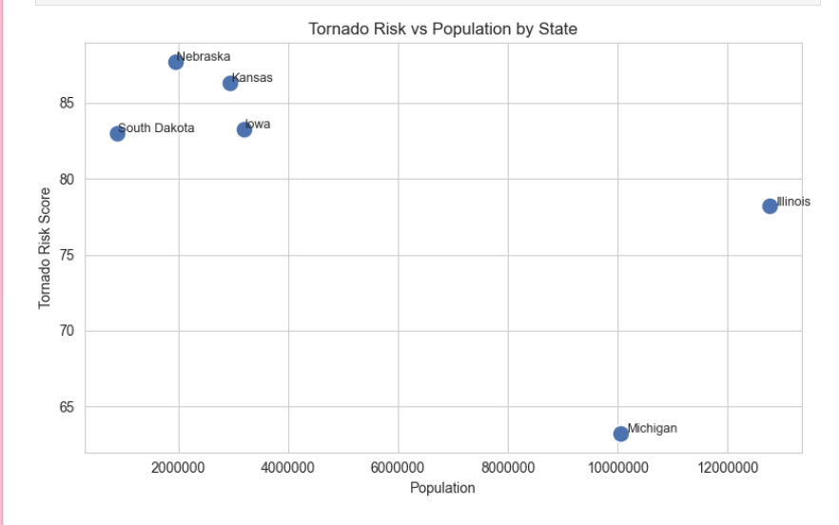

The spatial distribution of tornado risk across the selected states reveals clear regional patterns and important variations within each state. Nebraska and South Dakota both exhibit strong west-to-east gradients, with lower risk in their western regions and significantly higher risk toward the east, likely due to increasing moisture and more favorable storm conditions. In contrast, Kansas shows consistently high risk across nearly the entire state, reinforcing its position within the core of Tornado Alley. Iowa also demonstrates relatively uniform and elevated risk, indicating widespread exposure to tornado-favorable conditions. Illinois presents a more variable pattern, with moderate-to-high risk dispersed throughout the state but without the same level of uniform intensity seen in the Plains states. Meanwhile, Michigan stands out as having the lowest overall risk, with most areas showing relatively minimal exposure and only slight increases in the southern portion of the state. Overall, these patterns highlight how tornado risk is not evenly distributed, but instead shaped by geographic location, regional climate, and prevailing atmospheric conditions.
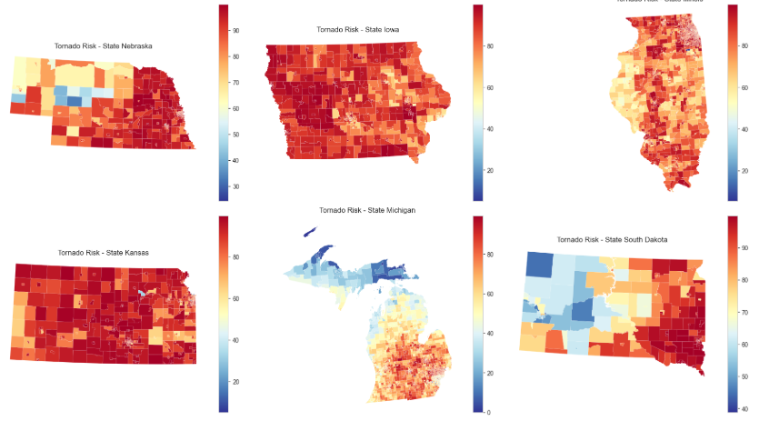

Conclusion
This analysis examined tornado risk across Nebraska, Iowa, Illinois, Kansas, Michigan, and South Dakota using FEMA’s National Risk Index (NRI) Census Tract data alongside the Social Vulnerability Index (SVI). The results show that tornado risk is not evenly distributed across the Midwest and Great Plains, but instead follows strong geographic patterns closely tied to Tornado Alley. Nebraska emerged as the highest-risk state, while Kansas, Iowa, and South Dakota also demonstrated consistently elevated risk levels with relatively similar patterns of exposure. In contrast, Michigan showed substantially lower risk, highlighting how regional climate and storm-track positioning strongly influence tornado vulnerability even with a broader Midwestern context.
The comparison between tornado risk and population further indicated that there is no clear corrleation between population size and hazard risk. States such as Illinois, with large populations, did not necessarily exhibit higher tornado risk, while Nebraska maintained the highest risk despite a more moderate population. This suggests that environmental and geographic factors are far more influential in determining tornado risk than population alone. However, population remains an important factor when considering potential impacts, as higher population areas may experience greater overall exposure to damage and casualties.
Finally, spatial patterns within each state reinforced these findings by showing localized variation in risk, including gradients in Nebraska and South Dakota and more uniform high-risk zones in Kansas and Iowa. When combined with social vulnerability and economic exposure metrics, these results emphasize that tornado risk is shaped by both physical hazard conditions and community characteristics. Overall, the findings highlight the importance of using both environmental and social data when assessing natural hazard risk, as this integrated approach provides a more complete understanding of where impacts are more likely to be severe.

References
Centers for Disease Control and Prevention. (n.d.-b). SVI data & documentation download. Centers for Disease Control and Prevention. https://www.atsdr.cdc.gov/place-health/php/svi/svi-data-documentation-download.html
Resilience Analysis and Planning Tool (RAPT) | fema.gov. (n.d.-d). https://www.fema.gov/emergency-managers/practitioners/resilience-analysis-and-planning-tool

