Introduction

Starting off, this project was in collaboration with the Federal Highway Administration (FHWA) where certain transportation aspects were analyzed. Transportation is the center of the United States. Think about how often we use transportation. From cars commuting to their everyday occupations to giant semis travelling across country to deliver crucial products for our economy to remain stable. Transportation as we said is important, but just like anything else, it can be engineered more to the utmost of productivity. This is what our group was tasked with doing. In this project we will be analyzing data given to us by the FHWA and then using that said data to code certain deliverables they have asked for. These deliverables include creating graphical visualizations for our highway data. Deciding variables was up to us as we saw was best fit for the other deliverables down the road. These deliverables are to be in the form of a bar chart, histogram, boxplot, and two other time-series plots than analyze the trajectory/ driver behavior. Moving on, the other deliverable we were tasked with problem solving out was creating a simulation study using the Intelligent Driver Model (IDM). Here it is our job to basically predict the future on how we imagine different driving patterns to be. Thus, we are running a simulation to for further analysis and research that can be explored in variety of ways.
The datasets that were given to us include NHTS and NGSIM which give insight into how transportation is used and driving behavior respectfully. When separated these two data sets give a plethora of information, but when combined and compared to one another they can create real life solutions to real life problems. All of this together is why we were initially tasked with these variables. Representation is key when we need to distribute information to people who may not understand it completely yet.

Methods
When looking at the deliverables, it was up to us to choose the variables that we saw most useful for this project. With that in mind, we split up the code into the code that dealt with the graphical representations of the NHTS data, then the NGSIM data, the IDM visualization for the trajectories, and then finally the comparison plot. Starting with the NHTS dataset, we grouped three different graphical representations, each with its own independent data, so we could obtain a wide scope of what this data set really withholds. We had a bar graph display information specifically for one-family detached, so only those home types were used for this data, as well as the rest of the NHTS data and their graphs. The first graph demonstrates the frequency of the days that were travelled pertaining to the day of the week. The second graph was used to show the difference of ages in vehicles in the one-family detached households. The third graph and largest graph shows a box plot with the household size and the vehicle make of the car. The method behind this was to show if certain brands had higher interest than others depending on the size of the family. The methods behind the other two graphs were selecting normal variables that are easy to read and understood by a variety of people. This was done, to whoever this information is getting passed on, so the presenter could give realistic data that anybody could comprehend easily.
Next, the NGSIM also provided some very interesting visuals that we are sure the firm will find most beneficial. This data provided us with simple line plots that show driver behavior. The gap first time graph was chosen because it shows the tendency of drivers to either increase or decrease the gap behind or ahead of them based on the time that they have been in that current situation. This plot was constructed by using the simple plot template and was then filled in with the appropriate descriptions and variables, so the graph could be visually and logically appealing to the readers. The next graph demonstrates the speed comparisons of a leader and follower car. Again, the method behind this graph comes straight from driver behavior. We wanted to see how quickly either car reacts in the situation, and whether understanding it further can lead to future crash predictions.
Finally, the last graphical representation we have from our data comes from a simulation. This simulation takes data that we just described in the previous paragraph and turns it into a prediction meter on what we think will happen. The coding here involves creating a function that involves a for statement to essentially create the simulation. That function is then used in our graphical analysis, so a visualization can be present.
In the end, all of the variables that we selected in our graphs came from the intuition that we wanted to have transportation information that was across the board from the data we were given. Driver behavior paired up with transportation tendencies that have enveloped people can be used for a wide variety of new projects and even revolutions in AI. Just think of the simple code we used, AI could take it to the next level.
Results and Discussion

Thanks to the datasets provided by the National Household Travel Survey (NHTS) and the Next Generation Simulation (NGSIM) Data, our team was able to develop multiple visualizations to showcase the trends in the data. Each of the following visualizations were present: a bar chart, histogram, boxplot, and two time-series plots. Our bar chart showed the number of trips made by vehicles from a one-family household each day of the week. Monday was the highest value in the chart, being at over 2000 trips. 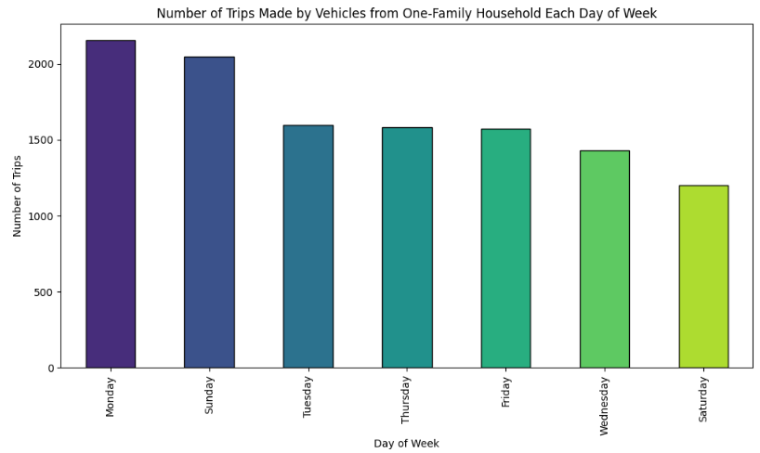
The next figure our team plotted, with the NHTS data, was a histogram. This chart shows the age of vehicles belonging to one-family detached households. Based on the chart, 1600 vehicles were at the lowest vehicle age in years, ranging from 0-1. As the age increased, the number of vehicles decreased. There’s a space after ~30 years, indicating there are no vehicles that are ~30-35 years old. However, there is one plot of data at the end of the chart that shows there are about 300 vehicles at the age of ~36-38 years.
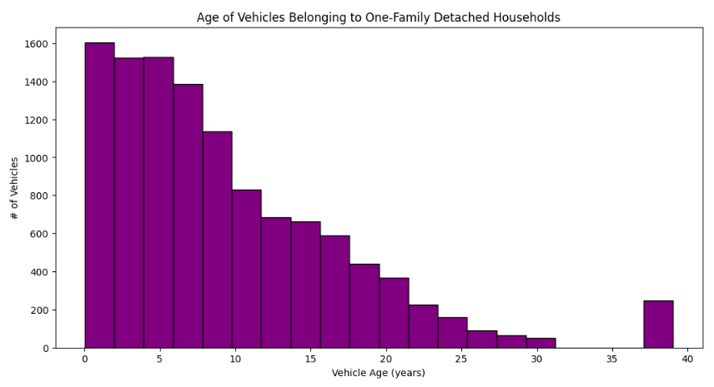
The boxplot in our code was grouped into vehicle make by number of members in one-family detached households. In this dataset, there were many outliers. Vehicles with the most outliers include Buick/Opel, Ford, Harley-Davidson, Hyundai, Subaru, etc. Many vehicle manufacturers had a median in the lower quartile of the data set. Most of the vehicle makes had an upper quartile at a household size of 4.
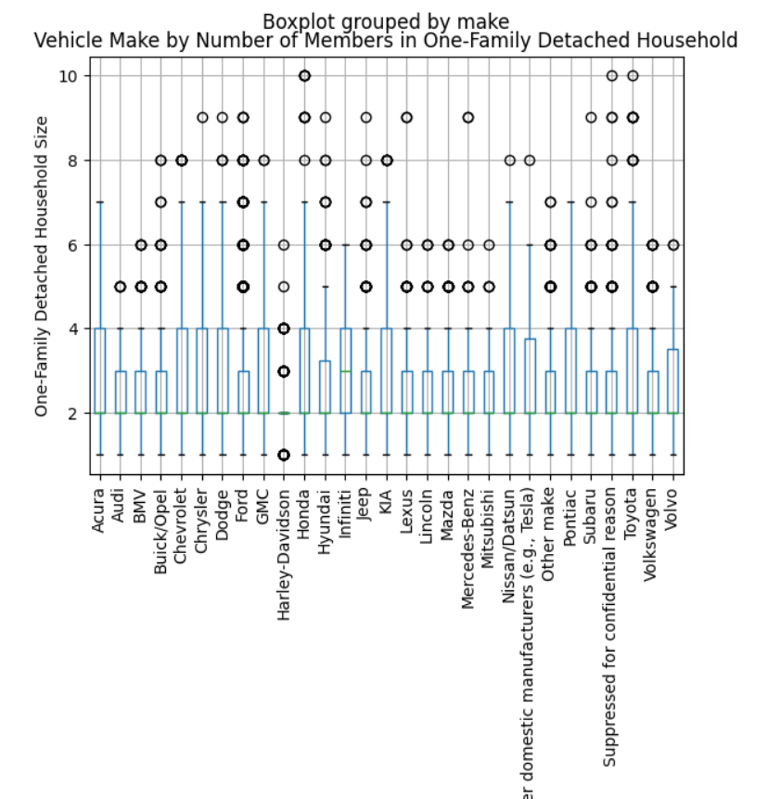
The next dataset plotted by our team was a line plot. The line plot represents follower acceleration and gap by time. At a time 0 seconds, the acceleration is at 50 m/s. Over time, it decreases and fluctuates. The lowest acceleration was below 10 m/s at 60 seconds. The data ends at 80 seconds, where the acceleration speeds back up to 30 m/s.
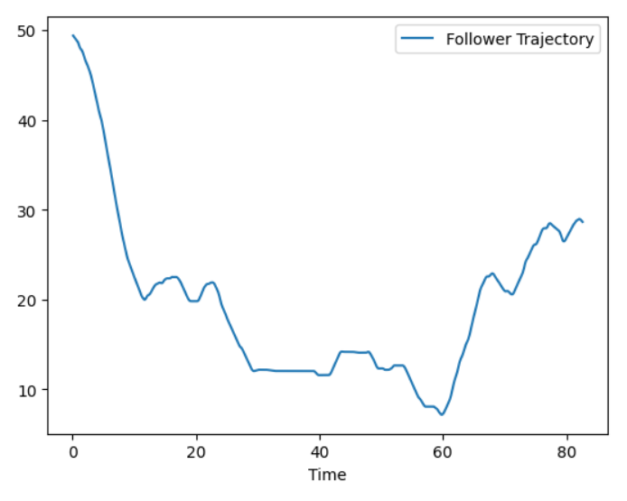
Our second to last dataset was another line plot which represents a speed comparison between follower and leader speed. The blue line indicates the leader, and the orange is the follower. For most of the time, the follower speed is faster than the leader speed. At 0 seconds, the follower is at 14 m/s, while the leader is at 13 m/s.
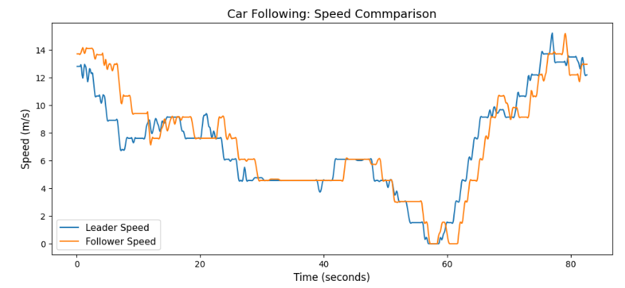

Our last dataset is another line plot which shows position vs. time. The dataset compares the leader, real follower, and simulated follower. The dashed black line indicates the leader, the green is the real follower, and the purple is the simulated follower. At time 0 seconds, the followers start at 0 m, while the leader starts at around 50 m. Over time, the three lines increase altogether, but the leader mostly stays at a greater position. The simulated and real followers are at the exact same position nearly every second. The leader ends at over 600 m at 80 seconds, while the followers end closer to 600 m.
