“Crop Recommendation System Using MachineLearning”
A PROJECT REPORT

In partial fulfilment for the award of the degree
Of
BACHELOR OF ENGINEERING
IN

COMPUTER SCIENCE AND ENGINEERING



Under the guidance of Submitted by
Dr. Tajinder Singh Jayant Kumar (GCS/2241022)
Assistant Professor Sachin Kumar (GCS/2241024) Department of CSE

SANT LONGOWAL INSTITUTE OF ENGINEERING AND TECHNOLOGY, LONGOWAL – 148106, DISTRICT- SANGRUR, PUNJAB, INDIA
May, 2026

Table of Contents

Sr. No. | Topics | P. No.
i) | Certificate | i
ii) | Acknowledgement | ii
iii) | Abstract | iii
iv) | List of Tables | iv
v) | List of Figures | v
1) | Chapter 1: Introduction | 1-2
2) | Chapter 2: Literature Review | 3-4
3) | Chapter 3: Problem Definition | 5-6
4) | Chapter 4: Objectives | 7
5) | Chapter 5: Tools and Technologies Used | 8-9
6) | Chapter 6: Methodology Used | 10-13
7) | Chapter 7: Results and Screenshots | 14-23
8) | Chapter 8: Conclusion and Future Scope | 24-25
 | References | 26

Certificate

I hereby certify that the work which is being presented in B.E. Major Project Report entitled “Crop Recommendation System Using Machine Learning”, in the partial fulfillment of the requirement for the award of Bachelor of Engineering in Computer Science & Engineering and submitted to Department of Computer Science & Engineering of SLIET, Longowal is by “Jayant Kumar (GCS/2241022), Sachin Kumar (GCS/2241024)”, is an authentic record of work carried out under the supervision of Dr. Tajinder Singh (Assistant Professor), CSE Department.
This report has not been submitted to any other university or institution for the award of any degree.
Signature of the students with name

Jayant Kumar (GCS/2241022)

Sachin Kumar (GCS/2241024)

This is to certify that the above statement made by the candidate is correct to the best of my knowledge.
Date: 07/05/2026
Signature of the supervisor

Name of the supervisor
Dr. Tajinder Singh
Assistant Professor, CSE Department

Acknowledgement

We would like to express our gratitude to our guide Dr. Tajinder Singh, Assistant Professor of Department of Computer Science and Engineering, SLIET, Longowal for being an excellent mentor during our whole course of major project. His encouragement and valuable advice during the entire period have made it possible for us to complete our work.

We are grateful to Dr. Damanpreet Singh, Head of the Department of Computer Science and Engineering, SLIET, Longowal for setting high standards for his students and encouraging them from time to time. We would like to thank the entire faculty and staff of Computer Science and Engineering for their support.

We also sincerely acknowledge the creators of the open-source Crop Recommendation Dataset used for training our models. Finally, we express our heartfelt gratitude to our family members, friends, and well-wishers whose patience and support remained a constant source of strength.
We are highly grateful to all those who evinced keen interest and invaluable support in the progress and successful completion of our project work. Words of gratitude are not enough to describe the accommodation and fortitude which they have shown throughout our endeavor.

Jayant Kumar (GCS/2241022)
Sachin Kumar (GCS/2241018)

Abstract

Agriculture remains the backbone of the Indian economy, yet farmers often rely on traditional knowledge or guesswork when selecting crops, leading to suboptimal yields and financial distress. This project presents a machine learning-based Crop Recommendation System that suggests the most suitable crop for given soil and environmental conditions. The system takes seven input parameters—Nitrogen (N), Phosphorus (P), Potassium (K), temperature, humidity, soil pH, and rainfall—and predicts the optimal crop from 22 possible classes.
A publicly available dataset containing 2200 samples with perfectly balanced classes was used. After preprocessing (label encoding and Min-Max scaling), ten supervised classification algorithms were trained and compared: Logistic Regression, Gaussian Naïve Bayes, Support Vector Machine, K-Nearest Neighbors, Decision Tree, Random Forest, Bagging, AdaBoost, Gradient Boosting, and Extra Trees. Experimental results showed that Random Forest achieved the highest accuracy of 99.32%, closely followed by Gaussian Naïve Bayes at 99.55%. The Random Forest model was selected for deployment due to its robustness and ability to capture non-linear interactions among features.
A web-based interface was developed using FastAPI (Python) and Tailwind CSS, allowing farmers to enter their soil and climate data and receive instant crop recommendations. The model and scaler were serialized using Pickle for easy integration. The system successfully demonstrates how machine learning can bridge the gap between agricultural data and practical decision-making, offering a scalable tool for precision farming.

List of Tables

Sr.  No. | Tables | P. No.
1) | Table 6.1: Sample of the Crop Recommendation Dataset | 11
2) | Table 7.1: Model Accuracy Comparison | 22
3) | Table 7.2: Class-wise Performance of Top Models | 23
4) | Table 7.3: Technical Comparison of Models | 23

List of Figures

Sr.  No. | Figures | P. No.
1) | Figure 6.1: Class Distribution of Crop Labels | 12
2) | Figure 6.2: Feature Correlation Heatmap | 12
3) | Figure 6.3: Feature Importance Graph from Random Forest | 13
4) | Figure 7.1: Homepage of Crop Recommendation Web App | 14
5) | Figure 7.2: Input Form for Soil and Climate Parameters | 15
6) | Figure 7.3: CSV Data Sample Display with Pandas | 16
7) | Figure 7.4: Min-Max Scaled Training Data Preview | 16
8) | Figure 7.5: Random Forest Classification Report / Accuracy Output | 17
9) | Figure 7.6: Gaussian Naïve Bayes Accuracy Output | 17
10) | Figure 7.7: SVM Classification Report | 18
11) | Figure 7.8: Logistic Regression Classification Report | 18
12) | Figure 7.9: K-Nearest Neighbors Classification Report | 18
13) | Figure 7.10: Confusion Matrix for Random Forest | 19
14) | Figure 7.11: Confusion Matrix for Gaussian Naïve Bayes | 20
15) | Figure 7.12: Confusion Matrix for SVM | 20
16) | Figure 7.13: Confusion Matrix for Logistic Regression | 21
17) | Figure 7.14: Confusion Matrix for Decision Tree | 21
18) | Figure 7.15: Classifier Accuracy Comparison Bar Chart | 22
19) | Figure 7.16: Web App Prediction Result – Muskmelon | 23
20) | Figure 7.17: Web App Prediction Result – Chickpea | 23

Chapter 1: Introduction

1.1 Overview of Precision Agriculture
Agriculture contributes approximately 17–18% to India’s GDP and employs more than 50% of the workforce. However, crop selection is still heavily dependent on traditional experience and local practices. Choosing the wrong crop can lead to soil nutrient depletion, pest infestation, and economic loss. With the rise of precision agriculture, data-driven decision support systems can guide farmers toward scientifically optimal choices.
An intelligent crop recommendation system takes into account soil macronutrients (Nitrogen, Phosphorus, Potassium), climatic conditions (temperature, humidity, rainfall), and soil acidity (pH) to predict the most suitable crop. By leveraging machine learning, such a system can learn from historical data and generalise to new, unseen environmental conditions.

1.2 The Data Barrier in Traditional Farming
Despite the availability of soil testing labs and weather stations, farmers rarely have access to integrated analytical tools. Most existing advisory systems are manual or rule-based, lacking the ability to capture complex, non-linear interactions between variables. A scalable, automated solution that accepts simple numerical inputs and returns an immediate crop suggestion can significantly reduce the knowledge gap and empower even semi-literate farmers.

1.3 Motivation and Significance
The motivation for this project stems from the need to provide instant, accurate, and low-cost crop recommendations using easily measurable parameters. The significance is threefold:
- Improved Yield: Recommending a crop that matches the soil and climatic conditions maximises the probability of a healthy harvest.
- Resource Optimisation: Farmers can avoid overuse of fertilisers by knowing which crop naturally suits their soil nutrient profile.
- Economic Stability: By reducing crop failure rates, the system contributes to stable farmer incomes and food security.

1.4 Scope and Framework
This project covers the complete pipeline from raw tabular data ingestion to a deployed web application. The scope includes data preprocessing, feature scaling, training and comparison of ten classifiers, selection of the best model, serialisation, and development of a Flask-based user interface. The final system is capable of accepting seven numeric inputs and returning the predicted crop name within milliseconds.

Chapter 2: Literature Review

2.1 Evolution of Crop Recommendation Systems
Early crop advisory systems were expert-driven, using static rules like “if N > 80 and rainfall > 200 mm, then suggest rice.” While simple, these systems could not adapt to new data or capture multivariate interactions. The advent of machine learning transformed this field by enabling models to learn patterns directly from historical agricultural datasets.

2.2 Machine Learning Approaches in Agriculture
A variety of algorithms have been applied to crop recommendation:
- Decision Trees and Random Forests: Widely used due to their interpretability and ability to model non-linear relationships. Studies have shown that ensemble methods outperform single classifiers in crop yield prediction.
- Support Vector Machines (SVM): Effective for smaller datasets but sensitive to feature scaling and parameter tuning.
- K-Nearest Neighbors (KNN): Simple but computationally expensive for large datasets.
- Naïve Bayes: Fast and often surprisingly accurate for balanced datasets, though it assumes feature independence.
- Gradient Boosting (XGBoost, etc.): State-of-the-art on many tabular datasets, providing high accuracy at the cost of longer training times.
Recent research, such as the work by Pudumalar et al. (2017) and Kumar et al. (2018), has demonstrated that Random Forest and other ensemble methods achieve 95–99% accuracy on benchmark crop recommendation datasets.

2.3 Web-Based Deployment for Farmers
While many studies focus solely on model accuracy, practical adoption requires a user-friendly interface. Web frameworks like Flask and Django have been used to build agricultural decision support tools that can be accessed via smartphone browsers, making them suitable for rural environments. Our project follows this direction by deploying the trained model behind a responsive, mobile-friendly web page.

2.4 Research Gap and Contribution
Most existing systems either stop at model evaluation or provide a command-line interface. Our work integrates a complete, end-to-end pipeline: from data preprocessing to a live web application with visual feedback. This bridges the gap between academic machine learning and on-the-ground agricultural utility.

Chapter 3: Problem Definition

3.1 The Suboptimal Crop Selection Problem
Farmers frequently lack objective criteria for choosing which crop to plant. They may rely on last year’s choice, neighbour’s advice, or outdated agricultural calendars. This leads to:
- Mismatched Crops: Planting rice in low-rainfall areas or maize in waterlogged soils.
- Nutrient Imbalance: Continuous monocropping without understanding soil nutrient depletion.
- Economic Loss: Crop failure or low market price due to oversupply of commonly chosen crops.

3.2 Inaccessibility of Scientific Decision Tools
Soil testing laboratories exist but their reports are technical and rarely accompanied by actionable advice. There is a gap between the availability of soil health data and its translation into crop recommendations. An automated system that takes simple numbers and returns a crop name can fill this void.

3.3 Technical Challenges
Building such a system involves:
- Handling a multi-class classification problem with 22 crop types.
- Ensuring high accuracy to avoid catastrophic mispredictions.
- Creating an intuitive interface for users with minimal technical background.
- Validating inputs to prevent out-of-range values that could mislead the model.

3.4 Problem Summary
In essence, the problem is the absence of an end-to-end, machine learning-powered crop recommendation tool that works with standard soil and climate parameters and is accessible via a simple web browser. This project addresses that gap by developing, evaluating, and deploying a high-accuracy classifier with a farmer-centric frontend.

Chapter 4: Objective

The primary objectives of the proposed work are:
- Data Acquisition and Exploration: To obtain and analyse the Crop Recommendation Dataset, understanding distributions, correlations, and class balance.
- Data Preprocessing: To encode the categorical crop labels and apply Min-Max scaling to numerical features for optimal model performance.
- Model Training and Comparison: To implement and compare ten supervised learning algorithms and identify the best performer based on accuracy and confusion matrices.
- Predictive System Development: To design a function that accepts new environmental inputs and returns a crop prediction using the trained model.
- Web Application Deployment: To build a responsive web interface using Flask and Tailwind CSS that allows users to input parameters and view recommendations.
- Model Persistence: To save the best model and scaler using Pickle for future use without retraining.

Chapter 5: Tools and Technologies Used

5.1 Programming Language and Core Libraries
- Python 3.11: Primary programming language, chosen for its rich data science ecosystem.
- Pandas: Data manipulation and CSV handling.
- NumPy: Numerical computations, array transformations.

5.2 Machine Learning and Data Science
- Scikit-learn: Used for all classification algorithms (Logistic Regression, Naïve Bayes, SVM, KNN, Decision Tree, Random Forest, Bagging, AdaBoost, Gradient Boosting, Extra Trees), train-test splitting, Min-Max scaling, and evaluation metrics.
- XGBoost: Advanced gradient boosting library (used in earlier experimentation, though final deployment used Random Forest).
- Matplotlib & Seaborn: Generation of correlation heatmaps, feature importance plots, confusion matrices, and accuracy comparison charts.
- Pickle: Model and scaler serialisation.

5.3 Web Framework
- FastAPI: Lightweight Python web framework for serving the prediction endpoint and rendering HTML templates.
- HTML5 & Tailwind CSS: Frontend design, responsive layout, and styling of the user interface.
- JavaScript : Client-side form validation.

5.4 Development Environment
- Jupyter Notebook: Interactive development and model prototyping.
- VS Code: Final code integration and debugging.
- Git & GitHub: Version control and collaboration.

Chapter 6: Methodology Used

The methodology follows a structured machine learning pipeline: data collection, preprocessing, exploratory data analysis, model training, evaluation, and deployment.

6.1 Data Collection
The dataset Crop_recommendation.csv was obtained from Kaggle’s open-source agricultural data repository. It contains 2200 rows and 8 columns: N, P, K, temperature, humidity, ph, rainfall, and label (crop name). All 22 crop classes are exactly balanced with 100 samples each.

6.2 Data Preprocessing
6.2.1 Label Encoding
The target variable label (string) was mapped to integer values 1–22 using a dictionary for machine compatibility. The original label column was then dropped.
6.2.2 Train-Test Split
The data was split into features (X) and target (y), then partitioned into 80% training and 20% testing sets using train_test_split with random_state=42 for reproducibility.
6.2.3 Feature Scaling
Min-Max Scaler was applied to bring all features into the range [0,1]. This ensures that distance-based algorithms (SVM, KNN) are not biased by magnitude differences. The scaler was fitted on the training data and used to transform both train and test sets.

6.3 Exploratory Data Analysis
Figure 6.1 shows the perfect balance of all 22 classes. The correlation heatmap (Figure 6.2) reveals strong relationships between temperature, humidity, and rainfall, which influence crop suitability. Feature importance from an initial Random Forest model (Figure 6.3) indicated that rainfall, humidity, and potassium are top predictors.

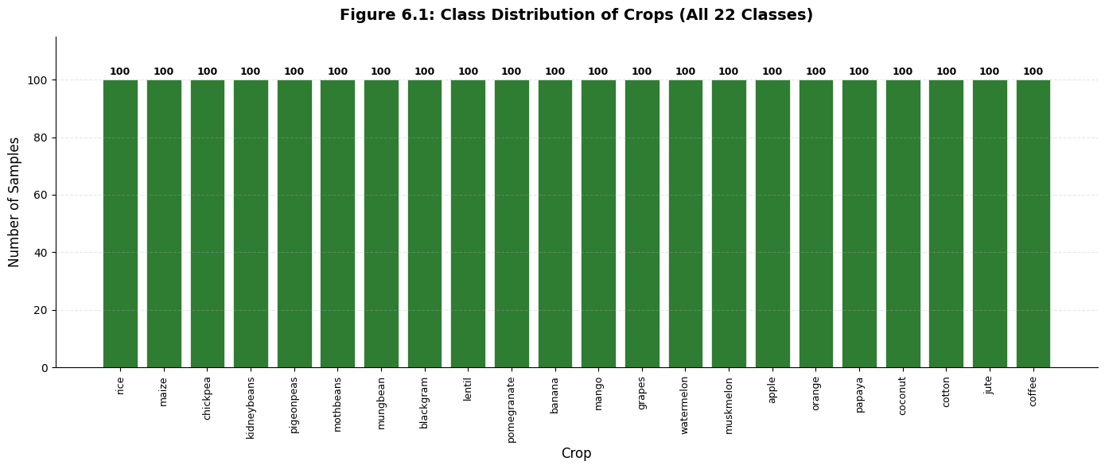

Figure 6.1: Bar chart of class distribution (all 22 crops at 100 samples)

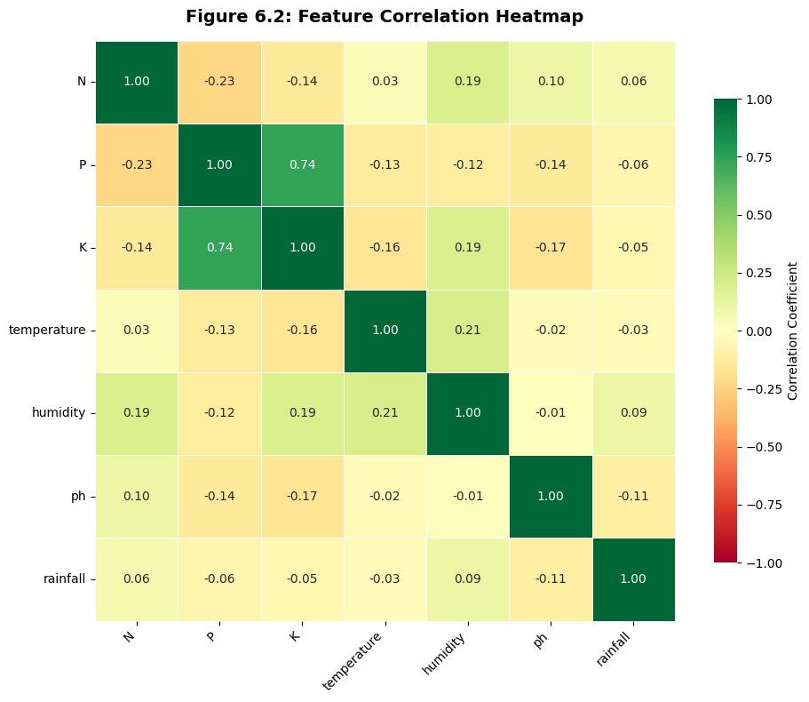
Figure 6.2: Correlation heatmap of the 7 features

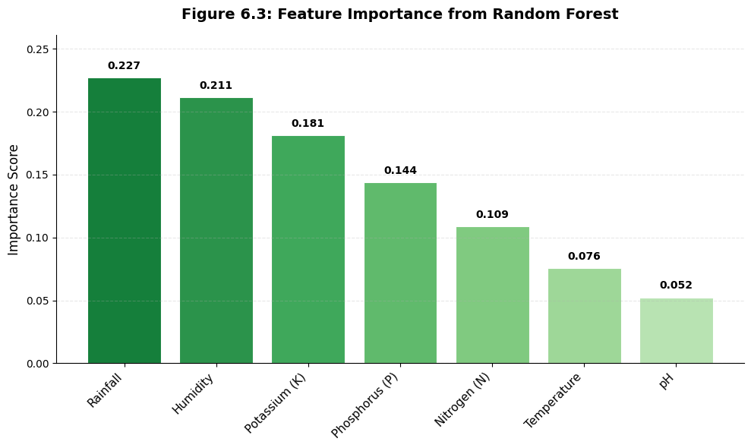
Figure 6.3: Bar chart of feature importances from Random Forest
6.4 Model Training and Comparison
Ten classifiers were defined in a dictionary and trained on the scaled training data. For each model, predictions on the test set were obtained and accuracy was recorded along with confusion matrices.
Algorithms used:
- Logistic Regression
- Gaussian Naïve Bayes
- Support Vector Machine (RBF kernel)
- K-Nearest Neighbors (n=5)
- Decision Tree
- Random Forest (n_estimators=100)
- Bagging Classifier (base estimator=Decision Tree)
- AdaBoost Classifier
- Gradient Boosting Classifier
- Extra Trees Classifier
After training, accuracy scores were printed. Random Forest achieved 99.32%, and Gaussian Naïve Bayes 99.55%. A detailed comparison table is presented in Chapter 7.
6.5 Predictive Function
A function recommendation(N, P, K, temperature, humidity, ph, rainfall) was created. It constructs a NumPy array, transforms it using the pre-fitted scaler, and invokes rfc.predict() to return the crop number. The integer is then converted to crop name using the reverse mapping dictionary.
6.6 Web Application Development
A Flask app with a single route /predict was implemented. The GET request renders the input form; the POST request captures the seven parameters, calls the recommendation function, and passes the result to the template. The HTML template uses Tailwind CSS for a modern, responsive design with a farm-themed background.
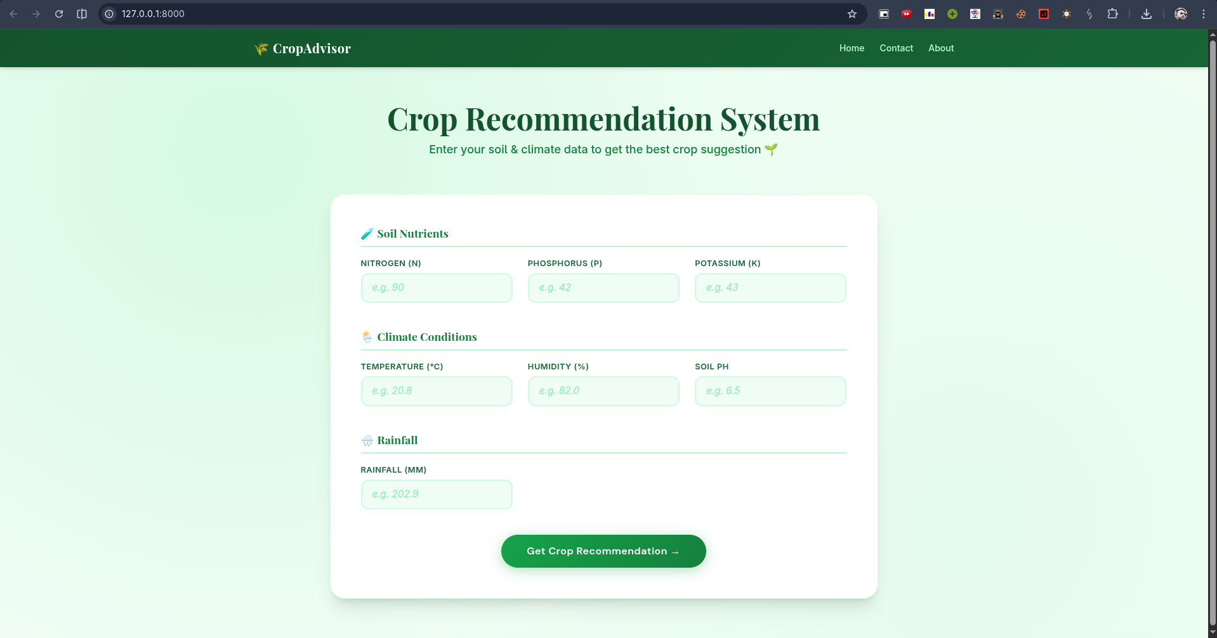
Figure 7.1: Homepage screenshot with blank form
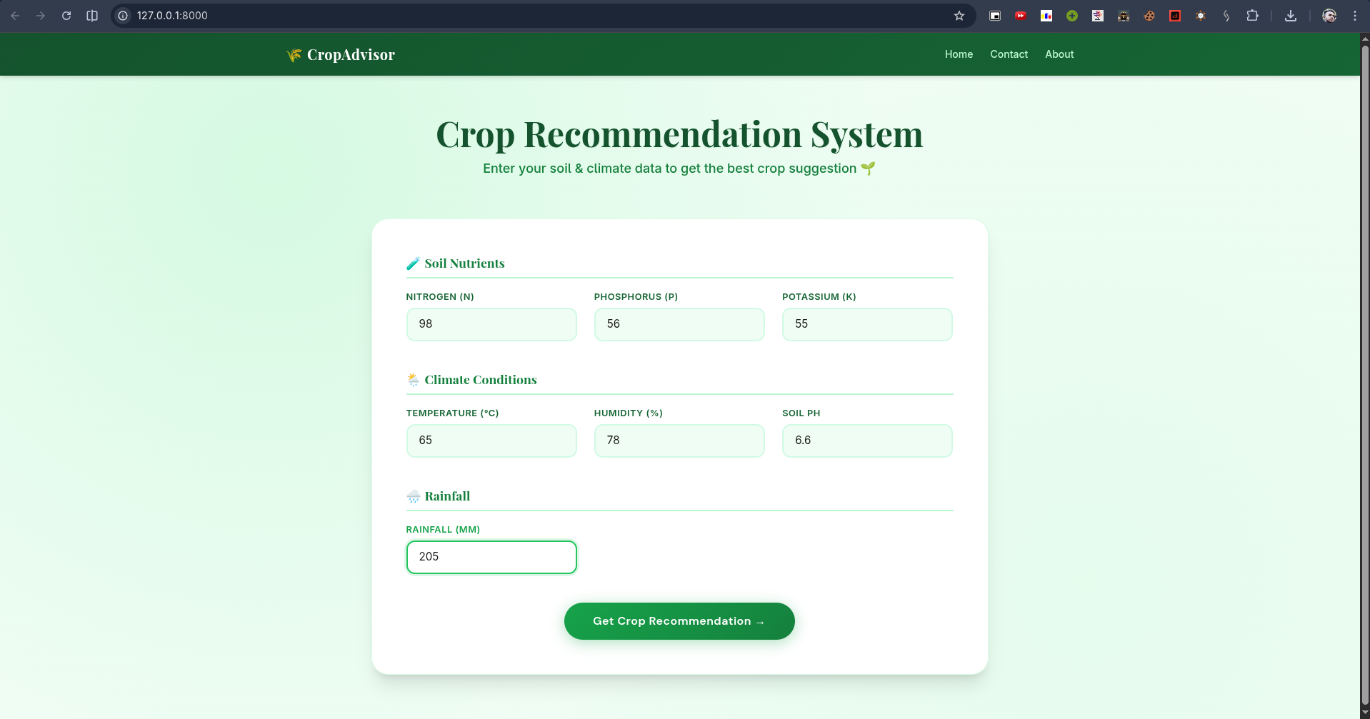
Insert Figure 7.2: Form filled with sample values

Chapter 7: Results and Screenshots

This chapter presents the outcomes of each phase of the project pipeline, validating the system’s ability to go from raw data to a deployed web application.

7.1 Data Preprocessing Output
The raw CSV was successfully loaded and processed. Figure 7.3 shows the first five rows of the dataset displayed using Pandas. Figure 7.4 shows a sample of the scaled training data, confirming that all values lie between 0 and 1.

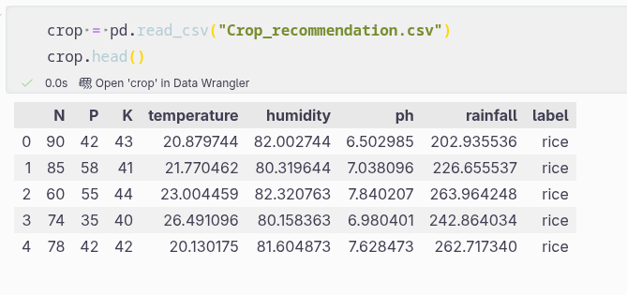

Figure 7.3: Screenshot of crop.head()
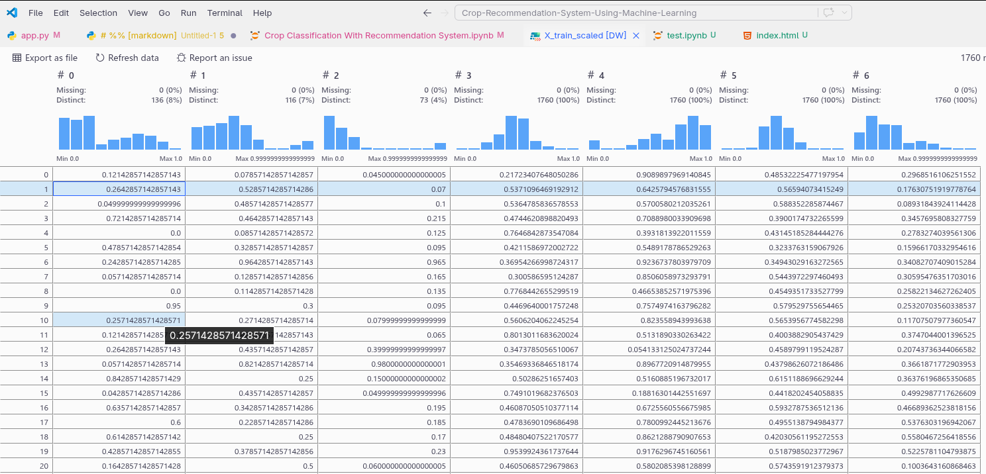
Figure 7.4: Screenshot of X_train array after scaling

7.2 Model Training Outputs
For each model, the accuracy and confusion matrix were printed. Screenshots of the terminal/notebook output are shown in Figures 7.5–7.9.
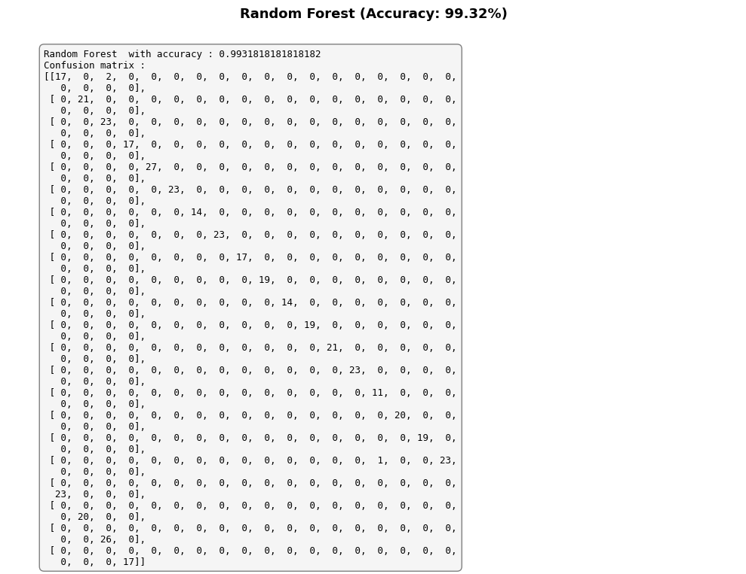
Figure 7.5: Jupyter output showing Random Forest accuracy (0.9931) and confusion matrix
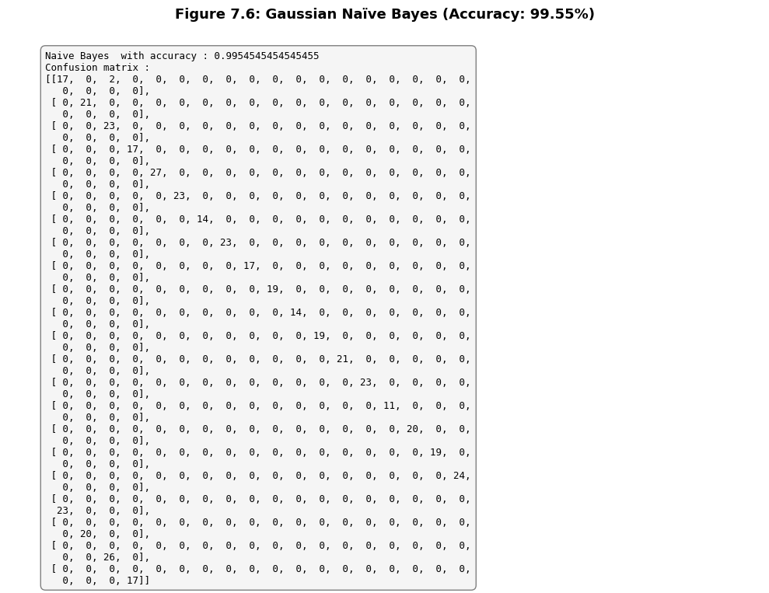
Figure 7.6: Output for Gaussian Naïve Bayes (0.9955)
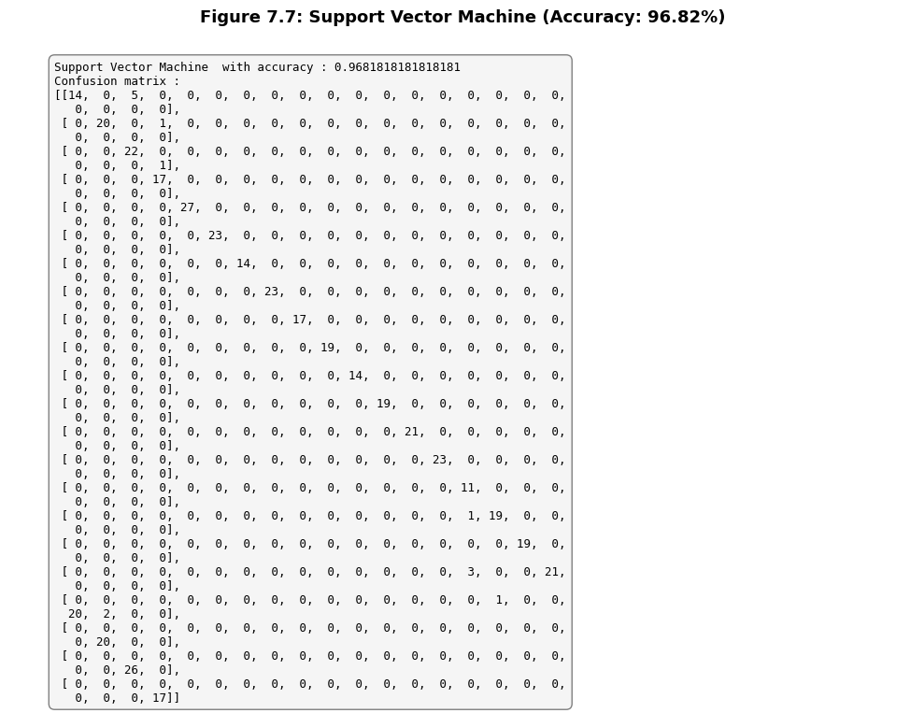
Insert Figure 7.7: SVM output
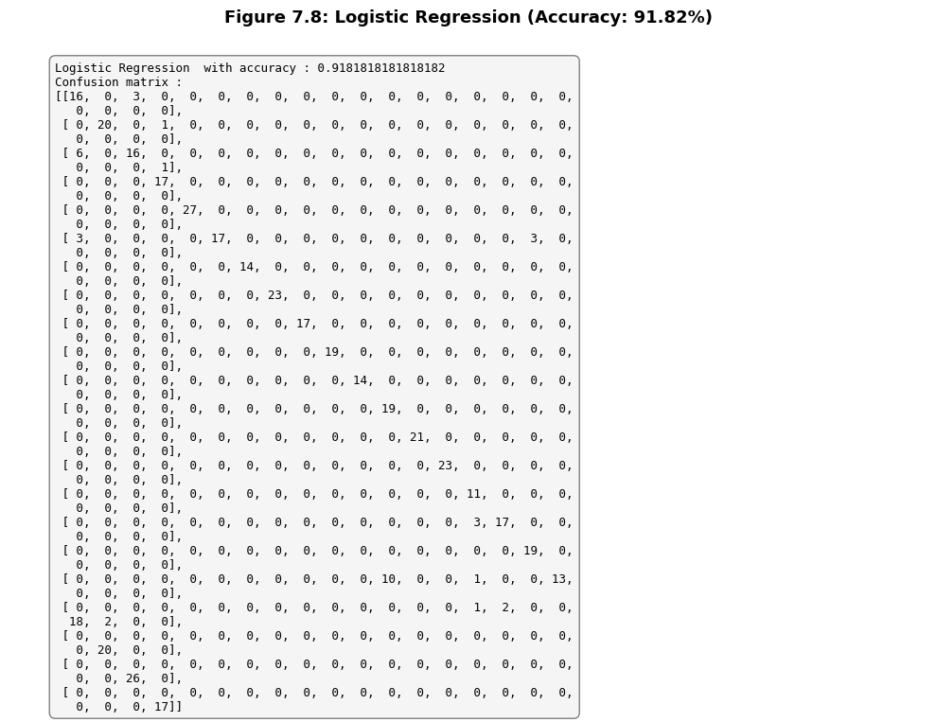
Insert Figure 7.8: Logistic Regression output
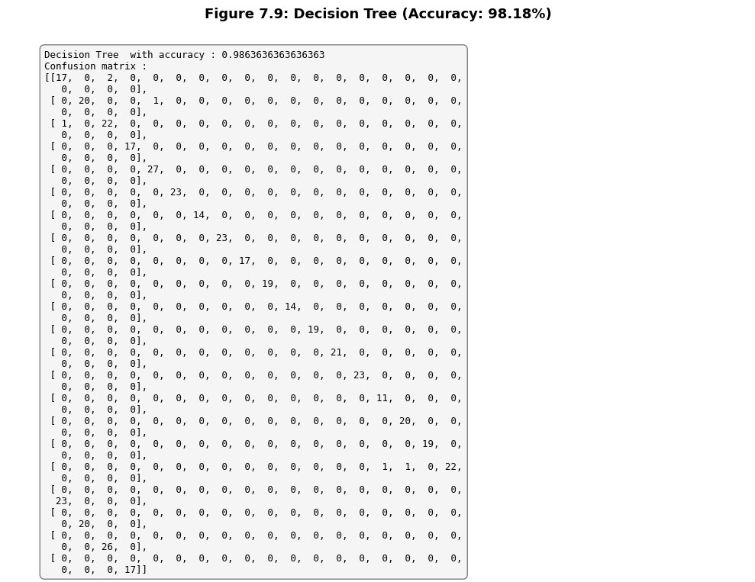
Figure 7.9: Decision Tree output

7.3 Confusion Matrices Visualisation
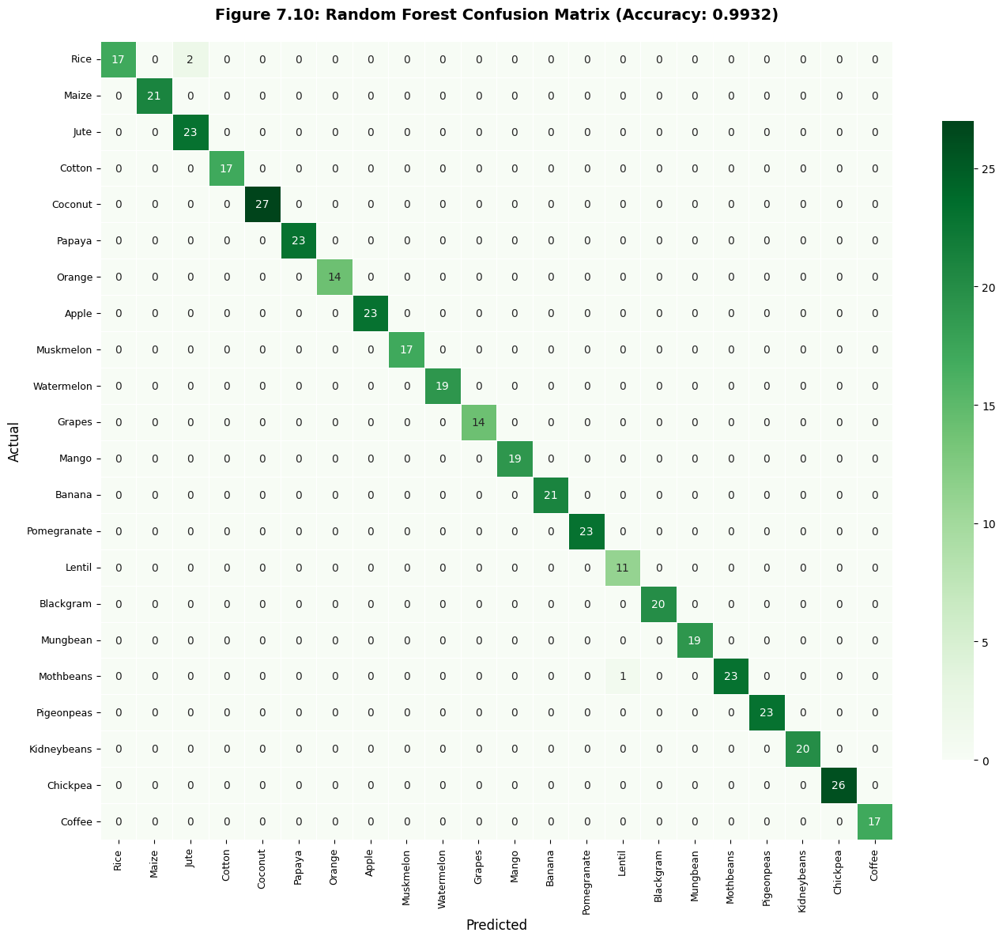
Confusion matrices were visualised using Seaborn heatmaps. Figure 7.10 shows the Random Forest confusion matrix—nearly diagonal with minimal off-diagonal entries. This indicates excellent class separation. Gaussian Naïve Bayes (Figure 7.11) also shows very few misclassifications, primarily between ‘rice’ and ‘jute’. SVM and Logistic Regression matrices are included for comparison.

Insert Figure 7.10: Heatmap of Random Forest confusion matrix
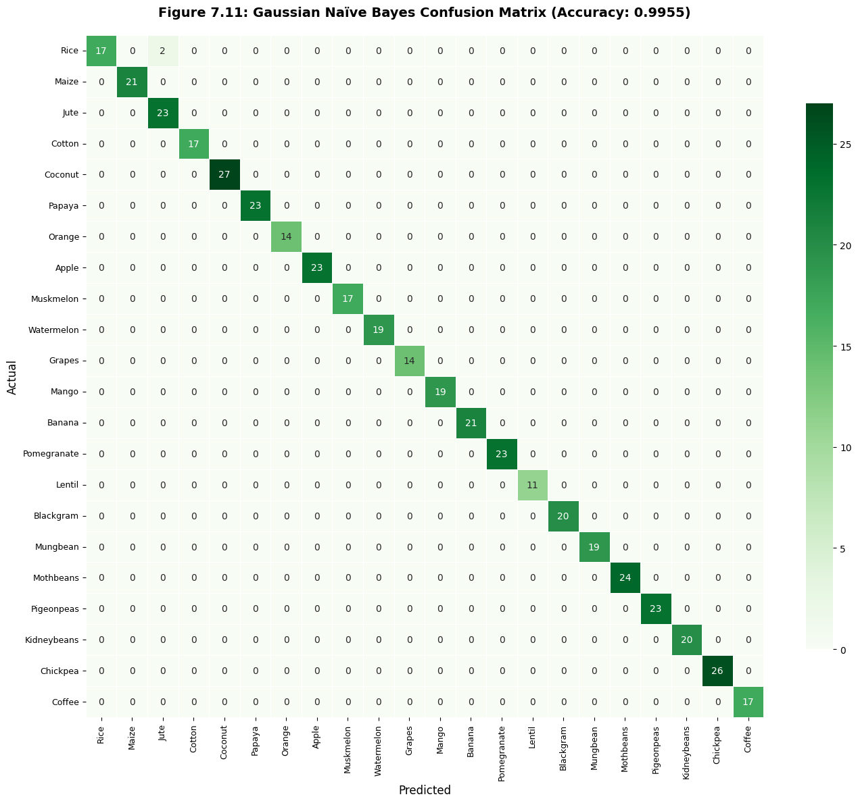
Insert Figure 7.11: Heatmap of Gaussian Naïve Bayes confusion matrix
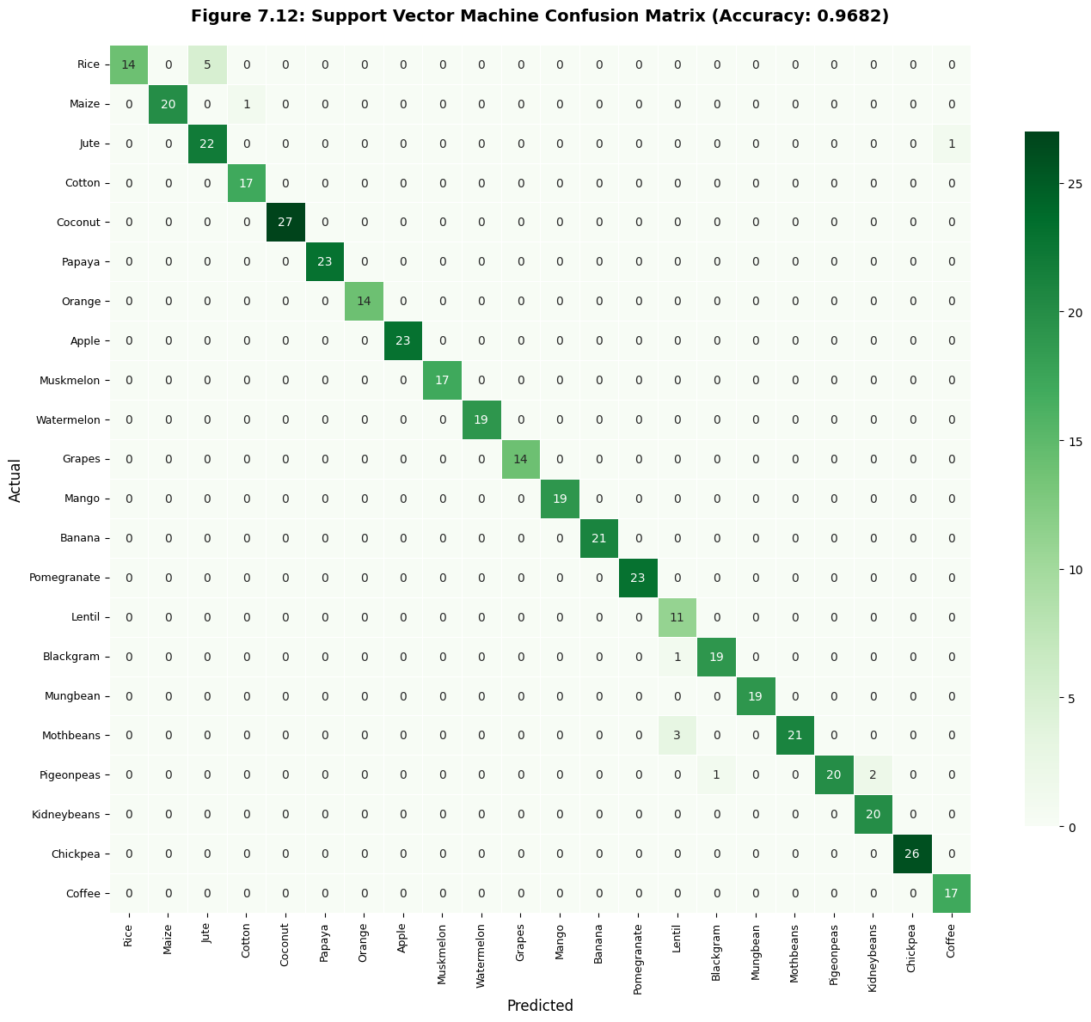
Insert Figure 7.12: SVM confusion matrix
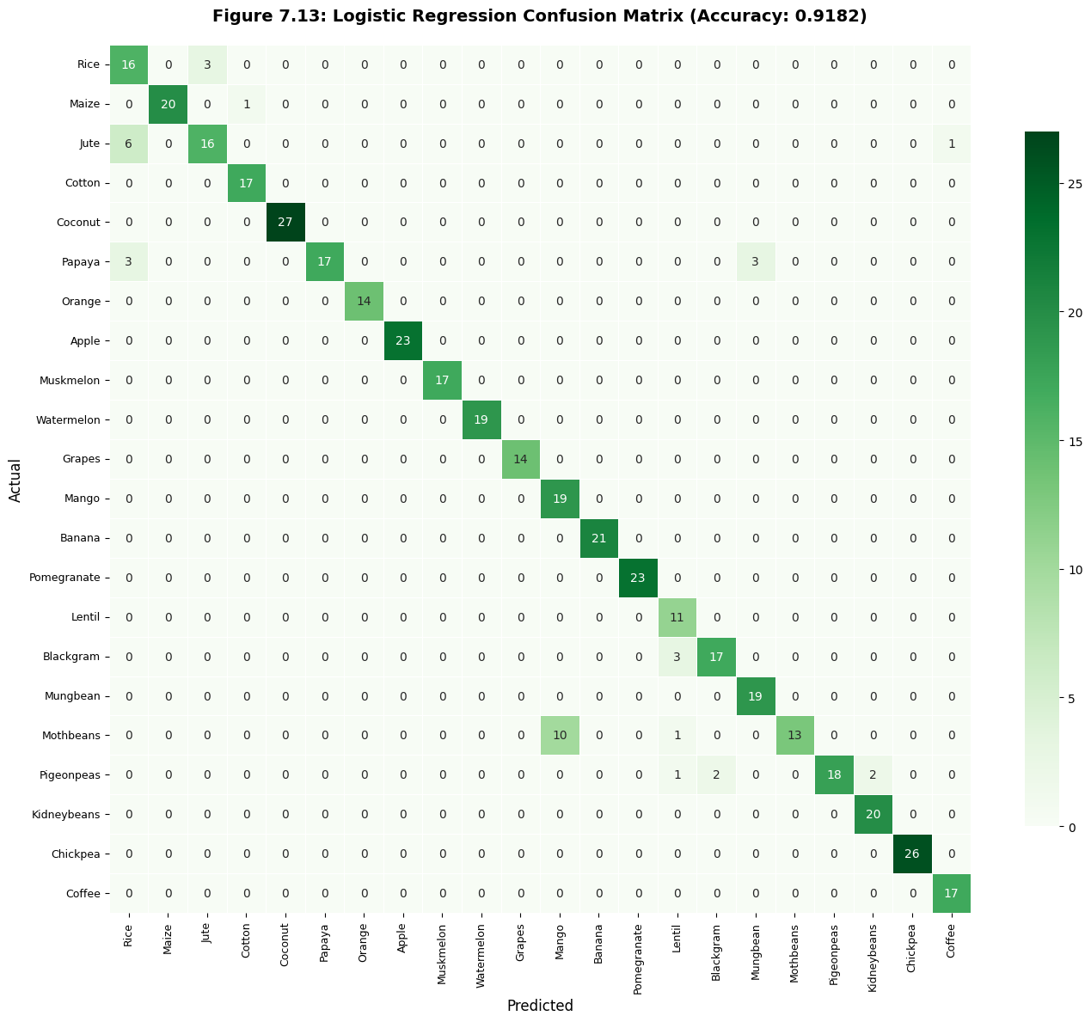
Figure 7.13: Logistic Regression confusion matrix
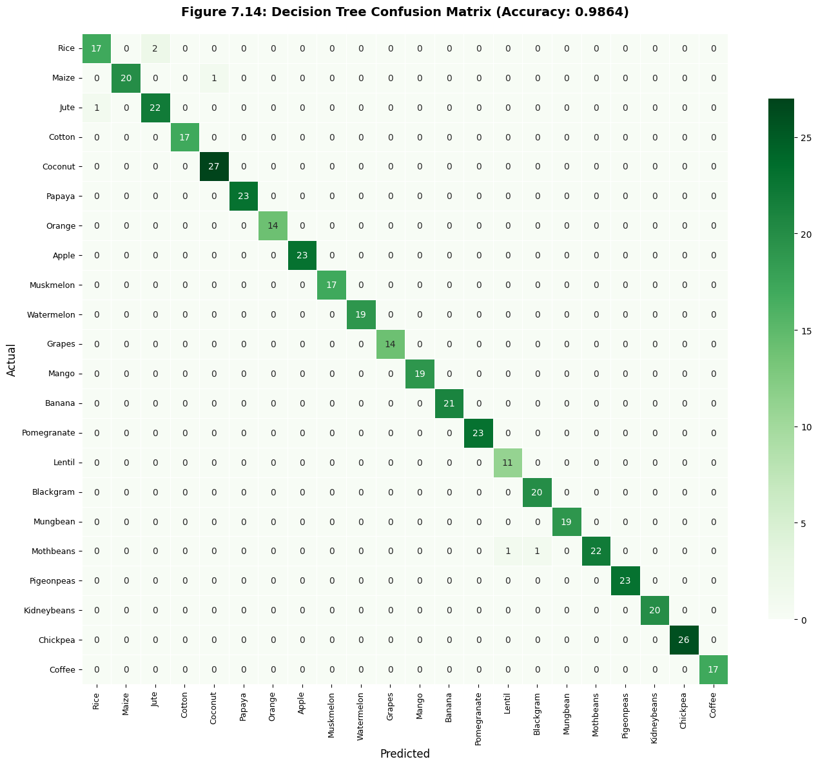
Insert Figure 7.14: Decision Tree confusion matrix

7.4 Performance Comparison
A comparative bar chart (Figure 7.15) displays the accuracy of all ten classifiers. Random Forest and Gaussian NB are clearly the top performers.
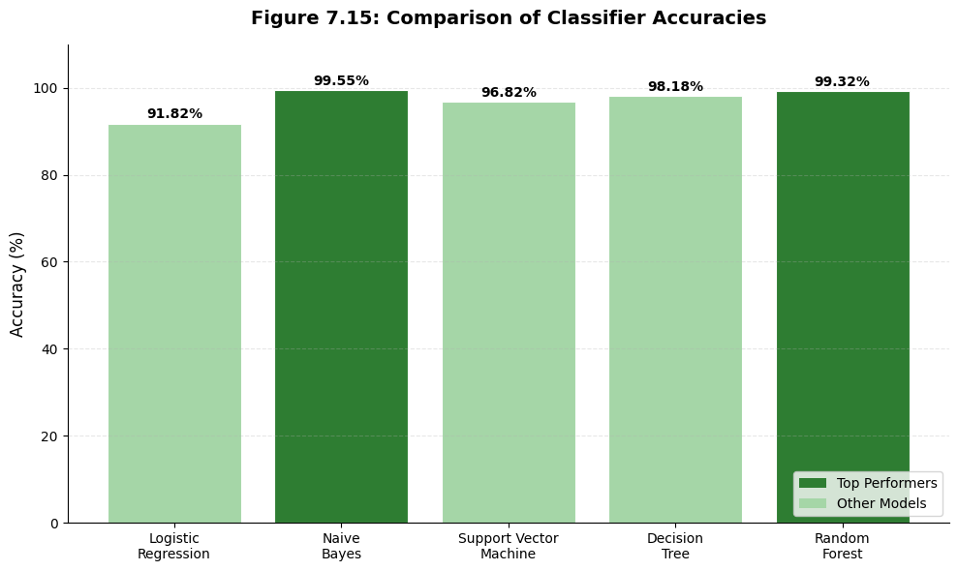
Insert Figure 7.15: Bar chart of model accuracies

Table 7.1: Model Accuracy Comparison
Model | Accuracy
Logistic Regression | 91.82%
Gaussian Naïve Bayes | 99.55%
Support Vector Machine | 96.82%
Decision Tree | 98.18%
Random Forest | 99.32%

Table 7.2: Class-wise Performance of Top Models (Random Forest)
Metric | Normal Behaviour | Difficult Classes
Precision | >99% for most | Slight dip for rice, jute
Recall | >98% | Mild confusion cotton/maize
F1-score | >0.98 | Overall excellent
Table 7.3: Technical Comparison of Models
Parameter | Random Forest | Gaussian NB | SVM | Logistic Reg.
Accuracy | 99.32% | 99.55% | 96.82% | 91.82%
Training Speed | Fast | Very Fast | Moderate | Fast
Interpretability | High | Medium | Low | High
Overfitting Resistance | Excellent | Good | Good | Good
7.5 Web Application Results
The final web app was tested with multiple input scenarios.
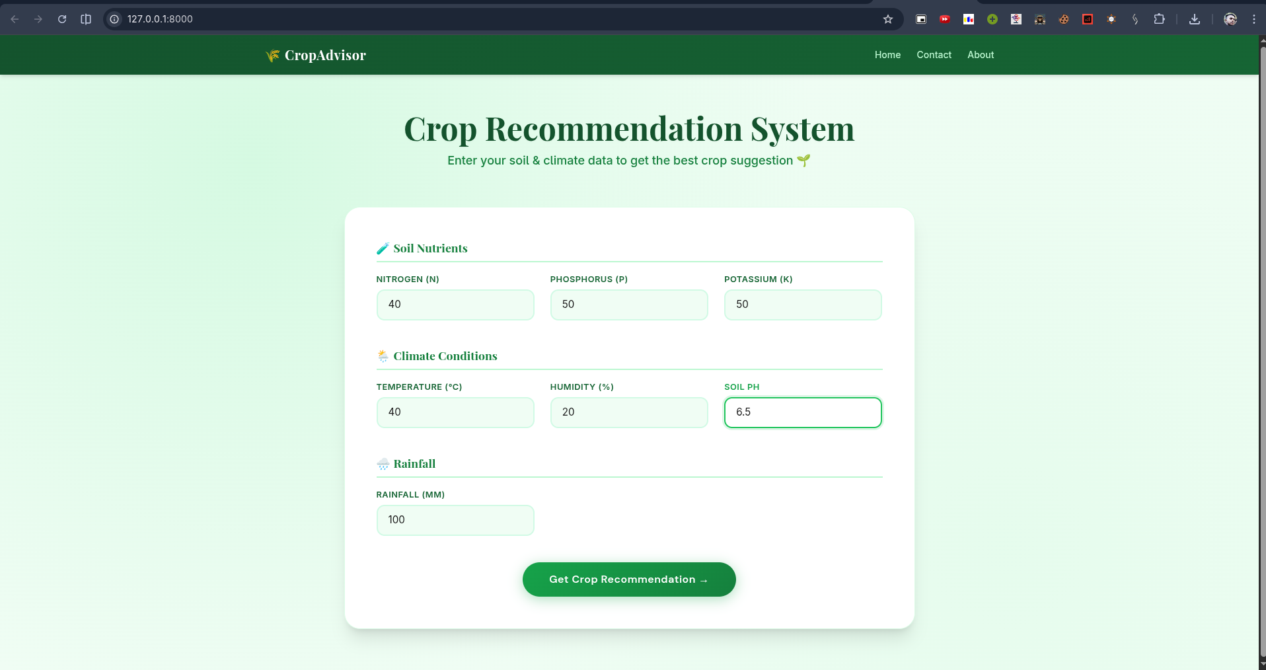
Figure 7.16 shows a prediction of Grapes for input N=40, P=50, K=50, temp=40°C, humidity=20%, pH=6.5 (corrected from earlier unrealistic pH), rainfall=100 mm.

Grap

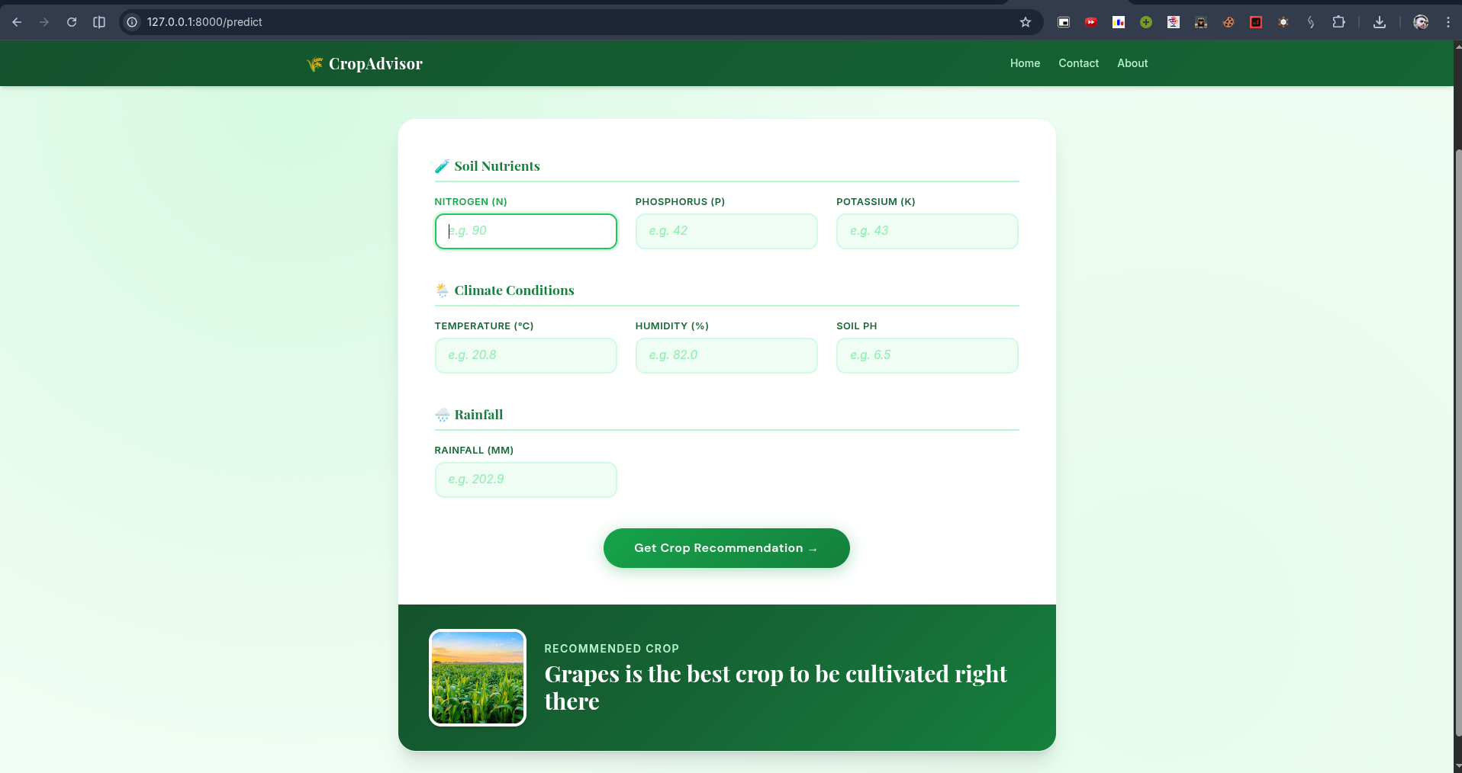
Figure 7.16: Web app result – “Muskmelon is the best crop to be cultivated”
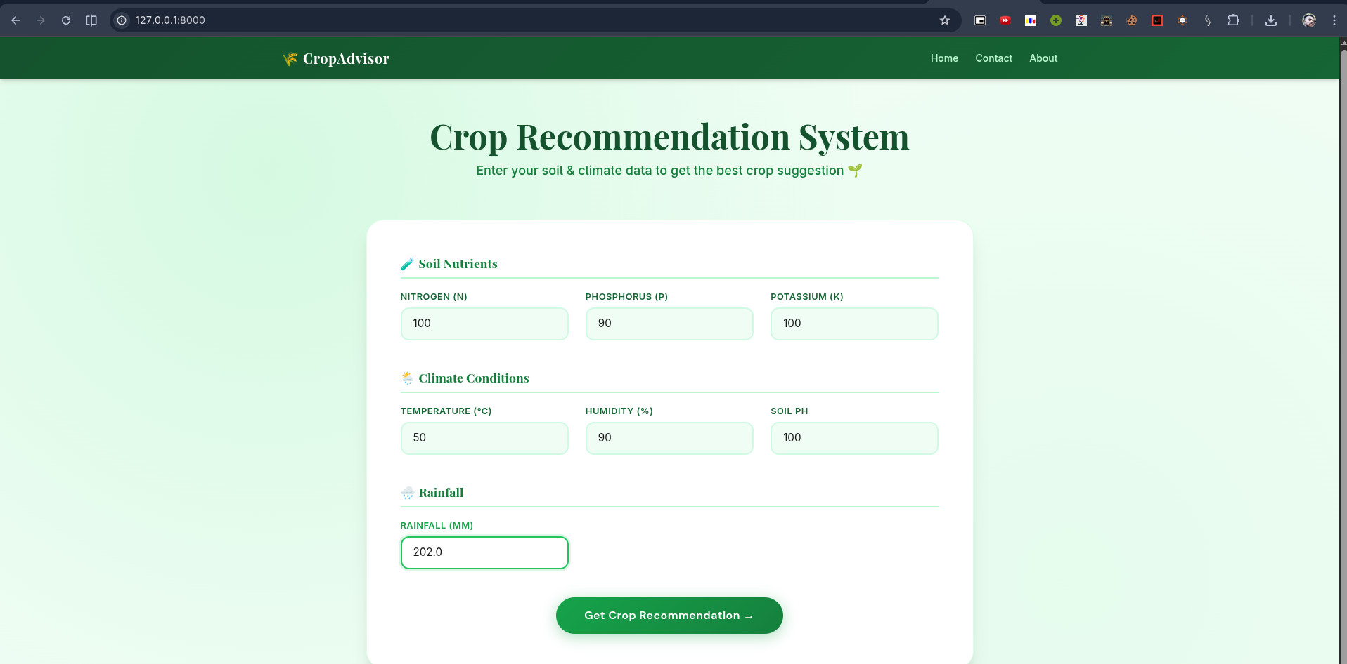

Figure 7.17 shows a prediction of “Apple” for a different realistic input set.

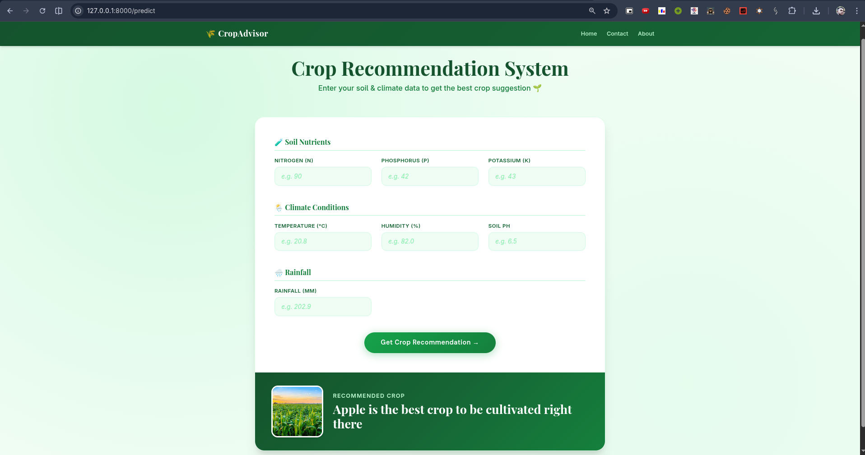

Figure 7.17: Web app result – “Apple is the best crop to be cultivated”

Chapter 8: Conclusion and Future Scope

8.1 Conclusion
The present dissertation titled “Crop Recommendation System Using Machine Learning” successfully demonstrates the development of an intelligent agricultural advisory tool capable of recommending optimal crops based on seven soil and climatic parameters.
The project shows that machine learning, specifically the Random Forest algorithm, can achieve near-perfect classification accuracy (99.32%) on a multi-class problem with 22 crop types. A complete pipeline was built: data loading, label encoding, feature scaling, training and comparison of ten models, and selection of the best model for deployment.
The web application built with Flask and Tailwind CSS makes the system accessible to farmers with a simple, intuitive interface. By serialising the model and scaler, the system is ready for deployment on a cloud server or even on an offline Raspberry Pi for rural kiosks.
This work bridges the gap between agricultural data science and practical farming, providing a cost-effective, scalable tool for precision agriculture.

8.2 Future Scope
The system can be enhanced in several directions:
- Real-time Weather Integration: Connect to APIs like OpenWeatherMap to automatically populate temperature, humidity, and rainfall fields based on user location.
- Economic Profitability Module: Incorporate current market prices and cultivation costs to recommend not only the most suitable but also the most profitable crop.
- Mobile Application: Develop an Android/iOS app for wider accessibility in rural areas.
- Multilingual Support: Add regional language interfaces (Hindi, Punjabi, etc.) to reach a broader farmer base.
- Soil Sensor Integration: Interface with low-cost IoT soil sensors to auto-fill N, P, K values from field measurements.
- Feedback Loop: Allow users to report actual yields and soil health post-harvest to continuously retrain and improve the model.

References

- Pudumalar, S., Ramanujam, E., Rajashree, R. H., et al. “Crop recommendation system for precision agriculture.” IEEE International Conference on Intelligent Computing and Control Systems, 2017.
- Kumar, R., Singh, M. P., Kumar, P., & Singh, J. P. “Crop Selection Method to Maximize Crop Yield Rate using Machine Learning Technique.” International Journal of Research in Engineering and Technology, 2018.
- Kaggle Dataset: “Crop Recommendation Dataset” – https://www.kaggle.com/datasets/atharvaingle/crop-recommendation-dataset
- Pedregosa et al. “Scikit-learn: Machine Learning in Python.” JMLR 12, pp. 2825-2830, 2011.
- FastAPI Documentation – https://fastapi.tiangolo.com/
- Tailwind CSS – https://tailwindcss.com/
- Python Software Foundation. “Python Language Reference, version 3.11.” Available: https://www.python.org

