Sprint 2 Feedback
Team 3, KnowledgeVault | MSCS 3999 Capstone, Fall 2026
Team members: Durvank Deorukhkar, Percival Tapera.
GitHub repo: https://github.com/falcon883/knowledgevault

1. Sprint structure
We track the project in Jira on a Scrum board (project KV, "KnowledgeVault Capstone, Fall 2026"). Four epics match the roadmap themes in our Vision document, and each story belongs to one of them.
Sprint 2 ran from October 1 to October 15. Sprint goal: make uploaded content findable by meaning. That means persisting documents, chunking and embedding their text, auto-tagging and summarizing, standing up vector search, and wiring the browse and search screens to live backend results.
The sprint covered 10 issues and 31 story points, and all 10 are Done with nothing carried over. Durvank took 19 points (backend) and Percival took 12 points (frontend and the sprint kickoff). One 1-point story, KV-22 (delete a document), was added on October 12 when the Browse screen needed a way to remove files. It is included in the 31 points and was finished inside the sprint.

2. What was completed
Issue | Completed work | Owner | Points
KV-13 | Uploads are saved to the database instead of only being read | Durvank | 2
KV-14 | Document text is split into overlapping chunks | Durvank | 3
KV-15 | Each chunk is embedded locally and stored in pgvector | Durvank | 5
KV-16 | Semantic search endpoint that ranks documents by meaning and hides weak matches | Durvank | 5
KV-21 | Automatic tags and a short summary for every upload | Durvank | 3
KV-22 | Delete a document and everything derived from it (backend endpoint, plus the delete action on the Browse screen) | Durvank, Percival | 1
KV-17 | Browse screen showing live documents with tags and summaries | Percival | 3
KV-18 | Search screen connected to the search endpoint | Percival | 5
KV-19 | Upload (Capture) screen connected to the backend upload endpoint | Percival | 3
KV-20 | Sprint 2 kickoff and task breakdown | Percival | 1
 | Total, all Done |  | 31

3. Jira sprint report (KV Sprint 2)
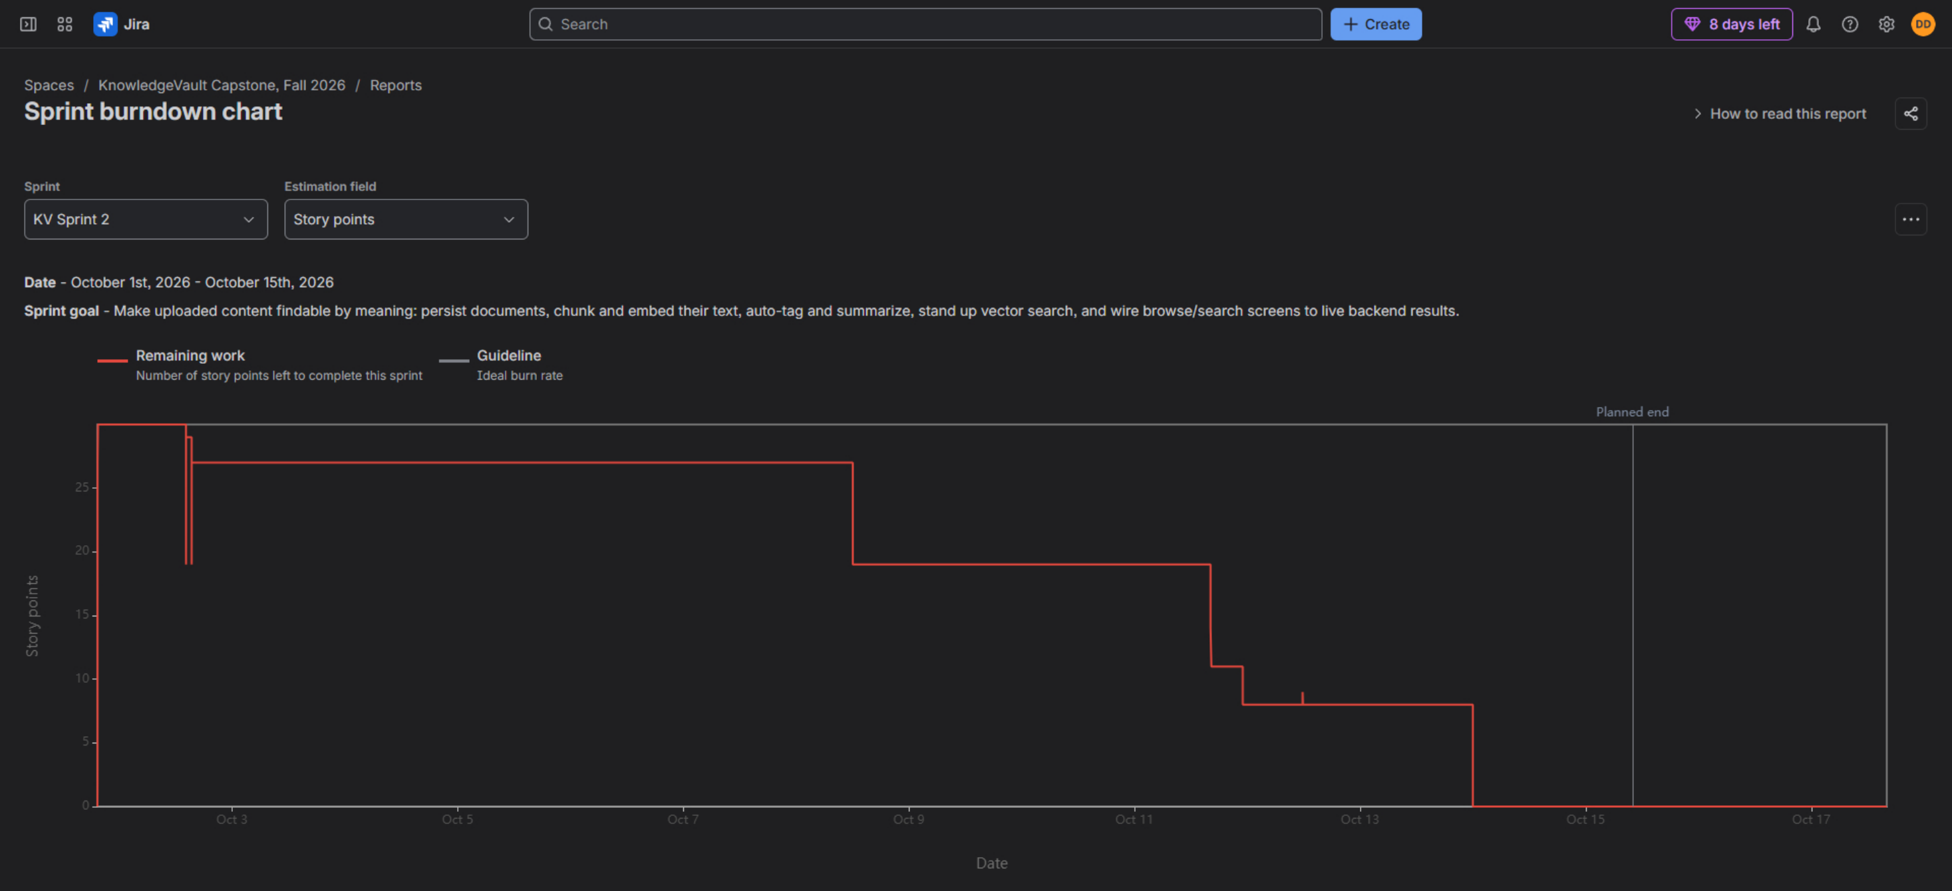
Sprint burndown for KV Sprint 2 (October 1 to October 15). Remaining work reaches zero before the planned end date.
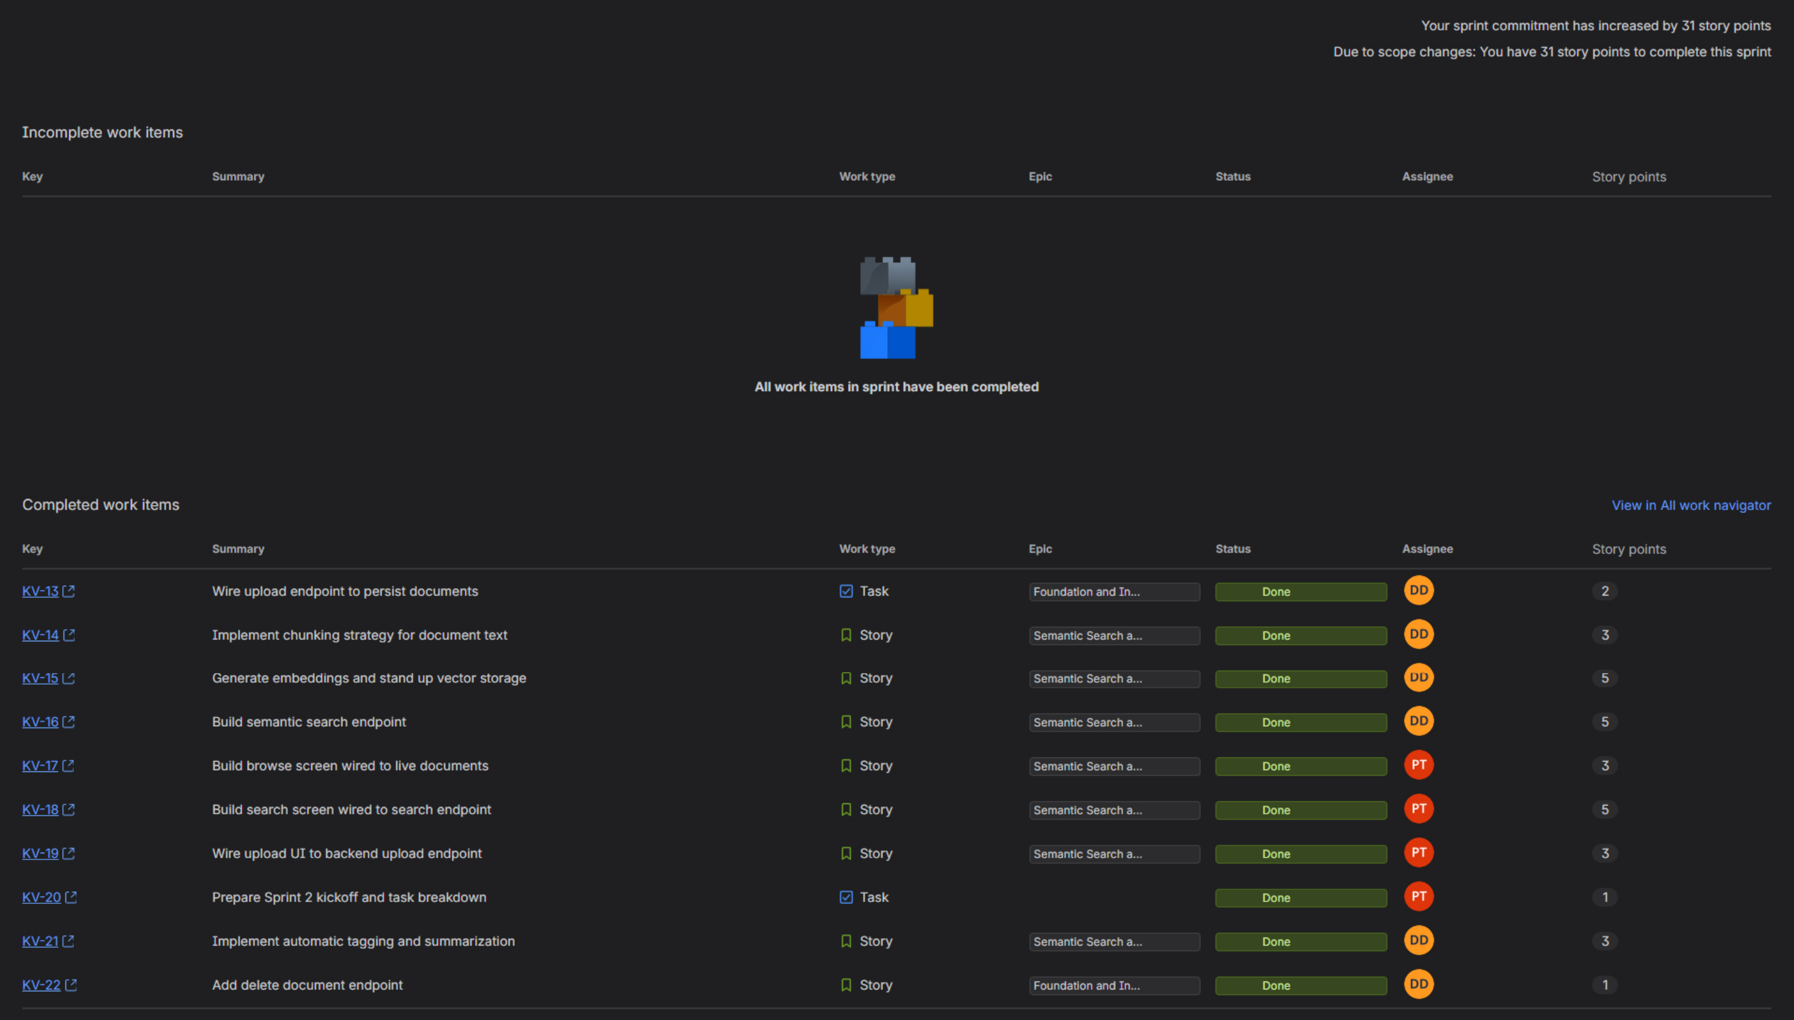
Same report: 31 story points to complete, no incomplete work items, and all 10 issues completed with their owners and points. No work was completed outside the sprint.

4. Backend progress
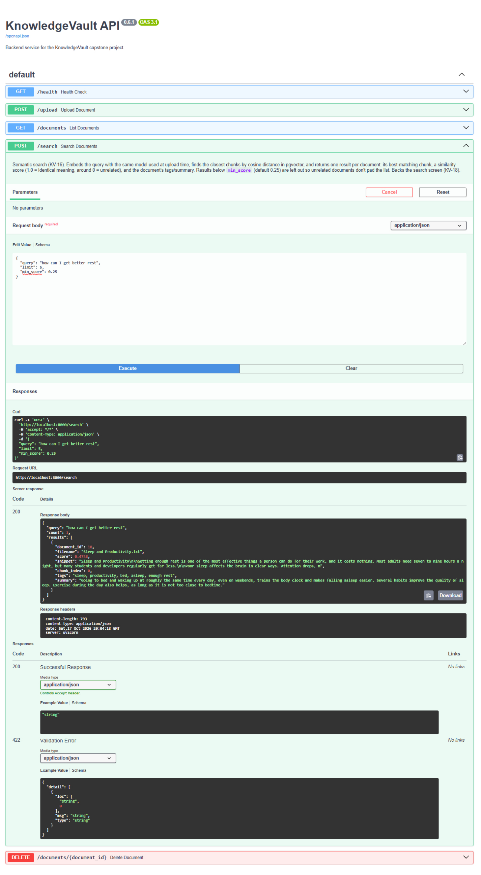
Backend API (FastAPI, Swagger UI, version 0.6.1) with all endpoints: /health, /upload, /documents, /search and DELETE /documents/{id}. The /search call shown asks "how can I get better rest" and returns the sleep document with a 0.47 similarity score, its snippet, tags and summary. The document never uses those words, so this is matching by meaning.
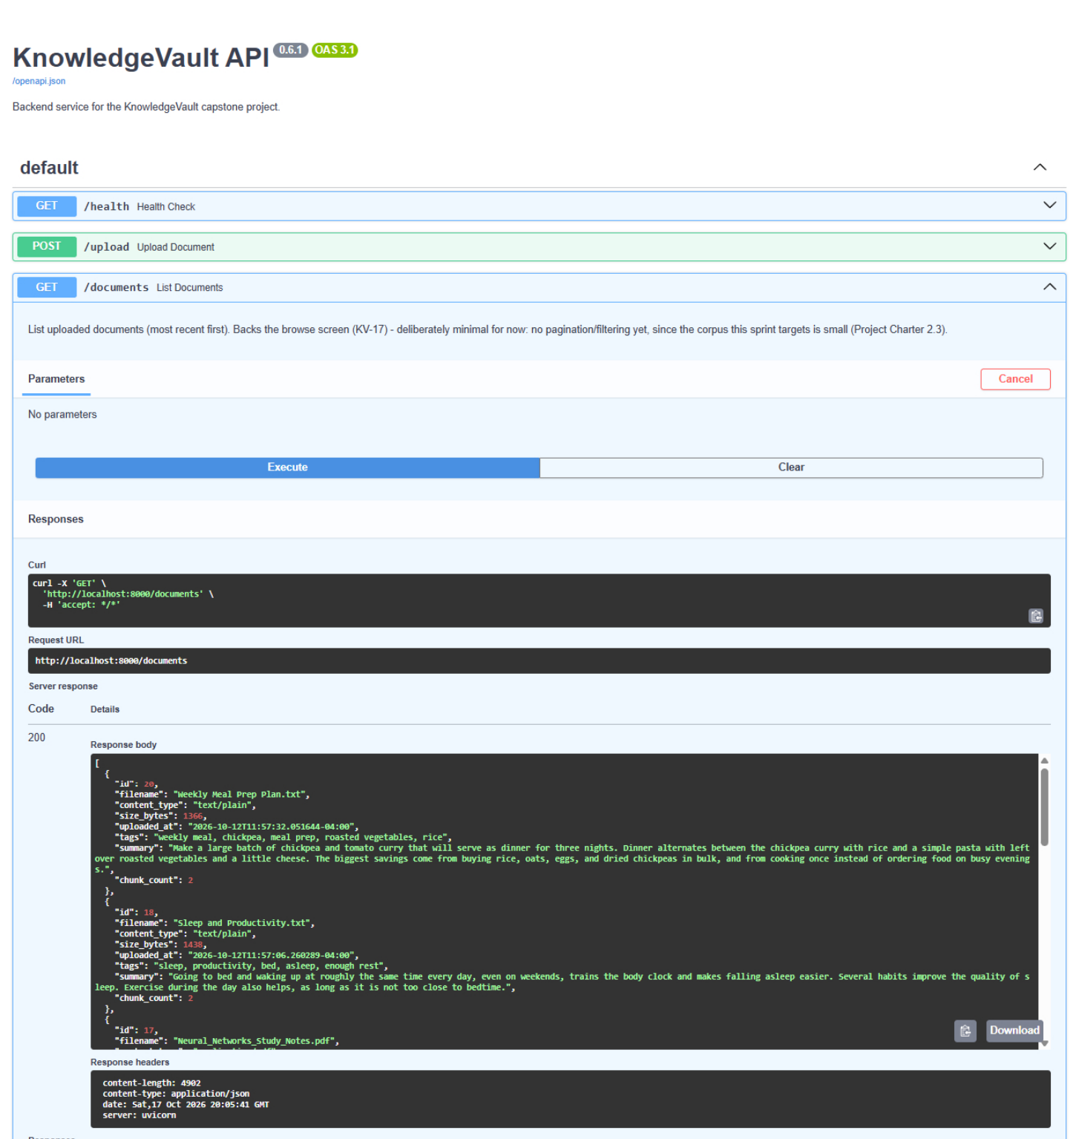
GET /documents returning the stored documents with the automatic tags and summary generated at upload (KV-21) and the number of chunks each one was split into.

5. Frontend progress
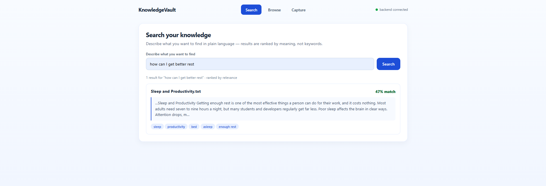
Search screen (KV-18): the same query returns the matching document ranked by relevance, with its tags. The status in the top right shows the frontend is connected to the backend.
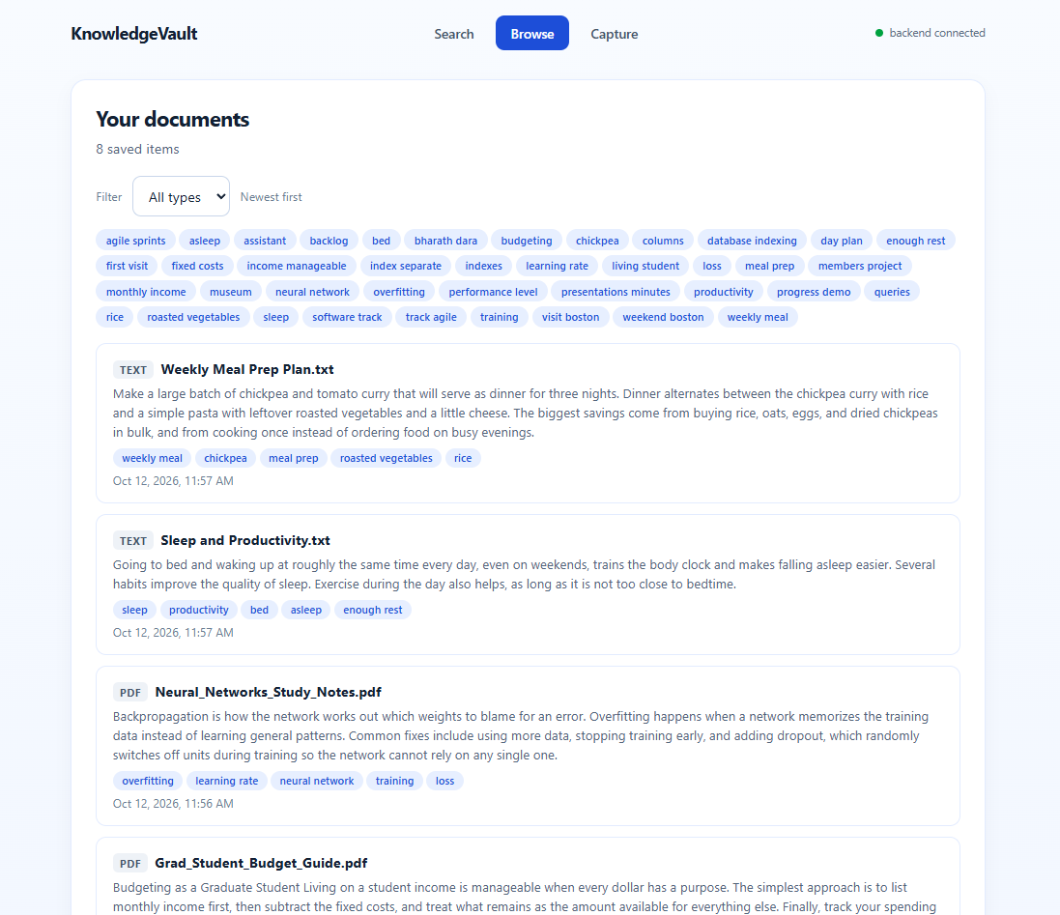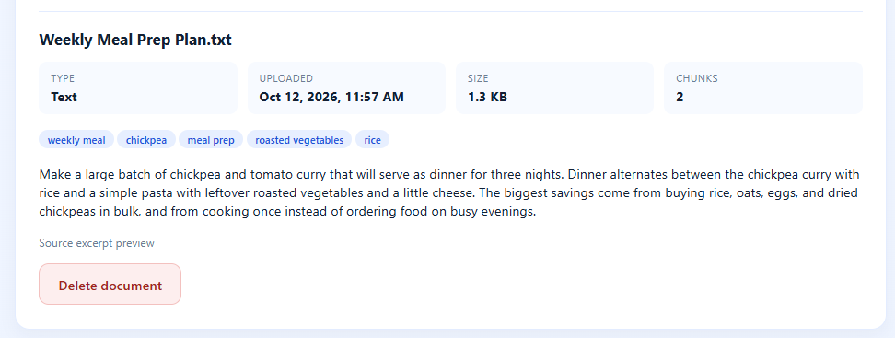
Browse screen (KV-17, KV-22): saved documents with tags, summaries and upload time, a type filter, and a way to delete a document.
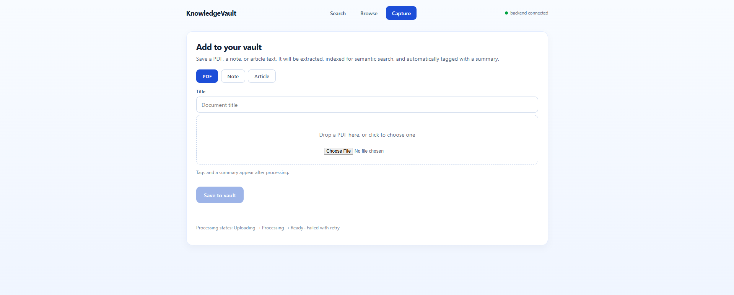
Capture screen (KV-19): adds a document and sends it to the backend upload endpoint.

6. Testing, documentation and code history
Each backend feature has a runnable test script that uses the real embedding model and a real Postgres database, and each finished with exit code 0.
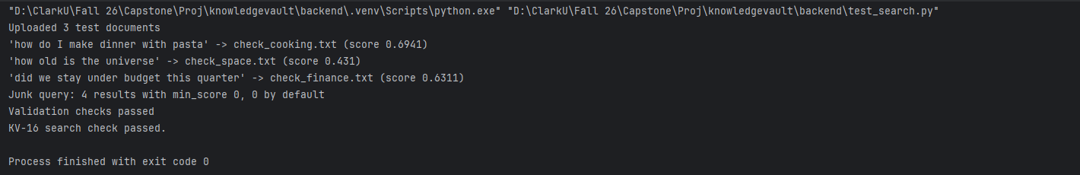
test_search.py (KV-16): the right document ranks first for three different questions, results are ordered, no document appears twice, weak matches are hidden by default, and bad input is rejected.
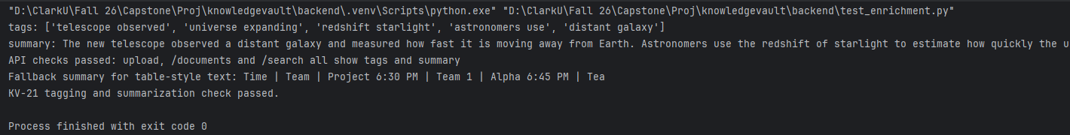
test_enrichment.py (KV-21): tags and summary are generated, and they show up through upload, /documents and /search.
test_delete.py (KV-22): a deleted document disappears from /documents and /search, its chunks are removed, and deleting it again returns 404.
The frontend and backend run together: all three screens call the live endpoints. Setup steps, endpoint documentation and the reasons behind our design choices (pgvector, local embeddings) are in backend/README.md.
Code is tracked in GitHub. Commit messages carry the Jira issue keys, and Percival's frontend work was merged through pull requests #1 and #2.
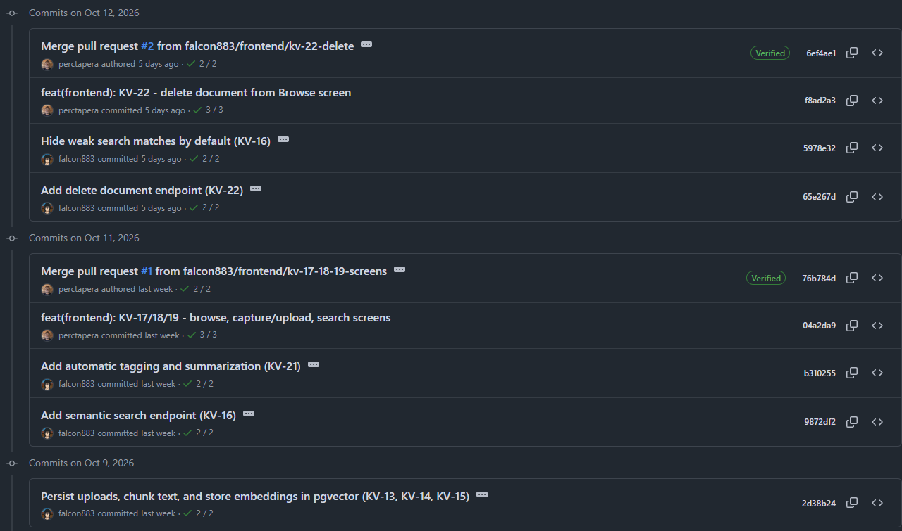
GitHub commit history for Sprint 2 (October 9 to October 12).
Known gaps, planned for later sprints: login and upload limits (security sprint), duplicate detection, and text extraction from scanned PDFs (Images).

