



REPORT
WXES3183 Fundamental Research in Academic Project
2015/2016 Semester 2
Plan of Journal Submission System

Name : Soh Jue Wern
Matric Number : WEK130050
Supervisor : Dr. Maizatul Akmar Ismail

TABLE OF CONTENT
Introduction 5
1.1 Issue/Motivation 5
1.2 Problem Statement 6
1.3 Objectives 7
1.4 Scope 8
1.4.1 System Overview 8
1.4.2 Target Users 8
2.0 Literature Review 9
2.1 Overview 9
2.2 Planning 11
2.2.1 Overview 11
2.2.2 Potential Risks of Not Planning 12
2.3 Journal Submission 14
2.3.1 Overview 14
2.4 Web-based System 15
2.4.1 Advantages of Web-based System 15
2.4.2 Interactive Web-based System 15
2.5 Plan of Journal Submission System 16
2.5.1 How to plan for journal submission? 16
2.5.2 Comparison of existing systems 17
2.5.2.1 Graduate Supervision System (GSS), University of Oxford 17
2.5.2.2 Environment Management System Tool, Australian Government, Department of the Environment, Water, Heritage and Arts 19
2.5.2.3 Acquity Scheduling System 20
2.5.2.3.1 What is Acquity Scheduling? 20
2.5.2.3.2 Main Features 20
2.6 Summary 24
3.0 Methodology 25
3.1 Software Development Methodology 25
3.1.1. Rapid Application Development Model 25
3.1.1.1 Overview 25
3.1.1.2 Advantages 26
3.1.1.3 Applying Rapid Application Development Model 27
3.1.1.3.1 Requirements Planning 27
3.1.1.3.2 User Design 27
3.1.1.3.3 Construction 27
3.1.1.3.4 Testing 27
3.1.1.3.5 Cutover 28
3.2 Data Gathering Methodologies 29
3.2.1 Literature Review 29
3.2.2 Interview 29
30
3.3 Data Analysis 30
3.3.1 Literature Review Findings 30
3.3.2 Interview Findings 31
4.0 System Design 33
4.1 Functional Decomposition Diagram (FDD) 33
4.2 Use Case Diagram 34
4.2.1 User 34
4.3 Data Flow Diagram (DFD) 35
4.3.1 Context Diagram DFD 35
4.3.2 Diagram 0 DFD 36
4.4 Entity Relationship Diagram (ERD) 38
4.5 Flow Chart 39
4.5.1 Lecturer Adding Students 39
39
4.5.2 Lecturers Planning and Updating Planned Journal 40
4.5.3 Management Viewing Report 41
References 50

Introduction

Issue/Motivation
Academicians are required to submit journal articles yearly according to number of PhD students they supervised and position (lecturer, senior lecturer, associate professor or professor).
The current planning of journal system is handled by the office admins using excel files. Being in the Faculty of Computer Science and Information Technology, we are driven to automate processes. The excel file will be shown in the next part for a more comprehensive understanding of the problem and issue arising.
After discussing with my supervisor, Dr. Maizatul, I am even more motivated to provide a platform like this system to make academicians and staffs’ lives and work productive.
It’s a win-win situation for the faculty and also lecturers. Faculty can oversee the academicians’ progress and key performance index (KPI) whereas academicians can manage their journal submission plan better and more efficiently.

Problem Statement
We all agree that we want a system that oversees and manages the plan of journal submission in the faculty that can be standardized. The research & development department can use this to track the KPI as well.
Today we have too many manual processes that are repetitive and redundant. If we ignore this problem, resources will need to increase to handle the cascading problems, and we may miss important information that results in misinformation or a big mess in achieving our objectives.
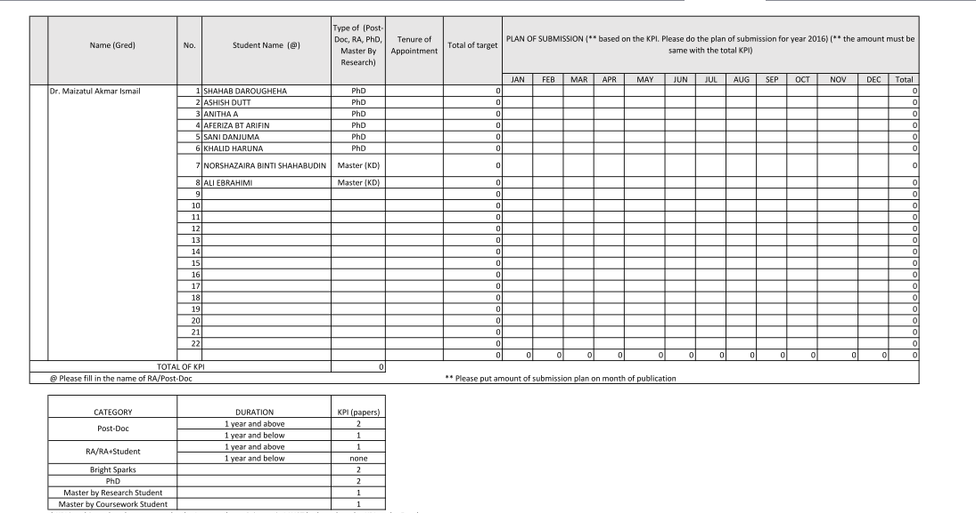
Figure 1.1 Current excel file to be updated constantly
As you can see from the figure above, it is tedious to keep updating the fields and there is no proper way to keep track of the previous entries when you overwrite the saving file. Keeping a copy of the same excel file for different planning will not be optimum and a lot of effort and resources wasted.
Thus, we will use interview questions that are designed to retrieve appropriate information. Also, interview will be done with different academicians in the faculty of different positions in order to have a holistic view of their thinking.

Objectives
This project aims to provide automatic monitoring of plan of journal articles submission. The objectives of the project are as follow:
- To identify specific criteria/information for the planning of journal submission
There are so many aspects to be taken care of when it comes to the planning of journal submission. For example, how many postgraduates student are under the supervision of one academician. When all these criteria and information are identified, the system can be developed better to suit the needs of users/stakeholders.

- To develop a prototype of Plan of Journal Submission Management System
As part of my Final Year Project, a working prototype of this system is developed to ease the work of faculty. This will be done after a clear understanding of user requirements.

- To produce reports for KPI purposes
The system can produce reports in graph form for easier viewing and interpretation for the staffs. This will be included in the end of the system once it is completed.

Scope

1.4.1 System Overview
Scope of the system includes limitations of the system. It only involves the academicians of Faculty of Computer Science and Information System (FCSIT).
The system will also function well when academicians update their plan accordingly and accurately. The system can also remind the academicians that they have already planned for a certain month but have not updated any details yet.
On the other hand, the management can view report based on lecturers by department, hence making it easier to keep track of the Key Performance Index (KPI) of the faculty.

1.4.2 Target Users
The target users for this system are divided into two categories. The first category is mainly for the academicians in FSKTM that supervise post-graduate students. They can further use this system for their own convenience and also for the faculty’s convenience to keep track of their progress.
Meanwhile, the second category is the management in FSKTM that will oversee the progress of this plan comprised of the dean, the deputy dean of research and also the rest of the management board. They can use this system to view reports based on the criteria that they want or mentioned.

2.0 Literature Review

2.1 Overview
Literature review serve to help researchers to better understand the problem domain or the background to the study being proposed. Hence, set a benchmark for the current project.
The following figure shows the process in conducting literature review:
Identify topic of research
What is your focus?
Writing the review
Searching and retrieval of relevant literature
Analyzing and interpreting readings
Why is it important?
Current source of evidence
Select appropriate keywords and search term
Sorting and prioritizing retrieved literature
Analytical and evaluative reading
Summarize the evidence
Rationale and purposes of proposed development

Figure 2.1 Steps in literature review process

Literature review has been conducted for Plan of Journal Submission (POJS) system to have a deeper insight and understanding on the condition of goal setting and achievements these days. Results from the process provide a strong basis for delivering the rationale of the research and ensures that the focus of the research is guided. The figure below shows the subdivision of the topic into various key areas. Further details will be looked into and discussed in each area respectively.
Planning
Overview
Journal Submission
Web-based system
Potential risks of not planning
Interactive Web-based System
Comparison of existing sytems

Overview

Advantages

Plan of Journal Submission System
How to plan for journal submission?

Figure 2.2 Literature Review of Plan of Journal Submission System

2.2 Planning

2.2.1 Overview
Planning (also called forethought) is the process of thinking about and organizing the activities required to achieve a desired goal. It involves the creation and maintenance of a plan, such as psychological aspects that require conceptual skills. There are even a couple of tests to measure someone’s capability of planning well. As such, planning is a fundamental property of intelligent behaviour.
Also, planning has a specific process and is necessary for multiple occupations (particularly in fields such as management, business, etc.). In each field there are different types of plans that help companies achieve efficiency and effectiveness. An important, albeit often ignored aspect of planning, is the relationship it holds to forecasting. Forecasting can be described as predicting what the future will look like, whereas planning predicts what the future should look like for multiple scenarios. Planning combines forecasting with preparation of scenarios and how to react to them. Planning is one of the most important project management and time management techniques. Planning is preparing a sequence of action steps to achieve some specific goal. If a person does it effectively, he can reduce much the necessary time and effort of achieving the goal. A plan is like a map. When following a plan, he can always see how much he have progressed towards his project goal and how far he is from his destination.
Patrick Montana and Bruce Charnov outline a three-step result-oriented process for planning: (Montana & Charnov, 2008)
- Choosing a destination
- Evaluating alternative routes, and
- Deciding the specific course of your plan.
In organizations, planning is a management process, concerned with defining goals for company's future direction and determining on the missions and resources to achieve those targets. To meet the goals, managers may develop plans such as a business plan or a marketing plan. Planning always has a purpose. The purpose may be achievement of certain goals or targets.

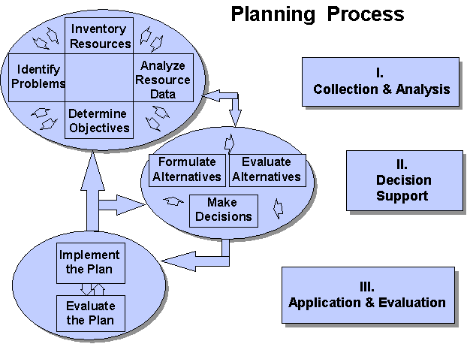
Figure 2.3 Framework for Planning (United States Department of Agriculture, 2003)

2.2.2 Potential Risks of Not Planning
There are many consequences of failure to plan. In this case, we are talking about the general terms of planning, regardless of business planning, project planning or even journal submission planning.
Following are the consequences of not planning in terms of business (Kruger, 2016):
- The failure to create a well-defined exit or transition plan virtually guarantees that business owners will:
- Exit their companies as a result of pressure from outside circumstances, not as a result of their own desires.
- Exit their companies on a timetable that's forced on them instead of one that meets their needs.
- Exit their companies as a result of pressure from outside circumstances, not as a result of their own desires.
- Exit their companies on a timetable that's forced on them instead of one that meets their needs.
- Undervalue their companies and leave hard-earned wealth on the table
- Pay too much
- Undervalue their companies and leave hard-earned wealth on the table
- Pay too much in taxes
- Lose control over the process by being reactive and limiting their exit options
- Fail to realise all their business and personal goals
- Suffer unnecessary psychological stress
- Watch a lifetime of work disintegrate as a result of poor business continuity planning
- Lose confidentiality during the sale or exit process
Basically, practitioners and students of planning have given the word countless interpretations. Every writer, it seems, feels compelled to redefine the concept. For the confusion resulting from this semantic Tower of Babel impinges on the practice of planning. How does one evaluate a phenomenon when there is little agreement about what it is? How can one say that planning is good or bad or in between when there are no accepted criteria for determining degrees of success or failure? Planning is the attempt to control the consequences of our actions. The more consequences we control, the more we have succeeded in planning. To use somewhat language, planning is the ability to control the future by current acts. Instead of discovering his fate in the future, man plans to make its own image. But the present may be reluctant to give birth to the future. Man can attempt to plan and he can fail. (Wildavsky, 1973)

2.3 Journal Submission

2.3.1 Overview
An academic or scholarly journal is a peer-reviewed or refereed periodical in which scholarship relating to a particular academic discipline is published. Academic journals serve as forums for the introduction and presentation for scrutiny of new research, and the critique of existing research (Blake and Bly, 1993). Content typically takes the form of articles presenting original research, review articles, and book reviews. The purpose of an academic journal, according to the first editor of the world's oldest academic journal Henry Oldenburg, is to give researchers a venue to "impart their knowledge to one another, and contribute what they can to the Grand design of improving natural knowledge, and perfecting all Philosophical Arts, and Sciences."(The Royal Society, 2011) The term academic journal applies to scholarly publications in all fields; this article discusses the aspects common to all academic field journals. Scientific journals and journals of the quantitative social sciences vary in form and function from journals of the humanities and qualitative social sciences; their specific aspects are separately discussed.
There are two kinds of article or paper submissions in academia: solicited, where an individual has been invited to submit work either through direct contact or through a general submissions call, and unsolicited, where an individual submits a work for potential publication without directly being asked to do so. (Gregory, 2005) Upon receipt of a submitted article, editors at the journal determine whether to reject the submission outright or begin the process of peer review. In the latter case, the submission becomes subject to review by outside scholars of the editor's choosing who typically remain anonymous. The number of these peer reviewers (or "referees") varies according to each journal's editorial practice — typically, no fewer than two, though sometimes three or more, experts in the subject matter of the article produce reports upon the content, style, and other factors, which inform the editors' publication decisions. Though these reports are generally confidential, some journals and publishers also practice public peer review. The editors either choose to reject the article, ask for a revision and resubmission, or accept the article for publication. Even accepted articles are often subjected to further (sometimes considerable) editing by journal editorial staff before they appear in print. The peer review can take from several weeks to several months. (De Lange, 2011)

2.4 Web-based System

2.4.1 Advantages of Web-based System
The advantages of web-based system were discussed in many research papers in the past. One of them is the end users are allowed to recover from their mistakes (Lenz, 1999). Most importantly, web-based system is able to overcome limitations associated with traditional alternative mentioned such as manual work. For instance, it may improve problems of interaction, bottlenecks, accessibility and etc. It also brings potential benefits for organizations. This is because the overhead cost and transaction cost can be reduced, more timely dissemination of information to other departments, clerical errors can be reduced and time to complete transactions is shorter (Liu, Arnett, Capella & Beatty, 1997; Tenenbaum, 1998; Crawford, 1998). No doubt, web sites have shown to bring positive impacts on both established business practices and information sharing in an organization (Beatty, Shim & Jones, 2001).

2.4.2 Interactive Web-based System
According to Negash, Ryan and Igbaria (2003), the quality of a web-based system is determined by its characteristics, the service provided and information supplied by the system. The user satisfaction towards the system can reflect its effectiveness. In recent years, interactivity has been recognized as the most helpful way of ameliorating quality of communication for website design and has been considered as one of the most predominant features in the web applications. User satisfaction towards a web-based system is brought by happy user experience with a website. Due to the positive effects of user experience toward web-based system itself and its builders, user experience is so important that it has drawn increasing attention in website environment (Tu, 2014).

2.5 Plan of Journal Submission System

2.5.1 How to plan for journal submission?
According to Dr Azlan Mohd Zain, 2016:
The 6 main steps for publishisng article journal are as below:
- Prepare your article
Be fully equipped with the knowledge of the title (What + Why + How), abstract (short and interesting), content of the article and cite few articles from the journal that you send your article to.
- Identify suitable journal
Check the editorial board (Who + Where), think about the possibility of your paper to be accepted based on the similar topic that has been published in the journal previously, look at the number of paper/volumes published by the journal
- Sending process
If you asked to give a potential reviewer’s name for reviewing your article – name the reviewer’s which you cite their works from. Follow the submission format.
- Waiting feedback
The paper that is not suitable with the journal scopes will be rejected by editors. No response may indicate that the article is being reviewed but it does not guarantee that the paper will be accepted.
- Correction if needed
If reviewers ask for modification (revise), this is a strong indication that your paper is possible to be accepted for publications. Fulfil all changes needed by the reviewers (think that the reviewer’s opinions are always right).
- Reason for article to be rejected
The paper that is not suitable with the journal scopes will be rejected shortly by editors. Main reason is that the content is not satisfied. English is one of the main reason for articles to be rejected. The reviewer will ask you to improve this aspect if the English used is not of satisfaction.

2.5.2 Comparison of existing systems

2.5.2.1 Graduate Supervision System (GSS), University of Oxford
Historically, supervision reports were circulated around the university using a paper-based system, which was very labour, intensive and difficult to manage. Often, reports were not being reviewed until well into the following term making follow-up and resolution of concerns quite challenging. The control of graduate supervision reporting was noted in the 2004 Institutional Audit as an area for improvement. As a result, in 2006 the Education Policies and Standards Committee commissioned the development of an online system for Graduate Supervision reporting.
The main purpose of the GSS application is to allow supervisors to submit supervision reports about their graduate students. However, the application includes many other features and functionality that will be useful to Students, DGS, Subject Administrators, College Advisors, College Administrators and Funding Administrators.
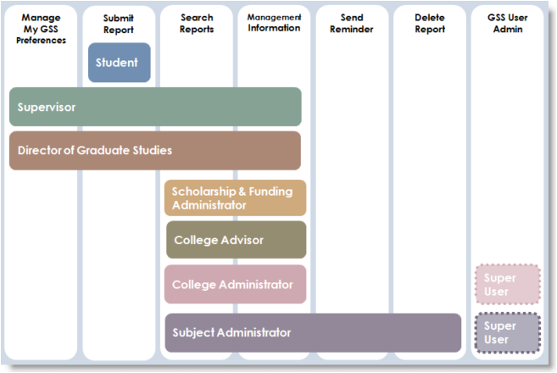
Figure 2.4 GSS Functionality

With GSS, the supervision reporting process will be controlled by a structured timetable with automatic reminders sent at the beginning of the reporting period and again throughout the term if a report is outstanding. Once reports are entered into the system they are immediately available to the student, supervisor and DGS for review.
Additionally, Subject Administrator, College Advisor, College Administrator and Scholarship and Funding Administrators are able to view reports as soon as they are submitted, drastically cutting the time and administrative processes required to circulate the report. New in the GSS system will be the facility for students to voluntarily make a self-assessment on their own progress. Other features include:
 Access and submit reports from anywhere, anytime with support for industry standard browsers and internet connections.
 Complete control over the frequency and number of email notifications (apart from start and end of reporting window system message).
 Automatic notifications to payroll to process Supervisor payments for internal staff.
Easy to use navigation and user dashboard for data entry.
Straight forward retrieval and review of current and previous term reports.
Save then Submit to allow reports to be created and saved before submitting.
Addition of comprehensive report information including training received and required, flagging concerns, number of student – supervisor meetings.
Online help and FAQ.

2.5.2.2 Environment Management System Tool, Australian Government, Department of the Environment, Water, Heritage and Arts
An Environmental Management System (EMS) is a structured system or management tool which, once implemented, helps an organisation to identify the environmental impacts resulting from its business activities and to improve its environmental performance. The system aims to provide a methodical approach to planning, implementing and reviewing an organisation’s environmental management.
Most organisations will have systems for managing their human resources, business objectives and finances as well as occupational health and safety, and security. An Environmental Management System will work more effectively if it is designed to operate in line with an organisation’s existing systems and processes, such as the planning cycle, the setting of targets and improvement programs, corrective and preventive action and management review. This system covers few aspects in term of functionality depicted in the figure below:
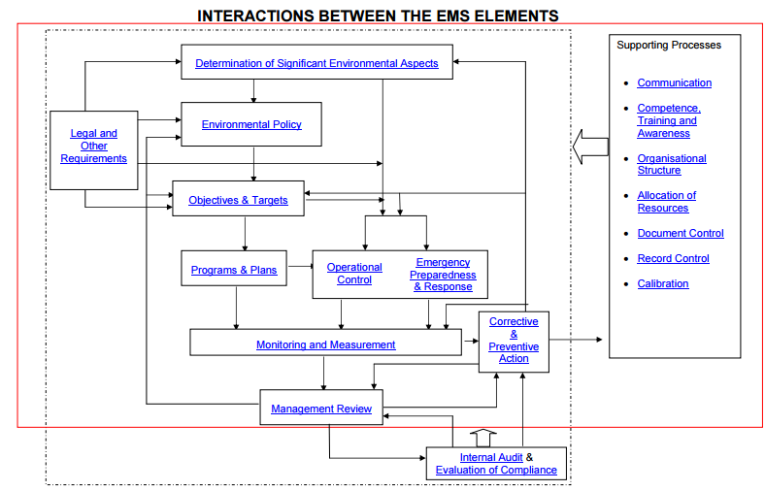

Figure 2.5 Functionalities in EMS

2.5.2.3 Acquity Scheduling System

2.5.2.3.1 What is Acquity Scheduling?
Showing up for an appointment the client totally forgot about or getting a phone call from an irate customer who expected you by her place for a tutoring session that completely slipped your mind are two scenarios you never want to have to deal with – that is, if you intend to make the most efficient use of your time and run a profitable business where your clients are also your brand ambassadors.
While it’s completely human and forgivable to forget stuff every once in a while, messing up your schedule, wasting your clients’ time, and then rescheduling appointments for a later time is one surefire way to damage your brand’s reputation and upset your work-life balance.
Acuity Scheduling empowers businesses to set their hours and take control of their calendars in the most efficient way possible – through automated appointments, cancellations, and reminders. When booking an appointment, your clients only see your dates and times available, and once a schedule is booked, it shows up in your Google Calendar (or any other supported web-based calendar) and events are automatically blocked off. (GetApp, 2016)

2.5.2.3.2 Main Features
24/7 Online Appointment Scheduling
Because it is web-based, Acuity Scheduling can be accessed from anywhere, and your clients can schedule an appointment at their convenience. Depending on your preference, your client appointment page can be set to either public or private. If set to private, only admins and clients with a direct link to the page can use it to book appointments.
Single and multiple bookings can be made, as well as class/group appointments, and both you and your client/s receive confirmation emails for successfully booked appointments. Blocked off schedules in Acuity Scheduling automatically show up in your synced Google Calendar, and vice versa. For Growing Business and Powerhouse Player accounts, notifications and reminders can also be sent via SMS/text messaging, and multiple calendars can be set up.
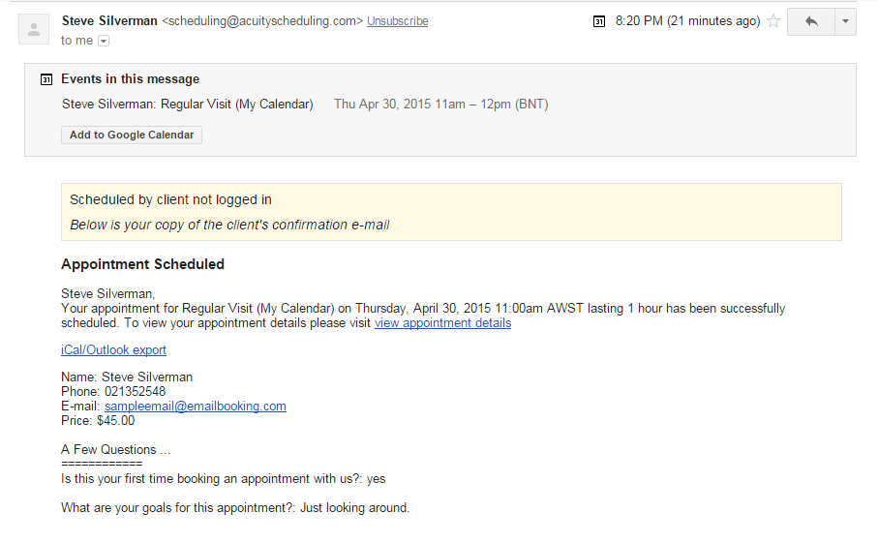
Figure 2.6 When a schedule is successfully booked, an email/SMS notification is automatically sent to both the staffs (or business owner) and client, along with the requisite appointment and client details.

Time Zone Conversion
To eliminate schedule confusion because of time zone differences, Acuity Scheduling automatically converts time zones. This means that all your appointments and schedules show up in your local time. Clients, when booking an appointment, are prompted to choose their time zones, and all available dates and times show up in their respective time zones as well. Acuity Scheduling supports all time zones worldwide.
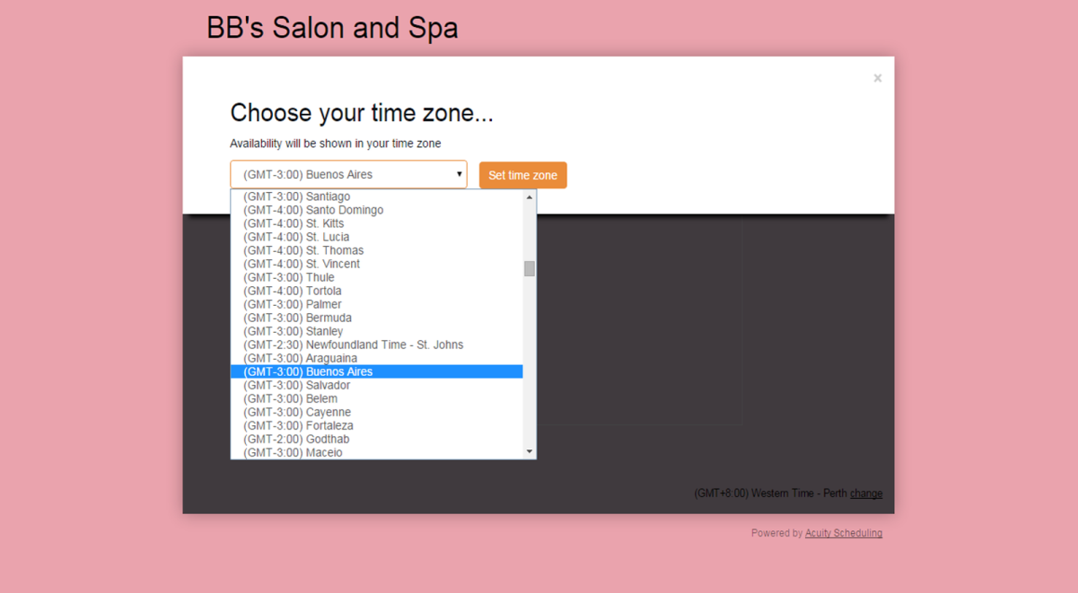
Figure 2.7 Acuity Scheduling supports all time zones worldwide and automatically converts time zones, so you and your clients see all schedules and appointments in your respective local times.

Staff/Location Management
As your business grows and your client base expands, setting up shop in multiple locations may become inevitable. This means more things to keep track of: schedules for several different branches, varying employee hours, and different availability for each appointment type.
Acuity Scheduling enables you to create user accounts for each of your staff so they can view and manage their schedules and be made accountable for any activity logged through their accounts. Unique calendars can be set up for each staff or location, and when booking an appointment, clients have the option to pick a particular staff or location. You may also set up your scheduling system to automatically assign a client to whoever staff is available for his/her chosen appointment period.

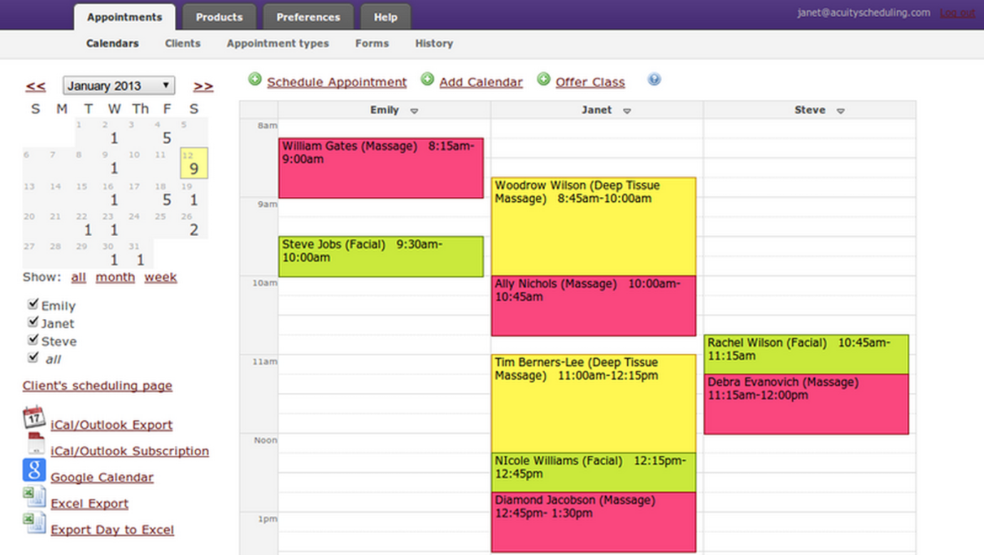

Figure 2.8 Acuity Scheduling keeps track of all confirmed appointments per location and even breaks down revenue by service type through its robust reporting functionality.

Integrations
Besides an API that’s available to use, Acuity Scheduling integrates with apps like WordPress, Joomla, Drupal, Squarespace, Weebly, Groupon, LivingSocial, MailChimp, Infusionsoft, ActiveCampaign, Aweber, Mad Mimi, Google Calendar, iCal, Outlook, PayPal, Authorize.net, Stripe, QuickBooks, FreshBooks, Google Analytics, GoToMeeting, and Zapier.

2.6 Summary
Understanding the problem domain, user demands as well as the ideal platform helps to structure the system. In addition, learning about the benefits and limitations of the existing applications available in market helps to support a better system structure.
The three existing systems mentioned above (Graduate Supervision System, Environmental Management System and Acquity Scheduling System) although cater to different environments, but it incorporates some main functionalities are needed for Plan of Journal Submission (POJS) system. For the purpose of a coarse, subjective summary, some system properties are pointed out as mentioned in the respective parts above and summarized as below.
 | Graduate Supervision System | Environmental Management System | Acquity Scheduling System
Role separation | Yes | Yes | No
Web-based | Yes | No | Yes
Reporting | Yes | Yes | Yes
Automatic notification | Yes | No | Yes
Integration with other systems | Yes | Yes | Yes
Table 2.1 Comparison of existing systems
All in all, this is a good foundation for the development of POJS and is crucial in determining the exact functionalities before we move on to system design and development.

3.0 Methodology

3.1 Software Development Methodology
Software Development Methodology is known as SDM is abbreviation, it is crucial in software development project. It provides guideline and conceptual representation of each phase in software development process from different perspective. These guidelines are to ultimately result in efficient planning, construct structure, and systematically control the flow of software development process.
There are few famous types of process model namely waterfall, spiral, prototyping model, iterative, agile model and incremental development model, which each are suitable to certain development technique developer practicing.
As for Plan of Journal Submission System (POJS), Rapid Application Development (RAD) model will be employed in order to achieve well-managed development process. Details and further justification of using this software development methodology will be explained in the following section.

3.1.1. Rapid Application Development Model

3.1.1.1 Overview
RAD refers to a development life cycle designed to give much faster development and higher quality systems than the traditional life cycle. It is designed to take advantage of powerful development software like CASE tools, prototyping tools and code generators. The key objectives of RAD are: High Speed, High Quality and Low Cost.
RAD is a people-centered and incremental development approach. Active user involvement, as well as collaboration and co-operation between all stakeholders are imperative. Testing is integrated throughout the development life cycle so that the system is tested and reviewed by both developers and users incrementally.
Professor Clifford Kettemborough of Whitehead College, University of Redlands, defines Rapid Application Development as “an approach to building computer systems which combines Computer-Assisted Software Engineering (CASE) tools and techniques, user-driven prototyping, and stringent project delivery time limits into a potent, tested, reliable formula for top-notch quality and productivity. RAD drastically raises the quality of finished systems while reducing the time it takes to build them.” Online Knowledge defines Rapid Application Development as “a methodology that enables organizations to develop strategically important systems faster while reducing development costs and maintaining quality. This is achieved by using a series of proven application development techniques, within a well-defined methodology.” In short, Rapid Application Development is exactly that. It is a process through which the development cycle of an application is expedited. Rapid Application Development thus enables quality products to be developed faster, saving valuable resources.
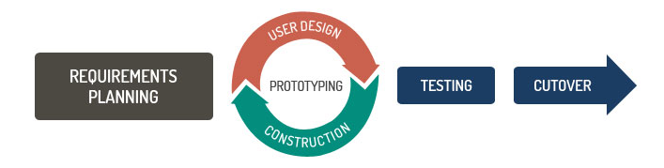
Figure 3.1 Rapid Application Development Model compared to Traditional Development

3.1.1.2 Advantages
Rapid Application Development is an effective methodology to provide much quicker development and higher-quality results than those achieved with the other software development approaches. The main objective of this methodology is to accelerating the entire software development process. This is goal is easily achievable because it allows active user participation in the development process. Few advantages are:
- Reduces the risk and required efforts on the part of the software developer.
- Helps client’s to take quick reviews for the project.
- Encourages customer feedback which always provides improvement scope for any software development project.
- Allows active user participation

3.1.1.3 Applying Rapid Application Development Model

3.1.1.3.1 Requirements Planning
Also known as the Concept Definition Stage, this stage defines the business functions and data subject areas that the system will support and determines the system’s scope.

3.1.1.3.2 User Design
Also known as the Functional Design Stage, this stage uses workshops to model the system’s data and processes and to build a working prototype of critical system components.

3.1.1.3.3 Construction
Also known as the Development Stage, this stage completes the construction of the physical application system, builds the conversion system, and develops user aids and implementation work plans. Various RAD tools are used to develop the prototype which will includes all the elements of any user interface such as screens, forms, reports etc. It is then checked to ensure the functionality developed is what the project sponsor actually wants. If the project sponsor is not satisfied, then changes are made in the model and then the prototype. This modification process goes on until the user is completely satisfied with the product.

3.1.1.3.4 Testing
In this phase, the developer tests the new components and the interfaces that are connected to those components. The overall testing time is reduced in RAD model as the prototypes are independently tested during each successive iteration process. However, the data flow and the interfaces between all the components need to be thoroughly tested with complete test coverage. This is to reduce any risk of major issues.

3.1.1.3.5 Cutover
This final task of the model resembles the final tasks in the SDLC implementation phase, including data conversion, testing, changeover to the new system, and user training. Compared with traditional methods, the entire process is compressed. As a result, the new system is built, delivered, and placed in operation much sooner. Its tasks are data conversion, full-scale testing, system changeover, user training.

3.2 Data Gathering Methodologies
It is essential to choose an appropriate data gathering methodology so as to be aware and understand better about user needs, preferences and demographics. A good data gathering process which results from a good data gathering method contributes to the effectiveness of the research and development of the application.

3.2.1 Literature Review
Literature review is another source of data gathering. This approach collect useful information from existing reliable journals and articles related to Plan of Journal Submission System directly or indirectly. Review of these journals and articles could extract preliminary functional, non-functional requirements, and the flow of processes. With this knowledge, I get an insight of how POJS work and solve users’ problems.

3.2.2 Interview
Interviews are also conducted to obtain detailed information from end users. During an interview session, face-to-face communications enable a clearer understanding among both parties. Immediate feedbacks can be received, and any follow-ups can be done instantaneously. Moreover, direct interactions allow intangible knowledge such as experiences and viewpoints to be shared. It is often hard to extract such information merely by close-ended questions. Open-ended interviews are conducted to retrieve detailed data for this system. Free-flow conversation is preferred and undeniably more efficient in obtaining information or opinions from repair manager and technicians. They are also free to raise issues and questions which they need further clarification. This often reveals some overlooked yet crucial criteria that are needed for the system. First, target interview participants are selected and a plan on how to conduct interview is developed. This is followed by developing an interview outlines based on the information which will be needed to answer the research questions. The content and order of interview are planned as well using the tactics of beginning the interview with factual questions, followed by questions that require judgments or opinions. The facts gathering process is carried out and the data is collected. Lastly, the interview is analyzed and organized in a document.

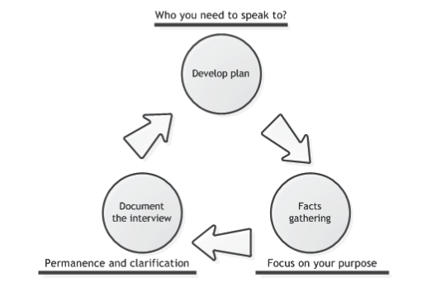
Figure 3.2 Steps involved in an interview session.

3.3 Data Analysis

3.3.1 Literature Review Findings
From the literature review process conducted, Plan of Journal Submission System should help users to submit their plan of supervised students’ journals at any given time for lecturers. Other than that, Plan of Journal Submission System should help users to easily see and view report as well as update the status of submission.
Wi-Fi connection are currently available almost everywhere and gradually decrease in price of data plan enable the growing of web application. It can be access through any smartphone, tablet or personal computer with any web browser. This fact fulfills the availability quality attribute of Plan of Journal Submission System.
Information store in this application is confidential as it safeguards the faculty’s KPI and plan of journal submission along with its status, thus, system should secure strictly by passcode protection to avoid identity theft and any form of privacy exploitation. Nowadays, there are no well -known plan of journal submission system here yet, therefore this web based system supported and used by our faculty here in Faculty of Computer Science and Information Technology in University of Malaya shall and will be developed.

3.3.2 Interview Findings
There are total of 4 interviewees chosen to conduct this interview with. Surveys are not conducted as the exact questions will be asked from each type of user. This includes:
- Dr. Maizatul Akmar Ismail as Senior Lecturer
- Associate Professor Dr. Rosli Salleh as both the management side and also as Deputy Dean of Research
- Dr. Norisma Idris as Head of Department of Artificial Intelligent and Senior Lecturer
- Dr. Mohd Yamani Idna Idris as Head of Department of Computer System & Technology and Senior Lecturer
Interview sessions are carried out with details stated as below:
Date: 14, 16, 21, 31 March 2016
Time: Differs for each interview session
Venue: Repair Center, Hilti (Malaysia) Sdn. Bhd.
Interviewees: Dr. Maizatul Akmar Ismail (Senior Lecturer)
Associate Professor Dr. Rosli Salleh (Deputy Dean of Research)
Dr. Norisma Idris (Head of Department of Artificial Intelligent)
Dr. Mohd Yamani Idna Idris (Head of Department of Computer System & Technology)
Interviewers: Soh Jue Wern
According to Dr. Maizatul, who first proposed to implement this system, the monthly work of having to update the same excel file is tedious and horrendous. Sometimes, she stops keeping in track and therefore will affect the following months ahead and subsequently the fiscal year. She proceeds to discuss further on the manual work and then mentioned the roles of Deputy Dean of Research and also the Head of Departments in terms of managing this plan of journal submission. She also provided me the excel template for me to get a clearer picture of the process.
Then I went to interview Associate Professor Dr. Rosli as he is the respected Deputy Dean and also managed the overall Key Performance Index (KPI) of this plan journal submissions handed over by lecturers and supervisors of postgraduate students. In the interview, he basically wants to automate as many processes as possible, if possible all. He also mentioned that this plan journal submission will only cover Institute of Science Index (ISI) Journals and not others such as SCOPUS or other indexing. He mentioned that he wants to view reports with a click of a button monthly by departments.
With both the Head of Departments on the other hand, they mentioned the same functionalities with additional features. Dr Yamani gave me useful information such as the current status of papers submitted are separated into 4 which are accepted, minor revision, major revision and rejected. Dr. Norisma on the other hand, she wanted to have a reminder scheduling functionality to update their plan of submissions evidently. She also mentioned that no proper proofs/evidence to support the claims given by staffs. In the reporting area, she would like to see it based on the 4 above mentioned statuses.
In general, all of the lecturers want the same basic functionalities with easy usability and simple yet efficient.
The outline of the interview questions can be referred to the Appendix A.

4.0 System Design

4.1 Functional Decomposition Diagram (FDD)
The purpose of the functional decomposition diagram is to show on a single page the capabilities of an organization that are relevant to the consideration of an architecture. By examining the capabilities of an organization from a functional perspective, it is possible to quickly develop models of what the organization does without being dragged into an extended debate on how the organization does it. Once a basic functional decomposition diagram has been developed, it becomes possible to layer heat-maps on top of this diagram to show scope and decisions. For example, the capabilities to be implemented during the different phases of a change program in a system.
This diagram can be enriched using links to other parts of the model, to indicate, for example, which application supports which function, which role uses which function, and so on.
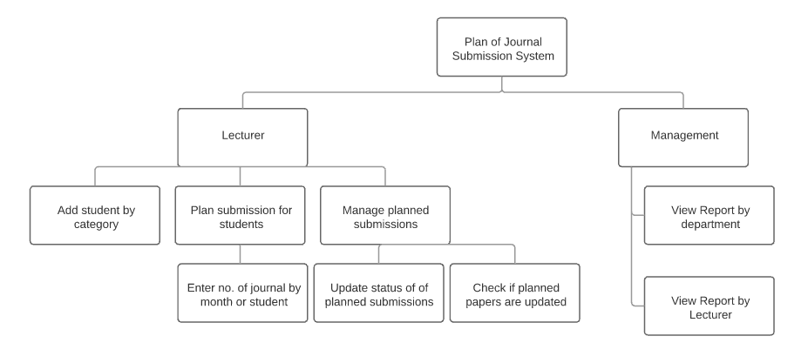
Figure 4.1 Functional Decomposition Diagram for POJS
The roles are clearly defined for two parts, the academicians who will be planning the journals and also the management who will be viewing the report by department as well as by lecturer to see who managed to hit the KPI as mentioned.

4.2 Use Case Diagram

4.2.1 User
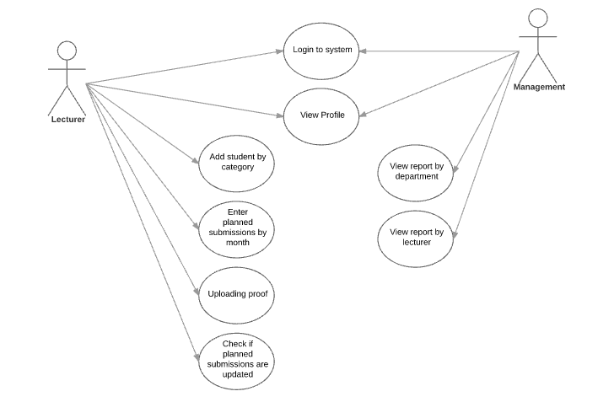

Figure 4.2 Use Case Diagram for User

The figure above shows the use case diagram for user of the Plan of Journal Submission System. Initially, user will be logged in using their UMMail account depending on their position in the faculty. Once in it whether as academician or management, they will be guided to their profile page. Academicians then can proceed to add or delete student from their monitoring list. After that they can go to monthly page and plan for their students journal submission. They can also update the plan by uploading details of it along with the proof of acceptance or rejection to show the progress.
Basically this is a good requirements analysis conceptual diagram. This diagram describes the system’s actions from the point of view of the user when the log in to POJS. This continues to tell a story by a sequence of events involving and also the interactions of them with the system.

4.3 Data Flow Diagram (DFD)
Data flow diagrams became popular in the 1970s in software development. They were first described in a classic text about Structured Design written by Larry Constantine and Ed Yourdon. Yourdon & Coad's Object Oriented Analysis and Design (OOA/OOD) was a way of visualizing software systems before UML diagrams.

4.3.1 Context Diagram DFD
A context diagram is a data flow diagram, with only one massive central process that subsumes everything inside the scope of the system. It shows how the system will receive and send data flows to the external entities involved.
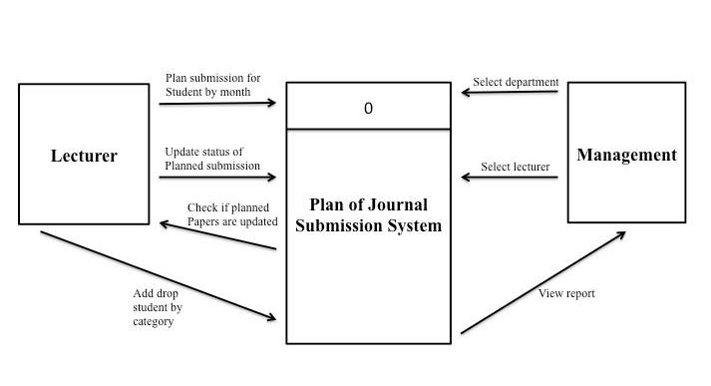
Figure 4.3 Context Diagram DFD for Plan of Journal Submission System

The main two entities are lecturer (academicians) and management and this diagram shows the process that depicts the relationships clearly in the high-level context. Based on the Figure 4.3, the user groups for the proposed system are the lecturers and management. Each user groups have their own specific functions in the system. For both lecturers and management, they have similar function, which is viewing their own profile at the home page. The difference is that lecturers can add or delete students and plan their journal monthly also updating the planned journals. For management on the other hand, it is mainly to view reports in the form of graphs based on the criteria mentioned.

4.3.2 Diagram 0 DFD
When it comes to conveying how information data flows through systems (and how that data is transformed in the process), data flow diagrams (DFDs) are the method of choice over technical descriptions for three principal reasons.
- DFDs are easier to understand by technical and nontechnical audiences
- DFDs can provide a high level system overview, complete with boundaries and connections to other systems
- DFDs can provide a detailed representation of system components1 DFDs help system designers and others during initial analysis stages visualize a current system or one that may be necessary to meet new requirements.
Systems analysts prefer working with DFDs, particularly when they require a clear understanding of the boundary between existing systems and postulated systems. DFDs represent the following:
- External devices sending and receiving data
- Processes that change that data
- Data flows themselves
- Data storage locations
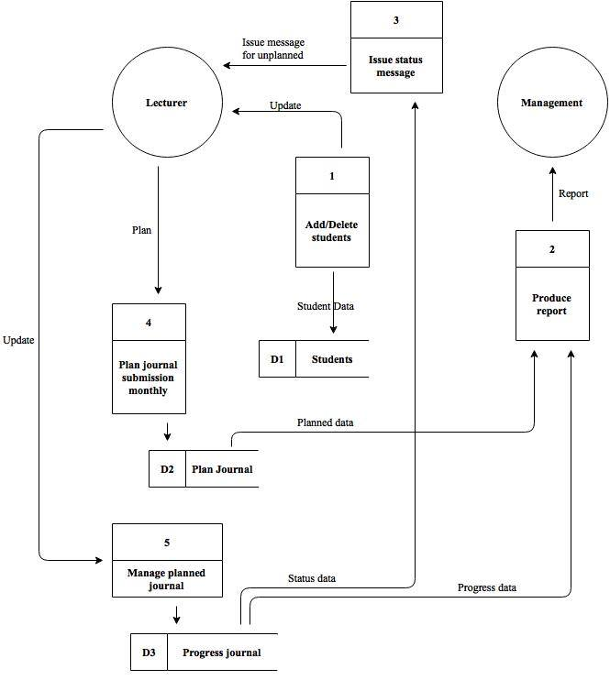
Figure 4.4 Diagram 0 DFD for Plan of Journal Submission System

The above Figure 4.4 shows the more specific data flow processes for each entity showing how data flows in a system by illustrating how four basic components relate to each other. The four basic components are entity, process, data store and also data flow. It also shows how data are retrieved for different scope in the system for example reporting for the management to see after academicians have planned their journal or updated the planned journals.

4.4 Entity Relationship Diagram (ERD)
Entity-Relationship Diagrams (ERDs) are another way of showing information flow for a process. An ERD shows what data is being used in the process or program, and how the files are related. The E-R (entity-relationship) data model views the real world as a set of basic objects (entities) and relationships among these objects. It is intended primarily for the database design process by allowing for the specification of an enterprise scheme. This enterprise scheme represents the overall logical structure of the database. ERDs do not show any program functions, nor data flow.
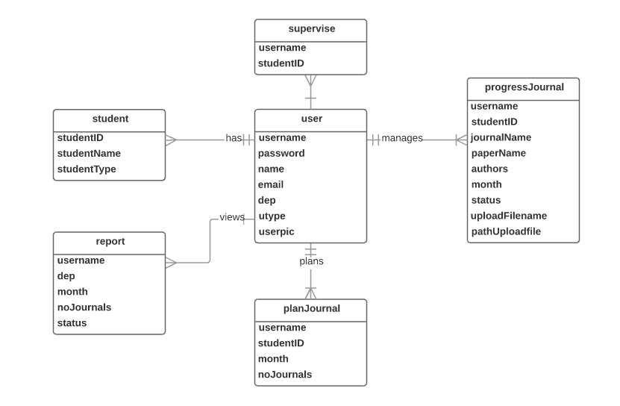
Figure 4.5 ERD for Plan of Journal Submission System
On how the data in POJS stored, it is depicted generally in Figure 4.5 above. The users regardless of academicians or have their table that stores their general information such as position and etc. Academicians can add their own student in a one-to-one relationship that the lecturer supervises. Also, in the student table, there will be the post-graduate type as there are many categories such as different types of Masters and PhD. The lecturer will plan the journal submission and the info is stored in planJournal table where as the progress or updates will be stored in progressJournal. The report will be stored in a different table whereby it will then retrieve the information needed by management to view.

4.5 Flow Chart
A flowchart is a picture of the separate steps of a process in sequential order. Elements that may be included are: sequence of actions, materials or services entering or leaving the process (inputs and outputs), decisions that must be made, people who become involved, time involved at each step and/or process measurements.

4.5.1 Lecturer Adding Students

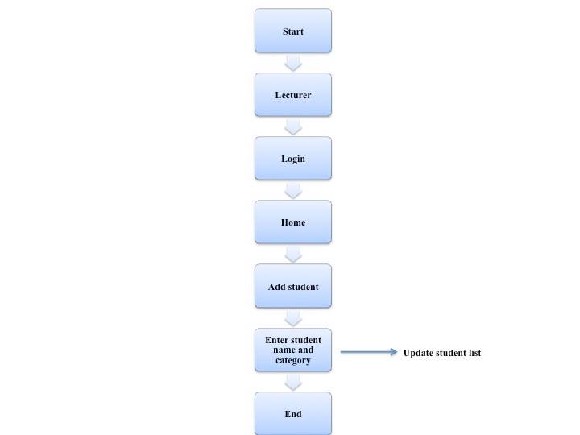
Figure 4.6 Flow Chart for lecturers updating student list
This function in Figure 4.6 is available only for lecturers for them to add or delete students that they are supervising as they themselves know the best which student is active and what to be planned for them.

4.5.2 Lecturers Planning and Updating Planned Journal
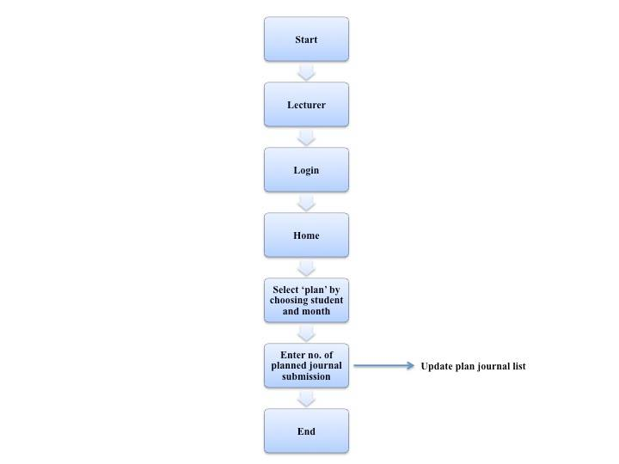
Figure 4.7 Flow Chart for lecturers planning and updating their planned journals

In the figure above, lecturers will then select the students added previously depending on which month and will input how many planned number of journals for that particular month. Once they planned it, they can proceed to update the journal such as name of journal, paper, status (by uploading proof) and etc.

4.5.3 Management Viewing Report
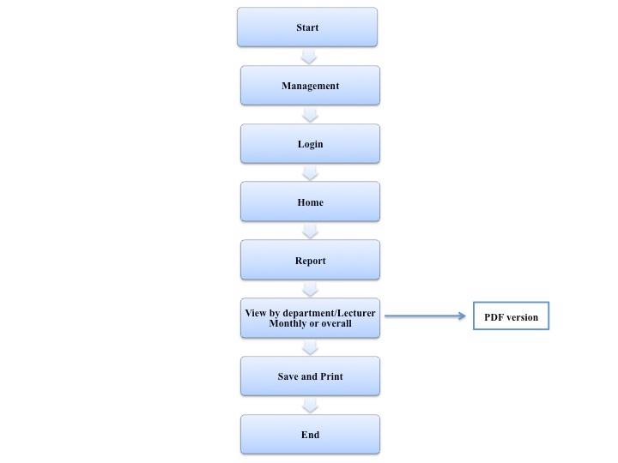
Figure 4.8 Flow chart for Management to View Report
This figure will show how the management users have this function to view report based on department or lecturer. This can be viewed monthly or overall. Basically, to give a gist on how the management will have a final view of the report of every academicians update on their planned journals for their supervised students.
Appendix A: Interview Questions for Plan of Journal Submission System
PLAN OF JOURNAL SUBMISSION MANAGEMENT SYSTEM
Requirement Elicitation Interview with Stakeholder
This project aims to provide automatic monitoring of plan of journal articles submissions. The objectives are:
1. To identify specific criteria/information for the planning of journal submission
2. To develop a prototype of Plan of Journal Submission Management System

- Stakeholder details:
Name: _______________________________________
Department: __________________________________
Role in the Plan of Journal Submission Community: ____________________
Primary responsibility in the Plan of Journal Submission Community: __________________________________________________________________________________
__________________________________________________________________________________
- Interview Questions:
- Current process
- What is the current process for the plan of journal submission in faculty?
- What are the problems with the current process?
- What do you have to do manually that you would like to automate?
- How do you keep track of the journal submission plan other than input from academicians?
- What is the minimum number of journals expected to be submitted by academicians yearly according to position?
- What aspects of the current process do you want to retain? To replace?

- New system
- What goals might you have in mind that this product could help you accomplish?
- What the most important aspect that you want to see in the new system?
- What are your expectations from the new system usability?
- Are there any constraints or rules to which the system must conform? – eg: KPI according to Post Graduate students
- What other IT systems does the faculty use today that the new system will need to link to?
- The new systems will generate reports at the end of the year based on input from lecturers. What kind of documentation do you expect?

- Identify users
- Who will be using the system?
- What are the roles of the people who will use the system?
- The new systems will generate reports at the end of the year based on input from lecturers. What kind of documentation do you expect?

Appendix B: Interview Answers for Plan of Journal Submission System
- Stakeholder details:
Name: Associate Professor Dr. Rosli Salleh
Department: Deputy Dean of Research
Role in the Plan of Journal Submission Community: Management of KPI
Primary responsibility in the Plan of Journal Submission Community: To check for KPI and see whether academicians reach the mentioned plan journal submissions monthly

- Interview Questions:
- Current process
- What is the current process for the plan of journal submission in faculty?
At the end of the year, lecturers will submit the excel file manually.
- What are the problems with the current process?
Manual, Head of Department will have to compile everything. Some academicians do not even submit.
- What do you have to do manually that you would like to automate?
If possible, every process that is included. The goal is to make it easier for Head of Department and to have a more optimum plan.
- How do you keep track of the journal submission plan other than input from academicians?
There are no other ways to keep track. Solely based on trust.
- What is the minimum number of journals expected to be submitted by academicians yearly according to position?
It depends on the type of post graduate. It is written in the excel file. However, it is only for ISI Scopus Journal to monitor for now.
- What aspects of the current process do you want to retain? To replace?
Process is to be retained. Just want to automate it from manual.

- New system
- What goals might you have in mind that this product could help you accomplish?
Generate report by department and lecturer and can be monitored monthly or overall.
- What the most important aspect that you want to see in the new system?
Mentioned as above questions. To ensure manual work is not being done and can be keep track of.
- What are your expectations from the new system usability?
To not have manual work. And can remind academicians to constantly update on the status.
- Are there any constraints or rules to which the system must conform? – eg: KPI according to Post Graduate students
It is stated in the excel file.
- What other IT systems does the faculty use today that the new system will need to link to?
No other. Just database of staffs from UMIS or HR department.
- The new systems will generate reports at the end of the year based on input from lecturers. What kind of documentation do you expect?
Graph or table, looks presentable and can be generated every month or end of year.

- Identify users
- Who will be using the system?
Academicians, Dean of FSKTM, Deputy Dean of Research, Head of Departments, Management
- What are the roles of the people who will use the system?
To plan and update progress for academicians. To monitor progress for management.
- The new systems will generate reports at the end of the year based on input from lecturers. What kind of documentation do you expect?
As mentioned, graphs or tables.

- Stakeholder details:
Name: Dr. Mohd Yamani Idna Idris
Department: Computer System and Technology
Role in the Plan of Journal Submission Community: Head of Department
Primary responsibility in the Plan of Journal Submission Community: To consolidate the plans from department and also to show it to the deputy dean

- Interview Questions:
- Current process
- What is the current process for the plan of journal submission in faculty?
Academicians will send it to HOD at the end of the year with their plan, or monthly with changes.
- What are the problems with the current process?
Manual, Head of Department will have to compile everything. Some academicians do not even submit.
- What do you have to do manually that you would like to automate?
If possible, every process that is included. The goal is to make it easier for Head of Department and to have a more optimum plan.
- How do you keep track of the journal submission plan other than input from academicians?
There are no other ways to keep track. Solely based on trust.
- What is the minimum number of journals expected to be submitted by academicians yearly according to position?
It depends on the type of post graduate. It is written in the excel file. However, it is only for ISI Scopus Journal to monitor for now.
- What aspects of the current process do you want to retain? To replace?
Process is to be retained. Just want to automate it from manual. Status of paper is divided into 4, accepted, major or minor revision and rejected. This can be included as the progress along with uploading proof such as email screenshots or pdf file.

- New system
- What goals might you have in mind that this product could help you accomplish?
Generate report by department and lecturer and can be monitored monthly or overall and automate planning so that can keep track.
- What the most important aspect that you want to see in the new system?
Mentioned as above questions. To ensure manual work is not being done and can be keep track of.
- What are your expectations from the new system usability?
To not have manual work. And can remind academicians to constantly update on the status.
- Are there any constraints or rules to which the system must conform? – eg: KPI according to Post Graduate students
It is stated in the excel file depending on the positions.
- What other IT systems does the faculty use today that the new system will need to link to?
None that I know of.
- The new systems will generate reports at the end of the year based on input from lecturers. What kind of documentation do you expect?
Graph or table, looks presentable and can be generated every month or end of year. Maybe can be printed or saved as pdf file for convenience.

- Identify users
- Who will be using the system?
Academicians, Dean of FSKTM, Deputy Dean of Research, Head of Departments, Management
- What are the roles of the people who will use the system?
To plan and update progress for academicians. To monitor progress for management.
- The new systems will generate reports at the end of the year based on input from lecturers. What kind of documentation do you expect?
As mentioned, graphs or tables.
- Stakeholder details:
Name: Dr. Norisma Idris
Department: Artificial Intelligence
Role in the Plan of Journal Submission Community: Head of Department
Primary responsibility in the Plan of Journal Submission Community: To consolidate the plans from department and also to show it to the deputy dean as well as plan and update progress of journal submission as a lecturer

- Interview Questions:
- Current process
- What is the current process for the plan of journal submission in faculty?
The academic staff have to fill up the template of plan of submission (POS) prepared by the deputy dean’s office at the beginning of the year. Then, the deputy dean and also the head of department (HoD) need to monitor the academic staff plan of submission every month whether they have followed their plan accordingly.
- What are the problems with the current process?
• It is difficult for the HoD to monitor the achievement of the academic staff every month.
• There is no evidence to support the claims given by the staff.
- What do you have to do manually that you would like to automate?
• Monitoring process
• Reminder to all staff to updates their POS
- How do you keep track of the journal submission plan other than input from academicians?
Via email
- What is the minimum number of journals expected to be submitted by academicians yearly according to position?
So far, no requirement for submissions.
- What aspects of the current process do you want to retain? To replace?
None.

- New system
- What goals might you have in mind that this product could help you accomplish?
POS monitoring system
- What the most important aspect that you want to see in the new system?
Automated monitoring
- What are your expectations from the new system usability?
Easy to be use
- The new systems will generate reports at the end of the year based on input from lecturers. What kind of documentation do you expect?
• The statistics of those who have accomplished their plan of submission
• The statistics of the papers submitted are being accepted, published or even rejected

- Stakeholder details:
Name: Dr. Maizatul Akmar Ismail
Department: Management of Information System
Role in the Plan of Journal Submission Community: Senior Lecturer
Primary responsibility in the Plan of Journal Submission Community: To plan and update progress based on the students supervised monthly

- Interview Questions:
- Current process
- What is the current process for the plan of journal submission in faculty?
The academic staff have to fill up the template of plan of submission (POS) prepared by the deputy dean’s office at the beginning of the year. Then, the deputy dean and also the head of department (HoD) need to monitor the academic staff plan of submission every month whether they have followed their plan accordingly.
- What are the problems with the current process?
It is tedious and not conform to normal standards. Values are overwritten and cannot be keep track of. Also, there are no proper proofs about the plan of journal submission.
- What do you have to do manually that you would like to automate?
Monitoring process and reminder to all staff to updates their POS about not being updated after being planned.
- How do you keep track of the journal submission plan other than input from academicians?
No other proper inputs from different source. Via email and excel file only.
- What is the minimum number of journals expected to be submitted by academicians yearly according to position?
In excel file.
- What aspects of the current process do you want to retain? To replace?
Current process is to be retained. Just add reminder to plan and update progress.

- New system
- What goals might you have in mind that this product could help you accomplish?
Ease planning and progress update for all academicians and management.
- What the most important aspect that you want to see in the new system?
Automated monitoring
- What are your expectations from the new system usability?
Usability should be considerably highly of. Easy to be use and can monitor easily monthly.
- The new systems will generate reports at the end of the year based on input from lecturers. What kind of documentation do you expect?
Graph or pie chart. To divide them according to criteria such as department, lecturer and even status of journal submission to see the progress overall more efficiently

References
Azlan Mohd Zain. (2016). Tips to publish article in journal: An experience. Faculty of Computer Science and Information Systems, UTM, Skudai, Johor.
Beatty, R. C., Shim, J. P., & Jones, M. C. (2001). Factors influencing corporate website adoption: A time-based assessment. Information and Management, 38(6), 337-354.
Blake, G., & Bly, R. W. (1993). The Elements of Technical Writing. London, UK: Macmillan Publishers.
CASEMaker INC. (2000). What is Rapid Action Development(RAD)? Retrieved from http://www.eng.auburn.edu/~sealscd/COMP6620/project/SoftwareDevelopmentProcess/rad_wp.pdf
FTMS Global College. (2014). Introduction to Rapid Action Development(RAD). Retrieved from http://www.ftms.edu.my/images/Document/IMM006%20-%20RAPID%20APPLICATION%20DEVELOPMENT/IMM006%20RAPID%20APPLICATION%20DEVELOPMENT%20-%20note%20chapter%201.pdf
GetApp. (2016). Acuity Scheduling Pricing, Features, Reviews & Comparison of Alternatives. Retrieved from GetApp: https://www.getapp.com/hr-employee-management-software/a/acuity-scheduling/#top
Government, A. (2004). Environmental Management System Tool. Department of the Environment, Water, Heritage and the Arts.
Gregory, G. M. (2005). The successful academic librarian: Winning strategies from library leaders. Medford, New Jersey: Information Today.
Lamont, M. (2009). How professors think: Inside the curious world of academic judgment. Cambridge, MA: Harvard University Press.
Lenz, V. (1999). The Saturn Difference: Creating Customer Loyalty in Your Company. New Jersey, USA: John Wiley and Sons.
Le Vie, D. S. (2005). Understanding data flow diagrams. Retrieved from http://ratandon.mysite.syr.edu/cis453/notes/DFD_over_Flowcharts.pdf
Liu, C., Arnett K. P., Capella L. P., & Beatty R. C. (1997). Web sites of the Fortune 500: facing customers through home pages. Information and Management, 31(6), 335-345.
Montana, P. J., & Charnov, B. H. (2008). Management (4th ed.). Hauppauge, New York: Barron’s Educational Series.
Negash, S., Ryan, T., & Igbaria, M. (2003). Quality and effectiveness in Web-based customer support systems. Information & Management, 40(8), 757-768.
Shapiro, D. L. (2005). Action plan, resourcing, and cost. Establishing and Publishing an Online Peer-Reviewed Journal.
The Royal Society. (2011). Royal Society journal archive made permanently free to access. Retrieved from https://royalsociety.org/news/2011/Royal-Society-journal-archive-made-permanently-free-to-access/
Tu, Y. H. (2014). Exploring the relationship between website interactivity and user experience. Paper presented at the Innovation, Communication and Engineering - Proceedings of the 2nd International Conference on Innovation, Communication and Engineering, ICICE 2013, Taiwan.
Verma, E. P. (2015). SDLC RAD Model design phase, application, advantages, disadvantages, pros and cons. Retrieved from http://er.yuvayana.org/sdlc-rad-model-design-phase-application-advantages-disadvantages-pros-and-cons/
Wildavsky, A. (1973). If Planning is Everything, Maybe it's Nothing. Policy Sciences, 4, 127-153.

