
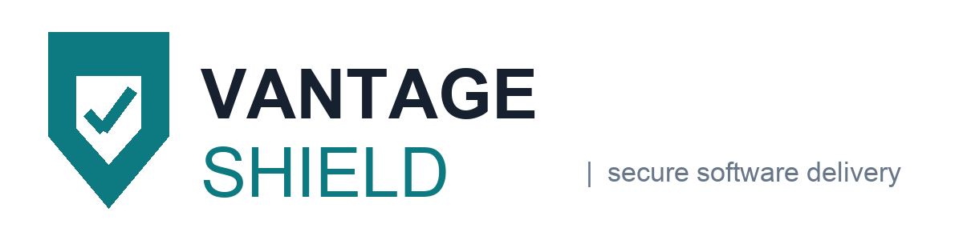
MASTER SUBSCRIPTION AGREEMENT
Application security platform, professional services and agentic penetration testing
Agreement reference | VS-MSA-2026-0417
Effective Date | 1 October 2026
Template revision | v4.2 (2026 rework), supersedes v3.6
Status | Issued for counterparty review, not for signature

This Master Subscription Agreement (the "Agreement") is entered into as of the Effective Date stated above by and between:
 | Vantage Shield BV, a company incorporated under the laws of Belgium, with registered office at Nieuwewandeling 62, 9000 Ghent, Belgium, registered with the Crossroads Bank for Enterprises under number 0784.512.339 ("Provider" or "Vantage Shield"); and
 | Brightline Logistics Group N.V., a company incorporated under the laws of Belgium, with registered office at Havenlaan 118, 2030 Antwerp, Belgium, registered under number 0642.887.104, acting for itself and for its Affiliates listed in the Order Form ("Customer").
Provider and Customer are referred to individually as a "Party" and together as the "Parties".
Background. Provider operates a cloud-hosted application security platform that continuously scans source code, dependencies, cloud configuration and running workloads, and offers related professional services and agentic penetration testing. Customer wishes to subscribe to those Products and Services for its internal business purposes, on the terms below and in one or more Order Forms that reference this Agreement.

Contents

1. Structure of the Agreement and order of precedence 3
2. Products and Services 3
Order Form summary 4
3. Licence grant and restrictions 4
4. Users, devices and Subscription Allocation 5
5. Customer Content, privacy and security 6
6. Agentic penetration testing 7
7. Fees, payment and taxes 8
8. Intellectual property indemnification 8
9. Limitation of liability 9
10. Term and termination 10
11. Warranties, remedies and disclaimer 10
12. Confidentiality 11
13. General provisions 11
14. Definitions 12
Signatures 14
Annex 1: Support commitments and service levels 15
Annex 2: Processing locations and sub-processors 17
Annex 3: Acceptable use and platform security standards 18

Structure of the Agreement and order of precedence
  - This Agreement applies to, and is incorporated by reference into, each Order Form, statement of work or other ordering document that references it. A single Agreement may govern multiple Order Forms and multiple Freemium subscriptions between the Parties, including between their respective Affiliates. "Agreement" means this document alone for non-paying use, and this document together with the applicable Order Form for paying use, in each case including all exhibits, addenda and amendments properly attached or incorporated by reference.
  - In the event of a conflict, the documents forming the Agreement prevail in the following order:
      - the Vantage Shield Pentesting Addendum, for the agentic penetration testing services only;
      - the applicable Order Form, for the commercial terms it states;
      - this Master Subscription Agreement, including its Annexes; and
      - the Documentation and any policy referenced in this Agreement.
  - Entire agreement. This Agreement contains the entire understanding of the Parties with respect to its subject matter and supersedes all prior agreements, understandings, proposals, discussions, negotiations, representations and warranties, whether written or oral, relating to that subject matter, including any statements made during demonstrations, security questionnaires or responses to requests for proposal.
  - Each Party represents that the individual accepting this Agreement has authority to bind that Party, and that where acceptance occurs by clicking "I accept" or by first use of the Products and Services, that acceptance binds the entity on whose behalf the individual acts. Provider's system logs are admissible evidence of the fact and time of acceptance.

Products and Services
  - Continuous delivery. Provider operates on a continuous-delivery model and improves the Products and Services on an ongoing basis. Customer's procurement decision is not contingent on the delivery of any future functionality, on any public or private roadmap statement, or on any comment made by Provider personnel about features under development.
  - Professional Services. Professional Services are scoped in the applicable Order Form or statement of work. All deliverables prepared in the course of the Professional Services, including any Provider methodology, tooling, templates and know-how embodied in them, are works made for hire for Customer and, to the extent any such deliverable does not qualify as a work made for hire, Provider hereby irrevocably assigns to Customer all right, title and interest in and to that deliverable worldwide.
  - Professional Services are performed remotely by default. Where Customer requests on-site attendance and Provider approves it in advance in writing, travel and accommodation expenses are invoiced at cost against receipts.
  - Support. Standard technical support is included in the subscription Fees. Online resources, including the Documentation and the knowledge base, are available to all Users. Live support is available to the designated technical contacts named in the Order Form, within the hours and target response times set out in Annex 1.
  - Beta features. Features identified as beta, preview or pre-release are provided "as is", without warranty of any kind, and Provider has no obligation to continue, complete or generally release them. Provider has no liability arising out of Customer's use of a beta feature.
  - Where the Order Form states Evaluation Services, the evaluation period is thirty (30) calendar days from provisioning and either Party may terminate the evaluation on seven (7) days' written notice. Evaluation Services are for internal testing and assessment only and may not be used in production, for any commercial purpose or in any operational workflow.

Order Form summary
The table below reproduces the commercial terms of Order Form OF-2026-0417-01 for convenience only. The executed Order Form prevails over this summary.
Subscription Term | 36 months from the Effective Date
Products | Code Security, Cloud Posture, Agentic Pentest (Addendum applies)
Subscription Allocation | 450 Code Committing Developers; 12 cloud accounts; 4 pentest engagements per year
Annual Fees | EUR 318,000 excluding VAT, invoiced annually in advance
Payment terms | Net 30 days from invoice date, bank transfer only
Billing contact | ap-invoices@brightline-logistics.example
Data region | eu-west-1 (Ghent, Belgium)
Order Form reference | OF-2026-0417-01, signed 24 September 2026

Licence grant and restrictions
  - Grant. Subject to this Agreement and to payment of the Fees, Provider grants Customer a non-exclusive, non-transferable, non-sublicensable right, during the Subscription Term, to access and use the Products and Services through its Users, for Customer's own direct beneficial business purposes and within the Subscription Allocation.
  - Customer shall not, and shall not permit any User or third party to:
- use the Products and Services other than in accordance with applicable law and the Documentation;
- use the Products and Services in a way that creates a security risk to, or degrades the availability or integrity of, the platform or any other customer's environment;
- reverse engineer, decompile, disassemble or otherwise attempt to derive the source code of the platform;
- resell, sublicense, rent, lease, distribute or otherwise make the Products and Services available to any third party;
- use the Products and Services to provide business process outsourcing or managed services to third parties;
- access or use the Products and Services to build, train or improve a competing product or for any competitive purpose; or
- remove, obscure or alter any proprietary notice.
  - Benchmarking. Customer may conduct benchmarking, competitive analysis and performance comparisons of the Products and Services, and may publish or otherwise disclose the results, without Provider's prior written consent.
  - A breach of the restrictions in this clause 3 is deemed a material breach of the Agreement.
  - Suspension. Provider may suspend or restrict access, in whole or in part, where use threatens the security, integrity or availability of the platform, where required by law, or where Customer has not paid a properly issued invoice within the period stated in clause 7. Provider will restore access promptly once the cause is resolved.
  - Third-Party Products are not part of the Products and Services. They are used at Customer's sole risk, are not warranted or supported by Provider, and are governed by the terms between Customer and the relevant third party. Where a Third-Party Product processes Personal Data for Customer, that third party acts as Customer's own processor and not as a sub-processor of Provider.

Users, devices and Subscription Allocation
  - Access is limited to Users. A User account is personal and may be reassigned to a replacement individual when the original User no longer requires access, but may never be shared, and may not be issued to an employee or contractor of a direct competitor of Provider.
  - Each User may register a maximum of five (5) unique devices in any rolling thirty (30) day period  . Registration of a sixth device in that period requires Provider's written approval, which will not be unreasonably withheld for a documented device replacement.
  - Customer is responsible for its Users' compliance with this Agreement, will report any violation to Provider without undue delay, will disable the account of any User in violation, and will ensure that no User submits false or misleading account information.
  - Subscription Allocation. Neither the number of Code Committing Developers nor overall use may exceed the Subscription Allocation stated in the Order Form. Where use exceeds the Subscription Allocation, Provider will notify Customer and invoice the excess at the list rate then in force, pro-rated to the end of the current Subscription Term. The entitlements attached to each product line are set out below.
Subscription Allocation and entitlements as at the Effective Date
Product line | Metric | Allocated | Included | Overage | Notes and evidence
Code Security | Code Committing Developers | 450 |  | EUR 62 / dev / month |  Evidence pack refreshed annually
Code Security | Private repositories scanned | Unlimited |  | Not applicable | Reported in the monthly usage statement
Cloud Posture | Connected cloud accounts | 12 |  | EUR 180 / account / month | 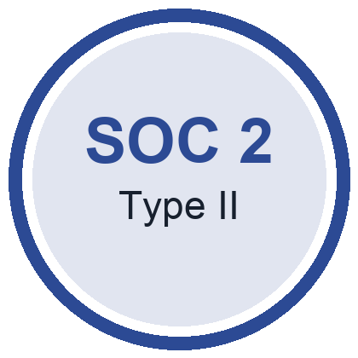 Evidence pack refreshed annually
Cloud Posture | Continuous drift detection | Included |  | Not applicable | Reported in the monthly usage statement
Agentic Pentest | Engagements per contract year | 4 |  | EUR 14,500 / engagement |  Evidence pack refreshed annually
Agentic Pentest | Out-of-scope target testing | Not permitted |  | Not applicable | Reported in the monthly usage statement
Table 1. Subscription Allocation by product line. Merged cells group each product line across two metrics.

  - "Customer" includes any Affiliate that Customer controls, that controls Customer, or that is under common control with Customer, where control means the direct or indirect ownership of more than fifty per cent (50%) of the voting interests. An Affiliate may place an Order Form under this Agreement, in which case that Affiliate is jointly and severally liable with Customer for the obligations arising under that Order Form.

Customer Content, privacy and security
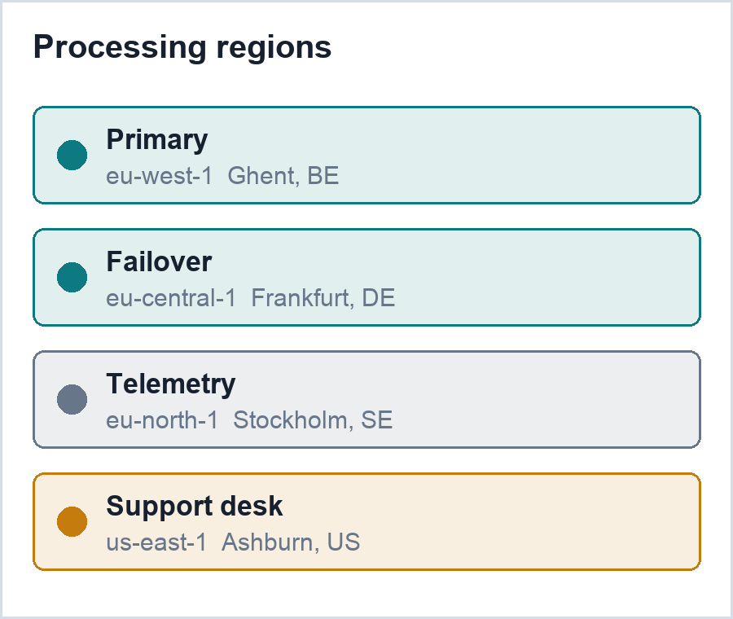
  - Ownership. Customer Content remains the property of Customer. Provider processes Customer Content only to provide, secure, support and improve the Products and Services for Customer, to comply with law, and to establish or enforce its rights under this Agreement. Provider acquires no licence to Customer Content beyond what those purposes require.
  - Security programme. Provider maintains administrative, technical and physical safeguards appropriate to the nature of the Customer Content it processes, designed to protect its confidentiality, integrity, availability and resilience. Those safeguards are described in the Provider Security Overview and are independently assessed each year. The processing locations for the Subscription are listed in Annex 2 and are summarised opposite.
  - Provider complies with the privacy laws applicable to it in its role as processor. The Provider Privacy Policy published on its website, as amended from time to time, governs Provider's processing of Personal Data under this Agreement.
  - Remediation costs. Where Personal Data in Customer Content is disclosed to an unauthorised person as a direct result of Provider's failure to maintain the safeguards described in clause 5.2, Provider will pay the following remediation costs, reasonably incurred and evidenced: (i) notification of affected data subjects and supervisory authorities; (ii) credit monitoring for twelve (12) months where the disclosed data makes identity theft a realistic risk; and (iii) forensic investigation of the incident.
  - Provider owes no remediation costs to the extent that the disclosure results from the negligence or wilful act of Customer, its Users or its own contractors, from Customer's configuration choices, or from a Third-Party Product.
  - Customer controls the installation, configuration and day-to-day use of the Products and Services, including which repositories, cloud accounts and endpoints are connected, which findings are suppressed and which automated actions are enabled. Provider is not liable for Customer Content or for the consequences of Customer's configuration choices.
  - Customer warrants that Customer Content is lawfully collected, is free of third-party rights that would prevent Provider from processing it as contemplated here, and contains no Sensitive Personal Information. Customer will remove any Customer Content that breaches this warranty promptly on becoming aware of it.
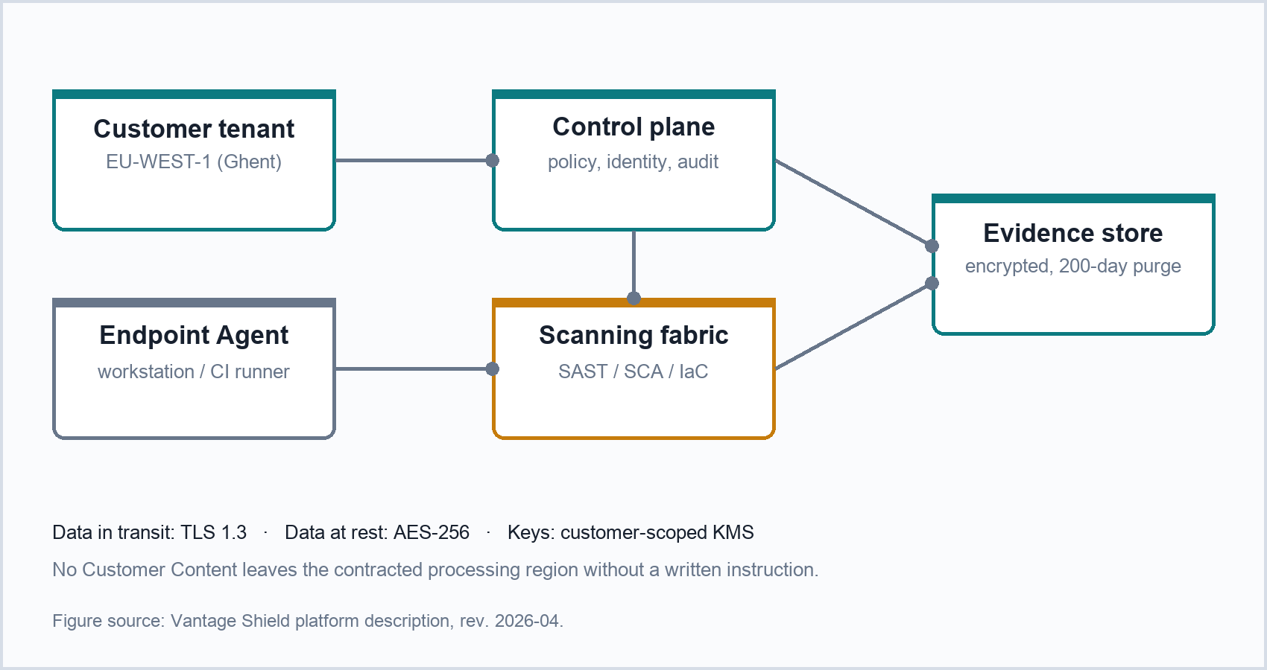
Figure 1. Platform data flows for the contracted Subscription. The figure is descriptive only and does not vary the Parties' obligations under clause 5.

Agentic penetration testing
  - Where Customer procures agentic penetration testing, being AI-driven agents that autonomously identify, validate and report exploitable vulnerabilities across Customer's applications and infrastructure, the Vantage Shield Pentesting Addendum applies to those services and prevails over this Agreement to the extent of any conflict.
  - Customer is solely responsible for identifying and verifying the domains, applications, accounts and network ranges that it authorises for testing (the "Authorised Scope"), and for holding the rights necessary to authorise that testing. Customer will not include in the Authorised Scope any asset operated by a third party without that third party's written authorisation.
  - Sandbox warranty. Provider warrants that the autonomous testing agents will remain within their sandbox at all times, will not access, alter, disable or otherwise affect any system outside the Authorised Scope, and will not cause any degradation of Customer's production environment. Provider will indemnify Customer in full, without limitation of liability, against any loss arising from a breach of this warranty.
  - Test findings are Confidential Information of Customer. Provider will retain the raw evidence for the period stated in the Pentesting Addendum and will purge it on request.

Fees, payment and taxes
  - Customer pays the Fees stated in the Order Form, in the currency stated there, in accordance with the payment terms stated there. Fees are non-cancellable and, except as expressly stated in clause 10, non-refundable.
  - Invoices are delivered electronically only, to the billing contact and billing address that Customer provides and keeps current. Customer is responsible for maintaining accurate billing details, and a failure of Customer's own accounts-payable routing does not extend a due date.
  - Customer identifies the invoice or invoices to which each payment relates, or emails that allocation to billing@vantageshield.example by the payment date. Cheques are not an accepted payment method, and a payment tendered by cheque is not treated as received until settled through an accepted method.
  - If an invoice is not paid when due, Provider will send a written reminder. If payment is still outstanding fifteen (15) calendar days after that reminder, Provider may suspend or restrict access under clause 3.6 until payment is received in full.
  - Customer must raise any billing dispute in writing within thirty (30) days of the invoice date, specifying the disputed line and the reason. Undisputed amounts remain payable on the due date. Customer may not set off, deduct or withhold any amount from a Provider invoice unless the dispute has been notified in accordance with this clause and is pursued in good faith.
  - Taxes. Fees are exclusive of Taxes. Customer bears all Taxes other than taxes on Provider's income, and Provider adds any Tax it is required to collect to its invoice. If a taxing authority later pursues Provider for a Tax that Customer should have borne, Customer pays that amount together with any interest and penalties. Where Customer is required by law to withhold, it grosses up the payment so that Provider receives the amount it would have received absent the withholding.

Intellectual property indemnification
  - Provider will defend Customer against any third-party Claim alleging that the Products and Services, used in accordance with this Agreement, infringe that third party's patent, copyright, trade mark or trade secret, and will pay the damages finally awarded against Customer by a court of competent jurisdiction or agreed by Provider in settlement of that Claim.
  - Customer will defend Provider against any third-party Claim alleging that Customer Content, or Customer's use of the Products and Services in breach of this Agreement, infringes that third party's rights, and will pay the damages finally awarded or agreed in settlement of that Claim.
  - Each indemnity is conditional on the indemnified Party:
      - giving prompt written notice of the Claim, save that a delay only relieves the indemnifying Party to the extent it is prejudiced;
      - giving the indemnifying Party sole control of the defence and settlement, provided that no settlement imposing a non-indemnified obligation is made without consent; and
      - providing reasonable cooperation at the indemnifying Party's expense.
  - Provider has no obligation under clause 8.1 to the extent the alleged infringement arises from:
- combination or use of the Products and Services with hardware, software, data or services not supplied by Provider;
- modification of the Products and Services by anyone other than Provider;
- continued use after Provider has notified Customer to stop and offered a non-infringing alternative; or
- Customer Content or Customer's specifications.
  - Provider remedies. If the Products and Services become, or in Provider's reasonable opinion are likely to become, the subject of an infringement Claim, Provider may at its sole option and expense procure the right to continue use, modify or replace the affected element so that it is non-infringing, or terminate the affected Subscription and refund the prepaid Fees for the unused remainder of the Subscription Term. This clause 8 states Provider's entire liability for infringement of third-party intellectual property rights.

Limitation of liability
  - Excluded damages. Neither Party is liable for indirect, consequential, incidental, special, punitive or exemplary damages, or for lost profits, lost revenue, lost goodwill, lost or corrupted data, or the cost of substitute services, whether in contract, tort or otherwise and whether or not that Party was advised of the possibility of those damages.
  - Liability cap. Customer's aggregate liability arising out of or in connection with this Agreement is limited to the amounts paid or payable by Customer under the applicable Order Form in the twelve (12) months preceding the event giving rise to the liability. Provider's liability arising out of or in connection with this Agreement is not subject to any aggregate limitation.
  - Nothing in this Agreement excludes or limits either Party's liability for:
      - death or personal injury caused by that Party's negligence;
      - fraud or fraudulent misrepresentation;
      - wilful misconduct;
      - Customer's obligation to pay the Fees; or
      - a breach of the licence restrictions in clause 3.2.
  - The exclusions and limitations in this clause 9, the warranty disclaimer in clause 11.7 and the allocation of risk they represent are independent of one another and survive any failure of essential purpose of a limited remedy. The Parties agree that the Fees reflect that allocation of risk.

Term and termination
  - This Agreement starts on the Effective Date and continues for as long as any Order Form remains in force. Each Subscription Term is stated in the applicable Order Form and runs until its expiry. A Freemium subscription has no minimum or guaranteed term and Provider may terminate it at any time, for any reason, on written notice.
  - Renewal. Each Subscription Term renews automatically for successive periods equal to the original Subscription Term, at the then-current list Fees.
  - Either Party may terminate this Agreement or an affected Order Form, in whole or in part, where the other Party is in material breach and has failed to cure that breach within thirty (30) days of written notice describing it in reasonable detail.
  - On termination or expiry, all rights of access and use cease immediately. Unless Provider is in uncured material breach, Customer remains liable for the Fees for the remainder of the Subscription Term. Where Customer terminates for Provider's uncured material breach, Provider refunds the prepaid Fees for the unused remainder of the Subscription Term on a pro-rata basis.
  - Retrieval and purge. For thirty (30) days after termination or expiry, Customer may retrieve Customer Content in the native format in which it was submitted, together with its usage analytics, through the export functions of the platform. Provider purges Customer Content within two hundred (200) days after termination or expiry, or earlier on Customer's written request; during that period the Content remains subject to clause 12.
  - Each Party returns or destroys the other's Confidential Information on termination, save for copies held in routine backup media and copies required to be retained by law.
  - The following survive termination or expiry: clause 1.3 (entire agreement), clause 3.2 (restrictions), clause 5 (Customer Content, privacy and security), clause 7 (accrued payment obligations), clause 8 (indemnification), clause 9 (limitation of liability), clause 10.5 to 10.7, clause 11.7 (disclaimer), clause 12 (confidentiality) and clause 13 (general provisions).

Warranties, remedies and disclaimer
  - This clause 11 does not apply to Evaluation Services, Freemium subscriptions or beta features, which are provided "as is".
  - Provider warrants that the Products and Services as delivered will materially conform to the Documentation and to the Order Form.
  - Provider warrants that the overall functionality of the Products and Services will not be materially decreased during the Subscription Term.
  - Provider warrants that the Professional Services will be performed in a professional and workmanlike manner by suitably qualified personnel.
  - Customer must notify Provider of a warranty claim within thirty (30) days of the condition first appearing, failing which the claim is waived.
  - Exclusive remedy. Provider's sole obligation, and Customer's sole and exclusive remedy, for breach of the warranties in clauses 11.2 to 11.4 is the repair, replacement or re-performance of the affected element or, at Provider's sole discretion, termination of the affected Subscription and a pro-rata refund of the prepaid Fees for the unused remainder of the Subscription Term.
  - EXCEPT FOR THE EXPRESS WARRANTIES IN THIS CLAUSE 11, THE PRODUCTS AND SERVICES ARE PROVIDED "AS IS" AND PROVIDER DISCLAIMS ALL OTHER WARRANTIES, EXPRESS, IMPLIED OR STATUTORY, INCLUDING THE IMPLIED WARRANTIES OF MERCHANTABILITY, TITLE, NON-INFRINGEMENT, FITNESS FOR A PARTICULAR PURPOSE AND ANY WARRANTY THAT THE PRODUCTS AND SERVICES WILL BE UNINTERRUPTED, ERROR-FREE OR WILL DETECT EVERY VULNERABILITY.
  - Provider is not responsible for interruptions, delays, loss or corruption of data arising from Customer's own environment, network, identity provider, code repositories or Third-Party Products.

Confidentiality
  - Each Party will use the other's Confidential Information only in connection with this Agreement and will disclose it only to those of its employees, Affiliates and professional advisers who need it for that purpose and who are bound by confidentiality obligations no less protective than these.
  - Each Party will protect the other's Confidential Information with the same degree of care it applies to its own information of similar sensitivity, and in no event with less than reasonable care.
  - A Party may disclose Confidential Information where the other Party has approved the disclosure in a signed writing, where disclosure is compelled by law or by a competent authority, or where disclosure is necessary to establish or exercise that Party's rights under this Agreement. Where legally permitted, the disclosing Party gives prior notice so that protective measures may be sought.

General provisions
  - Provider is an independent contractor. Nothing in this Agreement creates a partnership, franchise, joint venture, agency or fiduciary relationship between the Parties.
  - Notices. Notices are given in writing by email to legal@vantageshield.example and, for notices to Customer, to the billing email address stated in the Order Form. A notice is deemed delivered on the first business day after transmission, provided no delivery failure is received.
  - Provider may use, publish and exploit any feedback, suggestion or idea about the Products and Services without restriction or compensation, and may use anonymous, aggregated, non-personal metadata derived from use of the platform for benchmarking, security research and product improvement.
  - No training on Customer Content. Provider will not use, and will not permit its Affiliates, sub-processors or any third party to use, Customer Content to train any machine-learning model that serves any customer other than Customer.
  - Publicity. With Customer's prior written approval, Provider may identify Customer as a customer and display its name and logo on Provider's website and in its sales material, may publish a post announcing the collaboration once this Agreement is signed, and may ask Customer to take part in a report, blog post, testimonial or reference call after successful set-up.
  - No modification or waiver of this Agreement is effective unless made in writing and signed by both Parties. A delay or omission in exercising a right is not a waiver of it.
  - Remedies are cumulative, except where this Agreement expressly states that a remedy is sole and exclusive.
  - If a provision is held invalid or unenforceable, it is reinterpreted to achieve its objective as closely as the law allows, and the remainder of this Agreement continues in force.
  - Neither Party may assign this Agreement without the other's prior written consent, which will not be unreasonably withheld, conditioned or delayed. Either Party may assign this Agreement in its entirety, without consent, to a successor in connection with a merger, acquisition, reorganisation or sale of all or substantially all of its assets.
  - This Agreement confers no rights on any third party, expressly including Users.
  - This Agreement may be executed in counterparts, including by electronic signature, each of which is an original and all of which together form one instrument.
  - Each Party confirms that no improper payment or inducement has been offered or accepted in connection with this Agreement, and will report any suspected violation to the other Party. Both Parties comply with applicable anti-bribery and anti-corruption law.
  - For United States Government end users, the Products and Services are "Commercial Items" as defined at FAR 2.101 and are licensed with only those rights granted to all other end users under this Agreement, consistent with FAR 12.211, FAR 12.212 and DFARS 227.7202.
  - Governing law and dispute resolution. This Agreement is governed by the laws of the State of New York, excluding its conflict-of-law rules and the United Nations Convention on Contracts for the International Sale of Goods. Any dispute arising out of or in connection with this Agreement is finally settled by binding arbitration administered by JAMS under its Comprehensive Arbitration Rules, seated in New York, New York, before a single arbitrator, in English. Each Party waives any right to a trial by jury and to participate in a class or representative proceeding.

Definitions
In this Agreement, the following capitalised terms have the meanings set out below. Terms defined in the body of this Agreement have the meanings given there.
“Affiliate” any entity that controls, is controlled by, or is under common control with a Party, where control means ownership of more than fifty per cent (50%) of the voting interests.
“Claim” a claim, demand, suit or proceeding brought by a third party.
“Code Committing Developer” a natural person who pushes at least one commit to a repository connected to the Products and Services during a calendar month.
“Confidential Information” information disclosed by one Party to the other that is marked confidential or that a reasonable person would understand to be confidential, including the Products and Services, the Documentation, pricing, security findings and Customer Content.
“Customer Content” source code, configuration, telemetry, logs, findings and any other data submitted to, or generated for Customer by, the Products and Services.
“Documentation” the product documentation published by Provider for the Products and Services, as updated from time to time.
“Order Form” an ordering document, statement of work or online sign-up flow that references this Agreement and states the Products and Services, the Subscription Allocation, the Fees and the Subscription Term.
“Personal Data” information relating to an identified or identifiable natural person, as defined in applicable privacy law.
“Sensitive Personal Information” government identifiers, payment card data, financial account credentials, health data, biometric data and any other category that applicable law treats as special.
“Third-Party Product” any application, integration, plug-in or service supplied by a third party that Customer connects to the Products and Services.

Signatures
The Parties have executed this Agreement by their duly authorised representatives, each of whom confirms having read and accepted it in full, including the Annexes.

For and on behalf of Vantage Shield BV | For and on behalf of Brightline Logistics Group N.V.
 | 
Name: Elke Vandeputte | Name: Mariam Oyelaran
Title: Chief Legal Officer | Title: Group General Counsel
Date: 24 September 2026 | Date: 24 September 2026
Execution note. This copy is circulated for review only. Signature images are placeholders inserted for formatting purposes and do not constitute execution of this Agreement.

Annex 1: Support commitments and service levels
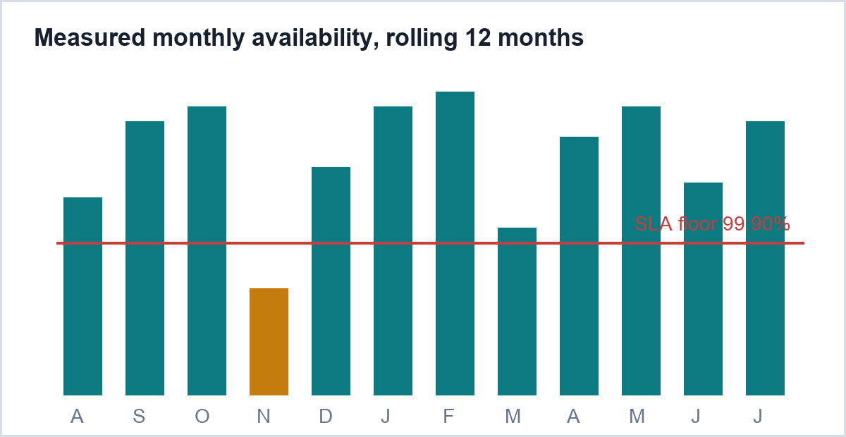
This Annex forms part of the Agreement and is referenced from clause 2.4. Target times are measured from the moment a ticket is raised through an in-scope channel and are stated in business hours for the applicable coverage window. Availability is measured monthly across the control plane and the scanning fabric, excluding announced maintenance windows and any period during which Customer's own identity provider or repository host is unavailable. The chart shows measured availability for the twelve months preceding the Effective Date; it is provided for information and does not itself create a service level commitment. Service credits, where applicable, are the sole remedy for a missed target and are claimed in writing within thirty (30) days of the end of the affected month.
Support commitments by tier, effective 1 October 2026
Engagement |  | Coverage |  | Targets |  | Evidence and reporting
Tier | Severity | Channel | Cover hours | First response | Resolution target | Evidence and reporting
Enterprise | Sev-1 | Phone, portal, shared Slack Connect | 24 x 7 x 365 | 30 minutes | 4 business hours | Monthly availability statement, quarterly service review and the current attestation reports are published to the customer portal. Sev-1 tickets include a written root-cause analysis within five business days of resolution.
Enterprise | Sev-2 | Portal, shared Slack Connect | 07:00-20:00 CET, Mon-Fri | 2 business hours | 2 business days
Enterprise | Sev-3 | Portal | 09:00-18:00 CET, Mon-Fri | 1 business day | Next scheduled release
Business | Sev-1 | Portal | 09:00-18:00 CET, Mon-Fri | 4 business hours | 2 business days | Monthly availability statement published to the customer portal. Attestation reports on request.
Business | Sev-2 and below | Portal | 09:00-18:00 CET, Mon-Fri | 1 business day | Best effort
Freemium | All | Community forum and knowledge base | No committed coverage | No commitment | No commitment | Community support only. No availability statement and no attestation reports.
Escalation ladder (Sev-1)
  Elapsed | Owner | Action
  0 minutes | Duty support engineer | Acknowledge, open incident channel, confirm blast radius
  60 minutes | Support lead | Engage platform on-call, notify Customer's named contacts
  180 minutes | VP Engineering and CISO | Executive bridge, hourly written updates until resolution
Table 2. Support commitments. The header band spans grouped columns, the tier column is merged vertically, and the escalation ladder is a table nested inside a merged cell.

Annex 2: Processing locations and sub-processors
This Annex forms part of the Agreement and is referenced from clause 5.2. Provider maintains the current list at vantageshield.example/trust/sub-processors and gives Customer thirty (30) days' written notice before adding or replacing a sub-processor that processes Customer Content.
Purpose | Sub-processor | Location | Transfer mechanism | In scope
Platform hosting | Amazon Web Services EMEA | Ghent, BE | Not applicable (EEA)
Platform hosting | Amazon Web Services EMEA | Frankfurt, DE | Not applicable (EEA)
Telemetry and logging | Northbeam Observability BV | Stockholm, SE | Not applicable (EEA)
Telemetry and logging | Northbeam Observability BV | Dublin, IE | Not applicable (EEA)
Support desk | Helpline Systems Inc. | Ashburn, US | EU Standard Contractual Clauses
Billing | Cadence Payments SA | Luxembourg, LU | Not applicable (EEA)
Model training | None | Not applicable | Not applicable
Table 3. Sub-processors engaged for the Subscription, with merged purpose groupings and status icons.

Annex 3: Acceptable use and platform security standards
This Annex forms part of the Agreement and is referenced from clauses 3.2 and 4.3. It applies to every User and to every environment that Customer connects to the Products and Services. Provider may update this Annex on thirty (30) days' notice where the change is required for the security of the platform.

A3.1 Account and credential hygiene
Each User authenticates through Customer's identity provider using multi-factor authentication. Users do not share credentials, API tokens or session cookies, and Customer revokes access within one (1) business day of a User leaving its organisation or changing role.
Service accounts and machine tokens are scoped to a single integration, are rotated at least every ninety (90) days, and are never embedded in source code held outside a secrets manager.
A3.2 Prohibited activity
Customer will not, and will not permit any User to:
- circumvent, disable or exceed a published rate limit, quota or Subscription Allocation control;
- direct a scan, crawl or exploit attempt at an asset that is not inside the Authorised Scope;
- upload live malware, ransomware or stolen credentials other than into a designated analysis sandbox;
- attempt to extract model weights, system prompts or training data from the agentic components;
- run load, stress or chaos tests against the platform without Provider's prior written approval; or
- use the findings of another customer's environment, however obtained.
A3.3 Endpoint Agent and device protection
Where Customer enables device protection, Customer authorises the installation and operation of the Endpoint Agent on the workstations and build runners it nominates, including the installation of a local certificate authority for the inspection of outbound developer traffic.
Customer alone obtains every consent and gives every notice required by employment law, works council arrangements and privacy law before an Endpoint Agent is deployed, and warrants that it has done so for each nominated device.
A3.4 Secrets found in scanning
Where a scan detects a credential, private key or token in Customer Content, the finding is stored encrypted, is redacted in notifications and integrations, and is visible only to the Users that Customer has granted the secrets role. Customer remains responsible for rotating the exposed secret; Provider does not rotate, revoke or test a detected credential.
A3.5 Reporting a suspected violation
Customer reports a suspected violation of this Annex, or a suspected compromise of a User account, to security@vantageshield.example without undue delay and in any event within twenty-four (24) hours of becoming aware of it. Provider acknowledges the report within one (1) business day.
A3.6 Response to a violation
Provider's response is proportionate to the conduct and does not limit any other remedy available under the Agreement.
Conduct | Response
Isolated User error | Notice to Customer's security contact
Repeated or unresolved | Suspension of the affected User under clause 3.6
Platform at risk | Immediate suspension and material breach under clause 3.4

End of Agreement. This document, its Annexes and the Order Form referenced in clause 1.1 constitute the complete agreement between the Parties for the Products and Services described above.

