**network-hw1-wireshark1-http**

20190532 Sangyun Lee

**[A]. The Basic HTTP GET/response interaction**

1. Is your browser running HTTP version 1.0 or 1.1? What version of HTTP is the server running?   
   A: We are Using HTTP 1.1 version in our computer and server
2. What is the IP address of your computer? Of the web server?   
   A: IP address of my computer is 165.194.17.12, and web server is 128.119.245.12
3. What is the status code returned from the server to your browser?

A: the status code I received is 200

1. When was the HTML file that you are retrieving last modified at the server?

A: that HTML File was modified at Thu, 21 March 2024, 05:59:02 GMT

1. How many bytes of content are being returned to your browser?

A: 128 bytes

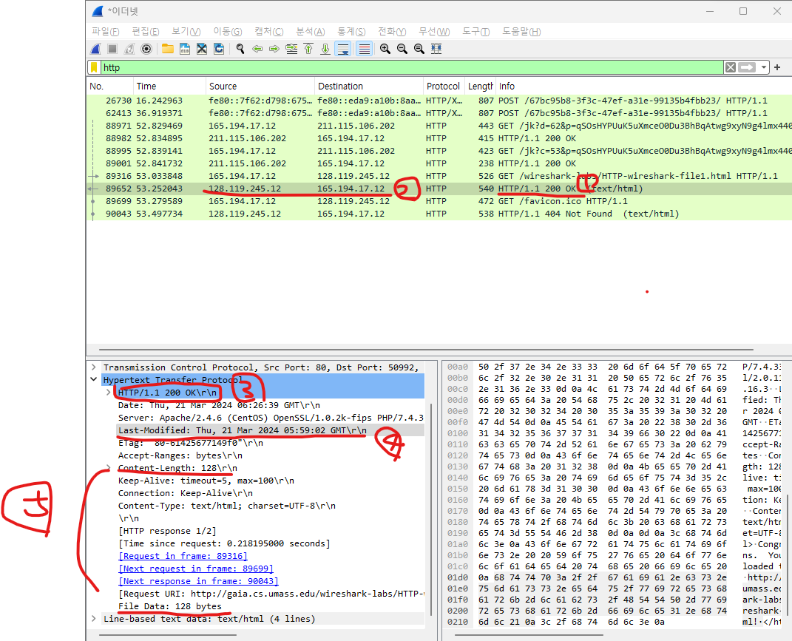

**[B]. The HTTP CONDITIONAL GET/response interaction**

1. Inspect the contents of the first HTTP GET request from your browser to the server. Do you see an “IFMODIFIED-SINCE” line in the HTTP GET?  
   A: No, HTTP Header doesn’t have IF-MODIFEIED-SINCE line  
   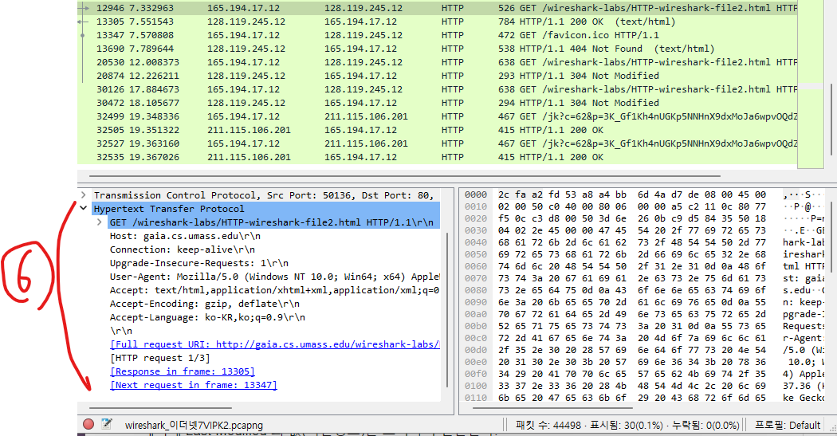
2. Inspect the contents of the server response. Did the server explicitly return the contents of the file?  
   A: Yes, The Server return the contents of the file. The status 200 and contents of content-length line = 371 is evidence  
   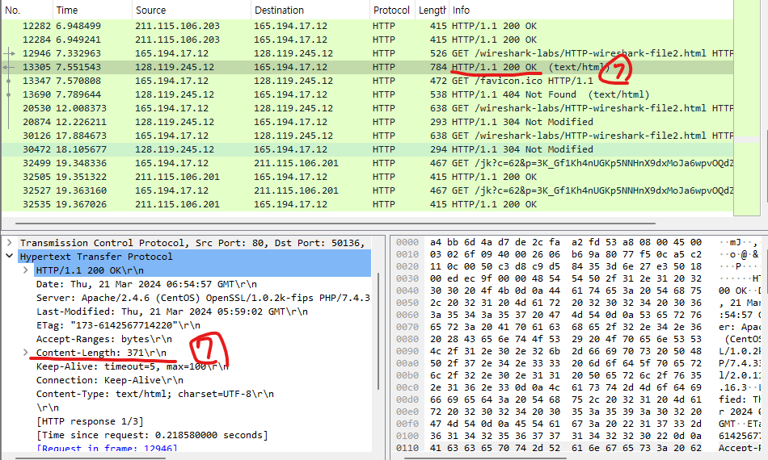
3. Now inspect the contents of the second HTTP GET request from your browser to the server. Do you see an “IF-MODIFIED-SINCE:” line in the HTTP GET? If so, what information follows the “IF-MODIFIED-SINCE:” header?  
   A: Yes, That have IF-MODIFIED-SINCE header. That header includes Last-Modified information of requesting to server first time  
   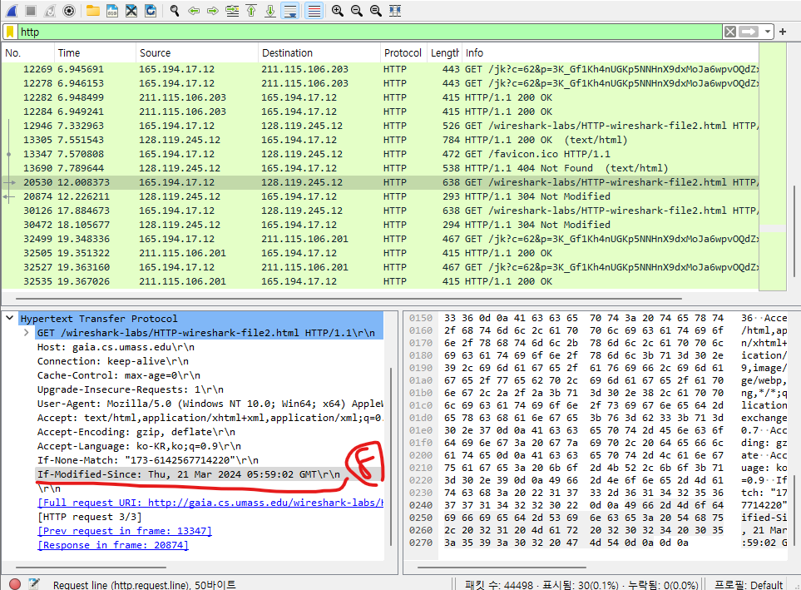
4. What is the HTTP status code and phrase returned from the server in response to this second HTTP GET? Did the server explicitly return the contents of the file? Explain.  
   A: response of second http header is status 304 Not Modified. Look inside the header, they didn’t return the contents of the file. Because of no including content-length line.   
   when the proxy server check the cached contents, If is Ok, then real server return 304 status.  
   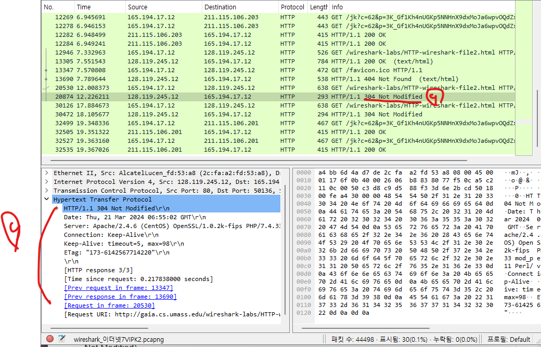

**[C]. Retrieving Long Documents**

1. How many HTTP GET request messages did your browser send? Which packet number in the trace contains the GET message for the ‘Bill of Rights’?  
   A: they are two request messages my browser send, the first packet contains the Get message for the ‘Bill of Rights’
2. What is the status code and phrase in the response?

A: First request of status code is 200 and phrase is OK and Second request of status code is 404 and phrase is Not Found because server doesn’t have /favicon.ico file  
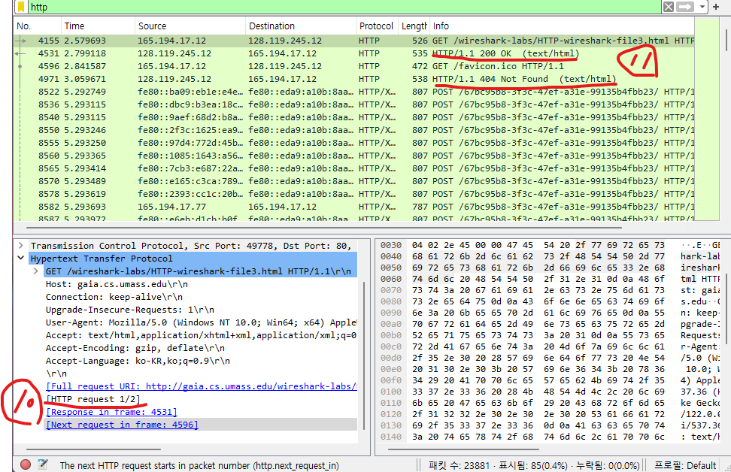

1. How many data-containing TCP segments were needed to carry the single HTTP response and the text of the Bill of Rights?  
   A: they are four data-containing TCP segments returned.   
   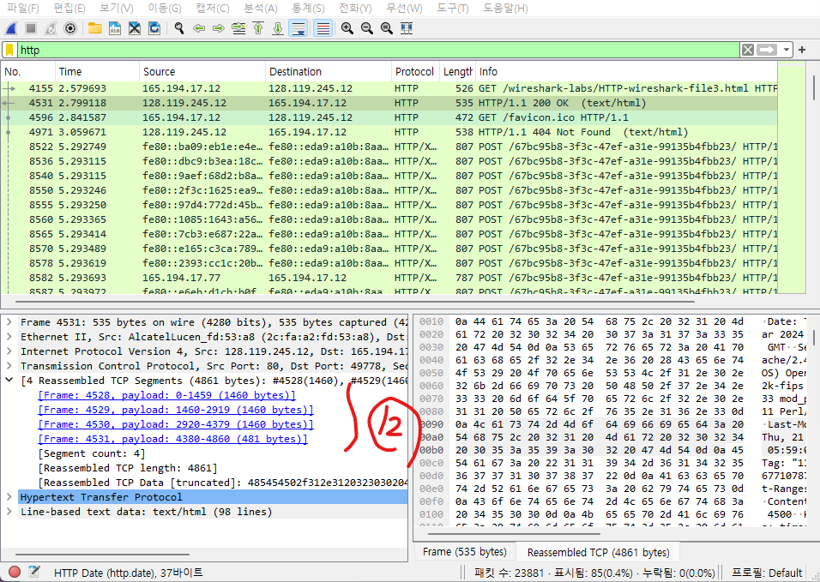

**[D]. HTML Documents with Embedded Objects**

1. How many HTTP GET request messages did your browser send? To which Internet addresses were these GET requests sent?  
   A: Total six times request message send, five request message sent to 165.194.1.2 and one request message sent to 165.194.35.201
2. Can you tell whether your browser downloaded the two images serially, or whether they were downloaded from the two web sites in parallel?  
   A: Italy_1.jpg is downloaded from nsl1.cau.ac.kr (ip address = 165.194.35.201), other contents of html are downloaded from cau.ac.kr (ip address = 165.194.1.2). and two web sites time order are mixed. So my browser downloaded from two web sites in parallel.

