) • • memorygorne Version control  ■GameLobby.php game-lobby.blade,php  <div class="max-w-4x1 mx-auto p-15"› <div class="mb-8"› | urren p e | 

<hi class="text-3x1 font-bold text-gray-900 mb-2"›Memory Game Lobby</h1>

<r) class=" text-gray-600"›Create a new game or join an existing one!</p> </div>
if (session()->has( error'))
<div class,"Ilbg-red-100 border Uborder-red-400 text-red-700 px-4 py-3 rounded mb-4"›
{4 session("error') II

.₇,
21
111
</div>
@endif
<div class,"grid md:grid-cols-2 gap-8">
<div class,"Ilbg-white rounded-lg shadow-md p-6"›
memoryigarne > resources > views > Ilvewire > game-lobby.blade.php PHP: 8.3 801 LF UTF-8 a 4 spaces

• • • rnemorygarne f Version control Current File

GameLolaby„prip game-Lobby.blade.php |  |  | : r_{p}f  A3 ₆₎
<div class="max-w-4x1 mx-auto p-6"›

0  ?-⁹ | <div class."grid and: grid-cols- gap-8"›  <div class="11bg-white rounded-lg shadow-md p-15"›  02 class="text-xl font-semibold rib-4">Create New Game<02>  <form Aagiamakt="createGare"›  <div class="mb-4"›  late for.mgameName" class="block text-sin font-medium text-gray-700 mb-2"›  Game Name  </label>  <input  type="text"  id="gameName"

meniorname > resources > views > Ilvevoire > game-lobby.blade.php PIS P: 8.3 7:23 (247 chars, 5 line breaks) 4.⁻ LF UTF-8 5 4 spaces

• • •
₀ 23
ES
CD
19
• • • memorygame Version control  111 GameLobby.php A game-lobby.blade.php | Current File | 

<div class=Hmax-w-4x1 mx-auto p-6"› 3

<div class="grid and :grid--cols- gap-8">
<div class="11bg-white rounded-lg shadow-md p-6"›
<form Ake'aW="createGame"
<div class="mb-4"›
Game Name

/label>
<input
type="text" id="gameName" wire:model="gantName"

class="w-full px-3 py-2 border ■border-gray-300 rounded-md focus:outline-I placeholder="Enter a game name..."
memorygame 7. resources ) views > Ilvewire > game-lobby.blade.prip PFIP; 8.3 23;40 LF UTF-8 6 614 spaces

GameLobby..phip game-lobbybiaciephp •

• • | memorygarne Version control | Current File v | 

<div class="max-w-4x1 mac-auto p-6">
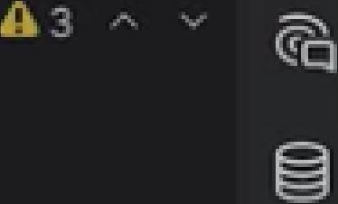
<div class="grid md:grid-cols-2 gap-8"›
<div class="11bg-white rounded-1g shadow-md p-6"› <form E:10alatilt="createGame"›
<div c1ass="mb-4"›
id="gameName"
23 9 wire:model="gameName"

class="w-full px-3 py-2 border ■border-gray-300 rounded-md focus:outl.ine-r placeholder="Enter a game name..."
required
0 | 
@erroreigameNameF)
<span class=" text-red-500 text-se {{ Smessage }}</span>

memorygame resources > views > Ilvewire > game-lobby.blade.ptip PHP: 8.3 23;40 LF UTF-8 15 4 spaces

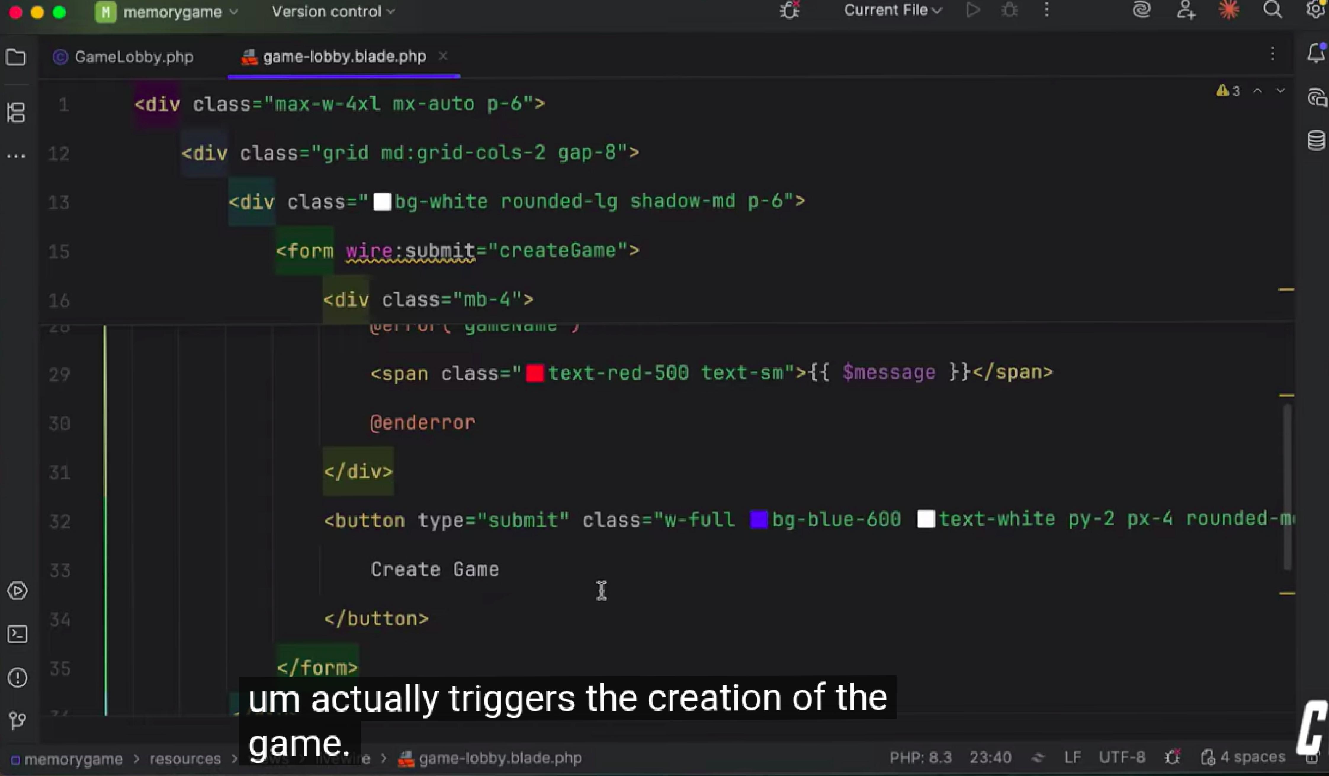
- 0
Current File
- • • memorygame Version control
[11 GameLobby.php 4.1 game-lobby.bladephp
<div class="max-w-4x1 mx-auto p-6">
<div class="grid and: grid-cols- gap-8">
<div class="11bg-white rounded-lg shadow-md p-6"›
<form Itamkeit="createGame"› 16 <div class="mb-4"›
yy.C.1 11.1.11 1„, UO11101101=
<span class="1text-red-500 text-se{{ $message 11</span>
@enderror
</div>
<button type="submit" class=mw-full bg-blue-600 ■text-white py-2 px-4 rounded-D
Create Game
I
</button>
A 3
cLj
29
30
31
32
CD
19
</form>
urn actually triggers the creation of the
memorygame > resources > ^{game.} e > .1 game-lobby blade php
PHP: 8.3 23;40 z LF LITF-8 Ci. Ca_{t} 4 spaces

