

USPS ENGINEERING SYSTEMS

DevOps Architecture for Machine Learning

Edge Compute Infrastructure Program (ECIP)
VERSION 00.01.00

Engineering Software Management
Software Process Management

04/08/2019

Revision Type | Date | Updated By
Initial Draft | 04/08/2019 | Nicholas Sampah

Table of Contents
Scope 4
System overview 4
Document overview 4
ECIP DevOps System 5
Functional Architecture 5
Environment Flow 7
ECIP DevOps Supporting Processes 11
Branching Standards 11
Coding Standards 11

Scope

System overview

The Edge Compute Infrastructure Platform (ECIP) is a platform designed to enable Computer Vision Applications for USPS Engineering. The system is initially focused on analysis of packages from Mail Processing Equipment (MPE) but will extend to supporting processing of letters in a future state.

ECIP is composed of three environments:

- ECIP Plants Processing Equipment (EPPE) (HPE Apollo 6500 system with 4xV100 SXM GPUs)
- ECIP Engineering Environment (EEE) (Dell DGX-Pod)
- ECIP Data Science Environment (EDSP) (Dell DGX-Pod)

While the ECIP system will be governed by the Scaled Agile Framework for Engineering (SAFe), it will leverage the DevOps process as a key enabler for continuous delivery of value from ideation to production. While the conventional use of the DevOps methodology is to enhance the delivery of traditional applications, in the Machine Learning domain the variation of this process is referred to as ML Ops. The ML Ops process straddles the typical phases of a Machine Learning development activity which include the Data Processing, Model Training & Testing, Model Validation and Model Deployment & Monitoring. While these steps differ from the development lifecycle of traditional application, the goals of the DevOps process still apply to ML Ops. These include the consistent and automated assurance of quality and security in all deployments to production.

Document overview

This document outlines the system-level and sub-system level design of the ECIPs DevOps/ML Ops System. This includes descriptions of the ECIPs functional architecture, environment flow, and development process. These descriptions outline a reference implementation of the ECIPs barcode detection software, which includes data processing, computer vision models, result-set enrichment interfaces, and finally the data transfer of outbound results to downstream systems. In addition to system design, this document establishes standard processes such as coding style, repository structure, security guidelines, and versioning rules.

ECIP DevOps System

Functional Architecture

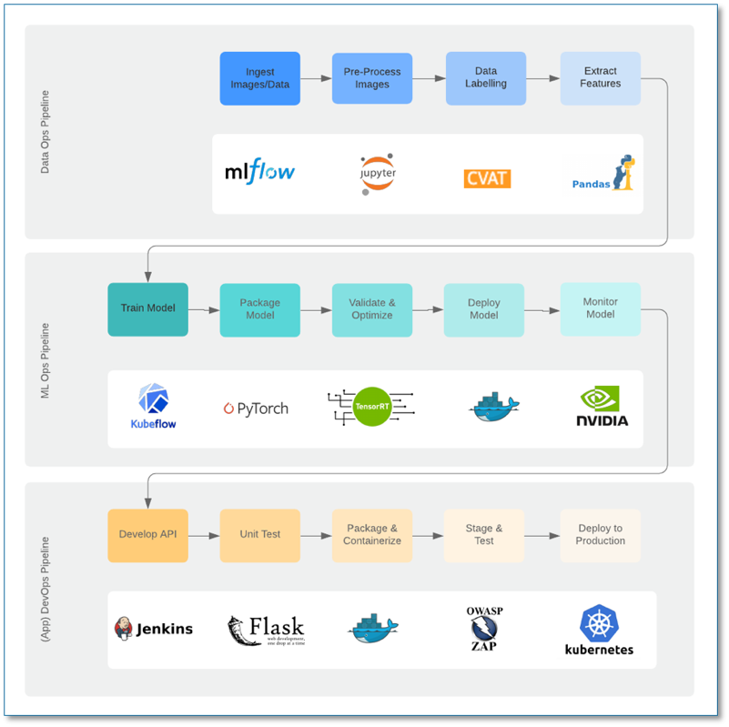

The above flow diagram illustrates the functional architecture system. This system is comprised of three pipelines – the Data Ops pipeline, the ML Ops pipeline, and the DevOps pipeline. The Data Ops pipeline describes the process in which Data Scientists prepare raw data for ML analysis. In this process, raw image data is consumed and processed with Jupyter notebooks. Next, these pre-processed images are labelled with annotations in CVAT. After this step, features are extracted from images by converting image annotations into parquet files with MLFlow. These parquet files are the output of the Data Ops pipeline and serve as the input to the ML Ops pipeline.

The ML Ops pipeline describes the process in which Data Scientists produce a trained image detection model ready for deployment into production. In this process, experiments are run with KubeFlow to train an NVIDIA RetinaNet model with the parquet data from the Data Ops pipeline. Trained models are then packaged, validated and optimized with TensorRT, and deployed into a testing environment. At this stage, hyperparameter tuning and performance evaluation are performed. Once a final model is generated, it is ready to be deployed into production on NVIDIA GPU hardware.

The DevOps pipeline describes the process in which software developers build an application that exposes models to end users and DevOps engineers generate an automated system that deploys the application into production environments. In this process, A Flask API application is used as a frontend interface that allows end users to interact with trained models. This API has several potential endpoints that depend on message consumption patterns. Development on this application is integrated with a CI/CD DevOps pipeline that tests code with a test harness, packages software into Docker containers, stages software in a production-like environment for additional testing, and deploys the application into production environments. Jenkins and Kubernetes are used to run this CI/CD pipeline.

Environment Flow

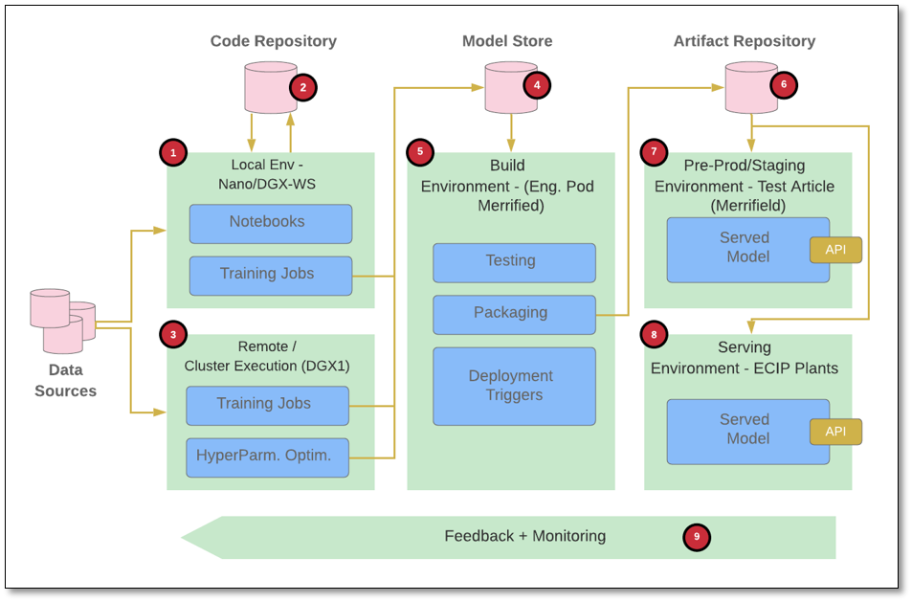

The above flow diagram illustrates the DevOps environment pipeline. Development starts in the local environment on the DGX workstation, where data scientists experiment with interactive notebooks and write training jobs. During local development, code is checked in and out of a code repository for model versioning. These training jobs are executed on a remote DGX cluster for automatic hyperparameter optimization. Training data is provided to the DGX cluster from an external source. After a model has been trained on a DGX cluster, it is published to a model repository along with its performance metrics, hyperparameters, dataset information, and version number.

Published models are evaluated by their performance metrics, and selected models are loaded into the Build environment on the Merrifield Engineering Pod. In this environment, they are tested with production-level usage and packaged into deployable and uniquely versioned Docker images. During the packaging process, an automated test harness is run that uses flake8, pytest, and coverage.py to evaluate coding style, test cases, and test coverage. After software has passed automated testing, it is scanned with SonarQube to inspect code quality and identify security vulnerabilities. The information provided by the test harness and security scan is used to review and resolve issues, and this process is iterated until the packaged images are ready to be published from the Build environment to an artifact repository.

Published image packages are deployed to the pre-production/staging environment on the Merrifield Test Article for further testing in a production-like environment. After an image package has been successfully tested in this environment, strategies such as canary, A/B, and shadow deployment are used to deploy the software to the Production Serving environments at ECIP sites. These strategies are useful in many software deployment applications, but provide additional benefits for ML model deployment. Canary deployment involves deploying a model to a small number of users to test the model in a production use case. The canary model is used to detect changes in both input and result data by providing a comparison benchmark against other production models. A/B deployment involves deploying multiple models to production and comparing them against each other to determine which model performs better for a specific production use case. Shadow deployment involves deploying a new model in an environment where it receives production traffic and data inputs but does not return a response to end users. Instead, shadow model results are stored and used for performance analysis. In production environments, models are continuously monitored to capture use-case-specific metrics.

Development Process

The development process takes place in two stages. The first stage takes place in the local environment on the DGX workstation and involves development on machine learning models. The second stage takes place in the Build environment on the Merrifield Engineering Pod and involves packaging trained machine learning models for use in a production application. In both stages, there are two options for the development process – the git flow model and the trunk model. Both options are currently going through evaluation to determine the option that is best suited for this software implementation.

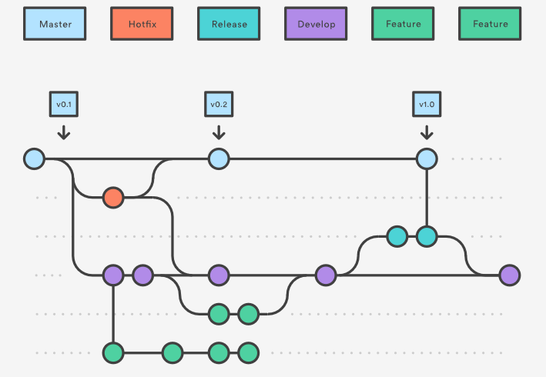

The above diagram illustrates the branching strategy of the git flow model. In this model, there are 4 main branches – master, hotfix, release, and develop. Each feature has its own branch where features are merged in parallel to the development branch. Pull requests are initiated by a feature branch developer when that feature branch is complete and ready to be merged into downstream environments (dev, test, and production). Pull request reviews are required for all pull requests to the external environments of Dev, Master, and Release from remote feature branches.

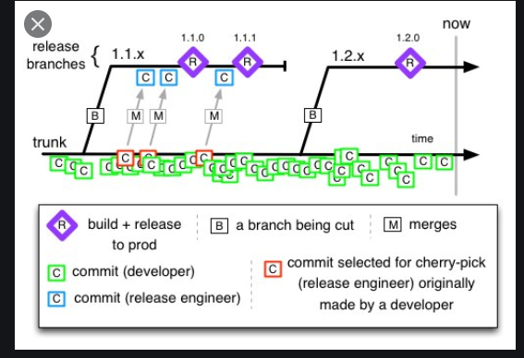

The above diagram illustrates the branching strategy of the trunk model. In this model, there are two main branches – trunk and release. Developers develop together on the trunk branch with all features present, and code changes and commits occur frequently. As a result, feature branches are not used in this model. Pull requests from the trunk branch to the release branch are initiated by release engineers after sprint periods where development is performed.

Both development options share similarities in versioning, testing, and deployment. Released software is versioned with the format vA.B.C. The versioning starts from v0.0.0, and each value increments based on specific criteria. The patch version (C) increments with each software build in which A and B are unchanged, such as in bug fixes or internal behavioral changes. The minor version (B) increments when backward-compatible feature improvements are made. The major version (A) increments with any backwards-incompatible change. Each change to B resets C to 0, and each change to A resets both B and C to 0. Initial development prior to production deployment will remain in major version 0 (v0.B.C) regardless of compatibility changes.

After a pull request is completed, the software is passed through the DevOps pipeline described in the Functional Architecture section of this document. In this pipeline, software is automatically tested with a test harness that evaluates coding style, test cases, and test coverage. Next, software is manually scanned with SonarQube to inspect code quality and identify security vulnerabilities. The information provided by the test harness and security scan is used to review and resolve issues, and this process is iterated until software is ready for release.

Deployment strategies are similar between the git flow and trunk models, but differ between the two stages of development. After ML model software passes through the testing process in the local environment on the DGX workstation, trained models are pushed to a model repository and then deployed to the Build environment on the Merrifield Engineering Pod for use in the second development stage. Software developed in the Build environment is packaged into deployable and uniquely versioned Docker images and pushed to an artifact repository. Software is first deployed to the pre-production/staging environment for testing in a production-like environment. Successful testing in this environment certifies the software as the Golden Image Update which is ready to be deployed to the Production Serving environments at ECIP sites.

ECIP DevOps Standards

Versioning Scheme for Branches

For feature development branches, software builds are versioned with the format vA.B.C.BranchName.D, with D iterating with each branch build. The v.A.B.C version in this format is based on the version the branch originates from. When the feature branch is merged into the destination branch, the destination branch version is incremented according to criteria defined in the Development Process section of this document.

Coding Standards

Code should follow the following general guidelines:
- Source code should be placed in an appropriate module directory rather than the root.
- Pipenv should be leveraged for dependency management.
- Ensure consistency in documentation (in source code) using reStructuredText to allow for on-the-fly generation of documentation.
- Additional documentation should be placed in the /docs directory.
- Unit tests should be placed in the /tests directory (refer to Test Automation standards for the unit test framework to use)

Code should follow the following naming convention guidelines:
- Names should not be generic and should have relevant meaning. They should be short yet descriptive.
- Variables should be named in lower case with an underscore ( _ ) separating each word; If the variable is not public, then the variable name should start with an underscore, example: _private_variable.
- Constants should be named in all caps and separated by an underscore. Example: PRODUCT_ID
- Function and Method names should also be in lower case separated by an underscore. If private (class level), then start with _.
- Classes should use upper case camel casing. Example: NeuralNetworkClass
- Packages should be named in lowercase with an underscore separating them, preferably single-worded.
- Hard-coded strings should be removed from source code and placed in configuration files or other data stores. Configuration files (including credential data) should be stored separately from source code in a secure location with restricted access. Examples: connectivity parameters, usernames, passwords, certificates, etc.
- Follow additional naming conventions outlined in the Hitch Hikers Guide to Python (https://docs.python-guide.org/writing/style/).
- For a more extensive list, refer to the PEP8 guidelines for styling code (https://www.python.org/dev/peps/pep-0008/).
- Use “pycodestyle” to check code for conformance to PEP8.
- Use “flake8” to checks for errors in Python code, enforce a coding standard, and find for code smells (https://flake8.pycqa.org/en/latest/). Flake8 behavior can be configured in the .flake8 file.

Code should follow the following security guidelines:
- Use the latest version of Python as it addresses known security flaws in the language
- Scan code with Bandit. Bandit automatically scans code for OWASP Top 10 security risks and more. Bandit usage is illustrated at https://bandit.readthedocs.io/en/latest/index.html and https://developer.rackspace.com/blog/getting-started-with-bandit/.
- Pipenv’s safety package should be leveraged to scan the entire dependency graph for known security vulnerabilities. This relies on a service operated by Pyup.io.
- Do not leave debugging enabled when deploying to production to avoid exposing weaknesses that could be exploited.
- Do not commit code with passwords or keys with it. This information needs to be configured securely in respective environments and protected by encrypted secrets management service.
- Ensure that legitimate and updated packages are installed. Third-party packages may have malicious code in them so research should be conducted on desired packages prior to installation. Ensure that you carefully spell out the package name.
- Be wary of code that allows injection of SQL strings or scripts that could get executed on databases or in end-user browsers. This can lead to unauthorized disclosure of information.

