

USPS ENGINEERING SYSTEMS

Development process document(Dpd)

<DEVOPS, (DPD),
VERSION 1 >

April 2nd, 2019

Table of Contents
1. Purpose 2
2. Git process 2
3. Feature Branch 3
4. Pull Request 3
5. Versioning 3
6. Testing 4
7. Test Coverage 4
8. Pull Request Review 4
9. Security Scan 4
10. Deploy Options 4
11. Push to Registry 4

Purpose
The purpose of this document is to supply an outline of the developmental process and provide strategies in order to fulfill a successful toolchain

Git process
- Git flow model (feature branch based): There are 4 branches excluding the feature branches, (Master, Hotfix, Release, Develop)
  - Development is separated and sandboxed per feature
  - 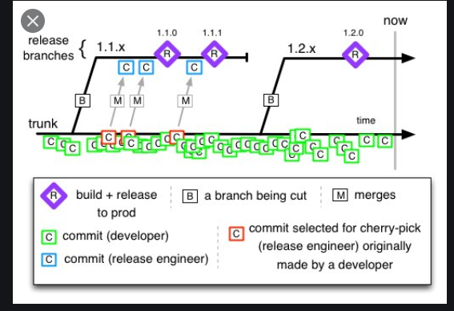
- Trunk based strategy: There are 2 branches total, the trunk branch and the release branch.
  - Code changes and commits are frequent occur quickly. Developers develop together on one single branch(trunk) with all features present
  - 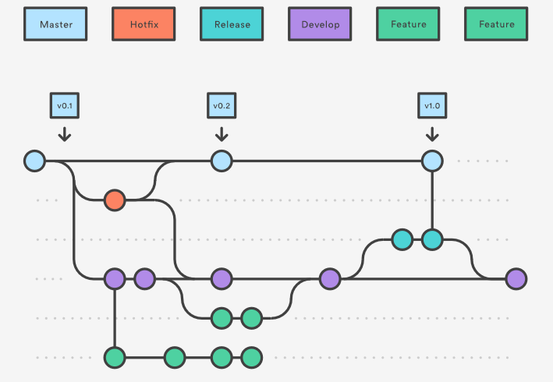

Feature Branch
- Git flow model: each feature will have its own branch where features are merged in parallel to the development branch and so forth to further environments.
- Trunk based strategy: There are no feature branches simply a trunk branch where any code changes and commits are made cohesively into one branch designated for integral commits which we call trunk.

Pull Request
- Git flow model: pull requests are issue by the developer when the feature branch is complete and ready to be merged into the further environments (dev, test, production)
- Trunk based strategy: pull requests are issued to the release branch by the developer after a sprint period

Versioning
- Released software is versioned with the format vA.B.C. The versioning starts from v0.0.0, and each value increments based on specific criteria. The patch version (C) increments with each software build in which A and B are unchanged, such as in bug fixes or internal behavioral changes. The minor version (B) increments when backward-compatible feature improvements are made. The major version (A) increments with any backwards-incompatible change. Each change to B resets C to 0, and each change to A resets both B and C to 0. Initial development prior to production deployment will remain in major version 0 (v0.B.C) regardless of compatibility changes.
- For new feature development branches, software builds will be versioned with the format vA.B.C.BranchName.D, with D iterating with each branch build. The v.A.B.C version in this format is based on the version the branch originates from. When the feature branch is merged into the destination branch, the destination branch version is incremented according to the above criteria.

Testing
- Git flow strategy: Testing will be done manually per branch before committing into the next environment.
- Trunk based strategy: The execution of test cases occur automatically after new changes are committed to the trunk branch

Test Coverage
- Code needs to be tested completely before it will be shipped out.
- Testing will run with pytest, with developers responsible for writing test cases for their code
- Coverage.py will be used to generate a test coverage report that gives the percentage of coverage for each module based upon the test cases written.

Pull Request Review
- Git flow model: pull requests reviews are required for all pull requests to the external environments of Dev, Master, and Release from remote feature branches
- Trunk based strategy: Pull request reviews are orchestrated by manager level resources to review code in order to facilitate commit merging from the trunk to the release branch

Security Scan
- Git flow strategy: per each/or designated successful environment builds and tests security scanning will be orchestrated
- Trunk based strategy: security scanning occurs in a CICD fashion per successful builds

Deploy Options
- Git flow strategy: Once code is successful from security scanning components are packaged into docker containers and orchestrated with docker compose through the further environments
- Trunk based strategy: Upon successful and favorable cicd build, test, and security phase code are first deployed in a canary manner
  - Deployment of code will be deployed to a small specific number of users in order to test the application as a real-world use case.
  - Upon successful operation of software with favorable user experience new code is migrated to the release branch environment with code packaged in docker containers coupled with an orchestration software

Push to Registry
- In order for container artifacts to be pushed to registry, required in both strategies, new code and any modifications to code must be properly tested by data scientists first within the Local Environment (Nano/DGX-WS).
- Tests are conducted by the manual execution of a test harness program that automatically runs test cases on the software. These instructions are found in the software installation guide
- From following the instructions, test coverage and security scanning results must be successfully generated and favorable in order for code to be versioned and pushed back into the code repository and pushed forward to the further environments from the model store (registry).
- Versioning protocols can be found in the sections above. Versioning will hold congruency between both active processes (versioning code to the repository and versioning code to the model store.)
- The successful model is then deployed to the Build Environment (Merrifield Pod Dev.) by a triggered build within a CICD agent where testing and security scanning will be automated within and throughout the pipeline process in order to ensure build stability.
- When the product build is successfully stable with favorable deliverables code is packaged and properly deployed to the Artifact registry with the same versioning schema as that set by the prior. Same consistency with congruency.
- After the artifact is packaged to the repository with the proper versioning schema it is then deployed to the Pre-Prod/Staging Environment for the article to be tested for production functionality.
- After the article is tested to be fully operational in the Pre-Prod/Staging Environment (Merrifield) that is when the artifact can be certified as the Golden Image Update and it will be ready to be deployed to the Serving Environment which is the ECIP Plants environment for production use.

