Alex Torres

EE5353

10/21/2016

Homework Project 2

For part (a) I used two 5x5 kernels to filter the original image with the window convolution method. Shown below are my results for part (a) with the corresponding mean-square-root-errors shown below the images. The original image along with its histogram is shown before the filtered images:

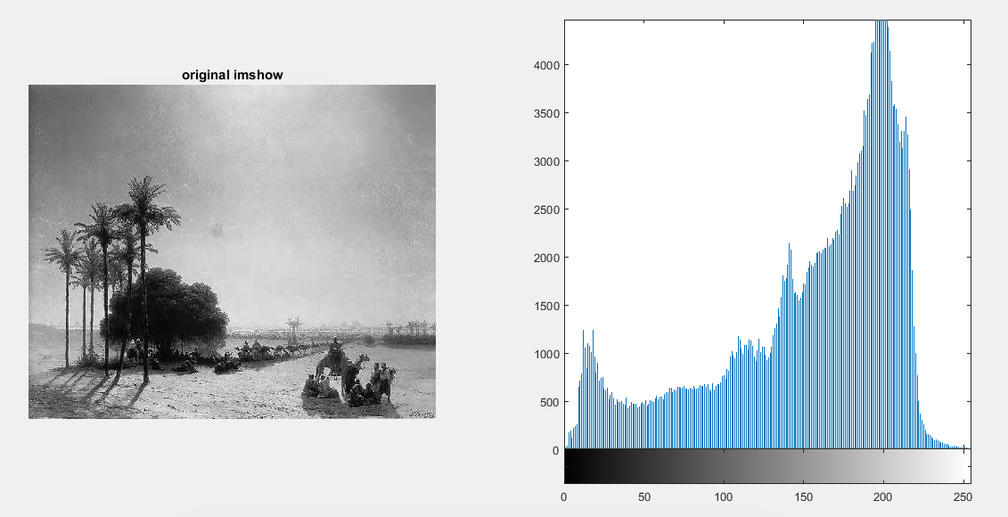Original Image-

First filtered image-

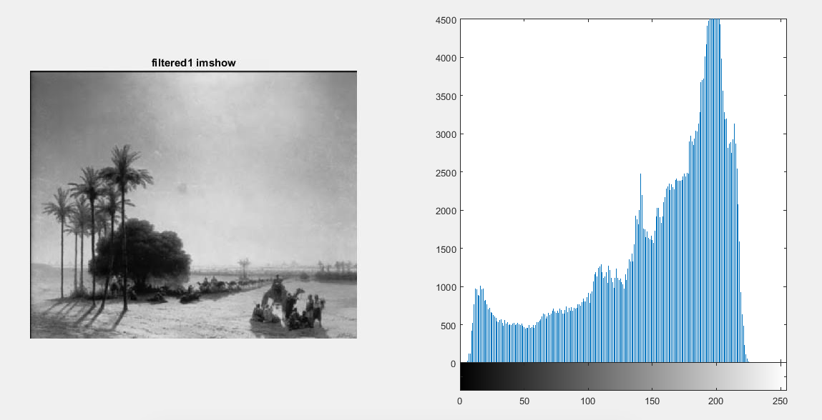

filtered1_error = 0.0091

Second filtered image-



filtered2_error = 0.0085

Third filtered image-

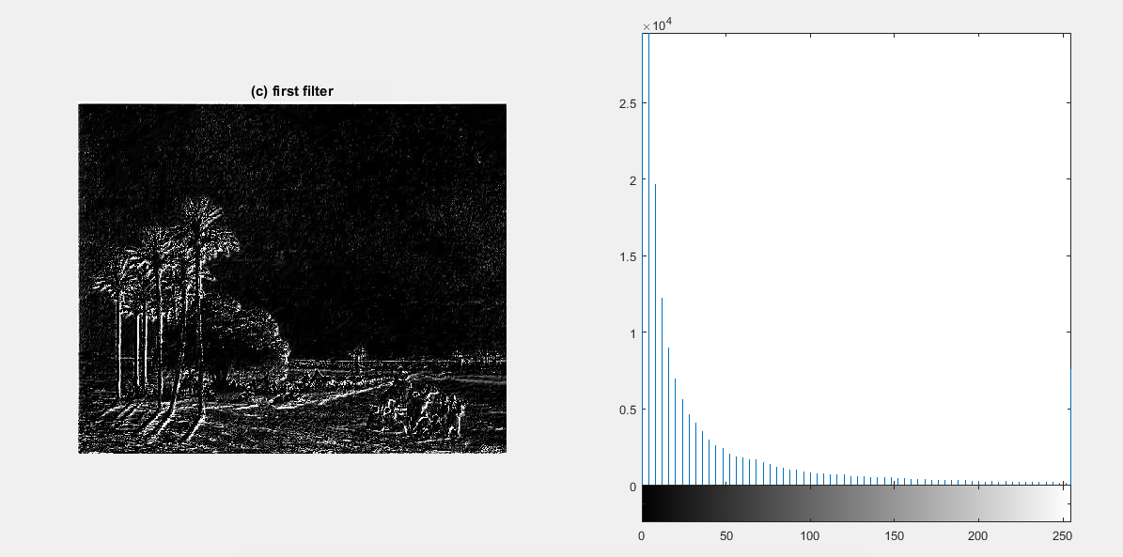

imshow_c1_error = 0.0269

Fourth filtered image-

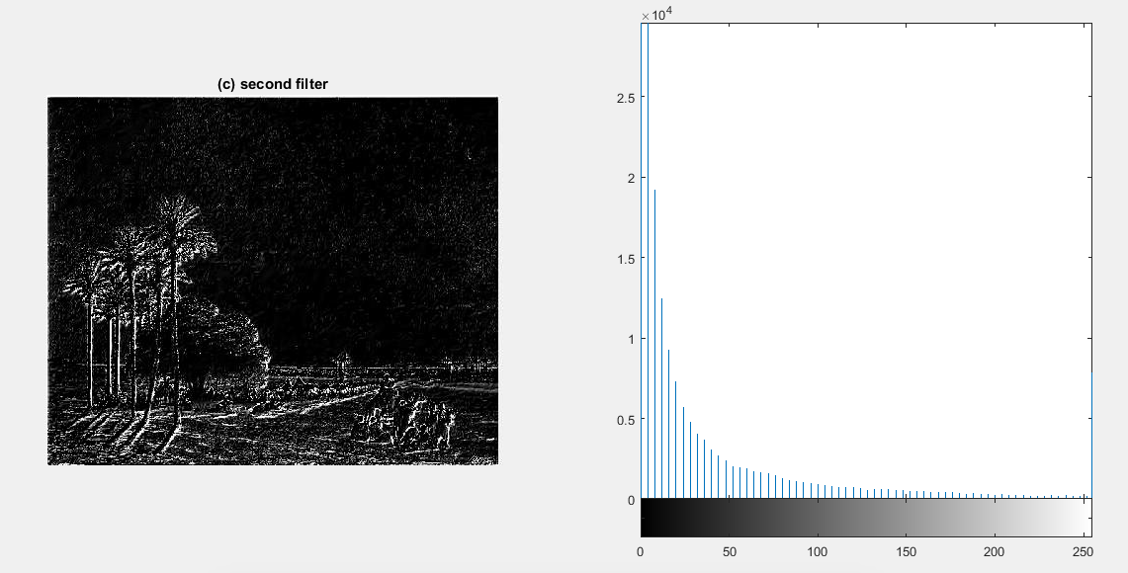

imshow_c2_error = 0.0271

For part (b) I used two 3x3 kernels to filter the original image using the Fast Fourier Transform convolution method. To obtain the convolution between kernel and original image, I took the Fourier transform of both the original image and the kernel before multiplying the two together and taking the inverse Fourier transform of the result.

Original Image-

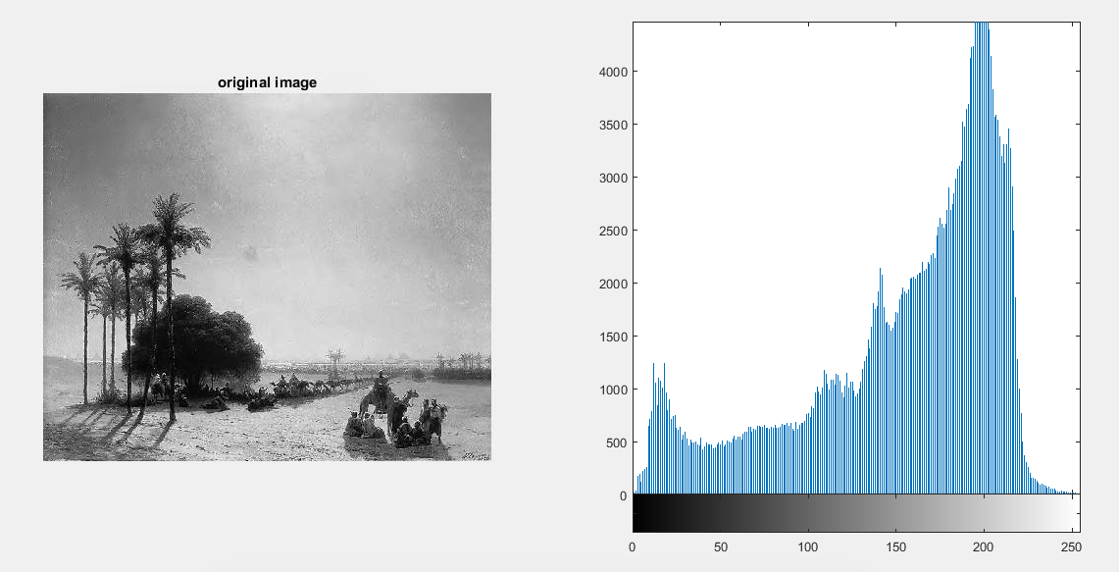

First filtered image-

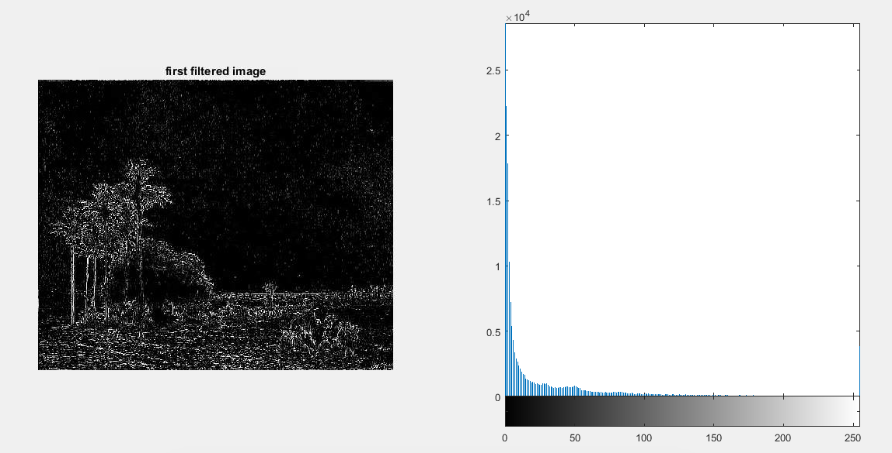

filtered1_error = 0.0264

Second filtered image-

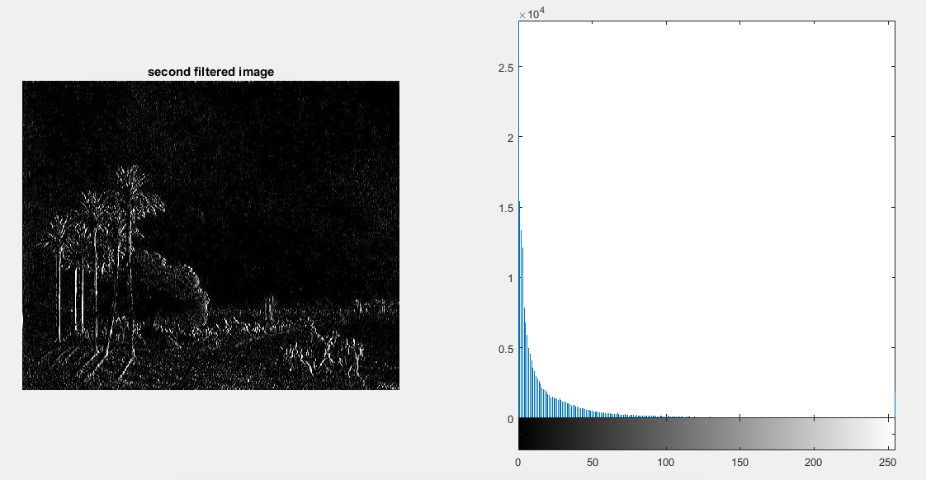

filtered2_error = 0.0268

Third filtered image-

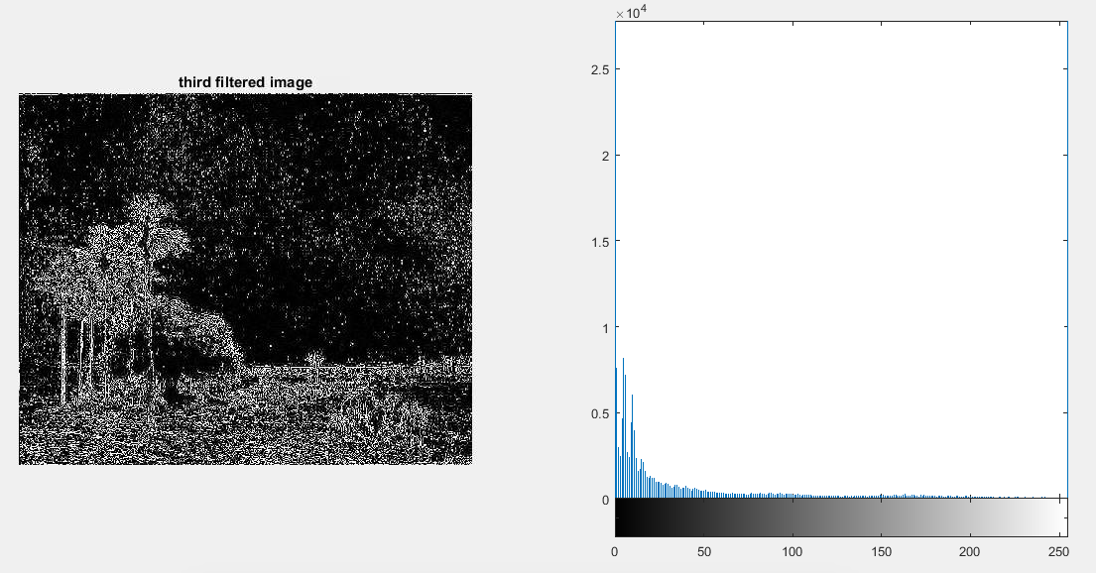

filtered3_error = 0.0252

Conclusion:

The errors from the filtered images in part (b) are on the same order of magnitude as the third and fourth filtered images from part (a). The errors from the first and second filtered images from part (a) are an order of magnitude less than all other filtered images. The histograms of the filtered images with higher errors have the majority of their pixels very close to 0, where the histograms of the filtered images with lower errors have the majority of their pixels closer to 200.