Alex Torres

EE5353

Fall 2016

Project 1

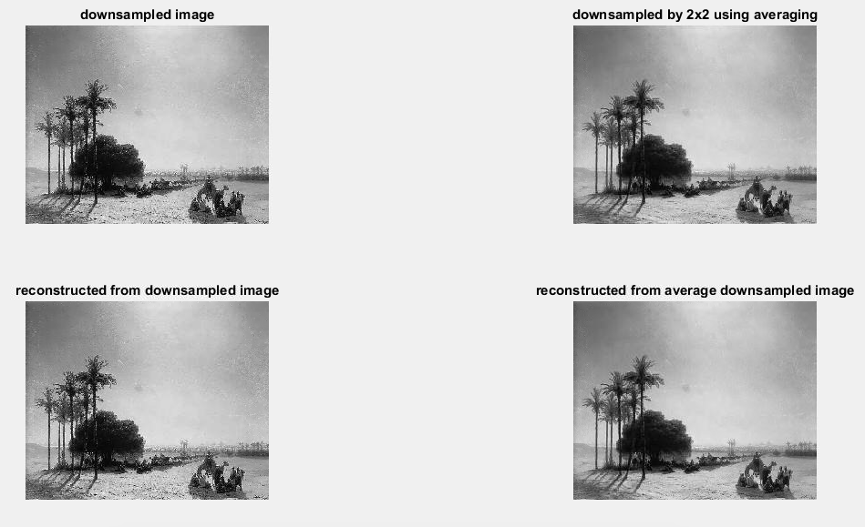

The mean-square-root error for the first reconstructed image is 0.0253.

The mean-square-root error for the second reconstructed image is 0.0179.