Alex Torres

EE5353

10/6/2016

Project Test 1

For this project, I used the correlation method to find the target images on the original. In order to do this, first I threshold both the target and original images, with both images converted with different thresholds. After obtaining the resulting binary images, I took the target and iterated over the entire original image, rotating the target by intervals of 45 degrees before proceeding to the next iteration. After each rotation, and before proceeding to the next iteration, I called the correlation function to determine whether or not the images matched. If the correlation function was above a certain value, then I saved the corresponding tile of the original image in a “cell” data structure. I then used the data inside the “cell” to find the center and draw boxes around the detected images.

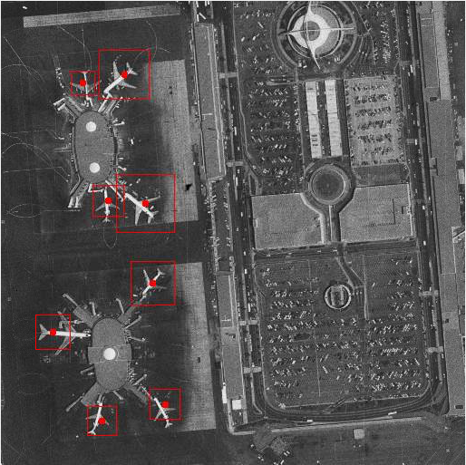The original tiff image with target detections is shown below:

The program’s total execution time was 28.548 seconds, with the majority of time being spent on rotating images (26.106 seconds) and computing the correlation between images (13.321 seconds).

Here is the time profile for my program:

