Candidate should develop the scenario for creating the list of accounts according to the design.

Steps for the realization:

- Log into <https://bitbucket.org>, clone the repo [1]

- Realize all features in own repo

- Give a link to the repo

Functionality which needs to be developed use angularJs/Angular:

- Create same lists of accounts (fig. 1)

- Implement created account feature (fig. 2)

- Implement validation form for creating accounts (fig. 3)

- Implement sorting by date

It will be a plus:

- Adaptive responsive layout for different devices;

- Automatic tests.

Useful links:

1. [https://bitbucket.org/GL-Apps/gl-bench-test/src/master/](https://bitbucket.org/GL-Apps/gl-bench-hybrid-test/src/master/)

2. <https://github.com/typicode/json-server>

Figure: 1

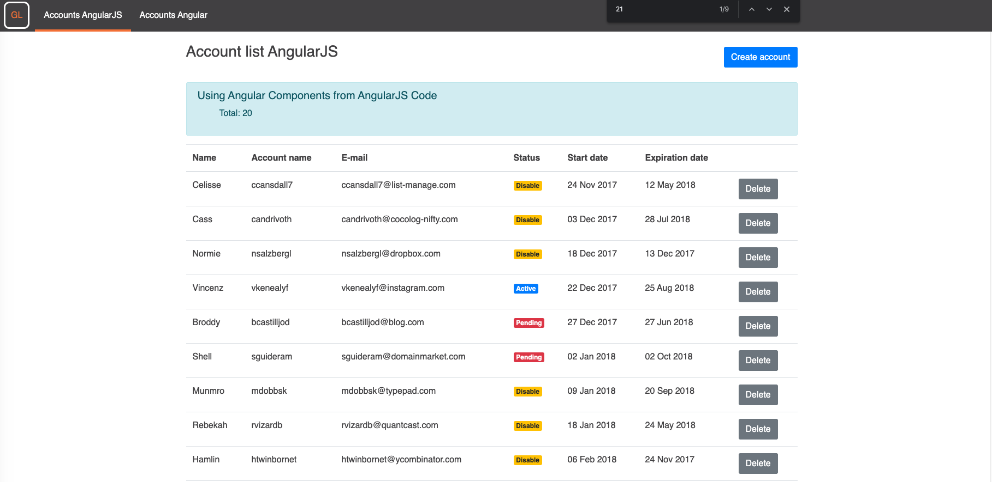

Figure: 2

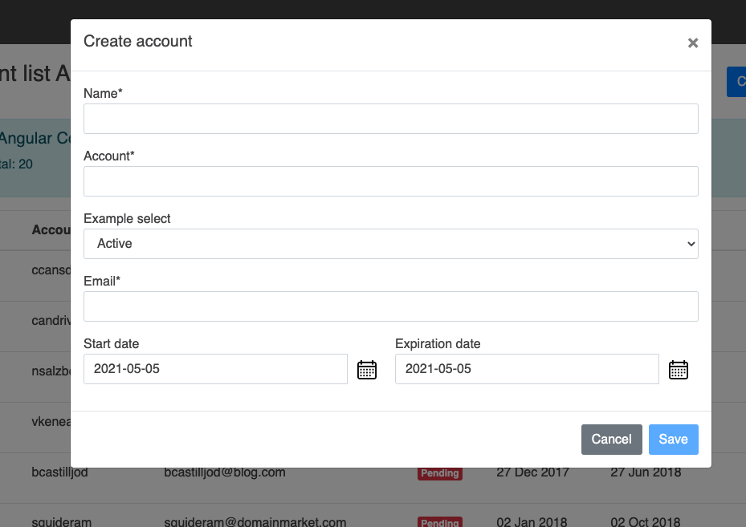

Figure: 3

