SNMP protocol Introduction

Simple Network Management Protocol (SNMP) is an “Internet-standard protocol for managing devices on IP networks”. SNMP support 5 basic core protocol data units (PDUs), they are GetRequest, GetNextRequest, Set Request, Get Response and Trap. SNMP is using one request and one reply protocol except Trap as Trap does not need to reply.

In actual field, SNMP Manager provide a Network management station (NMS). A network management station (NMS) executes applications that monitor and control managed devices. NMSs provide the bulk of the processing and memory resources required for network management. One or more NMSs may exist on any managed network. An agent is a network-management software module that resides on a managed device. An agent has local knowledge of management information and translates that information to or from an SNMP-specific form.

SNMP itself does not define which information (which variables) a managed system should offer. Rather, SNMP uses an extensible design, where the available information is defined by management information bases (MIBs).

The SNMP agent receives requests on UDP port 161. The manager may send requests from any available source port to port 161 in the agent. The agent response will be sent back to the source port on the manager. The manager receives notifications (Traps and InformRequests) on port 162.
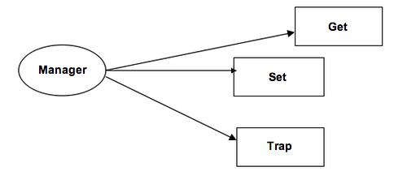
GetRequest
A manager-to-agent request to retrieve the value of a variable or list of variables. Desired variables are specified in variable bindings (values are not used). Retrieval of the specified variable values is to be done as an atomic operation by the agent. A Response with current values is returned.
SetRequest
A manager-to-agent request to change the value of a variable or list of variables. Variable bindings are specified in the body of the request. Changes to all specified variables are to be made as an atomic operation by the agent. A Response with (current) new values for the variables is returned.
Trap
Asynchronous notification from agent to manager. SNMP traps enable an agent to notify the management station of significant events by way of an unsolicited SNMP message. Includes current sysUpTime value, an OID identifying the type of trap and optional variable bindings. Destination addressing for traps is determined in an application-specific manner typically through trap configuration variables in the MIB. The format of the trap message was changed in SNMPv2 and the PDU was renamed SNMPv2-Trap. While in classic communication the client always actively requests information from the server, SNMP allows the additional use of so-called “traps”. These are data packages that are sent from the SNMP client to the server without being explicitly requested.

Below is the object identification of the manager
Object naming tree has 3 object on the top: ISO, ITU-T (Formerly CCITT) and one joint organization of these 2 organizations. Internet (tag is 1) is under the object dod, it is identifier code is {1.3.6.1}. The node below the node of Internet is mgmt (management) tagged 2. It’s identifier code is {1.3.6.1.2.1} or {Internet(1).2.1}. The object identifier or OID is an identifier used to name an object. Structurally, an OID consists of a node in a hierarchically-assigned namespace. For the MIB of the object {1.3.3.1.4.1} which is the enterprise, the number has been over 3,000. e.g. {1.3.6.1.4.1.2} is IBM, {1.3.6.1.4.1.9} is Cisco, etc… This mean any company and school send a email to iana-mib@isi.edu can get a named node. Therefore, each manufacture can naming their own product object identifier for the management of SNMP.
