Build process

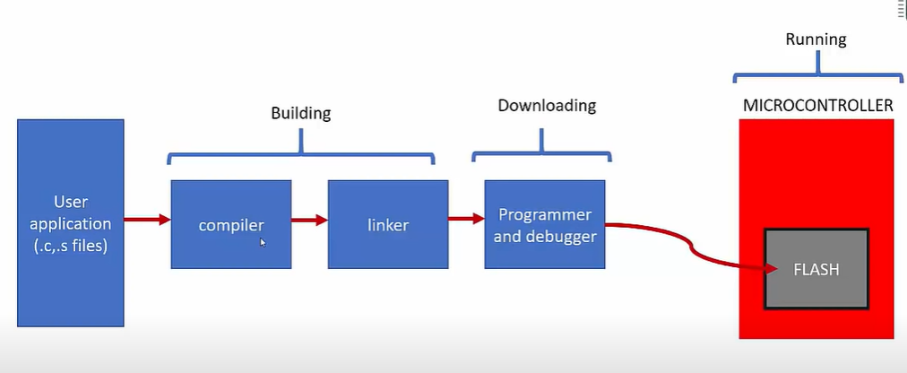

Cross toolchain important binaries:

Compiler,linker,assembler :

* arm-none-eabi-gcc

[note that arm-none-eabi-gcc not only does compilation, it also assemble and links object file to create final executable file . ]

Linker:

* arm-none-eabi-ld

Assembler:

* arm-none-eabi-as

Format converter:

* arm-none-eabi-objcopy

Elf file analyzer:

* arm-none-eabi-objdump
* arm-none-eabi-readelf
* arm-none-eabi-nm

Build process

Step1:

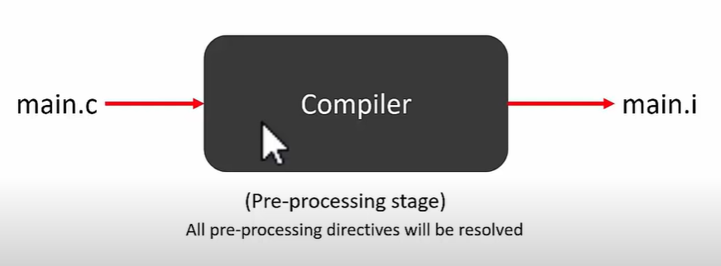

Step2:

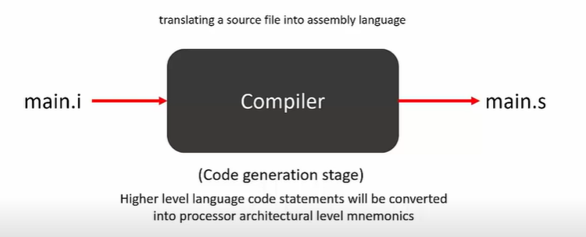

Step3:

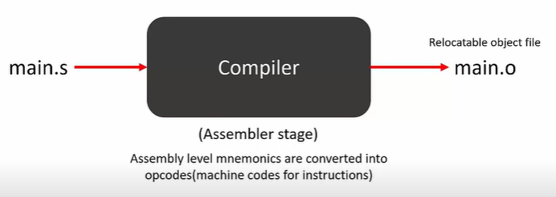

Full process :

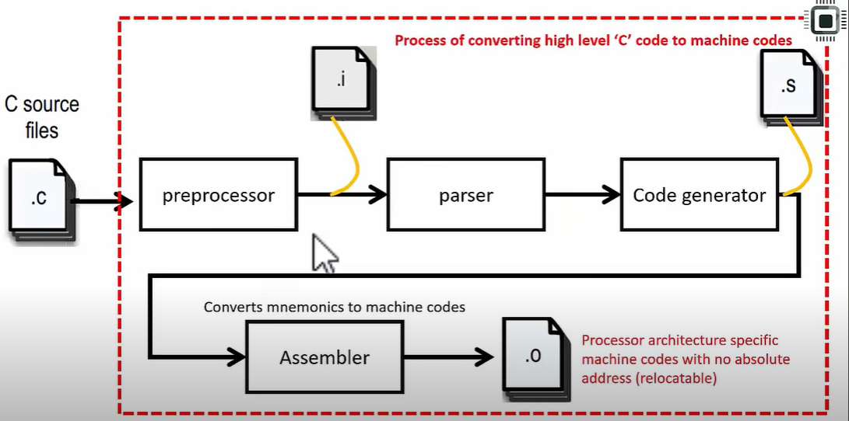

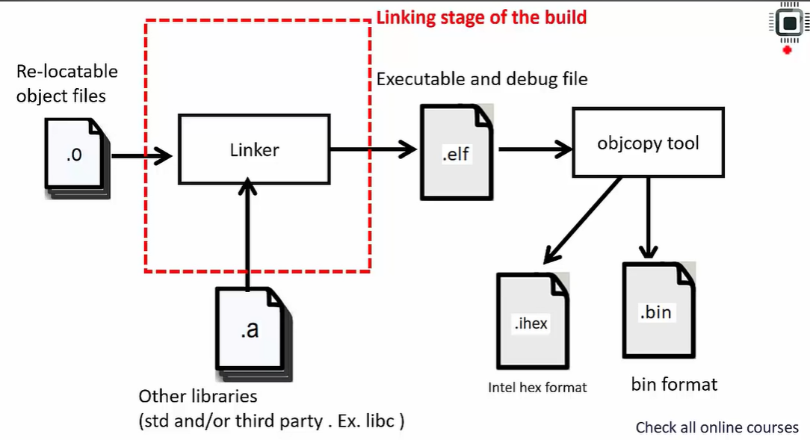

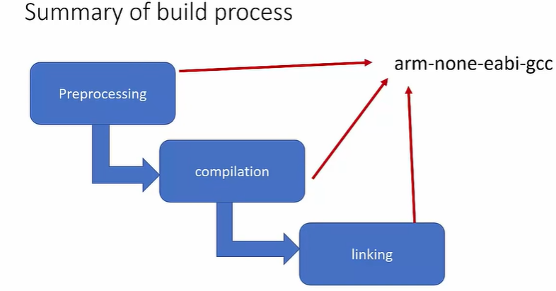

arm-none-eabi-gcc -c -mcpu=cortex-m4 -mthumb test.c -o test.o